Smart Tool for Jeraisy Projects

Below are some implemented feature in the SmartTool for Jeraisy Group Company

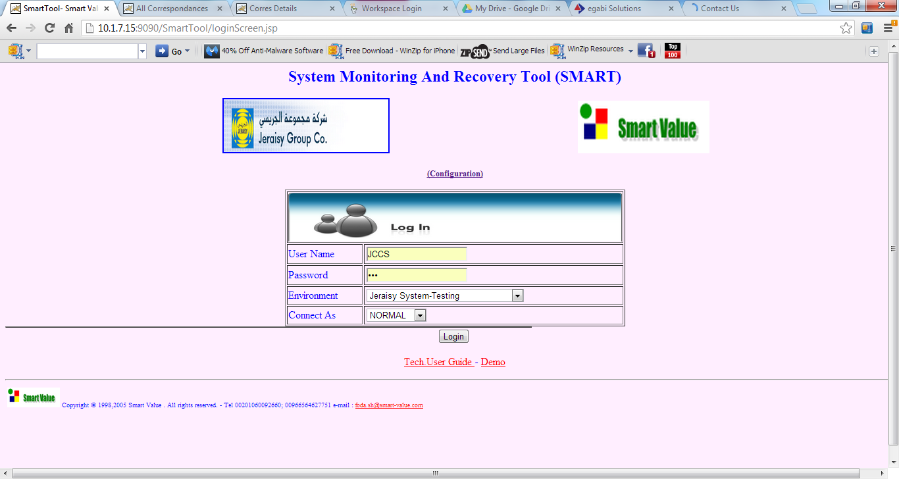

- As a Project Management Information System
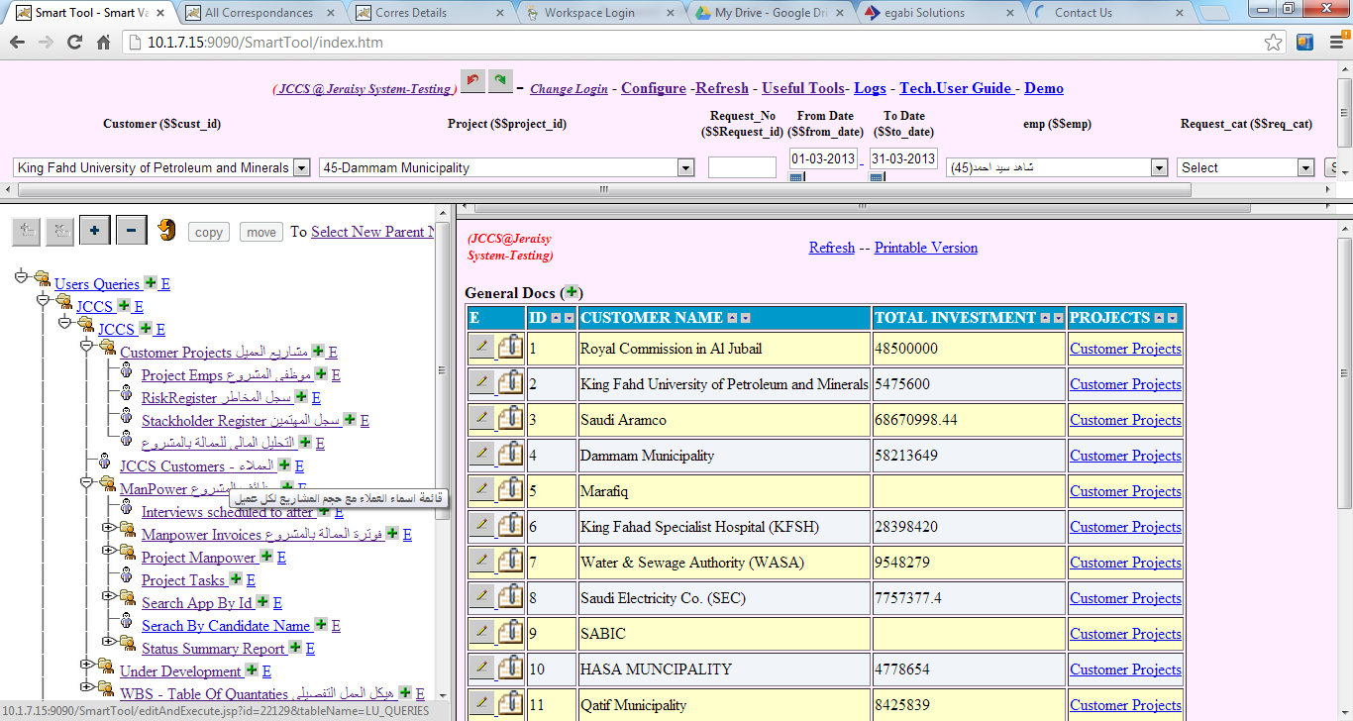

- As an IT Service Management (ITIL) and Help Desk – O&M Management
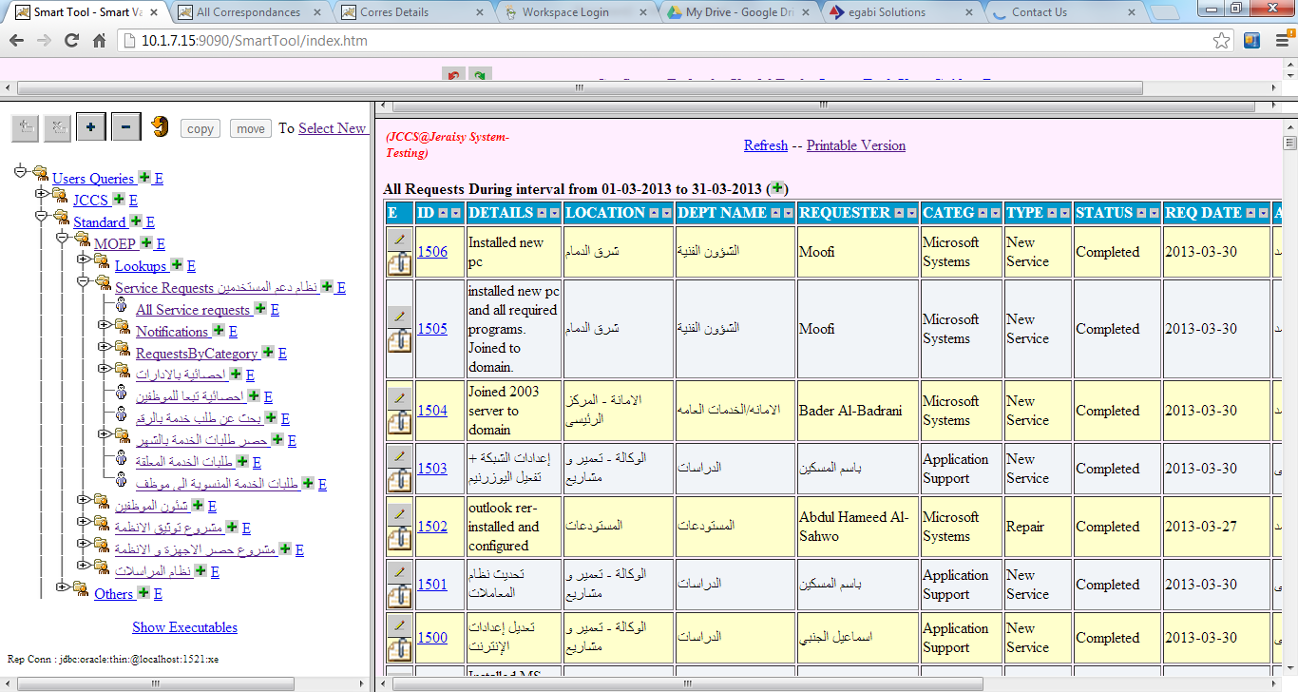

As an Archiving and Correspondences System
