**Smart Tool for Jeraisy Projects**

**Below are some implemented feature in the SmartTool for Jeraisy Group Company**

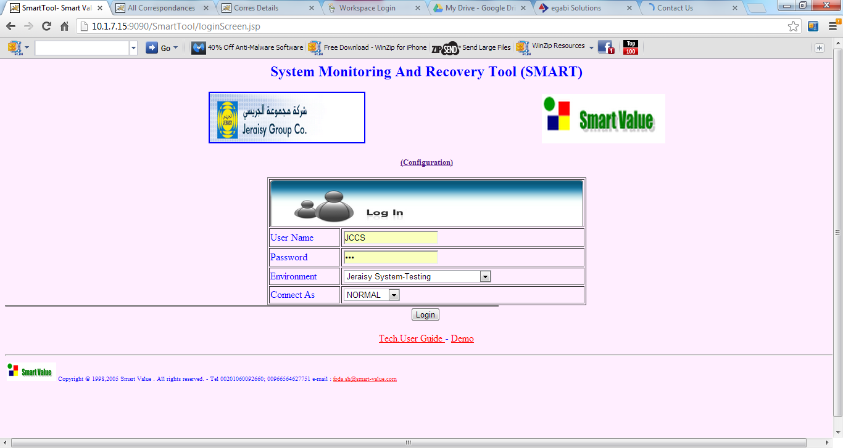

1. ***As a Project Management Information System***

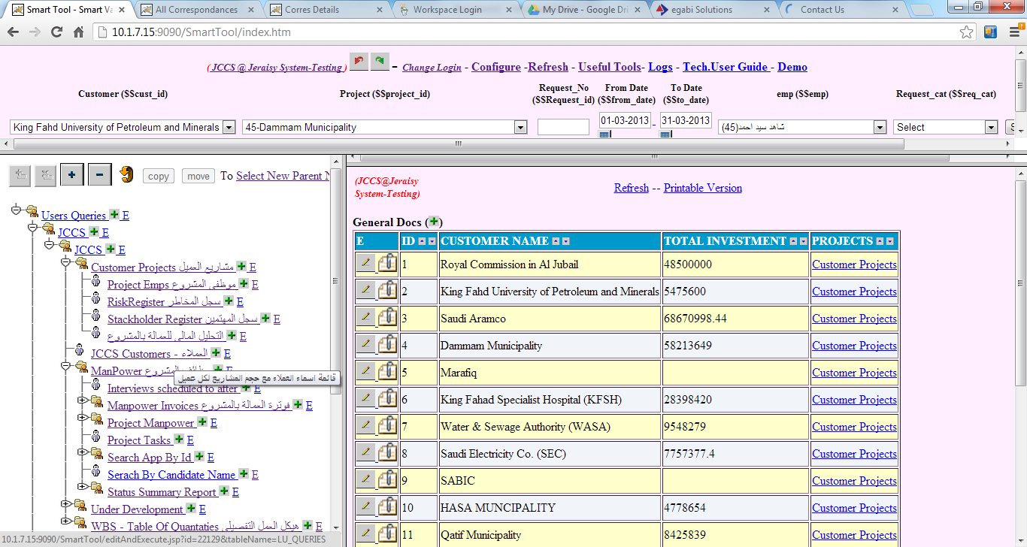

1. ***As an IT Service Management (ITIL) and Help Desk – O&M Management***

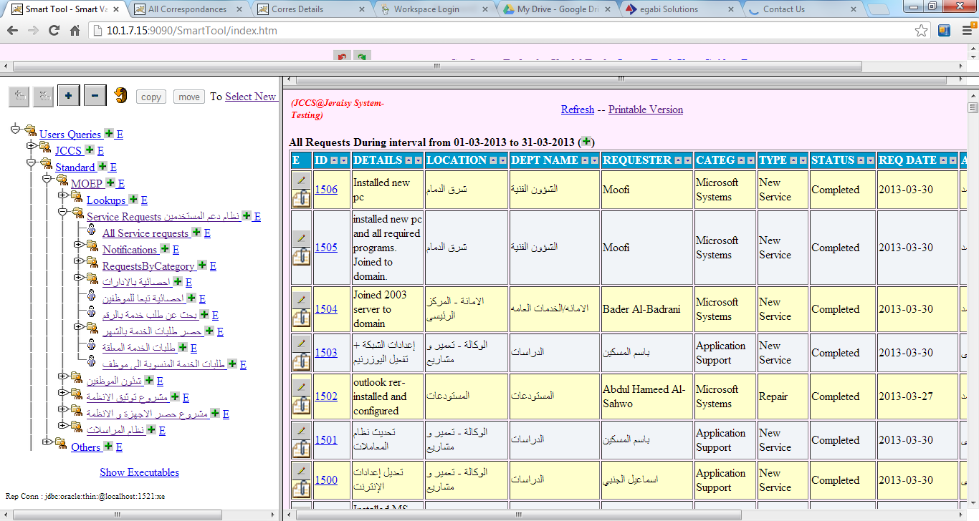

***As an Archiving and Correspondences System***

