

***Smart Tool Technical Guide***

Prepared by:

Smart Value for Systems Integration

**Reference:**

**Issue: 1.1**

**Last Saved: 04/03/2009 08:09**

**Approved by: \_\_\_\_\_\_\_\_\_\_\_\_\_\_\_\_\_\_\_\_\_\_\_\_\_\_\_\_\_\_\_\_\_\_\_\_\_\_\_\_\_**

**Approval Date: \_\_\_\_\_\_\_\_\_\_\_\_\_\_\_\_\_\_\_\_\_\_\_\_\_\_\_\_\_\_\_\_\_\_\_\_**

Document Control

|  |  |  |  |  |  |
| --- | --- | --- | --- | --- | --- |
| Version | Reason for Change | Authors | Reviewer | Remarks | Date |
| 1.0 | First Release | Smart-value |  | First Release | 20/02/2008 |
| 1.1 |  |  |  |  |  |

***Table of Contents***

[Introduction 5](#_Toc223881152)

[**What is great about this product?** 5](#_Toc223881153)

[**History** 5](#_Toc223881154)

[**Technical Requirements and Supported Databases** 5](#_Toc223881155)

[**What it does** 6](#_Toc223881156)

[**Who should use it?** 6](#_Toc223881157)

[**Competitive products** 6](#_Toc223881158)

[**Support** 7](#_Toc223881159)

[**About the Author** 7](#_Toc223881160)

[1 Install Smart Tool Web application 8](#_Toc223881161)

[1.1 Install Repository DB 8](#_Toc223881162)

[1.2 Deploy Smart Tool J2EE war application to your Application server 8](#_Toc223881163)

[1.2.1 Install TomCat Application Server: 8](#_Toc223881164)

[1.2.2 Deploy SmartTool To Your Tomcat Server 8](#_Toc223881165)

[2 Smart Tool layout 10](#_Toc223881166)

[3 Configure You DB Connection parameters 11](#_Toc223881167)

[4 Build you own Hyper Linked reports 13](#_Toc223881168)

[4.1 Add your first simple query 13](#_Toc223881169)

[4.1.1 Report with Multiple Results. 15](#_Toc223881170)

[4.2 Organize Your Reports 16](#_Toc223881171)

[4.3 Configure You SQL Bind Variables. 16](#_Toc223881172)

[4.4 Add new Query report 17](#_Toc223881173)

[4.5 Link Your Query report with SQL Bind Variable 18](#_Toc223881174)

[4.6 Link a query result to another query 18](#_Toc223881175)

[4.6.1 Display the second report in a new window 18](#_Toc223881176)

[4.6.2 Display the second report inside the first one (AJAX) 19](#_Toc223881182)

[4.7 Browse your query result in xml Format 20](#_Toc223881183)

[4.8 Monitor Your Reports Execution statistics 21](#_Toc223881184)

[4.9 Open your query results in MS Excel 22](#_Toc223881185)

[4.9.1 Building a new XLS template for Your Report 22](#_Toc223881186)

[4.10 Crystal report Integration 23](#_Toc223881187)

[4.11 Edit Your Query Result- DML Operations 24](#_Toc223881188)

[4.12 Post Your Query result to a Web Service 25](#_Toc223881189)

[4.13 Create an Insert Form for Your Data 26](#_Toc223881190)

[5 Built your own Executable Procedure 28](#_Toc223881191)

[6 Link Your Query result with File System (Windows/Unix) 29](#_Toc223881192)

[7 Using Oracle CLOB Reader Web Service 29](#_Toc223881193)

[8 Automatic Mail Notifiation 29](#_Toc223881194)

[7.1 – Query Result Mail Sender only if Data Found 29](#_Toc223881195)

[7.2 – Query Result Mail Sender 30](#_Toc223881196)

[9 Other Useful Tools 31](#_Toc223881197)

[9.1 General Purpose Excel Sheet Uploading Tool 31](#_Toc223881198)

[9.2 Http Poster Client Application 31](#_Toc223881199)

[9.3 SMS Sender 31](#_Toc223881200)

[9.4 XML Deployment Tool 31](#_Toc223881201)

[9.5 31](#_Toc223881202)

[10 Ready Made DBA Reports 32](#_Toc223881203)

[Appendices 34](#_Toc223881204)

[10.1 Appendix A 34](#_Toc223881205)

# Introduction

SMART Tool helps you manage your databases Systems from the convenience of your Web Browser. The software sits on the top of a Web Server and allows you to interactively access and administer your databases remotely. As of now it supports Oracle and Microsoft SQL Server. In future releases the product will support IBM DB2 UDB as well.   
  
The product has almost all the features for the day to day working of DBA’s and Application Support teams. Among the most innovative features is the Reports navigator which allows you to browse through the related views and get the up-to-date information about your database, and customizable HTML reports. The GUI is consistent and very intuitive. Among other features it includes real time instance monitoring, space organization, maintenance and tuning of SQL queries, etc.   
  
The product is very useful to DBA’s and Application Support Team and the user interface is friendly. There are a lot of administrative tools available in the market but many of them are not available under remote administration category. The product is ideal in todays world, where the databases are in London and New York and the development and administration team are in Egypt.

|  |
| --- |
| **What is great about this product?**   * SMART Tool simplifies the most common database management tasks, such as creating/modifying/deleting schema objects, the movement of objects and data across environments, data editing, creating and executing efficient SMART scripts, monitoring process information. * Remote administration via browser serves multiple users to use the application to manage multiple heterogeneous databases through a single intuitive interface. * Real-time performance can be viewed graphically. * Provides easy security administration for granting, revoking and assigning roles and privileges. * Provides users with an efficient means to view key instance statistics instead of querying V$ views manually. Drilling down to related views really helps in saving a lot of time. * Allows novice administrators to learn DDL syntax as they are creating and maintaining. * Any query could be modified as requied. * XMLs could be displayed ,Various date formats could be displayed as per convince   **History**  Smart Value cid:image001.gif@01C9215E.B0493540  is known for its database management tools. Now, SMART Tool is their answer to Web based database administration. <Company Name> Software Solutions enables database professionals with the ability to manage the entire life cycle of today's distributed environments. They have tools for the following categories:   - SQL Development  - Change Management  - Maintenance Optimization  - Performance Monitoring & Tuning  - Backup & Recovery  - Business Information Management   SMART Tool is the one from the Change Management category.  **Technical Requirements and Supported Databases**  The software has to be installed on the top of a web server. The operating systems supported are: Windows NT 4.0 with Service Pack 4 or 5 applied, Windows 2000 Server/Professional.   The supported web servers are: Apache Web server 1.3.9 - 1.3.12 with Apache JServ 1.0, 1.1, Microsoft IIS (Windows Server hosts) 4.0 with Allaire JRun 2.3.3. Apache Web Server 1.3.9 and Apache JServ 1.0 is bundled with the software.   The supported clients include: Windows 95, Windows 98, Windows 2000, Windows NT 4.0 with Service Pack 4 or 5 applied with either Netscape Navigator 4.0 or Internet Explorer 4.x. The browser requires a java plug-in version 1.3.   The Database Platforms supported are: Oracle 7.3.4, 8.0.x, and 8i with TCP/IP as the protocol and Net8 (SQL\*Net) installed on the database server.  **What it does**  SMART Tool enables you to administer your databases remotely via a browser. Web SMART is installed on a Web Server and has many modules. The most appealing ones are:   * V$ Navigator - Allows you to fetch V$ views and see the related views and drill down. * Data Editor - Allows you to insert/update/delete data to a table through the GUI. * SQL Scratch Pad - Allows you to write to SQL and view the execution plan before running it. * Reports (Customizable HTML) - Allows you to extract one of 26 HTML Database Reports or customize to suite your needs. * Monitors - Allows you to view one of Web SMART's color trend graphs of real-time performance information. * OS File Browser - Allows you to view & edit files from within Web SMART. * Online Community - Takes you to OTN error message page for help.   **Who should use it?**  SMART Tool's are the targeted users, the tool helps them with day-to-day monitoring and administrative tasks to a large extent. Novice administrator would learn a lot by using the product. Database programmers can also benefit from SMART Tool.  **Competitive products**  The competitive products are from CA, Embarcadero, and Quest. Computer Associate has a product called Manage IT. Quest has tools called Spotlight for Oracle, Schema Manager, etc. Emercadero has tools called DB Artisan, DB Artisan Change Manager, and Performance Monitor. Then there is product called HORA from KeepTool's. But most of the products are not web based and that's where Web SMART has an edge.   Competition is also with Oracle, which has a product called Oracle SMART studio. It can work from within Enterprise Manager. It has modules like schema manager, security manager, storage manager, etc. The products are well integrated with each other and have gone through significant improvements. It also supports database administration from Web Browser.   While choosing a product for yourself, you should figure out your requirements and try to match them with products available in the market. Competition for corporate dollars needs to be evaluated, but SHAWKY's Web SMART is good value if you are doing remote SMART work.  **Support**  *Smart Value* have a support section of their web site http://www.smart-value.com. You can get support by email foda.sh@smart-value.com  **About the Author**  Shawky Foda is a database/Web consultant. He is has interests in data modelling, database design, and performance tuning. He can be contacted at foda.sh@Smart-Value.com He is based in Egypt. |

# Install Smart Tool Web application

## Install Repository DB

Use Oracle “Imp” tool to import the Smart Tool export file “SmartToolDD-MM-YYYY.imp”

You May need to create a tablepace called “Smartts”

## Deploy Smart Tool J2EE war application to your Application server

Once Smart Tool is a standard J2EE Web Application, it can be easily installed over any standard Web Application Server like Tomcat, Oracle Application Server or IBM WebShere.

In the next section we will explain how to deploy SmartTool to Tomcat Apache Server

### Install TomCat Application Server:

* 1. Install Apache Tomcat/5.5. from <http://tomcat.apache.org/> - if you did not
  2. Assuming you have succefully installed tomcat to port 8888, open your browser with <http://127.0.0.1:8888/>
  3. You will get a page like the folloing:

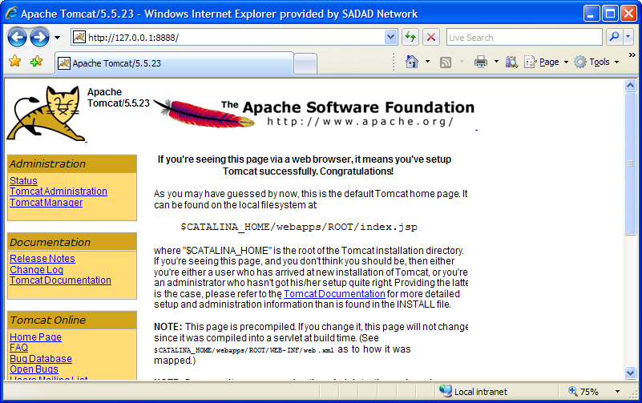

### Deploy SmartTool To Your Tomcat Server

#### Using (SmartTool.war) File

Click on the “Tomcat Manager” in the left part of the screen

Deploy Smart Tool War file SmartTool.war as shown below

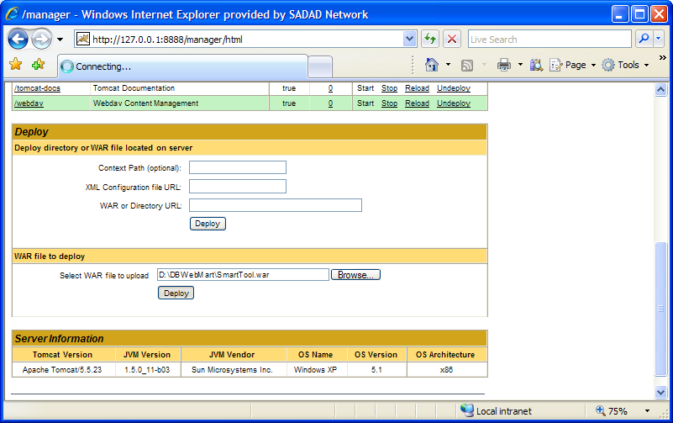

If smart Tool deployed successfully, you should get a screen like the following:

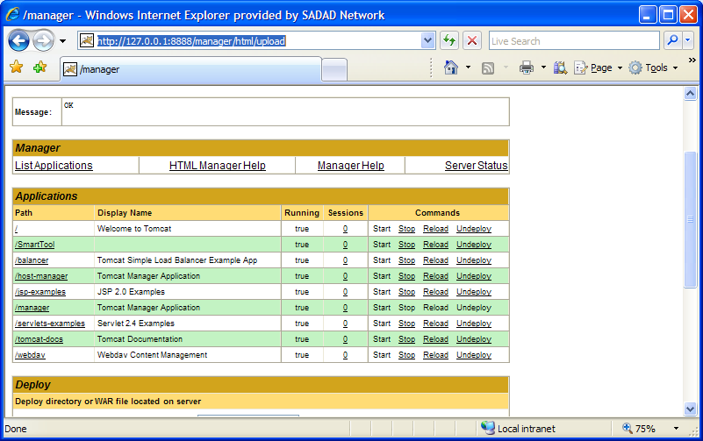

Now Smart Tool is running at your Machine at the following URL:

<http://127.0.0.1:8888/SmartTool/>

By this type of deployment,<*Class path*> variable used in this document will point to: <*Class path*> = <Your *TomCat Installation Path*> \webapps\SmartTool\WEB-INF\classes\

<*public\_html\_path>* = <Your *TomCat Installation Path*>\webapps\SmartTool

#### Using Tomcat Server.xml Configuration file

1. Go to C:\Program Files\Apache Software Foundation\Tomcat 6.0\conf
2. Edit file server.xml
3. Add the following line :

*<Context docBase="C:\Program files\SmartValue\SmartTool\WebContent" path="/SmartTool" reloadable="true" /></Host>*

Assume your installation folder is *C:\Program files\SmartValue*

Just before:

*</Host>*

*</Engine>*

*</Service>*

*</Server>*

At the end of the file.

# Smart Tool layout

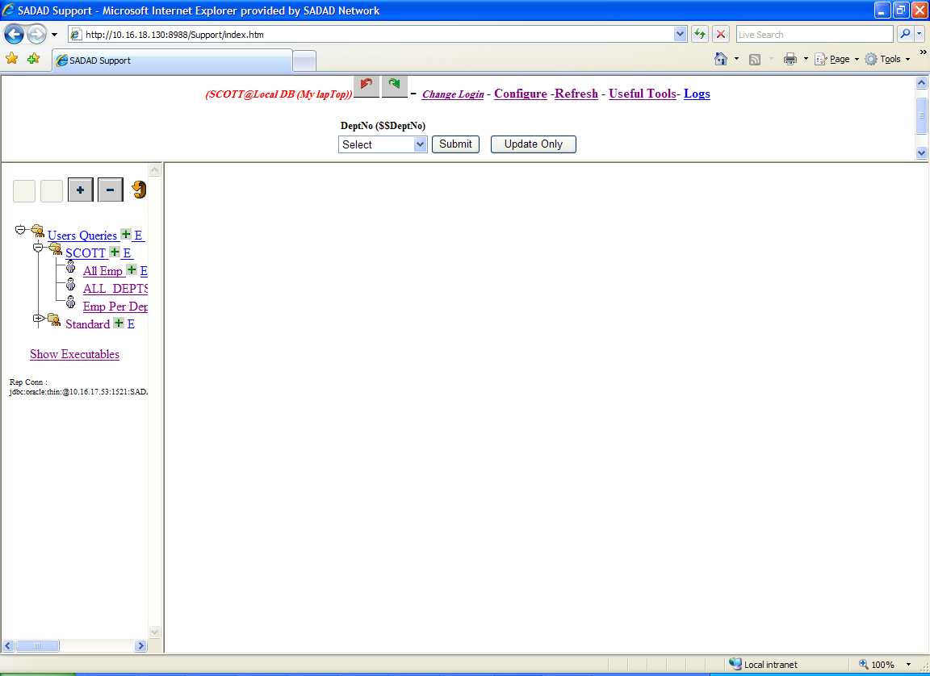



Bind Variables Frame

Report (Query) Result Frame

Smart Tool consists mainly of 3 frames as indicated above

1. Bind Variables Frames

Your own SQL bind variable will be appear at this frame, queries depend on any of these variables i.e. have a reference to it with ‘$$’ before its name will be executed after substituting this reference with the value selected or entered for this variable.

1. Reports Navigation Frame:

This frame contains a navigational tree with 2 mains subnodes

1. Standard : Contains all Reports with is accessable to all Users
2. <Your Login Id>: if this is the first time you log to the system, Smart will automatically generate a new node with your DB login Id. This node will be the parent node for all your customized reports.
3. Report Result Frame:

By just click on an report from the Report Navigation frame, Smart will start to execute it and display the result in this frame.

# Application Configuration Parameters

Under Construction :

Located “sys\_params” table in the Reposatory DB….

|  |  |  |  |
| --- | --- | --- | --- |
| ****E NAME**** | ****VAL**** | ****E NAME**** | ****E DSC**** |
| SMTP\_SERVER | 217.136.241.34 | SMTP\_SERVER | IP Address of SMTP Mail Server |
| Support User Email | foda.sh@smart-value.com | Support User Email | Smart Report User Email Sender |
| MailSenderUserName | sfoda | MailSenderUserName | For Mail Autentication ( If requjired ) |
| MailSenderPassword | welcome2side | MailSenderPassword | For Mail Autentication ( If requjired ) |
| Logging Path | D:\MyWork\JavaWork\Smart Value Products\SmartTool\WebContent\ | Logging Path | Logging Path |
| Admin\_Notify\_Mail\_Address\_Receiver | sfoda@eastnets.com | Admin\_Notify\_Mail\_Address\_Receiver | Admin\_Notify\_Mail\_Address\_Receiver |
| AutoLogin\_Environment\_Name | MyLabtop | AutoLogin\_Environment\_Name | All Process which auto log to DB uses this Environment Name |
| AutoLogin\_Username | scott | AutoLogin\_Username | All Process which auto log to DB uses this username |
| AutoLogin\_Password | tiger | AutoLogin\_Password | All Process which auto log to DB uses this password |
| Enable\_Remote\_Control | N | Enable\_Remote\_Control | Enable\_Remote\_Control |
| UseGmailAccount | F | UseGmailAccount | UseGmailAccount to send Email Alterts and Notifications |
| ProjectLogo | EastnetsLogo.gif | ProjectLogo | ProjectLogo - SadadLogo.gif |

# Configure You DB Connection parameters

Smart Tool uses an xml configuration file to configure different DB environments

*<Installation\_Path>WebContent\classes\Support\Connections\_config.xml*

To configure you DB connections corresponding to different environment

***File Format:***

|  |
| --- |
| <?xml version=*'1.0'* encoding=*'windows-1256'*?>  <Configuration>  <!— An Oracle DB Connection Example-- >  <Connection>  <Name>Side Reporting (LOCAL ORCL)</Name>  <URL>jdbc:oracle:thin:@localhost:1521:orcl</URL>  <DRIVER>oracle.jdbc.driver.OracleDriver</DRIVER>  <SQLBINDVAR>  <BINDVARNAME>RepSchemaName</BINDVARNAME>  <BINDVARVALUE>side</BINDVARVALUE>  </SQLBINDVAR>  <Active>Y</Active>  </Connection>  <!— An MS SQL DB Connection Example-- >  <Connection>  <Name>Side Reporting(LOCAL SQL)</Name>  <URL>jdbc:jtds:sqlserver://localhost:1433;databasename=sidedb</URL>  <DRIVER>net.sourceforge.jtds.jdbc.Driver</DRIVER>  <SQLBINDVAR>  <BINDVARNAME>RepSchemaName</BINDVARNAME>  <BINDVARVALUE>sidedb.dbo</BINDVARVALUE>  </SQLBINDVAR>  <Active>Y</Active>  </Connection>  <!-- Location of the Smart Tool Reposatory DB -- >  <REPOSATORYCONN>  <TYPE>JDBC</TYPE>  <Name></Name>  <Name>Local Host Reposatory</Name>  <URL>jdbc:oracle:thin:@localhost:1521:orcl</URL>  <DRIVER>oracle.jdbc.driver.OracleDriver</DRIVER>  <Active>Y</Active>  <userName>support</userName>  <password>redsea11</password>  </REPOSATORYCONN>  </Configuration> |

|  |  |  |
| --- | --- | --- |
| **XML Tag** | **Description** | **Example** |
| **Name** | Smart Unique DB Name which will appear to the end User at the login screen | Production Emnvironment |
| **URL** | The URL Connect String for Your DB  For Oracle :  jdbc:oracle:thin:@<Server Name /IP >:1521:<Service Name>  For MS SQL :  jdbc:jtds:sqlserver://<Server IP>:1433;databasename=<DatabaseName> | Localhost |
| **DRIVER** | DB specific Driver Smart Tool Will Use to Connect to Data Source:  Typically  For Oracle Use:  <DRIVER>oracle.jdbc.driver.OracleDriver</DRIVER>  For MS SQL Use  <DRIVER>net.sourceforge.jtds.jdbc.Driver</DRIVER> |  |
| **SQLBINDVAR** | A name value pair for an sql bind variable. Any query contains $$BINDVARNAME will be replaced at run time with its corresponding BINDVARVALUE for this connection (Environment) |  |
| **BINDVARNAME** | Bind variable Name | Env\_File\_System |
| **BINDVARVALUE** | Bind variable Value | C:\Abc\Def |

\* For more information contact you DB system Administrator

***Smart Tool Repository Connection***

Similar to the above but it should be configured to point the Smart Tool Repository DB including User name and Password.

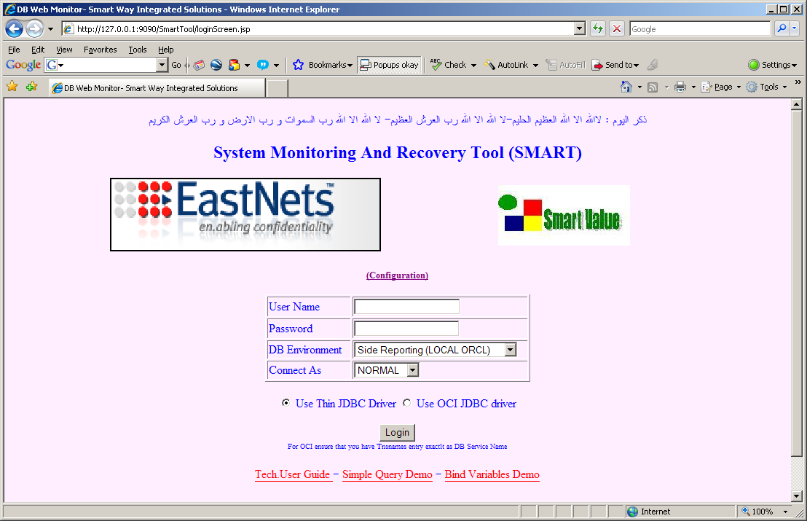

Login Screen Customized For Specific Customer

# Build you own Hyper Linked reports

By this section you will be able to create your first parameterized query report. Also you will be able to pass the result of one query to another query. Smart also provide a set of useful tools like converting your query result to XML format, migrate the result to MS Excel Sheet and edit query result

## Add your first simple query

Assume that you logged with Scott user you will get a screen like the following

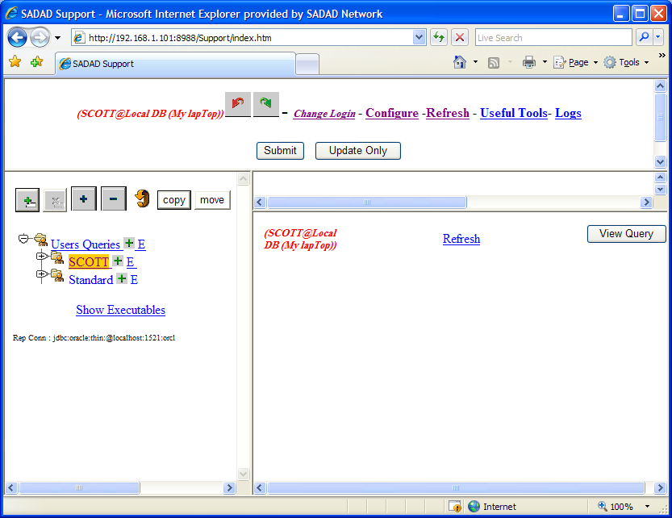

* 1. Click on The [Add Sub Item xxx](http://192.168.1.101:8988/Support/queryInsert.jsp?parentId=305&tableName=LU_QUERIES&headerId=0) sign just Beside the scott node in the tree to add a new report owned by yourself (scott user)
  2. An entry screen will be displayed like the following

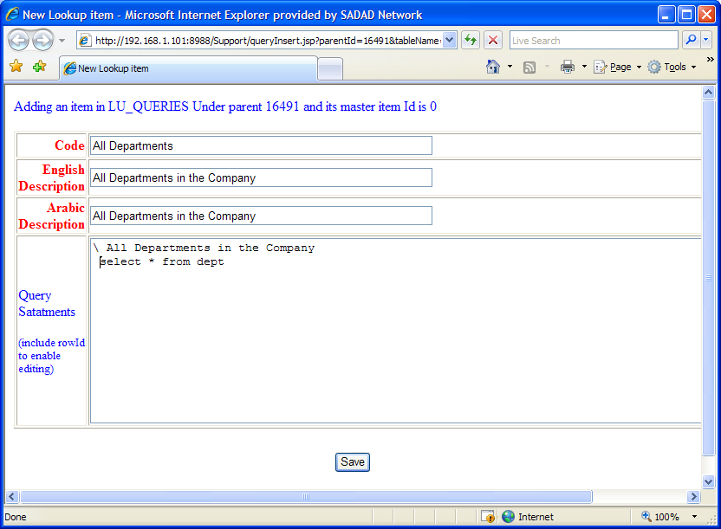

Enter your own query in the Query Statements Text Area

For Example:

*\ All Departments in the Company*

*Select \* from dept*

*Note:*

That First List Should Start with the “\” character following by the title of the report.

* 1. Click Save Button
  2. Execute Your Query by just selecting it from the Reports Navigational Frame (left frame)

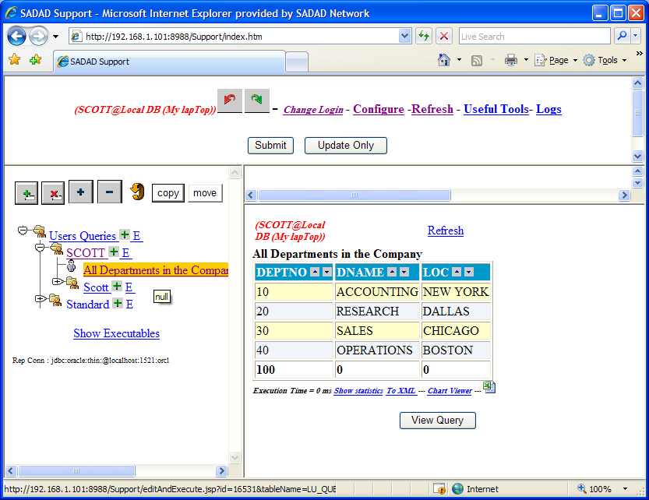

* 1. Your Report Result will be displayed in the Report Result Frame

### Report with Multiple Results.

You can have multiple results in the same report.

1. Edit You previous query to be like:

*\ All Departments in the Company*

*select \* from dept*

*\ All Available Salary Grades*

*select \* from SALGRADE*

1. Execute it to get the following:

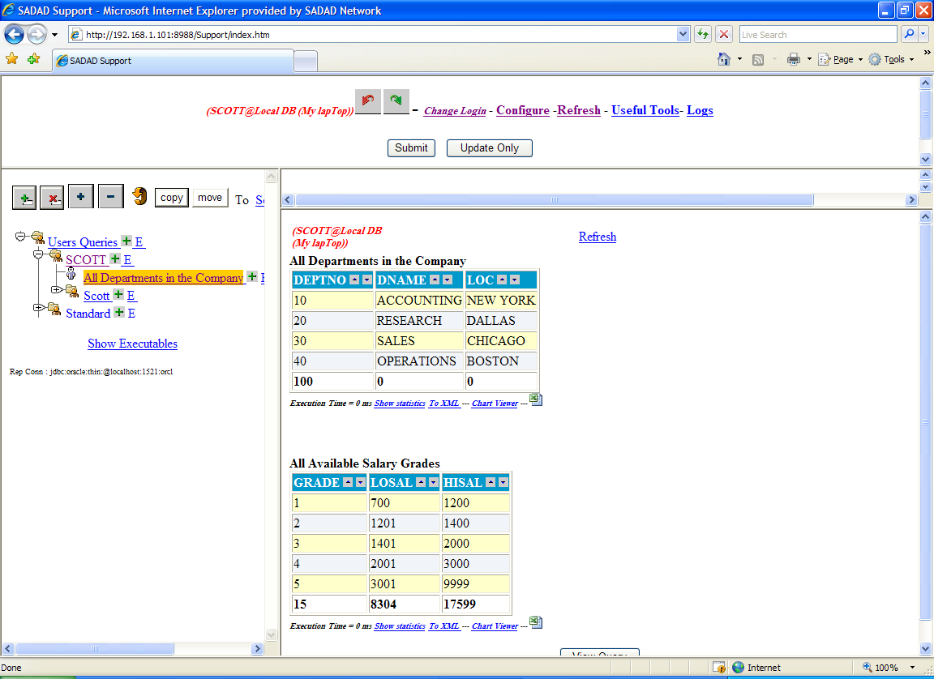

## Organize Your Reports

You can organize your reports in the Report navigation frame RNF – by moving a report from its parent node to another parent node

1. select the report you need to move
2. Click “Select New Parent” from the top of the
3. A new window will be poped up containing all your tree structure except the selected one
4. Select the new parent you want to move to

The browser will be closed or ask you to confirm close – click yes

1. Click the “move” button

## Configure You SQL Bind Variables.

Every User Could have his own set of input variables according to the reports he would have access to it

Just Click on “Config” at the Top Of the main Screen

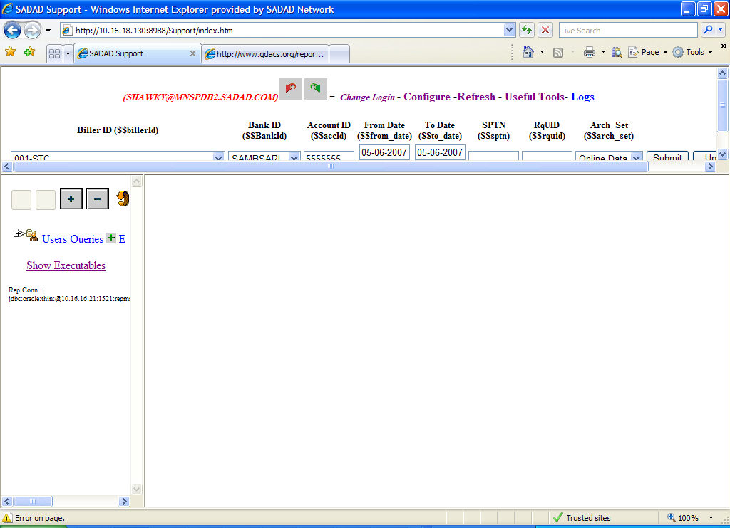

To maintain your set of input parameters

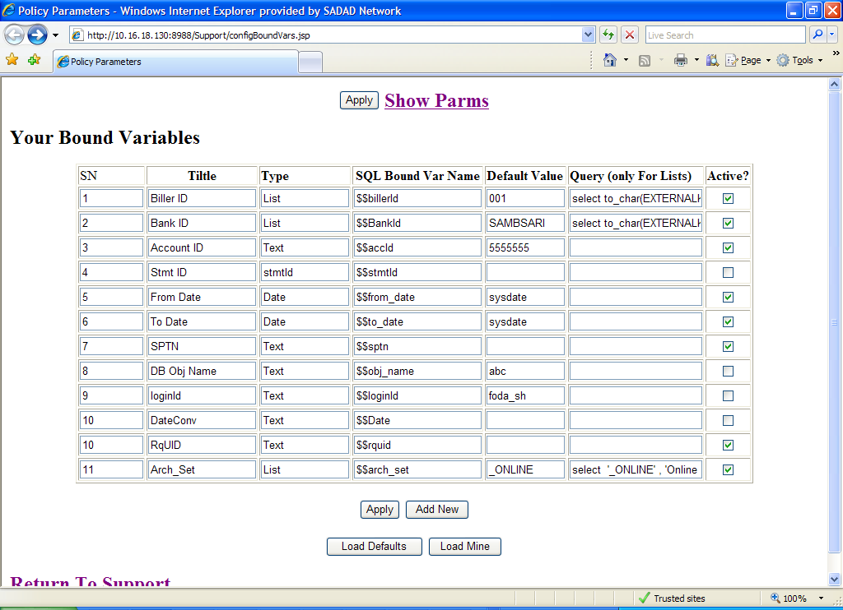

You can also load the already defined input parameters then copy it to your self

***Input parameters types***

1. **Text** : if You need the input parameter to appear just as a simple text field
2. **Date**: if you need to display your input parameter as a Date field with a calendar button
3. **List**: if you need to display your input parameter as a select list. For this type you should define your sql query that will return the required list

s

Your query should follow the following example:

Select

deptCode --code which will substituted by the bind variable in your query report

, deptAName -- Arabic name Which will be displayed in the list

, deptEName -- English name Which will be displayed in the list

From Depts

## Add new Query report

By default Smart Tool automatically creates a new empty node for the logged DB user as shown below.

Logged User have full power to create modify and delete any report under his own Node.

To create a new Smart Tool Report under any node, click on the plus icon [Add Sub Item xxx](http://127.0.0.1:8988/Support/queryInsert.jsp?parentId=16491&tableName=LU_QUERIES&headerId=0) for that node. A new report entry form will be displayed in the right pane.

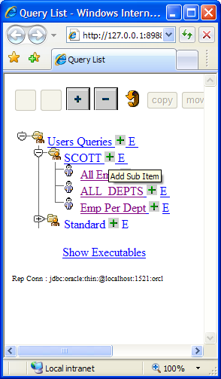

## Link Your Query report with SQL Bind Variable

You can easily parameterize your reports with Your Bind Variables,

Simply write your query as the following:

*Select \* from emp where id = $$emp\_id*

Where emp\_id is already defined bind variable.

## Link a query result to another query

Smart Tool Allow You easily to link two reports together. Results from the first report can be forwarded as input parameter to the second report. The next section describe how to display the second report in new or the same browser window or display both report in the same screen (using AJAX )

### Display the second report in a new window

All What You need to link two reports together- one report output considered as another report’s input- to be familiar with HTML hyperlink tag

<a href = ‘’ > </a>

Example:

Assume the following :

***Report 1 :***

Id = 100, for a list of All Departments

**Query :**

*\ALL DEPT'S LIST -- Report Title Line*

*SELECT DEPTNO , DNAME , LOC*

*FROM SCOTT.DEPT*

***Report 2 :***

Id = 200 , for a list of employs of a given department

**Query :**

*\ALL Employees of Dept no = $$deptno -- this is Report Title Line*

select \* from emp where deptno = $$deptno

To create a hyperlink on the id column of report 1 , modify the query as the following:

*\ALL Employees of Dept no = $$deptno -- this is Report Title Line*

*select ‘<a href = editAndExecute.jsp?id=200&deptno=’||deptno||’>’|| id ||’</a>’ , dname , loc from scott.dept*

### Display the second report inside the first one (AJAX)

To allow user to display the second report inside the first report do the same step as above and replace the direct hyperlink with a java script hyperlink as below :

<a href = "javaScript:loadDetails(''executeQuerySimple.jsp?id=16578&DeptNo='||DEPTNO||' '', ''DeptNo'||DeptNo||''') ">Emps</a> '   
||'<div id="DeptNo'||DeptNO||'"></div>' Emps

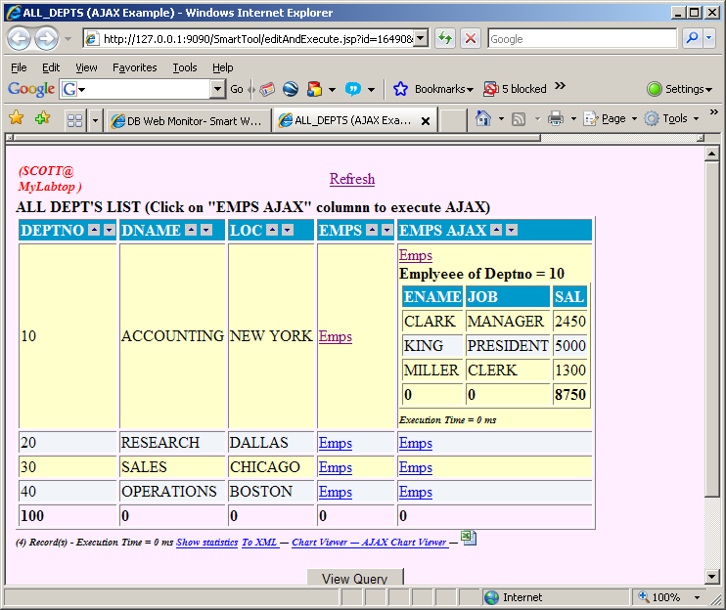

## Browse your query result in xml Format

You can easily display your report result set in an XML format, by clicking on the “To XML ” link as shown below.

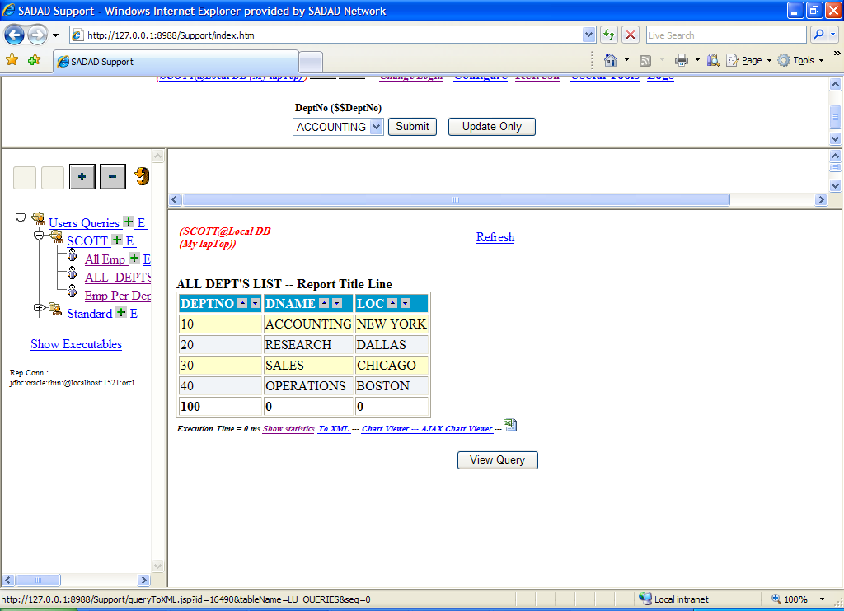

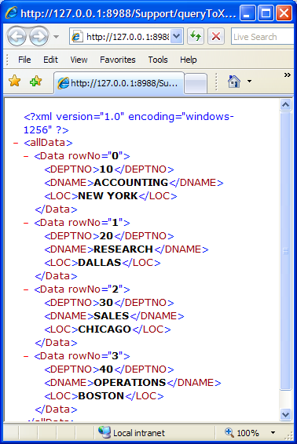

## Monitor Your Reports Execution statistics

You can also monitor your reports execution statistics including who is executing this report and how long it takes to be executed

Simply click on the link “show statistics” just below the result set.



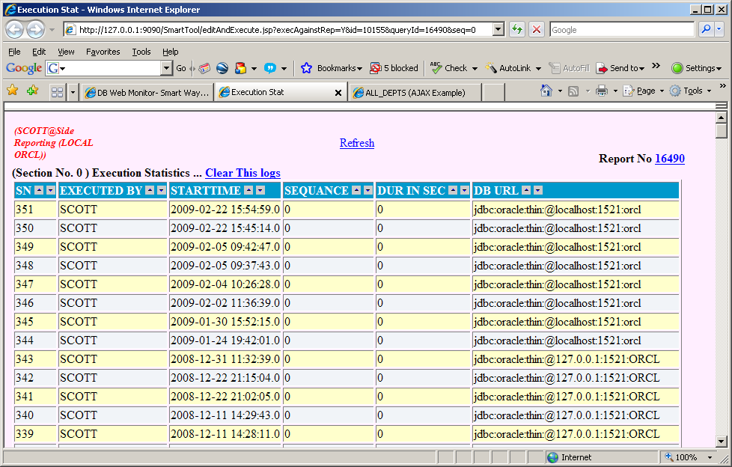

Note that you can create and customize your own statistics.

## Open your query results in MS Excel

You Can Integrate the Calculations and Graphs Power of MS Excel to the Smart Tool simply click on the EXCEL icon just below the result set to open your data in an Excel sheet- you should have install MS EXCEL at your Local Machine.

To enable this feature for a specific user , Administrator of Smart Tool should create a folder with the DB user name as shown below,

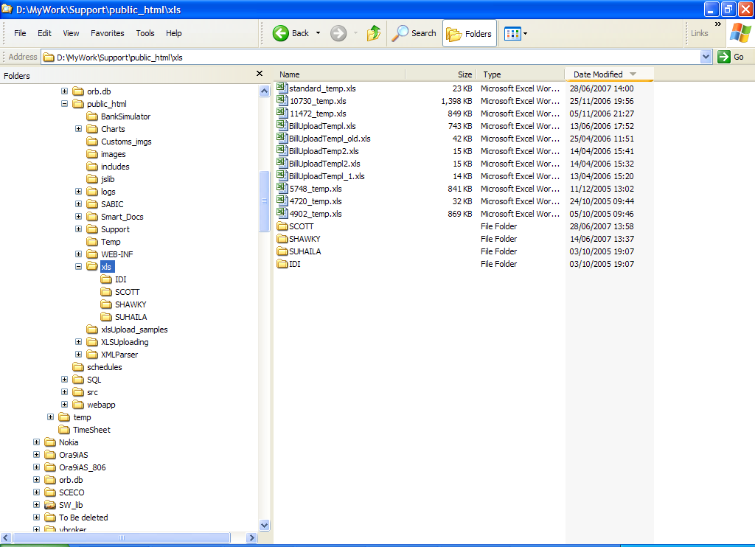

### Building a new XLS template for Your Report

Smart Tool using a blank default XLS template sheet located at : *<public\_html\_path>*\xls\*standard\_temp.xls*

You can create your own template for a specific report as follows

1. Create a new XLS file containing further calculation and graphs for your needs

Note: First sheet should be allocated for the raw data from Smart Tool

Use different sheets for your graphs , pivot tables , and statistics

1. Assume that you what Smart Tool to use this XLS template for Report Id= 200
2. Save Your XLS file as

*<public\_html\_path>*\xls\200\_temp.xls

Where *<public\_html\_path>* is the installation path of the public html and jsp’s of the Smart Tool.

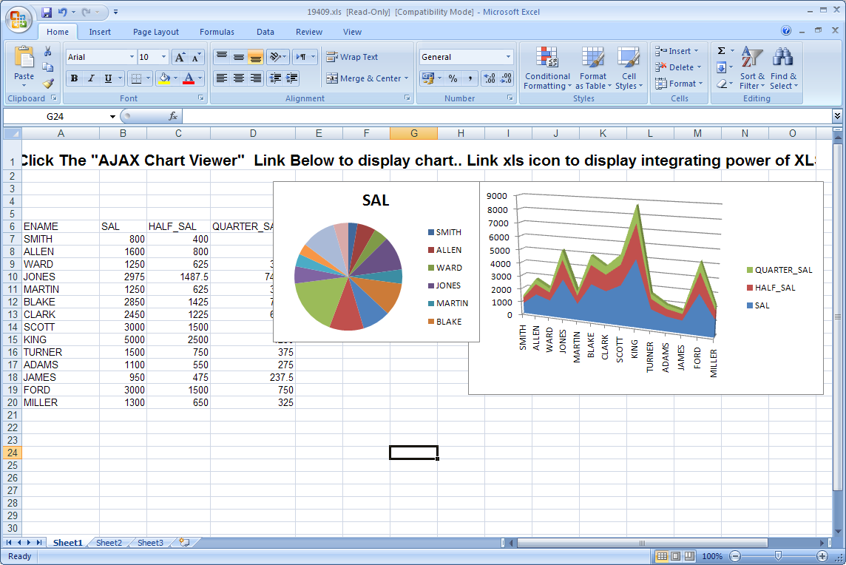

## Crystal report Integration

Smart Tool Can be easily customized to Integrate the power of Crystal Reports. This is done by using a java service in jsp page “open\_view\_report.jsp” below an example :

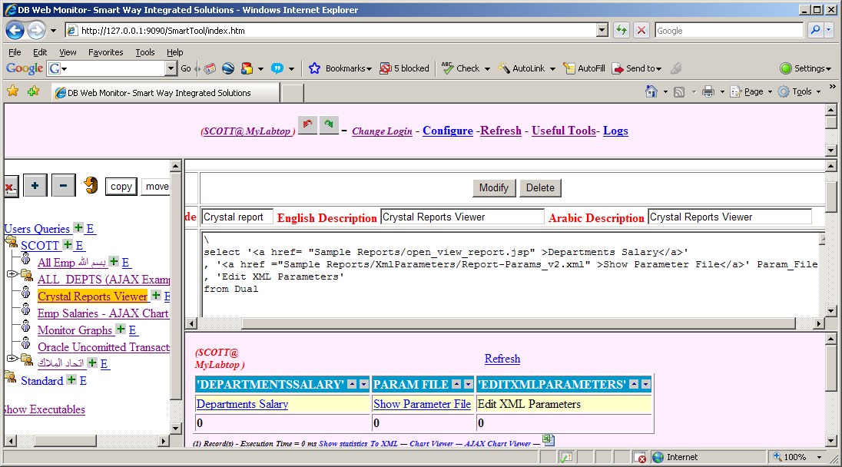

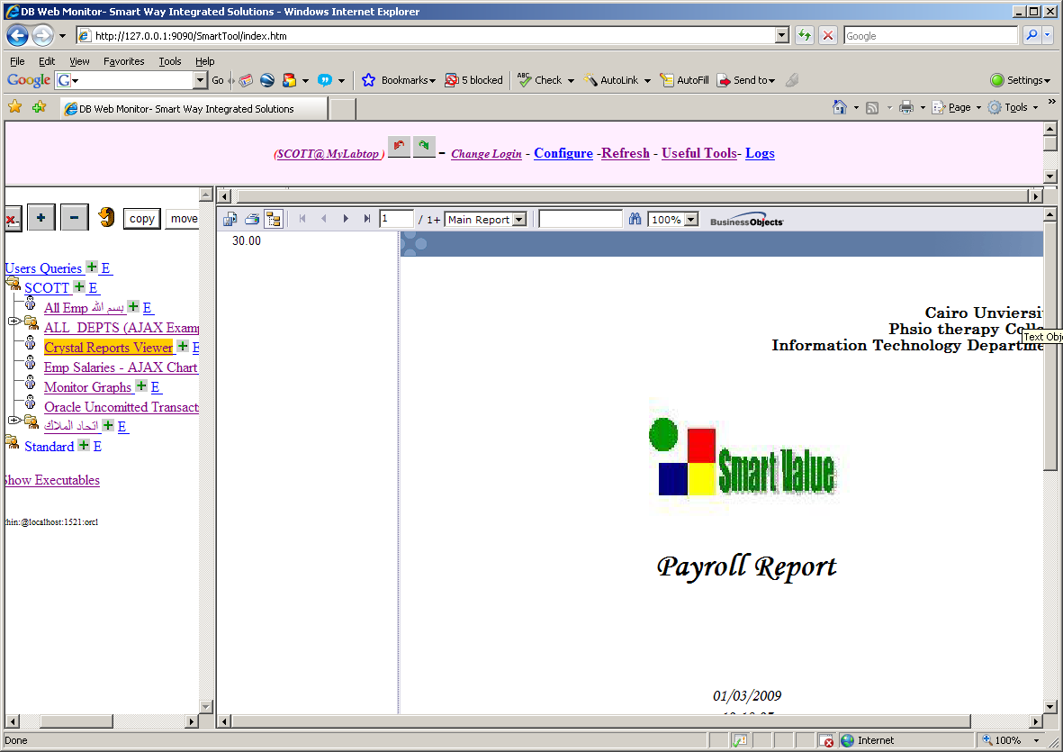

## Edit Your Query Result- DML Operations

Smart Tool as its name implies, it have the Recovery Power, recovery here means the power of modifying your Report result.

Example:

Assume you need to maintain Company Departments

1. Edit your Report Query and add a Oracle “rowid” column to it

*\ALL DEPT'S LIST -- Report Title Line*

*SELECT DEPTNO , DNAME , LOC , rowid*

*FROM SCOTT.DEPT*

*where 1=1*

*-- this where clause is mandatory to allow Smart Tool to Extract table name you need to update*

1. By adding Oracle rowid to your report, Smart Tool automatically will display an “E” link to edit the result set as shown below.

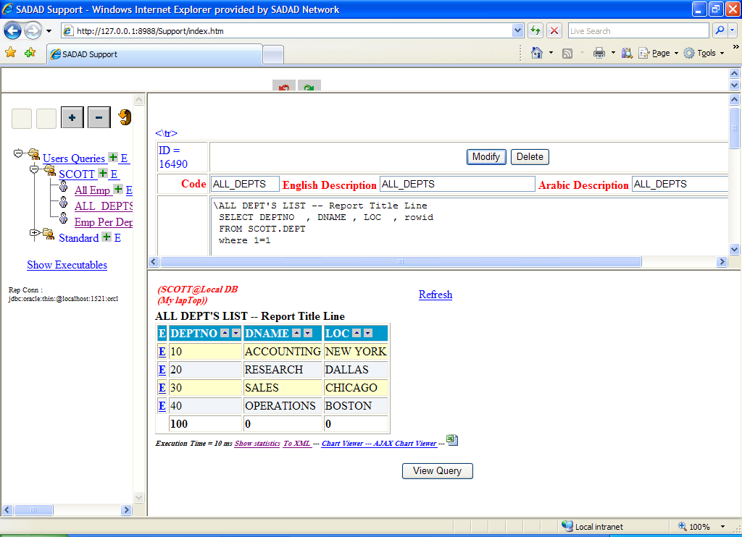

1. When you click on this “E” link, Smart Tool will display and Edit Form for the selected record as shown below

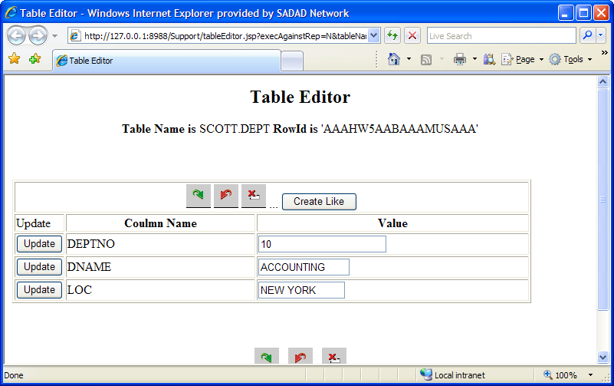

## Post Your Query result to a Web Service

Smart Tool Allow You to Post Your query result in XML format to any Web Service simply by click the link just below the query result. We you get a screen like the below

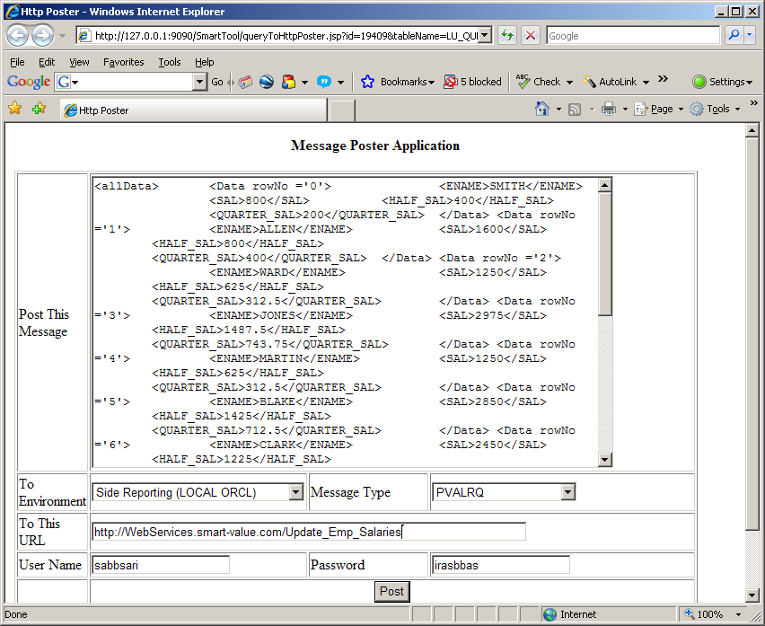

You will get web service response in the same screen.

A great customization can be performed here.

## Create an Insert Form for Your Data

Once a unique identifier is properly defined in your query (rowid for Oracle) a plus sign **[Add New Table Entry](http://127.0.0.1:9090/SmartTool/TableInsertForm.jsp?owner=scott&tableName=emp)** will appear at the title of the query enabling usage and creation of an insert form for the defined table.

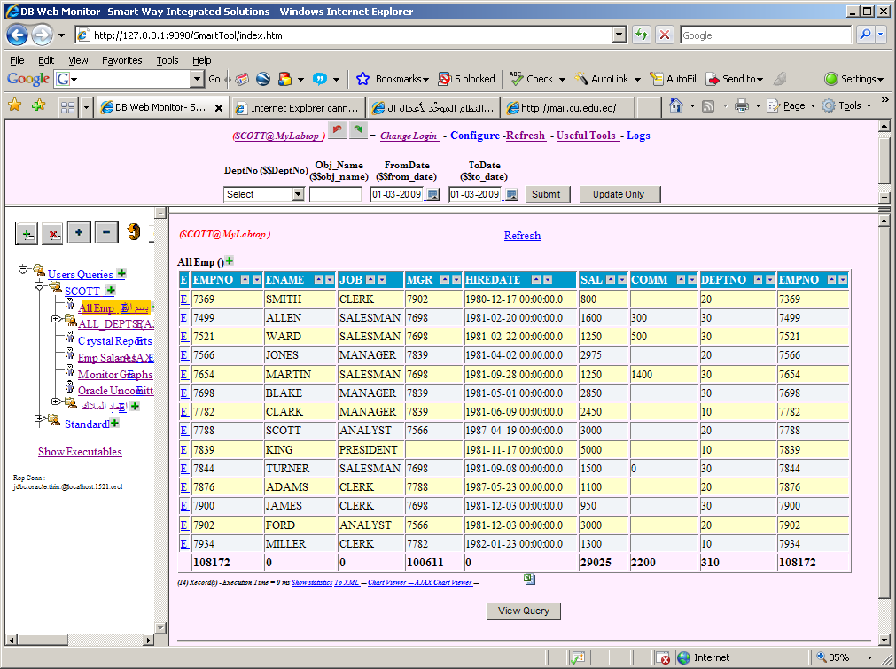

Create and Usage of the form

1. Click on the **[Add New Table Entry](http://127.0.0.1:9090/SmartTool/TableInsertForm.jsp?owner=scott&tableName=emp) appears in your title.** If it is the first time you use that table an empty form will appear with a link “[Reconstruct The Form](http://127.0.0.1:9090/SmartTool/tableFormEditor.jsp?owner=SCOTT&tableName=DEPT)
2. You should have admin access to reconstruct the form

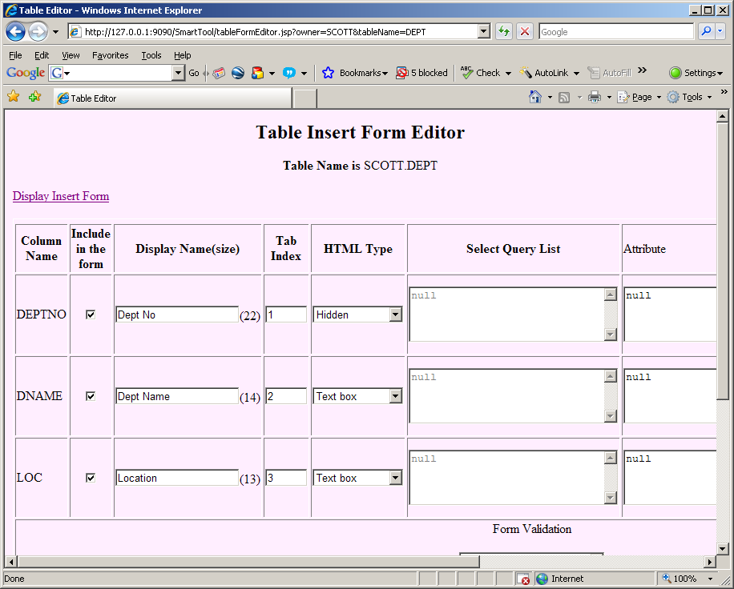

1. The above design screen will appear enabling you to select table columns to be included in yo
2. Select HTML type for each Column. Currently available are

* Text box : Simple Text Input type
* Drop Down List : a list of values. You should write down your sql statement
* Options : a list of values. A list of options You should write down your sql statement
* Date Calendar : A date calendar allowing user to pick up a calendar date
* Text Area
* Hidden :

1. In the Attribute column write down any extra attributes and values for example css class and others
2. In the “Java script” column write down any java script you need to be associated with that element

# Built your own Executable Procedure

Smart Tool is not a simple reporting tool but also it empowers you with the full power of the database scripting language (PL/SQL). you can simply create a new report with a column with a link to execute a certain plsql procedure.

1. Create a new Executable in the executable Tree

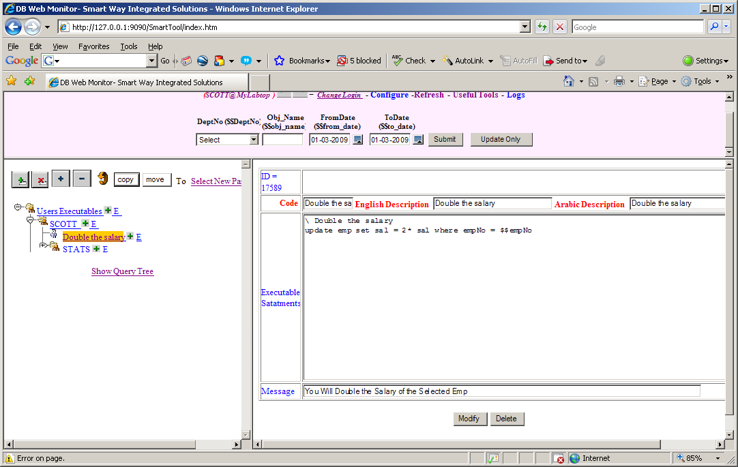

1. Record the ID of your script - in the above screen it is 17589 –
2. Create a new column in your query

\ All Emp

select t.\* , t.empno

*, '<a href = "editExecutable.jsp?id=17589&empNo='||empNo||'" >Double Salary</a>' double\_sal*

, t.rowid

from scott.emp t

where 1=1

1. You Results will look like :
2. 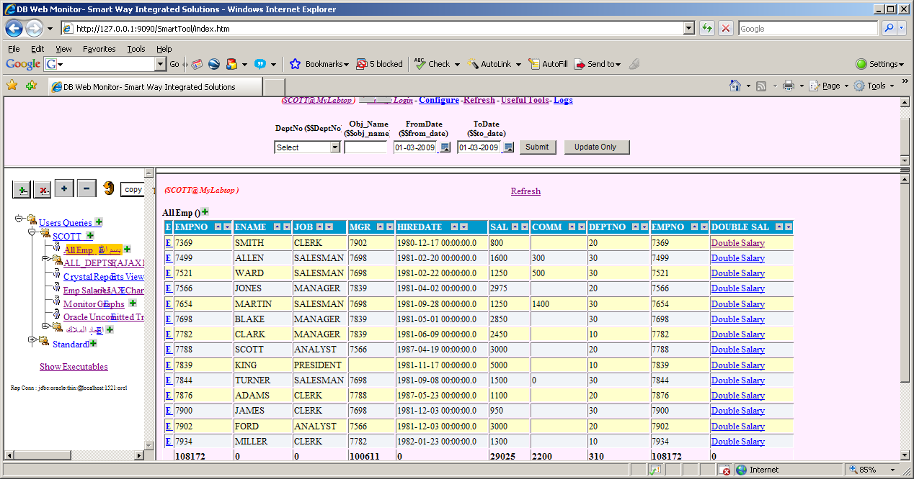
3. By clicking on the new created link you will be forwarding to the your new procedure with an ID representing the employee no. click “Execute” Smart Tool will substitute the emp no and execute the procedure.

Notes:

* 1. You can also call a DB Stored PLSQL Procedure
  2. You call run multiple statements separated by a new line starting with “\”
  3. You can make the link directly executes the procedure by replacing “editExecutable.jsp” with “executeExecutable.jsp”

# Link Your Query result with File System (Windows/Unix)

# Using Oracle CLOB Reader Web Service

# Automatic Mail Notifiation

## 7.1 – Query Result Mail Sender only if Data Found

This feature enables automatic mail notification containing any query result.

1. Edit the report you need to send results to an email – by clicking the letter “E” in the Query tree

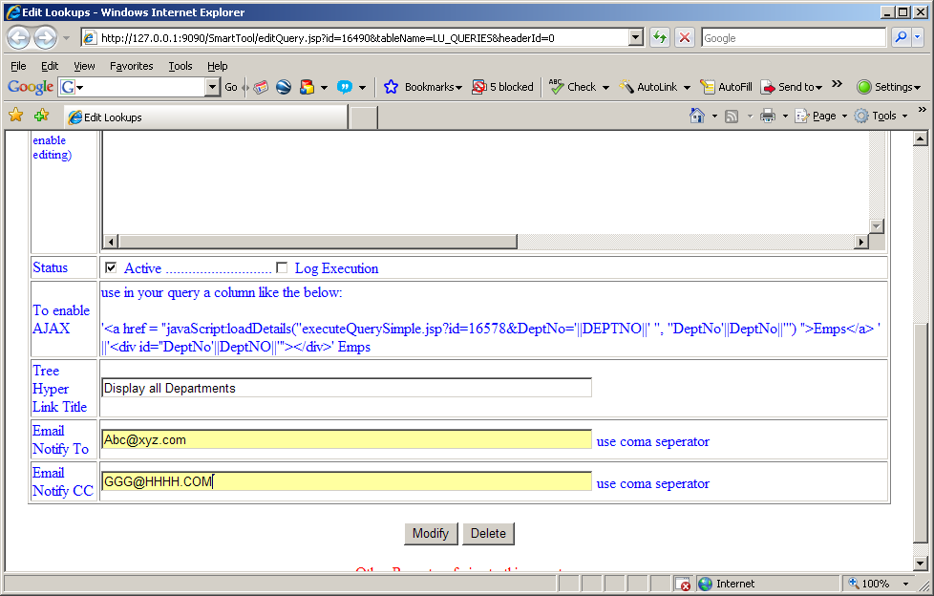

1. Create a .bat file as the one in <Installation\_path>/Batches/If\_Data\_Found\_Send\_Mail/ Mailesender\_templ.bat.

Contents of the above file can be found at ‎11.1Appendix A

1. Edit Line

***Set \_APP= Support.SqlReader ifDataFoundSendQueryResultByMail <QUERY\_ID> <QUERY\_SEQUANCE> "<DB CONFIGURATION FILE CONNECTION NAME>" <USERNAME> <PASSWORD>***

1. Change the <> Parameters for Example : to Send an email with the content of report No. 1234 when executed against System “Production Environment” using login credential scot /tiger

***Set \_APP= Support.SqlReader ifDataFoundSendQueryResultByMail 1234 0 "***Production Environment***” SCOT TIGER***

1. Run The batch File ( or the shell script file in Unix like environments
2. You can use windows scheduler or Unix “At” command to schedule execution of your email notifications

## 7.2 – Query Result Mail Sender

# Other Useful Tools

## General Purpose Excel Sheet Uploading Tool

## Http Poster Client Application

## ****SMS Sender****

## ****XML Deployment Tool****

## 

# Ready Made DBA Reports

SmartTool provides a set of ready made DBA’s reports Under the Standard node.. you can easily customize or interconnect them.

|  |  |  |
| --- | --- | --- |
| **Report** | **Description** |  |
| [[tree_open_middletree_folder_open](http://127.0.0.1:9090/SmartTool/queryTree.jsp?nodeToBeToggled=326)](http://127.0.0.1:9090/SmartTool/queryTree.jsp?nodeToBeToggled=326)[DB Configuration (OEM)](http://127.0.0.1:9090/SmartTool/editAndExecute.jsp?id=19528&tableName=LU_QUERIES" \o "null" \t "mainFrame) |  |  |
| [[tree_closed_middletree_folder_closed](http://127.0.0.1:9090/SmartTool/queryTree.jsp?nodeToBeToggled=19)](http://127.0.0.1:9090/SmartTool/queryTree.jsp?nodeToBeToggled=19)[1-Instance](http://127.0.0.1:9090/SmartTool/editAndExecute.jsp?id=19525&tableName=LU_QUERIES" \o "null" \t "mainFrame) | Contains a set of Reports related to Oracle DB instance like :  [[tree_branch_middletree_leaf](http://127.0.0.1:9090/SmartTool/queryTree.jsp?nodeToBeToggled=13)](http://127.0.0.1:9090/SmartTool/queryTree.jsp?nodeToBeToggled=13)[1- Database and Instance Information](http://127.0.0.1:9090/SmartTool/editAndExecute.jsp?id=19526&tableName=LU_QUERIES" \o "null" \t "mainFrame)  [[tree_branch_middletree_leaf](http://127.0.0.1:9090/SmartTool/queryTree.jsp?nodeToBeToggled=23)](http://127.0.0.1:9090/SmartTool/queryTree.jsp?nodeToBeToggled=23)[2- Database Options](http://127.0.0.1:9090/SmartTool/editAndExecute.jsp?id=19527&tableName=LU_QUERIES" \o "null" \t "mainFrame)  [[tree_branch_middletree_leaf](http://127.0.0.1:9090/SmartTool/queryTree.jsp?nodeToBeToggled=36)](http://127.0.0.1:9090/SmartTool/queryTree.jsp?nodeToBeToggled=36)[3- SGA Information](http://127.0.0.1:9090/SmartTool/editAndExecute.jsp?id=19529&tableName=LU_QUERIES" \o "null" \t "mainFrame)  [[tree_branch_middletree_leaf](http://127.0.0.1:9090/SmartTool/queryTree.jsp?nodeToBeToggled=274)](http://127.0.0.1:9090/SmartTool/queryTree.jsp?nodeToBeToggled=274)[Buffer Cache Hit Rate](http://127.0.0.1:9090/SmartTool/editAndExecute.jsp?id=19536&tableName=LU_QUERIES" \o "null" \t "mainFrame)  [[tree_branch_middletree_leaf](http://127.0.0.1:9090/SmartTool/queryTree.jsp?nodeToBeToggled=318)](http://127.0.0.1:9090/SmartTool/queryTree.jsp?nodeToBeToggled=318)[Current Users](http://127.0.0.1:9090/SmartTool/editAndExecute.jsp?id=19531&tableName=LU_QUERIES" \o "null" \t "mainFrame)  [[tree_branch_middletree_leaf](http://127.0.0.1:9090/SmartTool/queryTree.jsp?nodeToBeToggled=385)](http://127.0.0.1:9090/SmartTool/queryTree.jsp?nodeToBeToggled=385)[Initialization Parameters](http://127.0.0.1:9090/SmartTool/editAndExecute.jsp?id=19530&tableName=LU_QUERIES" \o "null" \t "mainFrame)  [[tree_branch_middletree_leaf](http://127.0.0.1:9090/SmartTool/queryTree.jsp?nodeToBeToggled=415)](http://127.0.0.1:9090/SmartTool/queryTree.jsp?nodeToBeToggled=415)[Locks](http://127.0.0.1:9090/SmartTool/editAndExecute.jsp?id=19538&tableName=LU_QUERIES" \o "null" \t "mainFrame)  [[tree_branch_middletree_leaf](http://127.0.0.1:9090/SmartTool/queryTree.jsp?nodeToBeToggled=577)](http://127.0.0.1:9090/SmartTool/queryTree.jsp?nodeToBeToggled=577)[Processes](http://127.0.0.1:9090/SmartTool/editAndExecute.jsp?id=19534&tableName=LU_QUERIES" \o "null" \t "mainFrame)  [[tree_branch_middletree_leaf](http://127.0.0.1:9090/SmartTool/queryTree.jsp?nodeToBeToggled=664)](http://127.0.0.1:9090/SmartTool/queryTree.jsp?nodeToBeToggled=664)[Session Statistics](http://127.0.0.1:9090/SmartTool/editAndExecute.jsp?id=19533&tableName=LU_QUERIES" \o "null" \t "mainFrame)  [[tree_branch_middletree_leaf](http://127.0.0.1:9090/SmartTool/queryTree.jsp?nodeToBeToggled=721)](http://127.0.0.1:9090/SmartTool/queryTree.jsp?nodeToBeToggled=721)[System Wait Statistics](http://127.0.0.1:9090/SmartTool/editAndExecute.jsp?id=19537&tableName=LU_QUERIES" \o "null" \t "mainFrame)  [[tree_branch_bottomtree_leaf](http://127.0.0.1:9090/SmartTool/queryTree.jsp?nodeToBeToggled=776)](http://127.0.0.1:9090/SmartTool/queryTree.jsp?nodeToBeToggled=776)[Waiting for Log Switch](http://127.0.0.1:9090/SmartTool/editAndExecute.jsp?id=19532&tableName=LU_QUERIES" \o "null" \t "mainFrame) |  |
| [[tree_closed_middletree_folder_closed](http://127.0.0.1:9090/SmartTool/queryTree.jsp?nodeToBeToggled=28)](http://127.0.0.1:9090/SmartTool/queryTree.jsp?nodeToBeToggled=28)[2- Schema](http://127.0.0.1:9090/SmartTool/editAndExecute.jsp?id=19540&tableName=LU_QUERIES" \o "null" \t "mainFrame) | Contains a set of reports Related to Oracle DB Schemas  [[tree_branch_middletree_leaf](http://127.0.0.1:9090/SmartTool/queryTree.jsp?nodeToBeToggled=17)](http://127.0.0.1:9090/SmartTool/queryTree.jsp?nodeToBeToggled=17)[1- Schema Objects Summary](http://127.0.0.1:9090/SmartTool/editAndExecute.jsp?id=19554&tableName=LU_QUERIES" \o "null" \t "mainFrame)  [[tree_branch_middletree_leaf](http://127.0.0.1:9090/SmartTool/queryTree.jsp?nodeToBeToggled=24)](http://127.0.0.1:9090/SmartTool/queryTree.jsp?nodeToBeToggled=24)[2- Invalid Objects](http://127.0.0.1:9090/SmartTool/editAndExecute.jsp?id=19555&tableName=LU_QUERIES" \o "null" \t "mainFrame)  [[tree_branch_middletree_leaf](http://127.0.0.1:9090/SmartTool/queryTree.jsp?nodeToBeToggled=37)](http://127.0.0.1:9090/SmartTool/queryTree.jsp?nodeToBeToggled=37)[3-Procedural Object Errors](http://127.0.0.1:9090/SmartTool/editAndExecute.jsp?id=19556&tableName=LU_QUERIES" \o "null" \t "mainFrame)  [[tree_branch_middletree_leaf](http://127.0.0.1:9090/SmartTool/queryTree.jsp?nodeToBeToggled=41)](http://127.0.0.1:9090/SmartTool/queryTree.jsp?nodeToBeToggled=41)[4-Objects (non SYS and SYSTEM) with statistics](http://127.0.0.1:9090/SmartTool/editAndExecute.jsp?id=19557&tableName=LU_QUERIES" \o "null" \t "mainFrame)  [[tree_branch_middletree_leaf](http://127.0.0.1:9090/SmartTool/queryTree.jsp?nodeToBeToggled=43)](http://127.0.0.1:9090/SmartTool/queryTree.jsp?nodeToBeToggled=43)[5-Objects (non SYS and SYSTEM) without statistics](http://127.0.0.1:9090/SmartTool/editAndExecute.jsp?id=19558&tableName=LU_QUERIES" \o "null" \t "mainFrame)  [[tree_branch_middletree_leaf](http://127.0.0.1:9090/SmartTool/queryTree.jsp?nodeToBeToggled=44)](http://127.0.0.1:9090/SmartTool/queryTree.jsp?nodeToBeToggled=44)[6- Analyzed tables with indexes not analyzed](http://127.0.0.1:9090/SmartTool/editAndExecute.jsp?id=19559&tableName=LU_QUERIES" \o "null" \t "mainFrame)  [[tree_branch_middletree_leaf](http://127.0.0.1:9090/SmartTool/queryTree.jsp?nodeToBeToggled=47)](http://127.0.0.1:9090/SmartTool/queryTree.jsp?nodeToBeToggled=47)[7-Tables with disabled primary keys](http://127.0.0.1:9090/SmartTool/editAndExecute.jsp?id=19560&tableName=LU_QUERIES" \o "null" \t "mainFrame)  [[tree_branch_middletree_leaf](http://127.0.0.1:9090/SmartTool/queryTree.jsp?nodeToBeToggled=49)](http://127.0.0.1:9090/SmartTool/queryTree.jsp?nodeToBeToggled=49)[8-Tables/Table Partitions Suffering from Row Chaining/Migration](http://127.0.0.1:9090/SmartTool/editAndExecute.jsp?id=19561&tableName=LU_QUERIES" \o "null" \t "mainFrame)  [[tree_branch_bottomtree_leaf](http://127.0.0.1:9090/SmartTool/queryTree.jsp?nodeToBeToggled=50)](http://127.0.0.1:9090/SmartTool/queryTree.jsp?nodeToBeToggled=50)[9- User objects in SYSTEM tablespace](http://127.0.0.1:9090/SmartTool/editAndExecute.jsp?id=19562&tableName=LU_QUERIES" \o "null" \t "mainFrame) |  |
| [[tree_closed_middletree_folder_closed](http://127.0.0.1:9090/SmartTool/queryTree.jsp?nodeToBeToggled=35)](http://127.0.0.1:9090/SmartTool/queryTree.jsp?nodeToBeToggled=35)[3- Securtiy](http://127.0.0.1:9090/SmartTool/editAndExecute.jsp?id=19541&tableName=LU_QUERIES" \o "null" \t "mainFrame) | [[tree_branch_middletree_leaf](http://127.0.0.1:9090/SmartTool/queryTree.jsp?nodeToBeToggled=14)](http://127.0.0.1:9090/SmartTool/queryTree.jsp?nodeToBeToggled=14)[1- General User Account Information](http://127.0.0.1:9090/SmartTool/editAndExecute.jsp?id=19563&tableName=LU_QUERIES" \o "null" \t "mainFrame)  [[tree_branch_middletree_leaf](http://127.0.0.1:9090/SmartTool/queryTree.jsp?nodeToBeToggled=30)](http://127.0.0.1:9090/SmartTool/queryTree.jsp?nodeToBeToggled=30)[2- User Roles](http://127.0.0.1:9090/SmartTool/editAndExecute.jsp?id=19564&tableName=LU_QUERIES" \o "null" \t "mainFrame)  [[tree_branch_bottomtree_leaf](http://127.0.0.1:9090/SmartTool/queryTree.jsp?nodeToBeToggled=766)](http://127.0.0.1:9090/SmartTool/queryTree.jsp?nodeToBeToggled=766)[User Tablespace Quota](http://127.0.0.1:9090/SmartTool/editAndExecute.jsp?id=19565&tableName=LU_QUERIES" \o "null" \t "mainFrame) |  |
| [[tree_closed_middletree_folder_closed](http://127.0.0.1:9090/SmartTool/queryTree.jsp?nodeToBeToggled=40)](http://127.0.0.1:9090/SmartTool/queryTree.jsp?nodeToBeToggled=40)[4- Storage](http://127.0.0.1:9090/SmartTool/editAndExecute.jsp?id=19542&tableName=LU_QUERIES" \o "null" \t "mainFrame) | [[tree_branch_middletree_leaf](http://127.0.0.1:9090/SmartTool/queryTree.jsp?nodeToBeToggled=3)](http://127.0.0.1:9090/SmartTool/queryTree.jsp?nodeToBeToggled=3)[01- Control files](http://127.0.0.1:9090/SmartTool/editAndExecute.jsp?id=19566&tableName=LU_QUERIES" \o "null" \t "mainFrame)  [[tree_branch_middletree_leaf](http://127.0.0.1:9090/SmartTool/queryTree.jsp?nodeToBeToggled=4)](http://127.0.0.1:9090/SmartTool/queryTree.jsp?nodeToBeToggled=4)[02- Tablespaces](http://127.0.0.1:9090/SmartTool/editAndExecute.jsp?id=19567&tableName=LU_QUERIES" \o "null" \t "mainFrame)  [[tree_branch_middletree_leaf](http://127.0.0.1:9090/SmartTool/queryTree.jsp?nodeToBeToggled=5)](http://127.0.0.1:9090/SmartTool/queryTree.jsp?nodeToBeToggled=5)[03- Datafiles](http://127.0.0.1:9090/SmartTool/editAndExecute.jsp?id=19568&tableName=LU_QUERIES" \o "null" \t "mainFrame)  [[tree_branch_middletree_leaf](http://127.0.0.1:9090/SmartTool/queryTree.jsp?nodeToBeToggled=6)](http://127.0.0.1:9090/SmartTool/queryTree.jsp?nodeToBeToggled=6)[04- Rollback Segments](http://127.0.0.1:9090/SmartTool/editAndExecute.jsp?id=19569&tableName=LU_QUERIES" \o "null" \t "mainFrame)  [[tree_branch_middletree_leaf](http://127.0.0.1:9090/SmartTool/queryTree.jsp?nodeToBeToggled=7)](http://127.0.0.1:9090/SmartTool/queryTree.jsp?nodeToBeToggled=7)[05- Redo Logs](http://127.0.0.1:9090/SmartTool/editAndExecute.jsp?id=19570&tableName=LU_QUERIES" \o "null" \t "mainFrame)  [[tree_branch_middletree_leaf](http://127.0.0.1:9090/SmartTool/queryTree.jsp?nodeToBeToggled=8)](http://127.0.0.1:9090/SmartTool/queryTree.jsp?nodeToBeToggled=8)[06- Archive Logs](http://127.0.0.1:9090/SmartTool/editAndExecute.jsp?id=19571&tableName=LU_QUERIES" \o "null" \t "mainFrame)  [[tree_branch_middletree_leaf](http://127.0.0.1:9090/SmartTool/queryTree.jsp?nodeToBeToggled=9)](http://127.0.0.1:9090/SmartTool/queryTree.jsp?nodeToBeToggled=9)[07- Most Recent Controlfile Backup](http://127.0.0.1:9090/SmartTool/editAndExecute.jsp?id=19572&tableName=LU_QUERIES" \o "null" \t "mainFrame)  [[tree_branch_middletree_leaf](http://127.0.0.1:9090/SmartTool/queryTree.jsp?nodeToBeToggled=10)](http://127.0.0.1:9090/SmartTool/queryTree.jsp?nodeToBeToggled=10)[08- Most Recent Datafile Backup](http://127.0.0.1:9090/SmartTool/editAndExecute.jsp?id=19573&tableName=LU_QUERIES" \o "null" \t "mainFrame)  [[tree_branch_middletree_leaf](http://127.0.0.1:9090/SmartTool/queryTree.jsp?nodeToBeToggled=11)](http://127.0.0.1:9090/SmartTool/queryTree.jsp?nodeToBeToggled=11)[09- Backup Sets](http://127.0.0.1:9090/SmartTool/editAndExecute.jsp?id=19574&tableName=LU_QUERIES" \o "null" \t "mainFrame)  [[tree_branch_middletree_leaf](http://127.0.0.1:9090/SmartTool/queryTree.jsp?nodeToBeToggled=20)](http://127.0.0.1:9090/SmartTool/queryTree.jsp?nodeToBeToggled=20)[10- Image Copies](http://127.0.0.1:9090/SmartTool/editAndExecute.jsp?id=19575&tableName=LU_QUERIES" \o "null" \t "mainFrame)  [[tree_branch_middletree_leaf](http://127.0.0.1:9090/SmartTool/queryTree.jsp?nodeToBeToggled=21)](http://127.0.0.1:9090/SmartTool/queryTree.jsp?nodeToBeToggled=21)[11- Current Rollback Segment Usage](http://127.0.0.1:9090/SmartTool/editAndExecute.jsp?id=19576&tableName=LU_QUERIES" \o "null" \t "mainFrame)  [[tree_branch_bottomtree_leaf](http://127.0.0.1:9090/SmartTool/queryTree.jsp?nodeToBeToggled=22)](http://127.0.0.1:9090/SmartTool/queryTree.jsp?nodeToBeToggled=22)[12- I/O activity against individual files within a tablespace](http://127.0.0.1:9090/SmartTool/editAndExecute.jsp?id=19577&tableName=LU_QUERIES" \o "null" \t "mainFrame) |  |
| [[tree_closed_middletree_folder_closed](http://127.0.0.1:9090/SmartTool/queryTree.jsp?nodeToBeToggled=42)](http://127.0.0.1:9090/SmartTool/queryTree.jsp?nodeToBeToggled=42)[5- Object Space Usage](http://127.0.0.1:9090/SmartTool/editAndExecute.jsp?id=19543&tableName=LU_QUERIES" \o "null" \t "mainFrame) | [[http://127.0.0.1:9090/SmartTool/images/tree_branch_middle.gifhttp://127.0.0.1:9090/SmartTool/images/tree_leaf.gif](http://127.0.0.1:9090/SmartTool/queryTree.jsp?nodeToBeToggled=15)](http://127.0.0.1:9090/SmartTool/queryTree.jsp?nodeToBeToggled=15)[1- Objects unable to extend](http://127.0.0.1:9090/SmartTool/editAndExecute.jsp?id=19580&tableName=LU_QUERIES" \o "null" \t "mainFrame)  [[http://127.0.0.1:9090/SmartTool/images/tree_branch_middle.gifhttp://127.0.0.1:9090/SmartTool/images/tree_leaf.gif](http://127.0.0.1:9090/SmartTool/queryTree.jsp?nodeToBeToggled=25)](http://127.0.0.1:9090/SmartTool/queryTree.jsp?nodeToBeToggled=25)[2- List of Objects which are nearing Max Extents](http://127.0.0.1:9090/SmartTool/editAndExecute.jsp?id=19581&tableName=LU_QUERIES" \o "null" \t "mainFrame)  [[http://127.0.0.1:9090/SmartTool/images/tree_branch_middle.gifhttp://127.0.0.1:9090/SmartTool/images/tree_leaf.gif](http://127.0.0.1:9090/SmartTool/queryTree.jsp?nodeToBeToggled=33)](http://127.0.0.1:9090/SmartTool/queryTree.jsp?nodeToBeToggled=33)[3- Overextended segments (non SYS and SYSTEM)](http://127.0.0.1:9090/SmartTool/editAndExecute.jsp?id=19582&tableName=LU_QUERIES" \o "null" \t "mainFrame)  [[http://127.0.0.1:9090/SmartTool/images/tree_branch_bottom.gifhttp://127.0.0.1:9090/SmartTool/images/tree_leaf.gif](http://127.0.0.1:9090/SmartTool/queryTree.jsp?nodeToBeToggled=39)](http://127.0.0.1:9090/SmartTool/queryTree.jsp?nodeToBeToggled=39)[4- Disk Space used by Tables (non SYS and SYSTEM)](http://127.0.0.1:9090/SmartTool/editAndExecute.jsp?id=19583&tableName=LU_QUERIES" \o "null" \t "mainFrame) |  |
| [[tree_closed_middletree_folder_closed](http://127.0.0.1:9090/SmartTool/queryTree.jsp?nodeToBeToggled=45)](http://127.0.0.1:9090/SmartTool/queryTree.jsp?nodeToBeToggled=45)[6- Replication](http://127.0.0.1:9090/SmartTool/editAndExecute.jsp?id=19544&tableName=LU_QUERIES" \o "null" \t "mainFrame) | [[http://127.0.0.1:9090/SmartTool/images/tree_closed_middle.gifhttp://127.0.0.1:9090/SmartTool/images/tree_folder_closed.gif](http://127.0.0.1:9090/SmartTool/queryTree.jsp?nodeToBeToggled=16)](http://127.0.0.1:9090/SmartTool/queryTree.jsp?nodeToBeToggled=16)[1- Overview](http://127.0.0.1:9090/SmartTool/editAndExecute.jsp?id=19585&tableName=LU_QUERIES" \o "null" \t "mainFrame)  [[http://127.0.0.1:9090/SmartTool/images/tree_branch_middle.gifhttp://127.0.0.1:9090/SmartTool/images/tree_leaf.gif](http://127.0.0.1:9090/SmartTool/queryTree.jsp?nodeToBeToggled=26)](http://127.0.0.1:9090/SmartTool/queryTree.jsp?nodeToBeToggled=26)[2- Multimaster Configuration](http://127.0.0.1:9090/SmartTool/editAndExecute.jsp?id=19586&tableName=LU_QUERIES" \o "null" \t "mainFrame)  [[http://127.0.0.1:9090/SmartTool/images/tree_branch_bottom.gifhttp://127.0.0.1:9090/SmartTool/images/tree_leaf.gif](http://127.0.0.1:9090/SmartTool/queryTree.jsp?nodeToBeToggled=32)](http://127.0.0.1:9090/SmartTool/queryTree.jsp?nodeToBeToggled=32)[3- Materialized View Configuration](http://127.0.0.1:9090/SmartTool/editAndExecute.jsp?id=19587&tableName=LU_QUERIES" \o "null" \t "mainFrame) |  |
| [[tree_closed_middletree_folder_closed](http://127.0.0.1:9090/SmartTool/queryTree.jsp?nodeToBeToggled=46)](http://127.0.0.1:9090/SmartTool/queryTree.jsp?nodeToBeToggled=46)[7- OLAP](http://127.0.0.1:9090/SmartTool/editAndExecute.jsp?id=19545&tableName=LU_QUERIES) | [[http://127.0.0.1:9090/SmartTool/images/tree_branch_middle.gifhttp://127.0.0.1:9090/SmartTool/images/tree_leaf.gif](http://127.0.0.1:9090/SmartTool/queryTree.jsp?nodeToBeToggled=315)](http://127.0.0.1:9090/SmartTool/queryTree.jsp?nodeToBeToggled=315)[Cubes](http://127.0.0.1:9090/SmartTool/editAndExecute.jsp?id=19551&tableName=LU_QUERIES" \o "null" \t "mainFrame)  [[http://127.0.0.1:9090/SmartTool/images/tree_branch_middle.gifhttp://127.0.0.1:9090/SmartTool/images/tree_leaf.gif](http://127.0.0.1:9090/SmartTool/queryTree.jsp?nodeToBeToggled=332)](http://127.0.0.1:9090/SmartTool/queryTree.jsp?nodeToBeToggled=332)[Dimensions](http://127.0.0.1:9090/SmartTool/editAndExecute.jsp?id=19552&tableName=LU_QUERIES" \o "null" \t "mainFrame)  [[http://127.0.0.1:9090/SmartTool/images/tree_branch_bottom.gifhttp://127.0.0.1:9090/SmartTool/images/tree_leaf.gif](http://127.0.0.1:9090/SmartTool/queryTree.jsp?nodeToBeToggled=440)](http://127.0.0.1:9090/SmartTool/queryTree.jsp?nodeToBeToggled=440)[Measure Folders](http://127.0.0.1:9090/SmartTool/editAndExecute.jsp?id=19550&tableName=LU_QUERIES" \o "null" \t "mainFrame) |  |
| [[tree_open_middletree_folder_open](http://127.0.0.1:9090/SmartTool/queryTree.jsp?nodeToBeToggled=48)](http://127.0.0.1:9090/SmartTool/queryTree.jsp?nodeToBeToggled=48)[8- Top 10](http://127.0.0.1:9090/SmartTool/editAndExecute.jsp?id=19546&tableName=LU_QUERIES" \o "null" \t "mainFrame) | [[http://127.0.0.1:9090/SmartTool/images/tree_branch_middle.gifhttp://127.0.0.1:9090/SmartTool/images/tree_leaf.gif](http://127.0.0.1:9090/SmartTool/queryTree.jsp?nodeToBeToggled=759)](http://127.0.0.1:9090/SmartTool/queryTree.jsp?nodeToBeToggled=759)[Top procedures](http://127.0.0.1:9090/SmartTool/editAndExecute.jsp?id=19549&tableName=LU_QUERIES" \o "null" \t "mainFrame)  [[http://127.0.0.1:9090/SmartTool/images/tree_branch_middle.gifhttp://127.0.0.1:9090/SmartTool/images/tree_leaf.gif](http://127.0.0.1:9090/SmartTool/queryTree.jsp?nodeToBeToggled=760)](http://127.0.0.1:9090/SmartTool/queryTree.jsp?nodeToBeToggled=760)[Top SQL](http://127.0.0.1:9090/SmartTool/editAndExecute.jsp?id=19547&tableName=LU_QUERIES" \o "null" \t "mainFrame)  [[http://127.0.0.1:9090/SmartTool/images/tree_branch_bottom.gifhttp://127.0.0.1:9090/SmartTool/images/tree_leaf.gif](http://127.0.0.1:9090/SmartTool/queryTree.jsp?nodeToBeToggled=761)](http://127.0.0.1:9090/SmartTool/queryTree.jsp?nodeToBeToggled=761)[Top Tables](http://127.0.0.1:9090/SmartTool/editAndExecute.jsp?id=19548&tableName=LU_QUERIES" \o "null" \t "mainFrame) |  |
| [[tree_open_middletree_folder_open](http://127.0.0.1:9090/SmartTool/queryTree.jsp?nodeToBeToggled=48)](http://127.0.0.1:9090/SmartTool/queryTree.jsp?nodeToBeToggled=48)[9- Audit](http://127.0.0.1:9090/SmartTool/editAndExecute.jsp?id=19546&tableName=LU_QUERIES) | [[http://127.0.0.1:9090/SmartTool/images/tree_branch_middle.gifhttp://127.0.0.1:9090/SmartTool/images/tree_leaf.gif](http://127.0.0.1:9090/SmartTool/queryTree.jsp?nodeToBeToggled=136)](http://127.0.0.1:9090/SmartTool/queryTree.jsp?nodeToBeToggled=136)[Audit Options](http://127.0.0.1:9090/SmartTool/editAndExecute.jsp?id=20790&tableName=LU_QUERIES" \o "null" \t "mainFrame) [[Add Sub Item xxx](http://127.0.0.1:9090/SmartTool/queryInsert.jsp?parentId=20790&tableName=LU_QUERIES&headerId=0)](http://127.0.0.1:9090/SmartTool/queryInsert.jsp?parentId=20790&tableName=LU_QUERIES&headerId=0" \t "mainFrame)[E](http://127.0.0.1:9090/SmartTool/editQuery.jsp?id=20790&tableName=LU_QUERIES&headerId=0)  [[http://127.0.0.1:9090/SmartTool/images/tree_branch_bottom.gifhttp://127.0.0.1:9090/SmartTool/images/tree_leaf.gif](http://127.0.0.1:9090/SmartTool/queryTree.jsp?nodeToBeToggled=660)](http://127.0.0.1:9090/SmartTool/queryTree.jsp?nodeToBeToggled=660)[Session Creations](http://127.0.0.1:9090/SmartTool/editAndExecute.jsp?id=20788&tableName=LU_QUERIES" \o "null" \t "mainFrame) [[Add Sub Item xxx](http://127.0.0.1:9090/SmartTool/queryInsert.jsp?parentId=20788&tableName=LU_QUERIES&headerId=0)](http://127.0.0.1:9090/SmartTool/queryInsert.jsp?parentId=20788&tableName=LU_QUERIES&headerId=0" \t "mainFrame)[E](http://127.0.0.1:9090/SmartTool/editQuery.jsp?id=20788&tableName=LU_QUERIES&headerId=0) |  |

# Appendices

## Appendix A

Contents of “Mailesender\_templ.bat” File

@echo off

set \_CP=..\..\WebContent\WEB-INF\classes;

set \_CP=%\_CP%..\..\WebContent\WEB-INF\lib\BC4J;

set \_CP=%\_CP%..\..\WebContent\WEB-INF\lib\bc4jhtml.jar;

set \_CP=%\_CP%..\..\WebContent\WEB-INF\lib\bc4juixtags.jar;

set \_CP=%\_CP%..\..\WebContent\WEB-INF\lib\bc4j\_jclient\_common.jar;

set \_CP=%\_CP%..\..\WebContent\WEB-INF\lib\Bluetooth;

set \_CP=%\_CP%..\..\WebContent\WEB-INF\lib\cayenne.jar;

set \_CP=%\_CP%..\..\WebContent\WEB-INF\lib\CheckFree;

set \_CP=%\_CP%..\..\WebContent\WEB-INF\lib\CHeckFree\_LogReader\_old;

set \_CP=%\_CP%..\..\WebContent\WEB-INF\lib\clrt.jar;

set \_CP=%\_CP%..\..\WebContent\WEB-INF\lib\common;

set \_CP=%\_CP%..\..\WebContent\WEB-INF\lib\commons-collections-3.1.jar;

set \_CP=%\_CP%..\..\WebContent\WEB-INF\lib\commons-configuration-1.2.jar;

set \_CP=%\_CP%..\..\WebContent\WEB-INF\lib\commons-lang-2.1.jar;

set \_CP=%\_CP%..\..\WebContent\WEB-INF\lib\commons-logging.jar;

set \_CP=%\_CP%..\..\WebContent\WEB-INF\lib\Concurrent.jar;

set \_CP=%\_CP%..\..\WebContent\WEB-INF\lib\CrystalContentModels.jar;

set \_CP=%\_CP%..\..\WebContent\WEB-INF\lib\CrystalDatabaseConnectors.jar;

set \_CP=%\_CP%..\..\WebContent\WEB-INF\lib\CrystalExporters.jar;

set \_CP=%\_CP%..\..\WebContent\WEB-INF\lib\CrystalExportingBase.jar;

set \_CP=%\_CP%..\..\WebContent\WEB-INF\lib\CrystalFormulas.jar;

set \_CP=%\_CP%..\..\WebContent\WEB-INF\lib\CrystalQueryEngine.jar;

set \_CP=%\_CP%..\..\WebContent\WEB-INF\lib\CrystalReportEngine.jar;

set \_CP=%\_CP%..\..\WebContent\WEB-INF\lib\CrystalReportingCommon.jar;

set \_CP=%\_CP%..\..\WebContent\WEB-INF\lib\datatags.jar;

set \_CP=%\_CP%..\..\WebContent\WEB-INF\lib\dsn.jar;

set \_CP=%\_CP%..\..\WebContent\WEB-INF\lib\fileaccess.jar;

set \_CP=%\_CP%..\..\WebContent\WEB-INF\lib\FTP;

set \_CP=%\_CP%..\..\WebContent\WEB-INF\lib\icu4j.jar;

set \_CP=%\_CP%..\..\WebContent\WEB-INF\lib\imap.jar;

set \_CP=%\_CP%..\..\WebContent\WEB-INF\lib\inetfactory.jar;

set \_CP=%\_CP%..\..\WebContent\WEB-INF\lib\J2EE;

set \_CP=%\_CP%..\..\WebContent\WEB-INF\lib\jas.jar;

set \_CP=%\_CP%..\..\WebContent\WEB-INF\lib\JDBC\_for\_SQL\_Server;

set \_CP=%\_CP%..\..\WebContent\WEB-INF\lib\jrcadapter.jar;

set \_CP=%\_CP%..\..\WebContent\WEB-INF\lib\jrcerom.jar;

set \_CP=%\_CP%..\..\WebContent\WEB-INF\lib\JSP\_RunTime;

set \_CP=%\_CP%..\..\WebContent\WEB-INF\lib\jtds-1.2.jar;

set \_CP=%\_CP%..\..\WebContent\WEB-INF\lib\jug.jar;

set \_CP=%\_CP%..\..\WebContent\WEB-INF\lib\junit.jar;

set \_CP=%\_CP%..\..\WebContent\WEB-INF\lib\jxl;

set \_CP=%\_CP%..\..\WebContent\WEB-INF\lib\keycodeDecoder.jar;

set \_CP=%\_CP%..\..\WebContent\WEB-INF\lib\log4j.jar;

set \_CP=%\_CP%..\..\WebContent\WEB-INF\lib\mailapi.jar;

set \_CP=%\_CP%..\..\WebContent\WEB-INF\lib\MetafileRenderer.jar;

set \_CP=%\_CP%..\..\WebContent\WEB-INF\lib\side-sas.jar;

set \_CP=%\_CP%..\..\WebContent\WEB-INF\lib\nls\_charset12.jar;

set \_CP=%\_CP%..\..\WebContent\WEB-INF\lib\oc4j.jar;

set \_CP=%\_CP%..\..\WebContent\WEB-INF\lib\ojc.jar;

set \_CP=%\_CP%..\..\WebContent\WEB-INF\lib\ojdbc14.jar;

set \_CP=%\_CP%..\..\WebContent\WEB-INF\lib\ojsp.jar;

set \_CP=%\_CP%..\..\WebContent\WEB-INF\lib\ojsputil.jar;

set \_CP=%\_CP%..\..\WebContent\WEB-INF\lib\Oracle\_JDBC;

set \_CP=%\_CP%..\..\WebContent\WEB-INF\lib\Oracle\_XML;

set \_CP=%\_CP%..\..\WebContent\WEB-INF\lib\pop3.jar;

set \_CP=%\_CP%..\..\WebContent\WEB-INF\lib\rasapp.jar;

set \_CP=%\_CP%..\..\WebContent\WEB-INF\lib\rascore.jar;

set \_CP=%\_CP%..\..\WebContent\WEB-INF\lib\ReportPrinter.jar;

set \_CP=%\_CP%..\..\WebContent\WEB-INF\lib\rpoifs.jar;

set \_CP=%\_CP%..\..\WebContent\WEB-INF\lib\serialization.jar;

set \_CP=%\_CP%..\..\WebContent\WEB-INF\lib\sftp.jar;

set \_CP=%\_CP%..\..\WebContent\WEB-INF\lib\smtp.jar;

set \_CP=%\_CP%..\..\WebContent\WEB-INF\lib\sqljdbc.jar;

set \_CP=%\_CP%..\..\WebContent\WEB-INF\lib\sqljdbc1.2.jar;

set \_CP=%\_CP%..\..\WebContent\WEB-INF\lib\sqltaglib.jar;

set \_CP=%\_CP%..\..\WebContent\WEB-INF\lib\struts.jar;

set \_CP=%\_CP%..\..\WebContent\WEB-INF\lib\Telnet;

set \_CP=%\_CP%..\..\WebContent\WEB-INF\lib\utiltaglib.jar;

set \_CP=%\_CP%..\..\WebContent\WEB-INF\lib\WMParsers;

set \_CP=%\_CP%..\..\WebContent\WEB-INF\lib\xercesImpl.jar;

set \_CP=%\_CP%..\..\WebContent\WEB-INF\lib\xml-apis.jar;

set \_CP=%\_CP%..\..\WebContent\WEB-INF\lib\xmlcomp.jar;

set \_CP=%\_CP%..\..\WebContent\WEB-INF\lib\xmlparserv2.jar

set \_OPT=-Djbo.maxpoolsize=2 -Djbo.poolrequesttimeout=10000 -Dcom.sun.management.jmxremote -Dcom.sun.management.jmxremote.port=1100 -Dcom.sun.management.jmxremote.ssl=false -Dcom.sun.management.jmxremote.authenticate=false

set \_APP= Support.SqlReader ifDataFoundSendQueryResultByMail <QUERY\_ID> <QUERY\_SEQUANCE> "<DB CONFIGURATION FILE CONNECTION NAME>" <USERNAME> <PASSWORD>

@echo on

java.exe -classpath %\_CP% %\_OPT% %\_APP% >> <OUT\_LOG\_FILE>

@echo off