Smart Tool Technical Guide

Table of Contents

1. Install Oracle Smart Web application 3
2. Oracle Smart layout 3
3. Configure You DB Connection parameters 4
4. Build you own Hyper Linked reports 5
1.1. Add your first simple query 6
Multiple Results per Report. 8
1.2. Configure You SQL Bind Variables. 9
1.3. Add new Query report 9
1.4. Link Your Query report with SQL Bind Variable 9
1.5. Link a query result to another query 9
1.6. Browse your query result in xml Format 9
1.7. Open your query results in MS Excel 9
1.8. Edit Your Query Result- DML Operations 9
5. Built your own Executable Procedure 9
6. Schedule email sending Query results 9
7. Other Useful Tools 10
1.1. General Purpose Excel Sheet Uploading Tool 10
1.2. Http Poster Client Application 10
1.3. SMS Sender 10

Summary
SMART Tool for Oracle helps you manage your Oracle databases from the convenience of your Web Browser. The software sits on the top of a Web Server and allows you to interactively access and administer your databases remotely. As of now it supports Oracle and Microsoft SQL Server. In future releases the product will support IBM DB2 UDB as well.
The product has almost all the features for the day to day working of SMARTs. Among the most innovative features is the V$ navigator which allows you to browse through the related views and get the up-to-date information about your database, and customizable HTML reports. The GUI is consistent and very intuitive. Among other features it includes real time instance monitoring, space organization, maintenance and tuning of SQL queries, etc.
The product is very useful to SMARTs and the user interface is friendly. There are a lot of administrative tools available in the market but many of them are not available under remote administration category. The product is ideal in todays world, where the databases are in London and New York and the development and administration team are in India. We gave it a high rating of 4.5 stars overall, because we like the innovation in the product.
Usefulness to SMART Tool | Excelent
Usefulness to developers | Average
Functionality, how much does it do | Good
User interface, intuitive/friendly | Good
Software quality, integrity, robustness | Good
Documentation quality and scope | Poor
Technical support availability | Good
Value for money | Good
Ease of integration with other tools and systems | Excellent
Overall rating | Good

What is great about this product?
- SMART Tool simplifies the most common database management tasks, such as creating/modifying/deleting schema objects, the movement of objects and data across environments, data editing, creating and executing efficient SMART scripts, monitoring process information.
- Remote administration via browser serves multiple users to use the application to manage multiple heterogeneous databases through a single intuitive interface.
- Real-time performance can be viewed graphically.
- Provides easy security administration for granting, revoking and assigning roles and privileges.
- Provides users with an efficient means to view key instance statistics instead of querying V$ views manually. Drilling down to related views really helps in saving a lot of time.
- Allows novice administrators to learn DDL syntax as they are creating and maintaining.
- Any query could be modified as requied.
- XMLs could be displayed ,Various date formats could be displayed as per convince

History
Smart Value is known for its database management tools. Now, SMART Tool is their answer to Web based database administration. <Company Name> Software Solutions enables database professionals with the ability to manage the entire life cycle of today's distributed environments. They have tools for the following categories:
- SQL Development
- Change Management
- Maintenance Optimization
- Performance Monitoring & Tuning
- Backup & Recovery
- Business Information Management
SMART Tool is the one from the Change Management category.

Technical Requirements and Supported Databases
The software has to be installed on the top of a web server. The operating systems supported are: Windows NT 4.0 with Service Pack 4 or 5 applied, Windows 2000 Server/Professional.
The supported web servers are: Apache Web server 1.3.9 - 1.3.12 with Apache JServ 1.0, 1.1, Microsoft IIS (Windows Server hosts) 4.0 with Allaire JRun 2.3.3. Apache Web Server 1.3.9 and Apache JServ 1.0 is bundled with the software.
The supported clients include: Windows 95, Windows 98, Windows 2000, Windows NT 4.0 with Service Pack 4 or 5 applied with either Netscape Navigator 4.0 or Internet Explorer 4.x. The browser requires a java plug-in version 1.3.
The Database Platforms supported are: Oracle 7.3.4, 8.0.x, and 8i with TCP/IP as the protocol and Net8 (SQL*Net) installed on the database server.

What it does
SMART Tool enables you to administer your databases remotely via a browser. Web SMART is installed on a Web Server and has many modules. The most appealing ones are:
- V$ Navigator - Allows you to fetch V$ views and see the related views and drill down.
- Data Editor - Allows you to insert/update/delete data to a table through the GUI.
- SQL Scratch Pad - Allows you to write to SQL and view the execution plan before running it.
- Reports (Customizable HTML) - Allows you to extract one of 26 HTML Database Reports or customize to suite your needs.
- Monitors - Allows you to view one of Web SMART's color trend graphs of real-time performance information.
- OS File Browser - Allows you to view & edit files from within Web SMART.
- Online Community - Takes you to OTN error message page for help.

Who should use it?
SMART Tool's are the targeted users, the tool helps them with day-to-day monitoring and administrative tasks to a large extent. Novice administrator would learn a lot by using the product. Database programmers can also benefit from SMART Tool.

Competitive products
The competitive products are from Platinum (now CA), Embarcadero, and Quest. Computer Associate has a product called Manage IT. Quest has tools called Spotlight for Oracle, Schema Manager, etc. Emercadero has tools called DB Artisan, DB Artisan Change Manager, and Performance Monitor. Then there is product called HORA from KeepTool's. But most of the products are not web based and that's where Web SMART has an edge.
Competition is also with Oracle, which has a product called Oracle SMART studio. It can work from within Enterprise Manager. It has modules like schema manager, security manager, storage manager, etc. The products are well integrated with each other and have gone through significant improvements. It also supports database administration from Web Browser.
While choosing a product for yourself, you should figure out your requirements and try to match them with products available in the market. Competition for corporate dollars needs to be evaluated, but SHAWKY's Web SMART is good value if you are doing remote SMART work.

Detailed review
Let us look at the features with respect to database administration tasks:
Instance Monitoring & Space Organization: Available monitors are Buffer cache, data file I/O, data dictionary cache, library cache, rollback nowait, tablespace storage. Errors, Warnings are shown in different colors. You can get individual details for each of them as well. For example, if you looking at table space storage and find it 80% full, you can click on it to get details for each tablespace. Then you can use SQL Scratch Pad to add a data file or increase the size of an existing data file as the case may be.
Manage Schema Objects: You can create/modify and view different schema objects under Enterprise Data/Instances/Oracle/instance-name tree node. The schema objects that are available under this node are check constraint, cluster, database link, foreign key, function, index, package, package body, primary key, procedure, profile, refresh group, role, rollback segments, sequence, snapshot, snapshot log, synonym, table, tablespace, trigger, unique key, user, view. The good thing about managing this is that you can cut/copy/paste schema objects between databases and different schemas. Also the show ddl feature allows novice administrators to know about the syntax being used. The data editor allows you to view and modify table data through GUI and the editor is aware of the relational integrity involved. The data editor also supports multimedia data types, such as gif, jpg, mp3 and avi files.
Reporting: Reports are categorized under objects, space, performance, environment and users. There are in all 26 pre-defined reports, which can be customized. You can even create new reports, which you normally use for day-to-day operations. You can create and store scripts used to create reports via SQL Scratch Pad. You need to configure user.default_user.properties file under \installeddirecotry\webapps\dna\web-inf\conf\ directory. For more information refer to the document provided on the site.
SQL Scratch Pad: This tool allows you to execute SQL statements on different instances and view the explain plan of the SQL statement you want to run. You can even create new SMART scripts that can be labeled, shared and executed to run as customized or new reports and store them in the file system.
V$ Navigator: This tool provides you with all the information needed for your database instance through V$ views. No need to write manual queries to get data from V$ views and it helps to navigate through all the views that are either dependent on the current view that you have selected or the views that are dependent on your current view. This can help to browse easily through the database information you want to monitor.
Manage OS files:
- V$ Navigator - Allows you to fetch V$ views and see the related views and drill down.
- Data Editor - Allows you to insert/update/delete data to a table through GUI.
- SQL Scratch Pad - Allows you to write to SQL and view the execution plan before running it.
- Reports (Customizable HTML) - Extract one of 26 HTML Database Reports or customize to suite your needs.
- Monitors - View one of Web SMART's six color monitors for real-time performance information.
- OS File Browser - Allows you to view & edit files from within the Web SMART.
- Online Community - Takes you to OTN error message page for help.
Patrol DB Import Add-on: This is an add-on module, which allows you to open any export file and selectively import from the dump file. The import utility manages this by means of jobs and helps you to view/delete status of different import jobs through GUI. This module doesn't get installed automatically and is offered as an add-on.

Shortcomings
Need to add.

Cost and where to buy
SMART Tool costs $xxx xx including 3 months support and software updates. You can buy 12 months additional maintenance for $xxx. Contact SHAWKY via their website. You can download a 30 day full functionality free trial of Web SMART from the SHAWKY website here.
- <Company Name> Software Inc.
- Riyadh
- Contact SHAWKY using this form <Under Construction>
- Email foda.sh@gmail.com , foda.sh@smart-value.com

Support
<Company Name> have a good support section of their web site here. You can get support by email foda.sh@gmail.com

About the Author
Shawky Foda is a database/Web consultant. He is has interests in data modeling, database design, and performance tuning. He can be contacted at foda.sh@gmail.com He is based in Saudi Arabia.

Install Smart Tool Web application
  - Install Repository DB
Use Oracle “Imp” tool to import the Smart Tool export file “Smart.imp”
You May need to create a tablepace called “Smartts”

  - Deploy smart Tool J2EE war application (SmartTool.war) to your Application server

Once Smart Tool is a standard J2EE Web Application, it can be easily installed over any standard Web Application Server like Tomcat, Oracle Application Server or IBM WebShere.
Example :Deployment to Tomcat Apache Server

  - Install Apache Tomcat/5.5. from http://tomcat.apache.org/ - if you did not
  - Assuming you have succefully installed tomcat to port 8888, open your browser with http://127.0.0.1:8888/
  - You will get a page like the folloing:
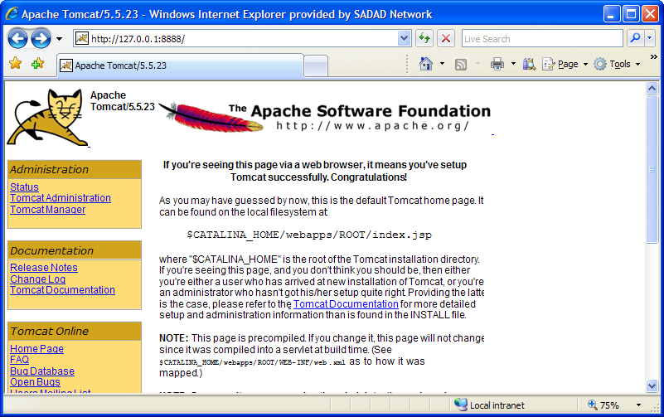
  - Click on the “Tomcat Manager” in the left part of the screen

Deploy Smart Tool War file SmartTool.war as shown below
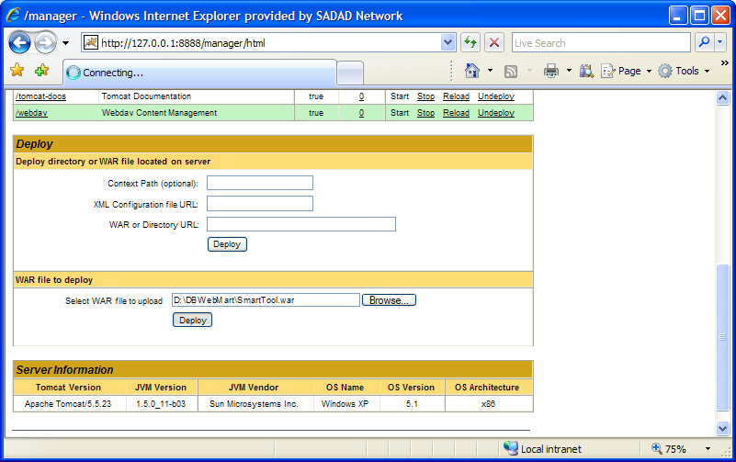

If smart Tool deployed successfully, you should get a screen like the following:
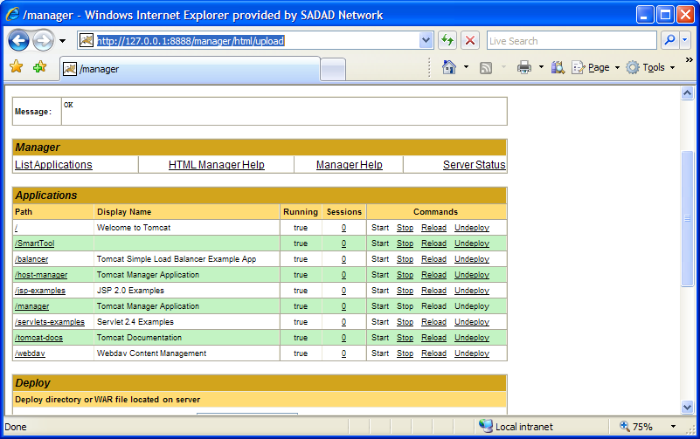
Now Smart Tool is running at your Machine at the following URL:

http://127.0.0.1:8888/SmartTool/loginScreen.jsp

By this type of deployment,<Class path> variable used in this document will point to: <Class path> = <Your TomCat Installation Path> \webapps\SmartTool\WEB-INF\classes\
<public_html_path> = <Your TomCat Installation Path>\webapps\SmartTool

Smart Tool layout

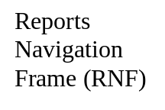
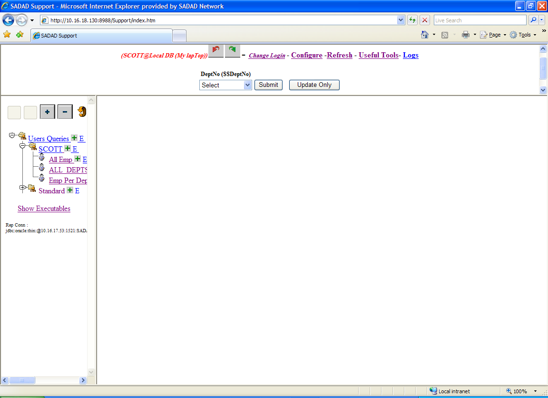
Bind Variables Frame
Report (Query) Result Frame

Smart Tool consists mainly of 3 frames as indicated above

- Bind Variables Frames
Your own SQL bind variable will be appear at this frame, queries depend on any of these variables i.e. have a reference to it with ‘$$’ before its name will be executed after substituting this reference with the value selected or entered for this variable.

- Reports Navigation Frame:
This frame contains a navigational tree with 2 mains sub nodes
- Standard : Contains all Reports with is accessible to all Users
- <Your Login Id>: if this is the first time you log to the system, Smart will automatically generate a new node with your DB login Id. This node will be the parent node for all your customized reports.

- Report Result Frame:
By just click on any report from the Report Navigation frame, Smart will start to execute it and display the result in this frame.

Configure You DB Connection parameters
Smart uses an xml configuration file
<Class Path>\Support\Connections_config.xml

To configure you DB connections corresponding to different environment

File Format:

<Configuration>
<Connection>
<TYPE>JDBC</TYPE>
<Name>Production Emnvironment </Name>
<Server>10.16.24.17</Server>
<ServiceName>spdb3</ServiceName>
<Active>Y</Active>
<SQLBINDVAR>
<BINDVARNAME>SADAD_SCHEMA_NAME</BINDVARNAME>
<BINDVARVALUE>MNSDWM</BINDVARVALUE>
</SQLBINDVAR>
<SQLBINDVAR>
<BINDVARNAME>TN_SCHEMA</BINDVARNAME>
<BINDVARVALUE>MNWMCI0301</BINDVARVALUE>
</SQLBINDVAR>
</Connection>
<Connection>
<TYPE>JDBC</TYPE>
<Name>Testing Environment </Name>
<Server>10.16.24.17</Server>
<ServiceName>spdb3</ServiceName>
<Active>Y</Active>
<SQLBINDVAR>
<BINDVARNAME>SADAD_SCHEMA_NAME</BINDVARNAME>
<BINDVARVALUE>MNSDWM</BINDVARVALUE>
</SQLBINDVAR>
<SQLBINDVAR>
<BINDVARNAME>TN_SCHEMA</BINDVARNAME>
<BINDVARVALUE>MNWMCI0301</BINDVARVALUE>
</SQLBINDVAR>
</Connection>

XML Tag | Description | Example
Type | Type of DB connection  Allowed values are :  - JDBC for both thin and oci  - ODBC | JDBC
Name | Smart Unique DB Name which will appear to the end User at the login screen | Production Emnvironment
Sever | Server Name or IP Address of the DB Server | Localhost
ServiceName | * Oracle DB unique Service Name | ORCL
SQLBINDVAR | A name value pair for an sql bind variable. Any query contains $$BINDVARNAME will be replaced at run time with its corresponding BINDVARVALUE for this connection (Environment)
BINDVARNAME | Bind variable Name | Env_File_System
BINDVARVALUE | Bind variable Value | C:\Abc\Def

* For more information contact you DB system Administrator

Smart Tool Repository Connection

Reparatory connection is a DB Connection at which Smart Tool Stores all Your Reports information and other configuration parameters.
You should configure your Repository Connection Details at the end of Connections_config.xml file descried above.

<REPOSATORYCONN>
<TYPE>JDBC</TYPE>
<Name>Local Host Reposatory</Name>
<Server>localhost</Server>
<ServiceName>orcl</ServiceName>
<Active>Y</Active>
<userName>smart</userName>
<password>smart</password>
</REPOSATORYCONN>

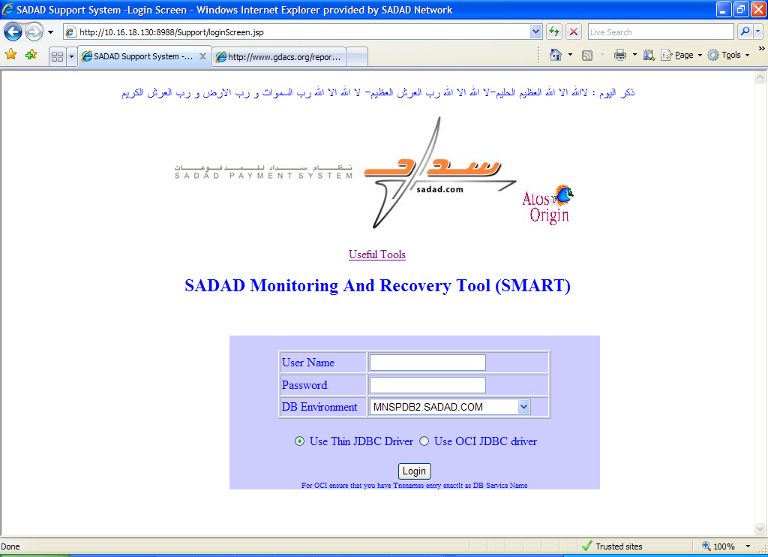

Smart Tool Configuration Parameters
The following parameters need to be configured in the repository connection in table “”

ID | E NAME | VAL (Example) | E DSC
2 | SMTP_SERVER | 10.16.18.12 | IP Address of SMTP Mail Server
3 | Support User Email | smart.reports@sadad.com | Smart Report User Email, all emails sent by Smart Tool will be sent By this Email.
7 | Admin_Notify_Mail_Address_Receiver | sfoda@sadad.com | Admin_Notify_Mail_Address_Receiver . for example when User encounter an Exception error and click on Send this Error, The Error will be sent to this Email
8 | AutoLogin_Environment_Name | ORCL.YourCompany.COM | All Process which auto log to DB uses connection details from Connections_config.xml file for this value
9 | AutoLogin_Username | Db user name | All Process which auto log to DB uses this username
10 | AutoLogin_Password | ???????? | All Process which auto log to DB uses this password

Build you own Hyper Linked reports
By this section you will be able to create your first parameterized query report. Also you will be able to pass the result of one query to another query. Smart also provide a set of useful tools like converting your query result to XML format, migrate the result to MS Excel Sheet and edit query result

Add your first simple query

Assume that you logged with Scott user you will get a screen like the following

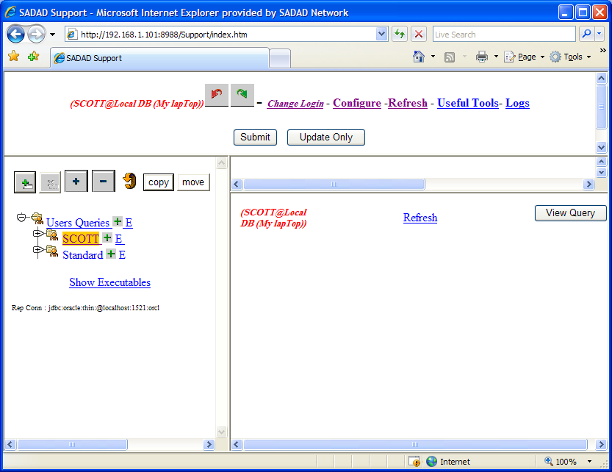

  - Click on The sign just Beside the scott node in the tree to add a new report owned by yourself (scott user)
  - An entry screen will be displayed like the following

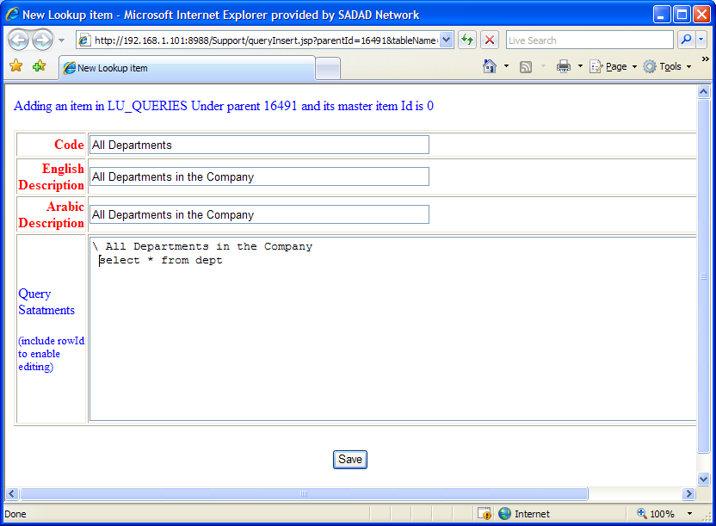

Enter your own query in the Query Statements Text Area
For Example:

\ All Departments in the Company
Select * from dept

Note:
That First List Should Start with the “\” character following by the title of the report.

  - Click Save Button
  - Execute Your Query by just selecting it from the Reports Navigational Frame (left frame)

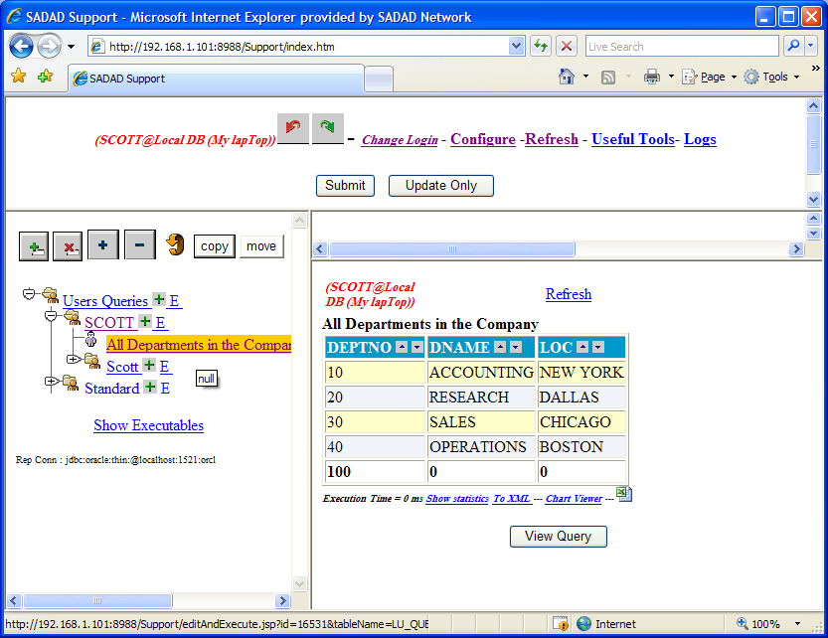

  - Your Report Result will be displayed in the Report Result Frame

Report with Multiple Results.
You can have multiple results in the same report.
- Edit You previous query to be like:

\ All Departments in the Company
select * from dept
\ All Available Salary Grades
select * from SALGRADE

- Execute it to get the following:
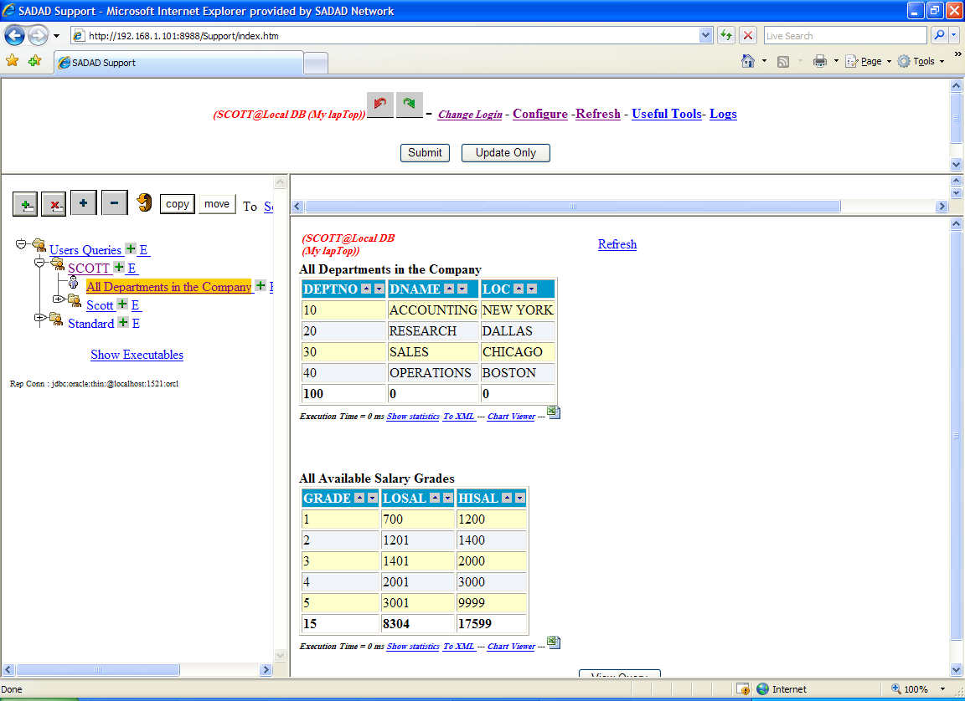

Configure You SQL Bind Variables.
Every User could have his own set of input variables according to the reports he would have access to it
Just Click on “Config” at the Top Of the main Screen
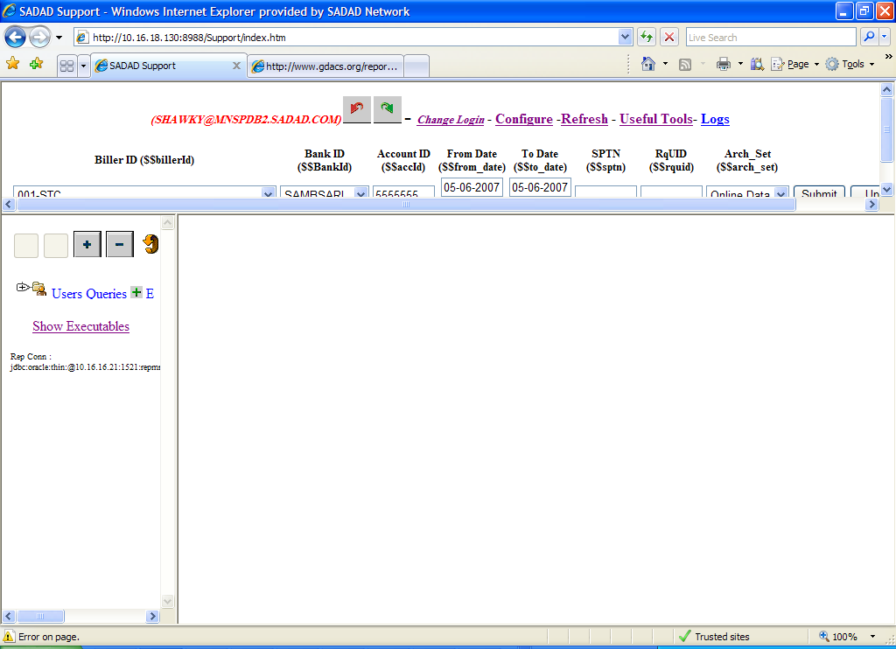

To maintain your set of input parameters
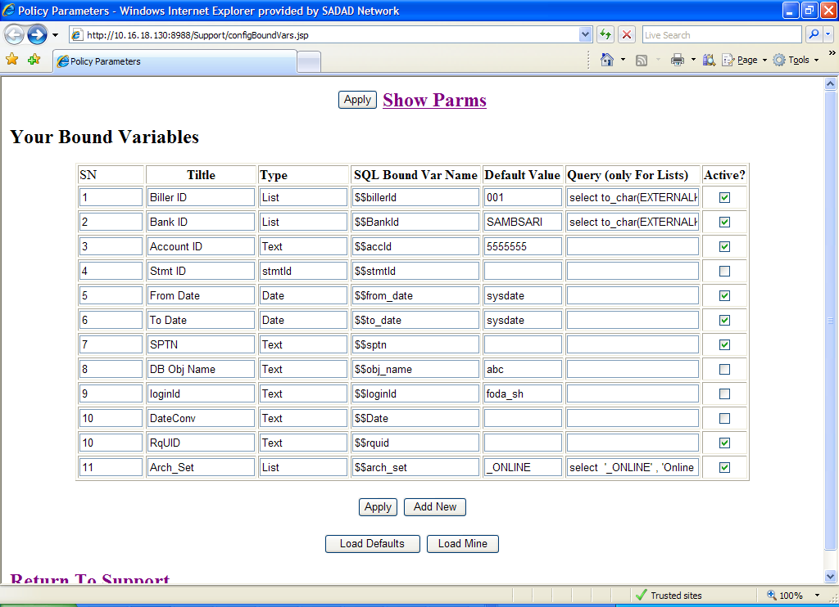

You can also load the already defined input parameters then copy it to your self

Input parameters types
- Text : if You need the input parameter to appear just as a simple text field
- Date: if you need to display your input parameter as a Date field with a calendar button
- List: if you need to display your input parameter as a select list. For this type you should define your sql query that will return the required list
Your query should follow the following example:

Select
deptCode --code which will substituted by the bind variable in your query report
, deptAName -- Arabic name which will be displayed in the list
, deptEName -- English name which will be displayed in the list
From Depts

Add New Query report
By default Smart Tool automatically creates a new empty node for the logged DB user as shown below.
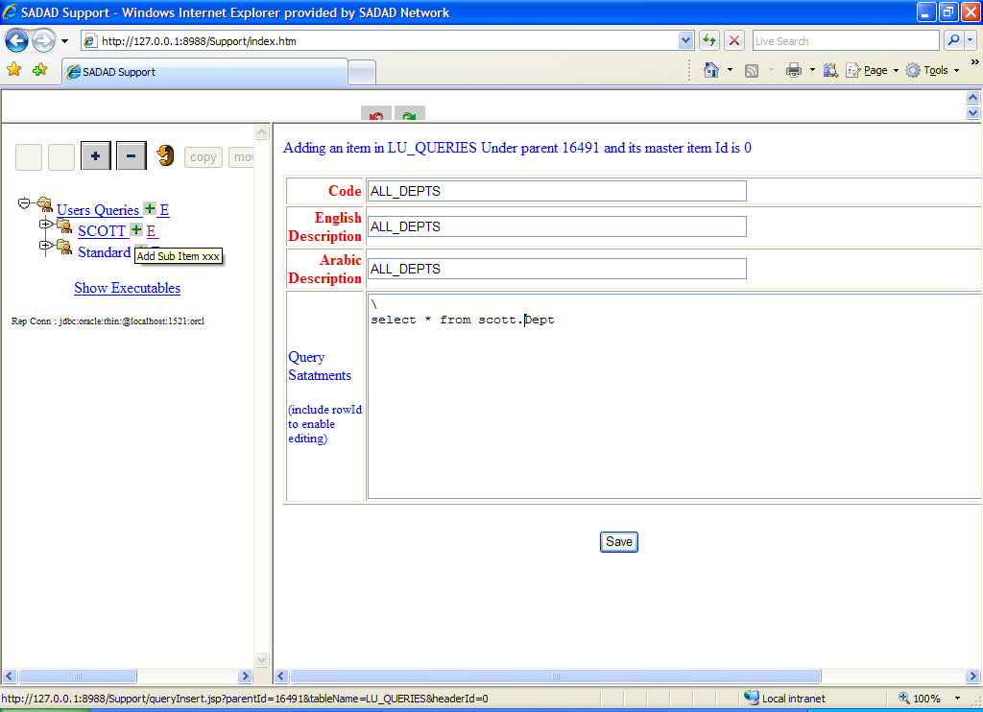

Logged User have full power to create modify, execute and delete any report under his own Node.

To create a new Smart Tool Report under any node, click on the plus icon for that node. A new report entry form will be displayed in the right pane.

Enter your report information as shown above.

Edit Your Report
Click on the “E” link for the report you need to modify.

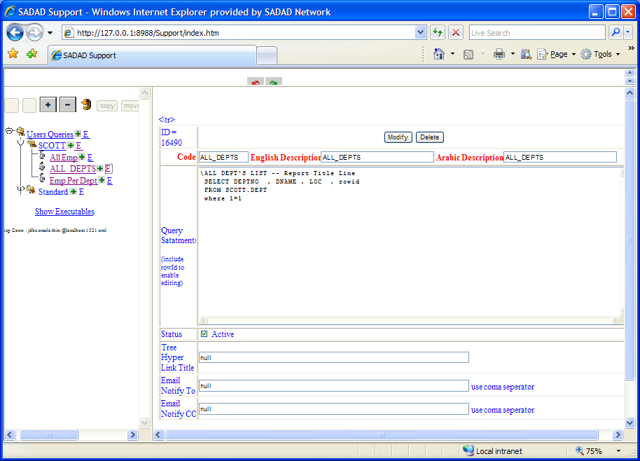

Link Your Query report with SQL Bind Variable
You can easily parameterize your reports with Your Bind Variables,
Simply write your query as the following:

Select * from emp where id = $$emp_id

Where emp_id is already defined bind variable.

Link a query result to another query
All What You need to link two reports together- one report output considered as another report’s input- to be familiar with HTML hyperlink tag
<a href = ‘’ > </a>

Example:
Assume the following :

Report 1 :

Id = 100, for a list of All Departments
Query :

\ALL DEPT'S LIST -- Report Title Line
SELECT DEPTNO , DNAME , LOC
FROM SCOTT.DEPT

Report 2 :

Id = 200 , for a list of employs of a given department

Query :
\ALL Employees of Dept no = $$deptno -- this is Report Title Line
select * from emp where deptno = $$deptno

To create a hyperlink on the id column of report 1 , modify the query as the following:

\ALL Employees of Dept no = $$deptno -- this is Report Title Line
select ‘<a href = editAndExecute.jsp?id=200&deptno=’||deptno||’>’|| id ||’</a>’ , dname , loc from scott.dept

Add AJAX to your Report
By adding AJAX to your report you will gain more flexability and your reports will become more dynamic and reducing reloading pages.
All what you need to do, add a column to your query as the below
'<a href = "javaScript:loadDetails(''executeQuerySimple.jsp?id=16578&DeptNo='||DEPTNO||' '', ''DeptNo'||DeptNo||''') ">Emps</a> '
||'<div id="DeptNo'||DeptNO||'"></div>' Emps
So your "All Depts" query needs to be modified to be:

SELECT DEPTNO
, '<a href = "javaScript:loadDetails(''executeQuerySimple.jsp?id=16578&DeptNo='||DEPTNO||' '', ''DeptNo'||DeptNo||''') ">Emps</a> '
||'<div id="DeptNo'||DeptNO||'"></div>' Emps
, DNAME , LOC
FROM SCOTT.DEPT

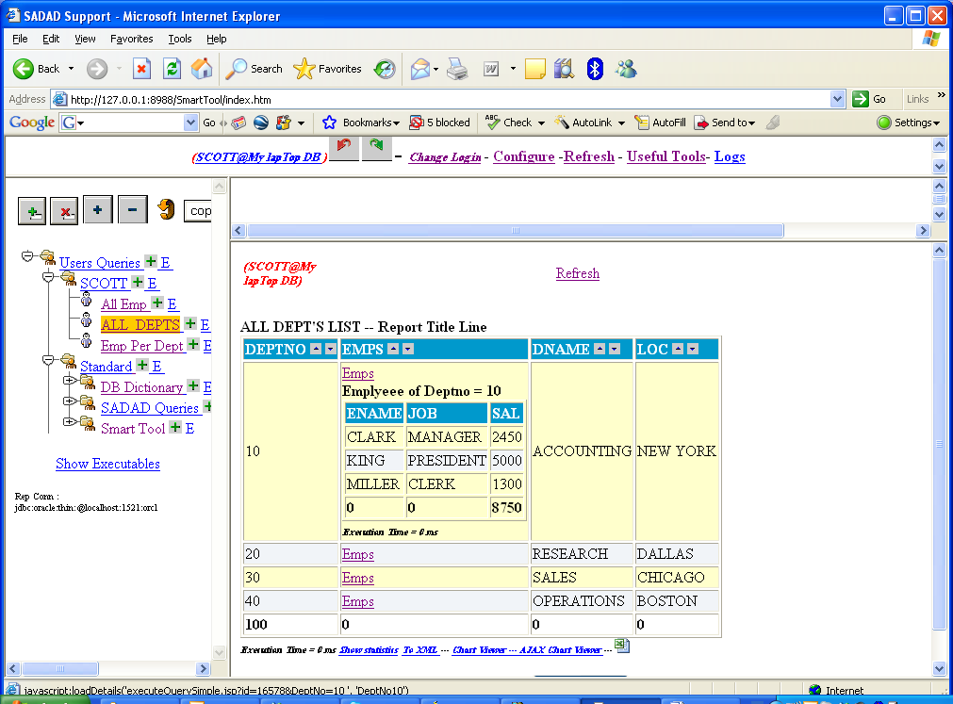

Browse your query result in xml Format
You can easily display your report result set in an XML format, by clicking on the “To XML ” link as shown below.

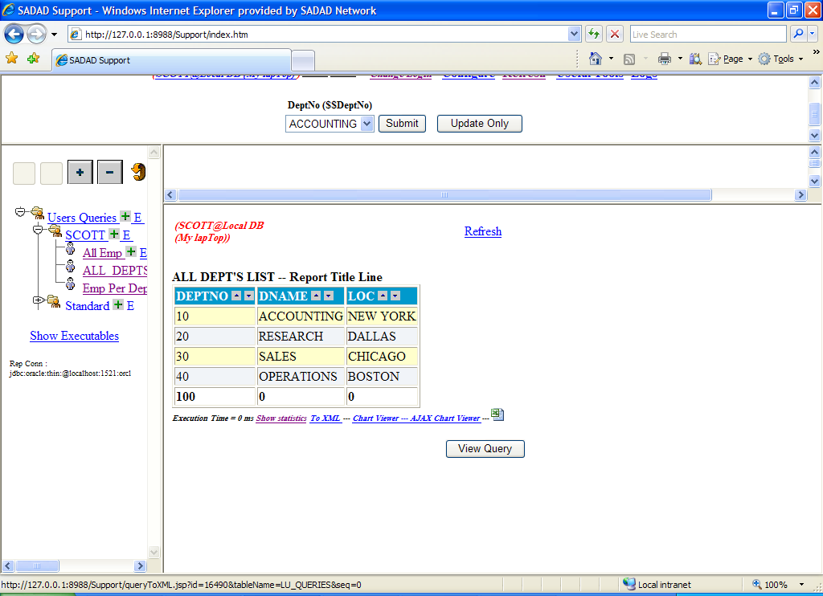

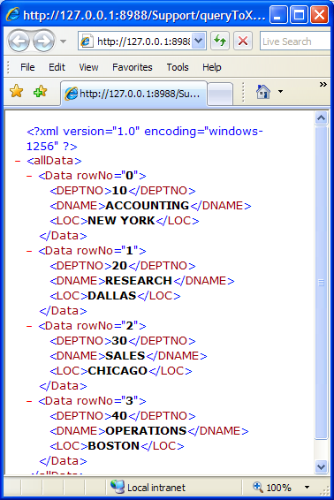

Monitor Your Reports Execution statistics
You can also monitor your reports execution statistics including who is executing this report and how long it takes to be executed
Simply click on the link “show statistics” just below the result set.

Note that you can create and customize your own statistics.

Open your query results in MS Excel
You Can Integrate the Calculations and Graphs Power of MS Excel to the Smart Tool simply click on the EXCEL icon just below the result set to open your data in an Excel sheet- you should have install MS EXCEL at your Local Machine.

To enable this feature for a specific user, Administrator of Smart Tool should create a folder with the DB user name as shown below,

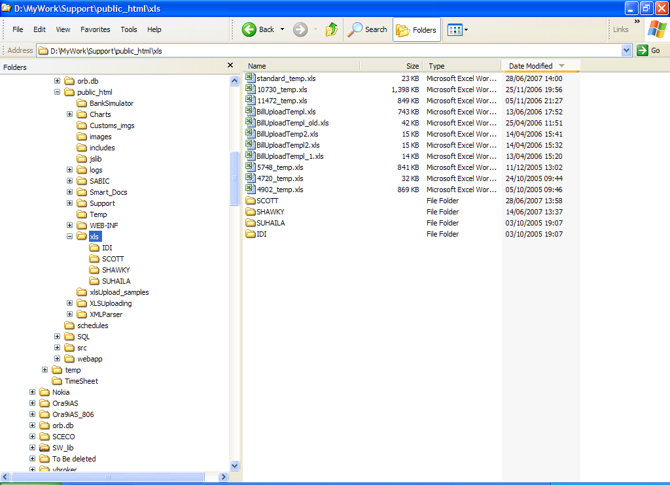

Building a new XLS template for Your Report

Smart Tool using a blank default XLS template sheet located at : <public_html_path>\xls\standard_temp.xls

You can create your own template for a specific report as follows

- Create a new XLS file containing further calculation and graphs for your needs
Note: First sheet should be allocated for the raw data from Smart Tool
Use different sheets for your graphs , pivot tables , and statistics
- Assume that you want Smart Tool to use this XLS template for Report Id= 200
- Save Your XLS file as
<public_html_path>\xls\200_temp.xls

Where <public_html_path> is the installation path of the public html and jsp’s of the Smart Tool.

Edit Your Query Result- DML Operations
Smart Tool as its name implies, it have the Recovery Power, recovery here means the power of modifying your Report result.
Example:
Assume you need to maintain Company Departments
- Edit your Report Query and add a Oracle “rowid” column to it

\ALL DEPT'S LIST -- Report Title Line
SELECT DEPTNO , DNAME , LOC , rowid
FROM SCOTT.DEPT
where 1=1
-- this where clause is mandatory tto allow Smart Tool to Extract table name you need to update

- By adding rowid to your report, Smart Tool Automaticalloy will display an “E” link to edit the result set as shown below.
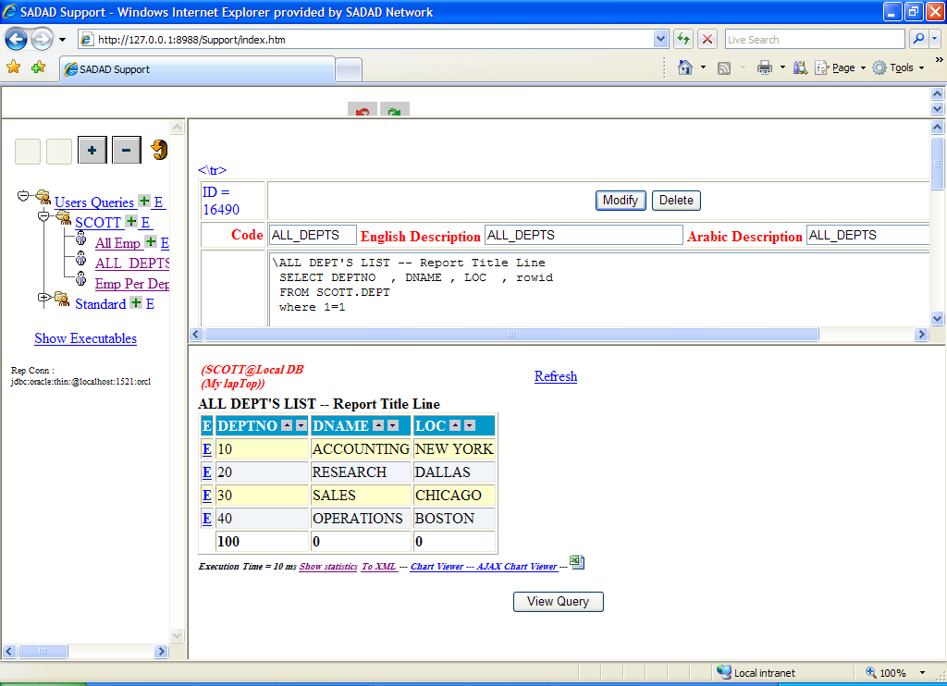
- When you click on this “E” link, Smart Tool will display and Edit Form for the selected record as shown below

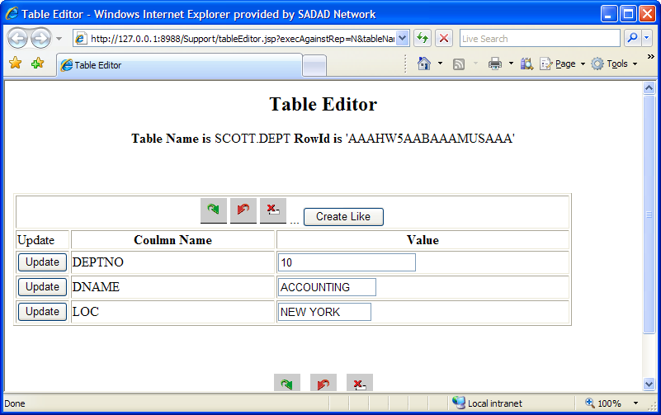

Organize Your Reports
You can organize your reports in the Report navigation frame RNF – by moving a report from its parent node to another parent node
- select the report you need to move
- Click “Select New Parent” from the top of the
- A new window will be poped up containing all your tree structure except the selected one
- Select the new parent you want to move to
The browser will be closed or ask you to confirm close – click yes
- Click the “move” button

Built your own Executable Procedure

Link Your Query result with File System (Windows/Unix)

Using Oracle LOB Reader Web Service
If Your result set contains Oracle LOB data type, you should include the rowid also of that table in your query, this will allow Smart Tool to display a link to the CLOB reader JSP service passing table name, rowid and column name contains CLOB data type. By this way you automatically have the power to display the content of the LOB object.

Automatic Mail Notifiation
Smart Tool has two different types of email notifications
  - Query Result Mail Sender
  - Query Result Mail Sender only if Data Found

1- Query Result Mail Sender
This feature enables automatic mail notification containing any query result.

Using any batch (script) file contains the following command:

java.exe -classpath <Class Path> Support.DownLoad.URLContentMailSender sfoda@sadad.com,habuattia@sadad.com,halenezi@sadad.com,ealsafadi@sadad.com,sbadran@sadad.com Yesterday_Payments_Message_Statistics http://10.16.18.130:8988/Support/executeQuery.jsp id=3672 AutoLog=Y parm1 =parm1Vaue parm2=parm2value

Running this batch (script) will cause query No 3672 to be executed with parameters parm1 =parm1Vaue, parm2=parm2value …. and its results automatically sent to sfoda@sadad.com,habuattia@sadad.com,halenezi@sadad.com,ealsafadi@sadad.com,sbadran@sadad.com with a mail subject = Yesterday_Payments_Message_Statistics

Using MS scheduler under Windows or “at” command under Unix, this process can be scheduled to run periodically as need.

In fact this is a general purpose URL contents mail sender tool, You can use it to send the content of any URL as an email.

2- Query Result Mail Sender only if Data Found
By the following java executable program you can build your own email alerts as follows:
  - Build your own query reports which return any data set you need to be notified when this type of data exist in your DB system.
  - In the “email To” field of your new query enter the email addresses you want to be notified.
  - In the “email Cc” field of your new query enter the email addresses you want to be cc notified.
Create a script as the folloing:

Java.exe classpath <Class Path> Support.SqlReader ifDataFoundSendQueryResultByMail <your new reportID> <query sequence in the report >

Example

Java classpath <Class Path> Support.SqlReader ifDataFoundSendQueryResultByMail 123 0

The above command will execute your query no. 0 in your report no. 123, if data found from that query an email will sent to the report defined email list containing the data found.

Using MS scheduler under Windows or “at” command under Unix, this process can be scheduled to run periodically as need.

Schedule email sending Query results

Other Useful Tools

General Purpose Excel Sheet Uploading Tool
In many cases we need to upload an MS Excel Sheet Data file to our DB. This tool simplify this operation as the following:

- Click in the “Useful Tools” Link at the Bind Variables Frame
- Click on “General Purpose XLS Sheet Uploading Tool”
- Follow instruction to upload your XLS sheet file to DB

Http Poster Client Application
Posting an HTTP request to an HTTP Server is a comman request especially in Application Integration environment and Service Oriented Architecture (SOA).

- Click on the “Useful Tools” Link at the Bind Variables Frame
- Click on “Http Poster Client Application”
- Follow instruction to post your request to your http server

SMS Sender
This feature requires recharging an account at http://www.clickatell.com/
It is subject to this third party conditions.

The Tool can be configured also to send SMS upon a certain condtion

Java Code Description

Main Java Classes Description:

Class Name | Function
Support.SqlReader | This is the main class responsible for reading sql query from repository and substituting all bind variables
Support.ConnParms | Represent a set of DB Connection parameter
Support.ConnectionFactory | This Class Responsible for creating a db connection
Support.LookupTreeV10 | This Class is responsible for the Navigation Tree in the Report Navigation Frame
Support.Misc | This is a general purpose class it contains some useful methods
Support.QueryTreeSecurity | This Class Responsible for security rules applied to the navigation tree ( Which User Can Update , Insert , Execute a new Report
Support.XMLConfigFileReader | This Class is responsible for reading the XML Connections Configuration file:  <Class Path>\Support \Connections_config.xml
Support.Download. URLDownLoader
Support . XLSUploading .XLSUpload | This Class Responsible for Uploading XLS sheet Data to DB.
Support.SqlBindVar | This Class represent an SQL bind variable XML tag in the XML Connections Configuration file:  <Class Path>\Support \Connections_config.xml

Main JSP files description
JSP File Name | Function
AJAX_Chart.jsp | Draws Query Result as a chart- graph
configBoundVars.jsp | Maintain bind variable screen
editAndExecute.jsp | This JSP contains a reference to both editQuery.jsp and executeQuery.jsp
editQuery.jsp | This page for sql query maintenance
errorPage.jsp | The main application error page
executeQuery.jsp | This JSP file is the most important file, it reads the sql, execute it then render the result in html format to the screen
loginScreen.jsp | This is the login screen
oracleCLOBReader.jsp | This JSP responsible for displaying CLOB values if your query result returns CLOB.
queryToXLS.jsp | This JSP execute the sql query and writes its result set to XLS file
queryToXML.jsp | This JSP execute the sql query and display its result set in XML format
queryTree.jsp | Displays the query navigation tree in the Report Navigation Frame
sendError2SysSupp.jsp | This page will be used in case user encounter an exception and need to send exception details to system support
Top_Frame2.jsp | Displays the Top frames with sql bind variable for the logged user.

