Predictive Decision Support from an Existing Dataset
Breast Cancer Classification Using the Wisconsin Breast Cancer (Original) Dataset
Data Science Modelling Assignment
Student Name: ______________________________
Student ID: ________________________________
Course / Module: ___________________________
Instructor: __________________________________
Submission Date: ____________________________
Organisational scenario: hospital clinical decision support for prioritising breast tissue samples for clinician review.

Executive Summary
This report evaluates whether an existing breast-cancer dataset can support a recurring hospital decision: identifying breast tissue samples that are more likely to be malignant and therefore require prompt clinician review. The analysis uses the Breast Cancer Wisconsin (Original) dataset, a public classification dataset containing 699 records, nine integer-valued diagnostic features, a sample identifier, and a class label. The original label uses 2 for benign and 4 for malignant. No new data were collected.
The modelling problem was framed as supervised binary classification because labelled outcomes are available. Malignant disease was defined as the positive class because a missed malignant case is the more serious clinical error. The model boundary is deliberately narrow: it predicts benign versus malignant from the nine recorded measurements and can support prioritisation or second-review decisions. It is not designed to make an autonomous diagnosis, prescribe treatment, or replace pathology and clinical judgement.
Data investigation identified several issues that materially affected the engineering design. Eight exact duplicate rows were removed, leaving 691 records. Sixteen predictor values were missing, all associated with the Bare Nuclei field. The data also contained repeated sample identifiers and four identifiers associated with both class labels. To reduce information leakage, the sample identifier was excluded from the predictive features and used as a grouping variable so that the same identifier could not occur in both training and test partitions. Median imputation was performed inside each modelling pipeline so that validation folds did not receive information from records outside the fold.
Five candidate approaches were compared: Logistic Regression, Random Forest, Extra Trees, Gradient Boosting, and a radial-basis-function Support Vector Machine. Hyperparameters were tuned using five-fold Stratified Group cross-validation on the training data. Extra Trees achieved the highest mean cross-validated accuracy at 96.95% (SD 1.75%) and was selected before the holdout test set was evaluated. Its probability threshold of 0.467 was chosen from training out-of-fold predictions to maximise classification accuracy.
On the untouched holdout set of 134 records, the selected Extra Trees model achieved 99.25% accuracy, 100% sensitivity, 98.78% specificity, 98.11% positive predictive value, 99.05% F1 score, and 99.84% ROC-AUC. The confusion matrix contained 52 true positives, 81 true negatives, one false positive, and no false negatives. These results show strong proof-of-concept performance on this dataset, but they are not evidence that the model would achieve the same accuracy in a current hospital population. External validation, prospective testing, clinical threshold setting, fairness assessment, and monitoring for data drift would be required before responsible deployment.

1. Problem Definition and Framing Decision

1.1 Organisational scenario and recurring decision
The proposed organisation is a hospital diagnostic unit that already records numerical characteristics from breast tissue or cytology samples during routine investigation. The recurring operational question is whether an observed sample should be treated as more consistent with a benign or malignant pattern and therefore whether it should be prioritised for further clinician review. This is a decision-support scenario rather than an automated diagnostic system.
The decision matters because errors have unequal consequences. A false negative means that a malignant sample is predicted as benign, which may delay further investigation. A false positive means that a benign sample is flagged as malignant, which may cause additional review, cost, workload, and patient anxiety. The model must therefore be evaluated using measures that distinguish these two error types instead of relying on overall accuracy alone.

1.2 Stakeholders and their needs
Table 1. Stakeholders, needs, and consequences of model error
Stakeholder | Need from the system | Main risk | Required safeguard
Clinicians / decision-makers | A clear, reproducible indication that supports review priority. | Missed malignant cases or excessive false alarms. | Show probability/classification, error profile, and allow clinician override.
Patients / subjects | Safe and fair use of recorded information. | Delayed review from false negative; unnecessary concern from false positive. | Human confirmation and clear limits on automated use.
Hospital management | Measurable benefit without unacceptable clinical or operational risk. | Over-reliance on a model that has not been externally validated. | Pilot evaluation, monitoring, maintenance, and governance.
Technical / data staff | Reproducible preprocessing, validation, and update process. | Leakage, data drift, broken pipelines, or unreproducible results. | Versioned code, group-aware validation, audit logs, and retraining rules.
Oversight / compliance | Evidence of intended use, limitations, accountability, and data protection. | Model used beyond its validated scope. | Documented system boundary, human oversight, auditability, and external validation.
Human oversight is central to this scenario. WHO guidance for artificial intelligence in health emphasises human autonomy, transparency, accountability, safety, and ongoing evaluation. These principles support a decision-support design in which the clinician remains responsible for the final clinical decision (World Health Organization, 2021).

1.3 Framing decision
The problem is framed as supervised binary classification. This choice follows directly from the data: each record has a known class label, with 2 representing benign and 4 representing malignant. The target was recoded to 0 = benign and 1 = malignant. Supervised learning is therefore appropriate because the objective is to learn a mapping from nine recorded tumour characteristics to the known diagnostic class.
An unsupervised approach could be useful as a secondary exploratory tool for detecting unusual records or clusters, but it is not the primary framing because the organisation needs a recurring labelled decision. The assignment model therefore uses supervised classification and treats unsupervised anomaly detection as outside the main scope.

1.4 System boundary
The model is asked to estimate whether a sample is more consistent with the malignant or benign class using only the nine recorded predictors. The sample code is not a predictor. The model does not use symptoms, imaging, genetic tests, clinical history, demographic information, treatment information, or clinician notes.
The output may support prioritisation for clinician review. It must not independently diagnose cancer, decide treatment, deny care, or replace pathology. Any real deployment would require external validation on current local data and approval of the operating threshold by appropriate clinical and governance stakeholders.

2. Investigation of the Data

2.1 Dataset origin and structure
The analysis uses the Breast Cancer Wisconsin (Original) dataset. The model was run on a Kaggle mirror of the public data, while the original source is the UCI Machine Learning Repository. UCI describes the dataset as a health and medicine classification dataset with 699 instances and nine integer-valued features. It was donated in 1992 and contains clinical cases collected in chronological groups from 1989 to 1991 (Wolberg, 1990). The UCI metadata also identifies missing values in the Bare Nuclei variable.
The raw file contains 11 columns: one sample identifier, nine predictor variables, and one class label. Predictor scores are mostly bounded from 1 to 10. The identifier is administrative rather than a biological measurement, so it is excluded from model inputs.
Table 2. Dataset variables and modelling roles
No. | Variable | Role | Scale / coding | Used as predictor?
1 | Sample code number | Identifier | Numeric ID | No - grouping only
2 | Clump Thickness | Feature | 1-10 | Yes
3 | Uniformity of Cell Size | Feature | 1-10 | Yes
4 | Uniformity of Cell Shape | Feature | 1-10 | Yes
5 | Marginal Adhesion | Feature | 1-10 | Yes
6 | Single Epithelial Cell Size | Feature | 1-10 | Yes
7 | Bare Nuclei | Feature | 1-10; missing values present | Yes
8 | Bland Chromatin | Feature | 1-10 | Yes
9 | Normal Nucleoli | Feature | 1-10 | Yes
10 | Mitoses | Feature | 1-10 | Yes
11 | Class | Target | 2 = benign; 4 = malignant | Target only
After exact duplicate removal, the feature matrix used for modelling contained 691 rows and nine predictor columns. The target vector contained 691 binary labels. This produces X with shape approximately (691, 9) and y with shape (691,).

2.2 Data quality audit
Table 3. Observed data-quality indicators from the Kaggle run
Indicator | Observed value
Original records | 699
Records after exact duplicate removal | 691
Exact duplicate records removed | 8
Unique sample IDs after deduplication | 645
Repeated-ID rows in original data | 54
Sample IDs associated with both labels | 4
Missing predictor cells | 16
Benign records after deduplication | 453
Malignant records after deduplication | 238
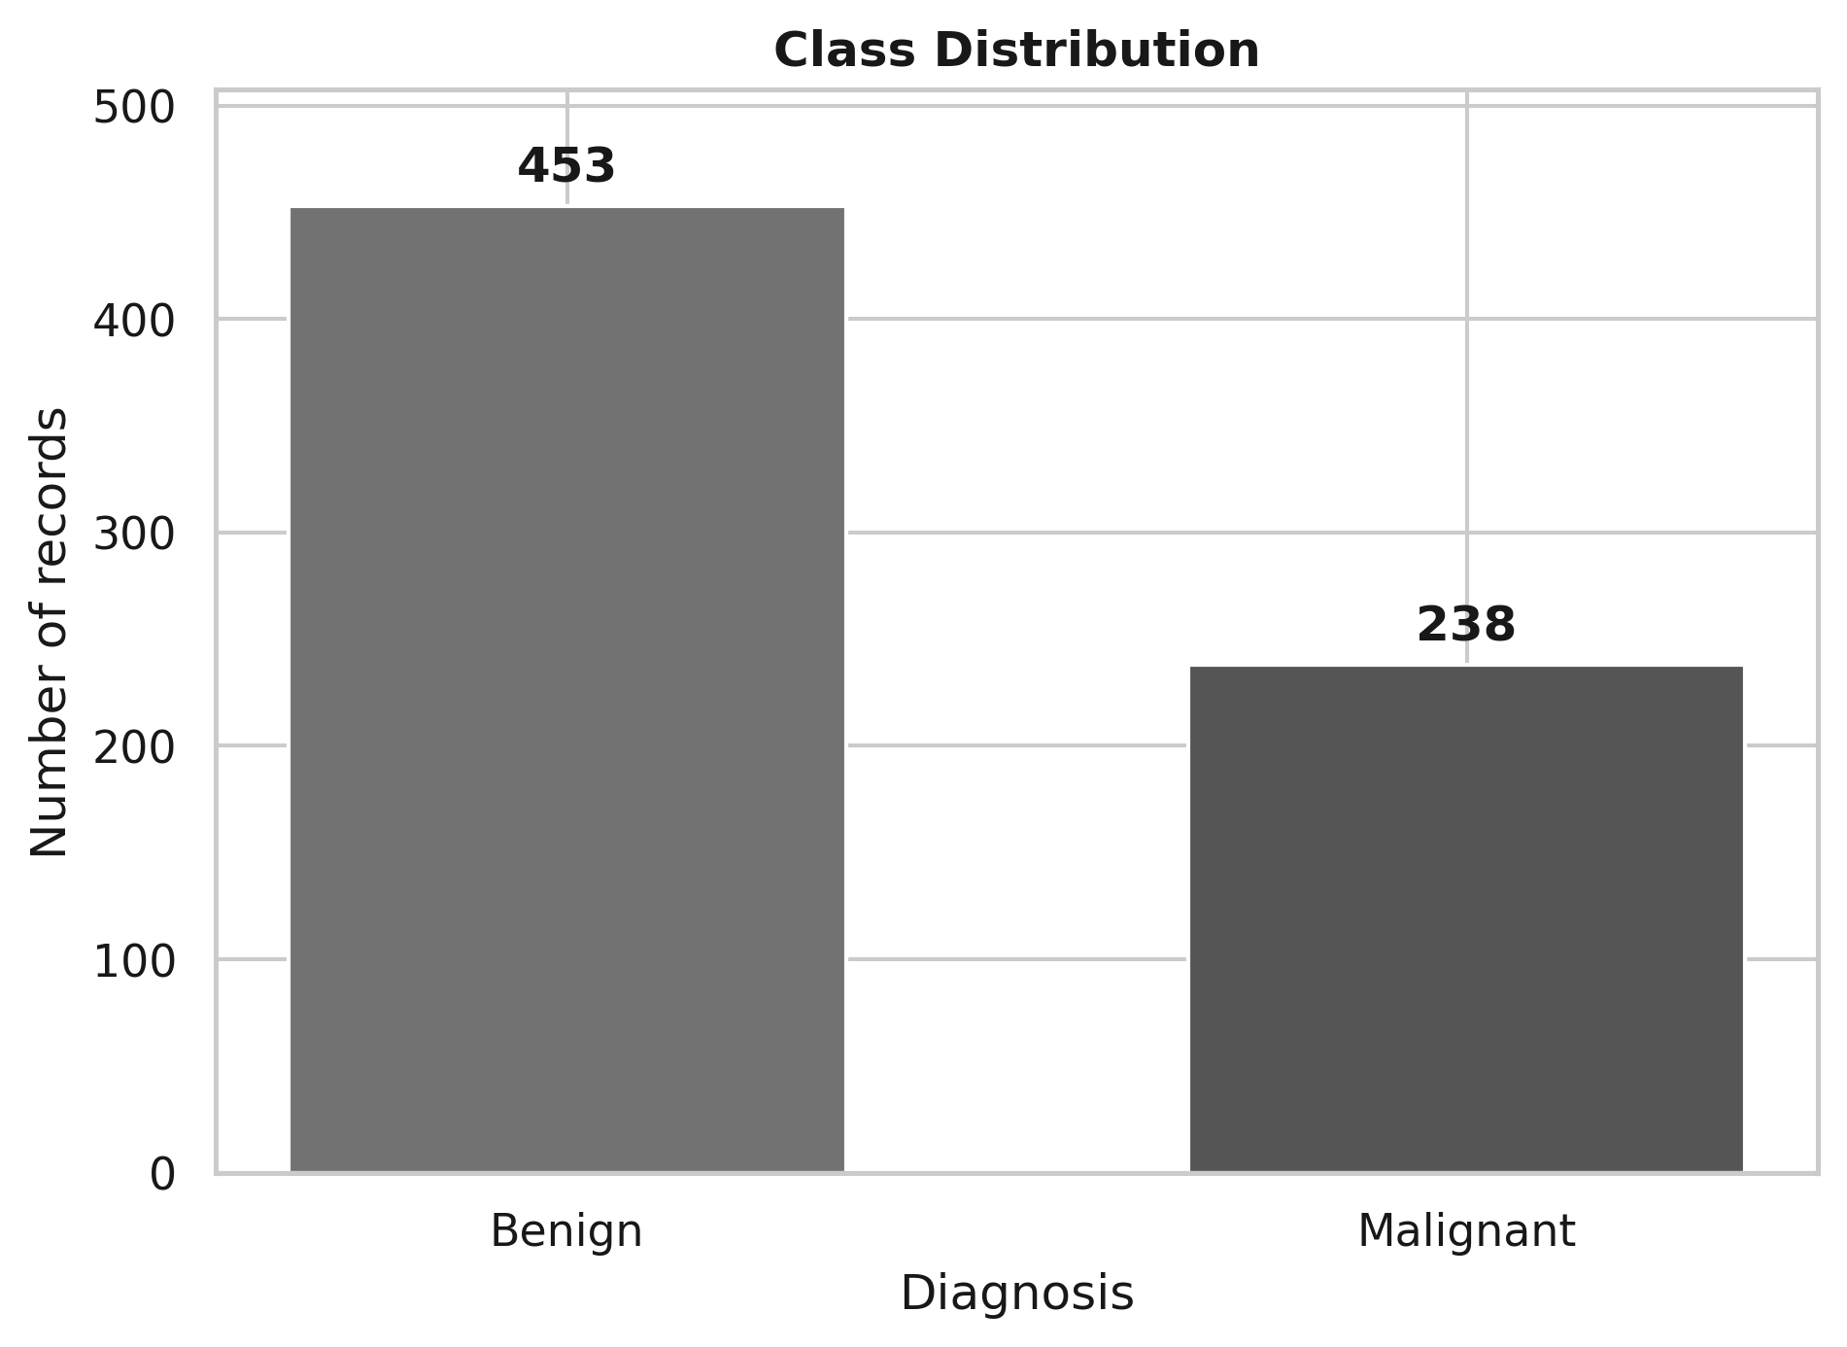
Figure 1. Class distribution after exact duplicate removal. Benign cases remain more common than malignant cases.
The cleaned data contain 453 benign records and 238 malignant records, corresponding to approximately 65.6% benign and 34.4% malignant. This is a moderate class imbalance rather than an extreme one. Because malignant cases are the clinically important positive class, the modelling grids allowed balanced class weights where supported by the algorithm.
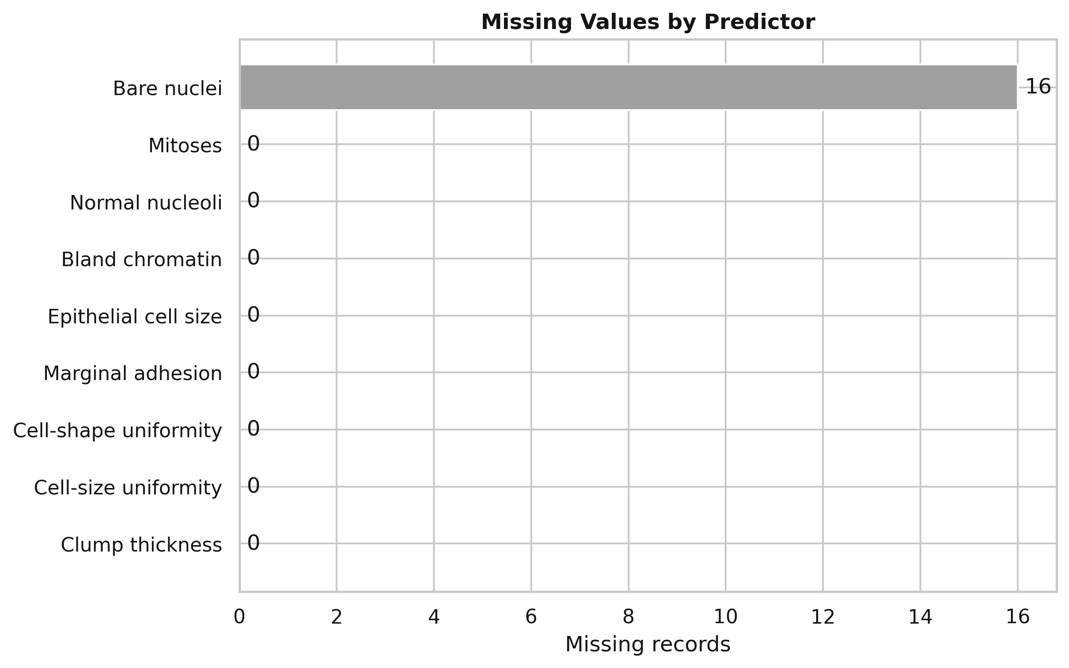
Figure 2. Missing-value count by predictor. The 16 missing predictor entries occur in Bare Nuclei.
Missingness is concentrated in one variable. Median imputation was selected because the predictors are bounded ordinal-like integer scores and the median is robust to skewed distributions. Crucially, imputation was fitted inside each cross-validation pipeline rather than on the whole dataset, preventing information from the validation fold from influencing the imputed values.

2.3 Distributional and correlation properties
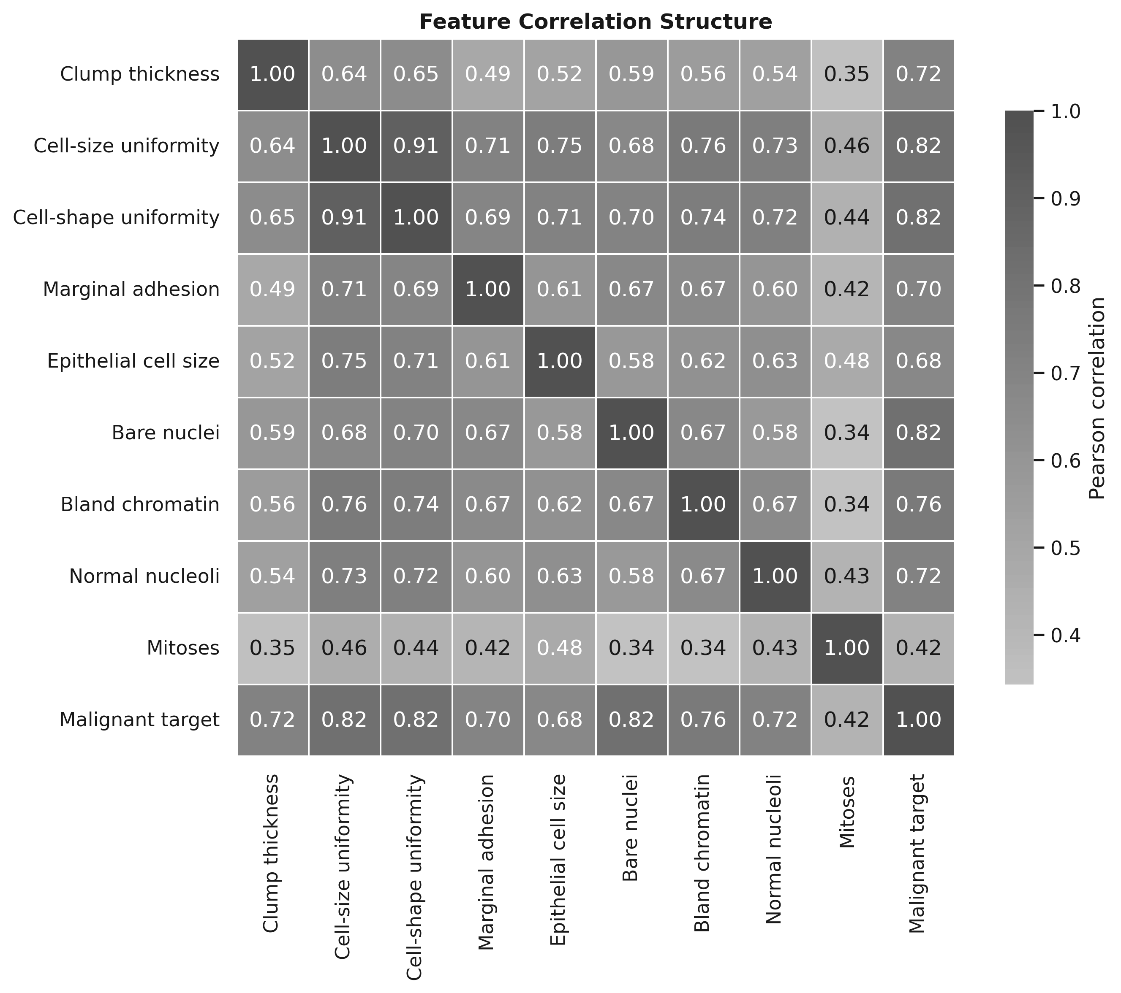
Figure 3. Correlation structure among predictors and the malignant target.
The correlation matrix shows that several measurements are strongly related, particularly the variables describing uniformity of cell size and cell shape. This means the predictor space is not independent. For a linear model, strong correlation can make individual coefficient interpretation unstable even when overall prediction remains good. Tree ensembles are less dependent on a linear independent-feature structure and can represent interactions and threshold effects directly.
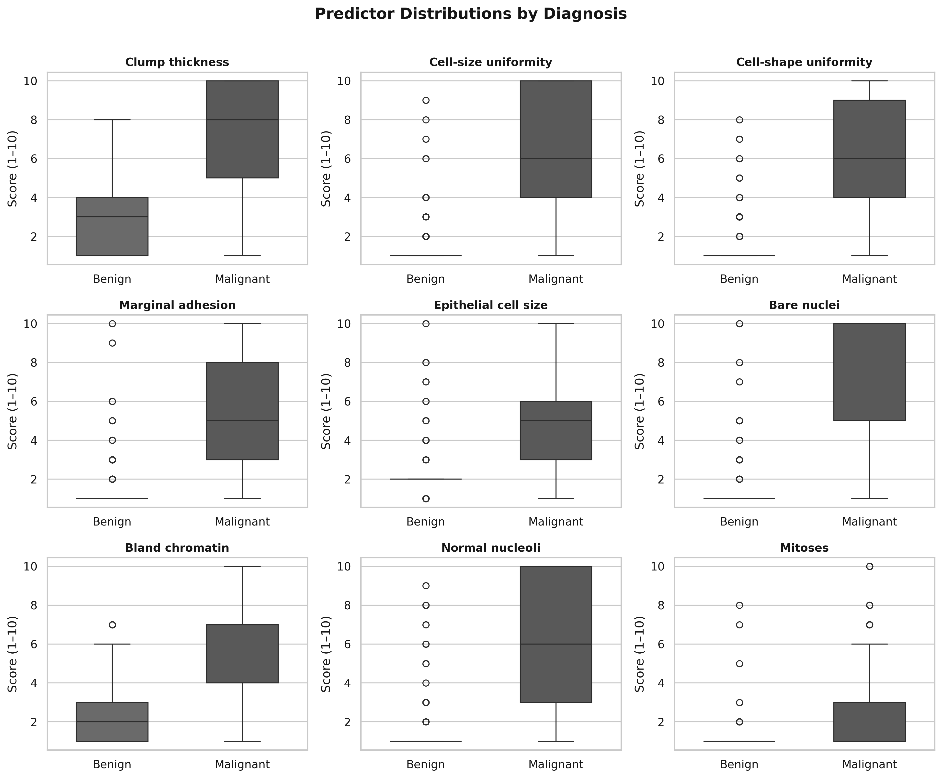
Figure 4. Distribution of each predictor by diagnosis. Malignant records generally occupy higher score ranges for several variables.
The boxplots show visible separation between benign and malignant records for several features, although overlap remains. This supports the use of classification methods while also explaining why multiple very different algorithms can achieve strong performance. The data are low-dimensional, bounded, correlated, and partially separable; these characteristics motivate comparison of both simple linear and nonlinear models rather than automatic selection of a single familiar algorithm.

2.4 Label quality and known scope limitations
The labels make supervised learning possible, but they should not be treated as perfect ground truth without examination. Four sample identifiers are associated with both class labels. This may reflect repeated measurements, data correction, or record inconsistencies. The analysis does not silently remove these conflicting-label identifiers; instead, it prevents the same identifier from being split across training and test data. This preserves the evidence of label uncertainty while reducing leakage.
The original UCI metadata states that samples arrived in chronological groups, but the modelling file used here does not include a usable time or group field. As a result, a true temporal validation design could not be implemented. This limits claims about performance on future populations and is one reason external validation is required.

3. Candidate Modelling Approaches
Five candidate methods were evaluated. The comparison was based on their mathematical behaviour and fit to the dataset, not on tutorial familiarity. The purpose was to contrast an interpretable linear baseline with several nonlinear methods capable of modelling correlated, threshold-like, and interacting effects.
Table 4. Principled comparison of candidate modelling approaches
Approach | Core mathematical idea | Fit to this dataset | Main limitation
Logistic Regression | Models log-odds as a linear function of predictors; outputs probabilities. | Strong interpretable baseline for binary classification; low dimensionality is favourable. | Linear log-odds assumption; correlated features complicate coefficient interpretation.
Random Forest | Averages many decorrelated decision trees trained on resampled data and random feature subsets. | Handles nonlinear thresholds and interactions without scaling; robust to mixed predictor relationships. | Less transparent than a linear model; probabilities may need calibration.
Extra Trees | Builds an ensemble of highly randomised trees by randomising feature and split-point choices, then aggregates predictions. | Suitable for bounded nonlinear predictors and interactions; reduces variance through ensemble averaging. | Reduced direct interpretability; importance can be distributed across correlated variables.
Gradient Boosting | Sequentially adds trees that reduce the current loss, producing an additive nonlinear model. | Can capture complex boundaries with small trees and controlled learning rate. | More sensitive to tuning and sequential overfitting than bagged/randomised ensembles.
RBF SVM | Maps observations implicitly into a nonlinear feature space and maximises the separating margin. | Useful where classes are nonlinearly separable; low feature count is computationally manageable. | Requires scaling and careful C/gamma tuning; probability output is less directly interpretable.
Logistic Regression uses the form P(Y=1|x) = 1 / (1 + exp(-(b0 + b1x1 + ... + bpxp))). This gives a clear probability model but assumes the log-odds change linearly with the predictors. Random Forest and Extra Trees instead partition the predictor space using many tree-based rules. Extra Trees adds stronger randomisation of attributes and cut-points, which can reduce variance and produce competitive classification performance (Geurts, Ernst, & Wehenkel, 2006). Random Forests provide a related ensemble approach based on collections of randomised trees (Breiman, 2001). Gradient Boosting builds an additive model by sequentially reducing the loss function (Friedman, 2001). RBF SVM uses a nonlinear kernel and a maximum-margin decision boundary (Cortes & Vapnik, 1995).

4. Model Development and Validation

4.1 Data preparation
1. Convert class labels to a binary target: benign = 0 and malignant = 1.
2. Remove eight exact duplicate rows so identical records do not receive additional statistical weight.
3. Exclude the sample code number from predictors because it has no biological meaning for classification.
4. Retain the sample code as a grouping key so repeated identifiers cannot cross the training/test boundary.
5. Convert question-mark entries to missing values and median-impute them inside each pipeline.
6. Standardise features for Logistic Regression and RBF SVM because their coefficients/distances depend on feature scale. Tree-based models are not standardised because split rules are invariant to monotonic rescaling.
7. Allow class weighting in models that support it, because the malignant class is less frequent.

4.2 Validation architecture and leakage control
A conventional random split would be unsafe because repeated sample identifiers exist. If records sharing an identifier appeared in both training and test data, the reported test score could be artificially optimistic. The analysis therefore used StratifiedGroupKFold. One of five group-aware folds was held out as the final test set, and all repeated identifiers were kept within one side of the split.
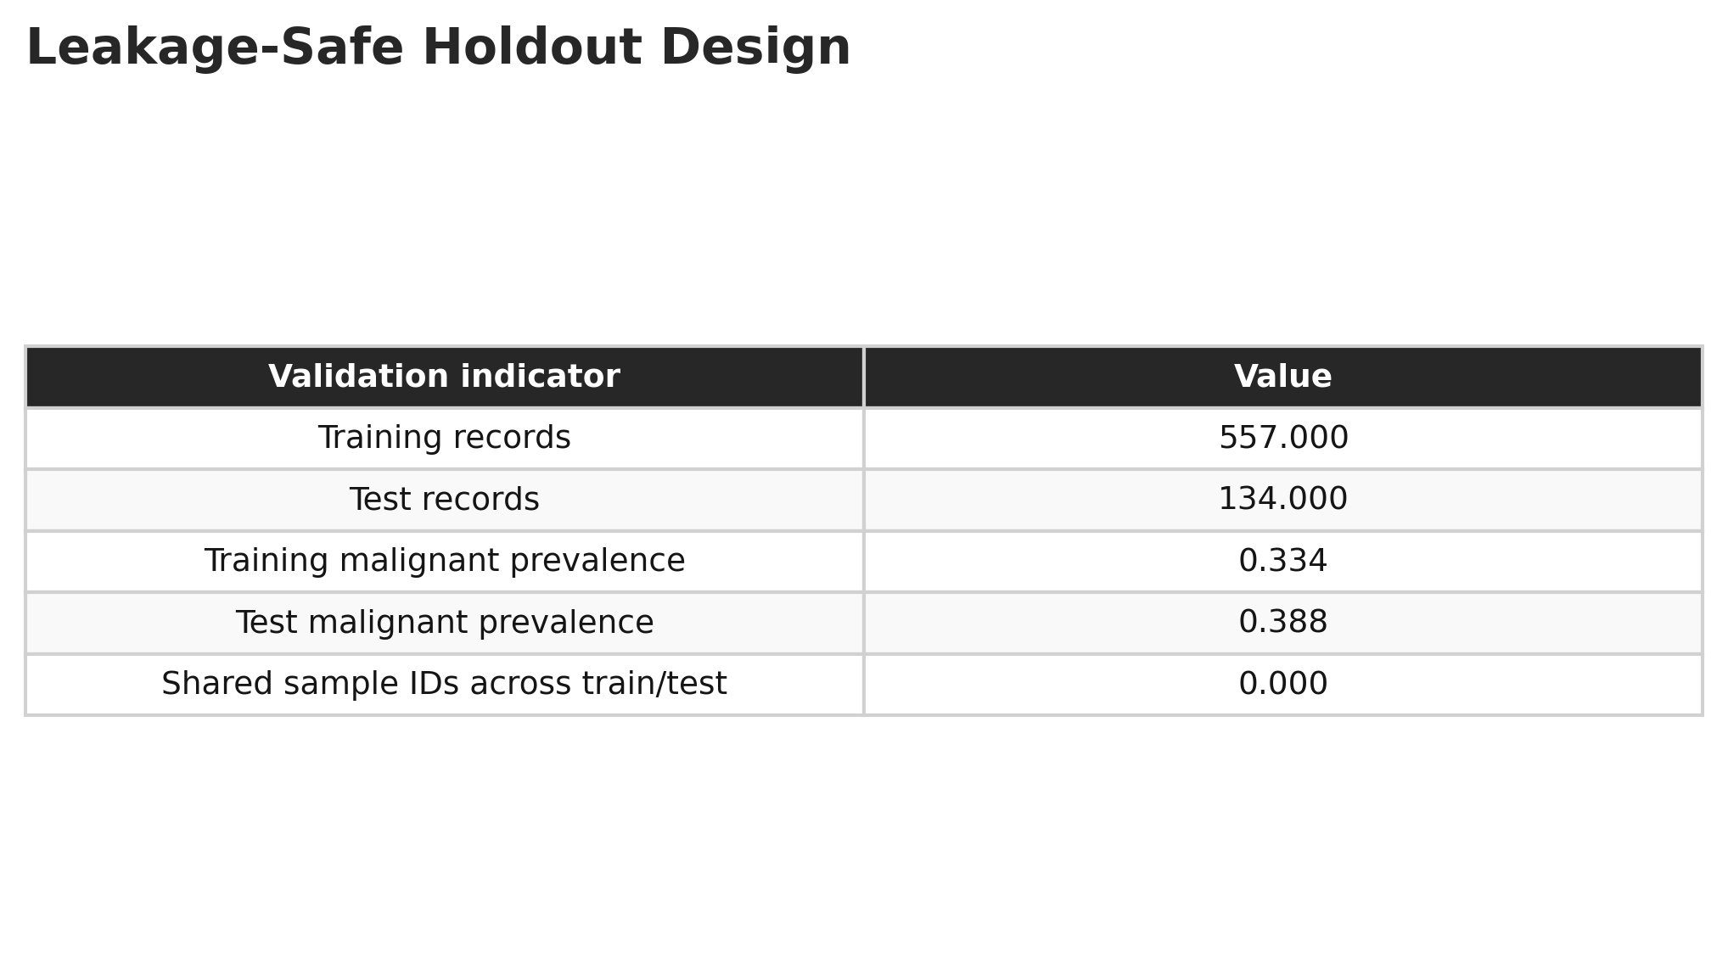
Figure 5. Leakage-safe holdout design. The training set contains 557 records and the final test set contains 134 records, with no sample IDs shared between them.
The training set contained 557 records with malignant prevalence 0.334, while the holdout contained 134 records with malignant prevalence 0.388. No sample identifier was shared across the two partitions. Hyperparameter tuning was then conducted only within the 557 training records using a second five-fold Stratified Group cross-validation procedure.
The validation sequence was therefore: dataset -> group-aware holdout split -> five-fold group-aware hyperparameter tuning on training data -> out-of-fold probability generation -> threshold selection from training out-of-fold predictions -> refit selected candidate on all training records -> one final evaluation on the untouched holdout. This design separates model selection from final performance estimation.

4.3 Hyperparameter tuning and selection rule
GridSearchCV evaluated candidate hyperparameter combinations using cross-validated accuracy as the refit criterion. Multiple additional measures were recorded, including ROC-AUC, PR-AUC, sensitivity, balanced accuracy, and F1. The final algorithm was selected using highest mean cross-validated training accuracy, with out-of-fold accuracy, ROC-AUC, and sensitivity as tie-breaks. The holdout results were not used to choose the model.
The decision threshold was also selected from training out-of-fold probabilities, not from the holdout set. The implemented threshold rule searched probabilities from 0.01 to 0.99 and selected the threshold that maximised out-of-fold accuracy, with balanced accuracy, sensitivity, specificity, and proximity to 0.50 used as tie-breakers. This design honours the user requirement to maximise validated accuracy, while the report separately evaluates the clinically important false-negative and false-positive consequences.

4.4 Evaluation measures and asymmetric error costs
Accuracy alone is insufficient because false negatives and false positives have different clinical consequences. The following measures were therefore used:
- Accuracy = (TP + TN) / (TP + TN + FP + FN): overall proportion correctly classified.
- Sensitivity = TP / (TP + FN): proportion of malignant records correctly detected. This directly measures missed-malignancy risk.
- Specificity = TN / (TN + FP): proportion of benign records correctly rejected as benign.
- Precision (PPV) = TP / (TP + FP): proportion of malignant predictions that are truly malignant.
- Negative predictive value (NPV) = TN / (TN + FN): proportion of benign predictions that are truly benign.
- F1 score: harmonic balance between precision and sensitivity.
- Balanced accuracy: average of sensitivity and specificity, useful when class frequencies differ.
- ROC-AUC: ranking/discrimination ability across all probability thresholds.
- PR-AUC: precision-recall performance with emphasis on the positive malignant class.
- Matthews correlation coefficient (MCC): a balanced summary of all four confusion-matrix cells.
- Brier score: mean squared error of predicted probabilities; lower values indicate better probabilistic accuracy.
The main safety-oriented interpretation focuses on sensitivity and the false-negative count. However, specificity is also retained because excessive false positives would increase clinician workload and unnecessary follow-up. Thus the evaluation explicitly represents the sensitivity-versus-specificity conflict.

5. Results and Interpretation

5.1 Cross-validated candidate performance
Table 5. Candidate model results from five-fold group-aware training cross-validation
Model | CV Accuracy | SD | CV ROC-AUC | OOF Sensitivity | OOF Specificity
Logistic Regression | 0.9625 | 0.0213 | 0.9923 | 0.9892 | 0.9596
Random Forest | 0.9677 | 0.0209 | 0.9872 | 0.9892 | 0.9623
Extra Trees | 0.9695 | 0.0175 | 0.9910 | 0.9892 | 0.9623
Gradient Boosting | 0.9552 | 0.0158 | 0.9885 | 0.9516 | 0.9596
RBF SVM | 0.9625 | 0.0255 | 0.9886 | 0.9946 | 0.9596
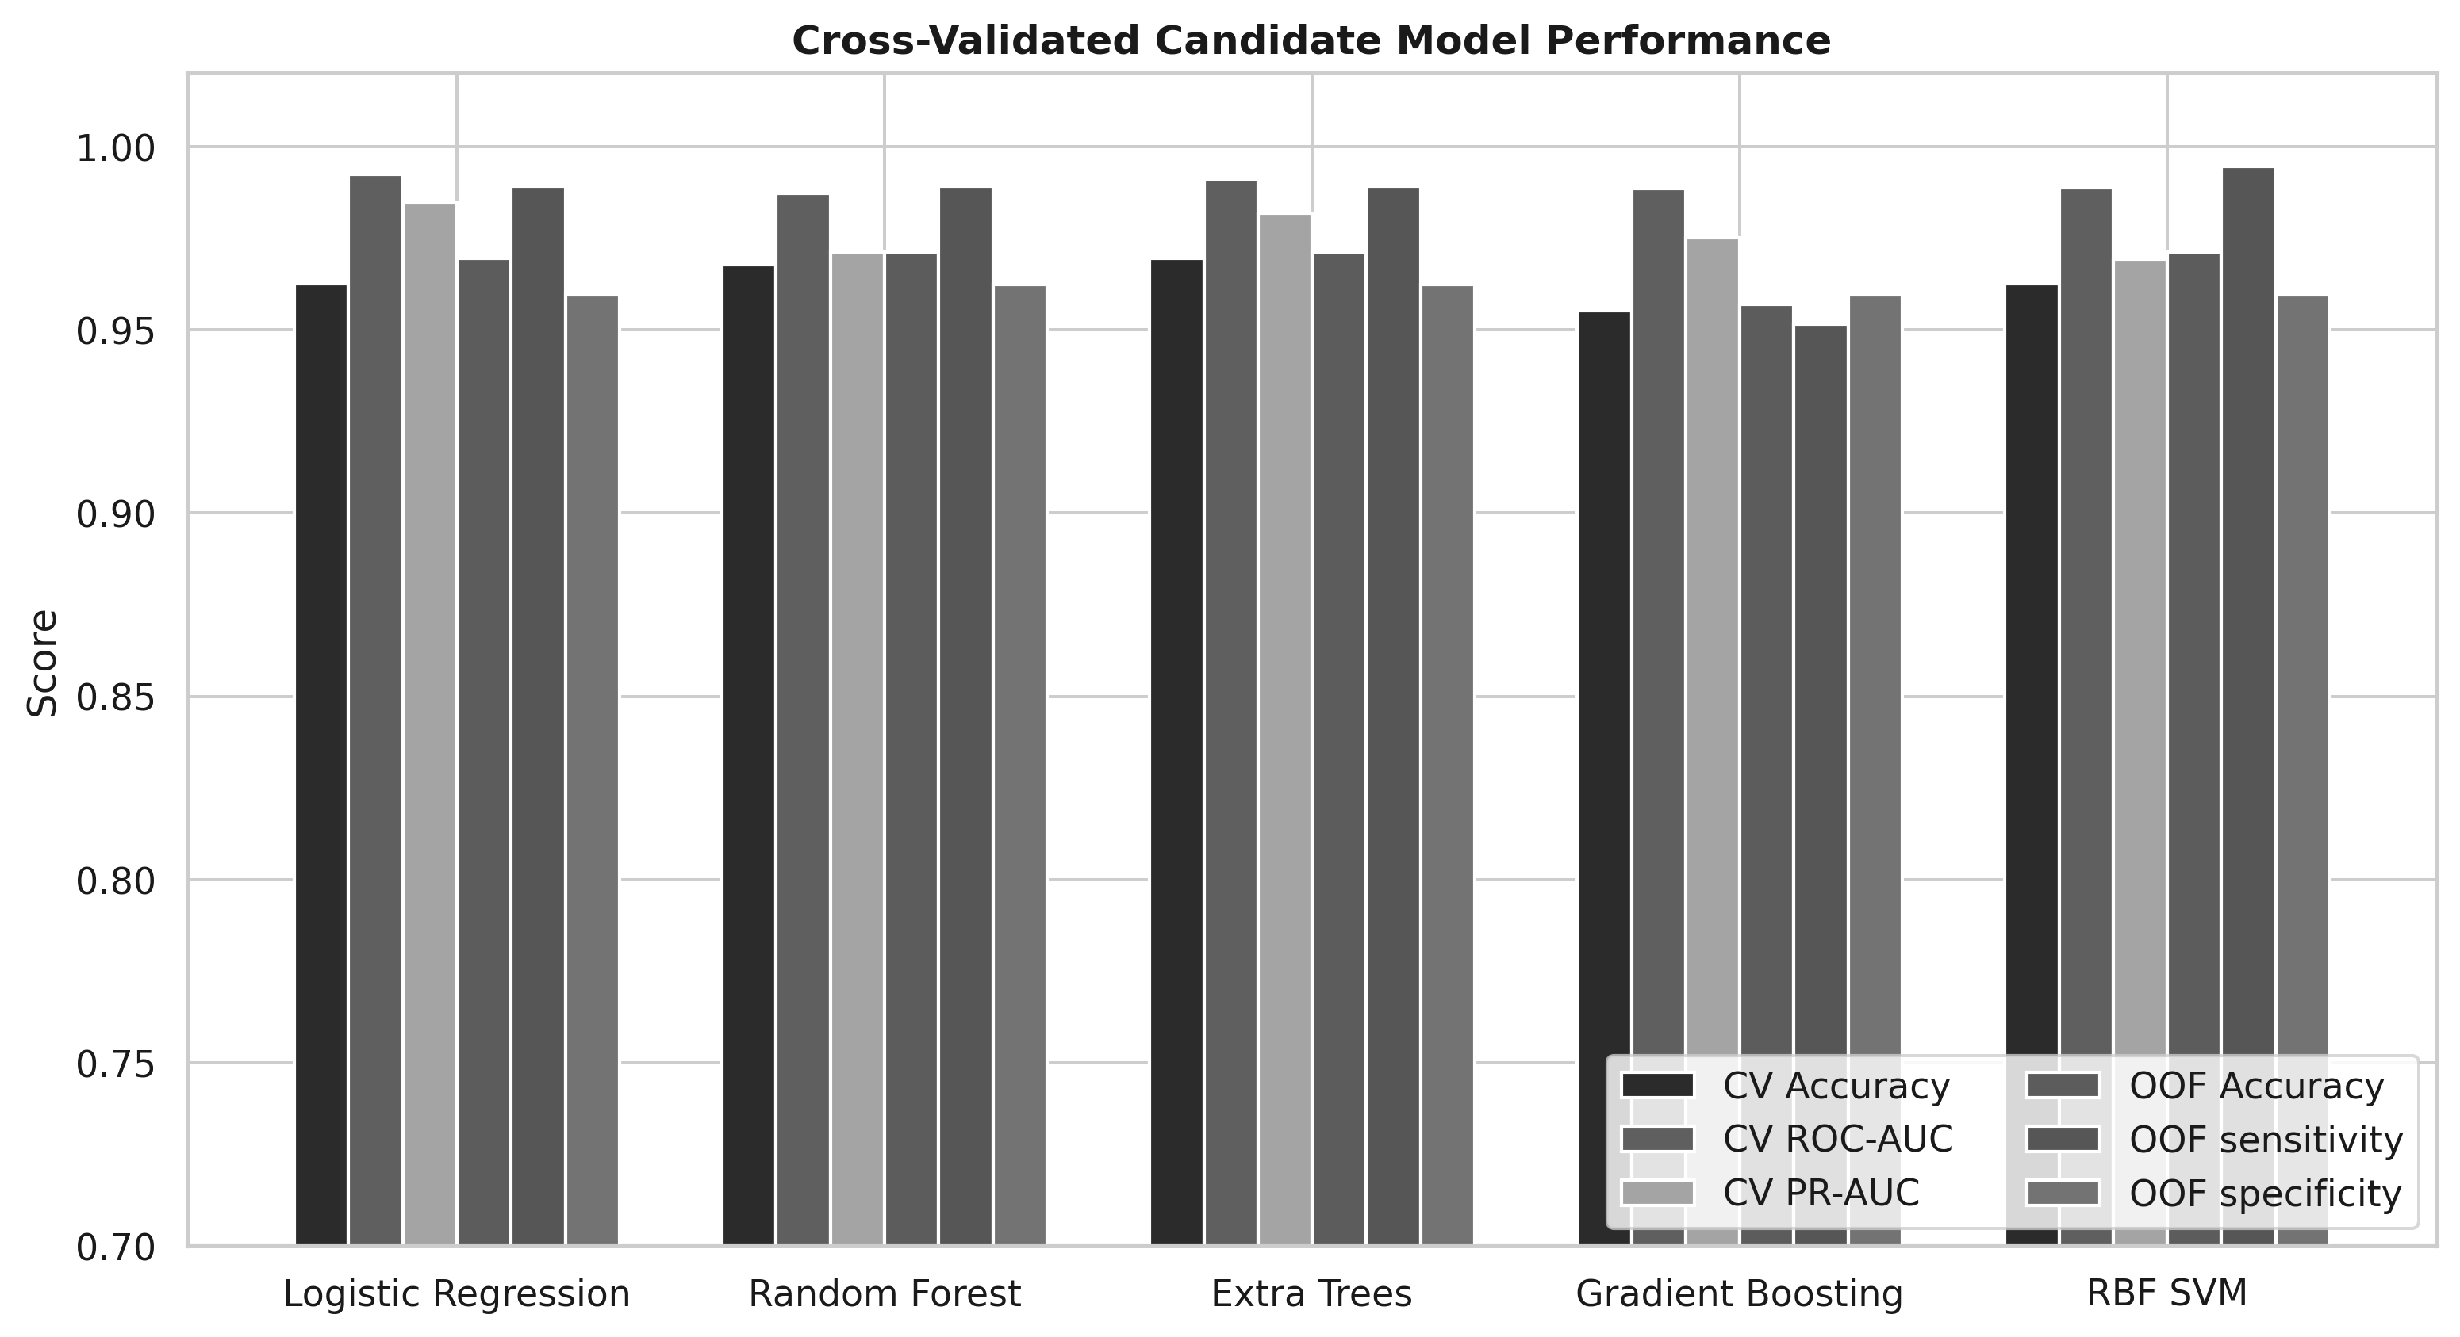
Figure 6. Cross-validated candidate model performance. Extra Trees achieved the highest mean cross-validated accuracy.
Extra Trees achieved the highest mean cross-validated accuracy of 0.9695 (96.95%) with standard deviation 0.0175. Random Forest was close at 96.77%, and Logistic Regression and RBF SVM both achieved 96.25%. The small differences show that the dataset is relatively separable, but the selection rule was defined before the holdout evaluation, so Extra Trees was chosen objectively from training evidence.
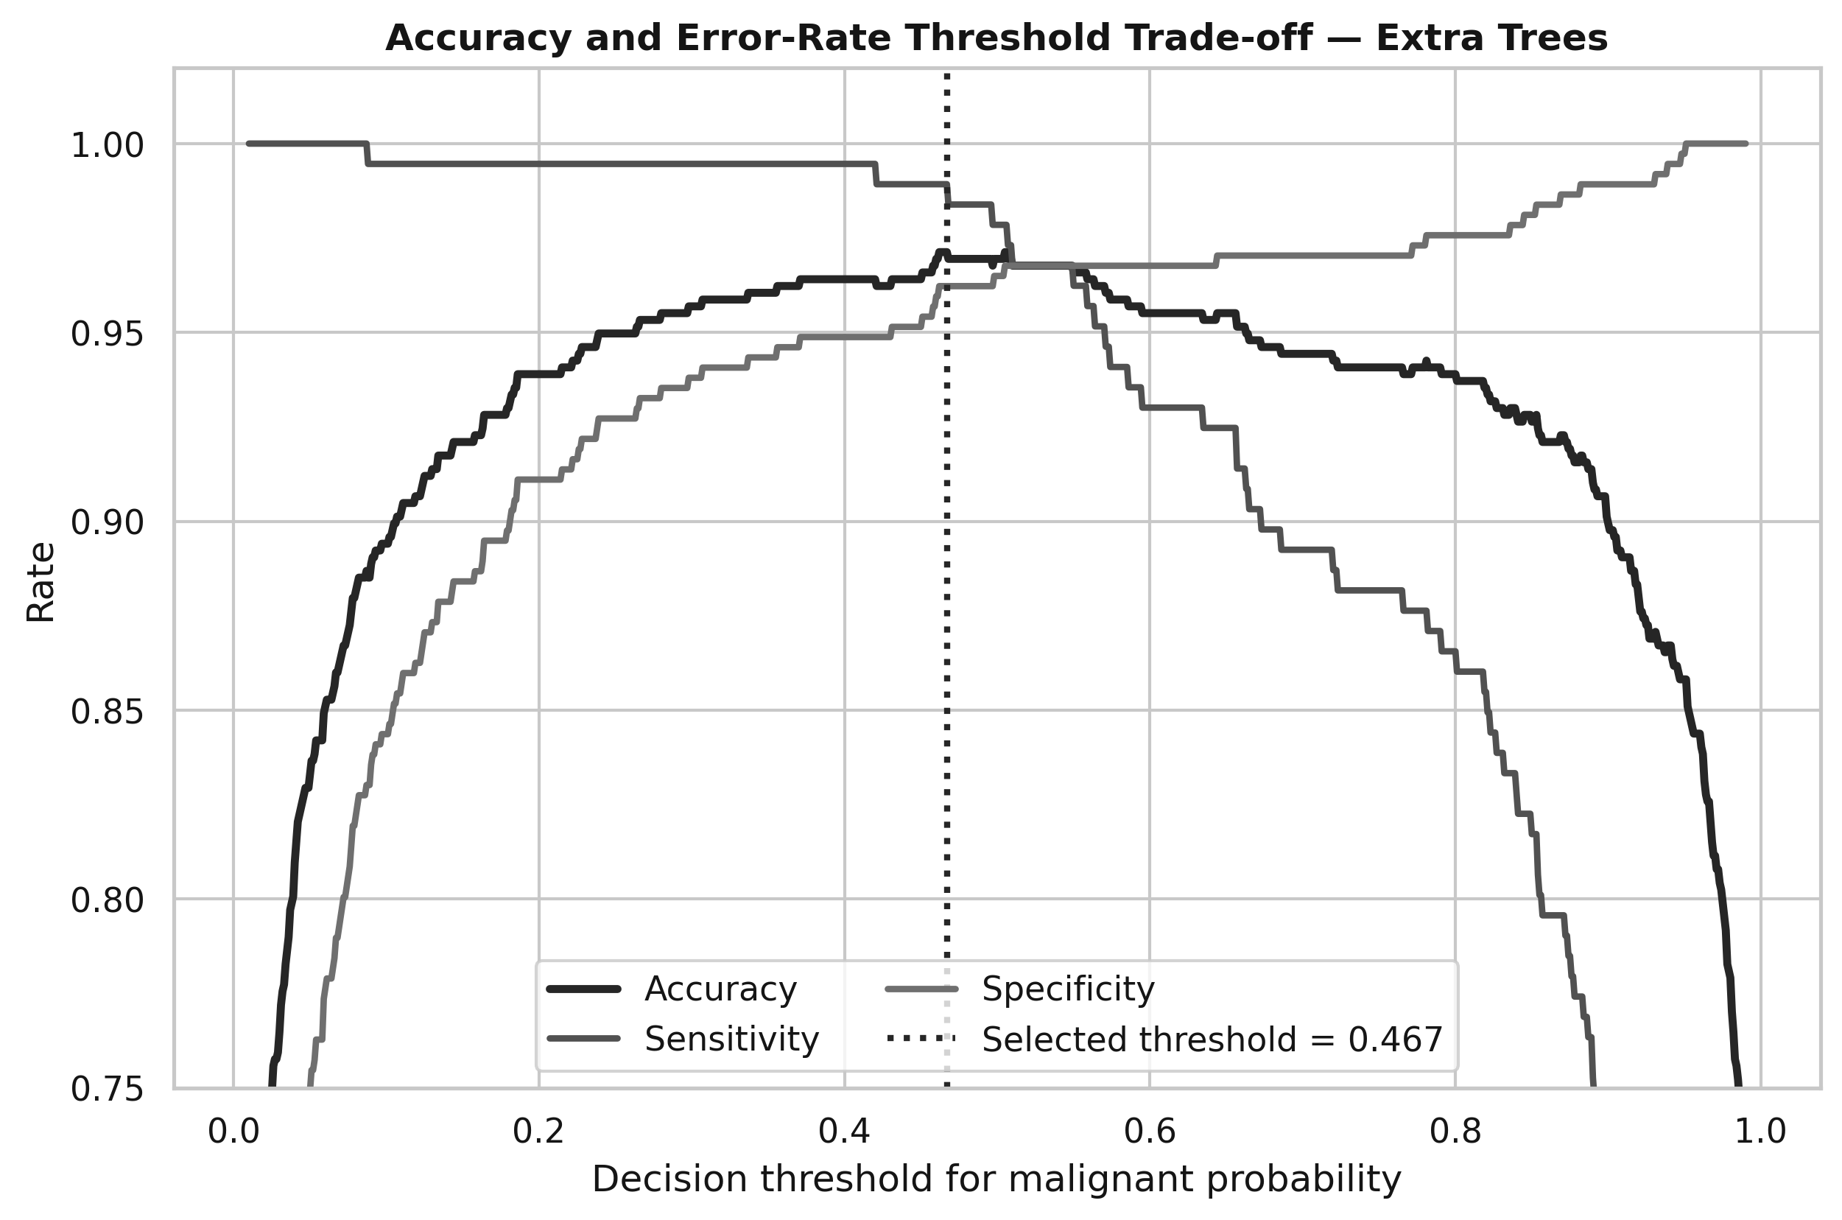
Figure 7. Training out-of-fold threshold trade-off for the selected Extra Trees model. The selected threshold was 0.467.
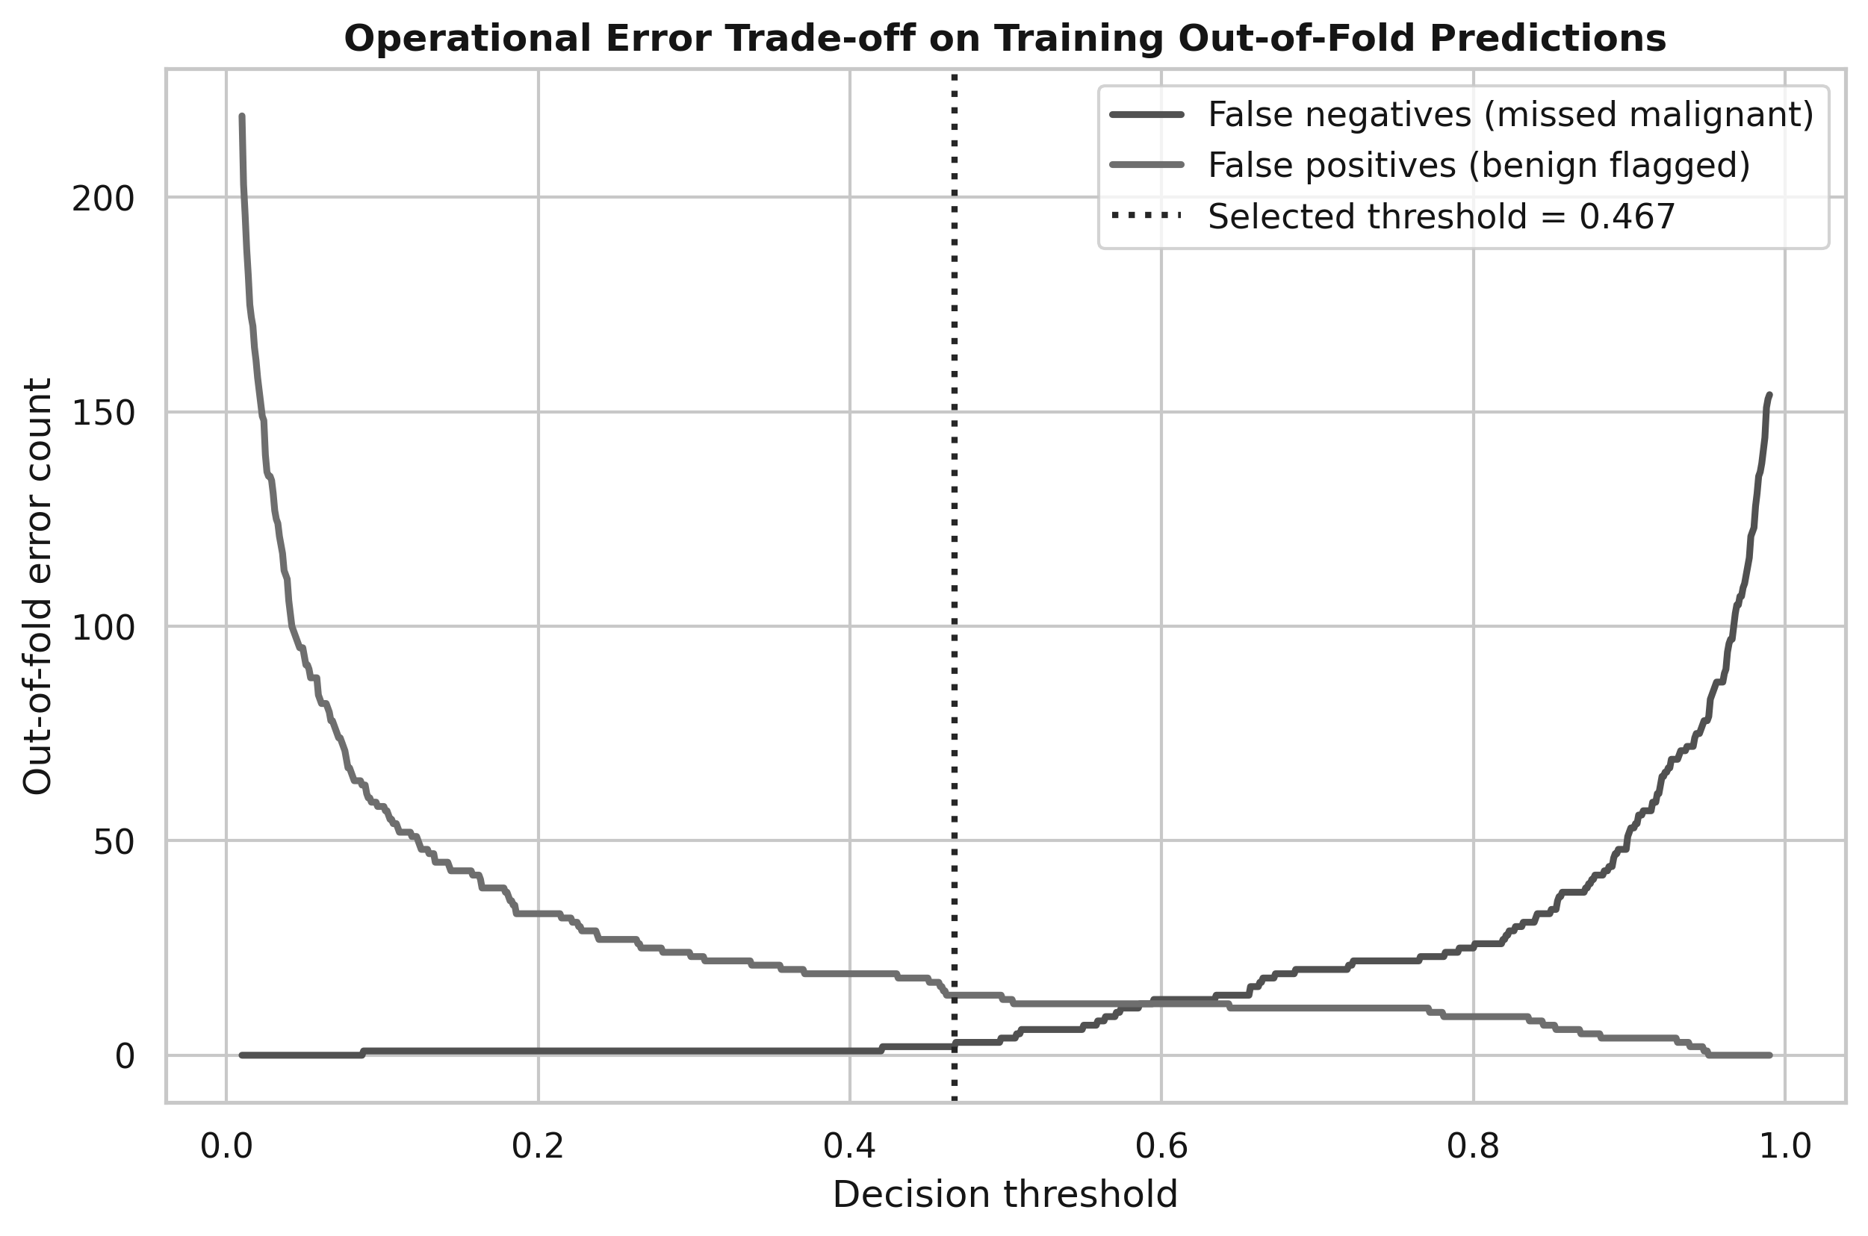
Figure 8. False-negative and false-positive counts across thresholds on training out-of-fold predictions.
The threshold graphs show that changing the decision threshold redistributes errors. Lower thresholds classify more cases as malignant, which tends to reduce false negatives but increase false positives. Higher thresholds do the reverse. The selected threshold of 0.467 maximised out-of-fold accuracy under the implemented rule. In a real clinical deployment, the threshold should be reselected using an explicitly agreed clinical cost or minimum-sensitivity target rather than assignment accuracy alone.

5.2 Selected final model
The selected model was Extra Trees with 300 trees, maximum depth 5, square-root feature sampling at each split, minimum leaf size 1, and balanced class weighting. The selected probability threshold was 0.467. Extra Trees was preferred because it provided the strongest mean cross-validated accuracy while remaining well suited to nonlinear interactions and threshold effects in bounded diagnostic scores.

5.3 Untouched holdout performance
Table 6. Final Extra Trees performance on the untouched holdout set
Metric | Value | 95% CI lower | 95% CI upper
Accuracy | 0.9925 | 0.959 | 0.999
Balanced Accuracy | 0.9939
Sensitivity | 1.0000 | 0.931 | 1.000
Specificity | 0.9878 | 0.934 | 0.998
Precision (PPV) | 0.9811 | 0.901 | 0.997
NPV | 1.0000 | 0.955 | 1.000
F1 Score | 0.9905
MCC | 0.9845
ROC-AUC | 0.9984
PR-AUC | 0.9973
Brier Score | 0.0113
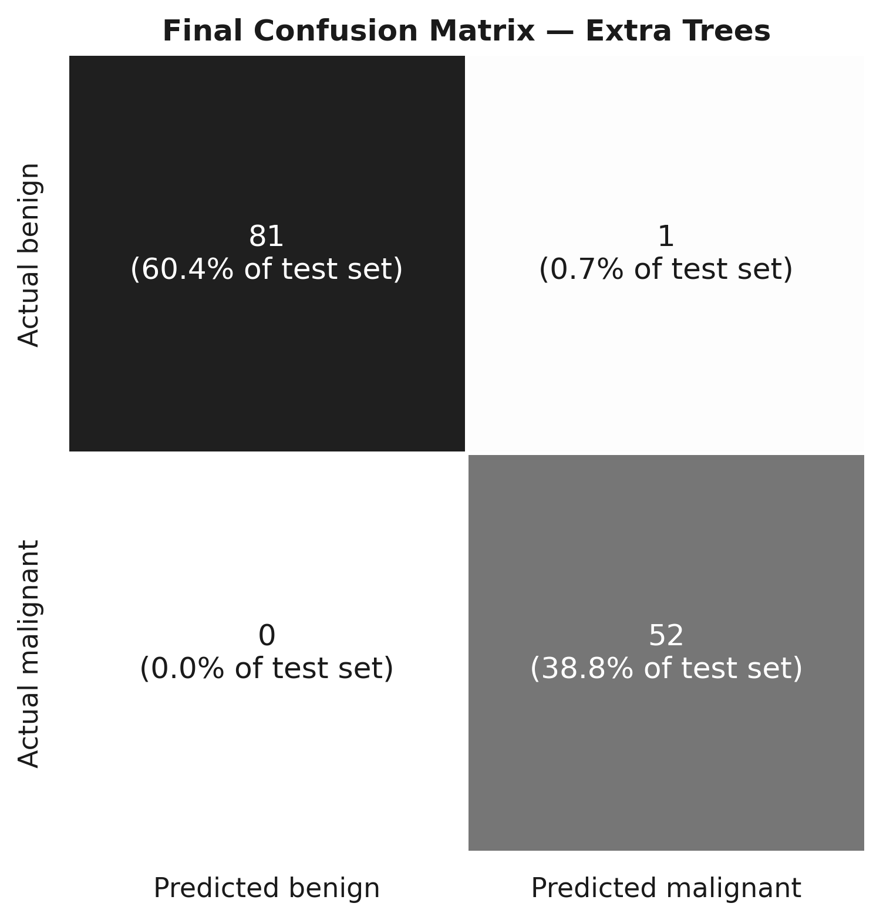
Figure 9. Confusion matrix for the selected Extra Trees model on the 134-record holdout set.
The holdout confusion matrix contained 81 true negatives, one false positive, zero false negatives, and 52 true positives. Therefore, all 52 malignant records in this particular holdout sample were detected, while one benign record was incorrectly flagged as malignant. The resulting sensitivity was 100% and specificity was 98.78%.
The observed 99.25% test accuracy should not be interpreted as a guaranteed hospital accuracy. The test set contains only 134 records, and the Wilson 95% interval for accuracy is approximately 95.9% to 99.9%. The cross-validated training estimate of 96.95% is a more conservative indicator of model-selection performance. Both figures should be reported together.
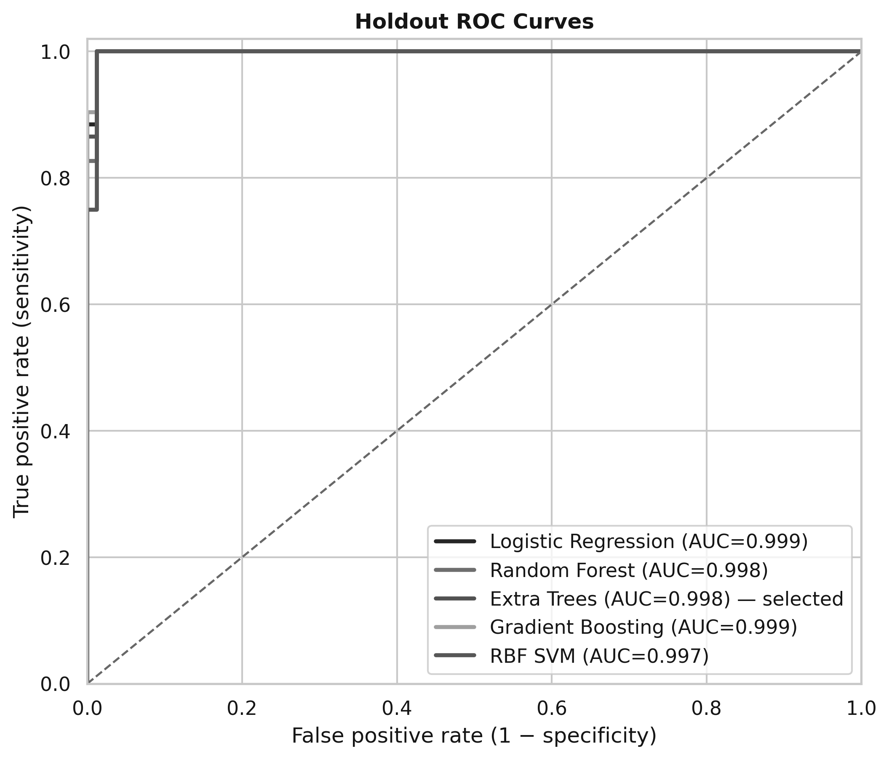
Figure 10. Holdout ROC curves reported after model selection. These curves were not used to choose the final algorithm.
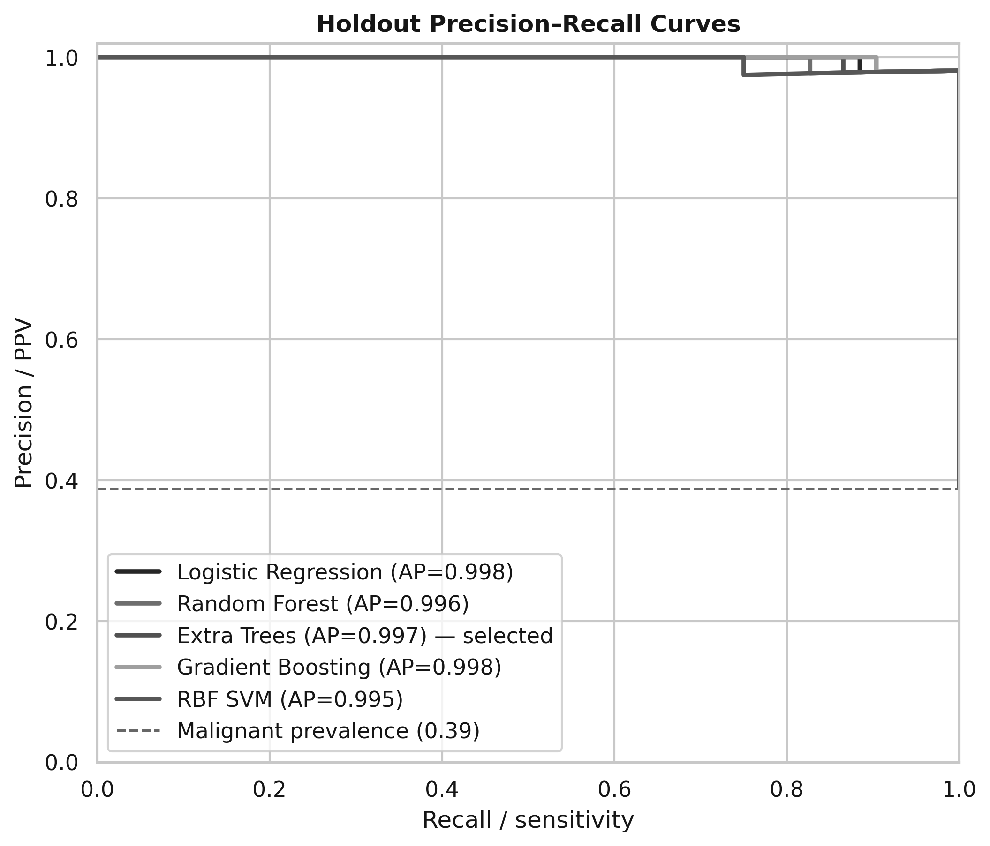
Figure 11. Holdout precision-recall curves reported after model selection.
The selected model achieved ROC-AUC 0.9984 and PR-AUC 0.9973 on the holdout. These values indicate very strong ranking performance in this sample. The post-selection curves also show that several candidate models performed similarly on the holdout; this reinforces why the final algorithm was chosen from cross-validation rather than by selecting the best-looking test result.
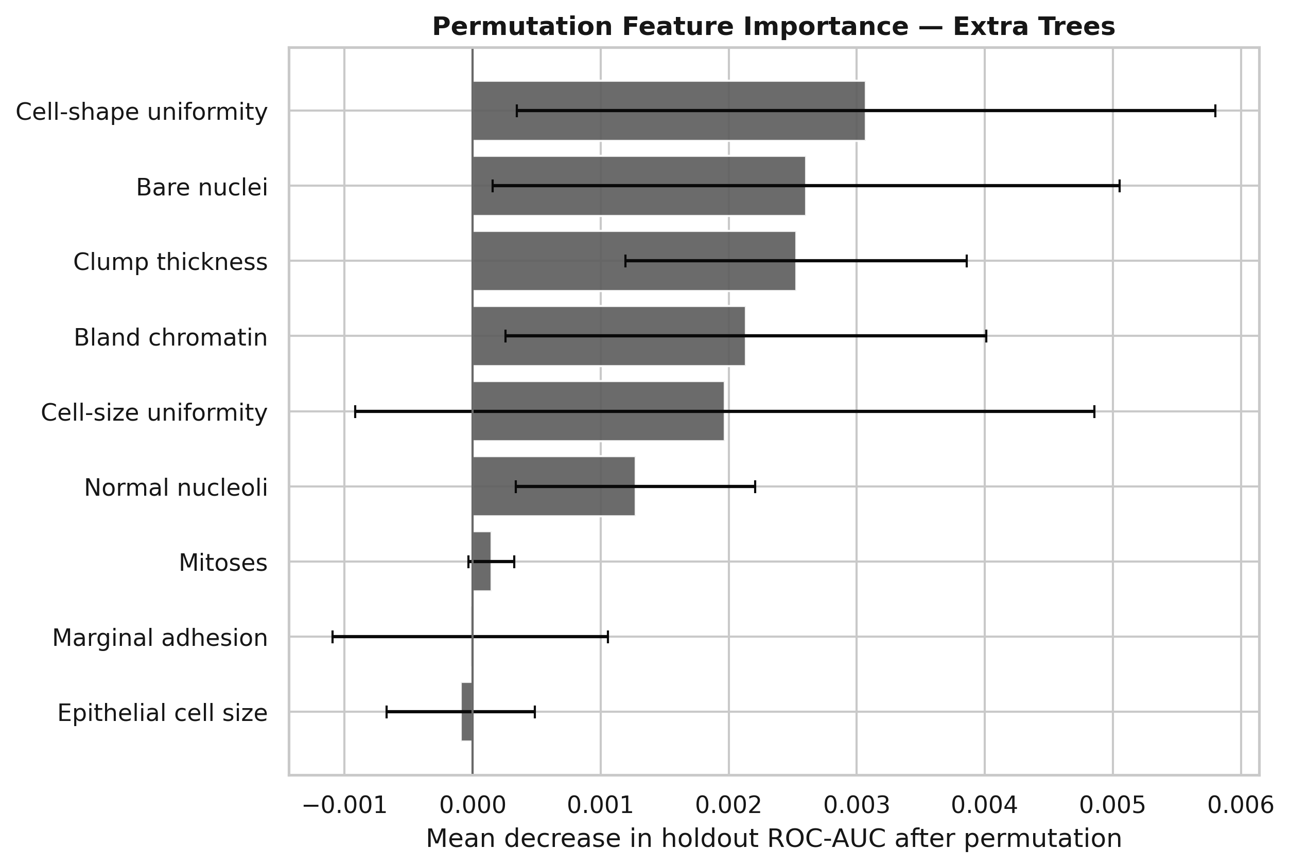
Figure 12. Permutation feature importance for the selected model, measured as the change in holdout ROC-AUC after feature permutation.
Permutation importance suggests that cell-shape uniformity, Bare Nuclei, and Clump Thickness were among the more influential predictors for holdout discrimination. These importance values should not be interpreted as causal effects. Predictors are correlated, so importance may be shared between related variables, and the holdout set is small. The plot is therefore an interpretability aid rather than a clinical explanation of disease mechanism.
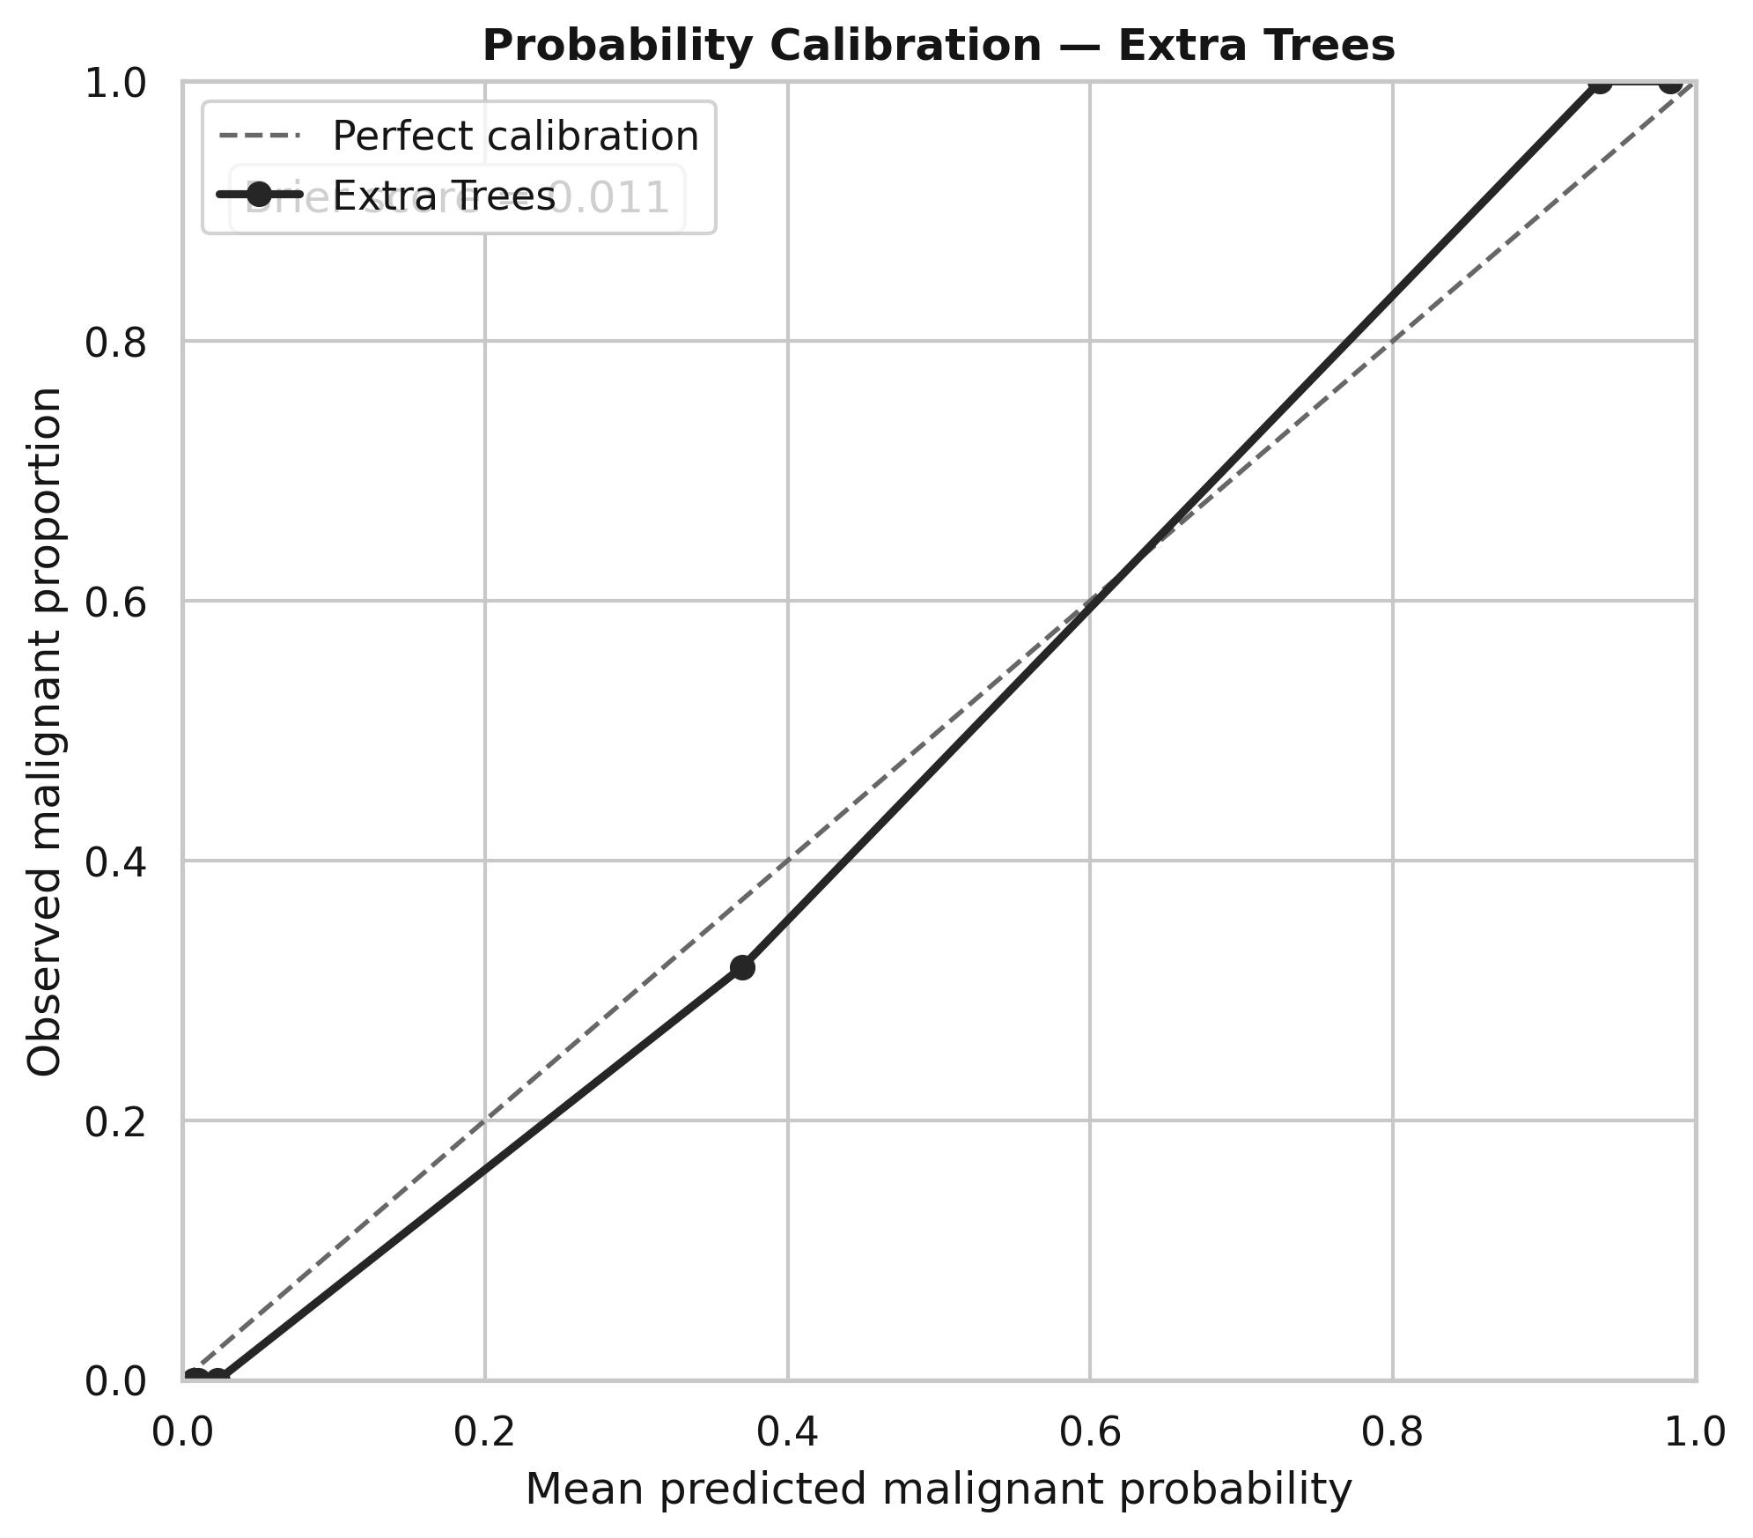
Figure 13. Probability calibration of the selected Extra Trees model on the holdout set.
The Brier score was 0.0113, indicating low squared probability error on this holdout. However, only six quantile bins were used and the test set is small. The probabilities should not be presented to clinicians as calibrated clinical risk estimates until calibration has been validated on larger, independent, contemporary data.

6. Conflict and Trade-off Analysis
The assignment requires conflicting requirements to be actively managed rather than merely listed. Five conflicts were encountered in this analysis.
Table 7. Conflict analysis and engineering compromises
Conflict | Requirement A | Requirement B | Resolution / compromise in this analysis
Sensitivity vs specificity | Catch malignant cases and minimise missed detections. | Avoid excessive false alarms and unnecessary follow-up. | Malignant was defined as the positive class; sensitivity, specificity, error counts and threshold curves were reported. The selected accuracy-optimised threshold produced 0 false negatives and 1 false positive on the holdout. A real deployment should use a clinician-approved sensitivity/cost constraint.
Interpretability vs predictive performance | Use a model whose reasoning can be challenged by non-technical users. | Use the model with the strongest validated prediction. | Logistic Regression was retained as the interpretable baseline. Extra Trees had higher mean CV accuracy (96.95% vs 96.25%) and was selected. Permutation importance was added to improve transparency, while recognising it is not a full case-level explanation.
Label trust vs label availability | Use available labels for supervised learning. | Recognise that historical labels may contain inconsistency. | Supervised learning was used because labels exist, but four sample IDs had both labels. Group-aware splitting prevented the same ID from leaking across validation boundaries, and label uncertainty is explicitly reported as a limitation.
Automation vs human oversight | Provide fast consistent classification. | Preserve human responsibility and ability to override. | The model role is restricted to prioritisation / decision support. It must not autonomously diagnose or determine treatment. Clinician confirmation remains mandatory.
Generalisation vs dataset scope | Produce a useful recurring decision rule. | Acknowledge historical and population limits of the dataset. | A leakage-safe holdout and cross-validation were used, but the report restricts conclusions to proof-of-concept performance and requires external contemporary validation before deployment.

7. What the Model Can and Cannot Support

7.1 Decisions supported by the result
- Use the nine recorded tumour-characteristic measurements to estimate whether a record resembles the benign or malignant class learned from the historical dataset.
- Provide a repeatable decision-support signal to help prioritise samples for clinician review.
- Flag cases for additional attention when the predicted malignant probability exceeds the defined operating threshold.
- Support auditing of sensitivity, specificity, false positives, false negatives, and changes in model performance over time.

7.2 Decisions not safely supported
- The model cannot independently diagnose breast cancer.
- The model cannot determine or recommend treatment.
- The model cannot replace biopsy, pathology, imaging, or clinician judgement.
- The model cannot be assumed to perform equally in a different hospital, country, time period, laboratory process, or patient population.
- The model cannot support subgroup fairness claims because demographic variables are not available in this dataset.
- The 0.467 threshold is not a clinically validated treatment or diagnostic threshold; it is an assignment-derived classification threshold.
This boundary is a required part of responsible interpretation. A high test score does not convert a historical machine-learning experiment into an autonomous medical device.

8. Limitations and Deployment Readiness
1. Historical scope. The UCI data were collected in historical clinical groups and donated in 1992. Current measurement practice and patient populations may differ.
2. Limited sample size. Only 691 records remained after exact duplicate removal, and the final holdout contained 134 records. This increases uncertainty in test metrics.
3. Label inconsistency. Four identifiers were associated with both class labels, showing that labels are not perfectly clean.
4. Missing values. Sixteen Bare Nuclei values were missing and required imputation. A deployed system would need an explicit missing-data policy.
5. Repeated identifiers. Repeated IDs required group-aware splitting and indicate that records are not fully independent in a simple row-wise sense.
6. No external validation. Performance was evaluated only within this dataset. No independent hospital dataset was used.
7. No temporal validation. UCI reports chronological data groups, but the modelling file does not provide a usable timestamp/group field for a future-time test.
8. No demographic fairness analysis. The available predictors do not provide sufficient demographic information to estimate subgroup performance or equity.
9. Threshold choice. The 0.467 threshold maximised training out-of-fold accuracy. A real clinical threshold should reflect acceptable false-negative and false-positive costs set by clinicians and governance staff.
10. Model interpretability. Extra Trees is less directly interpretable than Logistic Regression. Permutation importance is global and does not explain every individual prediction.
11. Validation uncertainty. A repeated or nested cross-validation study could provide a more stable estimate of model-selection uncertainty, especially with a small dataset.
12. Prospective workflow effects are unknown. The analysis does not measure whether using the model would actually improve time to review, patient outcomes, workload, or cost.

9. Final Evaluation and Systems-Level Reflection

9.1 Was the organisational question answered?
The organisational question was answered at proof-of-concept level. The existing dataset contains sufficient signal to build a classifier that distinguishes malignant from benign records with strong cross-validated and holdout performance. Therefore, the data can plausibly support a recurring review-prioritisation decision. The question was not answered at deployment level because the study does not establish safety, calibration, fairness, or generalisation in a current local hospital population.

9.2 Cross-task dependencies
Table 8. Examples of cross-task dependencies in the analytical system
Earlier finding / decision | Constraint created later | Engineering response
Task 1: malignant errors were judged more serious than benign false alarms. | Task 3 could not rely on accuracy alone. | Malignant was set as positive class; sensitivity, specificity, FN/FP counts, PR-AUC and threshold trade-offs were evaluated.
Task 2: repeated sample IDs were discovered. | A standard random split could leak related records into both train and test sets. | Sample ID was excluded from predictors but used for Stratified Group splitting.
Task 2: Bare Nuclei contained 16 missing entries. | Models requiring complete numeric inputs could not be trained directly. | Median imputation was fitted inside each CV pipeline to avoid preprocessing leakage.
Task 2: predictors were correlated and class separation was nonlinear/threshold-like. | A purely linear model might be unnecessarily restrictive. | Linear Logistic Regression was compared with tree ensembles, boosting, and RBF SVM.
Task 3: Extra Trees had the highest mean CV accuracy but lower transparency than Logistic Regression. | Task 4 required interpretation and stakeholder challengeability. | Permutation feature importance and explicit human oversight were added, while the interpretability limitation was documented.
These dependencies demonstrate that the pipeline functions as a system. Data-quality findings changed the validation architecture; the clinical framing changed the evaluation measures; and model selection created an interpretability requirement that had to be managed in the interpretation stage.

10. Recommendations Before Real Organisational Use
1. Collect or obtain a current independent validation dataset from the target hospital using the same measurement definitions.
2. Preserve timestamps and patient/sample grouping so performance can be tested prospectively or with a time-based holdout.
3. Have clinicians define the acceptable missed-malignancy rate and operational false-positive burden; then select the probability threshold against that clinical utility rather than maximum accuracy alone.
4. Validate probability calibration on a larger independent sample before showing probability values as clinical risk estimates.
5. Investigate the four conflicting-label identifiers and establish an auditable label-definition process.
6. Assess performance across relevant demographic and clinical subgroups once appropriate variables and sample sizes are available.
7. Run a silent prospective pilot in which predictions are logged but do not influence care, allowing comparison with real clinician decisions and outcomes.
8. Define monitoring for data drift, missingness, class prevalence, sensitivity, specificity, and calibration after deployment.
9. Maintain human override, audit trails, model/version documentation, and clear accountability for every clinical decision.
10. Retrain or retire the model when measurement processes, population characteristics, or performance change materially.

11. Conclusion
This assignment treated predictive modelling as an integrated engineering problem rather than a single accuracy calculation. The Breast Cancer Wisconsin (Original) dataset supports a supervised binary classification framing because labelled benign and malignant outcomes are available. Data investigation identified duplicates, missing values, repeated identifiers, label inconsistency, class imbalance, correlation, and visible class separation. These findings directly constrained preprocessing, validation, and interpretation.
Five candidate models were compared under group-aware cross-validation. Extra Trees achieved the highest mean cross-validated accuracy of 96.95% and was selected before the holdout was inspected. On the 134-record untouched test set it achieved 99.25% accuracy, 100% sensitivity, 98.78% specificity, and 99.84% ROC-AUC, with one false positive and no false negatives. This is strong evidence that the historical measurements contain predictive signal.
The result supports a proof-of-concept decision-support role for prioritising clinician review. It does not support autonomous diagnosis or treatment. The most important next step is external, contemporary, clinically governed validation. The central systems lesson is that the validity of the result depends not only on the algorithm, but on framing, data quality, leakage control, error costs, human oversight, and the boundary placed around the model's use.

References
Breiman, L. (2001). Random forests. Machine Learning, 45, 5-32. https://doi.org/10.1023/A:1010933404324
Cortes, C., & Vapnik, V. (1995). Support-vector networks. Machine Learning, 20, 273-297. https://doi.org/10.1007/BF00994018
Friedman, J. H. (2001). Greedy function approximation: A gradient boosting machine. The Annals of Statistics, 29(5), 1189-1232. https://doi.org/10.1214/aos/1013203451
Geurts, P., Ernst, D., & Wehenkel, L. (2006). Extremely randomized trees. Machine Learning, 63(1), 3-42. https://doi.org/10.1007/s10994-006-6226-1
Hastie, T., Tibshirani, R., & Friedman, J. (2009). The elements of statistical learning: Data mining, inference, and prediction (2nd ed.). Springer.
Wolberg, W. (1990). Breast Cancer Wisconsin (Original) [Dataset]. UCI Machine Learning Repository. https://doi.org/10.24432/C5HP4Z
World Health Organization. (2021). Ethics and governance of artificial intelligence for health: WHO guidance. World Health Organization. ISBN 978-92-4-002920-0.

Appendix A. Final Model and Reproducibility Details
The full reproducible Python script is submitted separately as breast_cancer_max_accuracy.py. It loads the Kaggle data file, performs the audit and preprocessing, trains all candidate pipelines, tunes hyperparameters, creates training out-of-fold predictions, selects the classification threshold, evaluates the untouched holdout, and saves the PNG evidence used in this report. The random seed is fixed at 42.
Table 9. Best hyperparameters identified for each candidate model
Model | Best parameters from training cross-validation
Logistic Regression | C = 0.05; class_weight = balanced; penalty = L2
Random Forest | n_estimators = 300; max_depth = None; max_features = sqrt; min_samples_leaf = 4; min_samples_split = 2; class_weight = balanced
Extra Trees | n_estimators = 300; max_depth = 5; max_features = sqrt; min_samples_leaf = 1; class_weight = balanced
Gradient Boosting | n_estimators = 200; learning_rate = 0.03; max_depth = 2; min_samples_leaf = 1; subsample = 1.0
RBF SVM | C = 1; gamma = 0.03; class_weight = balanced
Reproducibility sequence: load data -> coerce missing markers -> audit -> remove exact duplicates -> recode target -> group-aware holdout -> inner group-aware cross-validation -> pipeline-based imputation/scaling -> grid search -> out-of-fold probabilities -> threshold selection -> final training -> one-time holdout evaluation -> figure export.

Appendix B. Supplementary Model Outputs
The following figures are supplementary evidence generated by the same Kaggle run. They are included for transparency and auditability; the main report uses the most decision-relevant outputs.
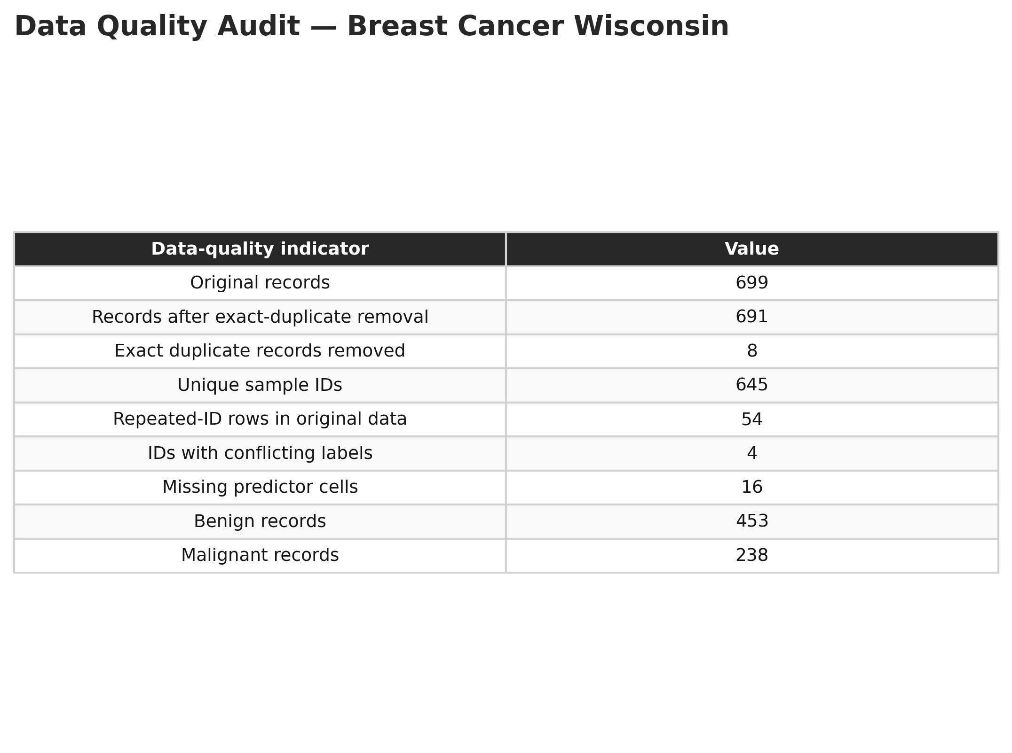
Figure 14. Supplementary data-quality audit table.
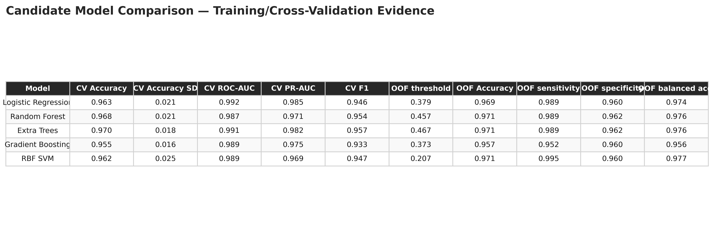
Figure 15. Full training/cross-validation model comparison table.
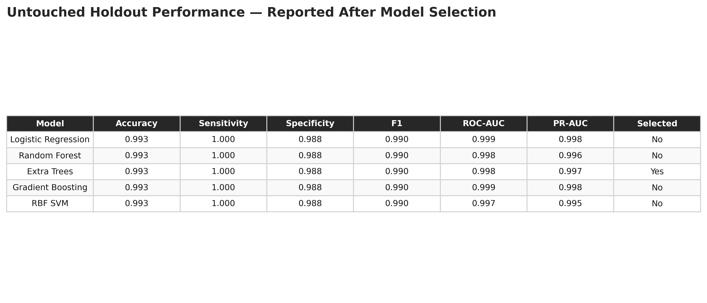
Figure 16. Post-selection holdout comparison of all candidate models. Holdout scores were reported only after the final algorithm had been selected.
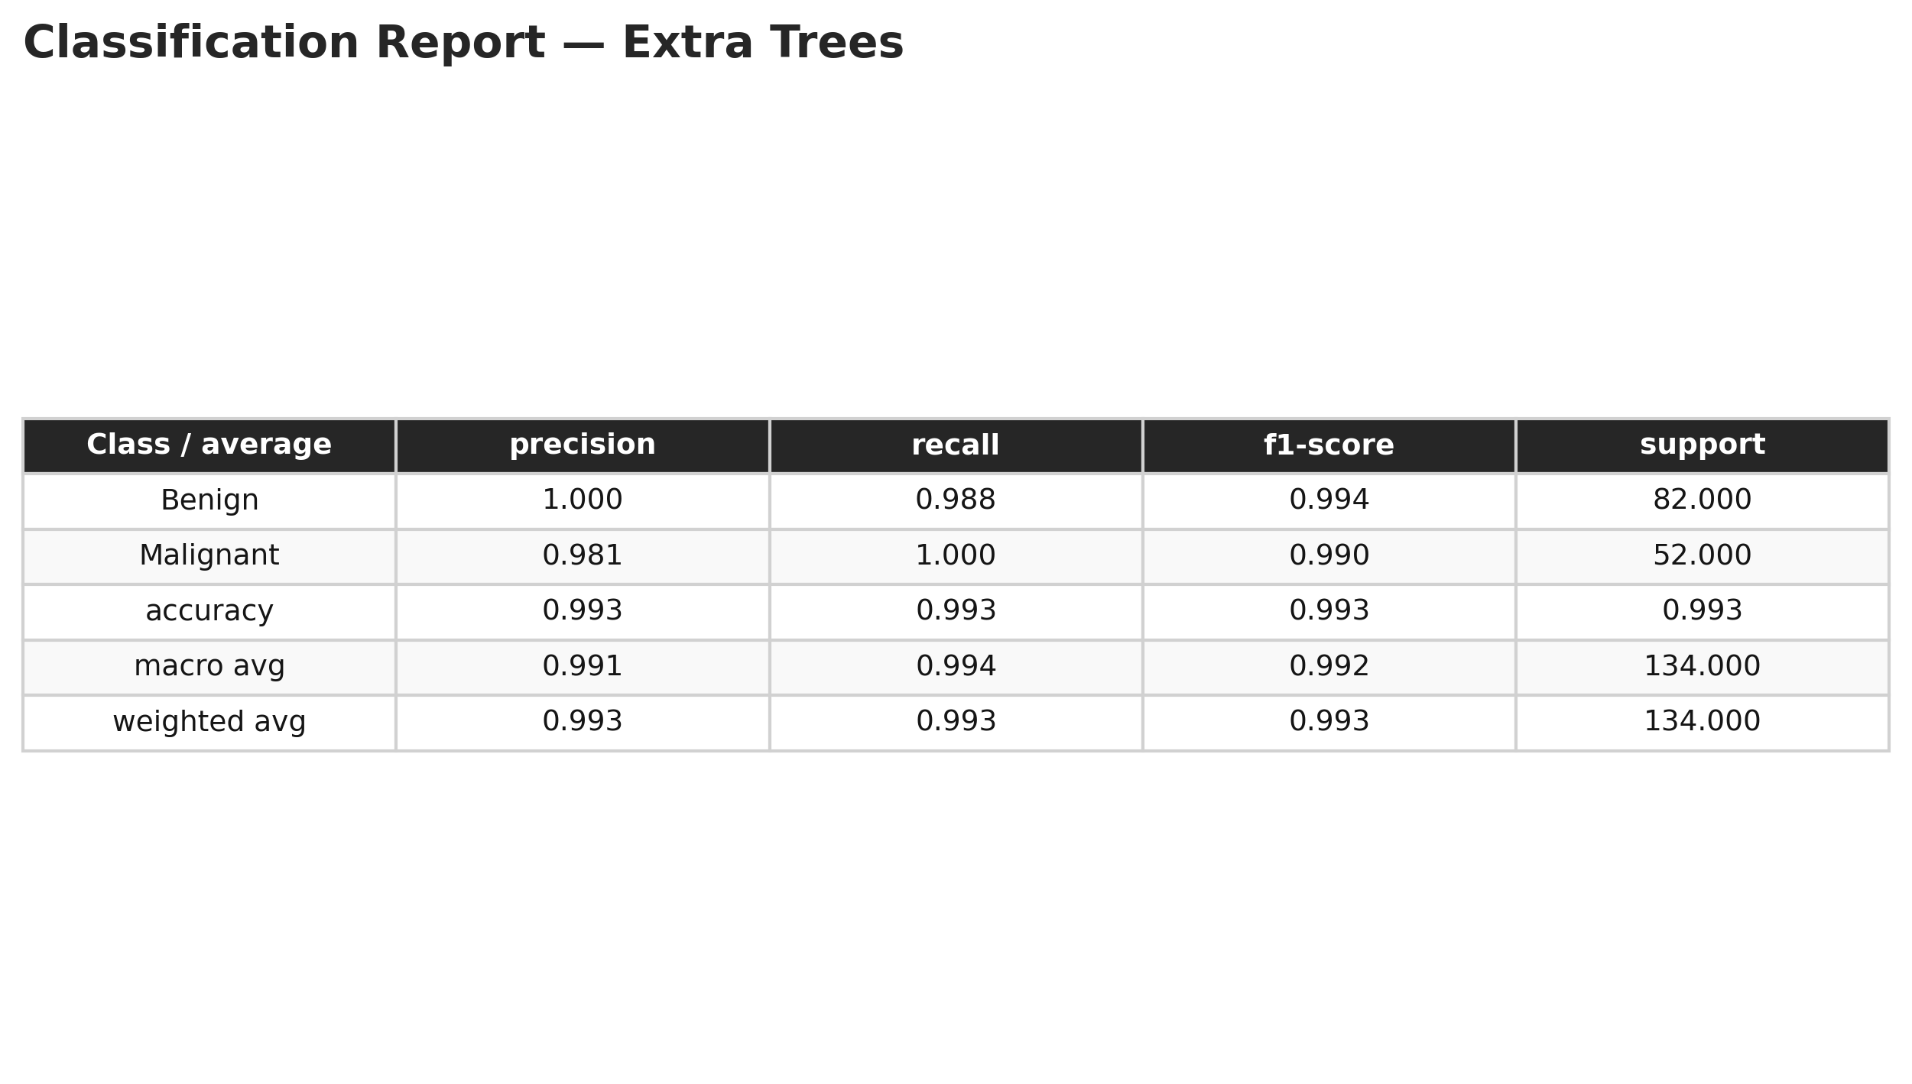
Figure 17. Detailed classification report for the selected Extra Trees model.
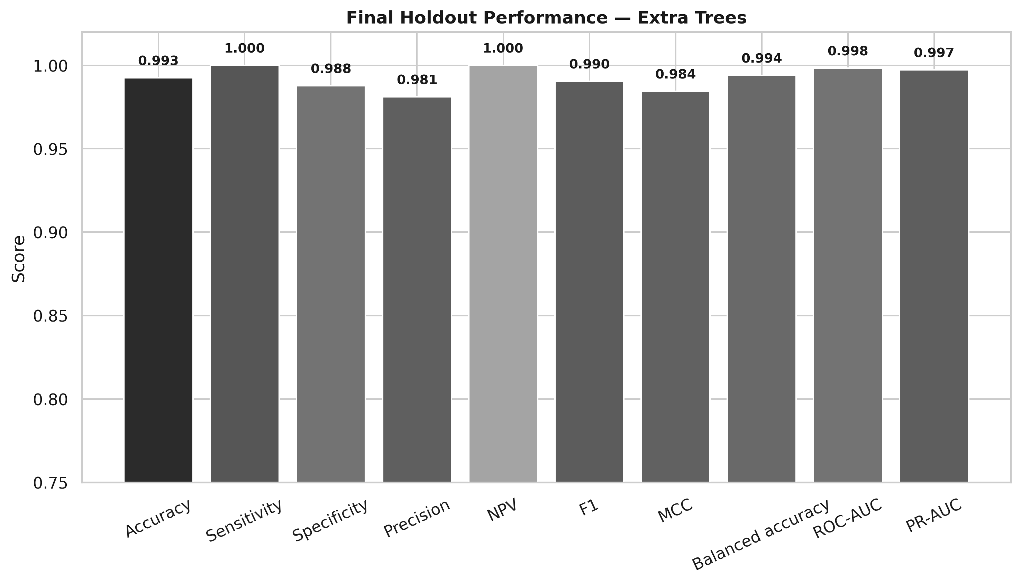
Figure 18. Graphical summary of final holdout metrics.
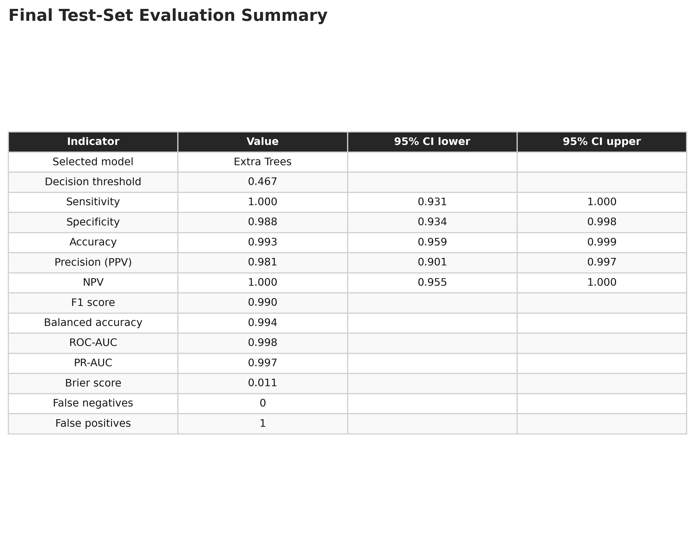
Figure 19. Final holdout metric table with Wilson 95% confidence intervals for selected proportions.
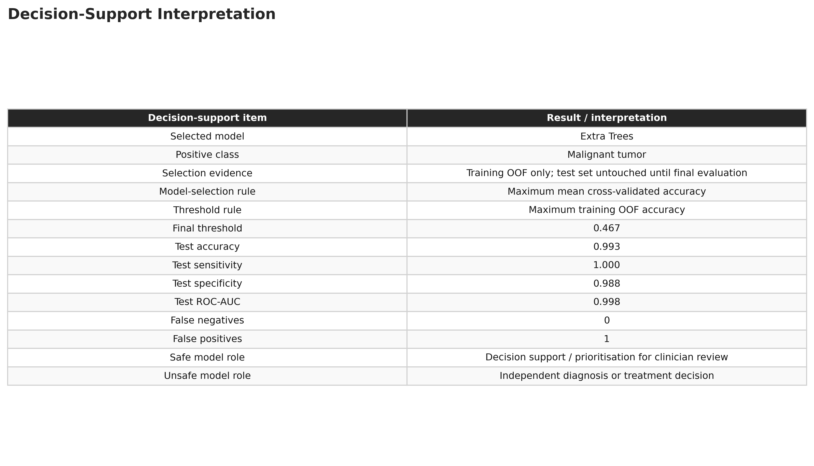
Figure 20. Summary of the final model role, threshold, performance, and safe/unsafe use boundary.

Appendix C. One-Page CEP Evidence Table
This table identifies where each required KPI and knowledge/problem attribute is demonstrated in the report.
Code | Requirement demonstrated | Evidence in this report | Primary sections / outputs
CO3-KPI 1 | Justified problem framing | Labels 2/4 support supervised binary classification; malignant defined as positive class; system boundary restricts use to decision support. | Sections 1.3-1.4, 2.1
CO3-KPI 2 | Analysis under conflicting requirements | Five conflicts are resolved or managed: sensitivity/specificity, interpretability/performance, label trust/availability, automation/human oversight, generalisation/scope. | Section 6; threshold and error-trade-off figures
CO3-KPI 3 | Principled model selection and validation | Five mathematical approaches compared; group-aware CV, pipeline imputation/scaling, hyperparameter tuning, untouched holdout, multiple risk-relevant metrics. | Sections 3-5; CV comparison; confusion matrix
CO3-KPI 4 | Honest interpretation | Explicit CAN/CANNOT statements; external validation, sample size, label inconsistency, historical scope, calibration and fairness limitations. | Sections 7-8
CO3-KPI 5 | Systems-level reflection | Earlier findings directly constrain later design: repeated IDs -> group CV; missing data -> in-fold imputation; error costs -> sensitivity/FN reporting. | Section 9.2
WK1 | Natural/social science context | Clinical consequences of false predictions, patient/clinician/management/oversight stakeholders, human autonomy and accountability. | Sections 1.1-1.2, 6-8
WK2 | Mathematics, data analysis and statistics | Class distribution, missingness, correlation, preprocessing rationale, threshold analysis, sensitivity/specificity, AUC, MCC, Brier score and confidence intervals. | Sections 2, 4.4, 5
WK3 | Engineering fundamentals | Model assumptions compared from first principles; leakage-safe system design; algorithm-specific scaling; validation architecture. | Sections 3-4
WK4 | Specialist knowledge | Overfitting/generalisation, class imbalance, label uncertainty, probability calibration, interpretability trade-off, external validation and drift. | Sections 4-8
WP1 | Requires in-depth WK1-WK4 knowledge | Correct solution depends on interacting clinical consequences, statistics, algorithm assumptions, validation, thresholding, governance and deployment limits. | Whole report; especially Sections 1, 3, 4, 6, 8
WP3 | No obvious solution; abstract reasoning | Multiple valid candidate models and thresholds were considered; model selected from evidence rather than a prescribed algorithm. | Sections 3-5
WP7 | Systems approach | Framing -> data audit -> modelling -> validation -> trade-offs -> deployment reflection, with explicit cross-task dependencies. | Section 9.2 and overall report structure

