**CS 320: Fundamentals of Software Engineering**

**Project 2: SDD**

**Section 2.1 (Activity Diagrams):**

Activity Diagram 1- Models Use Case: Create a Project (from landing page, or with button on main timeline page)

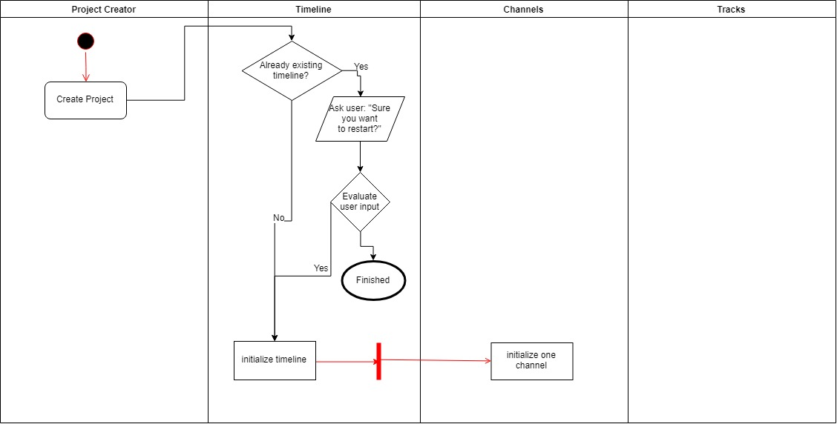

Activity Diagram 2- Models Use Case: Edit a Project (Bulk of operations within timeline page)Activity Diagram 3- Models Use Case: Export a Project (Spawned from timeline page, opens a popup window)

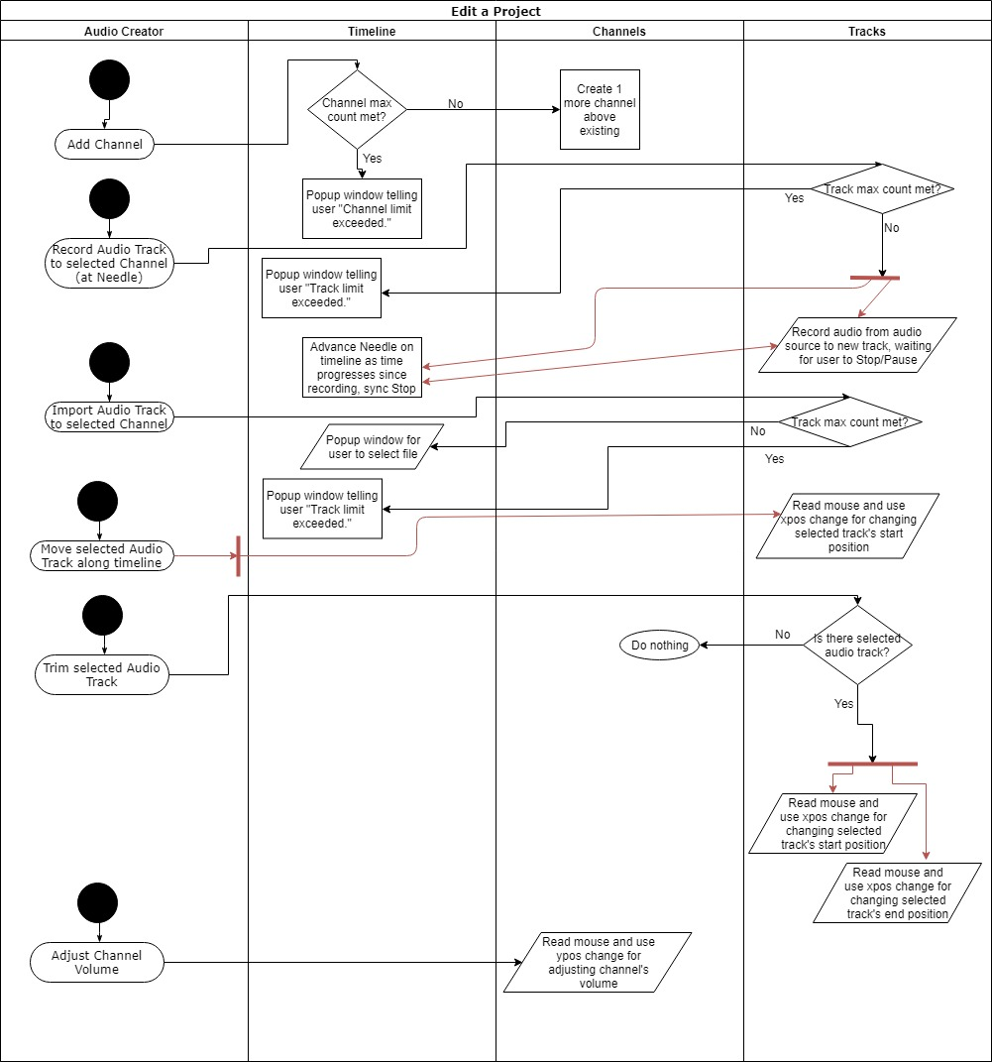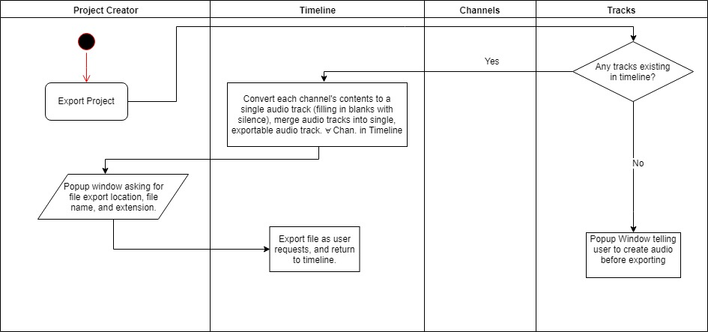

**Section 2.2 (Class Diagram):**

**A screenshot of a cell phone

Description generated with high confidence**

**Section 2.3 (State Diagram or Sequence Diagram):**