Modul 226b

Thema: Vehicle Rental

Dokumentinformationen

Dateiname: M226_VehicleRental_Lacarta

Autoreninformationen

Autor: Shawn Lacarta

E-Mail: shawn.lacarta@edu.tbz.ch

Inhaltsverzeichnis

1 Introduction 3

2 Planning 3

3 Diagram 3

3.1 Class-Diagram 3

3.2 Sequence-Diagram 3

4 Test-Cases 3

5 Conclusion 3

# Introduction

This document is the documentation of my Vehicle Rental project in module 226b. Here you can find the planning, testing and the different diagrams.

# Planning

The plannng was very important to me because I wanted to work in a structured way. That's why I created a GANTT so that I can check after each lesson whether I'm on schedule.

|  |  |  |  |  |
| --- | --- | --- | --- | --- |
|  | 13.12.2022 | 04.01.2022 | 11.01.2022 | 18.01.2022 |
| Use-Cases |  |  |  |  |
| Class-diagram |  |  |  |  |
| Coding |  |  |  |  |
| JavaDoc |  |  |  |  |
| Testing |  |  |  |  |
| Sequence-diagram |  |  |  |  |
| Documentation |  |  |  |  |

# Diagram

## Class-Diagram

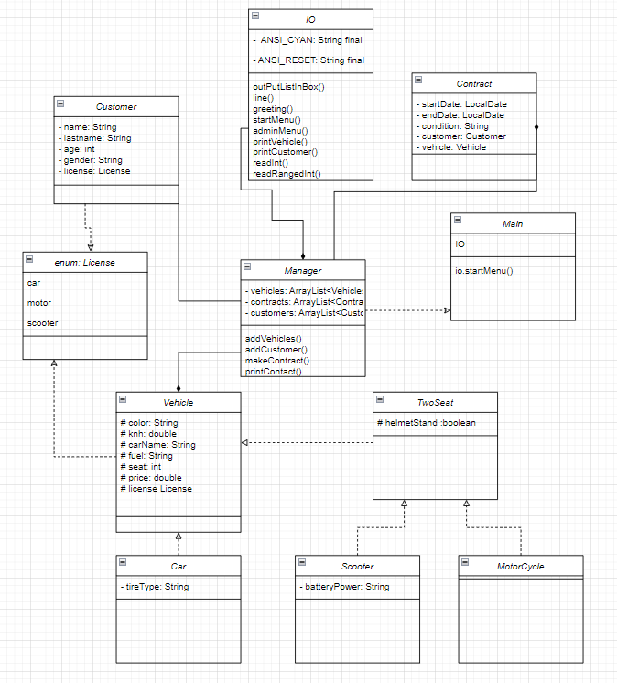

## Sequence-Diagram

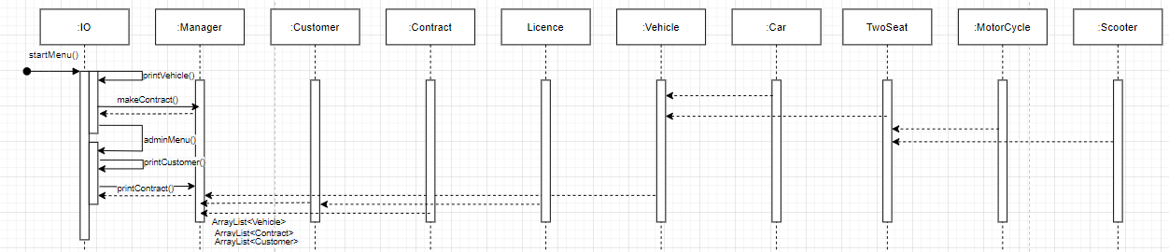

# Test-Cases

|  |  |  |  |  |  |
| --- | --- | --- | --- | --- | --- |
| Class | Method | Input | Output | Expected Output | Comment |
| IO | startMenu() | 1 | List vehicles | List vehicles | It worked |
| IO | startMenu() | 12 | Wrong Input | Wrong Input | It worked |
| IO | startMenu() | abc | Wrong Input | Wrong Input | It worked |
| Manager | makeContract() | 3 (Vehicle) | Tesla Model X | Tesla Model X | It worked |
| Manager | makeContract() | 1 (Customer) | Mikal | Mikal | It worked |
| Manager | makeContract() | 12 (Customer) | Wrong Input | Wrong Input | It worked |
| Manger | makeContract() | 1 (Vehicle), 3 (Customer) | Wrong License | Wrong License | It worked |
| Manger | makeContract() | 1 (Vehicle), 2 (Person) | Underage | Underage | It worked |

# Conclusion

This project took me a lot of time. I had a lot of stress, especially towards the end, because I underestimated the whole thing a bit. I did this project, as well as the 226a alone, because I wanted to put the responsibility entirely on me. So I can test myself and go beyond my limits. On the whole, I think this project was a success.