M226a

Topic: Mall-Project

Document information

Filename: M226a_Mall-Project_Lacarta

Author information

Autor: Shawn Lacarta

E-Mail: shawn.lacarta@edu.tbz.ch

Content

1 Introduction 3

2 My decisions 3

3 Planning 3

4 Use-Cases 4

5 Class-Diagram (before) 5

6 Class-Diagram (after) 6

7 Sequence-Diagram 7

8 Test Cases 8

9 Reflection 8

# Introduction

Our mission is to create a project according to specifications. This is to be implemented with the programming language Java. In addition, the whole work must be documented in detail. This includes things like the class diagram. At the end we will present our work.

# My decisions

First of all, I did some research on the internet about what project I wanted to do. However, I did not find anything helpful. Since I like shopping I thought about implementing a shopping mall. In this project I can practice well ArrayLists, which is perfect. So I decided to do a shopping mall.

# Planning

For my planning I use the Gantt system. With this I get a complete overview of my planning.

|  |  |  |  |  |  |
| --- | --- | --- | --- | --- | --- |
|  | 21.09 | 26.09 | 28.10 | 02.11 | Free time |
| Choose project |  |  |  |  |  |
| Planning |  |  |  |  |  |
| Git-Hub |  |  |  |  |  |
| Use-Cases |  |  |  |  |  |
| Class diagram |  |  |  |  |  |
| Coding |  |  |  |  |  |
| Java-Doc |  |  |  |  |  |
| J-Unit |  |  |  |  |  |
| Class diagram |  |  |  |  |  |
| Sequence Diagram |  |  |  |  |  |
| Documentation |  |  |  |  |  |

# Use-Cases

Ein Bild, das Text enthält.

# Class-Diagram (before)

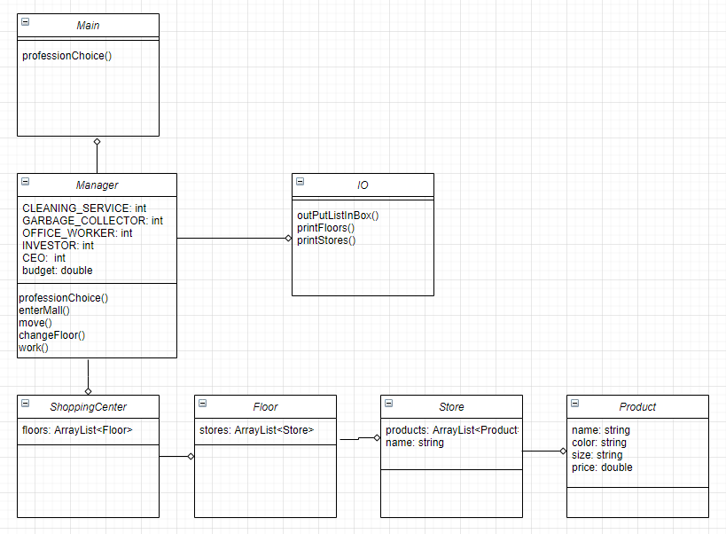

# Class-Diagram (after)

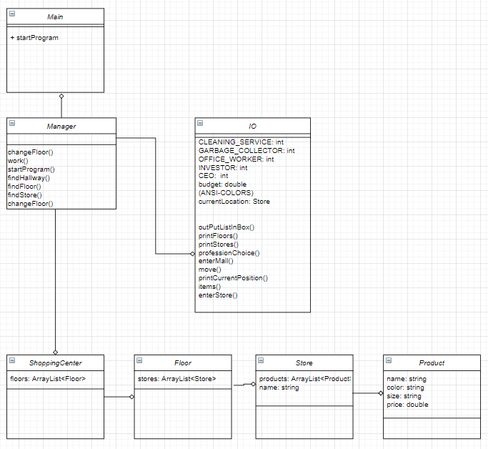

# Sequence-Diagram

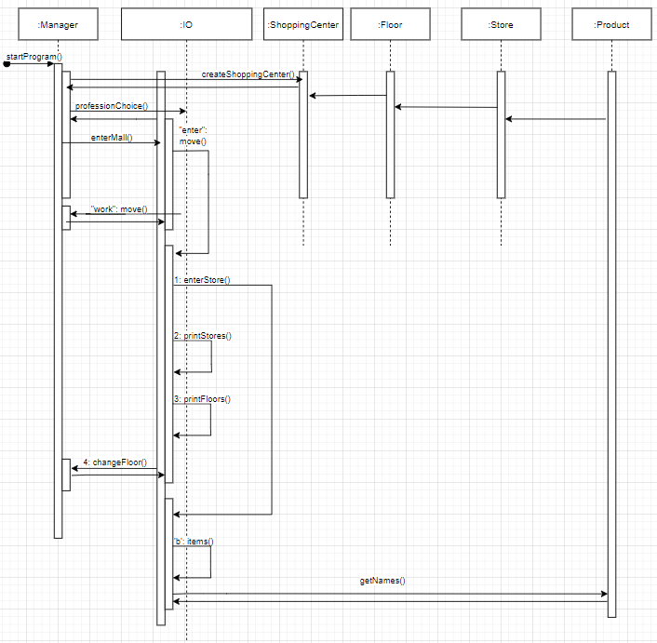

# Test Cases

|  |  |
| --- | --- |
| Modul | 226a |
| LB | 3 |
| Project | Mall-Project |
| Tested by | Shawn Lacarta |

|  |  |  |  |  |
| --- | --- | --- | --- | --- |
| Class | Method | Input | Expectation | Result |
| IO | proffesionChoice() | asdf | Wrong input | Wrong input |
| IO | proffesionChoice() | 7 | Wrong input | Wrong input |
| IO | proffesionChoice() | 3 | Budget = OFFICE WORKER | Budget = OFFICE WORKER |
| IO | enterMall() | asdf | Wrong Input | Wrong Input |
| IO | enterMall() | Enter | Enter mall | Enter mall |
| IO | enterMall() | Work | Work | Work |
| IO | enterMall() | Exit | Close Program | Close Program |
| IO | move() | Asdf | Wrong input | Wrong input |
| IO | move() | 9 | Wrong input | Wrong input |
| IO | move() | 1 | User shopping | User shopping |
| IO | move() | 2 | View stores | View stores |
| IO | move() | 3 | See map | See map |
| IO | move() | 4 | Change floor | Change floor |
| IO | move() | 5 | Exit | Exit |
| IO | enterStore() | Asdf | Wrong input | Wrong input |
| IO | enterStore() | 78 | Wrong input | Wrong input |
| IO | enterStore() | B | Buy item | Buy item |
| IO | enterStore | L | Leave store | Leave store |

# Reflection

I put a lot of effort into this project because I desperately need a very good grade. I wanted to do the project alone, because I think it's a good exercise. If something goes wrong I am aware that I am to blame. If something turned out well, I can only be proud of myself. I didn't have any big problems during the whole project except for the outsourcing of the methods in the different classes. I practically broke my whole program. But with patience I was able to fix the problems. Personally, I had a lot of fun with the project and I hope to get a good grade.