Measuring Learning
in
Open Source
Communities of Practice

Monte J. Shaffer
Marriott School of Management
Brigham Young University
monte.shaffer@gmail.com
April 2006

Culture reflects a group's effort to cope and learn and is the residue of the learning process.
—Edgar Schein (1992)
Abstract
Quantifying Etienne Wegner’s model for communities of practice using popular Open Source development projects at SourceForge,net coupled with Diffusion Theory creates a guide to measure learning in Open Source Communities of Practice. Specifically, trying to quantify the size of the community based on ‘legitimate peripheral participation’ generates interesting questions regarding how to measure learning, what is learning/knowledge, and what dynamics are required to build bridges between adjacent participation levels.

Keywords: learning, open source, communities of practice, diffusion theory, change agents
Measuring Learning

Learning is a complex subject, and its measurement is even more so—in its simplest sense, it is the acquisition of knowledge through various dynamics. These dynamics have been constantly question and challenged; however a synopsis of the dynamics can be presented, followed by a summary of econometric methodologies to capture these dynamics.

Knowledge is generally divided into two processes, as described by Michael Polanyi. The first process is tacit knowing which consists of knowledge that cannot be expressed in shared language. The second process refers to the knowing that can be codified and expressed. Both knowledge processes can be embedded in individuals and groups. Together, these processes create knowledge. "We know more than we can tell" was a euphemism coined by Polanyi to relate the dynamics of these processes.

Knowledge is generally categorized on how its acquisition occurs. "Know-what" or "know that" is the traditional, fact-driven, classroom type. "Know-why" has been the basis of natural philosophy and the scientific methods. "Know how" has been related to practical functional work experience and has recently gained popularity in Social Enculturation Learning Theory (e.g., Cognitive Apprenticeship). The final type, "know-who,' suggests the importance of social capital to the knowledge acquisition and transfer process, and will be discussed further.

As evident from this discussion, knowledge has dynamic, amorphous, and latent qualities. As such, measuring the diffusion of knowledge has its challenges. Based on accepted practices of measuring learning in organizational groups, measures can be related to "stocks of knowledge," "flows of knowledge," and "competitive advantage.” Based on the current argument, "competitive advantage" reflects the dynamics of knowledge diffusion as will be further discussed; "stocks and flows" together will represent the accumulation and movement of knowledge in the learning process.

Communities of Practice

Ikujiro Nonaka's seminal work regarding the integrative dynamics between tacit and explicit knowledge processes has led to modern importance being placed on 'know-how.' The activity-driven nature of knowledge merges process with socialization, which Etienne Wenger defines as communities of practice. These informal social networks stewards and diffuse knowledge that interests them. This stewardship creates identity for the community both collectively and individually (individual identity to group depends on the individuals level of participation within the community). Members are bound together by the value that find in learning together, as observed by three basic attributes: joint-enterprise, mutual engagement, shared repertoire.

Open Source Software Development as Communities of Practice

Computer Technology has always been an 'know-how' activity that bonds its members based on these three basic attributes. The first meetings (e.g., the Homebrew Computer Club at Stanford) revolved around the collaboration to learn and to program. Some members of such groups found opportunities to formalize organizations in attempts to make money on what they have been learning (Paul Allen and Bill Gates as examples). In general, however, the learning and collaboration to contribute to the public good drove these initial technology activities.

Software development continues today with similar collaborative energy as seen in the Open Source Community. With the advent of Email followed by the Internet, communication became virtually free allowing for collaboration in new ways. SourceForge.net has created a Internet Software Platform to allow software developers to meet, collaborate, and improve software. In many ways, SourceForge.net serves as a super community of practice allowing developers to create and manage software.

In simplest terms, Open Source software means free software - the source can be redistributed, modified, and shared without monetary costs. SourceForge.net has built tools the Open Source Community can use to develop software. Membership to SourceForge.net is free, and once affiliated, developers can use the tools to communicate internally on the development of their software and to promote the software externally to those interested in it.

SourceForge.net is the world's largest Open Source software development web site, hosting more than 100,000 projects and over 1,000,000 registered users with a centralized resource for managing projects, issues, communications, and code. SourceForge.net has the largest repository of Open Source code and applications available on the Internet, and hosts more Open Source development products than any other site or network worldwide. SourceForge.net provides a wide variety of services to projects we host, and to the Open Source community.
http://sourceforge.net/docs/about

Legitimate Peripheral Participation as Learning in Software Development -- From Caveman Ideology to Adopted Application

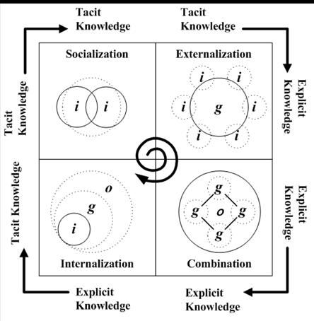
The software cycle from idea to stable application is an interesting learning dynamic. Project success is measured by more than the caveman’s perceptions – its utility is measured by adoption as it meets functional needs for a given audience. As such, it can be viewed as a product, albeit free. The diffusion of the product innovation can be measured based on Everett Roger’s Innovation Diffusion Theory (or more specifically Bass’ econometric model of product sales). The outcome of success and its determinants make an interesting question.

A more interesting question is to understand the dynamics of its development from a knowledge management perspective: can knowledge diffusion be mapped as a combination of Innovation Diffusion and Participation Levels?

This dynamic of knowledge diffusion is a complicated model that has failure potential at any stage in its growth across increasingly larger groups of more passive participation.


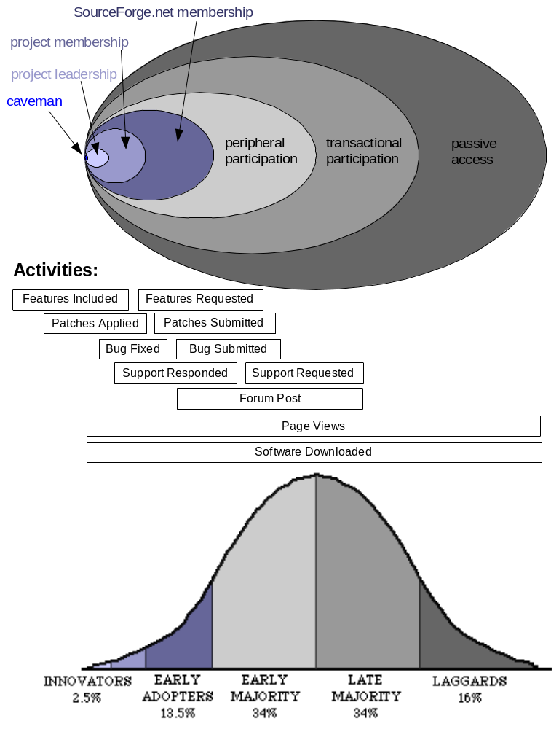

This model implies adoption rates at each level of participation. Significant knowledge diffusion to the next adjacent participation level requires stages (awareness, interest, evaluation, trial, and adoption) based on velocity parameters (innovation, communication channels, time, and social systems).

Model: Theoretical to Practical

The basic idea of this model is that core human capital (e.g., number of developers, developer experience, other commitments—coreHC_) interacts with human capital at the first level of participation (p1HC). This interaction (help1) represents many, if not all, aspects of the dynamics of knowledge diffusion. The first level of participation (p1HC) interacts with the second level of participation (p2HC) and their dynamics are also represented (help2).

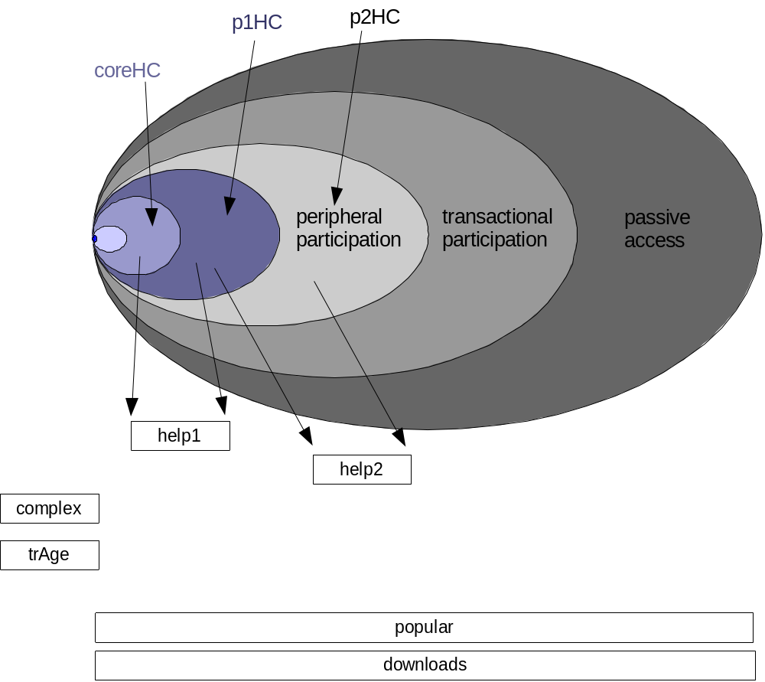

Outcomes of the group learning can be measured in terms of software complexity (complex – packages, releases, files, MB), responsiveness (trAge), popularity (popular – prHits, prPages), and downloads. Feedback from each dynamic and each outcome will have some effect on the human and social capital for the next period (each period is a month).

Due to the complexity of the model and its inherently endogenous nature, original variables were reduced to create composite variables using eigenvalue data-reduction techniques (six factors using principal components and varimax orthogonal rotation).

Data Collection

Data was harvested from the top projects as defined by SourceForge.net in January 2006 (monthly information from November 1999 – December 2005). This data was stripped from its HTML format into a dataset that contains cross-sectional and panel data.

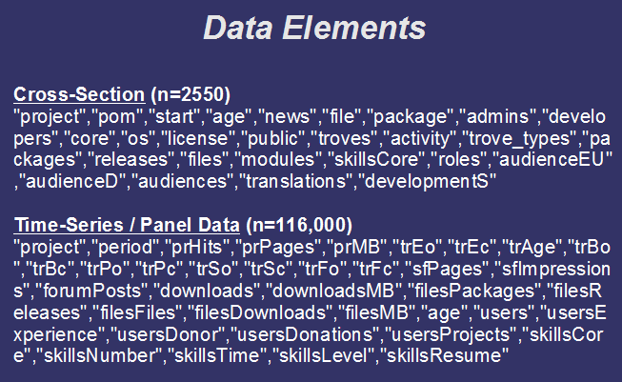

Hypotheses

This paper focuses on foundational hypotheses of this dataset; as such the panel data was analyzed in simple cross-section terms. Future research should extend these initial findings [panel data analysis with control elements: e.g., audience related – EU and D].

Open activities as a function of close activities (linear).

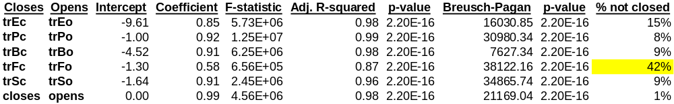

These results indicate the importance of feature requests, and the slowness of the core developers in responding in a timely fashion. This aligns with Wegner’s concept of becoming overwhelmed.

Downloads as a function of model dynamics and other outcomes (linear).

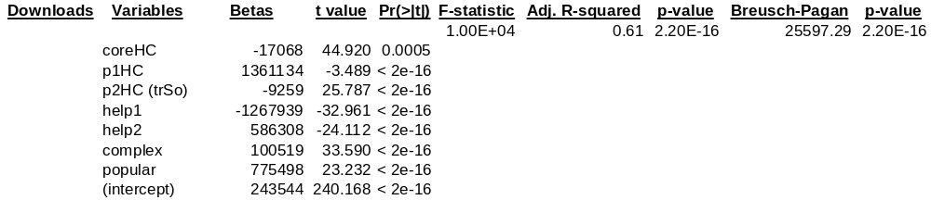

Download activity is significantly correlated to the Knowledge Diffusion Model presented in this paper. The core human capital (coreHC) is intriguing, but in context of the limited subset of projects that have substantial skill self-reporting, the negative relationship may be more strongly influenced by the skills-reporting bias.

The remaining results align nicely with the concept of Knowledge Diffusion – the more responsive the core group (coreHC) is to requests from the first peripheral group (p1HC) the more the software is downloaded. Also, it can be inferred that peripheral users want their support questions answered and such answers positively effects downloads. More support questions may be a result of usability issues and negatively effect downloads, which can be further seen in the dynamics between human capital at various levels of participation (help1 and help2). Further, the complexity (complex) of the software [not to be confused with the concept of usability] modules have positive utility impact on downloads. Finally, the relationship between software popularity (popular) and downloads relates to the adoption stages.

Conclusions

This analysis creates a solid basis for understanding knowledge diffusion. Barriers to adoption can be determined with further research with the current dataset, and with extending the dataset. One extension would be to add the CVS activities of the developers (code changes [lines by user and time]) to help understand the importance of governance in the diffusion process and to understand the implications of holdup on the knowledge system. A second extension would be to compare all types of projects and create a logit model to identify what were the key drivers for success to make these ‘top’ projects. Notre Dame may potential have enough information in their dataset, or the NGO running SourceForge.net may be contacted to see if the data can be accessed directly.

Finally, this research may be applied to the Bass Diffusion model with this model’s added complexity (overlapping adoption stages and velocities at each participation level).

Bibliography

Barro, R. and Lee, J.W. (2001) International Measures of Schooling Years and Schooling Quality. Economic Reform and Growth, Vol. 86, No. 2: pp. 218 - 223.

Bass, F.M. (1969) A New Product Growth for Model Consumer Durables. Management Science, 15: pp. 215-227.

Black, S. and Lynch, L. (2001) Human-Capital Investments and Productivity. AEA papers and proceedings, (Vol. 86, No. 2 [May 1996]: pp. 263-7.

Brown, J.S. et. al. (1989) Situated Cognition and the Culture of Learning. Educational Researcher, [Jan-Feb 1989]: pp. 32-42.

Cowan, R. et. al. (2000) The Explicity Economics of Knowledge Codification and Tacitness. Industrial and Corporate Change, Vol. 9, No. 2: pp. 211-253.

Comino, S. et. al. (2005) From Planning to Mature: on the Determinants of Open Source Take Off. Available online: http://opensource.mit.edu/papers/Comino_Manenti_Parisi.pdf

Crowston, K. et. al. (2003) Towards A Portfolio of FLOSS Project Success Measures. Available online: http://opensource.mit.edu/papers/crowston04towards.pdf

Dalgaard, P. (2002) Introductory Statistics with R. Springer.

Davenport, T. (2005) Thinking for a Living: How to Get Better Performances And Results from Knowledge Workers. Harvard Business School Press.

Decarolis, D.M. and Deeds, D.L. (1999) The Impact of Stocks and Flows of Organizational Knowledge on Firm Performance: An Empirical Investigation of the Biotechnology Industry. Strategic Managment Journal, Vol. 20, No. 10: pp. 953 - 968.

Deci, E.L. et. al. (2004) Motivating Learning, Performance, and Persistence: The Synergistic Effects of Intrinsic Goal Contents and Autonomy-Supportive Contexts. Journal of Personality and Social Psychology, Vol. 87, No. 2: pp. 246-260.

Dixon, N. (2000) Common Knowledge: How Companies Thrive by Sharing What They Know. Harvard Business School Press.

Edwards, K. (2001) Epistemic Communities, Situated Learning and Open Source Software Development. Available online: http://opensource.mit.edu/papers/kasperedwards-ec.pdf

Engelbrecht, H.J. (2002) Human capital and international knowledge spillovers in TFP growth of a sample of developing countries: an exploration of alternative approaches. Applied Economics, 34: pp. 831-841.

Faraway, J.J. (2002) Practical Regression and Anova using R. Available online: http://cran.r-project.org/doc/contrib/Faraway-PRA.pdf

Farnsworth, G.V. (2006) Econometrics in R. Available online: http://cran.r-project.org/doc/contrib/Farnsworth-EconometricsInR.pdf

Giuri, P. et. al. (2004) Skills and Opennenss of OSS Projects: implications for performance. Available online: http://opensource.mit.edu/papers/giuri_etal.pdf

Greene, William (2003) Econometric Analysis, 5th ed., Prentice Hall.
Hazy, J. et. al. (2002) Boundary Spanning in Organizational Learning: Preliminary computational explorations. Paper presented at: Managing the Complex IV [December 7-10, 2002]. Available online: http://isce.edu/ISCE_Group_Site/web-content/ISCE%20Events/Naples_2002/Naples_2002_Presentations/Hazy_Tivnan_Schwandt.ppt

Klincewicz, K. (2005) Innovativeness of open source software projects. Available online: http://opensource.mit.edu/papers/klincewicz.pdf

Krishnamurthy, S. (2002) Cave or Community? An Empirical Examination of 100 Mature Open Source Projects. Available online: http://opensource.mit.edu/papers/krishnamurthy.pdf

Kuhnert, P. and Venables, B. (2005) An Introduction to R. Available online: http://cran.r-project.org/doc/contrib/Kuhnert+Venables-R_Course_Notes.zip

Lakhani, K.R. and von Hippel, E. (2003) How open source software works: “free” user-to-user assistance. Research Policy, Vol. 32: pp. 923–943.

Madsen, T.L. et. al. (2003) Knowledge Retention and Personnel Mobility: The Nondisruptive Effects of Inflows. Organization Science, Vol. 14, No. 2 [March-April 2003]: pp. 173-191.

Maindonald, J. and Braun, J. (2003) Data Analysis and Graphics Using R: An Example-based Approach. Cambridge University Press.

Nonaka, I. and Takeuchi, H. (1995) The Knowledge-Creating Company : How Japanese Companies Create the Dynamics of Innovation. Oxford University Press

Productivity Commission 2003, Social Capital: Reviewing the Concept
and its Policy Implications, Research Paper, AusInfo, Canberra.

Rogers, E. (1995) Diffusion of Innovations, 4th ed. Free Press.

Roth, W.M. and McGin, M.K. (1998) Inscriptions: Toward a Theory of Representing as Social Practice. Review of Educational Research, Vol. 68, No. 1 [Spring 1998]: pp. 35-59.

Venkatraman, N. and Tanriverdi,H. (2004) Reflecting “knowledge” In Strategy Research: Conceptual Issues And Methodological Challenges. Research Methodology in Strategy and Management, Volume 1: pp. 33–65.

von Glasersfeld, Ernst. (1983) Learning as a constructive activity: pp. 41-69. In J.C. Bergeron (ed), Proceedings of the Fifth Annual Meeting of PME-NA, University of Montreal, Montreal, Canada

von Krogh, G. et. al. (2003) Collective Action and Communal Resources in Open Source Software Development: The Case of Freenet. Available online: http://opensource.mit.edu/papers/vonkroghhaefligerspaeth.pdf

Wasko, M.M. and Faraj, S. (2001) The Web of Knowledge: An Investigation of Knowledge Exchange in Networks of Practice. Available online: http://opensource.mit.edu/papers/Farajwasko.pdf

Wenger, E. (2000) Communities of Practice. In Despres, C. and Chauvel, D. (eds.) Knowledge Horizons: pp. 205-224. Butterworth Heinemann.

Zeileis, A. (2004) Econometric Computing with HC and HAC Covariance Matrix Estimators. Journal of Statistical Software, Vol. 11, No. 10 [November 2004]. Available online: http://www.jstatsoft.org/v11/i10/v11i10.pdf

The efforts of J. McDonald, N. Hatch, M. Thompson, B. Powers are respectfully acknowledged.

