Data Sources

1) Daily stock price of public listed container shipping companies.

Source: Yahoo Finance API.

Sample companies: Zim Integrated Shipping Services (Stock ticker: ZIM)

Sample data below, we would mostly just use daily “Close” price.

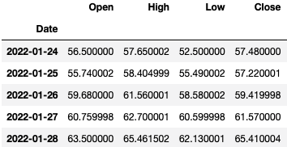

2) Daily stock sentiment.

Source: Twitter API

Note: my application for a developer account was denied by Twitter.

Currently looking for other sources of high frequency sentiment data on shipping stocks and/or shipping related topics.

3) Daily Container port congestion tracker.

No. of ships near Los Angeles & Long Beach ports on the U.S. west coast.

4) Weekly container shipping rate index.