TEMASEK POLYTECHNIC
SCHOOL OF ENGINEERING

Diploma in Computer Engineering

Design Report
Object-oriented Programming

Submitted By

Shawn James (2200151E)
Amal Suresh ()

PE01 – Group 1
Pizza Ordering System

Declaration of Originality

I am/We are the originator of this work and I/we have appropriately acknowledged all other original sources used as my reference for this work.
I/We understand that Plagiarism is the act of taking and using the whole or any part of another person’s work, including work generated by AI, and presenting it as my/our own.
I/We understand that Plagiarism is an academic offence
and if I am/ we are found to have committed or abetted the offence of plagiarism in relation to this submitted work, disciplinary action will be enforced.

AY2023/2024 APR SEMESTER

Note: This report should only cover items 1a, 1b & 2 of your project. No need to include bonus features in this report.

A) Project Objectives
The aim of this project is to develop a pizza ordering application for Temasek Pizzas using Java. This application is intended to help the customers order pizzas and drinks using online menu and the staff to manage these orders.

B) Project Design & Discussion
- Use Case Diagrams
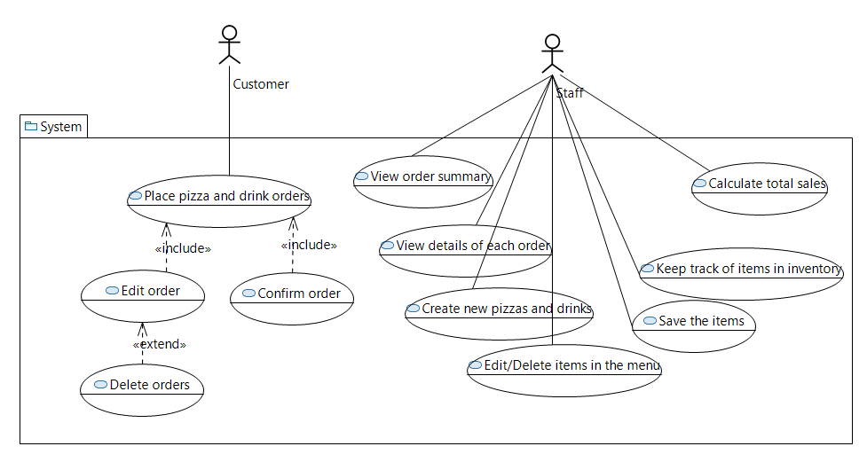
Use Case Name | Scenario
Place pizza and drink orders [Customer] | 1. User selects pizza of his/her choice.  2. User selects pizza size.  3. User selects pizza toppings.  4. User adds pizza to the order.  5. User selects drink.  6. User selects size.  7. User adds drink to the order.
Edit order [Customer] | 1. User clicks View Cart  2. User clicks the edit button to edit the pizza order.  3. User changes the toppings for the pizza.  4. User confirms the modification.
Confirm order [Customer] | 1. User adds pizza and drink order.  2. User clicks View Cart.  3. User clicks Confirm.
Delete orders [Customer] | 1. User adds pizza and drink order.  2. User clicks View Cart.  3. User click delete button near the drink.
View order summary [Staff] | Order summary appears as soon as the staff logs in.
View details of each order [Staff] | 1. Staff logs in.  2. Staff clicks Orders.  3. Staff selects order.  4. The no. of pizzas and drinks, total price of the order etc… is shown.
Keep track of items in inventory [Staff] | 1. Staff logs in.  2. Staff clicks inventory button.  3. Staff can see all the items available along with their quantities.  4. Staff removes one item.  5. Staff clicks done button.
Calculate total sales [Staff] | The total sales will be displayed as soon as the staff logs in.

- Domain Class Diagram
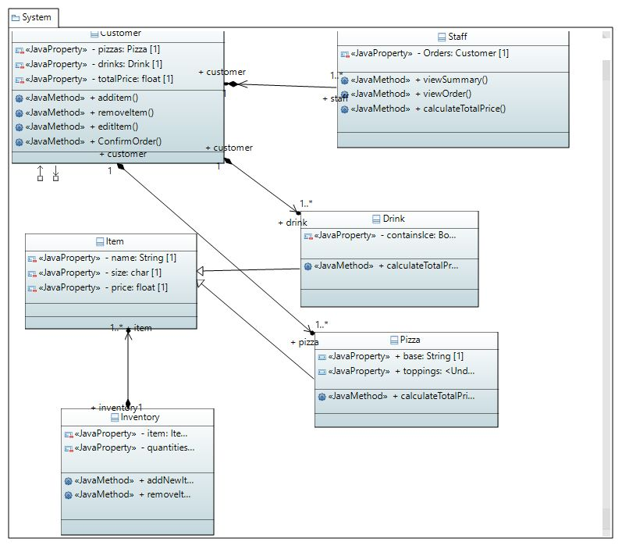

- Work Distribution

Tasks | Done by (who) | Completion(Y/N)
Objectives | Shawn | Y
Use Case Diagram Design | Amal | Y
Use Case Diagram Implementation | Shawn | Y
Domain Class Diagram Design | Amal | Y
Domain Class Diagram Implementation | Shawn | Y
Conclusion | Amal, Shawn | Y

C) Conclusion
State problems encountered, lessons learned and plan for next stage.
Problems encountered:
1. Specifying my own custom class as the datatype for an attribute of another class in UML Model.
2. Finding the right Edges (Arrows) in Eclipse for the relationship between the classes.

Lessons Learned:
1. Figured out how to specify my own class as datatype in UML Model.
2. Learned to see the program in a bigger picture.
3. Visualizing how the app would work for each task.
4. How to design classes and relate them for an application.

Plan for next stage:
1. Add more features, like additional customization of pizzas, combo meals, and discounts.
2. Add more visuals for the items in the menu.

