Design document for:

Snelps

The comical real-time strategy with a twist.

All work Copyright © 2007 Shawn Anderson
Written by Shawn Anderson
Version #1

Wednesday, October 17, 2007

Prove yourself worthy of becoming the Great Snelp by guiding your devoted snelplings to victory in this comical real-time strategy.

Player Motivation

The player fulfills the role of an elemental spirit, deity to their clan of snelplings. Through a challenging set of missions, the player must conquer the remaining spirits in the pursuit to seize the head seat of the retiring Great Snelp. This is done by gather resources, upgrading their snelplings, and strategically destroying or converting all of their enemies units. Players are allowed to choose one of the four spirits to play. Each snelp spirit (earth, wind, water, and fire) has a clan of snelplings that are imbued with the spirit's powers. These powers allow for diversity and balance in the game, as well as provide great replay value.
The snelp's personality will be reflected in each of the snelplings via abilities, sound, and animation. Each snelpling is a lump of gelatinous goo. This simple fact allows a very unique ability when it comes to controlling units. When orders are issued to groups of snelplings, the abilities of the group are greater than the sum of its parts. They amalgamate to form amusing weapons of goo-tastic destruction. For example, three or four basic worker snelps merge together to form an over-sized mallet to smash enemy buildings. These high-powered abilities and attacks add to the comical satire and overall enjoyment of Snelps.

Target Audience

Snelps is targeted for most gamers that enjoy wacky games that have unique gameplay. With that said, there are a few specific demographics and psychographics that Snelps is designed for. First to be targeted is the casual gamer. Snelps will have a very easy learning curve and short gameplay sittings. Although the main campaign will be deep and thorough, each individual scenario should not last more than an hour. This time scale allows the casual gamer to learn it quickly and play without reserving an entire afternoon to the game.
Snelps also creates an environment of competition and challenge with its multi-player mode. Multi-player Snelps will allow four players to compete against each other, over any network connection, in epic battles for the prize of Great Snelp. Once a player has mastered all the pre-built maps and campaigns, they can increase the challenge by creating their own content. Snelps will ship with a built-in map and campaign editor.
Another uniqueness in Snelps is the technology involved in its creation. It is the first real-time strategy (RTS) written in Ruby. Ruby is a programming language developed in Japan with an almost religious following. A large audience of Snelps will be Ruby evangelists that want nothing more than to see something creative and exciting done with Ruby.

Genre

Real-time strategy traditionally involve non-turn-based war strategy games. Successful RTS games usually include some form of resource gathering, base building, technological development, and abstract unit control. Snelps will not differ from these proven elements. However, it will be unique in its unit control and unit artificial intelligence. The real-time strategy genre has a track record of great sales and wide market appeal, making the top ten PC games lists for the past five years. The genre has been successful, but it has not yet been fully explored.

Entertainment Software Review Board Rating

Snelps will have an ESRB rating of “E for everyone”. Titles rated E (Everyone) have content that may be suitable for ages 6 and older. Titles in this category may contain minimal cartoon, fantasy or mild violence and/or infrequent use of mild language. Given its comical nature, lack of real or simulated violence, and its lack of harsh language, Snelps will have no problem maintaining an E rating.

Platform

Snelps will be developed for the personal computer (PC) market. It will be compatible with Mac OS X, Windows, and most flavors of Linux. Snelps will operate on a 2GHz computer with 1Gb of random access memory (RAM). Snelps will have very minimal three-dimensional graphics, but a 3D accelerated graphics card is highly recommended.

Storyline

It's time for the Great Snelp, leader of the Snelp spirits and the entire planet of Quaggle, to retire. A new Great Snelp must be appointed. But whom should it be? There are four seemingly equal candidates for the job: Earth Snelp, the oldest (and slowest) of the snelps, Wind Snelp (the blowhard), Water Snelp (who tends to go with the flow), and Fire Snelp, who is always a little short on the thinking and a little hot headed. These sibling spirits are all vying for the job. In his infinite wisdom, the Great Snelp places a challenge before the spirits. He grants each of the spirits a clan of snelplings, the natives of Quaggle. The first spirit to guide his snelplings to world domination will be deemed worthy of taking on the role of Great Snelp.
- Earth is always too cautious and slow
- Fire and Wind are always fighting
- Water is the peacemaker that tries to stop the arguing.
- Fire is hot-headed and irrational
- Earth and Fire are male
- Wind and Water are female

The storyline will be slightly different, depending on which Snelp spirit the player chooses. But it will consist of a few matches against each of the remaining spirits (nine battles total); will the Great Snelp himself make an appearance? Going with the comical theme, the dialogue will be written as a wacky sibling rivalry.

Game play

The game play will, for the most part, be that of a standard RTS. The unit control will be the differentiator. As in most standart RTS games, Snelps is a top down 2D game. Players will have to create snelplings, build structures used for advancements, gather resources, and organize attacks. The mouse is the primary interface used in conjuction with keyboard shortcuts. Using these inputs, orders are issued to units for their various abilities. Gameplay consists of the player being positioned in the map with a small base capable of creating the basic units and buildings that are needed to start playing and eventually create increasingly powerful units and buildings, or a small force, the core of which is generally a unit capable of establishing the initial production base. Thereafter, the game is typically a race of resource gathering, technology research and unit production to claim territory, suppress and defeat the opposition through force or attrition.

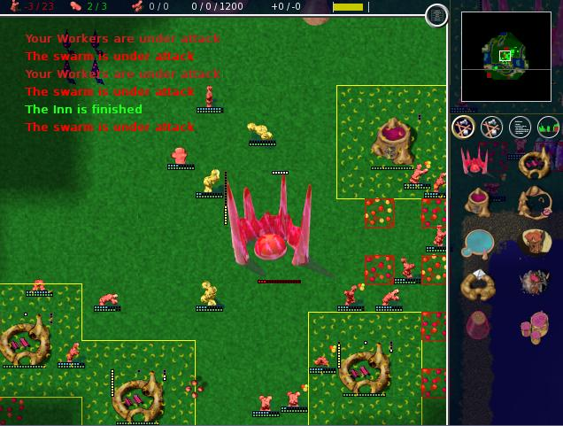
(Globulation 2 GUI shown globulation2.org)

Goal

The goal of Snelps is to allow players to escape in to a fantasy world of quirky little snelplings, challenge their skills of strategy via multi-player and well written AI. Snelps will provide a level of excitement due to its high-speed real-time action. It will also provide comical nostalgia for those that once loved two-dimensional top down real-time strategies.

Snelpling Concept Art




Engineer, warrior, and worker shown.

