CprE 3810, Computer Organization and

Assembly Level Programming

Lab 1 Report

Student Name Shawn Robinson

Submit a typeset pdf version of this on Canvas by the due date. Refer to the highlighted language in the lab document for the context of the following questions.

[Part 3.1.c] Think of three more cases and record them in your lab report.

Shawn’s Test Case #1 – Sum up to 7 (the day I was born, and also the month for what it’s worth)
-Let’s set iX to 03, a weight of 1, iLdw to 1, and iY to 04
-with a multiplied weight of 1, this should create the sum of 7

Shawn’s Test Case #2 – Sum up to F1, like the racing sports league!
-F1 is 16*15 + 1 = 241...so, let's load 6 as the weight, 40 as iX and 1 as iY

Shawn’s Test Case #3 – Testing to assert that weights don’t change when iLdw is zero
-Keep the weight at 6 if iLdw is 0, even if a new weight value is given

[Part 3.1.e] For labels 1, 7, 22, and 28, specify where (VHDL file and line number) these values are located – some will be found in more than one place. Also attempt to explain the functionality of each label as it occurs in the code

Label 1: TPU_MV_Element
Location: TPU_MV_Element.vhd – line number 24 is where the entity is defined
Description: This is the top-level of the hierarchy of components for this particular design, it contains and declares what other sub-modules it needs to function as a whole
Label 7: g_Add1
Location: TPU_MV_Element.vhd – line number 131
Description: This component takes the multiplication of iX * iW and adds it with iY, and this sum then flows onto oY after passing through a clock entity (a delay, or maybe just shorthand to say that that result will push onward with the next rising edge?)
Label 22: oQ
Location: RegLd.vhd – line number 30
Description: oQ acts as both the output for what gets sent as the weight to be multiplied later on, but also gets sent back through the 2:1 mux, so if iLdw is set to 0, then the value of oQ remains constant. However, if a new value comes in from iD and iLd is 1, then oQ is rewritten.
Label 28: s_X1
Location: TPU_MV_Element.vhd – line number 70
Description: I believe this is an intermediate signal which is carrying the value of oQ from g_Delay1 to iD of g_Delay3

[Part 3.1.f] Implement your test cases from part c into this testbench. Remember to include these in your waveform screenshot.
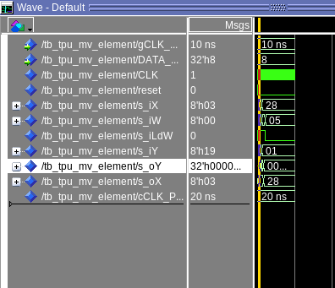

[Part 3.1.g.v] In your lab report, include a screenshot of the waveform. Describe, in plain English, any differences between what you expected and what the simulation showed.

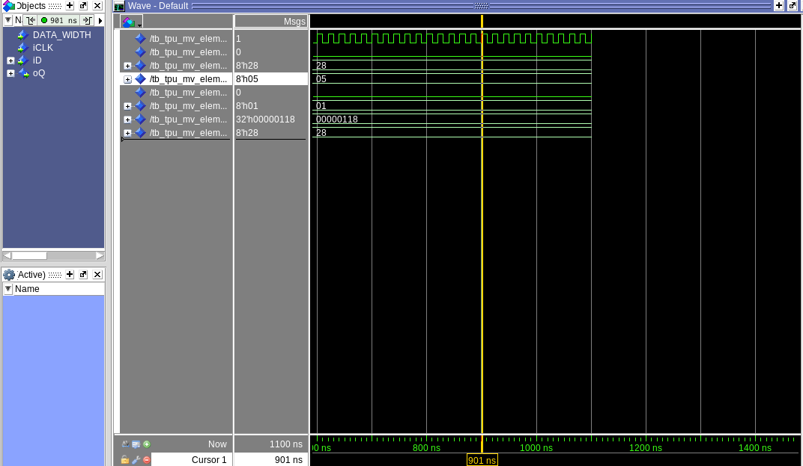
Fixes:
g_Delay2 needed to be changed...iD gets assigned to iY

[Part 3.1.h] In your lab report, include a screenshot of the waveform. Describe, in plain English, how your waveform matches the expected result (e.g., reference the specific cycles and times). In your submission zip file, provide the completed TPU_MV_Element.vhd file in a folder called ‘MAC’.

[Part 3.3.a] Draw the truth table, Boolean equation, and Boolean circuit equivalent (using only two-input gates) that implements a 2:1 mux. Include this in your lab report.

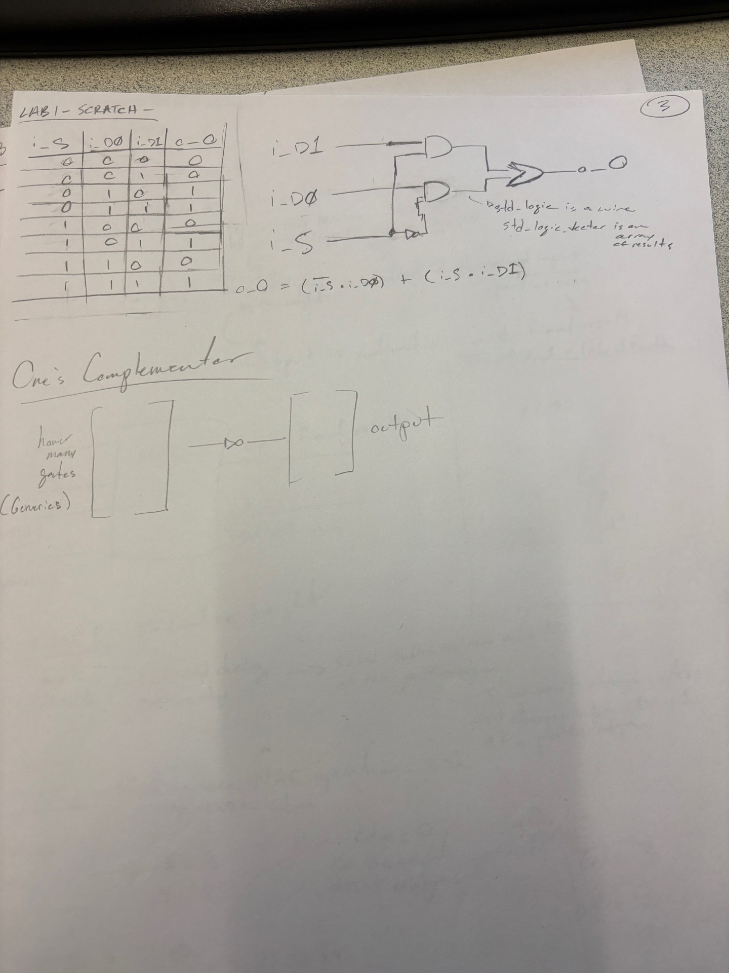

[Part 3.3.d] In your lab report, include a screenshot of the waveform. Make sure to label the screenshot with which module it is testing.
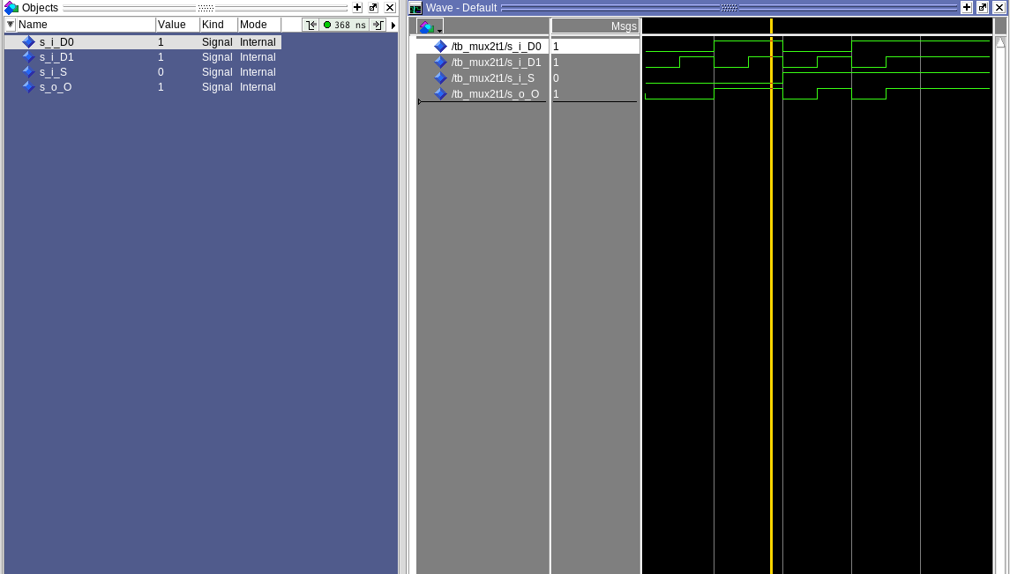

[Part 3.3.e] Again, in your lab report, include a labeled screenshot of the waveform showing the dataflow mux implementation working.

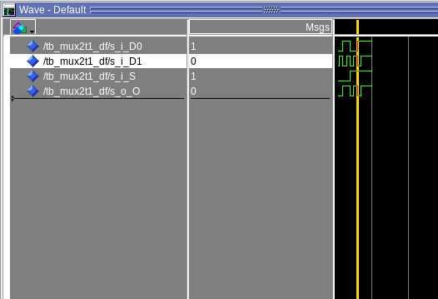

[Part 3.4] Include a waveform screenshot and corresponding description demonstrating it is working correctly.

Description: here you can see the testbench I wrote working successfully. The screenshot in question shows a situation where the select is set to 1, and d1 is also 1 – thus, the output is 1.
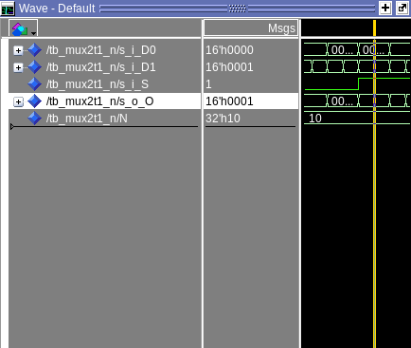

[Part 3.5.b] Include a waveform screenshot and description in your lab report.
Description: My testbench used all zeroes, all 1’s, and all A’s
I got the expected outputs of F’s, zeroes, and fives – respectively.

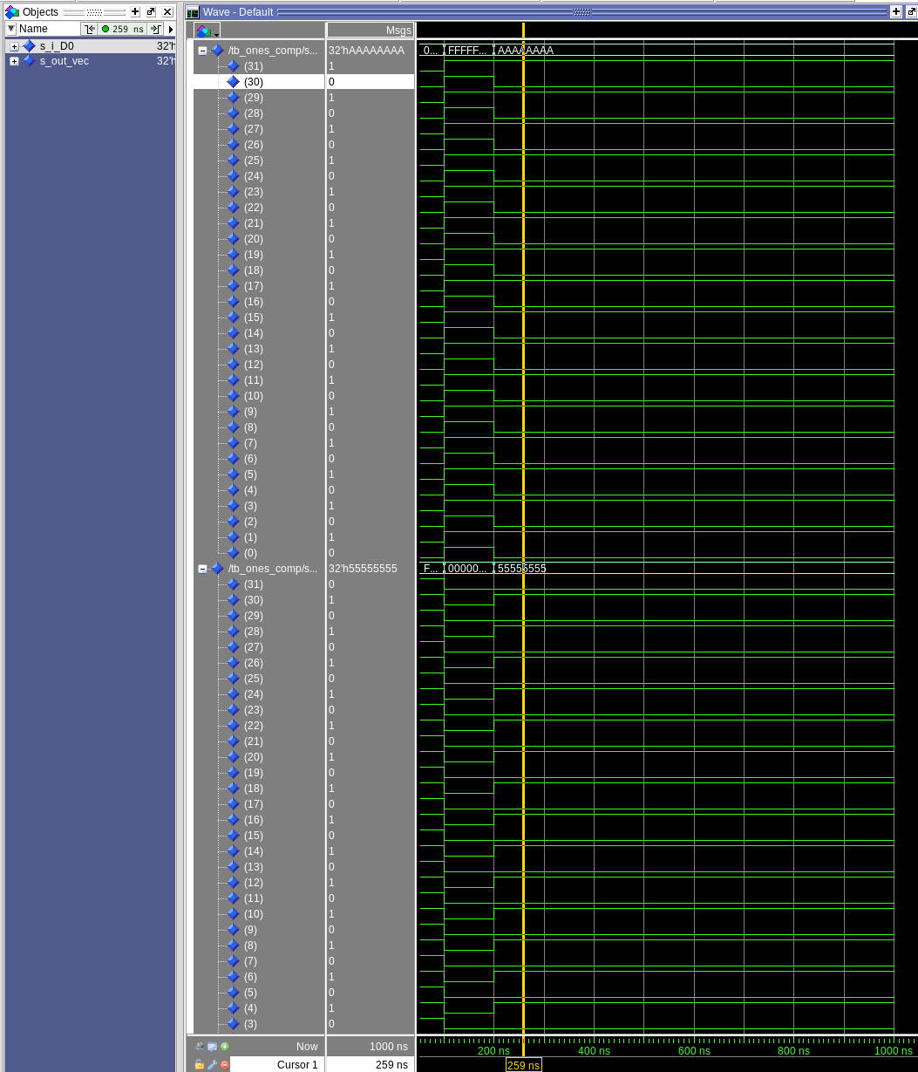

[Part 3.6.a] A full adder takes three single-bit inputs and produces two single-bit outputs – a sum and carry for the addition of the three input bits. Draw the truth table, Boolean equation, and Boolean circuit equivalent (using only two-input gates) that implements a 1-bit full adder. Include this in your report.
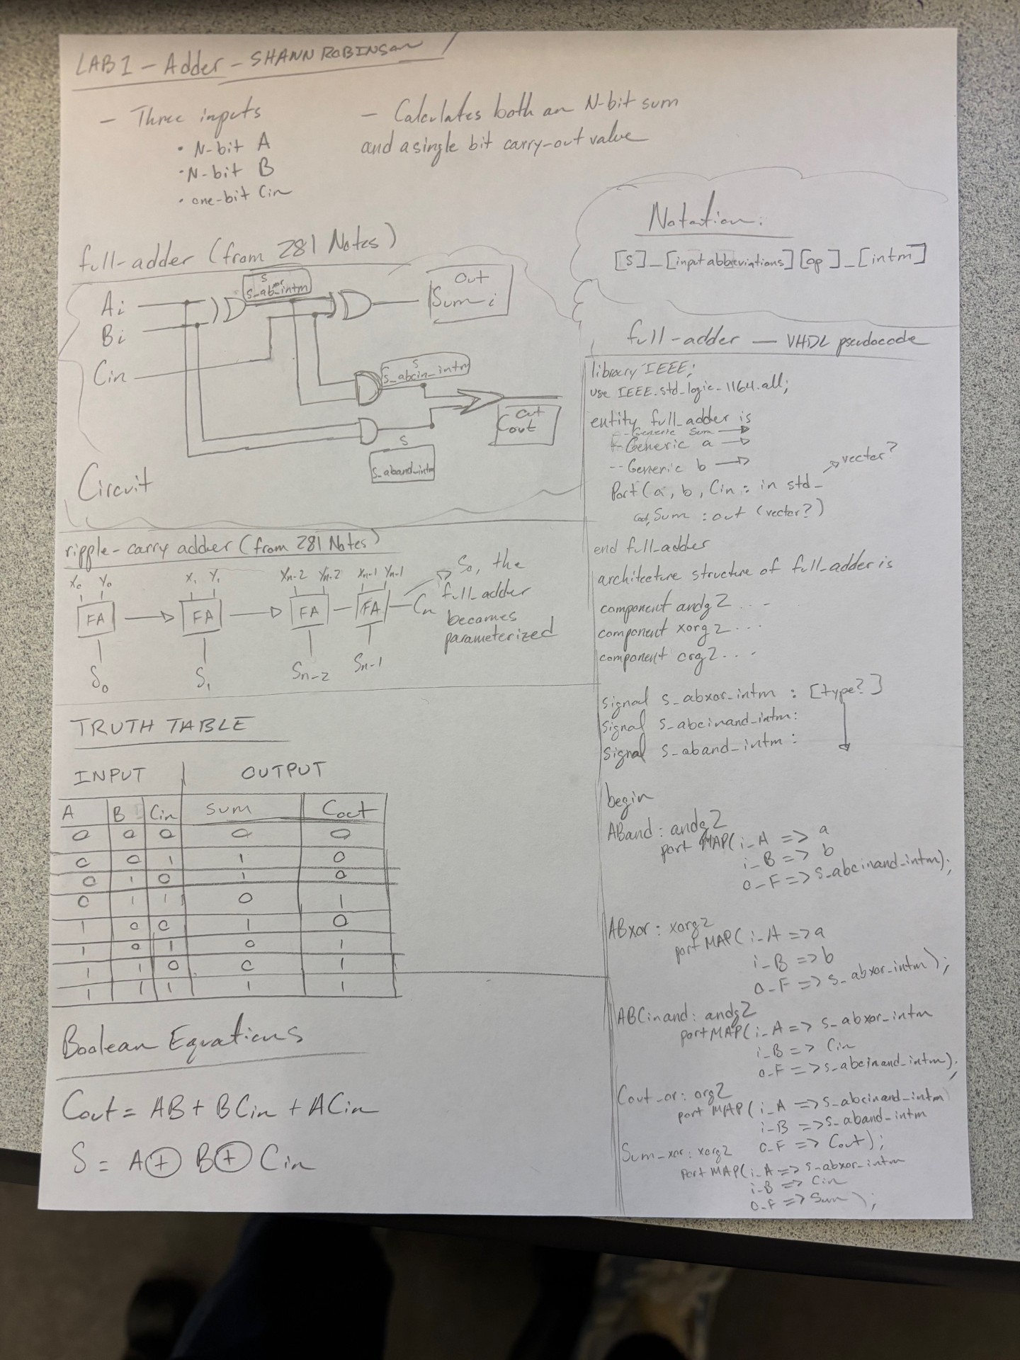

[Part 3.6.c] Then draw a schematic of the intended design, including inputs and outputs and at least the 0, 1, N-2, and N-1 stages. Include this in your report.
[My above screenshot also includes the schematic]
THREE INPUTS AND EXPECTED OUTPUTS:
1) 0000_0000_1111_1111 + 0000_0000_0000_0000 => 0000_0000_1111_1111 with carry_out 0
2) 1111_1111_1111_1111 + 1111_1111_1111_1111 => 1111_1111_1111_1110 with carry_out 1
3) 1010_1010_1010_1010 + 0000_0000_0000_0001 = > 1010_1010_1010_1011 with carry_out 0

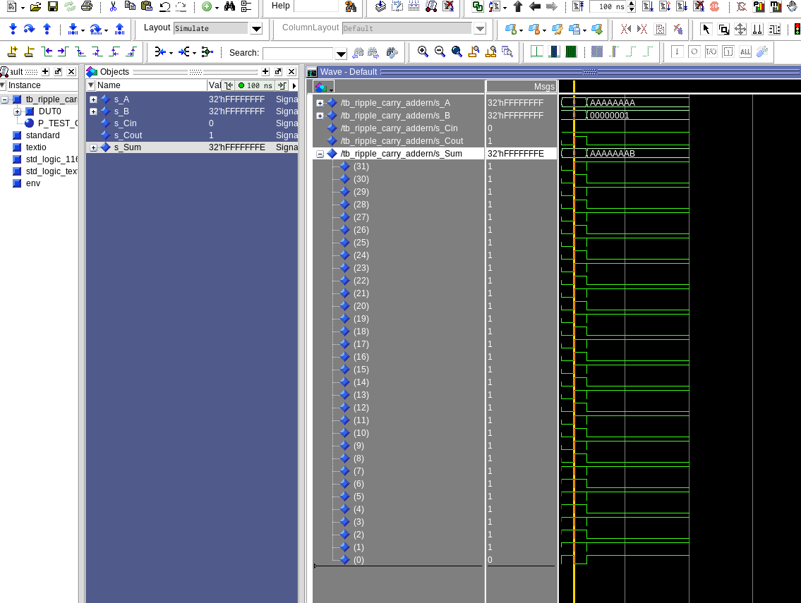
[Part 3.6.d] Include an annotated waveform screenshot in your write-up.

[Part 3.7.a] Draw a schematic (don’t use a schematic capture tool) showing how an N-bit adder/subtractor with control can be implemented using only the three main components designed in earlier parts of this lab (i.e., the N-bit inverter, N-bit 2:1 mux, and N-bit adder). How is the ‘nAdd_Sub’ bit used? Include this in your report
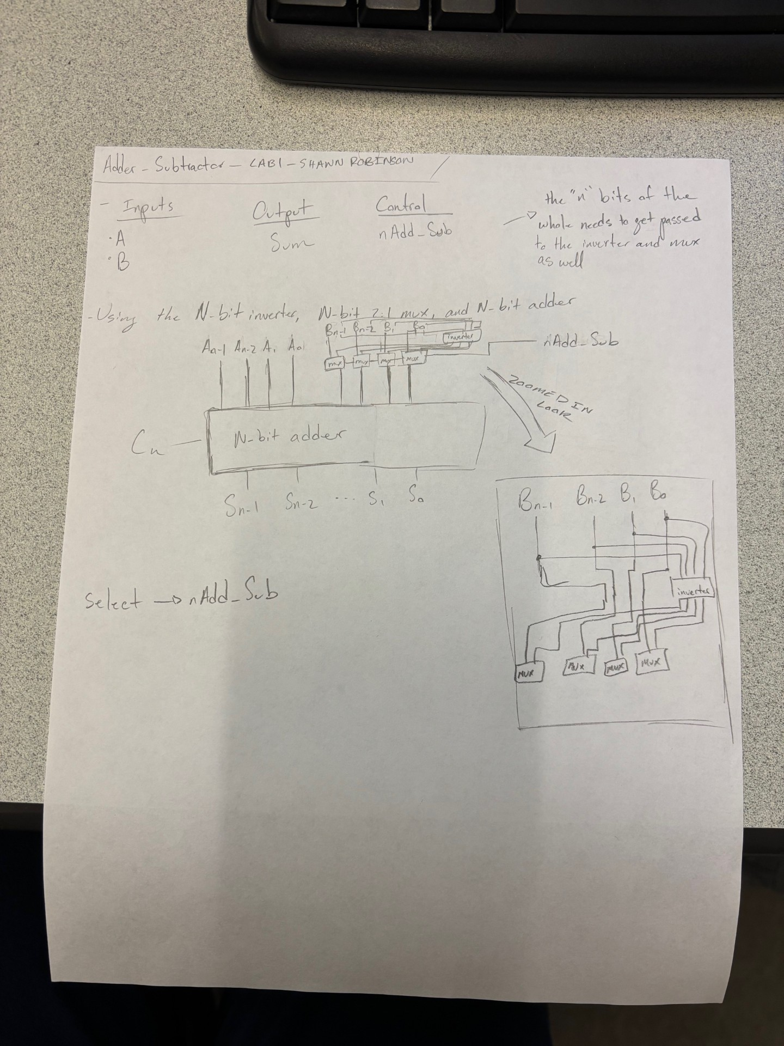

[Part 3.7.c] Provide multiple waveform screenshots in your write-up to confirm that this component is working correctly. What test-cases did you include and why?

I tested both addition and subtraction test cases, and tried to toggle whether there should be a carry out or not as part of the test. I know this isn’t currently the most extensive set of tests, but I wanted them to be fairly comprehensive for their quantity.

