CprE 381, Computer Organization and

Assembly-Level Programming

Lab 2 Report

Student Name SHAWN ROBINSON

PRELAB: The D Flip Flop Gate that is provided takes in four inputs and has one output. All of these are single-wire std_logic lines. There is a “with...select” structure used to set the data line like a multiplexer...Also, based off the reading it looks like the process implicitly creates stored values by not having a conclusive else statement in the if checks of the lower down process...it only checks for rising edges of i_CLK and if i_RST is 1.

Submit a typeset pdf version of this on Canvas by the due date. Refer to the highlighted language in the lab document for the context of the following questions.

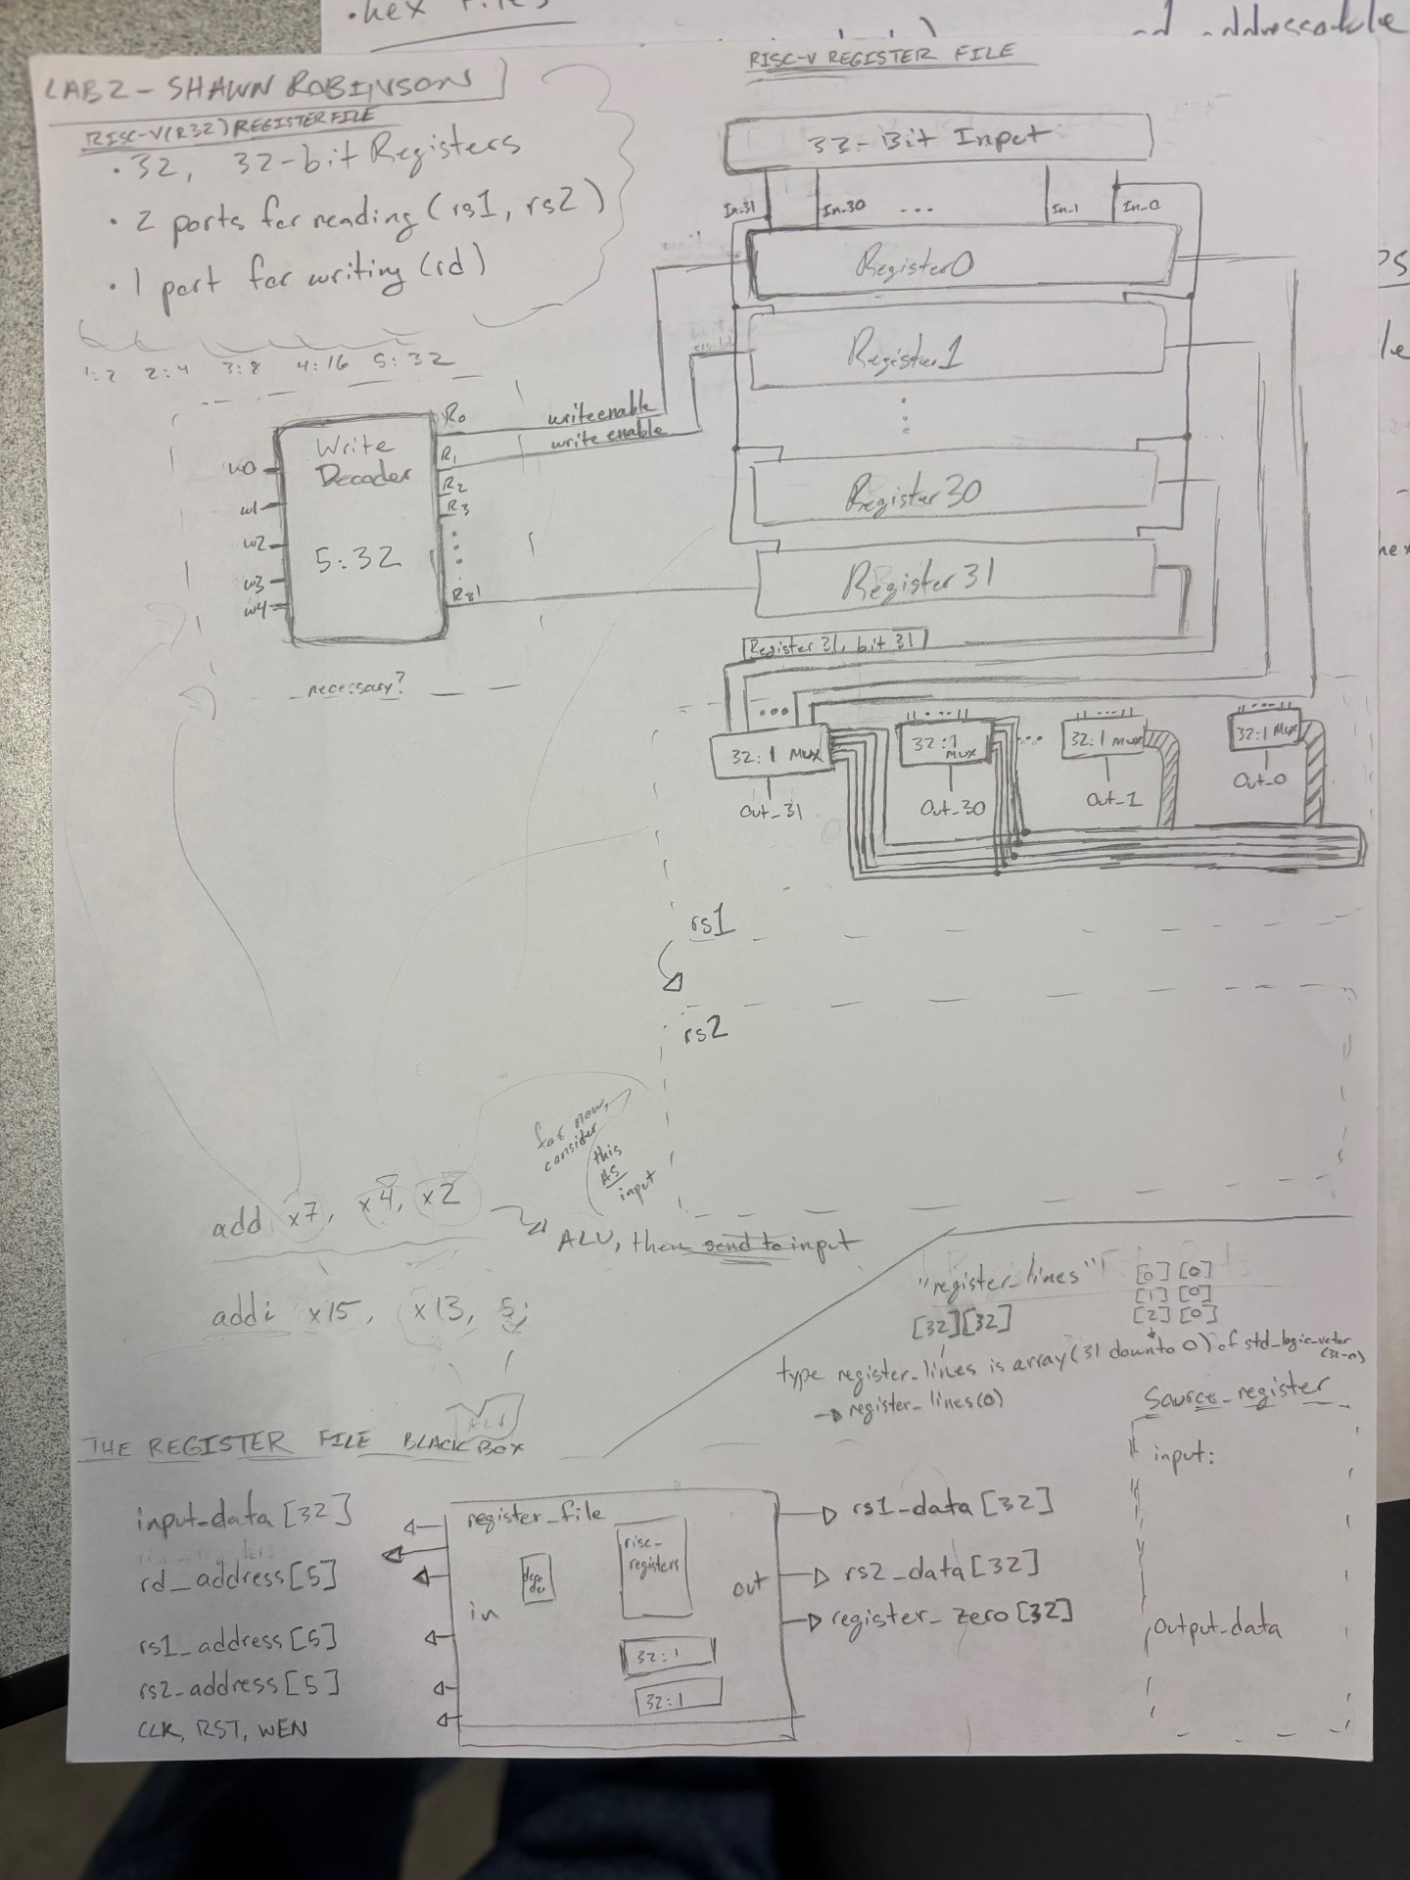
[Part 3 (a)] Draw the interface description (i.e., the “symbol” or high-level blackbox) for the RISC-V register file. Which ports do you think are necessary, and how wide (in bits) do they need to be?

[Part 3 (b)] Create an N-bit register using this flip-flop as your basis.

[Part 3 (c)] Waveform.
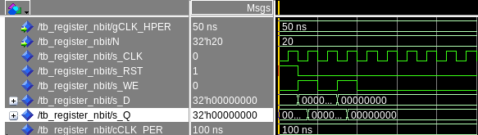

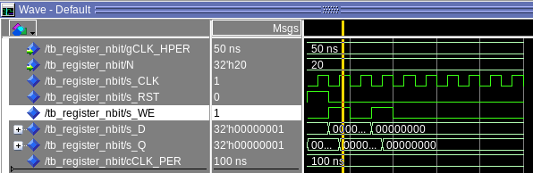

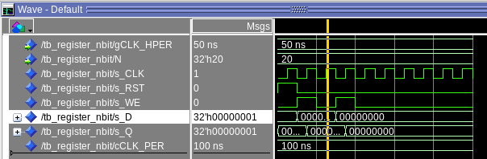

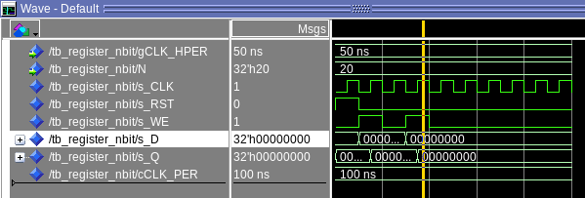

[Part 3 (d)] What type of decoder would be required by the RISC-V register file and why?
The decoder required by the RISC-V register file is a 5 to 32 decoder, because there are 32 registers in the file that can be accessed.

[Part 3 (e)] Waveform.

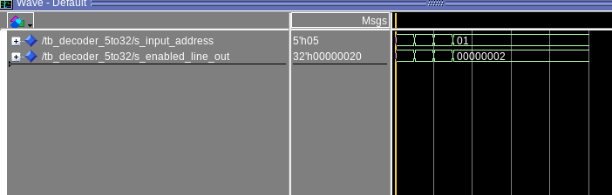

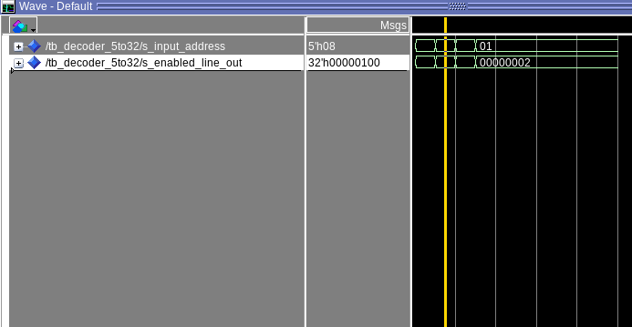

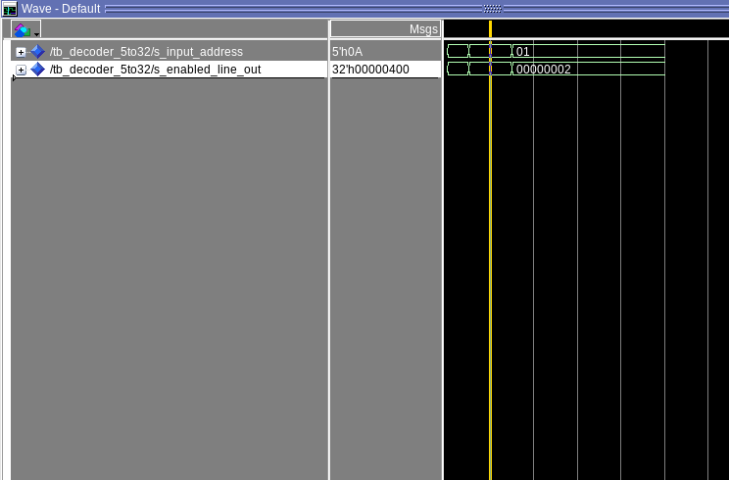

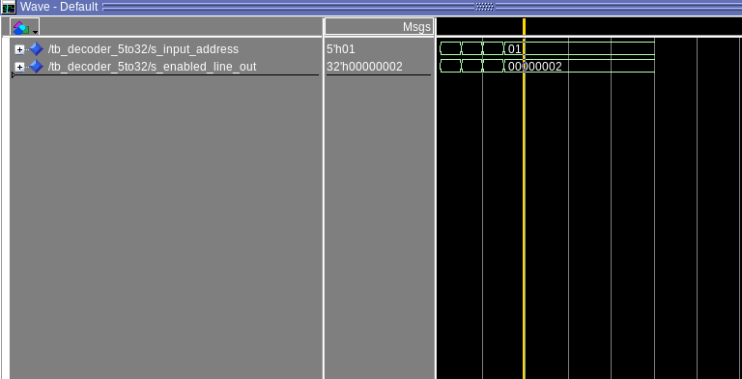

[Part 3 (f)] In your write-up, describe and defend the design you intend on implementing for the next part.
I intend to implement a dataflow design instead of a structural design for the 32:1 MUX. The reason for this is both the ease of initial writing and also the ease of debugging. If we went with a structural system (either with smaller muxes or pure logic gates) there’s a lot a more opportunities for an intermediary signal to get misplaced. The dataflow version essentially lets me implement the truth table, which is way easier to check for errors.

[Part 3 (g)] Waveform.

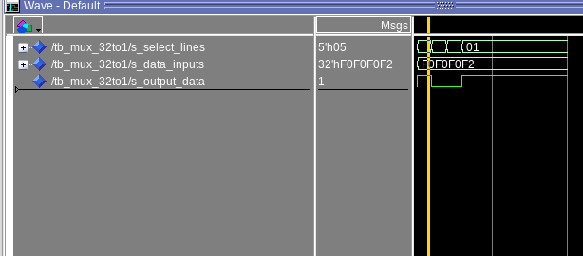

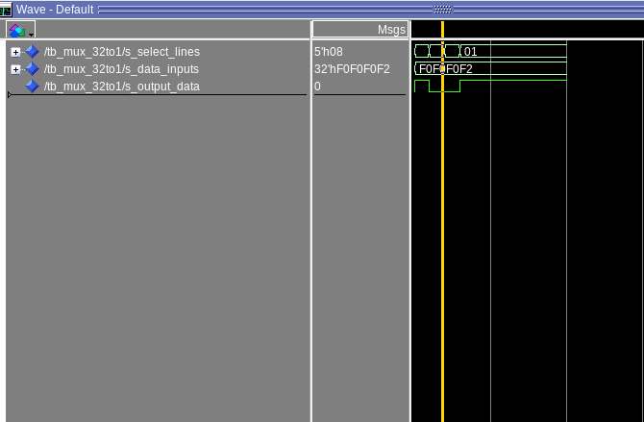

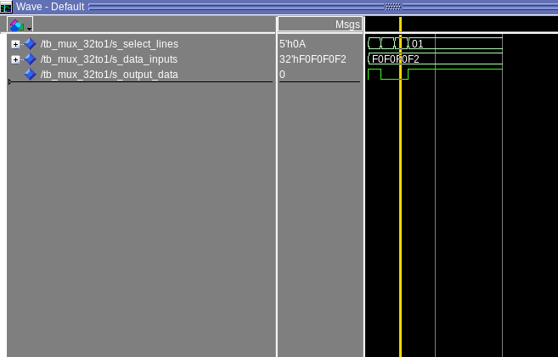

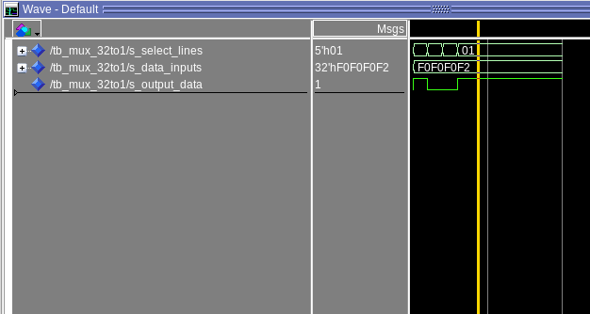

[Part 3 (h)] Draw a (simplified) schematic (i.e., components within the high-level blackbox) for the RISC-V register file, using the same top-level interface ports as in your solution describe above and using only the register, decoder, and mux VHDL components you have created.

[Part 3 (i)] Waveform.

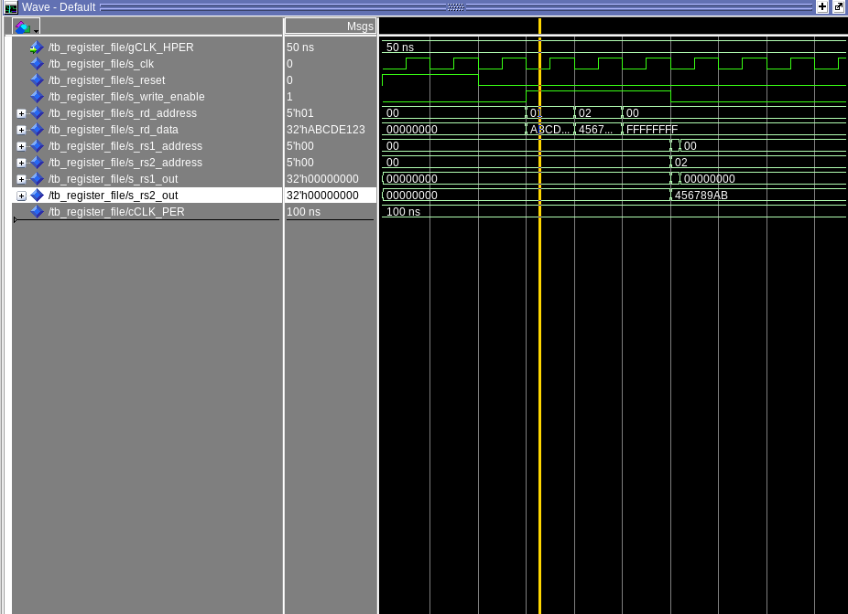
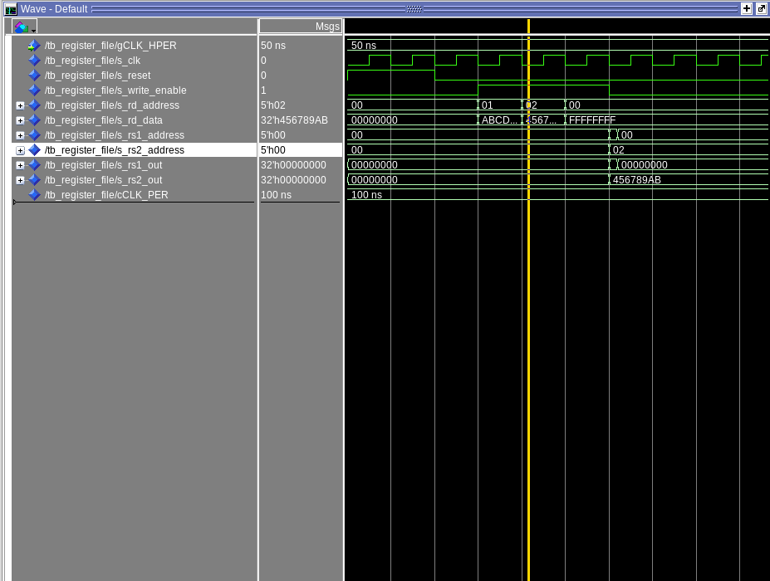

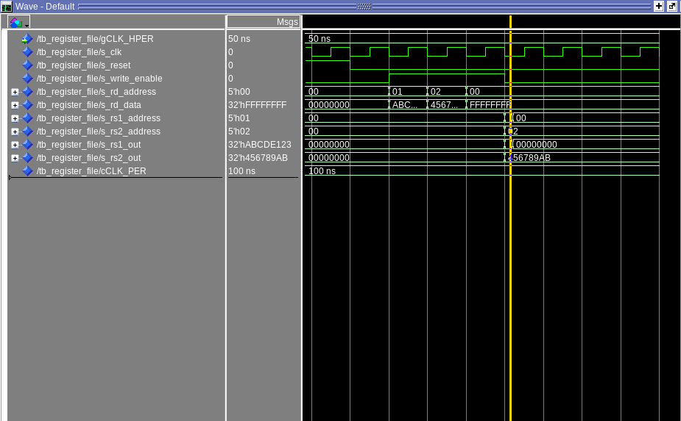

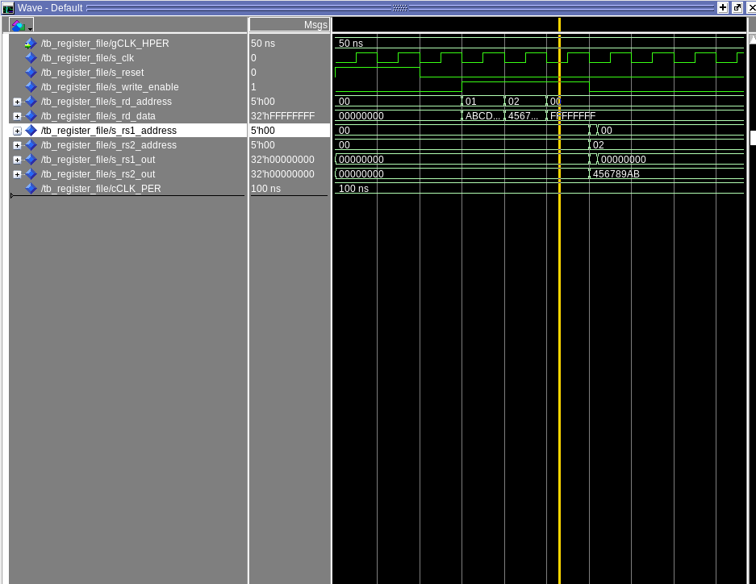
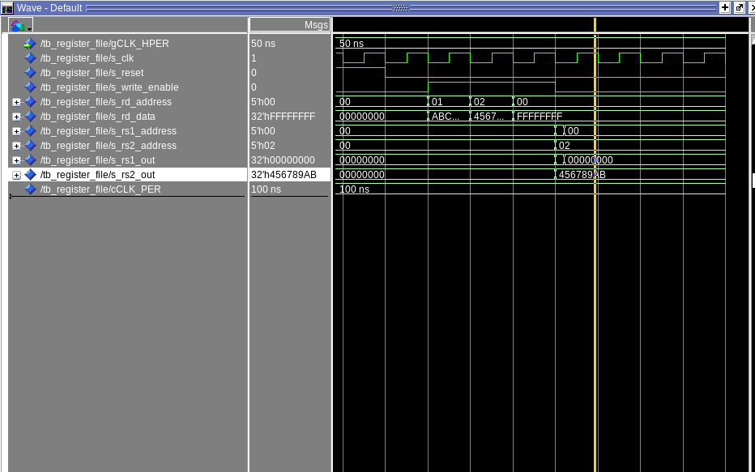

[Part 4 (b)] Draw a symbol for this RISC-V-like datapath.
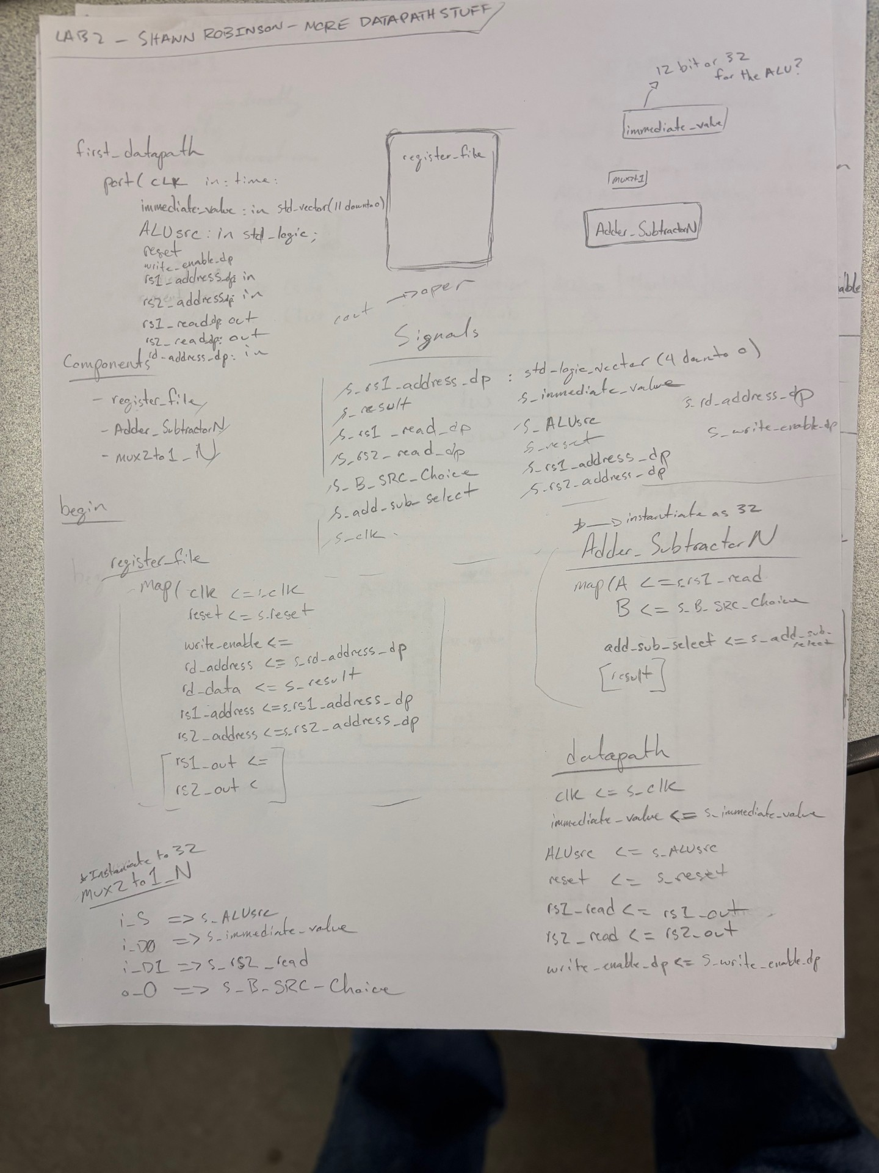

[Part 4 (c)] Draw a schematic of the simplified RISC-V processor datapath consisting only of the component described in part (a) and the register file from problem (1).

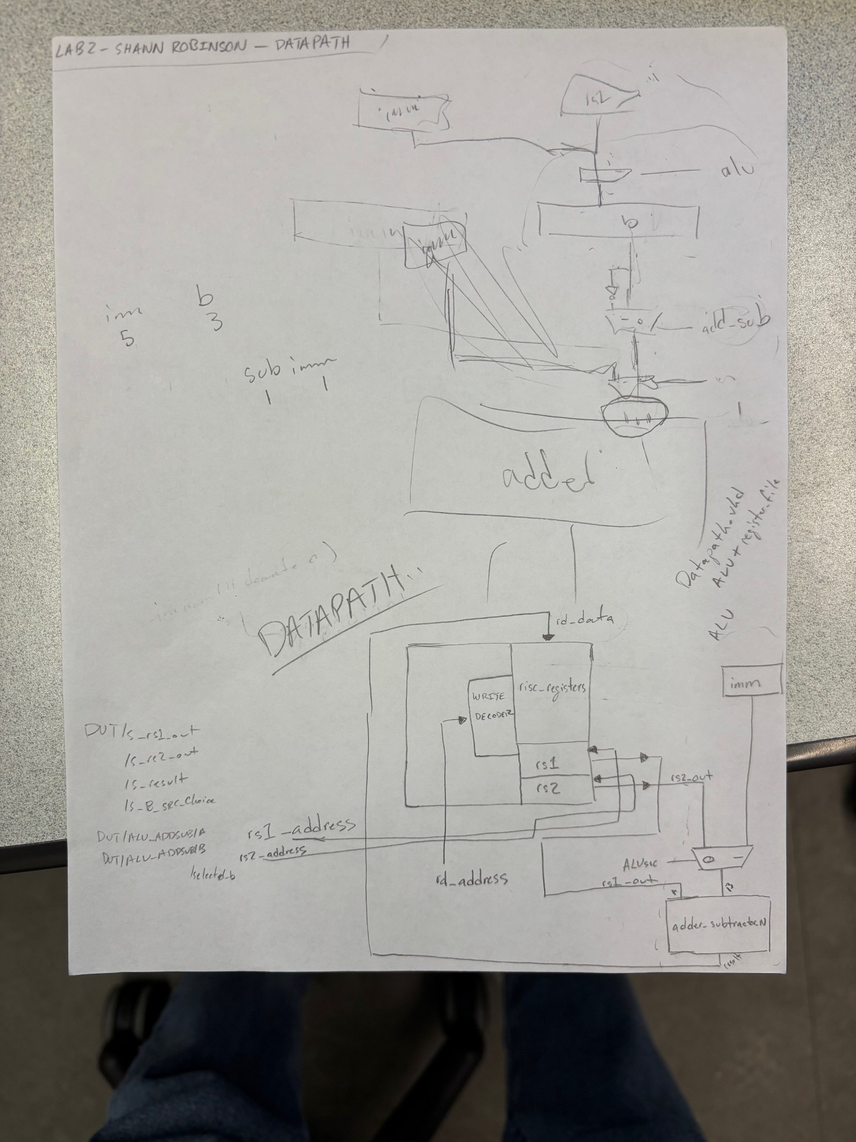

[Part 4 (d)] Include in your report waveform screenshots that demonstrate your properly functioning design. Annotate what the final register file state should be.
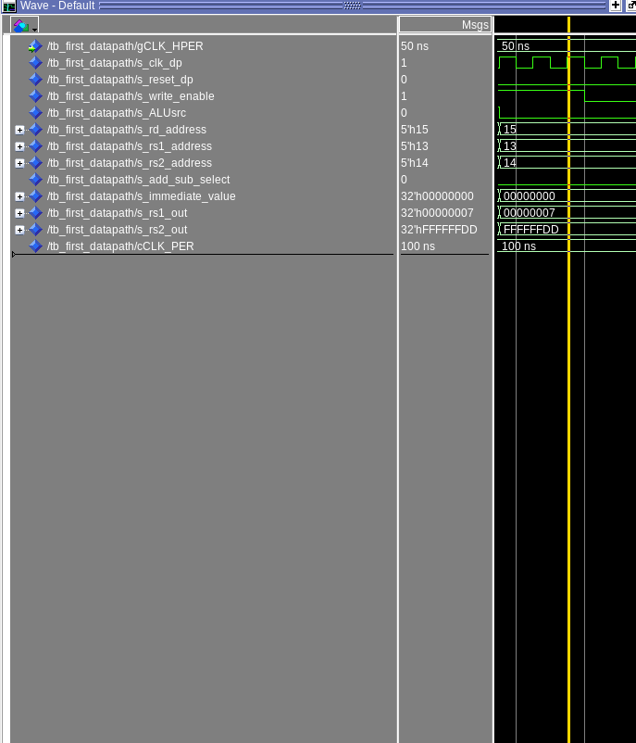

[Part 5 (a)] Read through the mem.vhd file, and based on your understanding of the VHDL implementation, provide a 2-3 sentence description of each of the individual ports (both generic and regular).

GENERIC PORTS:
DATA_WIDTH: sets a natural number (non-negative integer) size of 32 as the data width for actual memory at each data address.
ADDR_WIDTH: sets a natural number size of 10 for addresses of where that data will actually be stored.

REGULAR PORTS:
clk – works as it has throughout other parts of the lab. You need a clock for synchronous single-cycle actions

addr – an input address to where we want to write the data at
data – an input data signal (size 32-1 downto 0...so, it’s 32 bits as expected) that will be the actual written information
write_enable – input control signal that determines whether we are allowed to write or not
q – looking down at the process below, if it’s a rising clock edge, and if write enable is set, then ram will write “data” AT “addr”. Once that process is over q will be written to with the data that is currently IN “addr”...this output will help us verify that our write was successful, it seems.

[Part 5 (c)] Waveforms and hex file.
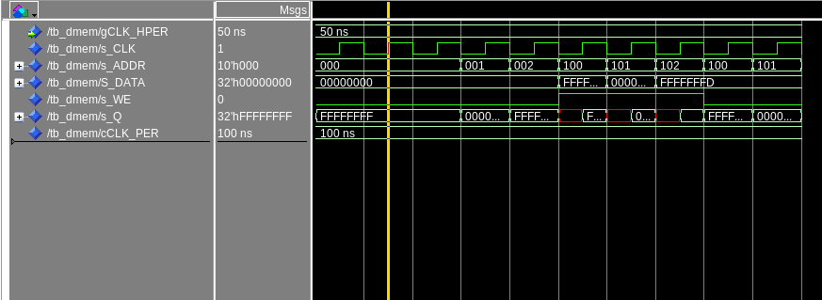
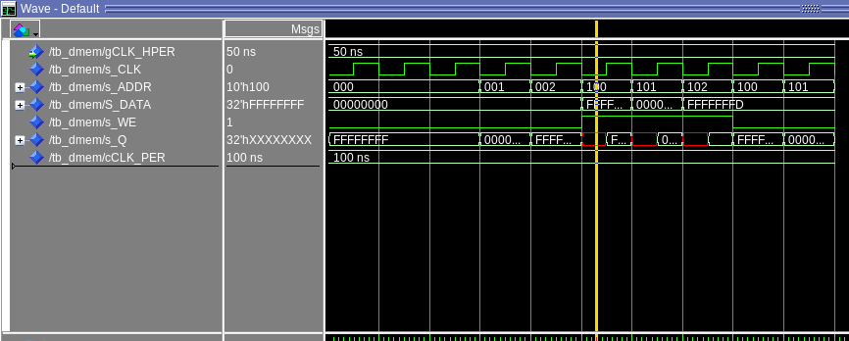

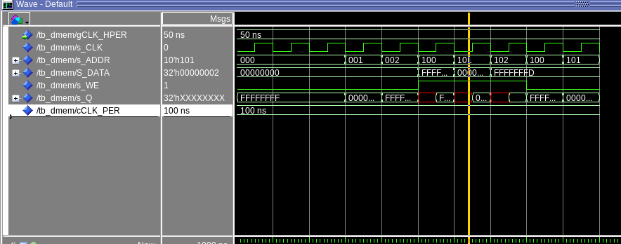

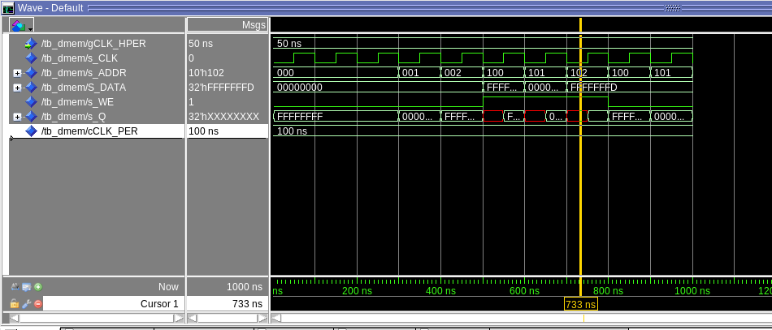

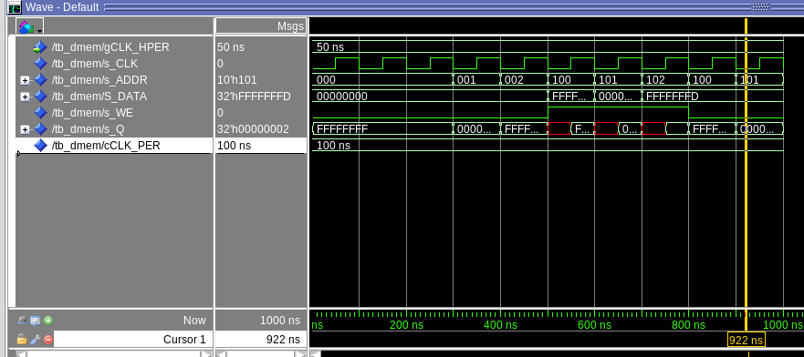

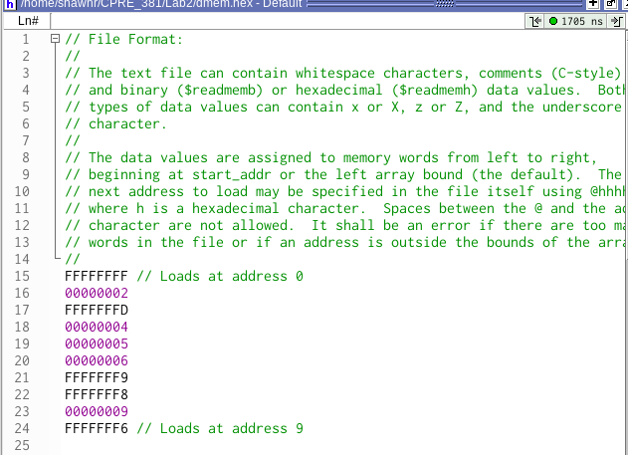

[Part 6 (a)] What are the RISC-V instructions that require some value to be sign extended? What are the RISC-V instructions that require some value to be zero extended?
The instructions that require some value to be sign extended are…(12 bit immediate field)
addi, slti, sltiu, xori, ori, andi
lb, lh, lw, lbu, lhu,
sb, sh, sw
beq, bne, blt, bge, bltu, bgeu
jalr,
lui, auipc

The instructions that require some value to be zero extended are…(memory data only)
lbu, lhu

[Part 6 (b)] what are the different 16-bit to 32-bit “extender” components that would be required by a RISC-V processor implementation?
In general you would also need an 8-bit to 32-bit extender the lab document tell us, but we just need a 12-bit extender for sign and for zeroes to 32-bit
[Part 6 (d)] Waveform.
The following two pictures show sign extension working both with all F’s and all zeroes
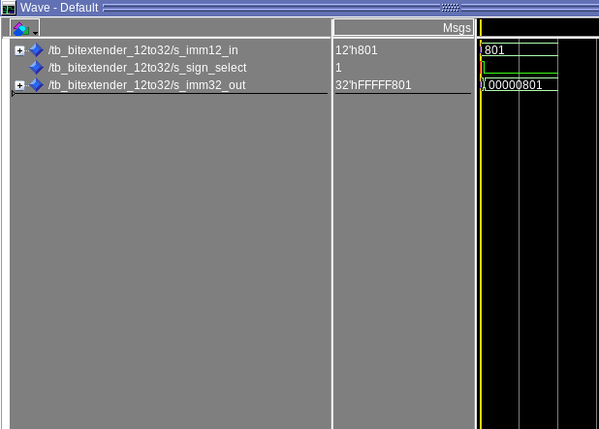
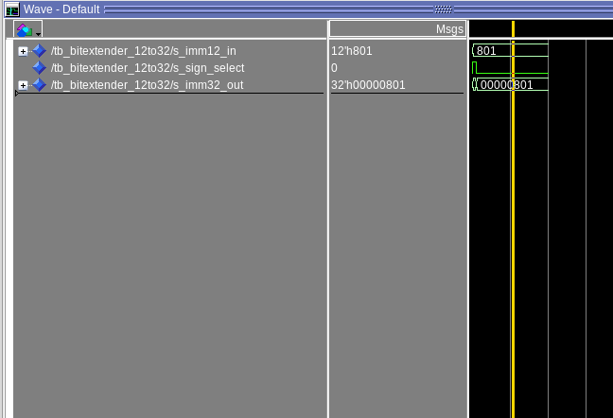
[Part 7 (a)] what control signals will need to be added to the simple processor from part 2? How do these control signals correspond to the ports on the mem.vhd component analyzed in part 3?
We need to add control signals for MemToReg, and MemWrite. MemWrite corresponds to “we” on the mem entity. MemToReg coreresonds to data, as this new mux will either take in “q”, the data from the Memory Block, or it will take in my “Result” from the Adder_SubtractorN component.

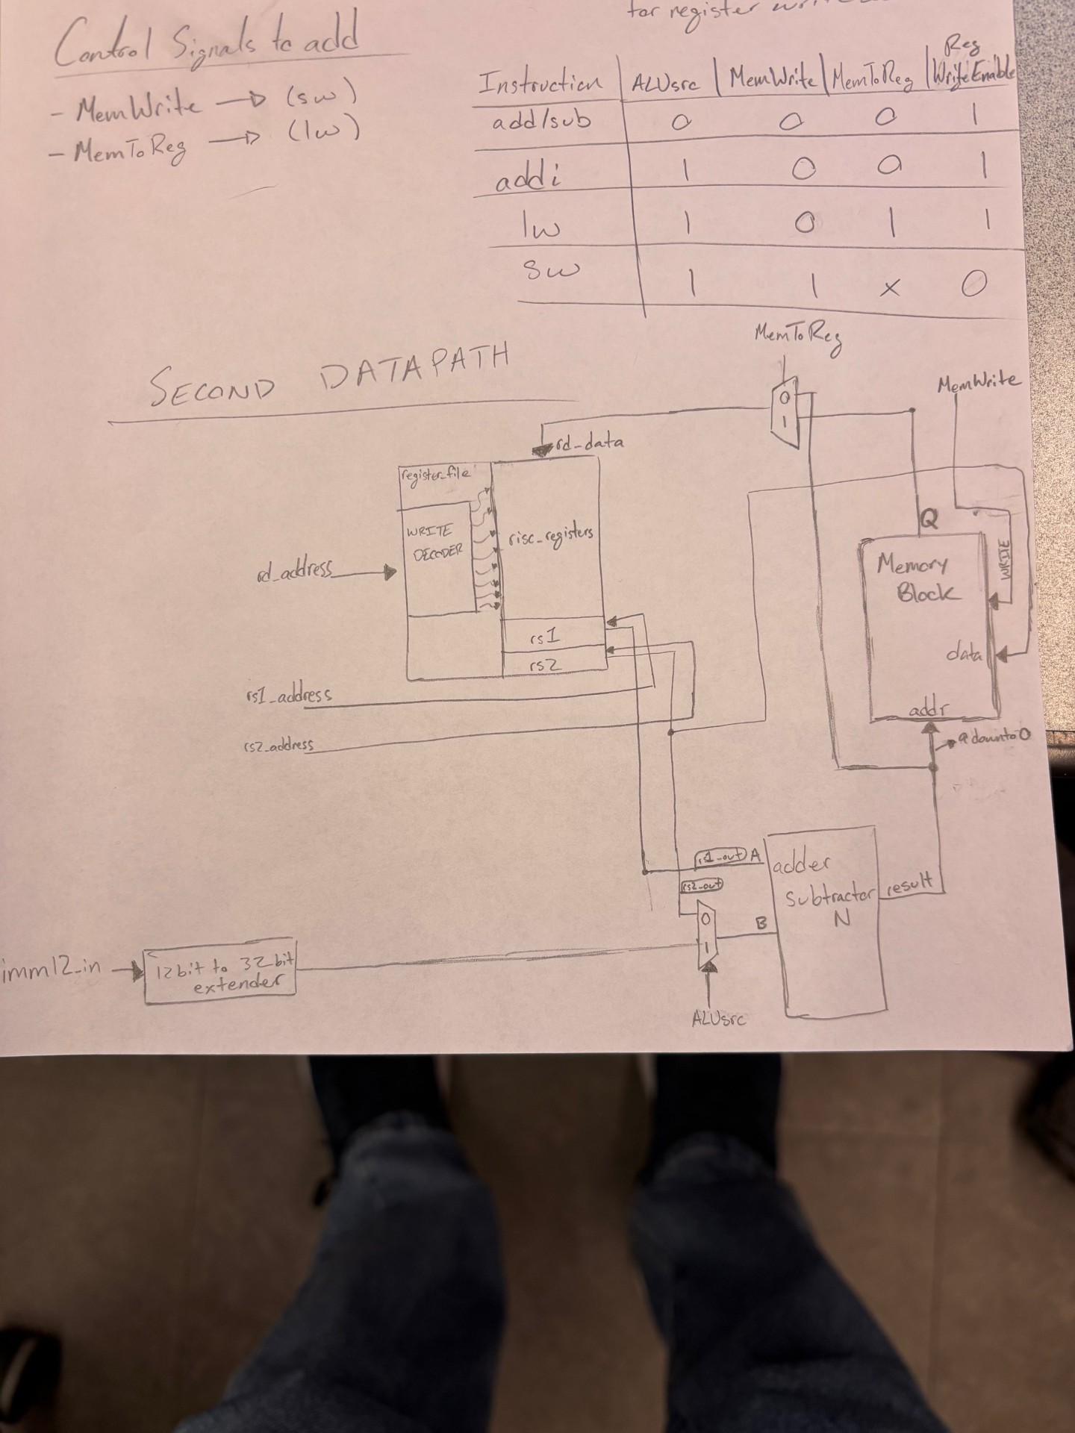
[Part 7 (b)] Draw a schematic of a simplified RISC-V processor consisting only of the base components used in part 2, the extender component described in part 4, and the data memory from part 3.

[Part 7 (c)] Waveform.
