CprE 3810: Computer Organization and Assembly-Level Programming

Project Part 2 Report

Team Members: Shawn Robinson

Jay Patel

Project Teams Group #: IS_01

Refer to the highlighted language in the project 1 instruction for the context of the following questions.

[1.a] Come up with a global list of the datapath values and control signals that are required during each pipeline stage.
IF | PC  Instr  PC Plus 4
ID | PC  Instr  PC Plus 4
EX | PC  Instr  PC Plus 4  rs1  rs2  immediate generated  [CONTROLS]  ALUSrc  ALUCtrl  isLUI  isAUIPC  Jump  Branch  PC SRC  MemWrite  MemRead  RegWrite  MemToReg
MEM | PC  Instr  PC Plus 4  rs2  ALU Result  Jump  Branch  PC SRC  MemWrite  MemRead  RegWrite  MemToReg
WB | PC  Instr  PC Plus 4  ALU Result  DMemOut  Rd Addr  Halt

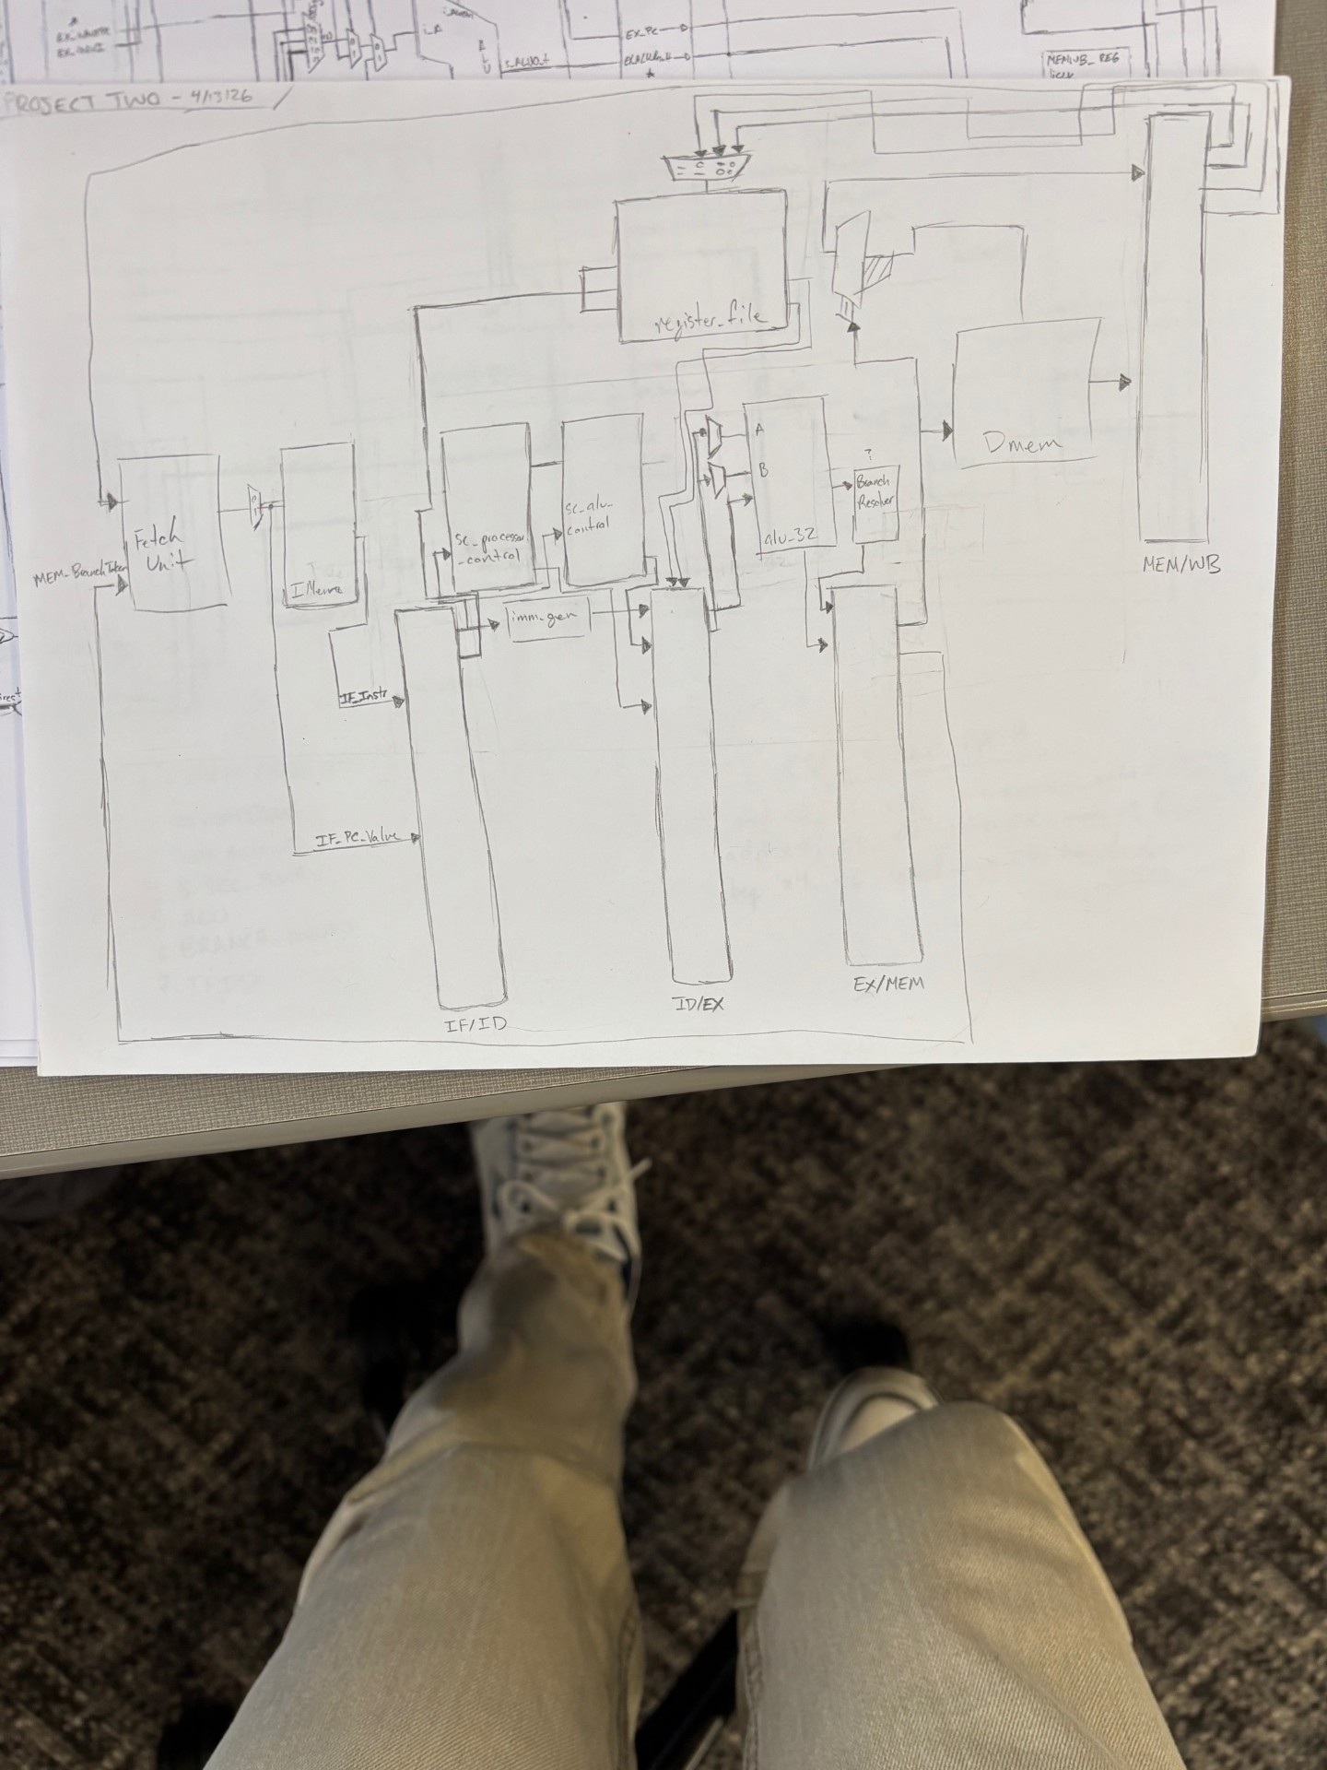
[1.b.ii] high-level schematic drawing of the interconnection between components.

[1.c.i] include an annotated waveform in your writeup and provide a short discussion of result correctness.

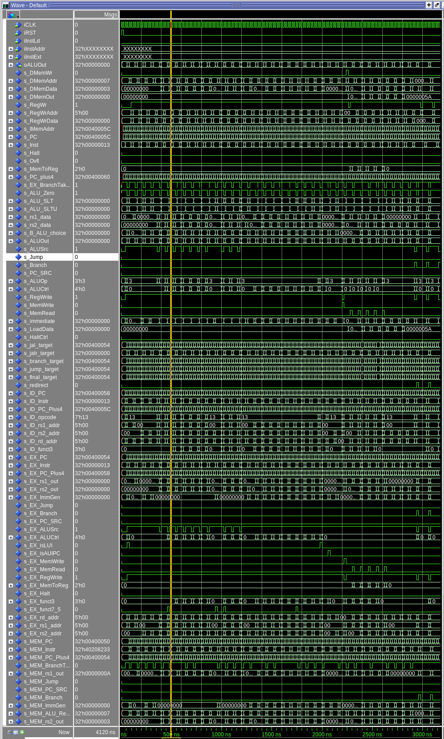

[1.c.ii] Include an annotated waveform in your writeup of two iterations or recursions of these programs executing correctly and provide a short discussion of result correctness. In your waveform and annotation, provide 3 different examples (at least one data-flow and one control-flow) of where you did not have to use the maximum number of NOPs.

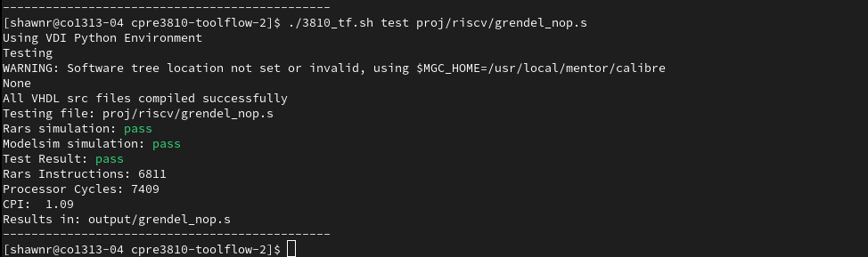

[1.d] report the maximum frequency your software-scheduled pipelined processor can run at and determine what your critical path is (specify each module/entity/component that this path goes through).
Maximum frequency: 51.04 MHZ
Critical Path: IDEX_REG > B_SRC_MUX > ALU > ALU output mux > branch_resolver > s_redirect > sw_fetch_unit (pc register)

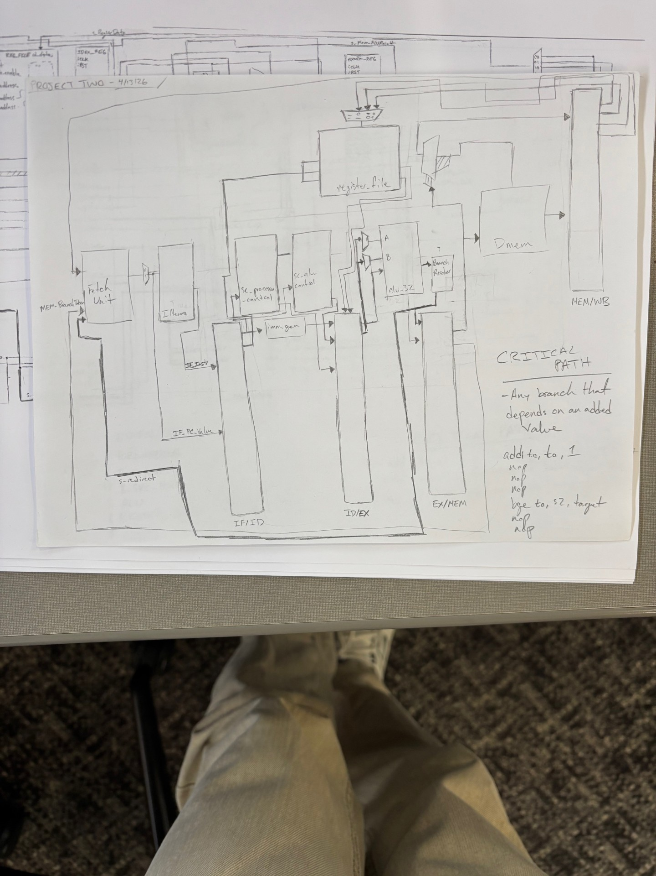

[2.a.ii] Draw a simple schematic showing how you could implement stalling and flushing operations given an ideal N-bit register.

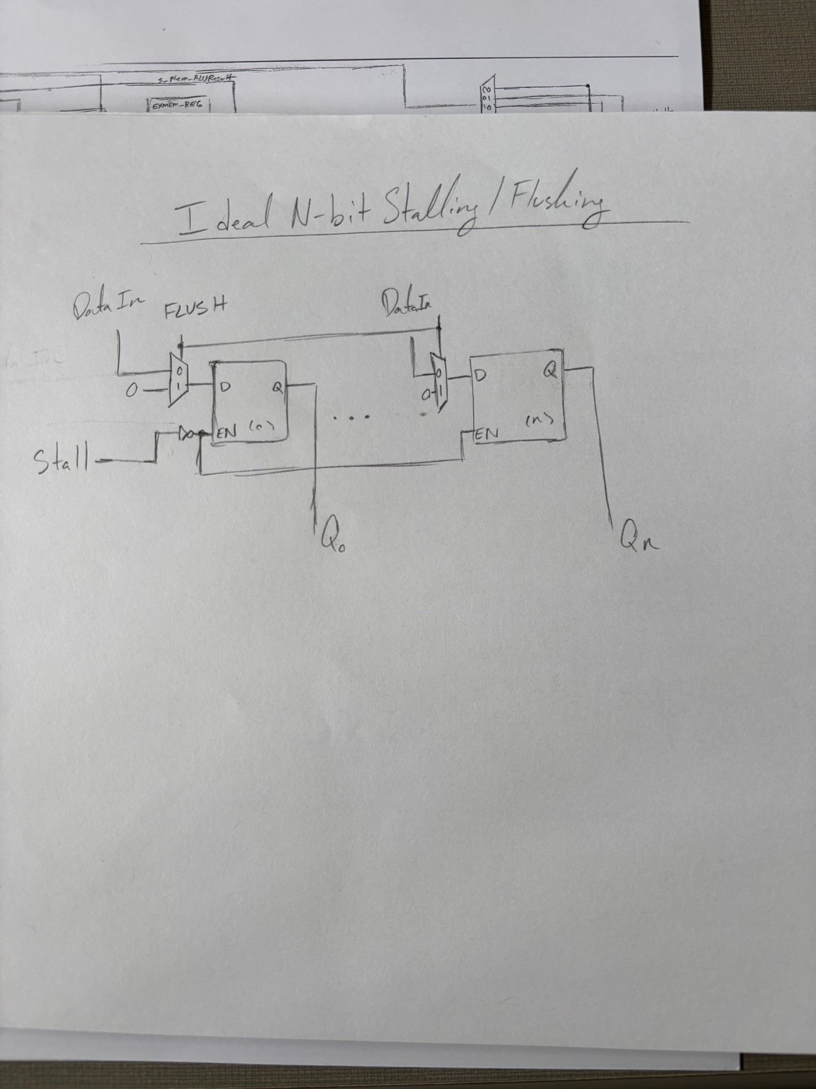

[2.a.iii] Create a testbench that instantiates all four of the registers in a single design. Show that values that are stored in the initial IF/ID register are available as expected four cycles later, and that new values can be inserted into the pipeline every single cycle. Most importantly, this testbench should also test that each pipeline register can be individually stalled or flushed.

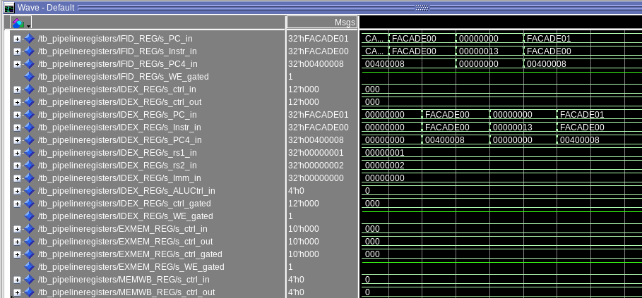

[2.b.i] list which instructions produce values, and what signals (i.e., bus names) in the pipeline these correspond to.
Type | Instructions | Produced value | Pipeline signals
R | Add, sub, and, or, xor, slt, sltu, sll, srl, sra | Rd = ALU result | s_ALUOut  s_MEM_ALU_Result  s_WB_ALU_Result  s_RegWrData
I | Addi, andi, ori, xori, slti, sltiu, slli, srli, srai | Rd = ALU result | s_ALUOut  s_MEM_ALU_Result  s_WB_ALU_Result  s_RegWrData
Load | Lw, lh, lb, lhu, lbu | Rd = memory data | s_ALUOUt  s_DmemOut  s_LoadData  s_WB_DmemOut  s_RegWrData
JAL/JALR | Jal, jalr | Rd = PC + 4 | s_EX_PC_Plus4  s_MEM_PC_Plus4  s_WB_PC_Plus4  s_RegWrData
LUI | Lui | Rd = Immediate | s_ALUOut  s_MEM_ALU_Result  s_WB_ALU_Result  s_RegWrData
AUIPC | Auipc | Rd = PC + immediate | s_ALUOut  s_MEM_ALU_Result  s_WB_ALU_Result  s_RegWrData
Store | Sw, sh, sb | mem[addr] = rs2 | s_EX_rs2_fwd  s_MEM_rs2_out  s_DmemData  s_DmemWr

[2.b.ii] List which of these same instructions consume values, and what signals in the pipeline these correspond to.

Type | Instructions | consumed value | Pipeline signals
R | Add, sub, and, or, xor, slt, sltu, sll, srl, sra | Rs1, rs2 | s_rs1_data,  s_rs2_data,  s_EX_rs1_fwd,  s_EX_rs2_fwd,  s_ALU_A,  s_B_ALU_choice
I | Addi, andi, ori, xori, slti, sltiu, slli, srli, srai | rs1 | s_rs1_data,  s_EX_rs1_fwd  s_ALU_A
Load | Lw, lh, lb, lhu, lbu | rs1 | s_rs1_data,  s_EX_rs1_fwd,  s_ALU_A,  s_DMemAddr
JAL | Jal | xx | s_EX_PC
LUI | Lui | xx | xx
AUIPC | Auipc | Rd = PC + immediate | s_EX_PC
Store | Sw, sh, sb | rs1 | s_rs1_data  s_EX_rs1_fwd  s_ALU_A  s_DmemAddr  s_rs2_data  s_EX_rs2_fwd  s_MEM_rs2_out  s_DmemData
JALR | Jalr | rs1 | s_rs1_data  s_EX_rs1_fwd
Branch | Beq, bne, blt, bge, bltu, bgeu | Rs1, rs2 | s_rs1_data  s_rs2_data  s_EX_rs1_fwd  s_EX_rs2_fwd  s_ALU_A  s_B_ALU_choice

[2.b.iii] generalized list of potential data dependencies. From this generalized list, select those dependencies that can be forwarded (write down the corresponding pipeline stages that will be forwarding and receiving the data), and those dependencies that will require hazard stalls.

Producer | Consumer | Condition | Forwarding Possible?
EX/MEM | EX(rs1) | Mem_RegWrite = 1  AND  Mem_rd != x0  AND  MEM_rd = EX_rs1 | YES  s_MEM_ALU_Result > s_EX_rs1_fwd
EX/MEM | EX(rs2) | Mem_RegWrite = 1  AND  Mem_rd != x0  AND  MEM_rd = EX_rs2 | YES  s_MEM_ALU_Result > s_EX_rs2_fwd
EX/MEM | EX(store) | MEM_RegWrite = 1  AND  MEM_rd != x0  AND  MEM_rd = EX_rs2 | YES  s_MEM_ALU_Result > s_EX_rs2_fwd >  s_MEM_rs2_out
MEM/WB | EX(rs1) | WB_RegWrite = 1  AND  WB_rd != x0  AND  WB_rd = EX_rs1  AND EX != MEM | YES  s_RegWrData > s_EX_rs1_fwd
MEM/WB | EX(rs2) | WB_RegWrite = 1  AND  WB_rd != x0  AND  WB_rd=EX_rs2  AND EX != MEM | YES  s_RegWrData > s_EX_rs2_fwd
WB | ID(rs1) | WB_RegWrite = 1  AND  WB_rd != x0  AND  WB_rd = ID_rs1 | YES  s_RegWrData > s_rs1_data
WB | ID(rs2) | WB_RegWrite = 1  AND  WB_rd != x0  AND  WB_rd = ID_rs2 | YES  s_RegWrData > s_rs2_data
EX/MEM | EX | EX_MEMRead = 1  AND  EX_rd != x0  AND  (EX_rd=ID_rs1  OR  EX_rd=ID_rs2) | NO!

[2.b.iv] global list of the datapath values and control signals that are required during each pipeline stage

IF | PC  Instr  PC Plus 4
ID | PC  Instr  PC Plus 4
EX | PC  Instr  PC Plus 4  rs1  rs2  immediate generated  [CONTROLS]  ALUSrc  ALUCtrl  isLUI  isAUIPC  Jump  Branch  PC SRC  MemWrite  MemRead  RegWrite  MemToReg
MEM | PC  Instr  PC Plus 4  rs2  ALU Result  Jump  Branch  PC SRC  MemWrite  MemRead  RegWrite  MemToReg
WB | PC  Instr  PC Plus 4  ALU Result  DMemOut  Rd Addr  Halt

[2.c.i] list all instructions that may result in a non-sequential PC update and in which pipeline stage that update occurs.
Instruction | Pipeline Stage
Beq | EX
Bne | EX
Blt | EX
Bge | EX
Bltu | EX
Bgeu | EX
Jal | EX
Jalr | EX

[2.c.ii] For these instructions, list which stages need to be stalled and which stages need to be squashed/flushed relative to the stage each of these instructions is in.

Instruction | Stages to Stall | Stages to Flush
Beq |  | IF & ID
Bne |  | IF & ID
Blt |  | IF & ID
Bge |  | IF & ID
Bltu |  | IF & ID
Bgeu |  | IF & ID
Jal |  | IF & ID
Jalr |  | IF & ID

[2.d] implement the hardware-scheduled pipeline using only structural VHDL. As with the previous processors that you have implemented, start with a high-level schematic drawing of the interconnection between components.
I attached the schematic underneath the timing output stuff!

[2.e – i, ii, and iii] In your writeup, show the QuestaSim output for each of the following tests, and provide a discussion of result correctness. It may be helpful to also annotate the waveforms directly.

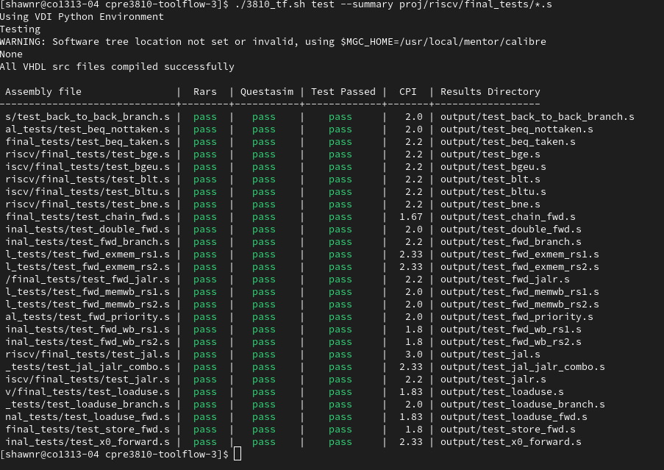

[2.e.i] Create a spreadsheet to track these cases and justify the coverage of your testing approach. Include this spreadsheet in your report as a table.

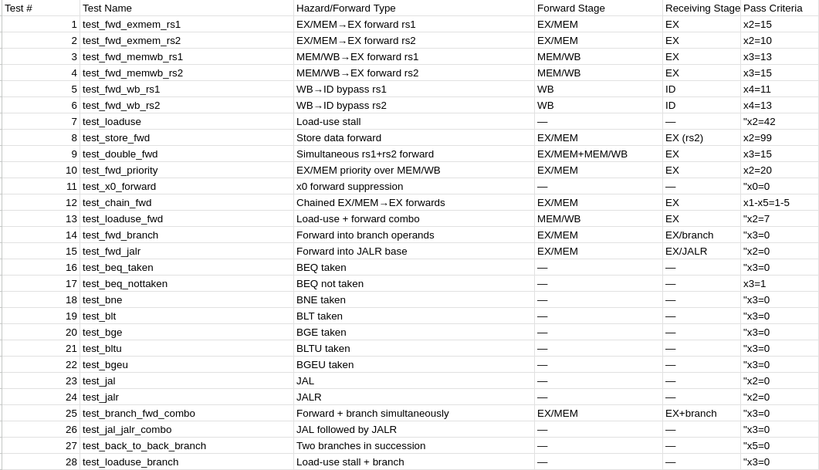

[2.e.ii] Create a spreadsheet to track these cases and justify the coverage of your testing approach. Include this spreadsheet in your report as a table.

[2.f] report the maximum frequency your hardware-scheduled pipelined processor can run at and determine what your critical path is (specify each module/entity/component that this path goes through).

Maximum frequency: 41.12 MHZ
Critical Path: EX/MEM> FORWARDING > FWD_MUX_B > B_SRC_MUX > ALU > BRANCH_COND > IF/ID
