**Predictive Capabilities of Machine Learning in Interpreting Fetal Cardiotocography Readings**

**Executive Summary**

**Shawn Chapler**

**Background**

Cardiotocography (CTG) was first introduced in 1957, by Dr. Orvan Hess and Dr. Edward Hon as a means to monitor a baby’s heartbeat in utero. The electronic fetal monitor is used to measure fetal heart rate in conjunction with uterine contractions which produces a visual representation in the form of a tracing that is read and interpreted by a physician. The use of CTG’s can distinguish a normal heart pattern from on that is suspect or pathological. In particular, it is used to detect fetal oxygenation levels. Interpretation of the CTG’s is highly subjective resulting in both intra and inter-observer variability. Additionally, multiple fetal heart rate guidelines can be applied which also impacts interpretation and intervention points. [1] [2] [3] Extensive research in the impact of CT monitoring has identified the use of CTG during labor to be associated with higher rates of Cesearean sections as well as instrument assisted deliveries (e.g. suction, forceps), but has not led to a decrease in the risk of fetal hypoxia/acidosis or brain injury due to lack of oxygen [4]

This study aims to use machine learning techniques to create a clinical decision support solution that applies consistent interpretation techniques to reduce intra and inter-observer variability and the reduction of the false positive rate. This study specifically focuses on the classification of “suspect” readings into an actionable state.

**Study**

The study was performed on a dataset of 2126 fetal cardiotocograms which included twenty-one features and a fetal response variable with three levels, Normal, Suspect, or Pathologic, as classified by three expert obstetricians. Normal readings are indicative of reassuring fetal health while pathologic is indicative of physician intervention while suspect is indeterminate leaving decision support exclusively to the physician. The dataset was originally published by the SisPorto 2.0 research team which was then obtained through Kaggle [4] [6] No existing kernels from Kaggle were used in this analysis.

Principal components analysis (PCA) was selected for feature extraction which were then fed into a decision tree model for dimension reduction through cross validation techniques and fetal state classification. Performance of the model in each step was measured in its accuracy rate, true positive rate, false positive rate, and area under the curve (AUC) as outlined in Table 1.

PCA was selected to address feature interactions known to exist in the data set. Multiple variables measure accelerations, decelerations, and variability in the fetal heart rate. Removing the NSP response variable, PCA components were calculated. Principal components 1 and 2 were compared against the known NSP response variables to visually detect separation of classes. Figure 1 indicates there is visual separation between the normal and pathologic readings, the suspect readings have the tendency to overlap both groups and have the greatest amount of variation. Further exploration was performed on each NSP level utilizing biplots. The vectors in each NSP level showed distinct characteristics. Normal readings showed strong movement in a uniform direction. The pathologic readings showed two distinctive groups reflective of heart rates at both ends of the spectrum which are in effect indications of bradycardia < 110 BPM or tachycardia > 160 BPM.. The suspect readings showed a strong propensity in direction and strength similar to the normal readings with weaker indications in the opposite direction indicating a likelihood of pathologic points. This reaffirmed the studies goal of classification predictions that are more definitive and prescriptive in nature.

Figure Principal Components Feature Selection and Prediction Comparison

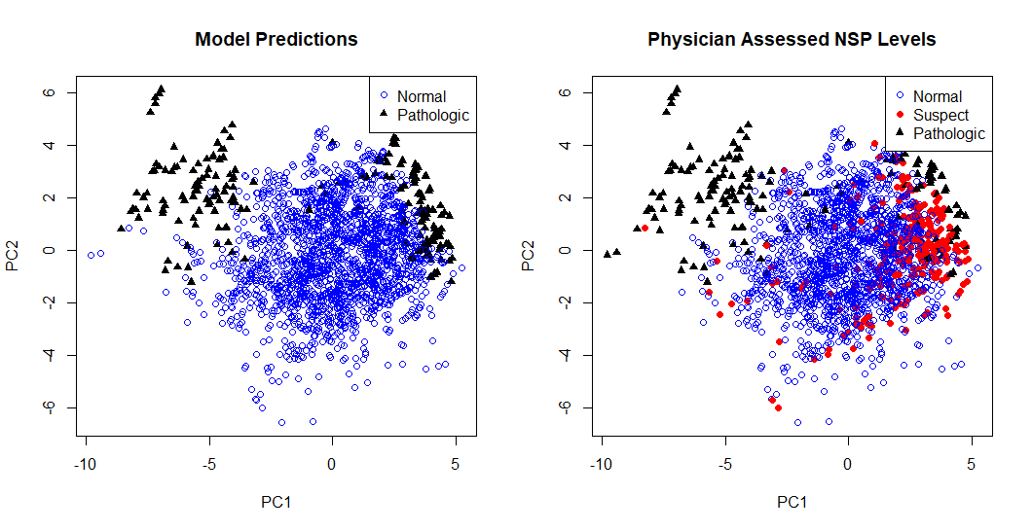

Principal components analysis was performed on the 1,831 records with normal and pathologic readings (NSP = 1 or NSP =3) utilizing the twenty-one available features. The principal components were then added to the 1,831 records retaining only the NSP outcome of 1 or 3 which were then fed into a decision tree model for model training and validation utilizing cross validation techniques.

The initial decision tree was pruned through cross validation for feature reduction while retaining the ability to explain 97% of the variance. The simplified model minimizing the deviance was selected for use in model assessment. Ten-fold cross validation was applied as the data was subset into training and validation groups to assess the model’s true predictive capabilities. As show in table 1, the final model obtained a classification accuracy rate of .98689 while also improving the false positive rate.

Table Model Performance Summary

|  |  |  |  |  |  |
| --- | --- | --- | --- | --- | --- |
| Model | Data Set | Accuracy Rate | True Positive Rate | False Positive Rate | AUC |
| Decision Tree | Training | .98744 | .8921 | .00242 | .9819 |
| Pruned  Decision Tree | Training | .98689 | .875 | .00121 | .987 |
| Pruned  Decision Tree | CV10 | .98689 | .88443 | .00125 | .98849 |

Recommendation:

We feel there is sufficient evidence in this early study to move forward with a partner friendly institution. This is type of decision support is desired in the field [7].

While the results of this study were encouraging as a proof of concept, this study lacks several important components including: actual patient outcomes, corroborating the physician interpretation; fetus age, directly correlates with acceptable baselines; and pertinent mother’s medical history, smoking or drug usage known to influence fetal heart rate, are needed to refine and strengthen the classification model.

Citations and Bibliography

|  |  |
| --- | --- |
| [1] | "Available to view: FIGO Intrapartum Fetal Monitoring Guidelines," 23 11 2015. [Online]. Available: https://www.figo.org/news/available-view-figo-intrapartum-fetal-monitoring-guidelines-0015088. |
| [2] | "Interpretation of cardiotocograph traces," 02 2017. [Online]. Available: https://www.nice.org.uk/guidance/cg190/resources/interpretation-of-cardiotocograph-traces-pdf-248732173. [Accessed 13 08 2018]. |
| [3] | "ACOG The American College of Obstetricians and Gynecologists," 2017. [Online]. Available: https://www.acog.org/. [Accessed 13 08 2018]. |
| [4] | I. PN, "Recent Advances in Computerized Fetal Monitoring in Labor," *Austin Journal of Obsterics and Gynecology,* vol. 5, no. 3, 2018. |
| [5] | N. Cohen, "Cardiotocography under a microscope," Kaggle, 12 2017. [Online]. Available: https://www.kaggle.com/propanon/cardiotocography-under-a-microscope/data. [Accessed 02 08 2018]. |
| [6] | C. e. al, "SisPorto 2.0 A Program for Automated Analysis of Cardiotocograms," *J Matern Fetal Med,* vol. 5, pp. 311-318, 2000. |
| [7] | M. Robert Stewart, *What fetal hear rate monitoring can-and can't-tell us,* Dallas : UT Southestern Medical Center, 2015. |