Critical Thinking Week 1

Shawn Conner
Colorado State University Global
Course Code: CSC507
Dr Issa
01/18/2026

Critical Thinking Week 1
Processor
Depending on the level of details needed there are several ways to get processor details on a Linux system. The command “nproc” will output the number of processors. If more detailed information is needed, you can use the command “lscpu”. Another option is to open the file “/prod/cpuinfo” (Penmetsa, 2022). The Ubuntu sever the below output was run on has two ARM CPUs. This VM is running on a Mac computer with Apple M4 chips which are ARM based.
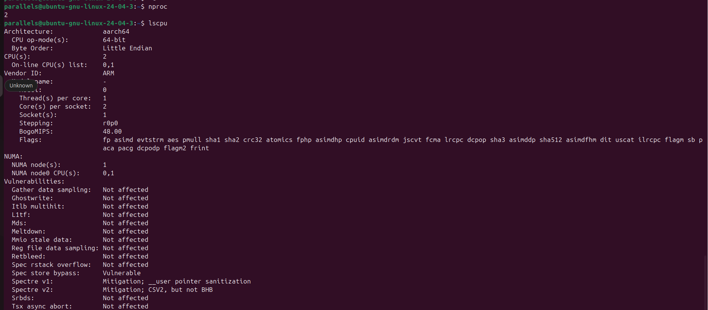

Main Memory
Like getting the number of processors on a Linux computer there are several ways to get details around the amount of main memory. The first option shown below is looking at the file “/prod/meminfo”. This below command is doing a grep command as well to only get the line in the file that shows the MemTotal. The command “free” will print out details around the amount of main memory as well as the details around swap. If you add the “-h” option to the “free” command it will show the output in “human readable” (Penmetsa, 2022). The output below indicates that the VM has 3.8 gibibytes allocated. When the VM was setup 4 gigabytes of memory were allocated. Gigabyte and gibibyte are two different ways of measuring memory or storage. A gibibyte is equal to 2^30 bytes and a gigabyte is equal to 10^9 bytes (Peterson, 2023).
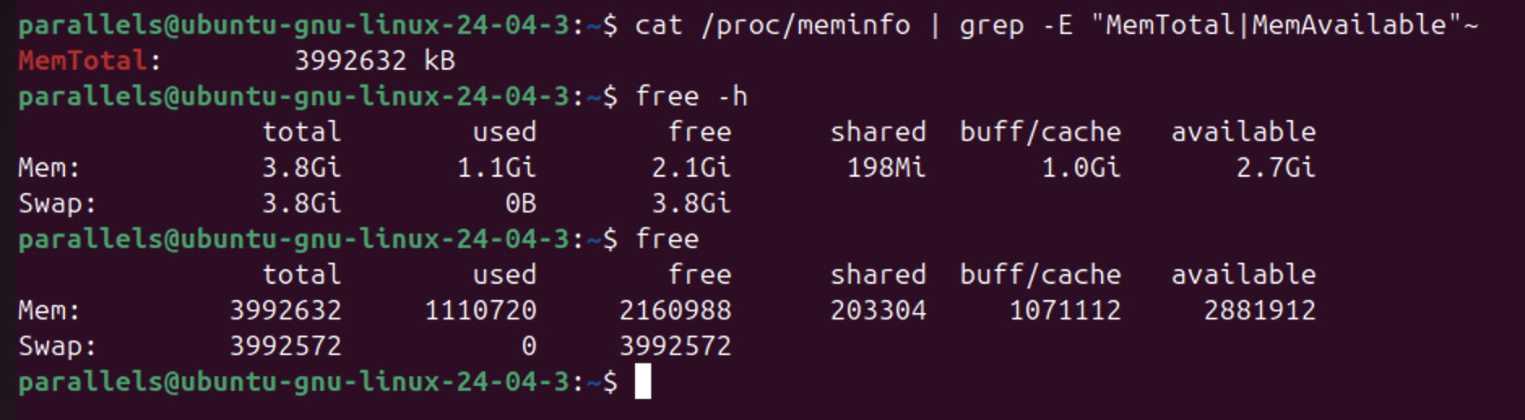
I/O Modules
The below output shows that the Linux VM has one network interface and several USB devices attached. The command “lsub” shows the USB devices on Ubuntu Linux and the command “ip link show” shows the network devices. The command below output is also showing there is a mouse, keyboard and two cameras attached to the VM.
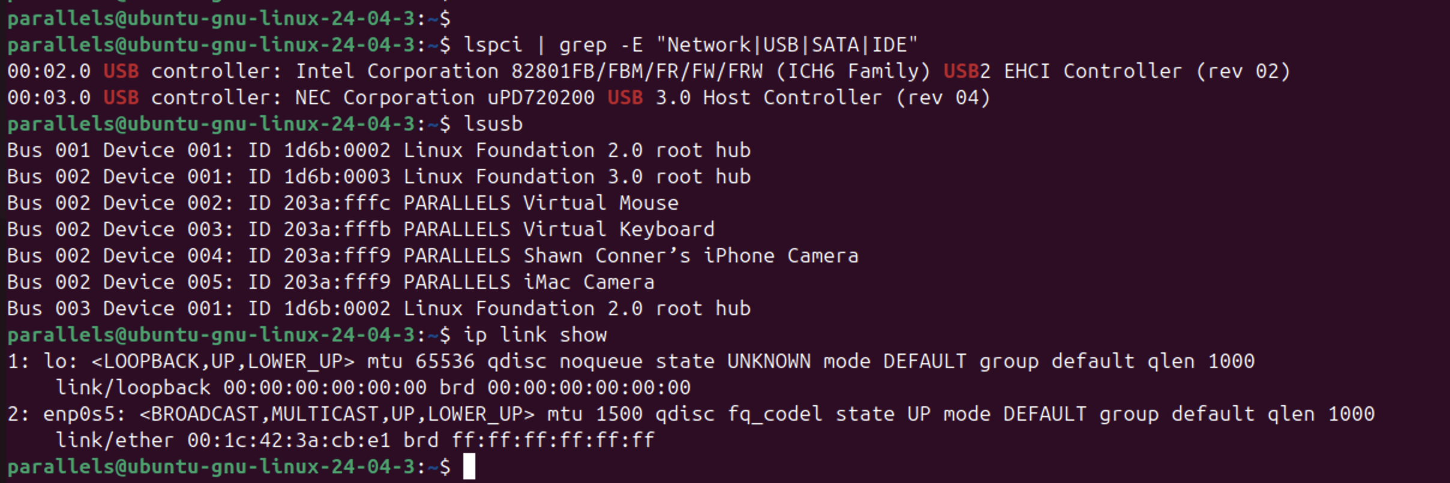
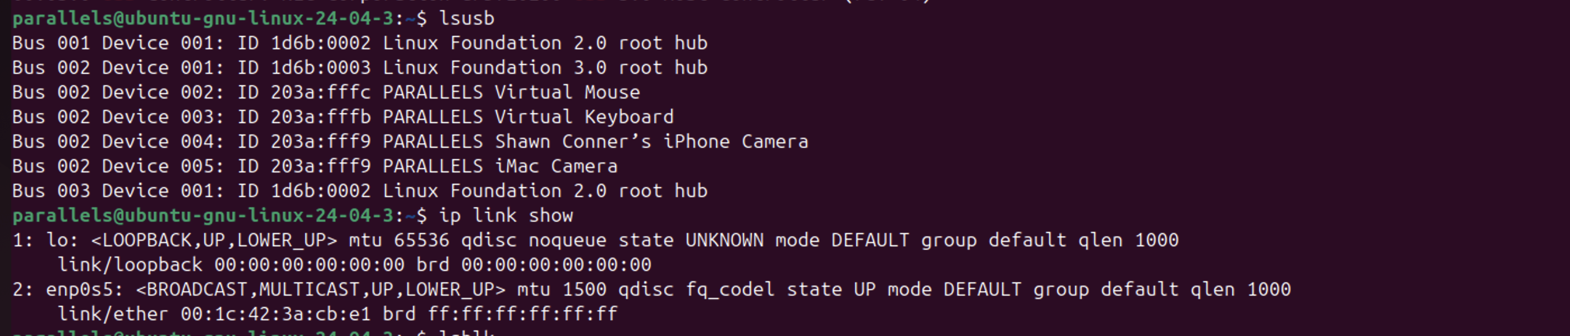
Storage devices
The command “lsblk” shows all the block devices attached to the machine. You can also get similar details by running the command “df” which will show details around the total size of the device, how much space is used and finally how much space is available. Both commands will show the mount point for the device on the Linux VM. Like the “free” command for memory you can pass the “-h” option to get an output that is “human readable”. The “sda” lines in the output below are the hard drive volumes on the Linux system. In the output below there is one volume for the boot device and another for the root file system. The output below also shows several loop devices which are defined as “a virtual or pseudo-device which enables a regular file to be accessed as a block device” (Nawalramka, 2023).
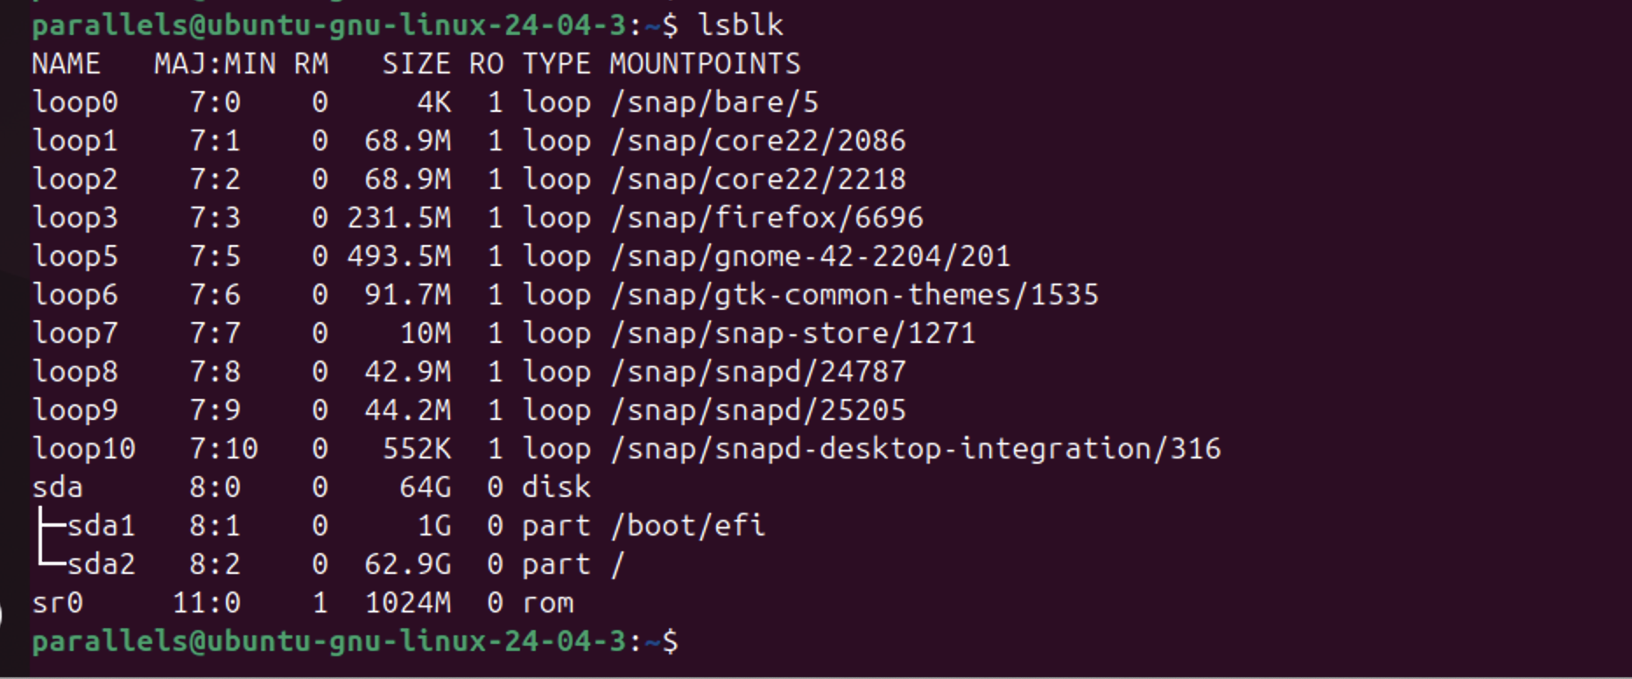
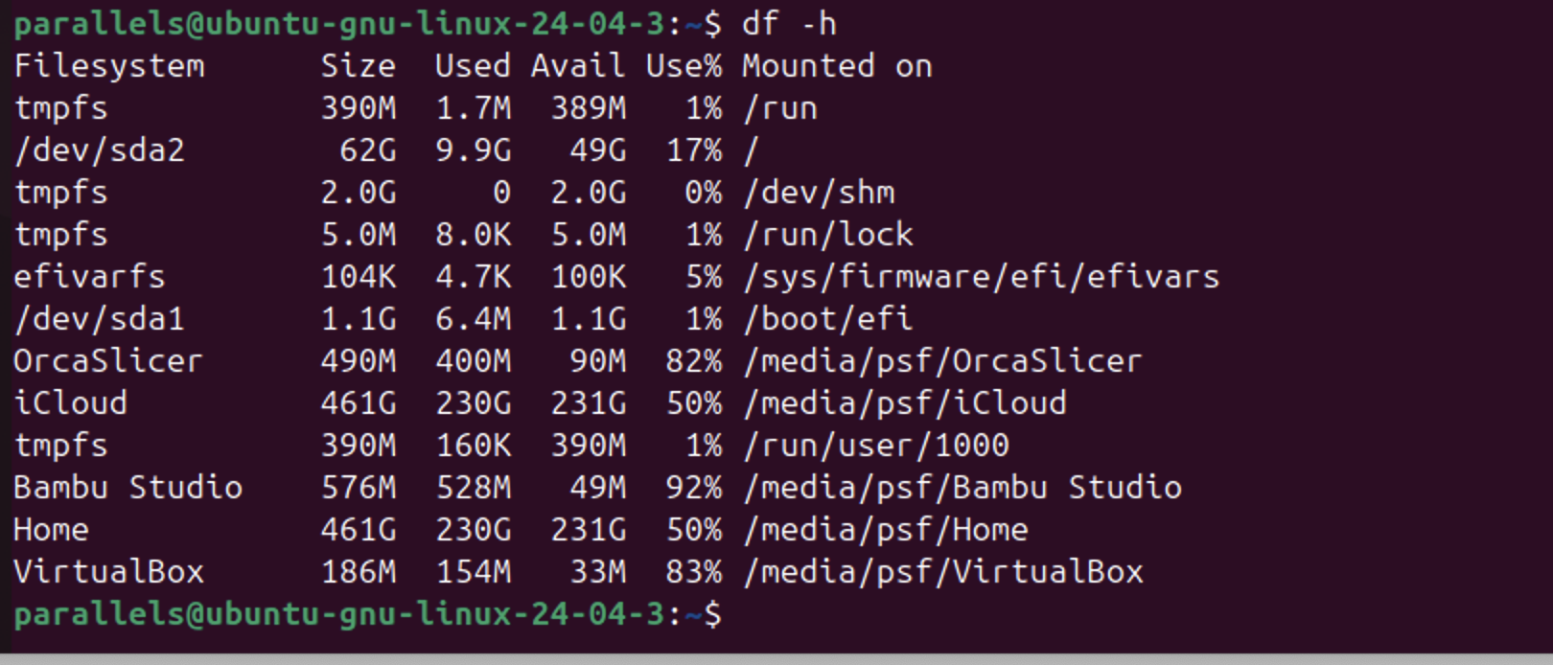

References
Nawalramka, P. (2023, March 23). Loop device in linux. Dzone. https://dzone.com/articles/loop-device-in-linux
Penmetsa, V. (2022, August 19). Basic system commands to get CPU, memory, and storage details in linux | by Vamsi Penmetsa | itversity | medium. Medium. https://medium.com/itversity/basic-system-commands-to-get-cpu-memory-and-storage-details-in-linux-9ee7f2778749
Peterson, S. (2023, June 2). What is gibibyte (GIB)?: Definition from TechTarget. Search Storage. https://www.techtarget.com/searchstorage/definition/gibibyte-GiB#:~:text=Gibibyte%20vs.-,gigabyte,to%20improve%20the%20reader%20experience.

