Portfolio Milestone Week 2

Shawn Conner
Colorado State University Global
Course Code: CSC507
Dr Issa
01/25/2026

Portfolio Milestone Week 2
Option #2: Using Python Programming language
- Generate a random number: echo $RANDOM
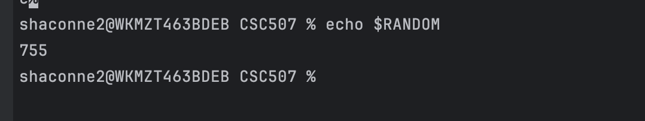
- Output a random number into a file called file1.txt: echo $RANDOM > file1.txt
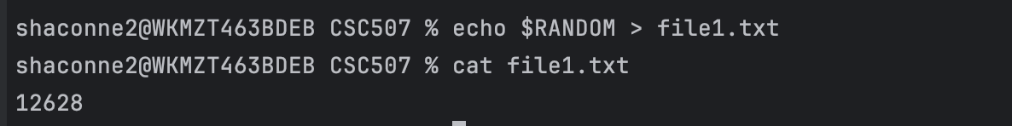
- Append another random number to the end of this file: echo $RANDOM >> file1.txt
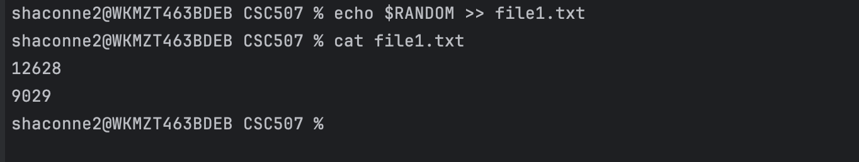

- Remove file1.txt: rm file1.txt
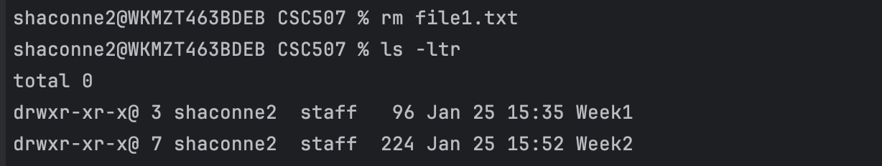
- Create a script called numbers.sh, that does this one thousand (1000) times, using the “for” loop.
- Make the script executable: chmod +x numbers.sh
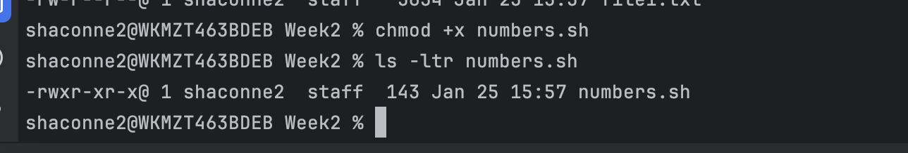
- Run the script: ./numbers.sh
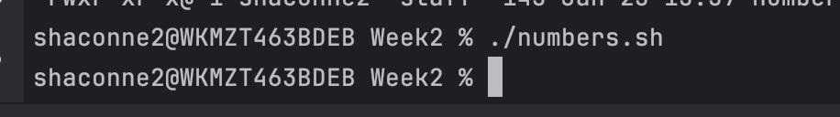
- Run “wc *”