WOC Marketing Performance Analysis
  - Prepared by: Sean Siracusa | WOC Marketing Team
KPMG Consulting Challenge – Track G

Purpose
Analyze WOC marketing spending, conversions, and revenue across channels using Tableau, and identify opportunities to improve marketing decisions. The dashboard uses the WOC marketing dataset and complements the SQL analysis.

Tableau Dashboard
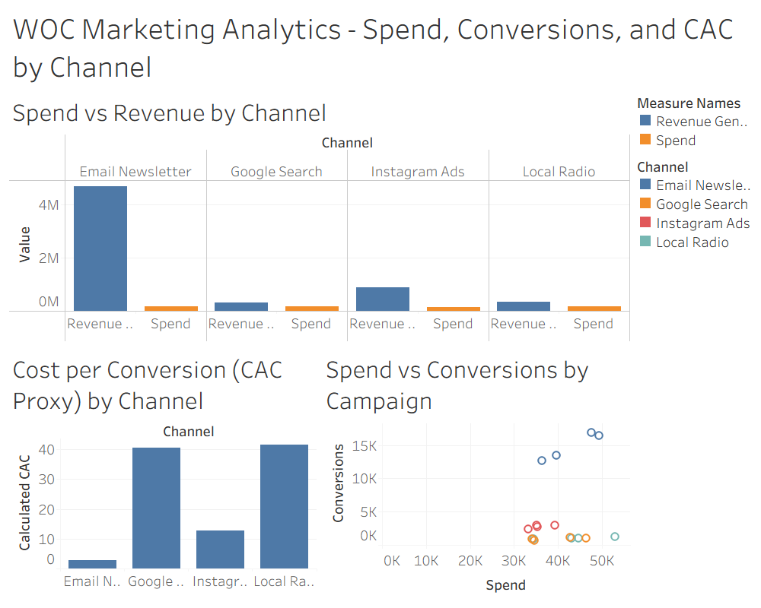
Figure 1. Marketing spending, revenue, cost per conversion, and campaign performance by channel.

Key Findings
- Email Newsletter was the most cost-efficient channel. Email generated the highest number of conversions and had the lowest cost per conversion at approximately $2.91.
- Instagram advertising performed better than Google Search and Local Radio. Instagram cost per conversion was approximately $12.87, compared with $40.55 for Google Search and $41.53 for Local Radio.
- Marketing performance varies significantly across channels. WOC can use these differences to evaluate marketing spending and identify opportunities to improve efficiency.

Connection Between Tableau and SQL Analysis
The Tableau dashboard and SQL analysis both show that Email Newsletter is WOC’s most cost-efficient marketing channel, followed by Instagram Ads. SQL helped calculate spending, conversions, revenue, and cost per conversion, while Tableau made these results easier to compare visually. Together, these tools help WOC identify which marketing channels are performing best and where spending could be improved.

Understanding the CAC Limitation
The dashboard measures cost per conversion (marketing spend divided by conversions). This is a proxy, not verified Customer Acquisition Cost (CAC), because the current marketing dataset does not independently identify new customers. True CAC would require reliable counts of newly acquired customers linked to marketing activity.

Business Recommendations
- WOC should test allocating more marketing resources to efficient channels such as Instagram while monitoring results.
- WOC should implement a centralized Marketing Information System that connects advertising, customer, and sales data.
- WOC should use Tableau dashboards to regularly monitor advertising spending, conversions, and campaign performance.

Improving Customer Acquisition Tracking
WOC should connect its marketing campaign data with customer and sales records to better understand which advertisements bring in new customers. Currently, the dashboard measures cost per conversion, but this does not necessarily represent the cost of acquiring a new customer. Connecting these systems would allow WOC to calculate more accurate customer acquisition costs and make better marketing decisions.

Suggested Implementation Steps
- Use a consistent campaign identifier across marketing, customer, and sales records.
- Validate data quality and distinguish new customers from repeat customers.
- Calculate verified CAC and monitor revenue by campaign in a centralized dashboard.
- Review results regularly and require appropriate privacy controls and human review before major budget changes.

Conclusion
Our Tableau analysis demonstrates that WOC could benefit from better marketing data integration. A centralized system would help managers make informed decisions, track customer acquisition costs more accurately, and improve marketing efficiency. Tableau and SQL provide a useful starting point, while linking customer and sales records is the next step toward a more complete Marketing Information System.

