WOC Track G
SQL Database Design & Marketing Analysis
Prepared by Sean Siracusa | KPMG Consulting Project – Marketing Information Systems

1. Project Overview
Wasatch Outfitters Collective (WOC) needs to connect marketing campaign information with customer and sales activity so managers can understand which campaigns are effective. For this SQL project, I designed four related tables and imported the WOC marketing CSV into a separate table, WOC_Marketing_Data. The imported dataset contains 800 marketing records.
The SQL analysis examines marketing spend, conversions, revenue, return on advertising spend (ROAS), monthly trends, and cost per conversion. The relational tables demonstrate a proposed structure for integrating customer and sales information; they have not yet been populated with customer-level or sales-level records.

2. Relational Database Design
The proposed system separates campaign information, customer acquisition, sales, and campaign results. Primary keys identify individual records, while foreign keys connect related information.

Campaigns
CREATE TABLE Campaigns (
campaign_id INTEGER PRIMARY KEY,
campaign_name TEXT NOT NULL,
channel TEXT NOT NULL,
spend REAL NOT NULL DEFAULT 0
);

Customers
CREATE TABLE Customers (
customer_id INTEGER PRIMARY KEY,
customer_name TEXT,
acquisition_date TEXT,
acquired_campaign_id INTEGER,
FOREIGN KEY (acquired_campaign_id)
REFERENCES Campaigns(campaign_id)
);

Sales
CREATE TABLE Sales (
sale_id INTEGER PRIMARY KEY,
customer_id INTEGER NOT NULL,
sale_date TEXT NOT NULL,
sale_type TEXT NOT NULL,
revenue REAL NOT NULL,
FOREIGN KEY (customer_id)
REFERENCES Customers(customer_id)
);

Campaign_Results
CREATE TABLE Campaign_Results (
result_id INTEGER PRIMARY KEY,
campaign_id INTEGER NOT NULL,
impressions INTEGER,
clicks INTEGER,
conversions INTEGER,
FOREIGN KEY (campaign_id)
REFERENCES Campaigns(campaign_id)
);

Entity Relationship Diagram
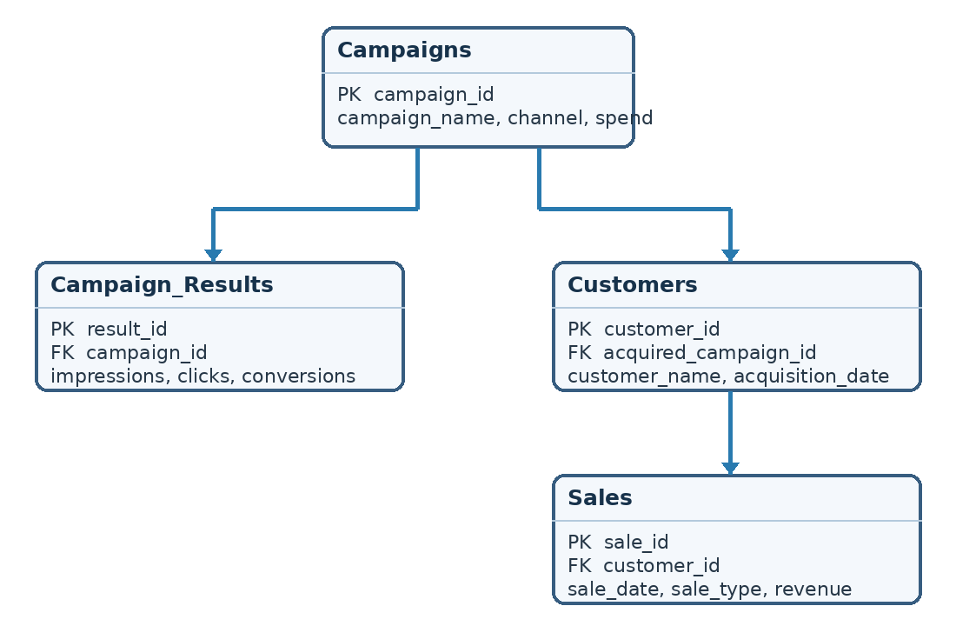
Figure 1. Proposed four-table schema with primary and foreign keys.
Customers.acquired_campaign_id links to Campaigns.campaign_id; Sales.customer_id links to Customers.customer_id; and Campaign_Results.campaign_id links to Campaigns.campaign_id.

Foreign-Key Verification
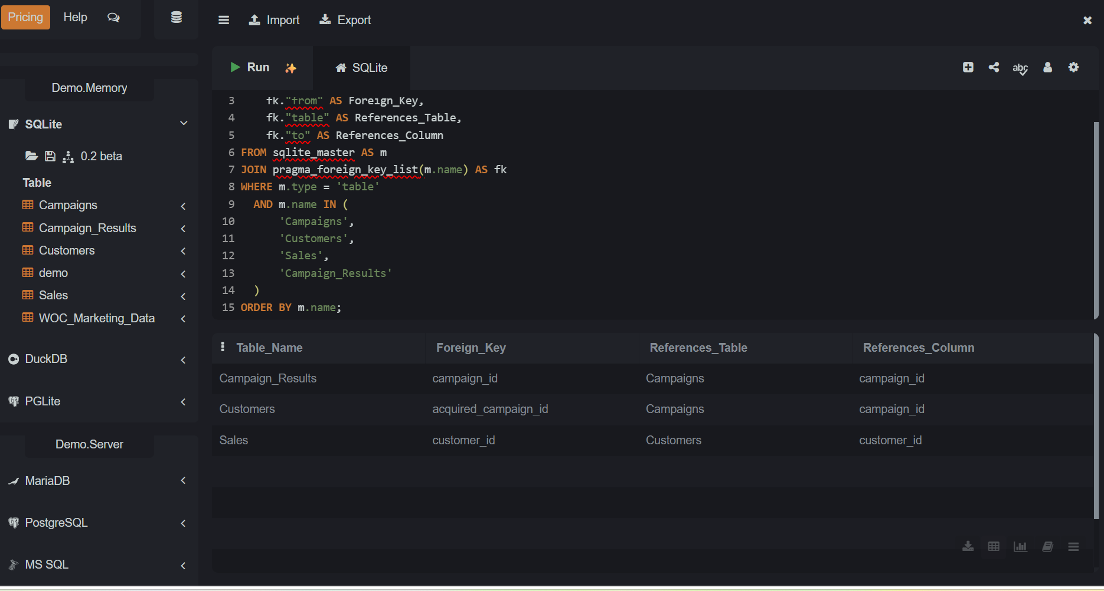
Figure 2. SQL query confirming three foreign-key relationships.

3. Dataset Import and Validation
The original CSV was imported into WOC_Marketing_Data, separately from the four relational tables. A record-count query returned 800 records. The four new relational tables currently contain zero records, so their design is demonstrated but a populated join across customer and sales data has not been tested.
SELECT COUNT(*) AS Total_Records
FROM WOC_Marketing_Data;

4. Marketing Performance Queries and Findings

Query 1 – Marketing Channel Comparison
SELECT channel, ROUND(SUM(spend), 2) AS Total_Spend,
SUM(conversions) AS Total_Conversions,
ROUND(SUM(revenue_generate), 2) AS Total_Revenue,
ROUND(SUM(spend) / NULLIF(SUM(conversions), 0), 2)
AS Cost_Per_Conversion
FROM WOC_Marketing_Data
GROUP BY channel
ORDER BY Cost_Per_Conversion ASC;
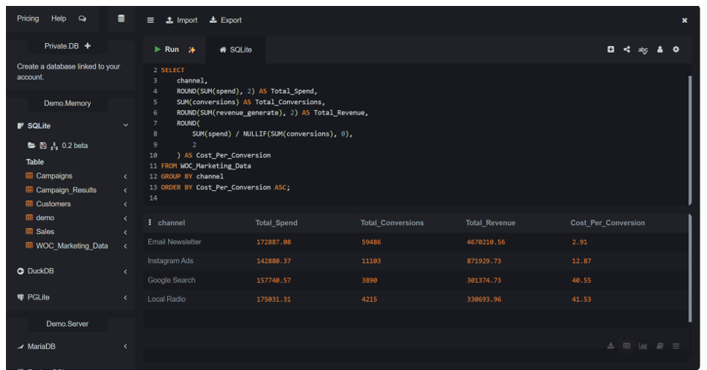
Figure 3. Channel comparison SQL and results.
Channel | Spend ($) | Conversions | Revenue ($) | Cost / conversion ($)
Email Newsletter | 172,887.08 | 59,486 | 4,670,210.56 | 2.91
Instagram Ads | 142,880.37 | 11,103 | 871,929.73 | 12.87
Google Search | 157,740.57 | 3,890 | 301,374.73 | 40.55
Local Radio | 175,031.31 | 4,215 | 330,693.96 | 41.53
Email Newsletter generated the most conversions and had the lowest cost per conversion ($2.91). This suggests strong efficiency for the measured conversions, but conversions are not necessarily new customers.

Query 2 – Campaign Performance Analysis
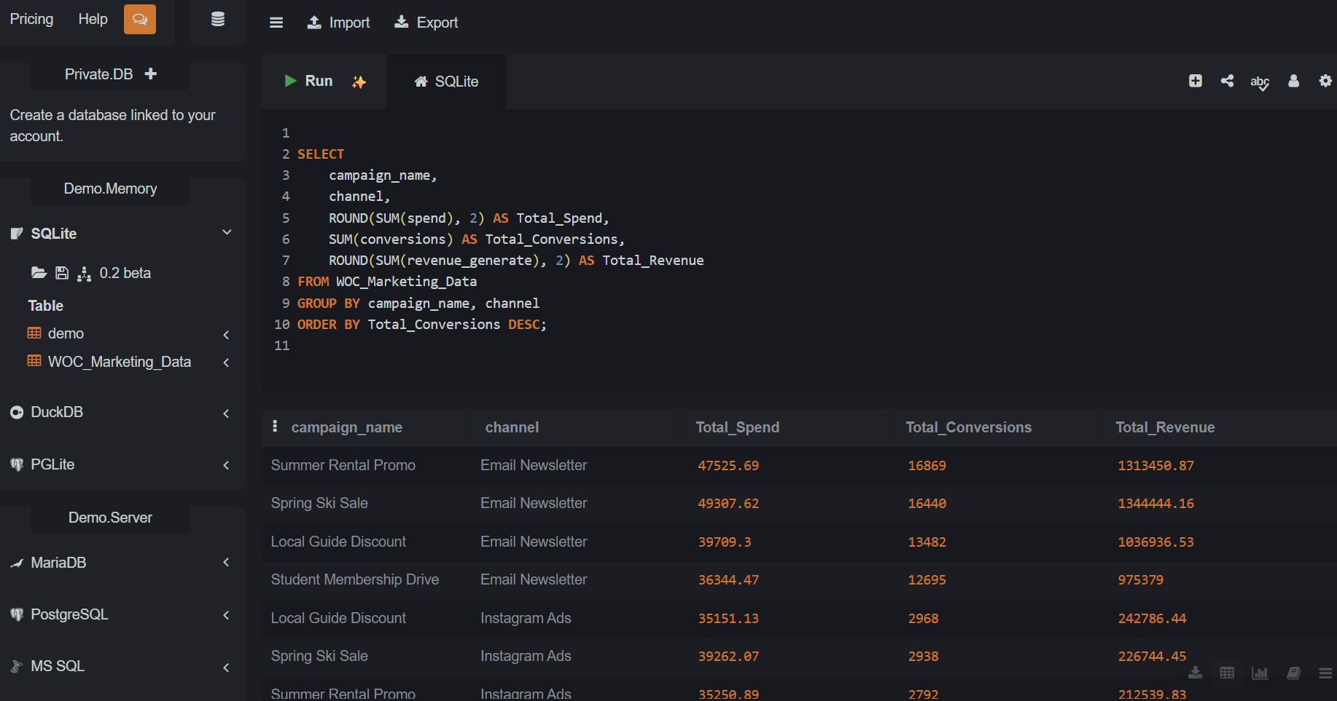
Figure 4. Campaign performance by campaign and channel.
This query groups marketing spend, conversions, and revenue by campaign and channel. Summer Rental Promo through Email Newsletter led the displayed results with 16,869 conversions. This helps WOC compare individual campaigns rather than looking only at overall channel totals.

Query 3 – Return on Advertising Spend (ROAS)
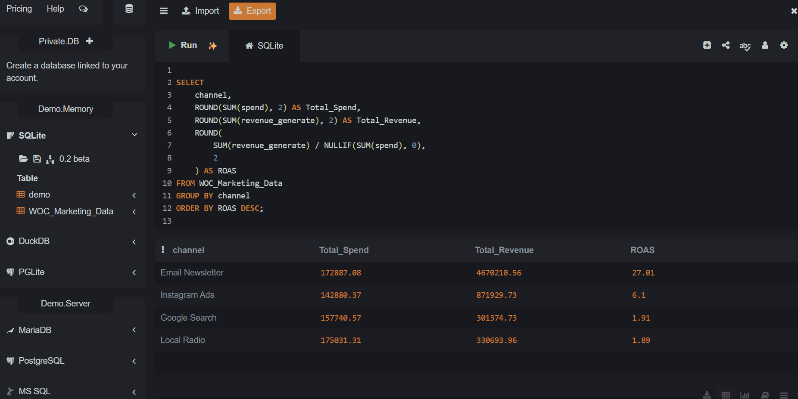
Figure 5. Channel-level return on advertising spend.
ROAS equals total reported revenue divided by total marketing spend. Email Newsletter had the highest ROAS at 27.01, followed by Instagram Ads (6.10), Google Search (1.91), and Local Radio (1.89). A ROAS of 27.01 means $27.01 in attributed revenue for each $1 spent; it does not measure profit.

Query 4 – Monthly Marketing Performance
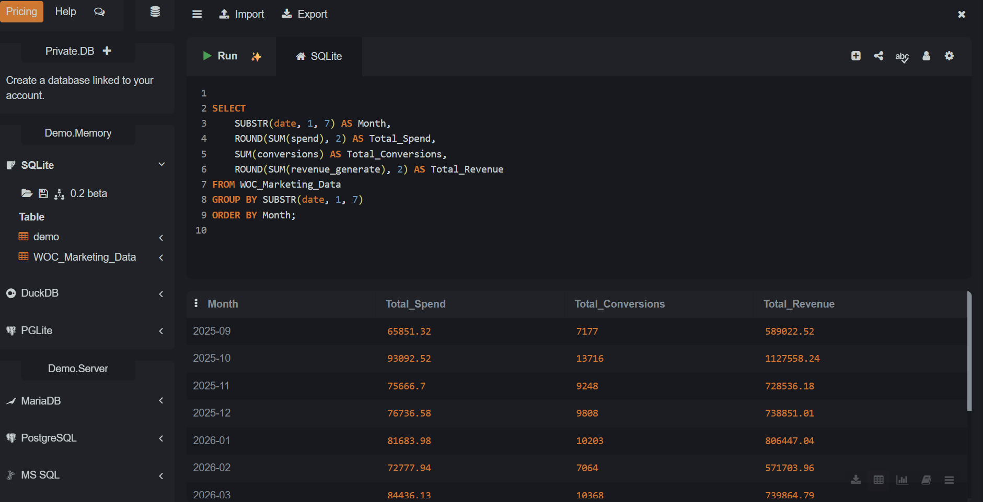
Figure 6. Monthly spend, conversions, and revenue.
This query groups marketing performance by year and month. October 2025 shows 13,716 conversions and $1,127,558.24 in revenue in the visible results. Reviewing the complete monthly result set would be needed before identifying the highest month overall.

Query 5 – Customer Acquisition Metric by Channel
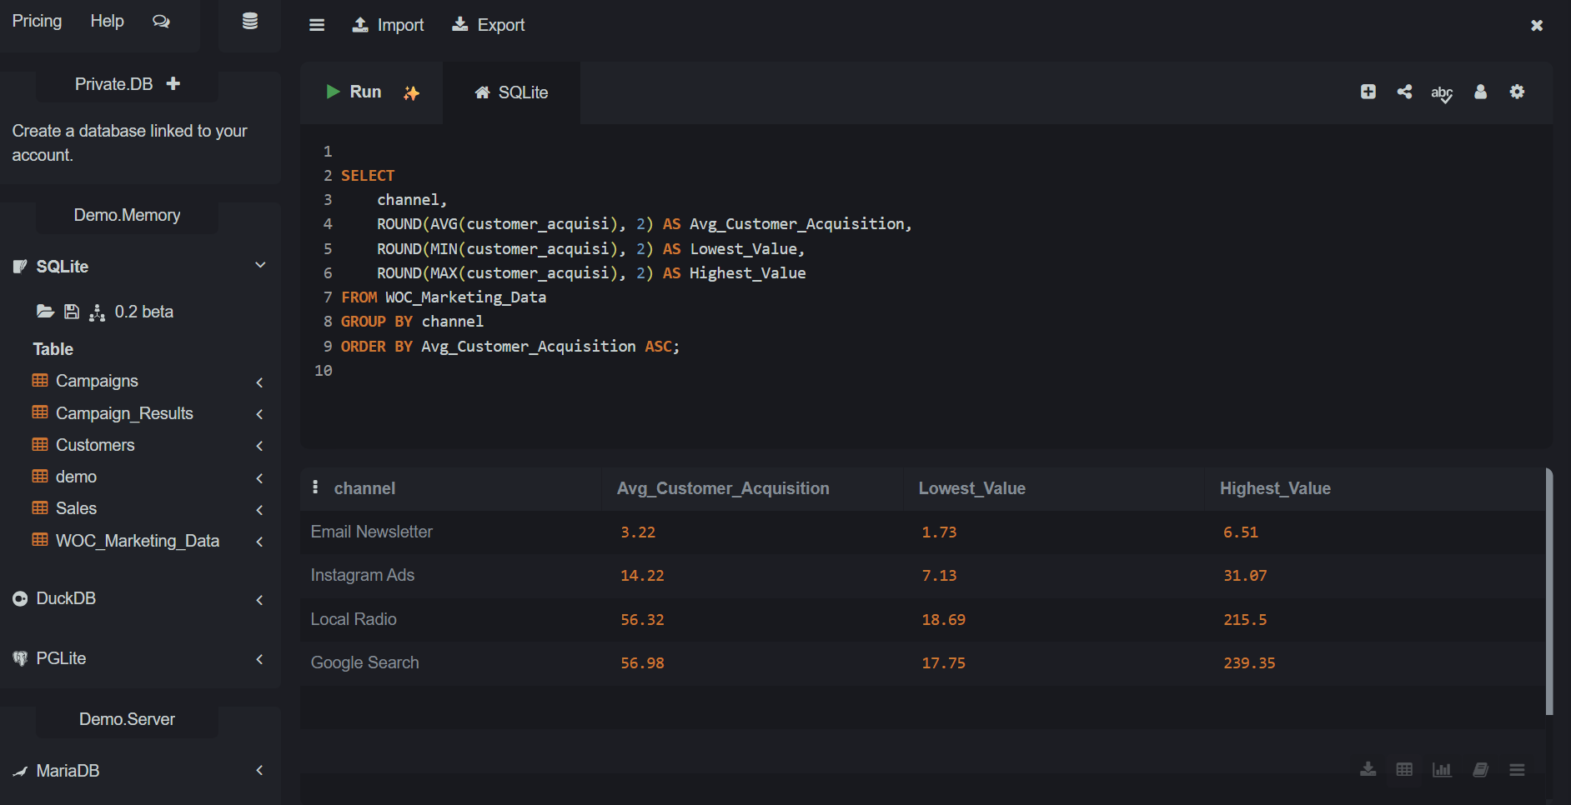
Figure 7. Average, minimum, and maximum customer_acquisi values by channel.
Channel | Average value | Minimum | Maximum
Email Newsletter | 3.22 | 1.73 | 6.51
Instagram Ads | 14.22 | 7.13 | 31.07
Local Radio | 56.32 | 18.69 | 215.50
Google Search | 56.98 | 17.75 | 239.35
The dataset field customer_acquisi has the lowest average value for Email Newsletter (3.22). These are simple averages of individual record-level values, not overall channel CAC. The next query checks what the field measures.

Query 6 – Customer Acquisition Metric Validation
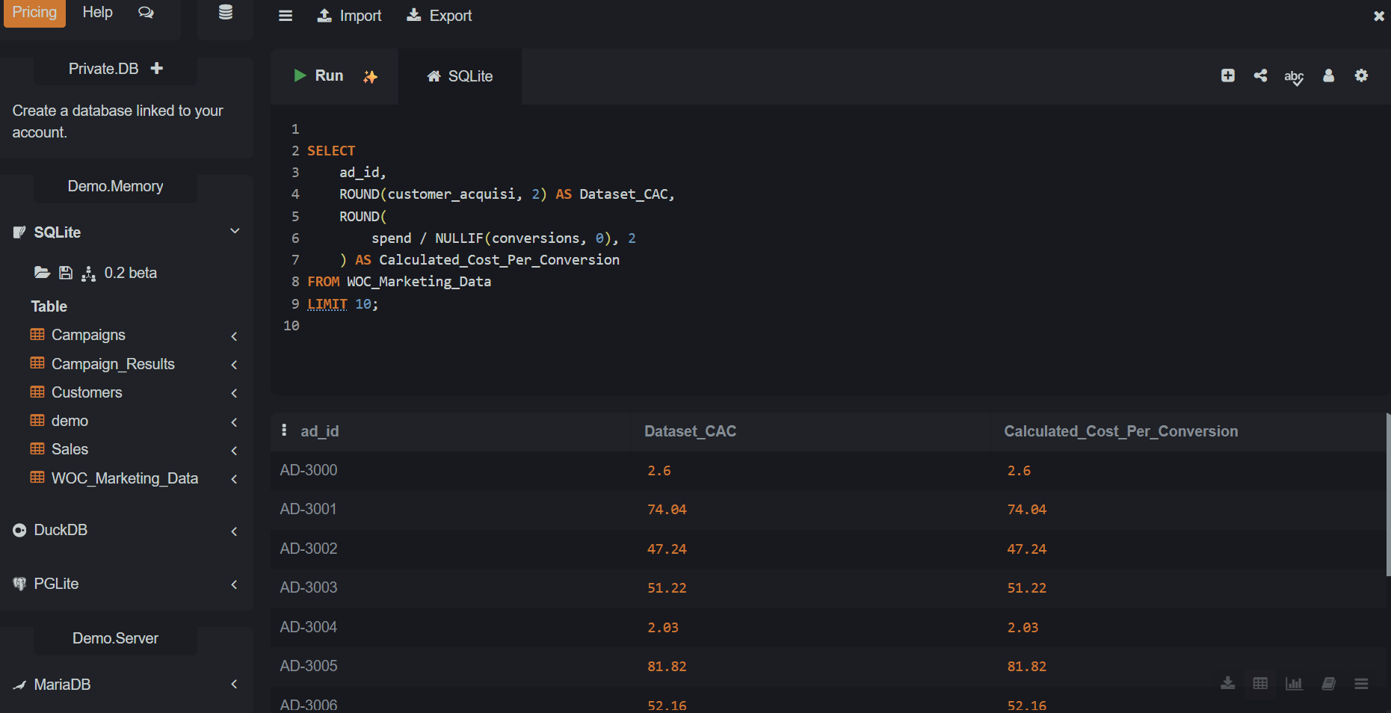
Figure 8. Dataset customer_acquisi compared with calculated spend per conversion.
SELECT ad_id,
ROUND(customer_acquisi, 2) AS Dataset_CAC,
ROUND(spend / NULLIF(conversions, 0), 2)
AS Calculated_Cost_Per_Conversion
FROM WOC_Marketing_Data
LIMIT 10;
The visible records match when customer_acquisi is compared with spend divided by conversions. This supports treating the field as cost per conversion for those records, not confirmed customer acquisition cost. True CAC requires the number of new customers acquired, not simply conversions.

5. What the Database Still Needs
The four relational tables have been created, but the record-count check showed that Campaigns, Customers, Sales, and Campaign_Results are empty. The imported marketing dataset alone cannot establish which specific customers were acquired or which purchases and rentals followed a campaign.
To complete a real integrated Marketing Information System, WOC would need reliable campaign identifiers, customer records with acquisition attribution, and transaction-level sales or rental data. Once these data are available, WOC could populate and test the linked tables, validate joins, and calculate CAC using marketing spend divided by new customers acquired. This is a proposed next phase, not completed work.

6. Business Recommendations
WOC should consider testing additional Email Newsletter campaigns because this channel had the lowest cost per conversion and highest ROAS in the dataset. Instagram Ads also performed relatively well. Before shifting budgets, WOC should verify attribution, conversion definitions, audience capacity, and whether revenue figures are comparable across channels.
WOC should use a shared marketing dashboard to track spend, conversions, cost per conversion, and ROAS. As customer and transaction data become available, the dashboard should add verified new-customer counts, true CAC, and sales or rental revenue linked to campaigns. Managers should review results regularly rather than relying on isolated platform reports.

7. Conclusion and Learning Reflection
This project helped me understand how SQL can organize marketing information and turn campaign data into useful business insights. I created a four-table relational design, verified the foreign-key relationships, imported 800 marketing records into a separate table, and used SQL to compare campaign and channel performance. I also learned why it is important to check what a metric actually means: cost per conversion is useful, but it is not automatically the same as the cost of acquiring a new customer.

8. Final Submission Checklist
☐ Include the SQL report with the existing screenshots and explanations.
☐ Capture and add a screenshot showing the COUNT(*) result of 800, if the instructor requests visual import evidence.
☐ Save a separate .sql script and/or SQLite database export if the team or instructor requires reusable files; the SQL Online Demo.Memory session may not persist.
☐ Explain that the relational tables are currently empty and that real customer and sales integration remains proposed.
☐ Confirm the required Tableau dashboard, project repository, and other team deliverables separately; this report covers the SQL portion only.

