##### PADRE CONCEICAO COLLEGE OF ENGINEERING

**VERNA GOA – 403722**



**“Product Listing Management system”**

An Internship Report Submitted in

partial fulfilment for the award of degree of

**Bachelor of Engineering**

**in**

**Computer Engineering**

submitted by,

**Shawnel Vas**

**19CE57**

Internship carried out at

**Enigmasoft Technologies**

Under the supervision of

**Salim Mandrekar**

**IT Project Manager**

**Enigmasoft Technologies**

Department of Computer Engineering

##### Padre Conceicao College of Engineering, Verna, Goa

(2022-2023)

##### PADRE CONCEICAO COLLEGE OF ENGINEERING

**VERNA GOA – 403722**



***Certificate***

This is to certify that the internship work entitled “**Product listing Management System**” is a bonafide work carried out by **Shawnel Vas, Semester VII, 19CE57** of Padre Conceicao College of Engineering, Verna. This report is submitted in partial fulfilment for the award of **Bachelor of Engineering in Computer Engineering** of **Goa University** during the academic year **2022-2023.**

…………..………………………. …………..…………………………

**Dr Anusha Pai Salim Mandrekar**

…………..…………….. …………..……………….

**Dr Anusha Pai Dr Mahesh Parappagoudar**

Head of the Department Principal

**Examined By:**

Examiner 1: ……………………………………....……………………….

(Name / Signature / Date)

Examiner 2: ……………………………………....……………………….

(Name / Signature / Date)

**Photocopy of Internship Certificate (On) Company Letterhead**

**ACKNOWLEDGEMENT**

The success and final outcome of this internship required a lot of guidance and assistance from many people and I am extremely privileged to have got this all along the completion of my internship. All that I have done is only due to such supervision and assistance and I will not forget to thank them.

I express my gratitude and respect to **Dr Mahesh Parappagoudar**, **Principal,** PCCE, Verna for granting permission to carry out the internship.

## I express my heartfelt gratitude to **Dr Anusha Pai****, HOD**, Department of Computer Engineering, PCCE, Verna for being supportive for my work throughout the internship.

I am also deeply indebted to my guide, **Mr. Salim Mandrekar** ,Enigmasoft, for the support, encouragement and valuable suggestions given to us during the course of our work.

**Shawnel Vas**

**(19CE57)**

**Abstract**

My internship was at Engimasoft technologies, Panjim as an IT intern. I was assigned to a group consisting of 3 members and the project allotted to my group was to create a Product listing management system using the MERN stack (MongoDB, Express, React, Node.js). The project had to have specific functionalities like user account creation, verification, password recovery, displaying of product to be sold by the user with. User could also list out new product and specify contact and price details

For the project we divided the project work amongst ourself. My responsibility was to develop the Front-end part of the product listing system. I was responsible for creating pages that would list or display the product that users had listed out for sale. My team-mates worked on the user account creation, authentication, and back-end of the project. I used React to create the front-end of project. Creating pages in react allowed me to create responsive pages for the product listing

**TABLE OF CONTENTS**

|  |  |  |
| --- | --- | --- |
| **Sr No.** | **Contents** | **Page No.** |
|  | **Certificate** |  |
|  | **Certificate from the organisation** |  |
|  | **Acknowledgement** |  |
|  | **Abstract** |  |
|  | **Chapter 1. Industry Profile**   * 1. Company Profile   2. Management Profile   3. Vision and Mission of Company   4. Products/ Services provided by organisation |  |
|  | **Chapter 2. Tasks Performed**  2.1 Introduction  2.2 Problem Statement  2.3 Objectives  2.2 Description of the work  2.3 Results |  |
|  | **Chapter 3. Conclusion** |  |
|  | **Bibliography** |  |

|  |  |
| --- | --- |
|  |  |

**CHAPTER 1**

**INTRODUCTION**

* 1. **Company Profile**

Enigmasoft Technologies Private Limited is a Private incorporated on 01 March 2021. It is classified as a non-government company and is registered at Registrar of Companies, Goa. This company was created to help achieve business goals with high quality performance driven and client centric business solutions.

* 1. **Management Profile**

Directors of Enigmasoft Technologies Private Limited are Abhimanyu Gargesh, Pinky Nikunjkumar Patel, Atul Tanaji Utturkar.

* 1. **Vision Mission of Company**

***Vision:***To align business goals, employee engagement and external partnership towards achieving a beneficial impact on social and environmental issues.

***Mission****:* To collaborate smoothly with customers and help them achieve their business goals by providing them with innovative and best-in-class consultation, IT solutions and services.

* 1. **Products/ Services provided by organization**

It is involved in various computer related activities as listed below.

* Cyber security
* ISO consulting
* Cloud solutions
* IT solutions including software, applications, programs and IT services
* Comprehensive outsourcing such as accounting, digital marketing, website design, logo designing, customer services, virtual assistants, Ombudsman liaison services, market analysis, operational set up, call centre solutions, patent registration and CFD modelling services.
* HR solutions

**Chapter 2**

**Tasks Performed**

**2.1 Introduction**

E-commerce is the growing technology of today’s generation. It uses various other technologies for its functioning. with newer advancement its growth has grown exponentially user can buy almost anything from a tooth brush to personal computer. Major Ecommerce brands in India are Amazon and Flipkart. These Ecommerce giants use various technology to maximize profits and keep the customer engaging on their website or their applications. To maximize profits ecommerce brands, use machine learning technology to provide recommendation to user about product they may be interested in buying. To ensure safe and secure payments and checkouts ecommerce brands use safe and secure code. Finally, the website or the app should be up and running all the time. Downtime of ecommerce website or apps could lead to brands and vendors on the ecommerce websites to losses millions in profits.

**2.2 Problem Statement**

To create a product -listing management system that’s list out product to be sold by user similar to an ecommerce website. And to learn about the various technologies its uses to work.

**2.3 Objectives**

* To Create a product listing management system to list out products that can be purchased by users
* To create secure login for users, with email authentication and with password recovery.

**2.2 Description of the work**

As an intern with EnigmaSoft technologies, the project division to which I was assigned for the project was software development. In the group consisting of four members, I was assigned the role of front-end. The purpose of this project was to make a web application that will allow the user to log in/register by clicking on the sign-in button. This E-commerce web application where admin can update his profile page and will be able to create his own product which will be displayed on the main dashboard along with the other user's products. Customers also can easily search for their favourite model and contact the admin.

For the project, we decided to use MERN stack technology and everyone was new to this technology so we started our weekly task to study the stack. We started watching tutorials on the basics of react and installed node js and other packages which were required. I also explored CSS(Bootstrap) tutorials and tried using it for the website. I was responsible for authentication for the register and login pages. Activation and verification of mail and logout buttons were some of the tasks. Also, the forms and styling of the pages for registration, login, forgot password, reset the password, create a product, and edit product pages were created. I also explored the server side, like understanding middleware, and the introduction of MongoDB, and explored CRUD operations i.e., creating a database, insertion, reading, updating, and deleting operations. After creating the website, we also tested all our pages and resolve errors in the dashboard, and other pages. After resolving our errors and doing final testing we gave our demo for our project. We also hosted our website on Heroku.

**2.3 Results**

Product listing management system using MERN stack was created.

**Main home page:**

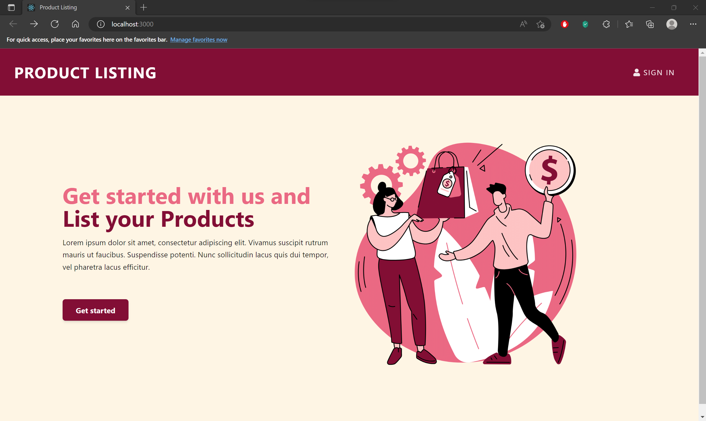

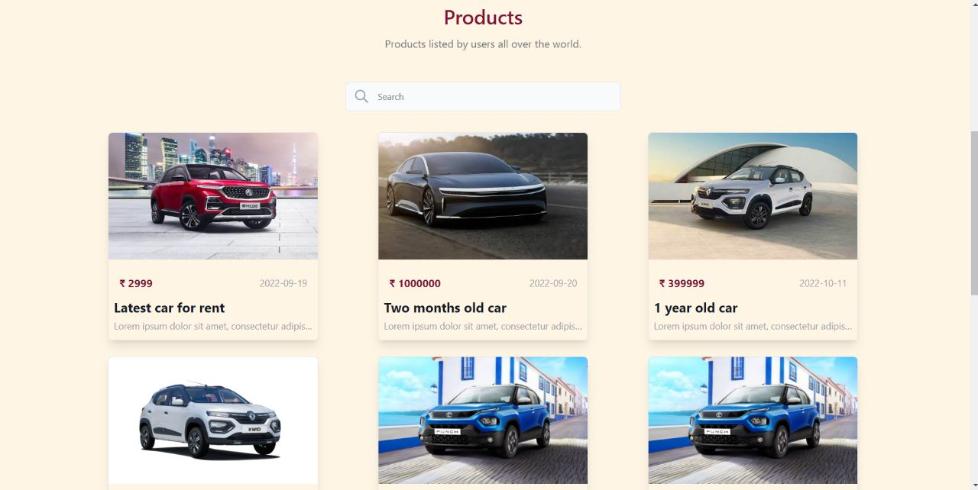

This is the main homage when any user whether registered or new visit the website he/she will be able to view products that are on sale. if he/she login with his/her email then he/she would be able to list their product which they wish to sell.

**Login Page:**

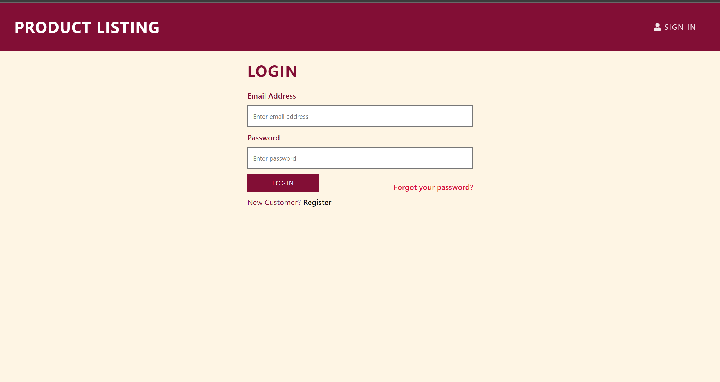

In the Login page registered users can login using their email and password.it has links to register for a new user and a forgot password link in case a user has forgotten his/her password.

**New User Registration Page:**

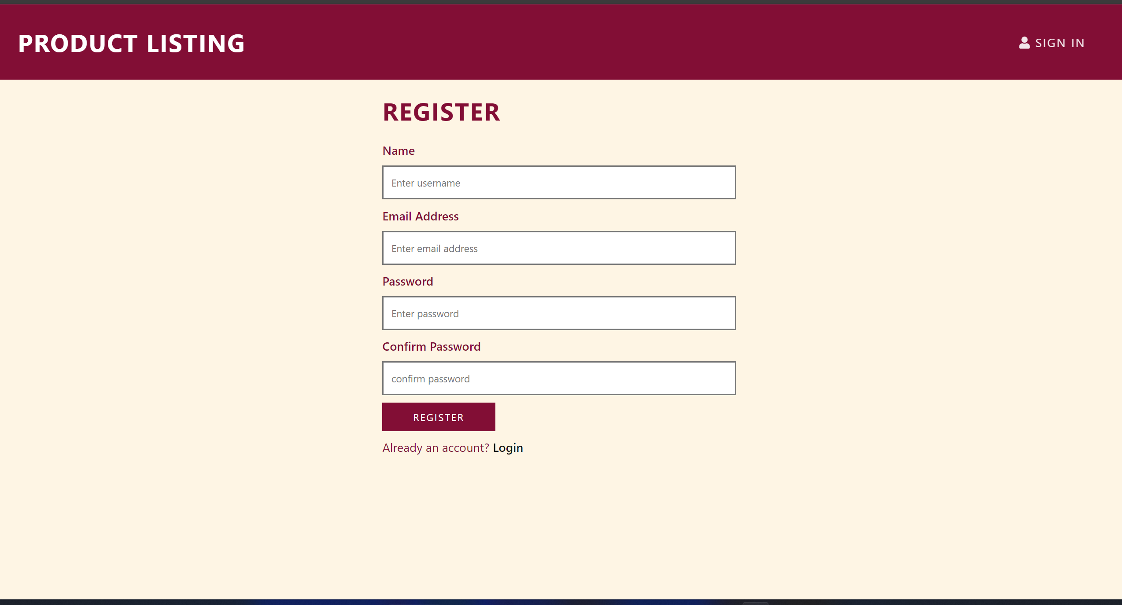

The Registration page is used if a new users want to create an account .it has filed such as name email and password. it also has a confirm password filed for the user to reconfirm the typed password

**Forgot Password Page**:

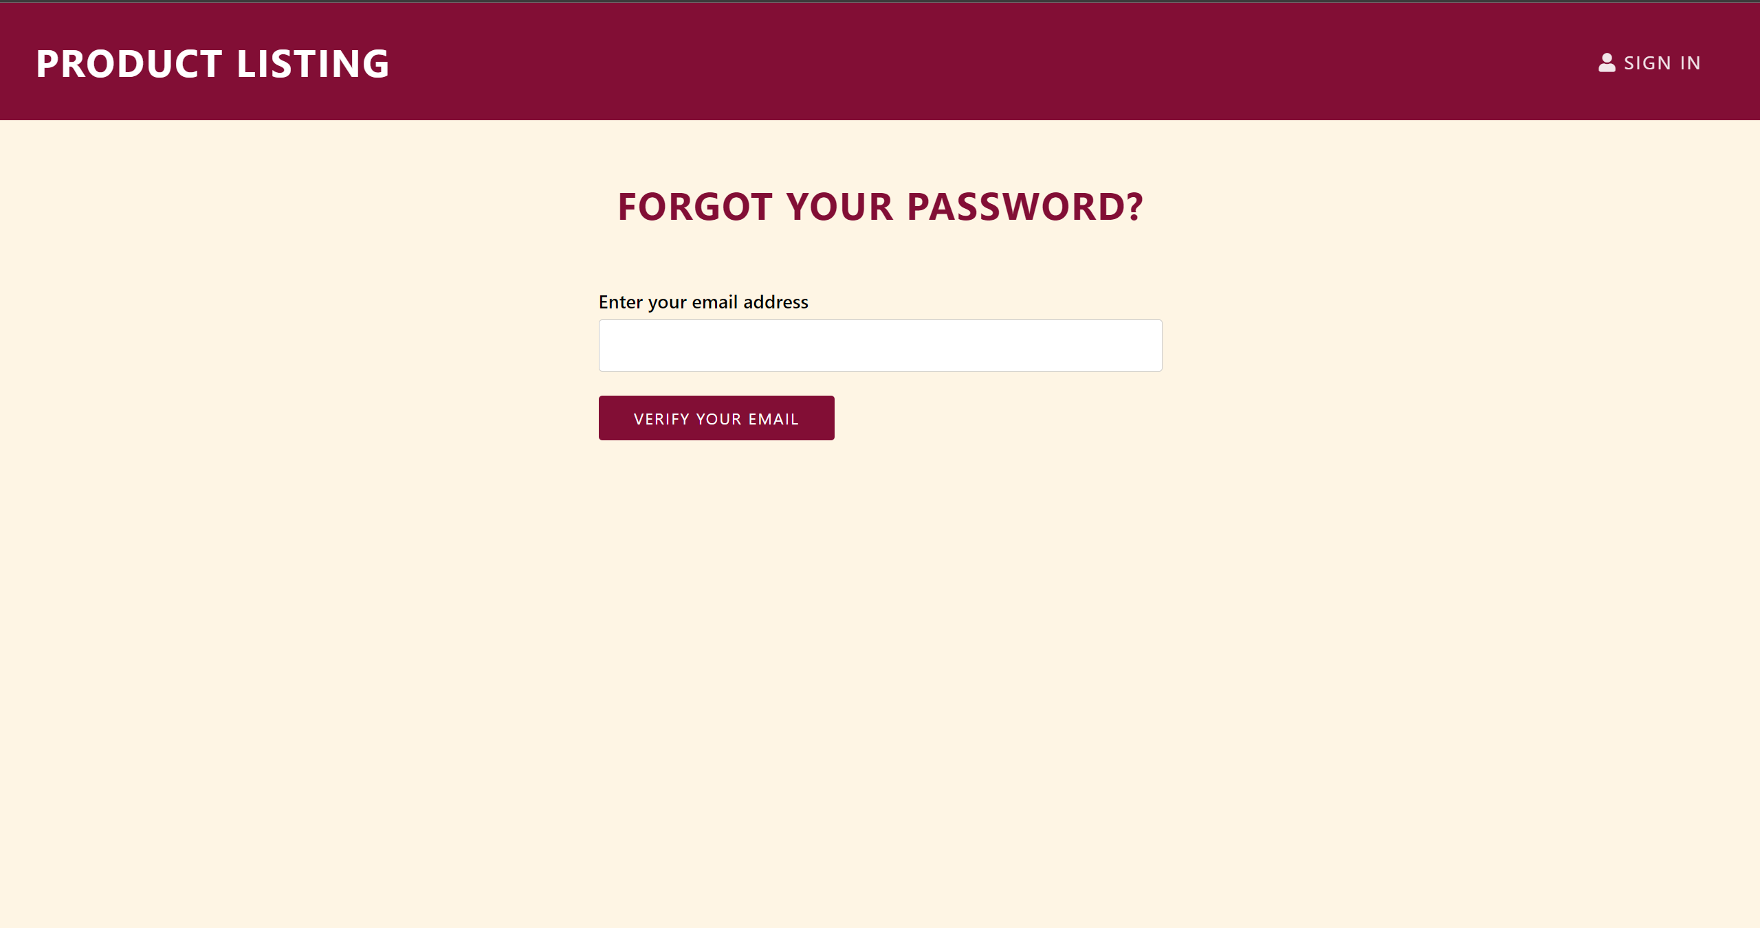

Forgot password page has a filed wherein a user enters the email of which password he has forgotten and then he will receive a link on his email to rest his password

**Product info page:**

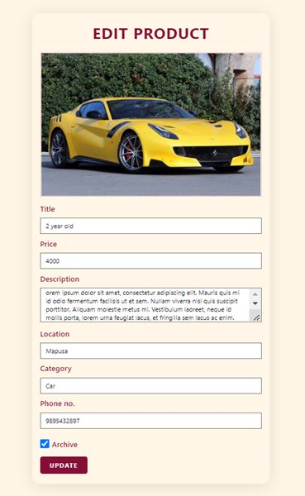

This page is used to upload the product details who information like price, description location, category and contact info has to be displayed. The details could be edited it the product was sold the archive checkbox could be ticked and the product would not be displayed.

**Chapter 3**

**Conclusion**

Product listing management system using MERN stack was created with functionalities such as user registration, authentication, displaying of products with description and contact information. Completing this project provided me with the necessary knowledge and skills required to succeed as a successful software developer.

My internship project showed me the difficulties and challenges faced by ecommerce brands like Amazon and Flipkart and how the engineers working there have to be creative to come up with necessary solution to move forward. And the technologies that they use on an everyday basics. It also taught me how to communicate and collaborate with my peers and my mentors about the project and its progress.

**Bibliography**

Tool/Software:

* Visual Studio
* Node.js

Websites:

* <https://reactjs.org/docs/getting-started.html>
* <https://nodejs.org/en/>

Videos:

* https://www.youtube.com/watch?v=DLX62G4lc44
* https://www.youtube.com/watch?v=Oe421EPjeBE&t=256s