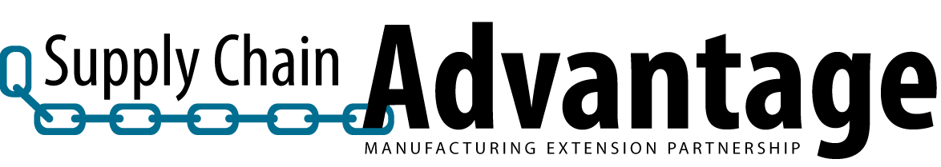

Accelerate Pre-project Supplier Company Profile Questionnaire

Company Name: Date:
Supplier Personnel Completing Questionnaire:
Organization Profile:
1) Which best describes your organization?

2) Which best describes the majority of your company’s production volume?

3) Which best describes the majority of your company’s products?

4) Number of SKUs in active production (ballpark # is fine)?

5) What is the 6 digit NAICS code (or SIC) for your organization?

6) Which best describes your primary customer base?

7) Average total number of FTEs at this location in the past year?

8) Average total number of PRODUCTION FTEs (direct and indirect)?

9) Total Annual Sales Revenue (all products) for the previous year?

10) Percent of sales that went to cover materials and outside services for the previous year? %

Relevant Company History:
The follow questions will help the MEP understand factors that often influence continuous improvement implementation.

For the questions 11-15, select the number (0-4) from the drop down list for the answer that best describe your company.

11) Use of Value Stream Mapping at this facility?
0  None | 1  A few isolated VSM events with outside assistance | 2  A few isolated VSM events; Self-led | 3  Regular VSM events;  Self-led | 4  Extensive VSM events;  Self-led

12) Which best describes your company’s awareness of your Local MEP prior to this Accelerate project?
0  None | 1  Distantly aware, but no recent project work. | 2  Some past MEP involvement; but no recent direct project work. | 3  Recent direct project work with the MEP;  Less than $10,000 of total contract value. | 4  Recent direct project work with the MEP;  More than $10,000 of total contract value.

Accelerate Pre-project Supplier Company Profile Questionnaire

Relevant Company History (continued):

13) Which best describes your company’s current “sales vs. production capacity” situation?
0  We can make more than we can sell. We have too much excess capacity. | 1  <<<>>> | 2  Our production capacity and sales are balanced. | 3  <<<>>> | 4  We’re able to sell more than we can produce. We’re max-out and need more capacity.

14) As a whole, which best describes your company’s current attitude towards Lean (strategic waste reduction/ performance improvement) initiatives?

0  Some resistance to lean. Some key players are not on board. | 1  We’re new to lean and willing to learn. No significant resistance to lean methodologies. | 2  We’ve started with Lean and making some progress. | 3  We’re pretty Lean already. We use lean mainly to address recognized problems. | 4  Lean is an embraced lifestyle. Widespread culture of systematic ongoing continuous improvement.

15) Over the past 3 years, on AVERAGE, have you had to change your sales prices (select one)?
0  On average, raised prices. | 1  On average, have been able to hold the line on prices. | 2  On average, have reduced prices somewhat- Less than 5% | 3  On average, have reduced prices significantly-  Between 5 and 10% | 4  On average, have reduced prices a great deal- more than 10%

For questions 16-20, select the answer from the drop down menu that best matches your company.

16) Total estimated OEM sponsored man hours (all OEM customers) for performance improvement events for this plant location in the past 3 years (NOT including this Accelerate project)?

17) What percentage of employees regularly participates in empowered work teams for continuous improvement activities (i.e. make decisions without supervisor approval)? %

18) How many formal training hours are devoted annually to each employee?

19) What is the percentage of deliveries on time for the past year (all products, all customers)? %

20) What is the percentage of deliveries achieving customer approved quality in the last year (all products, all customers)? %

