**Project Proposal**

**Title:** Swarm Robot Approach to Automated Loose Fruit Picking

**1. Abstract**

The aim of this project is to develop swarm robots for collection of loose fruits. The robots will need to measure the surrounding environment, navigate, , and completing the task of picking up loose fruits. A single swarm will be consisting of a beacon robot with multiple worker robots. A working prototype is expected at the end of the project, consisting of a beacon robot, and at least two worker robots for proof of concept. The beacon robot will capture images of the ground to identify loose fruits, and plan paths for worker robots to pick up.

**2. Project Introduction**

The oil palm tree is a tropical plant originated from West African tropical rainforest region, nowadays planted commercially in Malaysia. Oil palm’s fruit contains large amount of edible plant oil and can be further processed for various applications. An oil palm tree may produce between 8 to 12 bunches of fruit annually. Loose fruits are the ripest fruitlets fallen from the cluster, contain the highest amount of oil and often an indication of the ripeness of the entire cluster [1].

Conventional method for loose fruit collection includes manual collection and often cause back pain among workers. One solution is to deploy a remote-controlled robot with a roller-type collector, which increase the efficiency and alleviate the problem of back pain. There are also proven solutions using autonomous vacuum robot to collect the loose fruits [2].

To improve the solution, a swarm of robots can be utilized to split the burden. A beacon robot will be tasked to capture images, process images, and plan path for multiple worker robots. The worker robots will be using a roller cage to pick up the fruits as it moves over them.

Intel platforms are chosen for the implementation of the project. The embedded processor board Intel provides fit the perfect role as the controller for the worker robot for their task of navigation robotic control. It is also suitable for the beacon robot to achieve the task of image processing and coordination of multiple robots.

The objective of this project is to utilize the swarm robot concept to increase the efficiency of autonomous loose fruit picking robots. The final product of this project is expected to be a set of wheel robots, consisting of a beacon robot and at least two worker robots with the above functions.

**3. Design Methodology**

**3.1 Review on concept and functionality**

In the first phase, the overall functionality of the robots will be examined in detail. The functionality will affect the specifications of its components and directly affects the project cost. The main focus will be on the parameters such as battery life, vision range, area covered per unit time, storage size and weight, and other mechanisms to aid in navigation on uneven terrain.

This project will utilize swarm robot concept to achieve the desired result. Swarm robotics is defined as the coordination of large groups of simple robots through the use of local rules [3]. Localization of the robots will largely depend on communication between the robots using method such as light or radio communication. Light-based communication is vital for spatial knowledge of the robot and the direction of which the communication is coming from [4].

Traditionally, swarm robots are relatively simple and will be able to solve complex problems through uniformly designed local rules. However, the randomness of the robots’ motion will cause redundant and inefficient collection of loose fruits due to the use of local rules only. Thus, adding a centralized guide, named as beacon robot, will be able to make sure the paths travelled are not redundant.

The communication plan will be centered around the beacon robot, where the beacon will determine the position and orientation of the worker robots by scanning physical markers on the robots, and initiate a “handshake” [5], a short communication protocol, to identify the other party. The scanner will record the relative bearing of the markers and take it into account for coordinate calculation. At the end of this phase, a rough sketch of the robots and the flowchart of the algorithms will be produced along with the component specifications.

**3.2 Mechanical fabrication**

In the second phase, the detailed computer-aided design will be drawn by improvising the rough sketch. Software analysis will be carried out to test the robots’ physics, and checked with the required value of the parameters mentioned in the first phase.

The main focus in this phase will be the roller cage mechanism and temporary storage mechanism. The roller cage will need to be able to pick up loose fruits efficiently on both even and uneven terrains. The temporary storage mechanism will ensure all of the fruits in the roller cage are emptied out into a storage box, so that the roller cage can continue picking up fruits.

The system design utilizing Intel Edison for Arduino will be tested on breadboard for any component errors. The system design for worker and beacon robot are shown below:

Beacon Robot System Design

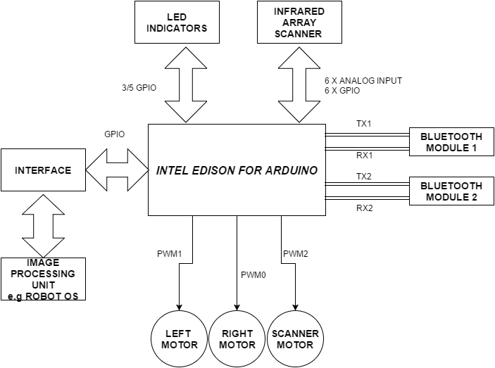

*\*Motor drivers are omitted for simplicity purpose.*

Worker Robot System Design

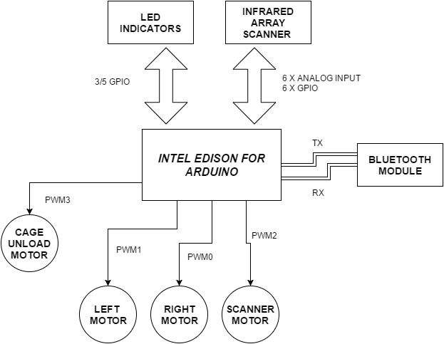

*\*Motor drivers are omitted for simplicity purpose.*

The completed design will then proceed to be realized with various tools and machines.

**3.3 Programming**

In this phase, the algorithm for image processing, navigation, path planning for worker robots, and swarm communication will be built.

The main focus on navigation and path planning is to avoid obstacles and to optimizing the yield per unit distance. Swarm communication will focus on the method and protocol of communication among the robots, taking latency and other real-time constraints into account. On the other hand, image processing will focus on identifying the loose fruits and clusters, and returns the extracted feature to the path planner algorithm for further processing.

The general flow of the operation for both robot types is shown below:

Beacon Robot Operation Flowchart

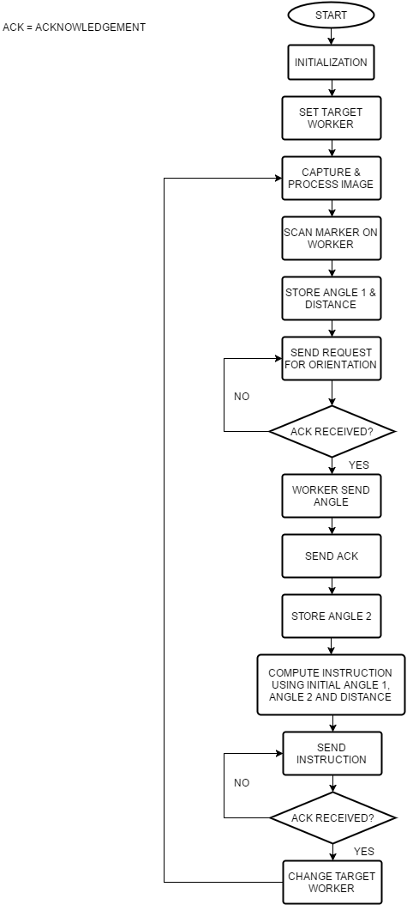

Worker Robot Operation Flowchart

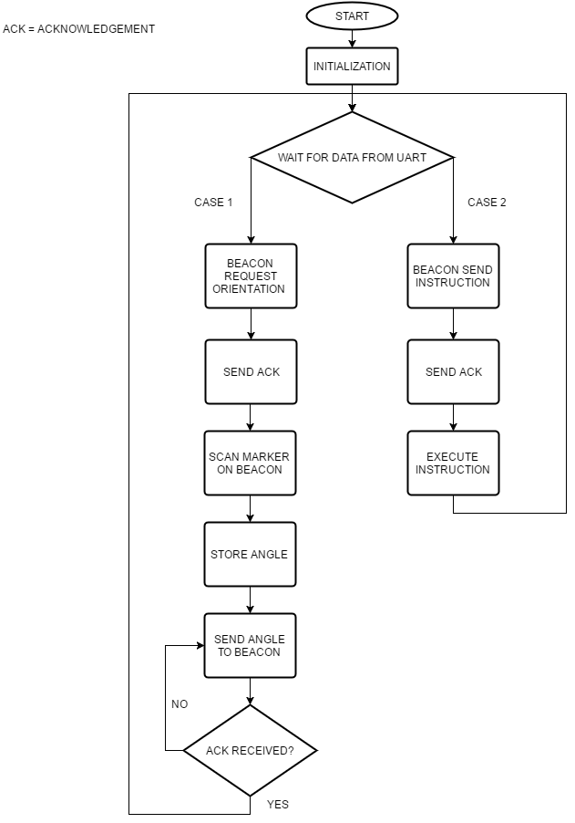

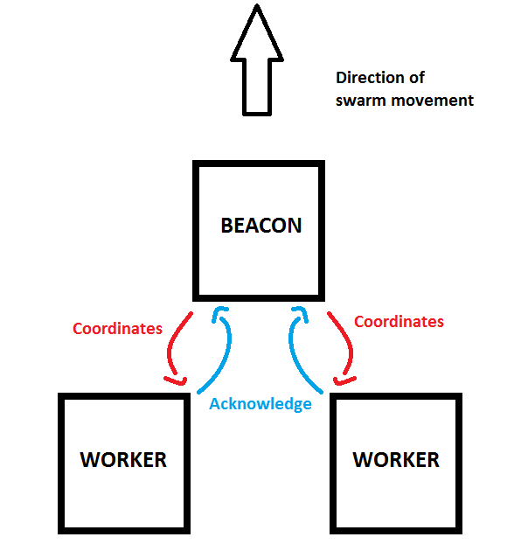

*Example of swarm communication.*

At the end of this phase, a fully functional set of swarm robots is expected. The specifications of functionality will be checked constantly with the result from the first phase.

**3.4 Field test**

In the last phase, the robots will be tested in an actual or a simulated palm oil plantation.

The major focus will be the practicality of the entire system, with reference to parameters such as fruits collected per unit time, storage capacity, and battery capacity. The results are compared with the initial specifications and minor corrections are expected.

**Gantt chart**

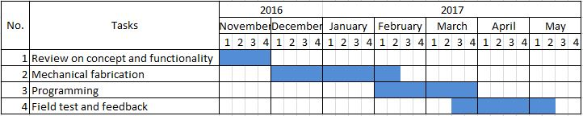

**References**

1. Sime Darby Plantation. 2014. Palm Oil Facts and Figures. Retrieved October 1, 2016, from <http://www.simedarbyplantation.com/upload/Palm-OilFacts-and-Figures.pdf>

2. Roller Picker Robot (ROPICOT 1.0) for Loose Fruit Collection System. 2016. Retrieved October 1, 2016, from

[http://www.arpnjournals.org/jeas/research_papers/rp_2016/jeas_0716_4712.pdf](http://www.arpnjournals.org/jeas/research_papers/rp_2016/jeas_0716_4712.pdf 3)

[3](http://www.arpnjournals.org/jeas/research_papers/rp_2016/jeas_0716_4712.pdf 3). Iñaki Navarro and Fernando Matía, “An Introduction to Swarm Robotics,” ISRN Robotics, vol. 2013, Article ID 608164, 10 pages, 2013. doi:10.5402/2013/608164

4. Correll N. & Rus D. (n.d.). Architectures and Control of Networked Robotics Systems. Retrieved October 1, 2016, from <http://correll.cs.colorado.edu/wp-content/uploads/correll_rus_chapter3.pdf>

5. Mao L., Chen J., Li Z. & Zhang D. 2013. Relative Localization Method of Multiple Micro Robots Based On Simple Sensors. Retrieved October 1, 2015, from <http://cdn.intechopen.com/pdfs-wm/43007.pdf>