

**Full Stack Development**

**(ESE3014)**

**Project Report**

**Declaration of Originality**

I am the originator of this work and I have appropriately acknowledged all other original sources used as my references for this work.

I understand that Plagiarism is the act of taking and using the whole or any part of another person’s work, including work generated by AI, and presenting it as my own.

I understand that Plagiarism is an academic offence and if I am found to have committed or abetted the offence of plagiarism in relation to this submitted work, disciplinary action will be enforced.

|  |  |  |
| --- | --- | --- |
| **Submitted By: Shawn James** | | |
| **Matric Number** | **Student Name:** | **Signature** |
| **2200151E** | **Shawn James** |  |
| **2200148A** | **Amal Suresh** |  |

**Class: PE05**

**AY2023/2024 OCT SEMESTERDeclaration on the use of Generative AI tools for assignments**

|  |
| --- |
| Describe how you have used Generative AI tools such as ChatGPT or Dall.E-2 in your assignment.  Show snapshots of the conversations with the AI tool (i.e., the prompts you used and the response you get from the AI tool). |
|  |
| How do you indicate the reference?  The content generated by AI tools are not retrievable except by the user who generated them, so they are considered non-recoverable sources. Although non-recoverable data or quotations in APA Style papers are usually cited as personal communications, with ChatGPT-generated text there is no person communicating. Quoting text from ChatGPT chat is therefore more like sharing the output of an algorithm, with a reference list entry and the corresponding in-text citation.  According to the official APA Style site, ChatGPT references should be cited as:  E.g. OpenAI. (2023). *ChatGPT* (Sep 25 version) [Large language model].  https://chat.openai.com/chat |

**Important Note:**

* Do not copy answers produced by the AI tool in totality as it is considered as plagiarism.
* Do not rely on any information produced by the AI tool blindly. You should always verify the answer with other sources. Do not assume that these answers provided by the AI tool are correct.
* To achieve quality outputs from the AI tool, you should provide good prompt that is clear and specific. Be precise and provide context. Avoid asking open-ended questions.

**Content Page**

1. Project Brief
   1. Introduction
   2. Overview, Goals and Milestones
   3. Target Audience
   4. Competitors Research
   5. Design Requirements and Specifications
   6. Project Schedule
   7. Project Deliverables
   8. Storyboard
2. Design Documents
   1. Site Map
   2. Entity Relationship Diagram
3. Conclusion
4. Reflections
5. References
6. Appendix

## Project Brief

## Introduction

**Business/Company:** Hooks

**Project Title:** To develop a dating app that helps users find partners.

**Project Group:** PE05 Group 4

**Group Leader: Shawn James**

**All Group Member(s):** Shawn James, Amal Suresh

## Overview, Goals and Milestones

Hooks is a dating app that helps users connect with dating, networking, or meeting friends online. In this digital age, dating apps have become a viable way to find suitable partners that matches your personality and desires.

|  |  |
| --- | --- |
| **Project Goals:** | |
| * Create an attractive, easy-to-use, and intuitive website for users. * Provide an alternative dating platform that gives something new to the users compared to other similar websites like Tinder, Bumble etc… * Design website with user experience in mind and in practice. | |
| **Personal Goals:** | **Group Member:** |
| I aim to complete my project by 26/01/2024*.*  I shall take initiative to find out the information needed.  I shall check the project rubric to ensure all items are done before submission. | Shawn James |
| I aim to complete my project by 26/01/2024.  I shall take initiative to find out the information needed.  I shall check the project rubric to ensure all items are done before submission. | Amal Suresh |

|  |  |  |  |
| --- | --- | --- | --- |
| **Milestones / Tasks** | **Deadline** | **Completion Date** | **Status** (early, on-time, delayed) |
| Install software   * Microsoft SQL Server Express * Microsoft Visual Studio Community Edition | 27/10/2023 | 25/10/2023 | Early |
| Draft initial project brief | 5/11/2023 | 4/11/2023 | Early |
| Set up GitHub for version control | 5/11/2023 | 28/10/2023 | Early |
| Design Entity Relationship Diagram | 27/11/2023 |  |  |
| Design Site Map | 27/11/2023 |  |  |
| Build a basic application   * User Login * Landing Page * Page Navigation | 1/1/2024 |  |  |

## Target Audience

**Ages**: 18+ (focusing mainly on youngsters)

**Gender**: any

This app is designed to be used by anyone older than 18 years old, but the design and user experience will be engineered with the youngsters (18-30) in mind.

## Competitors Research

**Tinder**

Official website: <https://tinder.com/>

What did they do well?

* Tinder has the largest customer base among dating apps. So, people looking for partners are the most likely to find what they’re looking for when using Tinder.
* The Tinder app is so easy to use and user-friendly.
* The mechanics of the app eliminates the fear of rejection in users.

What can they improve on?

* Better user verification to prevent fake profiles and catfishing.
* Provide better location-based results.
* Provide more search and filter options.

## Design Requirements and Specifications

* **User Registration**
  + Users should be able to create an account with their email or phone number.
  + Password requirements
  + Make sure user’s data is securely stored and not visible to the public.
* **User Profile**
  + Profile photo and verification.
  + Interesting questions enabling the users to show off their personality and specify what they’re looking for.
  + Basic information such as age, nationality etc.…
  + Additional photos
* **Search and Filter Options**
  + Provide sorting options
  + Provide filtering options
  + Provide location-based searching
  + Provide interest based suggestions
* **Notifications**
  + Alert the user when receiving a like, message, response etc…
* **Messaging system**
  + Allow users to send each other messages if the initial request by either party is accepted by the other.
  + Allow user to give a brief intro

## Project Schedule

Schedule board ink: <https://view.monday.com/1824086292-f1c5808e3d480dccf88ef4d32474ceb8?r=apse2>

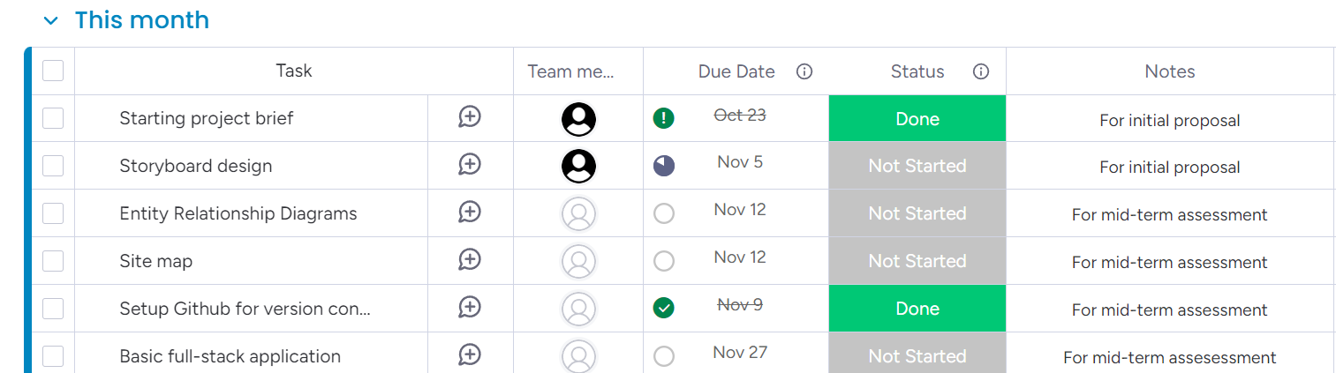

## Project Deliverables

|  |  |  |
| --- | --- | --- |
| **Task/Features** | **Student A** | **Student B** |
| Project brief | * Overview, goals & milestones * Project Schedule * Design requirements & specifications | * Target Audience * Competitor’s research * Storyboard |
| Website design |  |  |
| Basic application |  |  |

## Storyboard

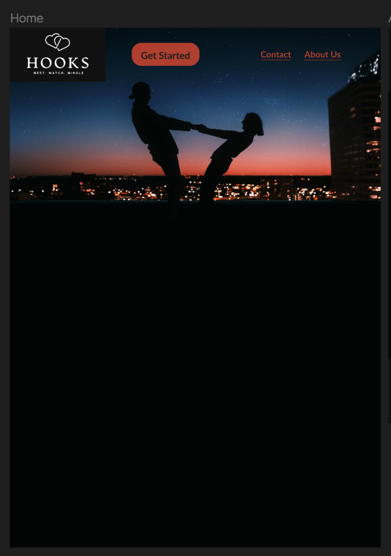

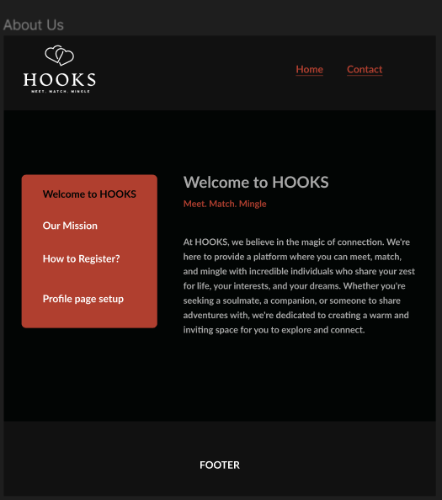

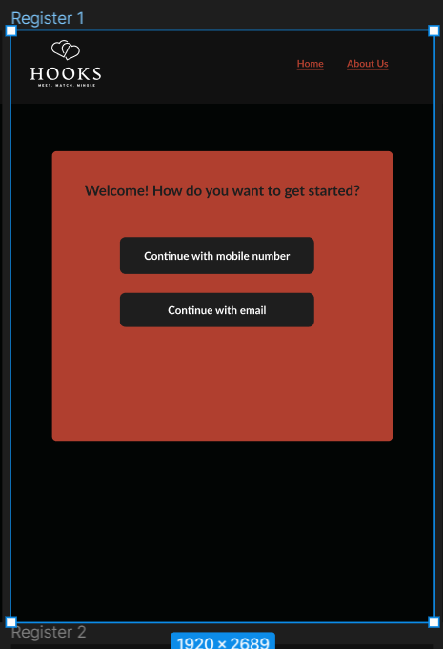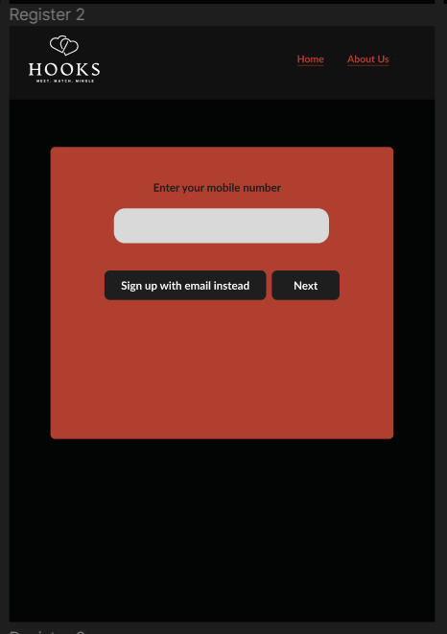

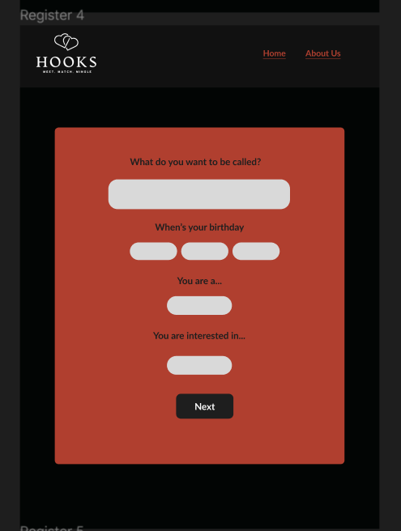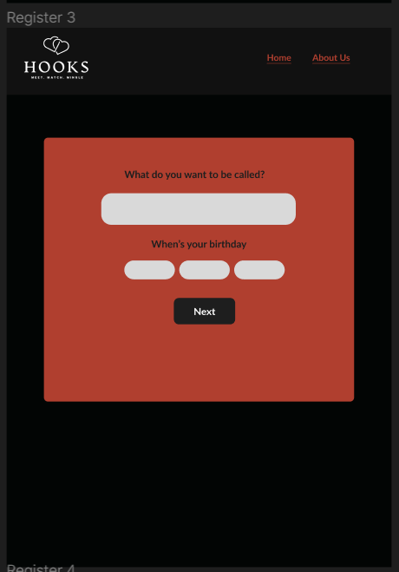

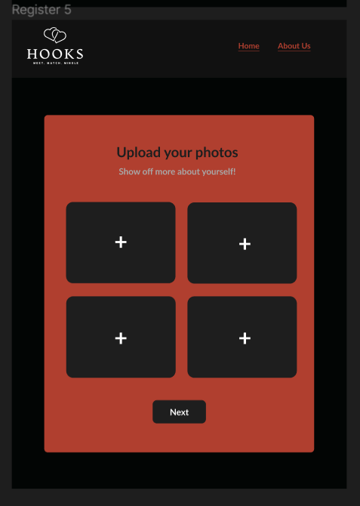

## Design Documents

For design documents, you are expected to document your design. Therefore, attach your ERD and Site Map here.

## Site Map

<https://en.wikipedia.org/wiki/Site_map>

## Entity Relationship Diagram

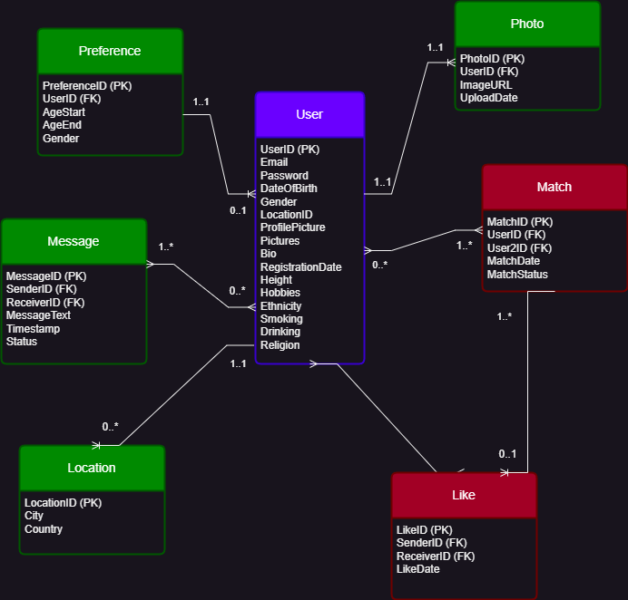

## Conclusion

Summarize your results and compare it with your competitors in section 1.4

## Reflections

Reflect on your individual learning process:

* What have you learnt?
* How well did you manage your time?
* What went right and what went wrong?
* How would you manage the project differently?
* What is the most difficult moment in the project and how did you overcome it?

## References

List your references (if any)

## Appendix

Screenshot of all individual pages of your web site.

Indicate which are done by you and your group member.

**Remember to remove all the report template comments in red font.**