NEXA
v1 Frontend & Design System Specification
Workplace Social Network / Internal Communication Platform
Purpose: a source of truth for NEXA's frontend UX, visual language, component system, responsive behavior, realtime UI, and implementation structure.
Design direction: professional, calm, information-dense, human, and intentionally restrained. NEXA must feel like a real workplace product, not a generic AI-generated SaaS template.
Document | Role
01 — Architecture Specification | Backend, tenancy, APIs, infrastructure
02 — Edge Cases & Risk Register | Failure modes, security, race conditions, recovery
03 — Frontend & Design System Specification | UX, UI, components, screens, responsive behavior
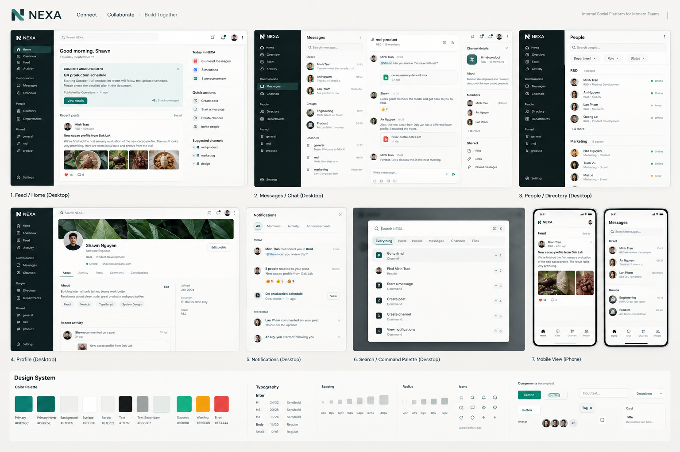

1. Product UX Principles
- Work before decoration — the content/task area gets the strongest visual emphasis.
- Structure should be felt, not seen — use spacing, alignment and hierarchy before heavy cards/borders.
- High information density, low visual noise.
- Context over chrome — navigation recedes after the user reaches the destination.
- Human workplace identity — department/role context is useful where relevant.
- Progressive disclosure — secondary details live in panels, sheets, dialogs and detail views.
- Fast interactions — command palette, keyboard shortcuts, deep links, optimistic reactions and realtime updates.
- No fake complexity — no decorative dashboards, gradients or animation without product purpose.
Reference principle: Linear's recent UI work explicitly emphasizes reduced visual noise, quieter navigation, smaller icon treatment, softer separators and stronger content hierarchy. NEXA should adopt these principles without copying Linear's branding or UI. citeturn0search0turn0search2

2. Information Architecture
NEXA
├── Home
│ ├── Overview
│ ├── Feed
│ └── Activity
├── Communicate
│ ├── Messages
│ ├── Channels
│ └── Mentions
├── People
│ ├── Directory
│ ├── Departments
│ └── Profiles
├── Search
└── Settings
Admin
├── Organization
├── Members
├── Departments
├── Roles & Permissions
├── Moderation
└── Audit Log
Do not make every future feature a top-level nav item. Prefer contextual entry points, pinned items, More menus, search and command palette.

3. App Shell

3.1 Desktop
┌──────────────┬───────────────────────────────┬──────────────┐
│ Global Nav │ Primary Workspace │ Context │
│ 220–240px │ flexible │ 300–360px │
│ │ │ optional │
└──────────────┴───────────────────────────────┴──────────────┘
The context column is optional. Feed can be two-column; chat can be conversation-list + chat; profile can be one main column. Never force three columns everywhere.

3.2 Sidebar
NEXA
HOME
Overview
Feed
Activity
COMMUNICATE
Messages
Channels
PEOPLE
Directory
PINNED
#general
#rnd
#marketing
Settings
Unread state should be restrained: dot/count and typography, not bright badges everywhere.

4. Visual System

4.1 Light theme
Token | Value | Purpose
background | #F7F7F5 | App background
surface | #FFFFFF | Primary surface
surface-subtle | #F1F2EF | Hover/secondary surface
text-primary | #171717 | Primary text
text-secondary | #6B6B67 | Metadata
border | #E7E7E2 | Subtle separators
accent | #087F6C | Primary accent
accent-soft | #E4F2EE | Soft accent
danger | #B42318 | Destructive/error
warning | #A15C00 | Warning

4.2 Dark theme
Token | Value
background | #151614
surface | #191A18
surface-subtle | #20221F
text-primary | #E7E7E2
text-secondary | #A4A7A0
border | #30332F
accent | #35A892

4.3 Typography
Role | Size | Weight
Page title | 22–24px | 600
Section title | 14–16px | 600
Body | 14px | 400
Metadata | 12px | 400
Navigation | 13px | 500
Chat message | 14px | 400

Recommended typeface: Inter or Geist. Keep one family for UI; avoid turning productivity screens into marketing pages.

4.4 Spacing / shape
Property | Rule
Base grid | 4px
Common gaps | 8 / 12 / 16 / 24px
Radius | 6 / 8 / 10–12px
Pills | Only when semantically useful
Shadows | Rare; prefer surface contrast and subtle borders

Avoid the AI-template look of every element being a large rounded card with a shadow.

5. Iconography
- Use one icon family consistently; Lucide is a good baseline.
- 16px navigation icons; ~18px prominent controls.
- Do not add icons to every label.
- Do not use colored icon backgrounds unless color has semantic meaning.
- Keep stroke treatment consistent.

6. Core Screens & Wireframes

Home / Overview
Good morning, Shawn.
Thursday, September 12
COMPANY
Q4 production schedule
Operations · 12 min
[announcement preview]
TODAY IN NEXA
8 unread messages
3 mentions
1 announcement
UX note: A concise workplace briefing, not a dashboard full of metric cards.

Feed
MINH TRAN
R&D · 42 minutes ago
New cacao profile from Dak Lak
We've finished the first sensory evaluation...
[image / attachment]
♥ 14 6 comments
UX note: Posts feel editorial/workplace-oriented; department context is useful.

Announcement
COMPANY ANNOUNCEMENT
Q4 production schedule
Starting October 1, all production teams...
Published by Operations · Sep 12
[ Acknowledge ] 48 / 51
UX note: Announcements are distinct from normal social posts and may require acknowledgement.

Messages / Chat
Messages #rnd-product
Direct R&D · 18 members
Minh ───────────────
An Minh · 10:42
Lan Can we test the new
Groups cacao batch tomorrow?
Engineering
Product Shawn · 10:44
Yes. I'll prepare them.
Channels
#general Message #rnd-product
#rnd Send →
#marketing
UX note: Do not use Messenger-style bubbles. Chat should read like clean workplace communication.

People
People
Search people...
R&D
● Minh Tran
R&D · Product Development
● An Nguyen
R&D · Quality
UX note: Prioritize discovery plus department/role context.

Profile
Shawn
Software Engineer
R&D · Product Development
About
Building internal tools...
Activity
Posts · Comments · Contributions
UX note: Avoid Facebook-style cover photos by default.

Notifications
TODAY
MENTIONS
Minh mentioned you in #rnd
“@Shawn can you review this?”
2 min
ACTIVITY
5 people reacted to your post
18 min
COMPANY
Q4 production schedule
Operations · 1h ago
UX note: Group by context/type instead of a flat stream of identical alerts.

Search
Search NEXA
Everything
Posts (8)
Messages (31)
Files (4)
People (2)
Result → deep link to original context
UX note: Search must inherit tenant and authorization scope.

7. Chat UX & Realtime
- Conversation types: Direct, Group, Channel.
- Composer supports text, emoji, attachments and @mentions.
- Message state: sending → sent → failed/retry.
- Client-generated message ID makes retries idempotent.
- Reconnect: authenticate → resubscribe → synchronize missed events.
- Presence is based on active connections, not one boolean.
- Read state synchronizes across devices.
- Deleted messages preserve backend-defined audit semantics.
- Deep links open the conversation and highlight the referenced message.
- Do not yank the user's scroll position when new messages arrive above their current reading point.
State | UI behavior
Sending | Subtle pending state; keep message visible
Sent | Normal presentation
Failed | Visible retry affordance
Offline | Non-blocking connection indicator; preserve drafts
Reconnecting | Show state and resync
New messages | Unread divider/count when user is not at bottom

8. Command Palette
Ctrl/Cmd + K
Search NEXA
────────────────
Go to #rnd
Find Minh Tran
Start a message
Create post
Create channel
View notifications
Open settings
- Global and permission-aware.
- Search/navigation must not expose inaccessible resources.
- Keyboard shortcuts complement mouse/touch; they never replace them.
- Initial shortcuts: Cmd/Ctrl+K, Esc, Enter, Cmd/Ctrl+Enter where appropriate.

9. Component System
packages/ui/
├── primitives/
│ ├── Button / IconButton / Input / Textarea
│ ├── Avatar / Badge / Tooltip / Popover
│ ├── Dialog / Dropdown / Tabs / Toast
├── navigation/
│ ├── Sidebar / Topbar / Breadcrumbs / CommandPalette
├── content/
│ ├── Post / Comment / ReactionBar / Attachment / UserCard
├── communication/
│ ├── ConversationList / MessageList / MessageItem
│ ├── MessageComposer / PresenceIndicator
└── feedback/
├── EmptyState / LoadingState / ErrorState
├── OfflineBanner / ConfirmDialog
Layering rule: UI primitives → reusable patterns → domain components → pages. Generic components must not contain business rules.

10. Frontend Architecture
apps/web/
├── app/
│ ├── (auth)/
│ ├── (workspace)/
│ │ ├── home/
│ │ ├── feed/
│ │ ├── messages/
│ │ ├── channels/
│ │ ├── people/
│ │ ├── search/
│ │ └── settings/
│ └── admin/
├── features/
│ ├── auth / organization / feed / chat
│ ├── notifications / search / people
├── components/
├── hooks/
├── stores/
├── lib/
└── styles/
packages/
├── ui/
├── api-client/
├── realtime/
├── types/
├── config/
└── validation/
Recommended implementation: React/Next.js + TypeScript, typed API client, query/cache layer for server state, small local UI state layer, and a dedicated realtime module.

11. State Management
State | Examples | Owner
Server state | Posts, messages, members, notifications | Query/cache layer
Session | User, active organization | Auth/session provider
Realtime | Socket, presence, event stream | Realtime client
UI | Modal, sidebar, active tab | Local state / small UI store
Draft | Message/post composer | Local component state

Keep server cache, realtime state and local UI state conceptually separate.

12. API → UI Contract
API
↓
API client / validation
↓
Query or mutation
↓
Domain feature
↓
Presentational component
Realtime event
↓
Realtime client
↓
Domain event handler
↓
Cache reconciliation
↓
UI
- Backend is authoritative for authorization.
- Normalize API errors into safe UI states.
- Optimistic updates must define rollback.
- Prefer cursor pagination where realtime/order/scale requires it.

13. Responsive Design
Viewport | Behavior
≥1280px | Full shell; optional context panel
1024–1279px | Desktop shell; context panel becomes drawer
768–1023px | Reduced sidebar; two-pane where useful
<768px | Mobile navigation; one primary pane; full-screen details

Mobile
┌──────────────────────────┐
│ NEXA Bell │
├──────────────────────────┤
│ │
│ Current screen │
│ │
├──────────────────────────┤
│ Home Chat Channels People│
└──────────────────────────┘
- Never shrink a desktop three-column layout into mobile.
- Conversation details use a route/sheet/full-screen view.
- Composer must remain usable above the mobile keyboard.
- Bottom navigation contains only high-frequency destinations.

14. Accessibility
- Keyboard navigation for all interactive controls.
- Visible focus states.
- Semantic buttons/links.
- WCAG AA-oriented contrast.
- Never encode meaning by color alone.
- Accessible labels for icon-only buttons.
- Respect reduced-motion preferences.
- Comfortable mobile touch targets.

15. Loading / Empty / Error / Offline
State | Rule
Loading | Skeletons for structured content; avoid spinner-only screens
Empty | Explain what is empty + next useful action
Error | State what failed + retry when meaningful
Permission denied | Do not reveal resource details
Offline | Preserve work and clearly communicate connection
No search results | Show query + useful refinement

No messages yet
Start the conversation with your team.
Upload failed
We couldn't upload this file.
[ Try again ]

16. Motion & Interaction
- Animation communicates state, continuity or hierarchy.
- Prefer short/subtle transitions.
- Reaction can use a small scale/fade response.
- Panels/dialogs get predictable entry/exit.
- Never animate large content areas without purpose.

17. FE Security & Privacy
- Frontend permission checks are for UX only; backend remains authoritative.
- Do not cache tenant-sensitive data across organization contexts.
- Clear/invalidate tenant-scoped queries and realtime subscriptions on org switch.
- Do not store sensitive message content in localStorage.
- Rich text rendering must follow content sanitization policy.
- File previews must use access-controlled URLs.

18. FE Edge Cases
Case | Expected behavior
User removed from org | Invalidate org-scoped session/cache and move to safe state
Role changed | Refresh effective permissions
Socket disconnect | Reconnect and resync without losing local work
Two tabs | Coordinate unread/presence without corrupting state
Duplicate message retry | Client ID prevents duplicate rendering/persistence
Message fails | Keep it visible with retry
Post deleted while open | Replace with deleted-state UI
Permission revoked | Remove sensitive content and show access state
Organization switched | Reset tenant-scoped queries/subscriptions
Slow network | Preserve drafts; avoid flicker

19. Design Anti-Patterns
- Excessive gradients.
- Glassmorphism as default surface treatment.
- 20–24px radius on every card.
- Huge hero typography inside productivity screens.
- Dashboard made entirely from metric cards.
- Icon for every label.
- Heavy shadows everywhere.
- Decorative AI sparkle motifs when no AI feature exists.
- Unrelated colors used only for variety.
- Animation without a functional reason.

20. FE Development Milestones
Milestone | Scope | Done when
FE-01 Foundation | Tokens, shell, sidebar, topbar, responsive layout, primitives | All future screens share one shell/language
FE-02 Workplace | Home, Feed, Post, Comments, People, Profile | Core social/workplace loop works end-to-end
FE-03 Communication | Messages, Channels, Composer, Realtime, Presence, Notifications | Chat is reliable and consistent
FE-04 Platform | Search, Command Palette, Admin, Settings, Audit | Product feels complete, not a demo

21. Definition of Done
- Desktop and mobile behavior defined.
- Loading, empty, error, permission and offline states implemented.
- Core flows keyboard-accessible.
- Realtime reconciliation tested where applicable.
- No tenant/user assumptions hard-coded.
- No duplicated shared visual patterns.
- Design tokens used instead of arbitrary raw colors/spacing.
- Realistic data-density visual QA completed.
- Visual hierarchy reviewed before shipping.

22. Recommended Build Order
1. Design tokens
2. App shell
3. Sidebar / Topbar / Command Palette
4. Primitive components
5. Auth + organization context
6. Home / Feed
7. Post / Comment / Reaction
8. People / Profile
9. Conversation list
10. Chat / Composer
11. Realtime synchronization
12. Notifications
13. Search
14. Settings
15. Admin
16. Mobile polish
17. Accessibility + performance pass
Stabilize the shell and design system before building every page. This prevents the frontend from developing multiple incompatible visual languages.

23. AI Coding Agent Rules
- Never invent a new visual pattern when an existing component/pattern fits.
- Do not add gradients, glass effects, giant rounded cards or decorative illustrations without a product reason.
- Before coding a screen, define its shell, hierarchy, states and responsive behavior.
- Use design tokens; do not scatter raw hex values.
- Do not put business rules in generic UI components.
- Do not silently change API contracts to make UI easier.
- New states should update the shared component/domain model rather than becoming one-off hacks.
- Keep domain feature code colocated; keep primitives domain-agnostic.
- Visual QA must include long names, unread counts, many channels, long messages, attachments and permission changes.

24. Product Feel Checklist
Question | Pass condition
Does main content dominate? | Yes; navigation is quieter
Does it look like a template? | No; spacing/hierarchy feel intentional
Can users find communication quickly? | Yes
Can users understand teammates? | Name + department/role where useful
Does density feel overwhelming? | No
Are errors recoverable? | Yes
Does realtime feel trustworthy? | Yes; state is visible
Does mobile feel native to the workflow? | Yes; not merely shrunken

25. Design Reference Notes
The visual direction is original. Linear is used only as a reference for general product-design principles: its 2024 redesign emphasized hierarchy, balance, density, consistent headers/tabs/panels and reduced visual noise; its 2026 refresh further emphasized quieter navigation, reduced icon treatment and softer separators. citeturn0search1turn0search2
Linear also documents personalized sidebar behavior, which supports the broader NEXA idea that users can eventually customize frequently used destinations without bloating the main navigation. citeturn0search8
NEXA v1 — quiet enough to work in, distinctive enough to remember.

