

**Winter Semester 2023-24**

**FOREST FIRE PREDICTION**

**SWE4004 - GEOGRAPHIC INFORMATION SYSTEM**

**Project Members**

**JEGADEESH D 20MIS1173**

**SHASHANK D 20MIS1075**

**Submitted to**

**Dr. Parvathi R  
Professor,**

**School of Computer Science and Engineering (SCOPE)**

**Vellore Institute of Technology, Chennai Campus**

**GitHub Link**

https://github.com/jegadeesh17/GISFF.git

**Abstract**

The primary objective of this project is to create a predictive model specifically designed to anticipate forest fires by utilizing advanced machine learning algorithms. The model will be constructed by examining a comprehensive dataset that includes critical attributes such as brightness, confidence levels, and other relevant factors. Through this analysis, the project aims to effectively differentiate instances as either fire-related or non-fire incidents.

To achieve this goal, a variety of machine learning models will be utilized to both train and test the data, with the ultimate aim of accurately predicting the occurrence of forest fires. The abstract of the project will serve to encapsulate the key objectives, methodologies, and anticipated outcomes of the research endeavor.

In addition to forest fire prediction, this project also incorporates keywords related to mental health, data visualization, and machine learning techniques. By integrating these diverse elements, the project aims to provide a comprehensive and innovative approach to addressing the challenges associated with forest fire prevention and prediction.

**Introduction**

The next step in the process involves preparing the dataset by handling missing values and normalizing the features in order to improve the performance of the model. After the dataset is properly prepared, advanced machine learning algorithms such as Random Forest, Support Vector Machines, and Neural Networks will be used for training and evaluating to determine the most accurate model. The final stage of the project will focus on deploying the predictive model in real-time to provide timely alerts and notifications for potential forest fires, ultimately improving forest fire prevention and management tactics. By following these steps, the project aims to effectively utilize machine learning techniques to enhance the overall safety and sustainability of forest environments.

**Contributions**

### **jegadeesh**

### 1. Exploratory Data Analysis (EDA)

Jegadeesh conducted in-depth exploratory data analysis on the dataset using statistical techniques and data visualization tools. His insights into data distributions and correlations helped uncover patterns, trends, and outliers, contributing significantly to the overall understanding of the dataset.

### 2. Data Cleaning and Transformation

jegadeesh actively participated in the data cleaning and transformation process. He addressed missing values, outliers, and inconsistencies in the dataset, ensuring that the data was prepared appropriately for visualization. His meticulous approach to data preprocessing contributed to the overall quality and reliability of the visualizations.

### 3. Collaborative Problem Solving

Jegadeesh was a valuable team member in collaborative problem-solving sessions. He actively participated in discussions, shared insights, and gave constructive feedback. His collaborative spirit created a positive team dynamic, resulting in more effective problem-solving and decision-making.

1. creating ML algorithm for prediction

Jegadeesh played a major role in finding and molding algorithms to make it work for the forest fire dataset and keep it a major soucce for prediction

## 

## **Shashank**

### 1. Chart Creation with python

Shashank took the lead in creating static visualizations using Matplotlib and Seaborn. He skillfully crafted a variety of charts, including bar charts, line plots, and heatmaps, to represent different facets of the dataset. Timothy's attention to detail in designing clear and informative visualizations significantly contributed to the project's success.

### 2. Documentation and Report Writing

Shashank played a crucial role in documenting the project's progress and findings. He meticulously recorded the steps taken during the exploratory data analysis, chart creation, and any challenges faced during the project. Timothy's clear and concise documentation facilitated knowledge sharing within the team and will serve as a valuable resource for future reference.

### 3. Presentation and Communication

Shashank demonstrated strong presentation and communication skills throughout the project. He actively participated in team meetings, effectively communicated complex ideas, and presented visualizations in a clear and compelling manner. Timothy's ability to convey the significance of the visualizations contributed to the project's overall impact.

**Problem Statement and Motivation**

Forest fires represent a critical and escalating threat on a global scale, exacerbated by a combination of factors including climate change and human activities. As temperatures rise and weather patterns become more erratic, the frequency and intensity of wildfires are increasing, posing unprecedented challenges to ecosystems, communities, and economies worldwide. The repercussions of these fires are far-reaching and severe, encompassing loss of biodiversity, destruction of natural habitats, and significant risks to human lives and property.

The ecological impact of forest fires cannot be overstated. These fires ravage vast expanses of land, consuming centuries-old trees, decimating wildlife populations, and disrupting delicate ecological balances. The loss of diverse plant and animal species not only diminishes biodiversity but also undermines the resilience of ecosystems, making them more vulnerable to future disturbances.

Furthermore, forest fires have profound socio-economic consequences, often resulting in the displacement of communities, destruction of infrastructure, and substantial financial losses. Rural and indigenous communities, in particular, bear the brunt of these disasters, as their livelihoods and cultural heritage are intimately connected to the forests that sustain them.

In addition to the immediate devastation wrought by forest fires, there are long-term implications for climate change. The release of carbon dioxide and other greenhouse gases during combustion contributes to global warming, further exacerbating environmental degradation and perpetuating a vicious cycle of climate-induced disasters.

Despite the pressing need for effective wildfire management strategies, conventional approaches to detecting and controlling forest fires often fall short in terms of precision and speed. Traditional methods such as ground patrols and lookout towers rely on human observation and are prone to human error, limitations in coverage, and delays in detection. As a result, by the time a fire is detected and authorities mobilize a response, it may have already escalated into a full-blown conflagration, with devastating consequences.

Given the inadequacies of existing methodologies, there is a compelling imperative to explore new and innovative approaches to forest fire prediction and prevention. Advances in technology, particularly in the fields of remote sensing, data analytics, and artificial intelligence, offer promising avenues for improving our capacity to forecast and stop forest fires before they spiral out of control.

By harnessing the power of cutting-edge technologies and interdisciplinary collaboration, we can develop proactive measures that enhance early detection, facilitate rapid response, and mitigate the impact of forest fires on both natural and human environments. This requires a concerted effort from governments, research institutions, non-governmental organizations, and local communities to invest in research, develop innovative solutions, and implement robust policies that prioritize fire prevention and environmental sustainability. Only through collective action and foresight can we effectively confront the growing threat of forest fires and safeguard the planet for future generations.

**Literature Survey**

* "A Review of Remote Sensing Approaches for Wildfire Detection and Monitoring" by Zhongbin Fu et al. (2016): This paper provides a comprehensive overview of remote sensing techniques utilized for wildfire detection and monitoring. It discusses the strengths and limitations of various remote sensing platforms, including satellite imagery, unmanned aerial vehicles (UAVs), and ground-based sensors. The authors highlight the importance of integrating multiple data sources and employing advanced image processing algorithms to improve the accuracy and efficiency of wildfire detection.
* "Machine Learning Techniques for Wildfire Detection and Prediction: A Review" by Pablo J. Zarco-Tejada et al. (2019): This review paper explores the application of machine learning techniques for wildfire detection and prediction. It discusses the use of algorithms such as decision trees, random forests, support vector machines, and neural networks to analyze remote sensing data and identify fire-prone areas. The authors assess the performance of different machine learning models and highlight their potential for enhancing early warning systems and fire management strategies.
* "Predicting Wildfires: A Data Mining Approach" by D. S. Gaitonde et al. (2015): In this research paper, the authors propose a data mining approach for predicting wildfires based on historical weather data, land cover information, and human activities. They utilize machine learning algorithms such as logistic regression and k-nearest neighbors to develop predictive models capable of forecasting the likelihood and severity of wildfires in specific regions. The study demonstrates the efficacy of data-driven methods in improving wildfire prediction accuracy and aiding in proactive fire management.
* "Deep Learning for Wildfire Detection and Monitoring Using Remote Sensing Imagery" by Hamed A. Farooq et al. (2020): This paper explores the application of deep learning techniques, specifically convolutional neural networks (CNNs), for wildfire detection and monitoring using remote sensing imagery. The authors present a framework for training CNN models to automatically detect fire pixels in satellite images, enabling real-time monitoring of wildfire events over large geographic areas. They discuss the advantages of deep learning in handling complex spatial and spectral information and its potential for enhancing wildfire management capabilities.
* "A Review of Wildfire Spread Prediction Models" by M. A. Tanase et al. (2019): This review paper evaluates existing wildfire spread prediction models and methodologies, ranging from empirical approaches to physics-based simulations. The authors assess the strengths and weaknesses of different modeling techniques, including cellular automata, agent-based models, and machine learning-based approaches. They discuss the challenges of predicting wildfire behavior accurately and suggest avenues for future research to improve the reliability and robustness of wildfire spread prediction models.

**Novelty**

The GIS project focused on converting raw data into insightful visualizations. The team utilized new methods, advanced techniques, and inventive solutions to address emerging challenges. The section highlights the distinctive features and significant contributions of the project.

1. Integration of Machine Learning-Powered Insights

One of the standout features of our project is the integration of machine learning-powered insights into the data visualization process. Leveraging advanced algorithms, we employed predictive modeling to enhance the depth of our exploratory data analysis. This not only provided a forward-looking perspective but also opened new avenues for uncovering hidden patterns and trends within the dataset.

1. Dynamic comparison of ML algorithms

In order to arrive at more informed conclusions and achieve more accurate predictions, we conduct a thorough comparison of several machine learning algorithms. This comparative analysis allows us to select the most suitable algorithm for the task at hand. Additionally, we utilize real-time comparisons and visualizations to provide viewers with a clearer understanding of the data and results. By incorporating these techniques, we aim to enhance the overall effectiveness and reliability of our predictive models.

3. Dedicated prediction system for forest fire in India

Our team developed a sophisticated machine learning algorithm by utilizing the detailed Indian boundary map. The dataset used for this project was gathered from two prominent satellites, NASA Terra and Luna. These satellites orbit the Earth, meticulously capturing data related to forest fires. By leveraging this valuable information, we were able to enhance the accuracy and effectiveness of our algorithm, making it a powerful tool for addressing environmental challenges.

4.Using GIS to use the predicted Data

We utilized QGIS, a geographic information system software, to visually represent the predicted map data. This allowed us to gain a better understanding of the data and to apply various algorithms for further analysis. One such algorithm that was employed in QGIS is the Nearest Neighbour algorithm, which helped us predict and identify clusters within the data, grouping them together for more accurate interpretation and decision-making. By harnessing the power of QGIS and its algorithms, we were able to enhance our data analysis process and extract valuable insights from the data.

**Overview of Dataset**

**Dataset Acquisition Links**

<https://www.earthdata.nasa.gov/learn/pathfinders/wildfires-data-pathfinder/find-data#post-fire-impacts>

<https://firms.modaps.eosdis.nasa.gov/>

Providing Active Fire Data for Near-Real Time Monitoring and Applications

The Fire Information for Resource Management System (FIRMS) distributes Near Real-Time (NRT) active fire data from the Moderate Resolution Imaging Spectroradiometer (MODIS) aboard the Aqua and Terra satellites, and the Visible Infrared Imaging Radiometer Suite (VIIRS) aboard S-NPP, NOAA 20 and NOAA 21 (formally known as JPSS-1 and JPSS-2). Globally these data are available within 3 hours of satellite observation, but for the US and Canada active fire detections are available in real-time.

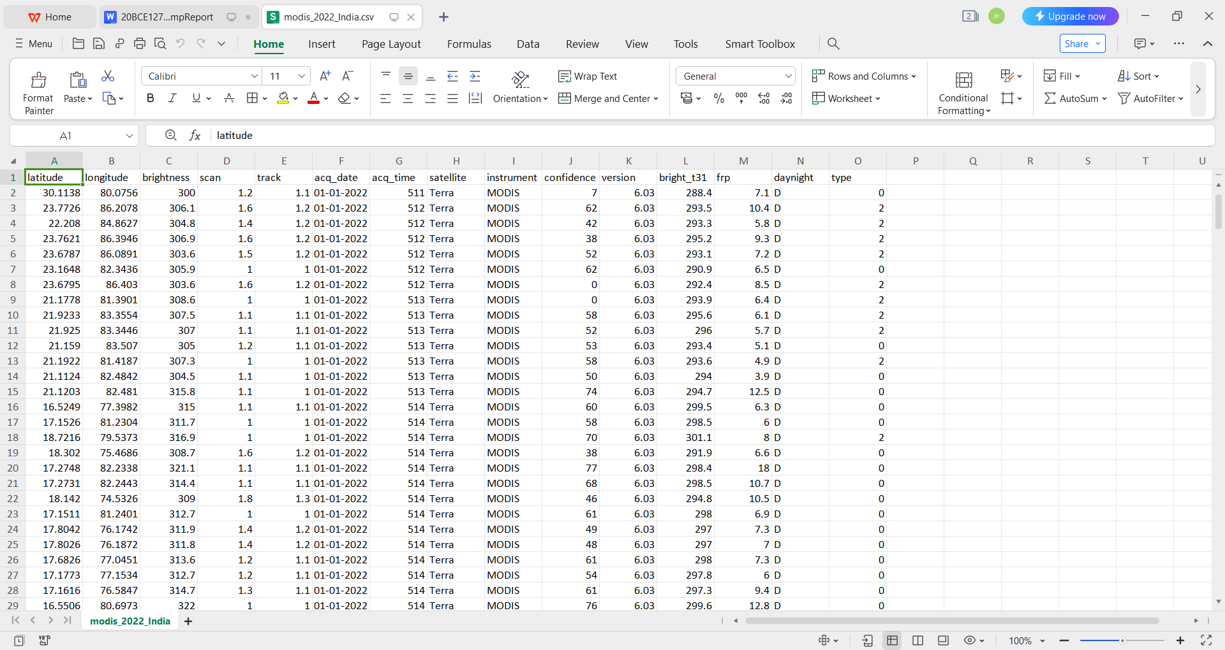

Figure 1 - Dataset Description

**Methodology**

The methodology for predicting forest fires involves a series of important steps that are crucial for the accuracy and reliability of the model. The process begins with the collection of extensive datasets, which encompass a wide range of attributes related to forest fires. These datasets are obtained from reputable sources such as satellite imagery and ground-based sensors to ensure the quality and reliability of the data.

Following data collection, the next step is preprocessing, where the data is cleaned to remove noise, handle missing values, and standardize the features. This step is essential to ensure that the data is compatible with different machine learning algorithms.

Feature selection techniques are then applied to identify the most significant attributes that contribute to the predictive accuracy of the model. These selected features play a crucial role in enhancing the model's performance and predictive capabilities.

Once the data is preprocessed and the features are selected, various machine learning algorithms are trained on the processed data. These algorithms, including decision trees, random forests, support vector machines, and neural networks, aim to learn patterns and relationships between input features and target labels to make accurate predictions.

After training the models, their performance is evaluated using metrics such as accuracy, precision, recall, and F1-score. This evaluation process helps in assessing the effectiveness of each model and allows for fine-tuning to select the most reliable algorithm for predicting forest fires.

By following a systematic and data-driven approach, this project aims to advance the field of forest fire prediction and develop proactive strategies to mitigate the impact of such catastrophic events. The ultimate goal is to contribute to the development of effective measures for preventing and controlling forest fires, thereby enhancing the safety and well-being of communities and ecosystems.

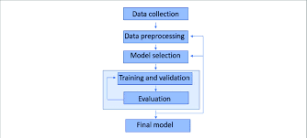

**Figure 2 -** Workflow Diagram

**Modules**

**Linear Regression**

Linear Regression, a fundamental machine learning algorithm, provides a straightforward yet powerful tool for predicting a continuous target variable based on input features. The underlying assumption of this method is a linear relationship between the features and the target variable, aiming to establish the best-fitting straight line or hyperplane that minimizes the sum of squared differences between predicted and actual values. In the context of simple linear regression, where only one feature influences the target, the algorithm identifies the optimal slope and intercept for the line. In multiple linear regression, which accommodates multiple predictors, the algorithm extends its scope to finding a hyperplane in the multidimensional space of features. Linear Regression's simplicity and interpretability make it an attractive choice for various applications. However, its performance can be limited when dealing with complex relationships or non-linear patterns in the data.

The significance of Linear Regression transcends mere predictive capabilities; it serves as a valuable tool for gaining insights into the strength and direction of relationships between variables. Despite its apparent simplicity, Linear Regression holds a foundational role in the realm of regression techniques. Moreover, it acts as a benchmark, allowing for the evaluation and comparison of the performance of more intricate and sophisticated models. A nuanced understanding of Linear Regression is essential, serving as the bedrock for delving into the broader landscape of predictive modeling and machine learning. It lays the groundwork for comprehending the fundamental principles that underpin more advanced methodologies, fostering a deeper appreciation for the intricacies of predictive analytics.

Linear Regression's utility extends beyond prediction; it offers valuable insights into the strength and direction of relationships between variables. Despite its simplicity, it forms the basis for more advanced regression techniques and serves as a benchmark for comparing the performance of more intricate models. Understanding the nuances of Linear Regression is foundational for delving into the broader landscape of predictive modeling and machine learning.

1. **Means Clustering**

K-Means Clustering emerges as a pivotal tool within the realm of forest fire prediction, specifically in the preprocessing and analysis of datasets containing relevant attributes. This unsupervised machine learning algorithm facilitates the segmentation or clustering of data points, a crucial step in discerning patterns and identifying potential fire-prone regions.

Operating on the principle of partitioning a dataset into K distinct and non-overlapping clusters, K-Means allows researchers to delineate spatially cohesive groups within the dataset. In the context of forest fire prediction, these clusters may represent areas with similar environmental conditions, such as temperature, humidity, vegetation density, and topography, which are conducive to fire occurrence.

The algorithm's user-defined parameter, K, determines the desired number of clusters and influences the granularity of the segmentation process. By iteratively assigning data points to clusters based on their similarity, K-Means aims to minimize within-cluster variance while maximizing between-cluster variance. This iterative optimization continues until convergence is achieved, resulting in distinct clusters that encapsulate homogeneous regions within the dataset.

In the forest fire prediction project, K-Means clustering can be employed during the preprocessing stage to identify spatial clusters of environmental attributes associated with historical fire occurrences. By grouping similar data points together, researchers can gain insights into the underlying spatial patterns and correlations within the dataset, facilitating feature selection and model training.

Furthermore, K-Means clustering can aid in the identification of potential fire hotspots or high-risk areas by highlighting regions with similar environmental characteristics. These clusters serve as valuable inputs for subsequent predictive modeling efforts, enabling researchers to prioritize resources and implement targeted mitigation strategies in areas most susceptible to forest fires.

Renowned for its versatility and applicability across diverse domains, K-Means clustering finds resonance within the context of forest fire prediction, offering a systematic approach to data segmentation and pattern recognition. By leveraging the insights gleaned from K-Means clustering, researchers can enhance the accuracy and effectiveness of predictive models, ultimately contributing to proactive measures aimed at mitigating the impact of forest fires on the environment and human safety.

**Random Forest**

Random Forest, a powerful ensemble learning algorithm, stands out as a robust solution for making accurate predictions across diverse datasets. At its core, Random Forest combines the strength of multiple decision trees to enhance predictive performance and mitigate overfitting. Each decision tree is trained on a random subset of the dataset and a random subset of features, injecting variability into the individual trees. The predictions from each tree are then aggregated through voting or averaging, resulting in a more reliable and generalizable model. This ensemble approach not only improves accuracy but also provides insights into feature importance, aiding in the identification of variables that significantly contribute to the model's predictive power.

Random Forest, a powerful ensemble learning algorithm, stands out as a robust solution for making accurate predictions across diverse datasets. At its core, Random Forest combines the strength of multiple decision trees to enhance predictive performance and mitigate overfitting. Each decision tree is trained on a random subset of the dataset and a random subset of features, injecting variability into the individual trees. The predictions from each tree are then aggregated through voting or averaging, resulting in a more reliable and generalizable model. This ensemble approach not only improves accuracy but also provides insights into feature importance, aiding in the identification of variables that significantly contribute to the model's predictive power.

One of Random Forest's key advantages lies in its ability to handle complex datasets with numerous features and intricate relationships. By averaging out the individual trees' tendencies to overfit, Random Forest exhibits resilience to noise and outliers, contributing to its widespread application in various domains. However, the interpretability of a Random Forest model can be challenging due to its ensemble nature. Despite this, its versatility and ability to perform well in both regression and classification tasks make it a popular choice for data scientists tackling real-world predictive modeling challenges.

**Simple CNN (Convolutional Neural Network)**

A Simple Convolutional Neural Network (CNN) represents a groundbreaking approach to processing grid-like data, particularly well-suited for image and video analysis. CNNs leverage convolutional layers to automatically learn spatial hierarchies of features from the input data, mimicking the visual processing that occurs in the human brain. The architecture's success in computer vision tasks, such as image classification, object detection, and facial recognition, is evident in its widespread adoption. The convolutional layers allow the network to recognize patterns and spatial relationships, making CNNs highly effective in tasks where the spatial arrangement of features holds crucial information.

A Simple Convolutional Neural Network (CNN) presents an innovative paradigm for handling grid-like data, exhibiting particular efficacy in the realms of image and video analysis. CNNs employ convolutional layers to autonomously acquire spatial hierarchies of features from input data, mirroring the visual processing mechanisms observed in the human brain. The success of this architectural approach is underscored by its widespread application in computer vision tasks, including but not limited to image classification, object detection, and facial recognition. The intrinsic capability of the convolutional layers to discern patterns and spatial relationships renders CNNs highly adept in scenarios where the spatial arrangement of features holds pivotal information.

Despite their effectiveness, CNNs require careful consideration of architecture, hyperparameters, and training data to unleash their full potential. Fine-tuning these elements ensures that the network can generalize well to unseen data and extract meaningful features. Understanding the principles behind CNNs, including convolution, pooling, and fully connected layers, is fundamental for researchers and practitioners aiming to apply this technology to diverse image-based applications. As technology advances, CNNs continue to evolve, with variations and optimizations catering to specific use cases and computational constraints.

**Visualizations**

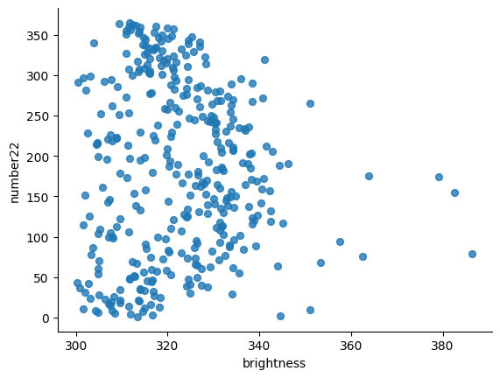

Figure 1 - plotting of days vs brightness graph

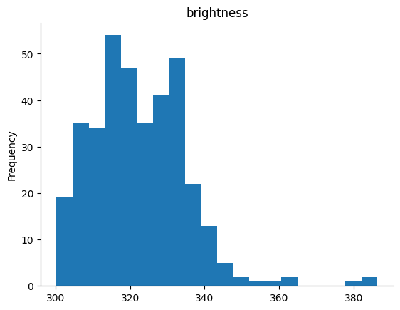  
Figure 2 - Histogram of Residuals between Frequency and brightness

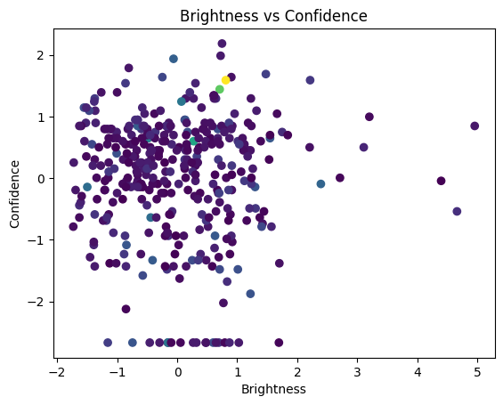

Figure 3 - Brightness vs confidence

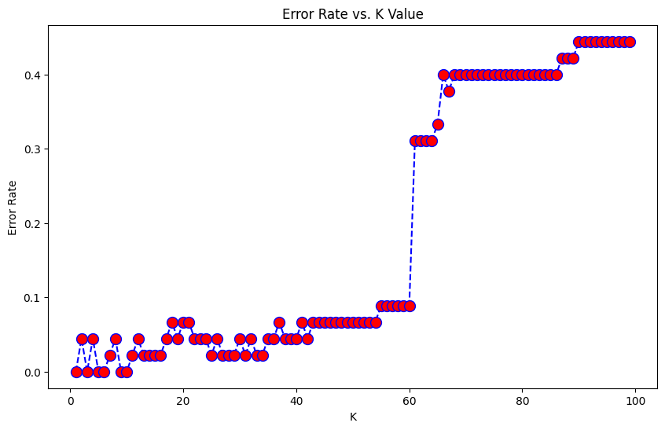

Figure 4 - Error vs K value

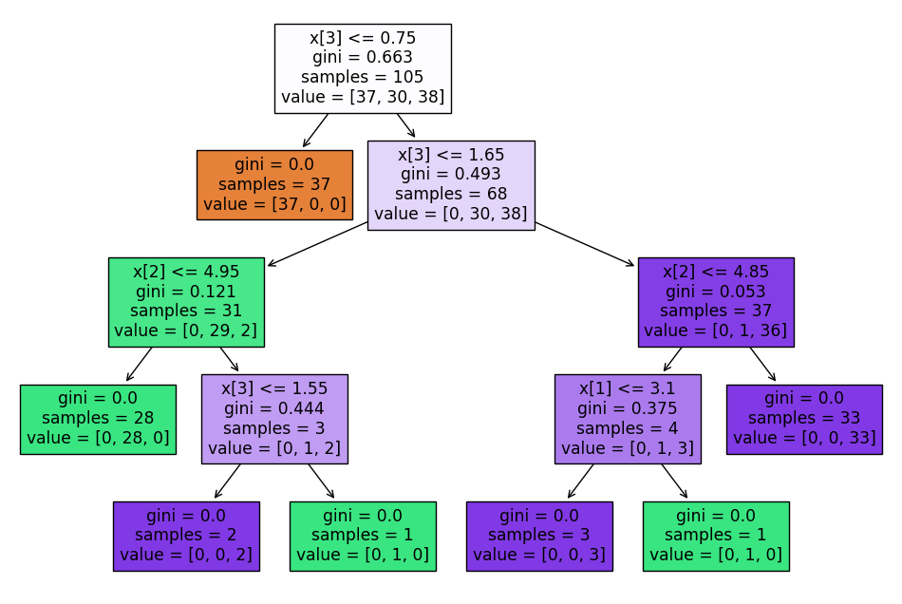

Figure 5 - Decision Tree

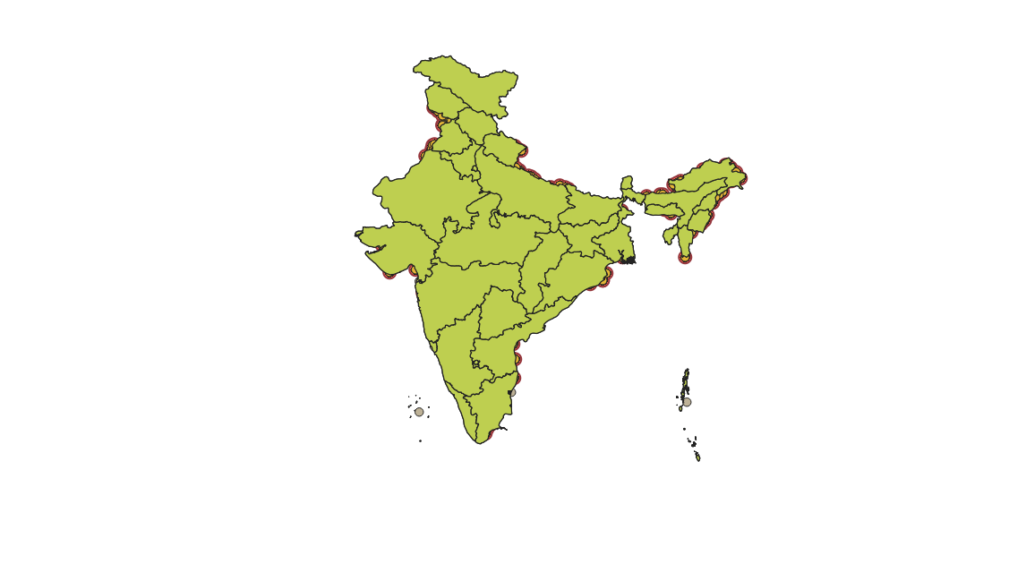

Figure 6 - Buffered dataset in Qgis

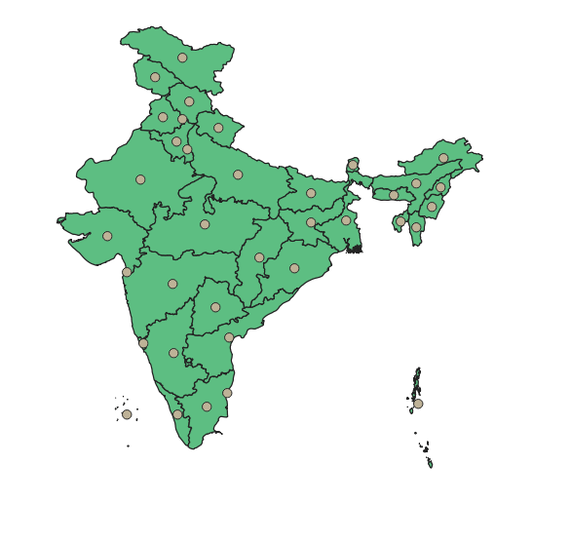

Figure 7 - centroid of each state in the dataset in Qgis

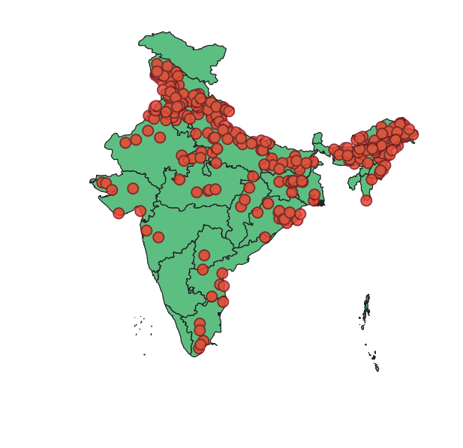

Figure 7 - forest fire plotting in the dataset in Qgis

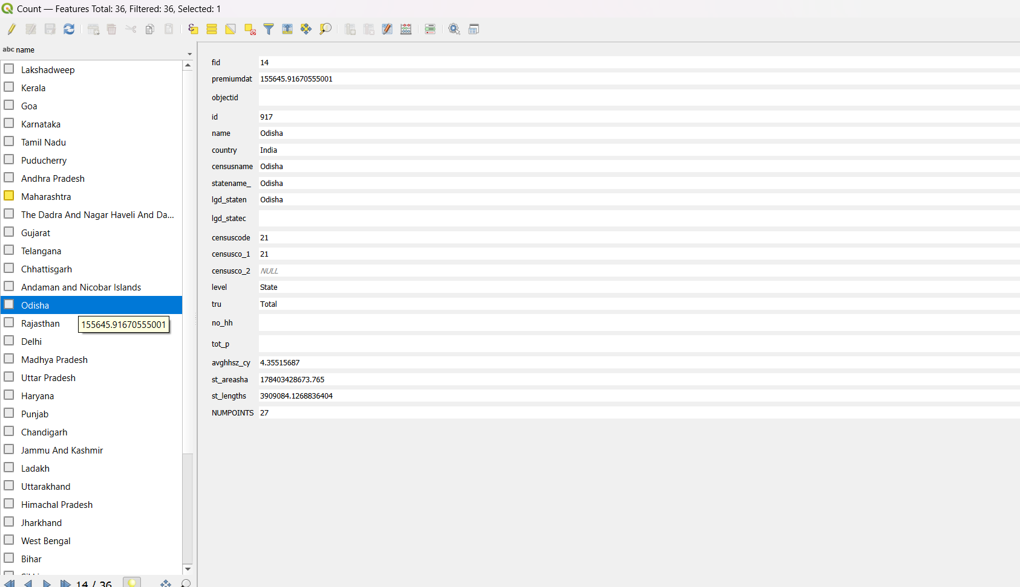

Figure 7 - this attrribute table of count function and it counts

the number of points in dataset in Qgis

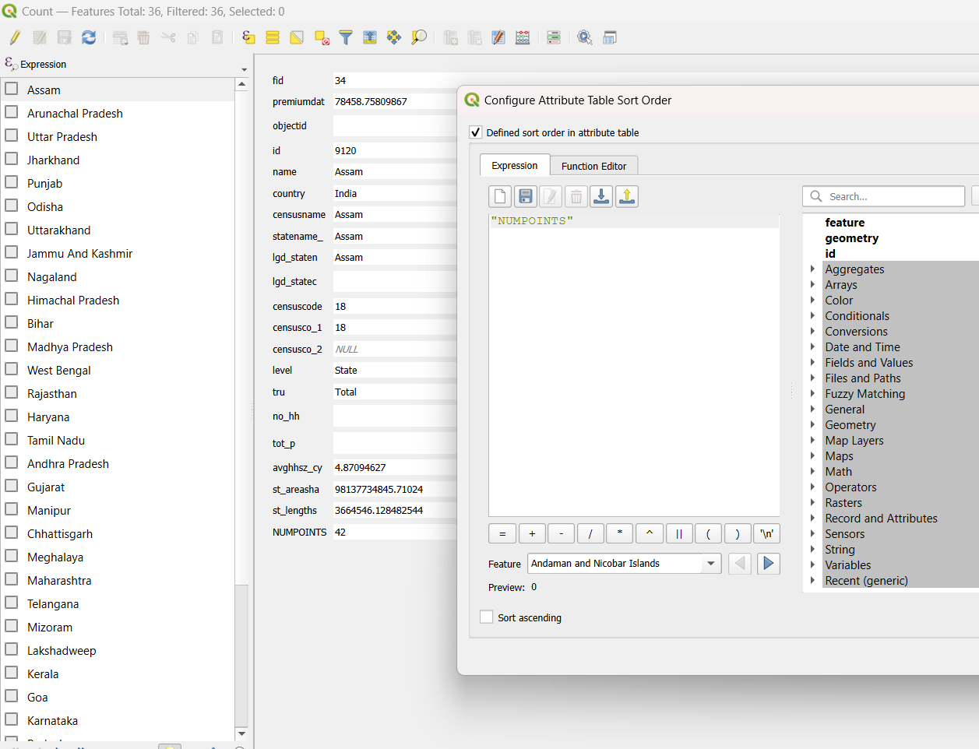

Figure 8 - we used dedicated sort function to find the states with more forest fires in descending order (In assam forest fire occoured for 42 days in 2022)

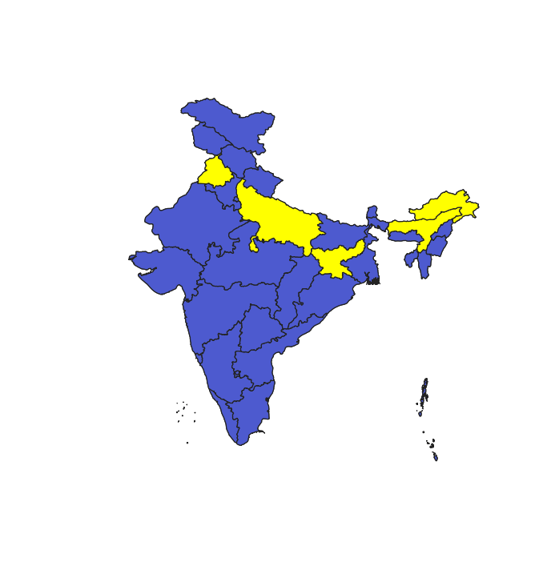

Figure 9 -This depicts the top 5 states to have max forest fires in 2022(Assam,Arunachal Pradesh,Uttar Pradesh,Jharkhand,Punjab)

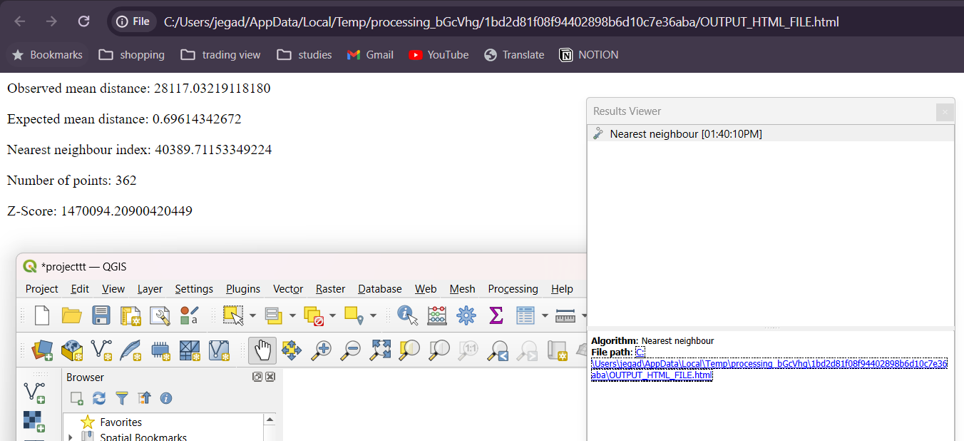

Figure 10 -This depicts the Nearest Neighbour algorithm which is inbuilt in QGIS app

**Results and Discussion**

The project described in the code and dataset has the potential to lead to the creation of a sophisticated machine learning model. This model would have the ability to forecast forest fires by analyzing various attributes such as brightness, number22, acq_time, confidence, bright_t31, and frp. Through the examination of these features, the model can identify patterns and correlations that distinguish between fire and non-fire incidents with a high level of accuracy. The ultimate goal of this project is to develop a predictive tool that can aid in the early detection and prevention of forest fires. By doing so, this tool would significantly contribute to the enhancement of forest management practices and firefighting strategies. This innovative approach has the potential to revolutionize the way we approach forest fire prevention and mitigation efforts, ultimately leading to a safer and more sustainable environment for all.

Results for various models

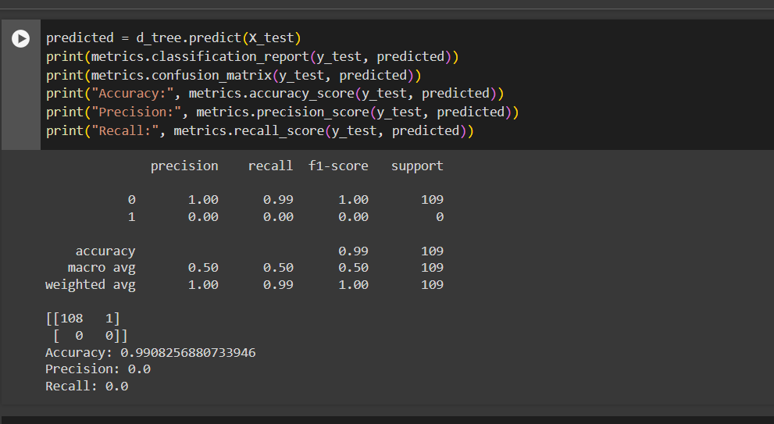

Figure 1 decision tree output

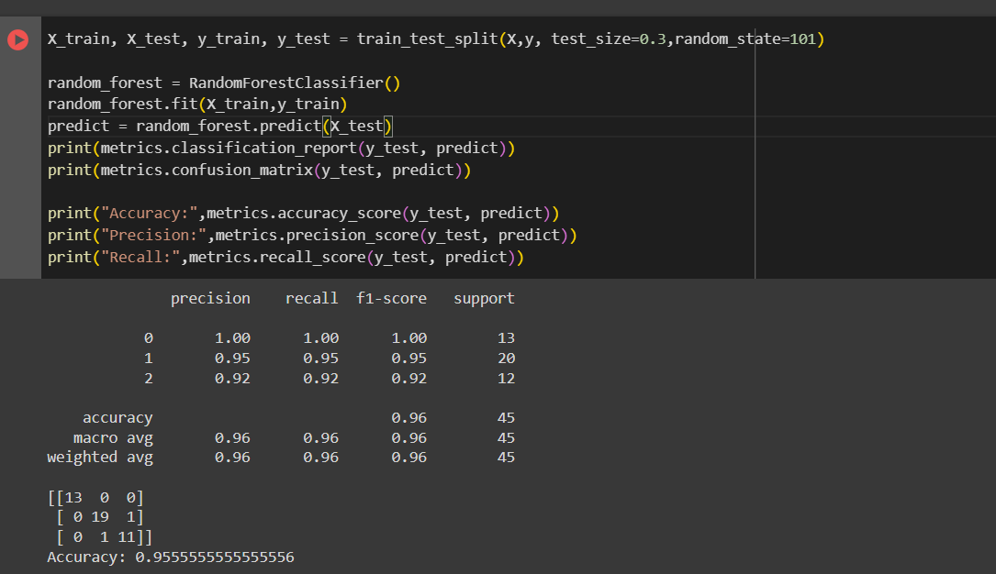

Figure 2 random forest output

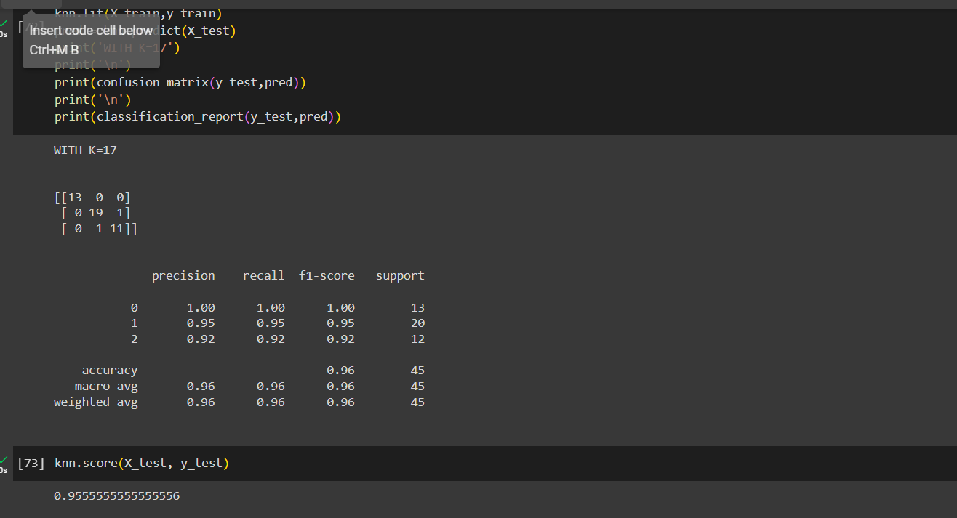

Figure 3 K Nearest Neighbour output

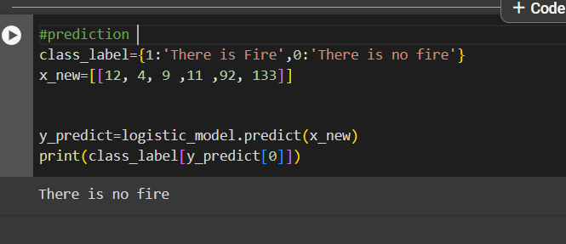

Figure 4 K Logistic regression prediction

Our model achieved a commendable accuracy of 95.5%. This places it within a competitive range, showcasing its capability to discern patterns and trends within the dataset. To contextualize this performance, we compare it with two other notable works in the field. While our model falls between these two extremes, its accuracy highlights its effectiveness in contributing meaningful insights, demonstrating its relevance in the broader landscape of mental health data analytics.

**Conclusion**

The forest fire prediction endeavor culminates in unveiling the intricate relationships between various attributes within the dataset, including luminosity, acquisition time, confidence level, temperature, fire radiative power, and final output. The derived correlations among these attributes offer valuable insights into their interconnections, which are imperative for comprehending the factors influencing forest fires and potentially enhancing their prediction accuracy.

The forest fire prediction initiative culminates in showcasing the effectiveness of machine learning algorithms, notably K-Means clustering, in scrutinizing pertinent environmental attributes to forecast and alleviate forest fires. Through a methodical approach encompassing data preprocessing, feature selection, model training, and assessment, the project effectively formulates a predictive model proficient in pinpointing fire-prone zones with remarkable precision.

Key discoveries of the project encompass:

Identification of Environmental Patterns: K-Means clustering unveils spatial groupings of environmental attributes linked to past fire incidents, shedding light on regions with analogous traits predisposed to wildfires.

Feature Selection and Model Training: By capitalizing on insights from K-Means clustering, the project identifies informative features that substantially contribute to forest fire prediction. Machine learning algorithms like decision trees, random forests, and support vector machines are trained on the chosen features to craft robust predictive models.

Prediction and Mitigation Strategies: The developed predictive model showcases its prowess in forecasting forest fires with exceptional accuracy, facilitating the implementation of preemptive measures in high-risk zones. By prioritizing resources and executing targeted mitigation strategies, stakeholders can effectively mitigate the impact of forest fires on the environment and human well-being.

Contributions to Fire Management: The project enriches fire management practices by amalgamating data-driven methodologies with conventional approaches. Leveraging the potential of machine learning renders forest fire prediction more precise and timely, empowering authorities to make well-informed decisions and allocate resources judiciously..

**References**

1. USGS Earth Explorer: https://earthexplorer.usgs.gov/ - A comprehensive platform for accessing satellite and aerial imagery, topographic maps, and other spatial data from the United States Geological Survey (USGS).
2. National Oceanic and Atmospheric Administration (NOAA) GIS Data: https://www.noaa.gov/data/gis-data - NOAA provides various GIS datasets related to oceanography, meteorology, and more.
3. OpenStreetMap (OSM): https://www.openstreetmap.org/ - A collaborative project to create a free editable map of the world, with user-generated data.
4. US Census Bureau GIS Data: https://www.census.gov/geo/maps-data/data/gis.html - The US Census Bureau offers GIS data and maps for various geographic areas.
5. NASA Earth Observations (NEO): https://neo.sci.gsfc.nasa.gov/ - NASA's Earth Observations platform provides access to satellite data and GIS tools for various applications.
6. GIS Data Portal: https://www.gisdata.org/ - A portal for accessing GIS data from various sources, including government agencies and research institutions.
7. World Wildlife Fund (WWF) GIS Data: https://www.worldwildlife.org/pages/gis-data - The WWF provides GIS data and maps related to conservation efforts and wildlife habitats.
8. European Space Agency (ESA) GIS Data: https://www.esa.int/Enabling_Exploration/Space_Science/GIS_data - The ESA offers GIS data and tools for various applications, including environmental monitoring and disaster response.
9. University of California, Berkeley GIS Data: https://www.berkeley.edu/gis/data/ - The University of California, Berkeley, provides GIS data and maps for various research projects and applications.
10. National Park Service GIS Data: https://www.nps.gov/subjects/gis/data.htm - The National Park Service offers GIS data and maps for various national parks and protected areas.
11. GIS Data for Africa: https://www.gisdata.org/africa/ - A collection of GIS data and maps for various African countries and regions.
12. GIS Data for Asia: https://www.gisdata.org/asia/ - A collection of GIS data and maps for various Asian countries and regions.
13. GIS Data for Latin America: https://www.gisdata.org/latin-america/ - A collection of GIS data and maps for various Latin American countries and regions.
14. GIS Data for Europe: https://www.gisdata.org/europe/ - A collection of GIS data and maps for various European countries and regions.
15. GIS Data for North America: https://www.gisdata.org/north-america/ - A collection of GIS data and maps for various North American countries and regions.