# Time Series Forecasting using Evolutionary Neural Network

## Motivation and background

Efficient time series forecasting is noted as an important area of research to make better decision under uncertainty. This paper evaluates the effectiveness of different ANN models.

## Research objective/question(s)

The authors note the drawback on typical statistical methods applied to time series forecasting and that the major drawback of this methods is due to the linear processing of data ignoring the temporal nature of the data. In this paper the authors apply evolutionary algorithms to time series forecasting to achieve better forecasting accuracy. They compare results against extended backpropagation algorithms.

## Prior relevant work/literature gap

* Radial Based Function networks - are distinguished from other neural networks due to their universal approximation and faster learning speed

* Bayesian neural networks - a stochastic artificial neural network trained using Bayesian inference.

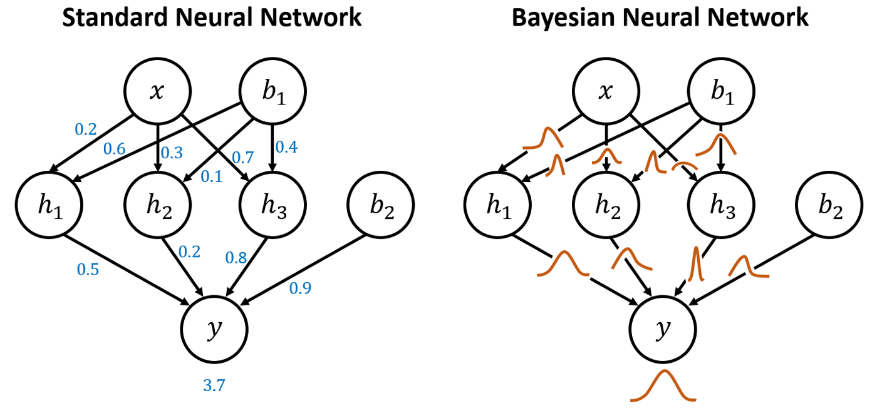

* Neuron-fuzzy networks - is a learning machine that finds the parameters of a fuzzy system (i.e., fuzzy sets, fuzzy rules) by exploiting approximation techniques from neural networks.

* Generalized regression neural networks - is a variation to radial basis neural networks.

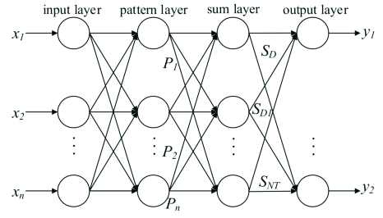

* Extreme Leaning Machine - are feedforward neural networks for classification, regression, clustering, sparse approximation, compression and feature learning with a single layer or multiple layers of hidden nodes, where the parameters of hidden nodes (not just the weights connecting inputs to hidden nodes) need not be tuned.

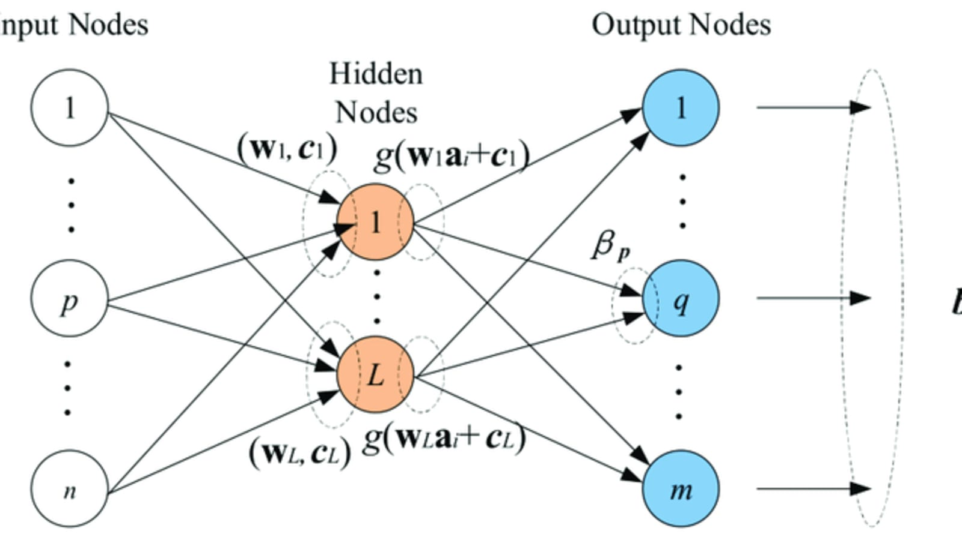

* Beta basis function neural networks - Beta Basis Function Neural Network (BBFNN) is a special kind of kernel basis neural networks. It is a feedforward network typified by the use of beta function as a hidden activation function.

The authors state that these ANN models use gradient based learning algorithms that suffer from slow convergence and performance issues lending using evolutionary ANN for time series forecasting.

## Theory, conceptual framing

Each

## Methods

The goal of this paper is to perform time series forecasting using an evolutionary artificial neural network.

The authors leverage a feed-forward multilayer perceptron (MLP) with one hidden layer. The weighs of the network are optimized by using evolutionary algorithms.

This methodology consists of four steps:

1) Data Normalization

2) Data Segmentation

3) ANN Training

4) Single-Step- Ahead(SSA) Forecasting

Data sources:

* Wisconsin Employment Time Series
* Monthly Milk production

## Discussion

ANN-GD – using extended back propagation

ANN-GA – generic algorithm

ANN-DE – differential evolution

From the table 4 and Table 5 it is observed that both the evolutionary neural networks provide better forecast accuracy than ANN-GD method.

## Thoughts

In this paper two global optimization techniques such as DE/rand/1/bin (a variant of DE) and GA are used to train the neural network. Basically, DE adds the weighted difference between two population members to a third member.

Rand – meaning the populations are formed randomly



