Mod4Ass1

#install.packages("rattle")  
#install.packages("RColorBrewer")  
#install.packages("rpart")  
#install.packages("caret")  
#install.packages("tidyverse")  
library(tidyverse)

## -- Attaching packages --------------------------------------------------------------------------------- tidyverse 1.2.1 --

## v ggplot2 3.1.0 v purrr 0.3.0   
## v tibble 2.0.1 v dplyr 0.8.0.1  
## v tidyr 0.8.2 v stringr 1.4.0   
## v readr 1.3.1 v forcats 0.4.0

## -- Conflicts ------------------------------------------------------------------------------------ tidyverse_conflicts() --  
## x dplyr::filter() masks stats::filter()  
## x dplyr::lag() masks stats::lag()

library(caret)

## Loading required package: lattice

##   
## Attaching package: 'caret'

## The following object is masked from 'package:purrr':  
##   
## lift

library(rpart)  
library(RColorBrewer)  
library(rattle)

## Rattle: A free graphical interface for data science with R.  
## Version 5.2.0 Copyright (c) 2006-2018 Togaware Pty Ltd.  
## Type 'rattle()' to shake, rattle, and roll your data.

# Data

parole = read.csv("parole.csv")

# Structure

str(parole)

## 'data.frame': 675 obs. of 9 variables:  
## $ male : int 1 0 1 1 1 1 1 0 0 1 ...  
## $ race : int 1 1 2 1 2 2 1 1 1 2 ...  
## $ age : num 33.2 39.7 29.5 22.4 21.6 46.7 31 24.6 32.6 29.1 ...  
## $ state : int 1 1 1 1 1 1 1 1 1 1 ...  
## $ time.served : num 5.5 5.4 5.6 5.7 5.4 6 6 4.8 4.5 4.7 ...  
## $ max.sentence : int 18 12 12 18 12 18 18 12 13 12 ...  
## $ multiple.offenses: int 0 0 0 0 0 0 0 0 0 0 ...  
## $ crime : int 4 3 3 1 1 4 3 1 3 2 ...  
## $ violator : int 0 0 0 0 0 0 0 0 0 0 ...

summary(parole)

## male race age state   
## Min. :0.0000 Min. :1.000 Min. :18.40 Min. :1.000   
## 1st Qu.:1.0000 1st Qu.:1.000 1st Qu.:25.35 1st Qu.:2.000   
## Median :1.0000 Median :1.000 Median :33.70 Median :3.000   
## Mean :0.8074 Mean :1.424 Mean :34.51 Mean :2.887   
## 3rd Qu.:1.0000 3rd Qu.:2.000 3rd Qu.:42.55 3rd Qu.:4.000   
## Max. :1.0000 Max. :2.000 Max. :67.00 Max. :4.000   
## time.served max.sentence multiple.offenses crime   
## Min. :0.000 Min. : 1.00 Min. :0.0000 Min. :1.000   
## 1st Qu.:3.250 1st Qu.:12.00 1st Qu.:0.0000 1st Qu.:1.000   
## Median :4.400 Median :12.00 Median :1.0000 Median :2.000   
## Mean :4.198 Mean :13.06 Mean :0.5363 Mean :2.059   
## 3rd Qu.:5.200 3rd Qu.:15.00 3rd Qu.:1.0000 3rd Qu.:3.000   
## Max. :6.000 Max. :18.00 Max. :1.0000 Max. :4.000   
## violator   
## Min. :0.0000   
## 1st Qu.:0.0000   
## Median :0.0000   
## Mean :0.1156   
## 3rd Qu.:0.0000   
## Max. :1.0000

# Data Clean

parole <- parole %>%   
 mutate(male = recode_factor(male, '1' = 'Male', '0' = 'Female')) %>%   
 mutate(race = recode_factor(race, '1' = 'White', '2' = 'Other')) %>%   
 mutate(state = recode_factor(state, '1' = 'Other', '2' = 'Kentucky', '3' = 'Louisiana', '4' = 'Virginia')) %>%   
 mutate(multiple.offenses = recode_factor(multiple.offenses, '1' = 'Yes', '0' = 'No')) %>%   
 mutate(crime = recode_factor(crime, '1' = 'Other', '2' = 'Larceny', '3' = 'Drug-related', '4' = 'Driving-related')) %>%   
 mutate(violator = recode_factor(violator, '1' = 'Yes', '0' = 'No'))  
  
parole=parole%>%drop_na()  
str(parole)

## 'data.frame': 675 obs. of 9 variables:  
## $ male : Factor w/ 2 levels "Male","Female": 1 2 1 1 1 1 1 2 2 1 ...  
## $ race : Factor w/ 2 levels "White","Other": 1 1 2 1 2 2 1 1 1 2 ...  
## $ age : num 33.2 39.7 29.5 22.4 21.6 46.7 31 24.6 32.6 29.1 ...  
## $ state : Factor w/ 4 levels "Other","Kentucky",..: 1 1 1 1 1 1 1 1 1 1 ...  
## $ time.served : num 5.5 5.4 5.6 5.7 5.4 6 6 4.8 4.5 4.7 ...  
## $ max.sentence : int 18 12 12 18 12 18 18 12 13 12 ...  
## $ multiple.offenses: Factor w/ 2 levels "Yes","No": 2 2 2 2 2 2 2 2 2 2 ...  
## $ crime : Factor w/ 4 levels "Other","Larceny",..: 4 3 3 1 1 4 3 1 3 2 ...  
## $ violator : Factor w/ 2 levels "Yes","No": 2 2 2 2 2 2 2 2 2 2 ...

# 1 Split: Train & Test

set.seed(12345)  
train.rows=createDataPartition(y=parole$violator,p=0.7,list=FALSE)  
train=parole[train.rows,]  
test=parole[-train.rows,]

# 2 Classification Tree

tree1 = rpart(violator ~., train, method="class")  
fancyRpartPlot(tree1)

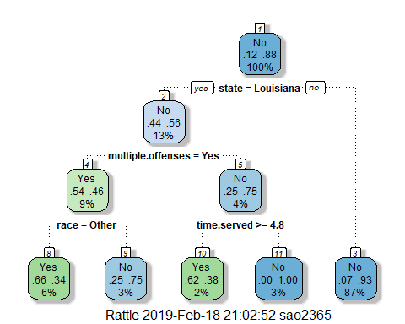

tree2 = rpart(violator ~., test, method="class")  
fancyRpartPlot(tree2)

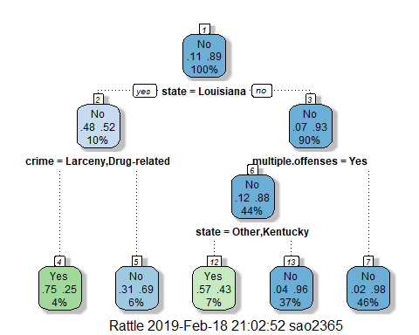 #3 40year old from Louisiana who served a 5 year sentence would veer to the left. First choosing ‘Yes’ being from Louisiana, then assuming multiple offenses, and having served greater than 4.8 years. After we analyze these, we can say that there is a 2% chance of this type of parolee, and 62% are violators while the remaining 38% are non violators.

# 4 Plot CP

printcp(tree1)

##   
## Classification tree:  
## rpart(formula = violator ~ ., data = train, method = "class")  
##   
## Variables actually used in tree construction:  
## [1] multiple.offenses race state time.served   
##   
## Root node error: 55/473 = 0.11628  
##   
## n= 473   
##   
## CP nsplit rel error xerror xstd  
## 1 0.054545 0 1.00000 1.0000 0.12676  
## 2 0.036364 3 0.83636 1.0545 0.12970  
## 3 0.010000 4 0.80000 1.0182 0.12775

plotcp(tree1)

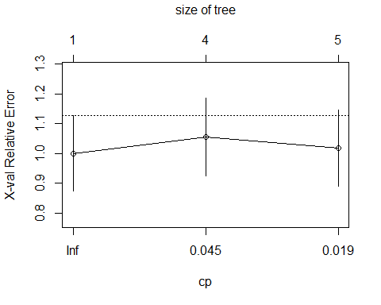

printcp(tree2)

##   
## Classification tree:  
## rpart(formula = violator ~ ., data = test, method = "class")  
##   
## Variables actually used in tree construction:  
## [1] crime multiple.offenses state   
##   
## Root node error: 23/202 = 0.11386  
##   
## n= 202   
##   
## CP nsplit rel error xerror xstd  
## 1 0.086957 0 1.00000 1.0000 0.19628  
## 2 0.043478 2 0.82609 1.1304 0.20694  
## 3 0.010000 4 0.73913 1.2174 0.21353

plotcp(tree2)

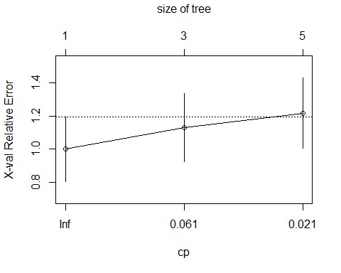 #4 For training set, the cp value of .05 should be selected.

# 5 Prune Tree

#tree3 = prune(tree1,cp=tree1$cptable[which.min(tree1$cptable[,"xerror"]),"CP"])  
#fancyRpartPlot(tree3)  
  
#tree4 = prune(tree2,cp=tree2$cptable[which.min(tree2$cptable[,"xerror"]),"CP"])  
#fancyRpartPlot(tree4)

# 6 Predictions

treepred = predict(tree1, train, type = "class")  
head(treepred)

## 1 3 4 5 6 7   
## No No No No No No   
## Levels: Yes No

confusionMatrix(treepred,train$violator,positive="Yes")

## Confusion Matrix and Statistics  
##   
## Reference  
## Prediction Yes No  
## Yes 24 13  
## No 31 405  
##   
## Accuracy : 0.907   
## 95% CI : (0.8771, 0.9316)  
## No Information Rate : 0.8837   
## P-Value [Acc > NIR] : 0.06272   
##   
## Kappa : 0.4724   
## Mcnemar's Test P-Value : 0.01038   
##   
## Sensitivity : 0.43636   
## Specificity : 0.96890   
## Pos Pred Value : 0.64865   
## Neg Pred Value : 0.92890   
## Prevalence : 0.11628   
## Detection Rate : 0.05074   
## Detection Prevalence : 0.07822   
## Balanced Accuracy : 0.70263   
##   
## 'Positive' Class : Yes   
##

treepred_test = predict(tree2,newdata=test, type = "class")  
head(treepred_test)

## 2 15 16 17 21 23   
## No No No No No No   
## Levels: Yes No

confusionMatrix(treepred_test,test$violator,positive = "Yes")

## Confusion Matrix and Statistics  
##   
## Reference  
## Prediction Yes No  
## Yes 14 8  
## No 9 171  
##   
## Accuracy : 0.9158   
## 95% CI : (0.8687, 0.9502)  
## No Information Rate : 0.8861   
## P-Value [Acc > NIR] : 0.1084   
##   
## Kappa : 0.5749   
## Mcnemar's Test P-Value : 1.0000   
##   
## Sensitivity : 0.60870   
## Specificity : 0.95531   
## Pos Pred Value : 0.63636   
## Neg Pred Value : 0.95000   
## Prevalence : 0.11386   
## Detection Rate : 0.06931   
## Detection Prevalence : 0.10891   
## Balanced Accuracy : 0.78200   
##   
## 'Positive' Class : Yes   
##

# 6 Accuracy- 0.907, Sensitivity- 0.43636, Specificity- 0.96890. P value 0.06 is almost significant. Better than testing

# 7 Accuracy- 0.9158, Sensitivity-0.60870, Specificity- 0.95531. Highher accuracy on this model, but a less significant value of .10.

# 8 Read In

blood = read.csv("Blood.csv")

# Data Clean

blood <- blood%>%  
 mutate(DonatedMarch = recode_factor(DonatedMarch, '1' = 'Yes', '0' = 'No'))  
  
blood=blood%>%drop_na()  
str(blood)

## 'data.frame': 748 obs. of 5 variables:  
## $ Mnths_Since_Last : int 2 0 1 2 1 4 2 1 2 5 ...  
## $ TotalDonations : int 50 13 16 20 24 4 7 12 9 46 ...  
## $ Total_Donated : int 12500 3250 4000 5000 6000 1000 1750 3000 2250 11500 ...  
## $ Mnths_Since_First: int 98 28 35 45 77 4 14 35 22 98 ...  
## $ DonatedMarch : Factor w/ 2 levels "Yes","No": 1 1 1 1 2 2 1 2 1 1 ...

# Structure

str(blood)

## 'data.frame': 748 obs. of 5 variables:  
## $ Mnths_Since_Last : int 2 0 1 2 1 4 2 1 2 5 ...  
## $ TotalDonations : int 50 13 16 20 24 4 7 12 9 46 ...  
## $ Total_Donated : int 12500 3250 4000 5000 6000 1000 1750 3000 2250 11500 ...  
## $ Mnths_Since_First: int 98 28 35 45 77 4 14 35 22 98 ...  
## $ DonatedMarch : Factor w/ 2 levels "Yes","No": 1 1 1 1 2 2 1 2 1 1 ...

summary(blood)

## Mnths_Since_Last TotalDonations Total_Donated Mnths_Since_First  
## Min. : 0.000 Min. : 1.000 Min. : 250 Min. : 2.00   
## 1st Qu.: 2.750 1st Qu.: 2.000 1st Qu.: 500 1st Qu.:16.00   
## Median : 7.000 Median : 4.000 Median : 1000 Median :28.00   
## Mean : 9.507 Mean : 5.515 Mean : 1379 Mean :34.28   
## 3rd Qu.:14.000 3rd Qu.: 7.000 3rd Qu.: 1750 3rd Qu.:50.00   
## Max. :74.000 Max. :50.000 Max. :12500 Max. :98.00   
## DonatedMarch  
## Yes:178   
## No :570   
##   
##   
##   
##

# 9 Split

set.seed(1234)  
train.rows2=createDataPartition(y=blood$DonatedMarch,p=0.7,list=FALSE)  
train2=blood[train.rows,]  
test2=blood[-train.rows,]

# Classification Tree

tree5 = rpart(DonatedMarch ~., train2, method="class")  
fancyRpartPlot(tree5)

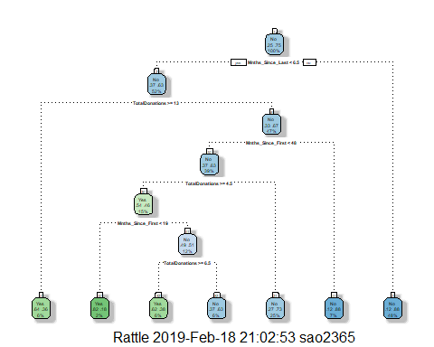

tree6 = rpart(DonatedMarch ~., test2, method="class")  
fancyRpartPlot(tree6)

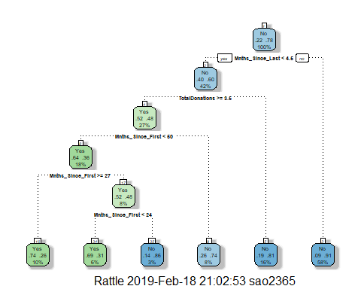 #9 Training Cp value of .034 shall be selected. Minimum cross validation of 1.00. It increases, decreases, but always remains above 1. #Testing set cp value of 0.01 shall be selected. Minimum cross validation of 0.085 in graph. N split is 5

printcp(tree5)

##   
## Classification tree:  
## rpart(formula = DonatedMarch ~ ., data = train2, method = "class")  
##   
## Variables actually used in tree construction:  
## [1] Mnths_Since_First Mnths_Since_Last TotalDonations   
##   
## Root node error: 117/473 = 0.24736  
##   
## n= 473   
##   
## CP nsplit rel error xerror xstd  
## 1 0.034188 0 1.00000 1.0000 0.080205  
## 2 0.025641 2 0.93162 1.0940 0.082584  
## 3 0.010000 6 0.81197 1.0256 0.080884

plotcp(tree5)

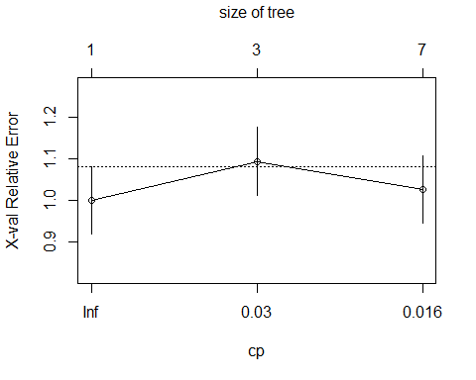

printcp(tree6)

##   
## Classification tree:  
## rpart(formula = DonatedMarch ~ ., data = test2, method = "class")  
##   
## Variables actually used in tree construction:  
## [1] Mnths_Since_First Mnths_Since_Last TotalDonations   
##   
## Root node error: 61/275 = 0.22182  
##   
## n= 275   
##   
## CP nsplit rel error xerror xstd  
## 1 0.076503 0 1.00000 1.00000 0.11295  
## 2 0.040984 3 0.77049 0.98361 0.11228  
## 3 0.010000 5 0.68852 0.88525 0.10799

plotcp(tree6)

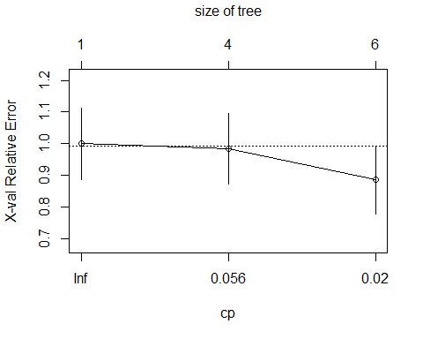

# 10 Prune

tree7 = prune(tree5,cp=tree5$cptable[which.min(tree5$cptable[,"xerror"]),"CP"])  
fancyRpartPlot(tree5)

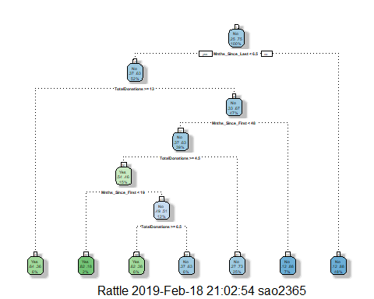

tree8 = prune(tree6,cp=tree6$cptable[which.min(tree6$cptable[,"xerror"]),"CP"])  
fancyRpartPlot(tree6)

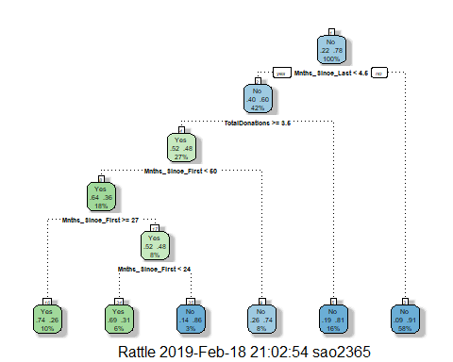

#treepred2 = predict(tree5, train, type = "class")  
#head(treepred2)  
  
#confusionMatrix(treepred2,train$DonatedMarch,positive = "Yes")  
  
#treepred_test2= predict(tree6, newdata = test, type = "class")  
  
#confusionMatrix(treepred2,test$DonatedMarch,positive = "Yes")