Outline of Final Project:

The project that I designed is based off my love of working out. Working in the fitness industry has shown me some of the problems that individuals run into throughout their fitness adventure. The purpose of this application is to provide users with a tool to both track their workouts and to provide users with a full functional workout that tells them exactly what to do.

This project is a mixture of meeting the demands of what I would want in a fitness application, along with reaching out to another target market of those who train with functional workouts. Personally, my workouts are all strength training based. However, working at a gym has allowed me to see the multitudes of people who need to be told exactly what to do in a workout. Therefore, I designed this project with a workout tracker, for myself and others like me, and a functional workout program, for those who need ideas for their workouts.

The goal of a functional workout is generally to perform a variety of low-weight or bodyweight exercises with limited rest and a high volume of repetitions. I designed my workout with solely bodyweight exercises. As I did not have the tools to import videos into canvas, I decided to import two pictures for each exercise that would show the range of motion for each exercise. At the end of the workout, the results are printed on a separate page with the total number of exercises and repetitions.

The goal of the strength training is to provide a platform for users to track their workouts. This program is more about keeping track of data rather than providing it. The user inputs their exercise, repetitions, and weight. The information is then printed to the workout log. The workout log can then be viewed via a text file and a scrollbar.

I feel that this application has the potential to attract the interest of the general public. It is a pretty simple application but fits the interests of almost all individuals who work out, regardless of fitness level.

Welcome Screen:

The welcome screen serves the purpose of providing an eye-catching image along with the necessary information to guide the user. It gives instructions for a first-time user to open a new workout file by clicking File, First Workout. It also, gives instructions for a returning user to choose either Functional Workout or Strength Training from the File Menu.

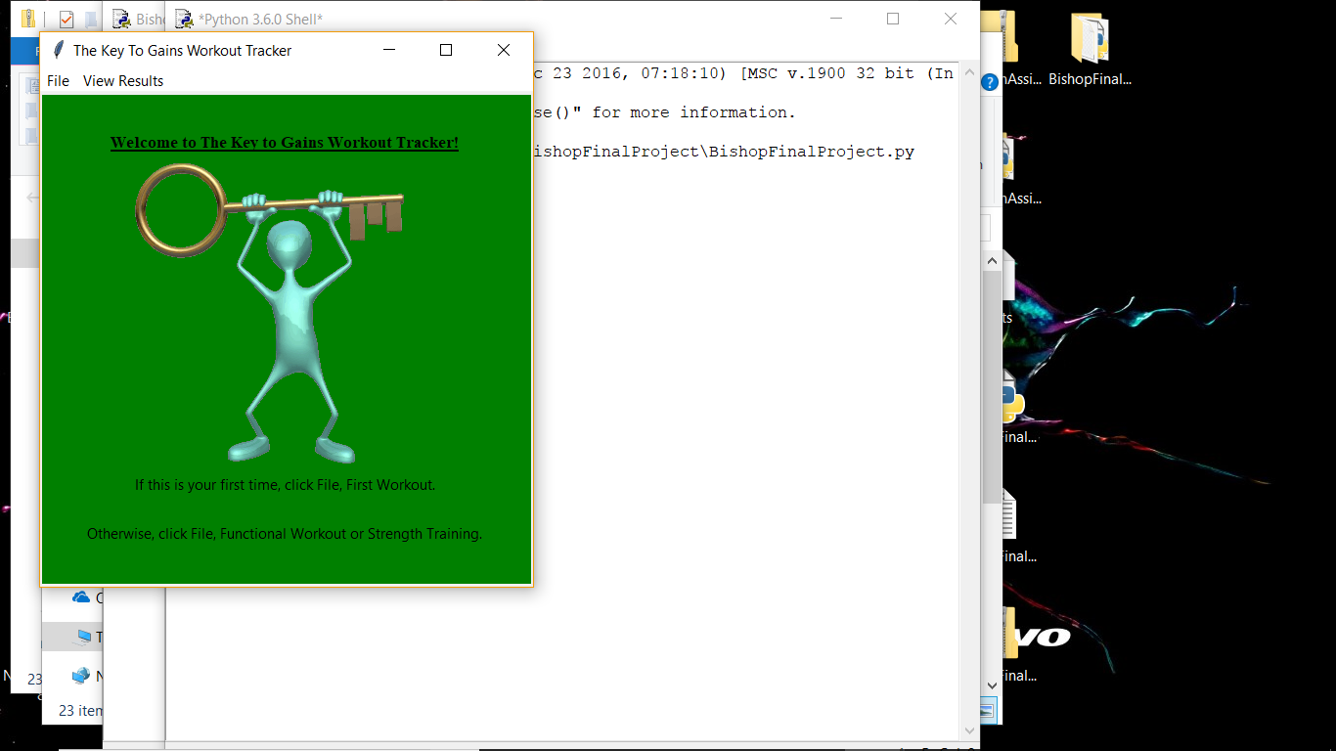

New User Screen:

The New User screen provides instruction on how to open a new workout file. If you are a first-time user, you need to right click to open a new workout file. Once this is done, text appears with further instruction. It also provides a warning as this will erase any previous workout files.

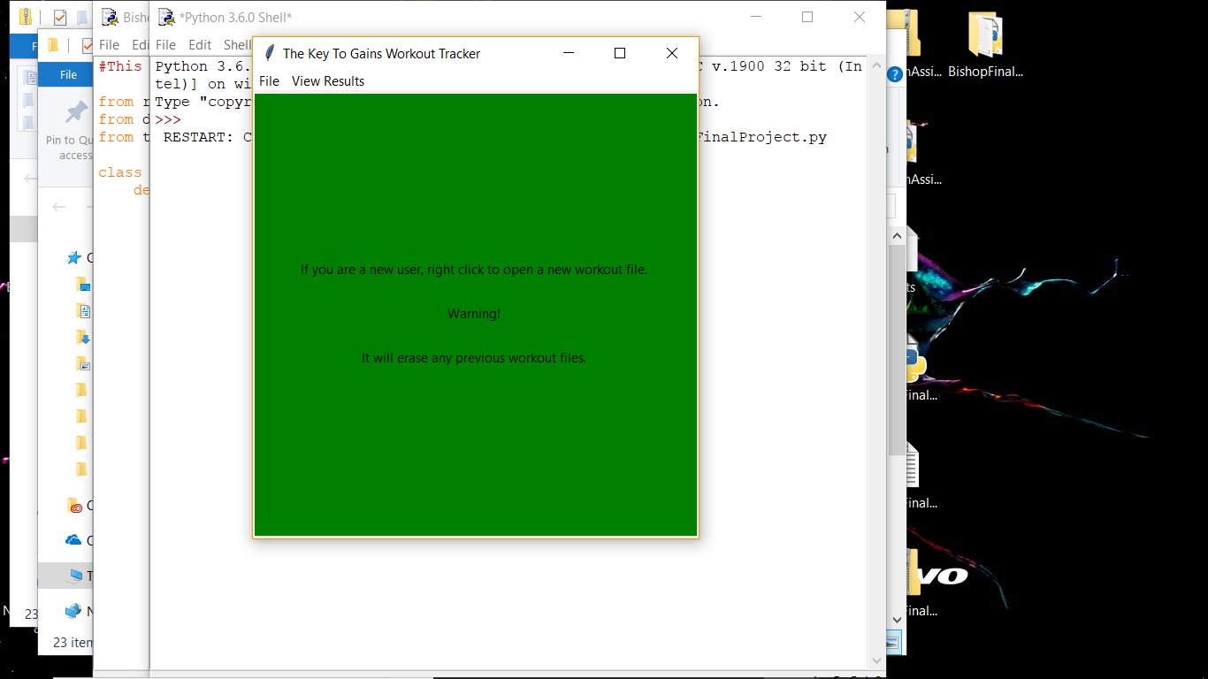

Functional Workout Screen:

This screen serves as instruction for doing a functional workout. The two buttons, Exercise and Complete Workout, serves as the two options for this screen. Advice is provided for beginner users in how many sets they should do and how long the rest periods should be.

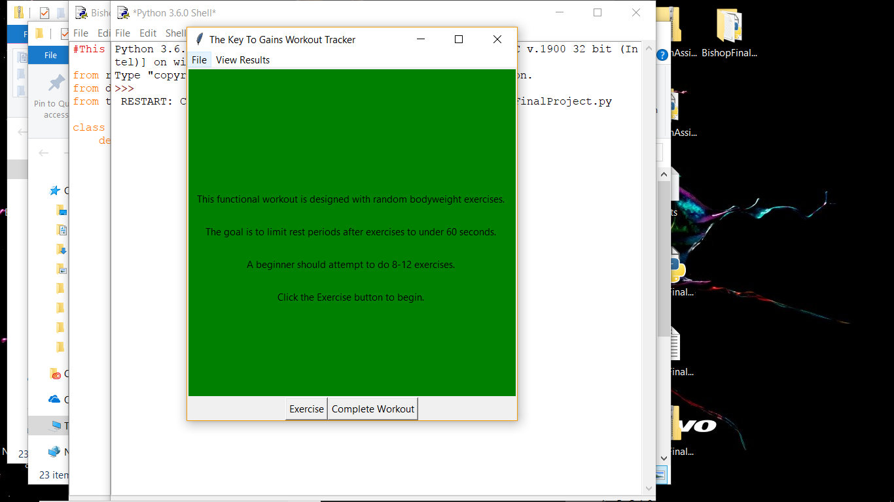

Sample Exercise Page:

Clicking the Exercise button imports one of ten exercises along with two pictures to explain each exercise. As the goal of functional workouts is high repetitions with short rest periods, the repetitions are set at 20.

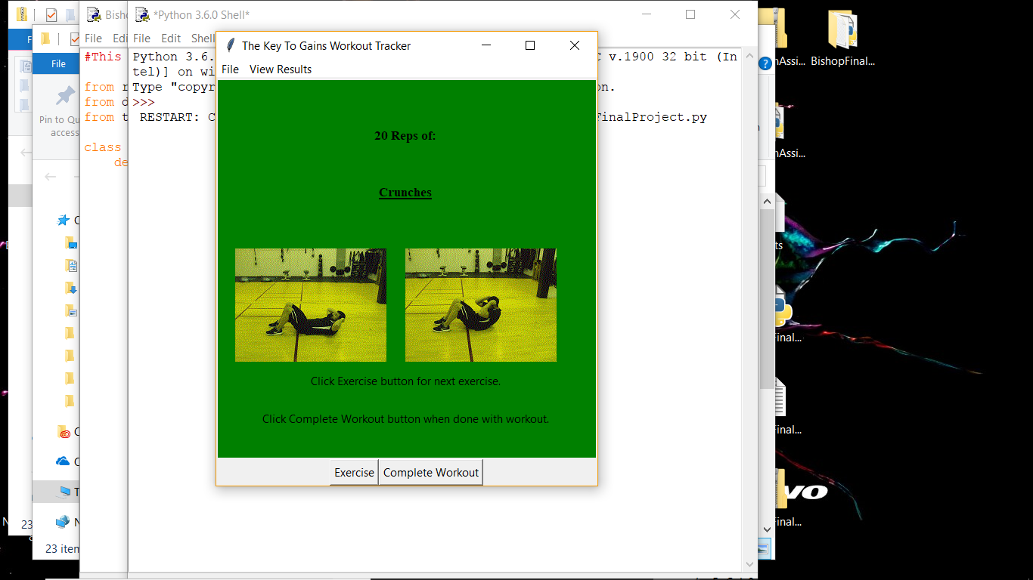

Complete Workout Screen:

Clicking the Complete Workout button takes the user to a separate page where it lists how many exercises were completed and how many repetitions where completed during the workout.

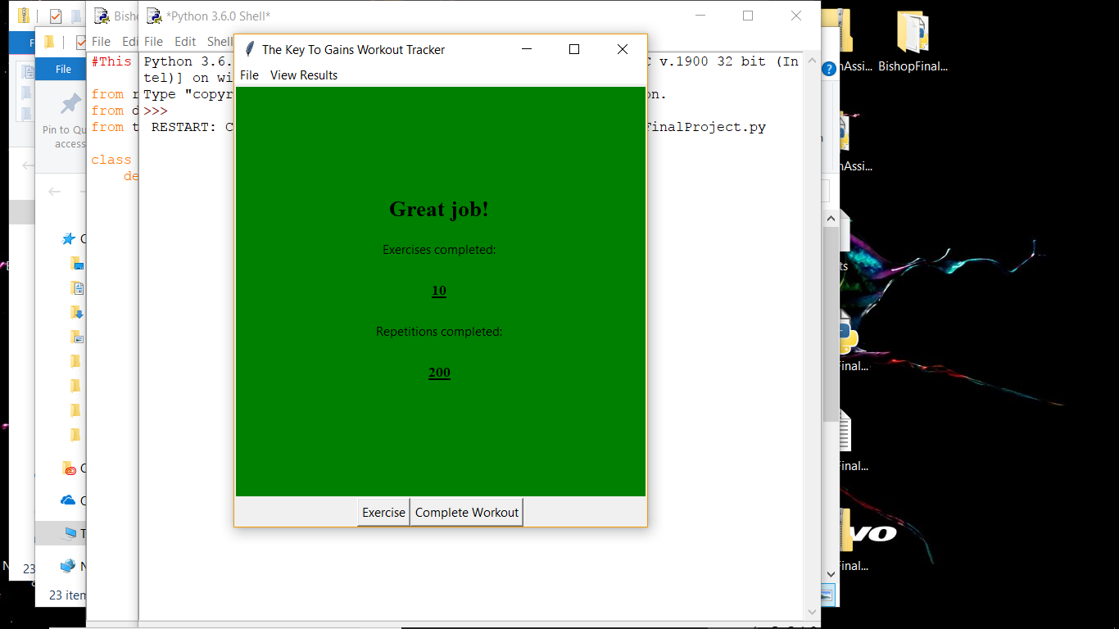

Strength Workout Screen:

The Strength Workout page has the user input all the data. The user first inputs the exercise. Second, the user inputs the repetitions. Third, the user inputs the weight. This information is then added to the workout file to viewed later. This serves the purpose of tracking workouts over time as it will show from the day the workout file was created until the most recent entry.

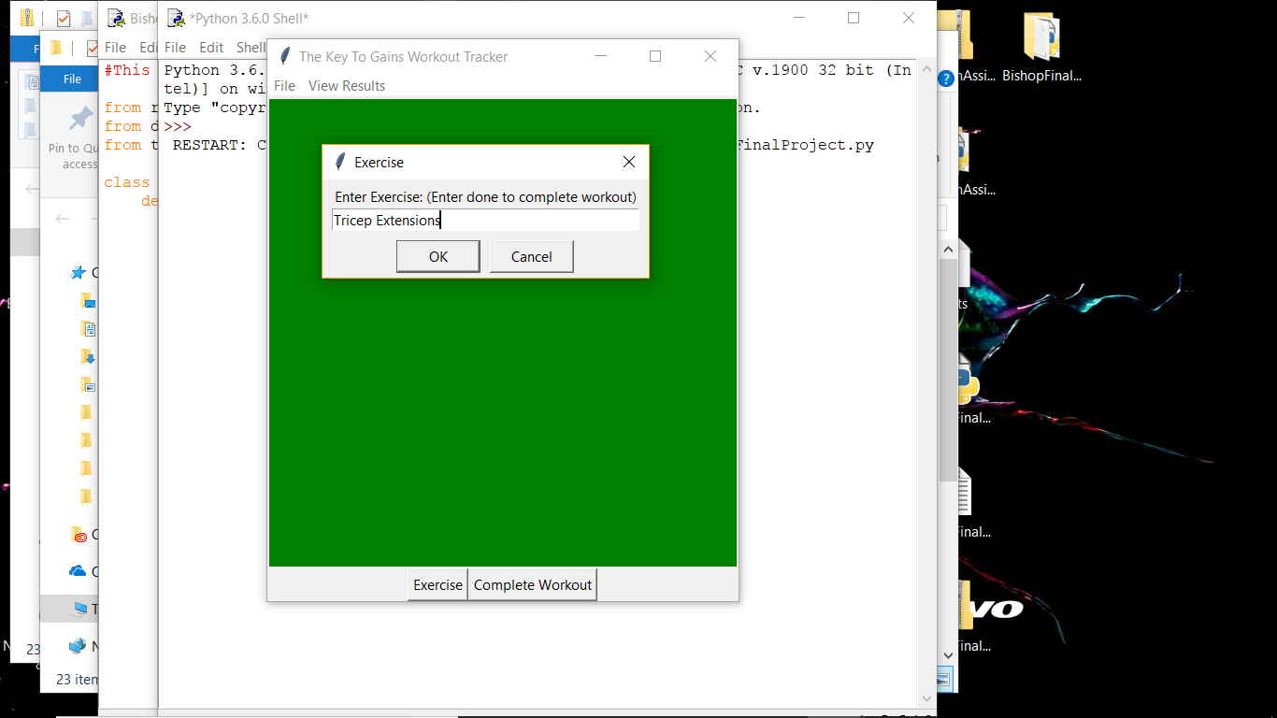

Strength Tracker Workout Log:

The Workout log creates a text file with a scrollbar to view all the contents. The purpose of this window is for users to continuously track their workouts over time. This screen reads the workout file and prints it in the text file.

