ARDUINO PHYSICAL AI CHALLENGE INDIA 2026
Project Report
Organised by Robu.in × Arduino · Submit as PDF · Max 10 MB
Project Title | Halo — Non-contact edge mmWave fall detector for elder care
Team Name | Maverick
Registration / Team ID | APC-2026-KL-12962
Contest Track | Smart Homes & Consumer AI
Institution & City | Mar Athanasius College Of Engineering, Kothamangalam

Team Members (1–4)
Name | Email | Role
SHAWN CHERIYAN SONY | shawnsony2005@gmail.com | Team Lead
Sreya V | sreyavelutholi@gmail.com | Member
Sryshnav CM | sryshnav1686@gmail.com | Member

1. Project Overview

Problem Statement

Falls are the leading cause of injury-related death among elderly people living alone or in care facilities. Traditional monitoring approaches — pressure mats, wrist-worn devices, and cameras — either require physical contact, compromise personal privacy, or fail when the resident is not wearing the device.
Halo addresses this gap with a 60 GHz FMCW mmWave radar that detects falls, tracks presence, and extracts vital signs passively — no cameras, no wearables, and no cloud dependency. All data is processed on the Arduino UNO Q, keeping raw sensor data entirely on-device.

How Your Project Works

Halo is a three-tier edge AI system. A TI IWR6843ISK 60 GHz mmWave radar runs TI's Vital Signs with People Tracking firmware on-chip, emitting a compressed 3D point cloud, tracked target bounding boxes, and pre-computed heart/breath rates over a 921,600-baud UART link.
The Arduino UNO Q STM32 MCU receives and parses the raw binary TLV stream in real time, applies spatial bounding-box filtering and per-field sanity validation, and forwards three structured data channels to its on-board Linux MPU via the Arduino RouterBridge internal UART — no external wiring or USB round-trip required.
The Linux MPU runs a Python application with four concurrent threads: a Spatial Engine detecting falls via Z-drop kinematics; an Activity Classifier feeding 25-frame rolling windows into a PyTorch CNN (MyCNN) for binary fall inference; a Vitals Consumer monitoring heart/breath anomalies; and an Event Router that persists all events and dispatches push notifications via Home Assistant and ntfy to a caregiver's phone when a fall is confirmed (CNN confidence > 85%) or breathing ceases for > 15 seconds.

Why Arduino UNO Q?

The Arduino UNO Q's dual-processor architecture is fundamental to this solution. The STM32H573 Cortex-M33 MCU at 250 MHz handles the hard real-time demands: parsing a 921,600-baud UART stream and unpacking binary TLV packets without frame drops — tasks that a Linux process cannot meet due to scheduling jitter.
At the same time, the on-board Linux MPU (NXP i.MX, running Debian) runs the full PyTorch fall-detection model, MQTT client, and HTTP webhook stack — workloads impossible on a bare MCU. The RouterBridge library multiplexes three named channels over the internal UART between the two processors, delivering clean, parsed data from the STM32 to Python threads without any external hardware.
No other single-board development platform provides this specific combination of a hard real-time Cortex-M33 MCU and a Linux MPU with a documented, software-managed internal communication bus — making the UNO Q uniquely suited to this safety-critical, privacy-preserving pipeline.

2. Components Used (BOM)
List every component. The Arduino UNO Q purchase proof must be uploaded separately with your submission.
Component | Qty
Arduino UNO Q (ABX00087) | 1
TI IWR6843ISK mmWave Radar Sensor + MMWAVEICBOOST Carrier Board | 1
5 V / 3 A Power Supply with Barrel Jack (for ICBOOST) | 1
Jumper Wires — Male-to-Female (GND, TX, RX lines) | 3
Micro-USB Cable (XDS110 flashing/debug on ICBOOST) | 1
Host PC — runs Home Assistant Docker stack and Arduino App Lab | 1

3. System Architecture & Circuit

Step-by-Step Workflow

1. IWR6843ISK radar emits 60 GHz FMCW chirps. On-chip DSP (CFAR, DBSCAN, EKF tracking, vital signs algorithm) produces a compressed point cloud, target list, and heart/breath rates.
2. Radar streams binary TLV packets at 921,600 baud to Arduino UNO Q STM32 (D0/D1 UART pins).
3. STM32 (sketch.ino) parses TLV 1010 (target list), TLV 1020 (compressed spherical point cloud — decompressed to Cartesian on-device), and TLV 1040 (vitals). Applies bounding-box and per-field sanity filtering. Emits three named channels via RouterBridge internal UART to the Linux MPU.
4. Linux MPU (main.py) four threads consume the three channels: Spatial Engine detects falls via Z-drop kinematics; Activity Classifier runs MyCNN PyTorch model on 25-frame windows; Vitals Consumer monitors heart/breath rates; Event Router persists all events to events.jsonl.
5. On confirmed fall (CNN > 85%) or breath-rate absent > 15 s: Event Router POSTs a JSON webhook to Home Assistant, which triggers the Mosquitto MQTT broker and dispatches an ntfy push notification to the caregiver's phone.

Block Diagram & Circuit Schematic
Paste your block diagram and circuit/wiring diagram below. Hand-drawn photos, Fritzing, KiCad — all accepted. Label pin connections.
[ Insert block diagram / circuit image here ]
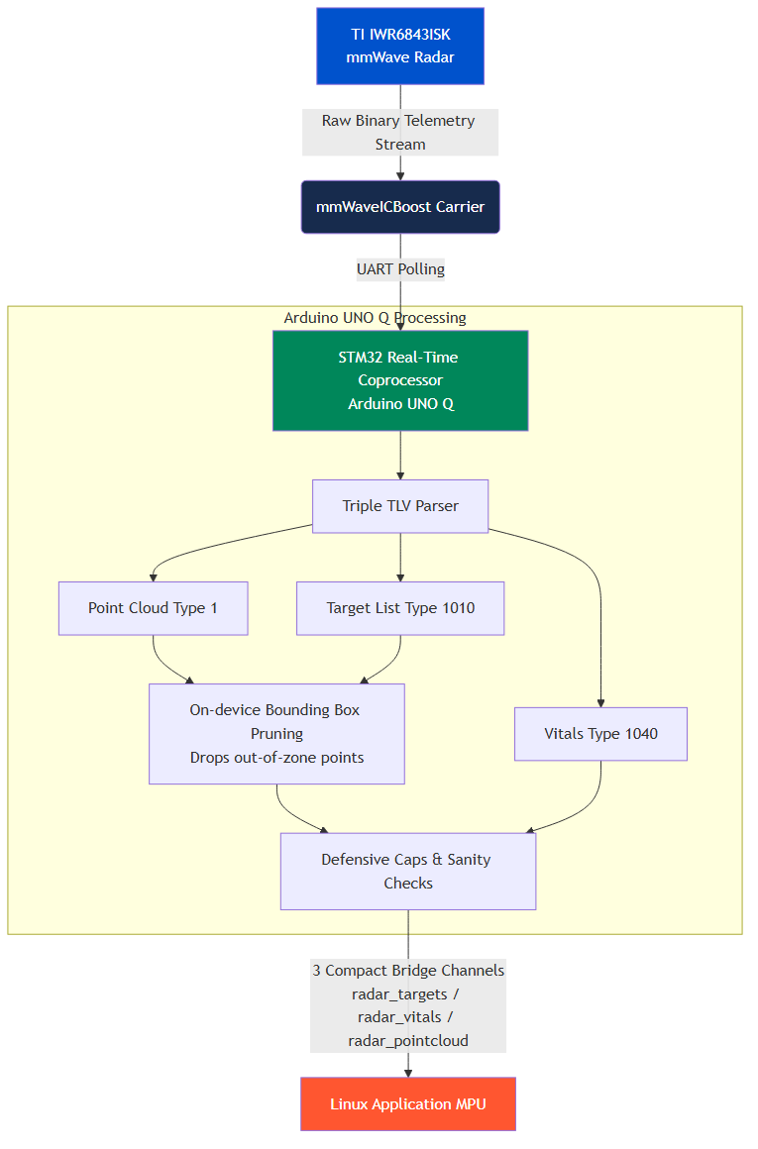
Figure 1: Halo system architecture — three-tier edge AI pipeline

4. AI / ML Model Details
If your project does not use AI/ML, write “Not Applicable” — but note that Physical AI projects score higher on Innovation.
Model Used | Custom PyTorch 2D CNN (MyCNN) — spatiotemporal convolutional classifier
Training Platform | PyTorch 2.x (CPU) — trained in Jupyter Notebook on PC; deployed as .pth state_dict on the Linux MPU
Accuracy | 95.1% average test accuracy, F1 Score: 0.95 (5-fold cross-validation)
Dataset | Real IWR6843 point cloud recordings of fall and non-fall events. Source: sareebali/mmwave-radar-fall-detection (GitHub). Input tensor (1, 25, 22, 4) — 25 frames x 22 points x [X, Y, Z, Doppler]. 5-fold K-Fold split.

Brief Description & Limitations

MyCNN processes a 25-frame rolling window of 3D point cloud data. Each frame holds up to 22 detected reflector points, each described by X, Y, Z and Doppler velocity (4 features). Input tensor shape: (1, 25, 22, 4). Two Conv2d layers (25->16, kernel 5; then 16->32, kernel 3) each followed by LeakyReLU and MaxPool extract spatiotemporal motion signatures. Three FC layers reduce the flattened feature map to a single sigmoid probability. A fall alert fires when this probability exceeds 0.85.
Known limitations: Trained on a single person in a single environment using proxy fall gestures; generalisation to other body types and room geometries is unverified. The current table-mount geometry (< 1 m height) cannot observe a real standing-to-floor fall arc — a production deployment requires a ceiling mount at >= 2 m.

5. Code Structure

sketch.ino (STM32 MCU)
setup() — Configures Serial1 at 921,600 baud for radar data; sends the full radar config file line-by-line at 115,200 baud; initialises RouterBridge channels.
loop() / readRadarData() — Reads bytes until the 8-byte magic word, parses the 40-byte frame header, iterates TLV blocks: parseTLV1010() (target list), parseTLV1020() (compressed point cloud, spherical decompression), parseTLV1040() (vitals). Each parser applies bounding-box and sanity filtering before writing to the bridge.
main.py (Linux MPU)
Bridge callbacks — Immediately enqueue raw bytes into queue.Queue objects; no parsing in callbacks (decouples receive latency from processing).
spatial_engine_thread() — Unpacks target structs (<2I3f), maintains active_targets dict, calls check_fall() using sliding Z-history deque to detect drop-then-settle patterns.
activity_classifier_thread() — Unpacks point cloud structs (<I4f), accumulates 25-frame windows (zero-padded to 22 points), converts to float32 tensor, runs MyCNN.forward(), publishes fall_probability events.
vitals_consumer_thread() — Unpacks vitals structs (<2H3f), validates per-field bounds, publishes vitals_reading events; emits vitals_alert after 15 s of zero breath rate.
event_router_thread() — Appends all events to events.jsonl; routes to MQTT bare-float topics (heart_rate, breath_rate, fall_probability) and HTTP webhook for fall/vitals alerts.

GitHub Repository | https://github.com/shawnsony07/Halo-Non-contact-edge-mmWave-fall-detector-for-elder-care
Demo Video Link | [To be added before submission — YouTube or Google Drive public link]

6. Testing & Results

The complete system was tested end-to-end indoors. The radar was mounted on a table at ~0.75 m height. A human subject performed: standing still, walking, sitting down, simulated fall gestures (rapid squat-to-floor), and stationary breath holds.
Fall Detection (CNN): MyCNN achieved 95.1% average test accuracy (F1: 0.95) on the training dataset (5-fold CV). In live tests, simulated falls triggered CNN alerts with probability > 0.85 within 1-2 frame windows (~200-400 ms at the 10 fps radar frame rate).
Vital Signs: Heart and breathing rate readings were published continuously to MQTT. Breath-rate-absent alerts fired correctly after 15 s of deliberate breath hold confirmed by the sensor.
UART Link: At 921,600 baud over short (< 20 cm) jumper wires, occasional bit-flip corruption was observed and silently rejected by the on-STM32 per-field sanity filter. No system crashes or bridge stalls occurred during extended test sessions.
Edge Cases: Targets with simultaneous Y=0 and Z=0 (tracker coast states) were filtered defensively. At the current table-mount height, the Z-range during a simulated fall matches the floor threshold, confirming a ceiling-mount is required for production validation.

Project Images (2–3)
[ Insert 2–3 photos of your project working]
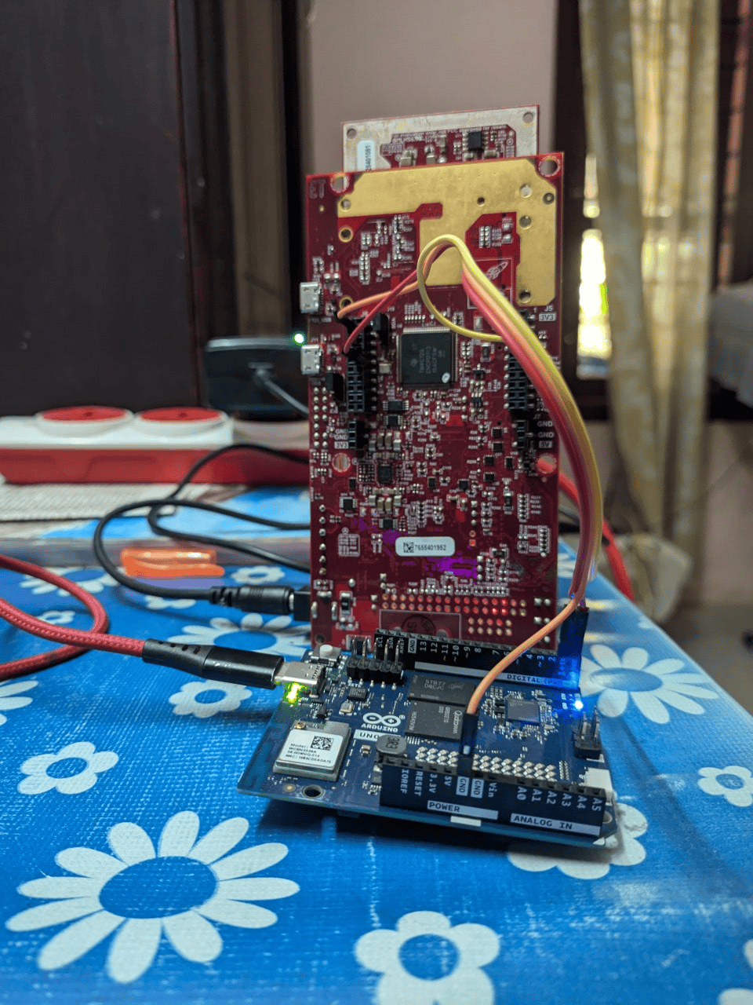
Figure 2: Arduino UNO Q to MMWAVEICBOOST 3-wire UART wiring

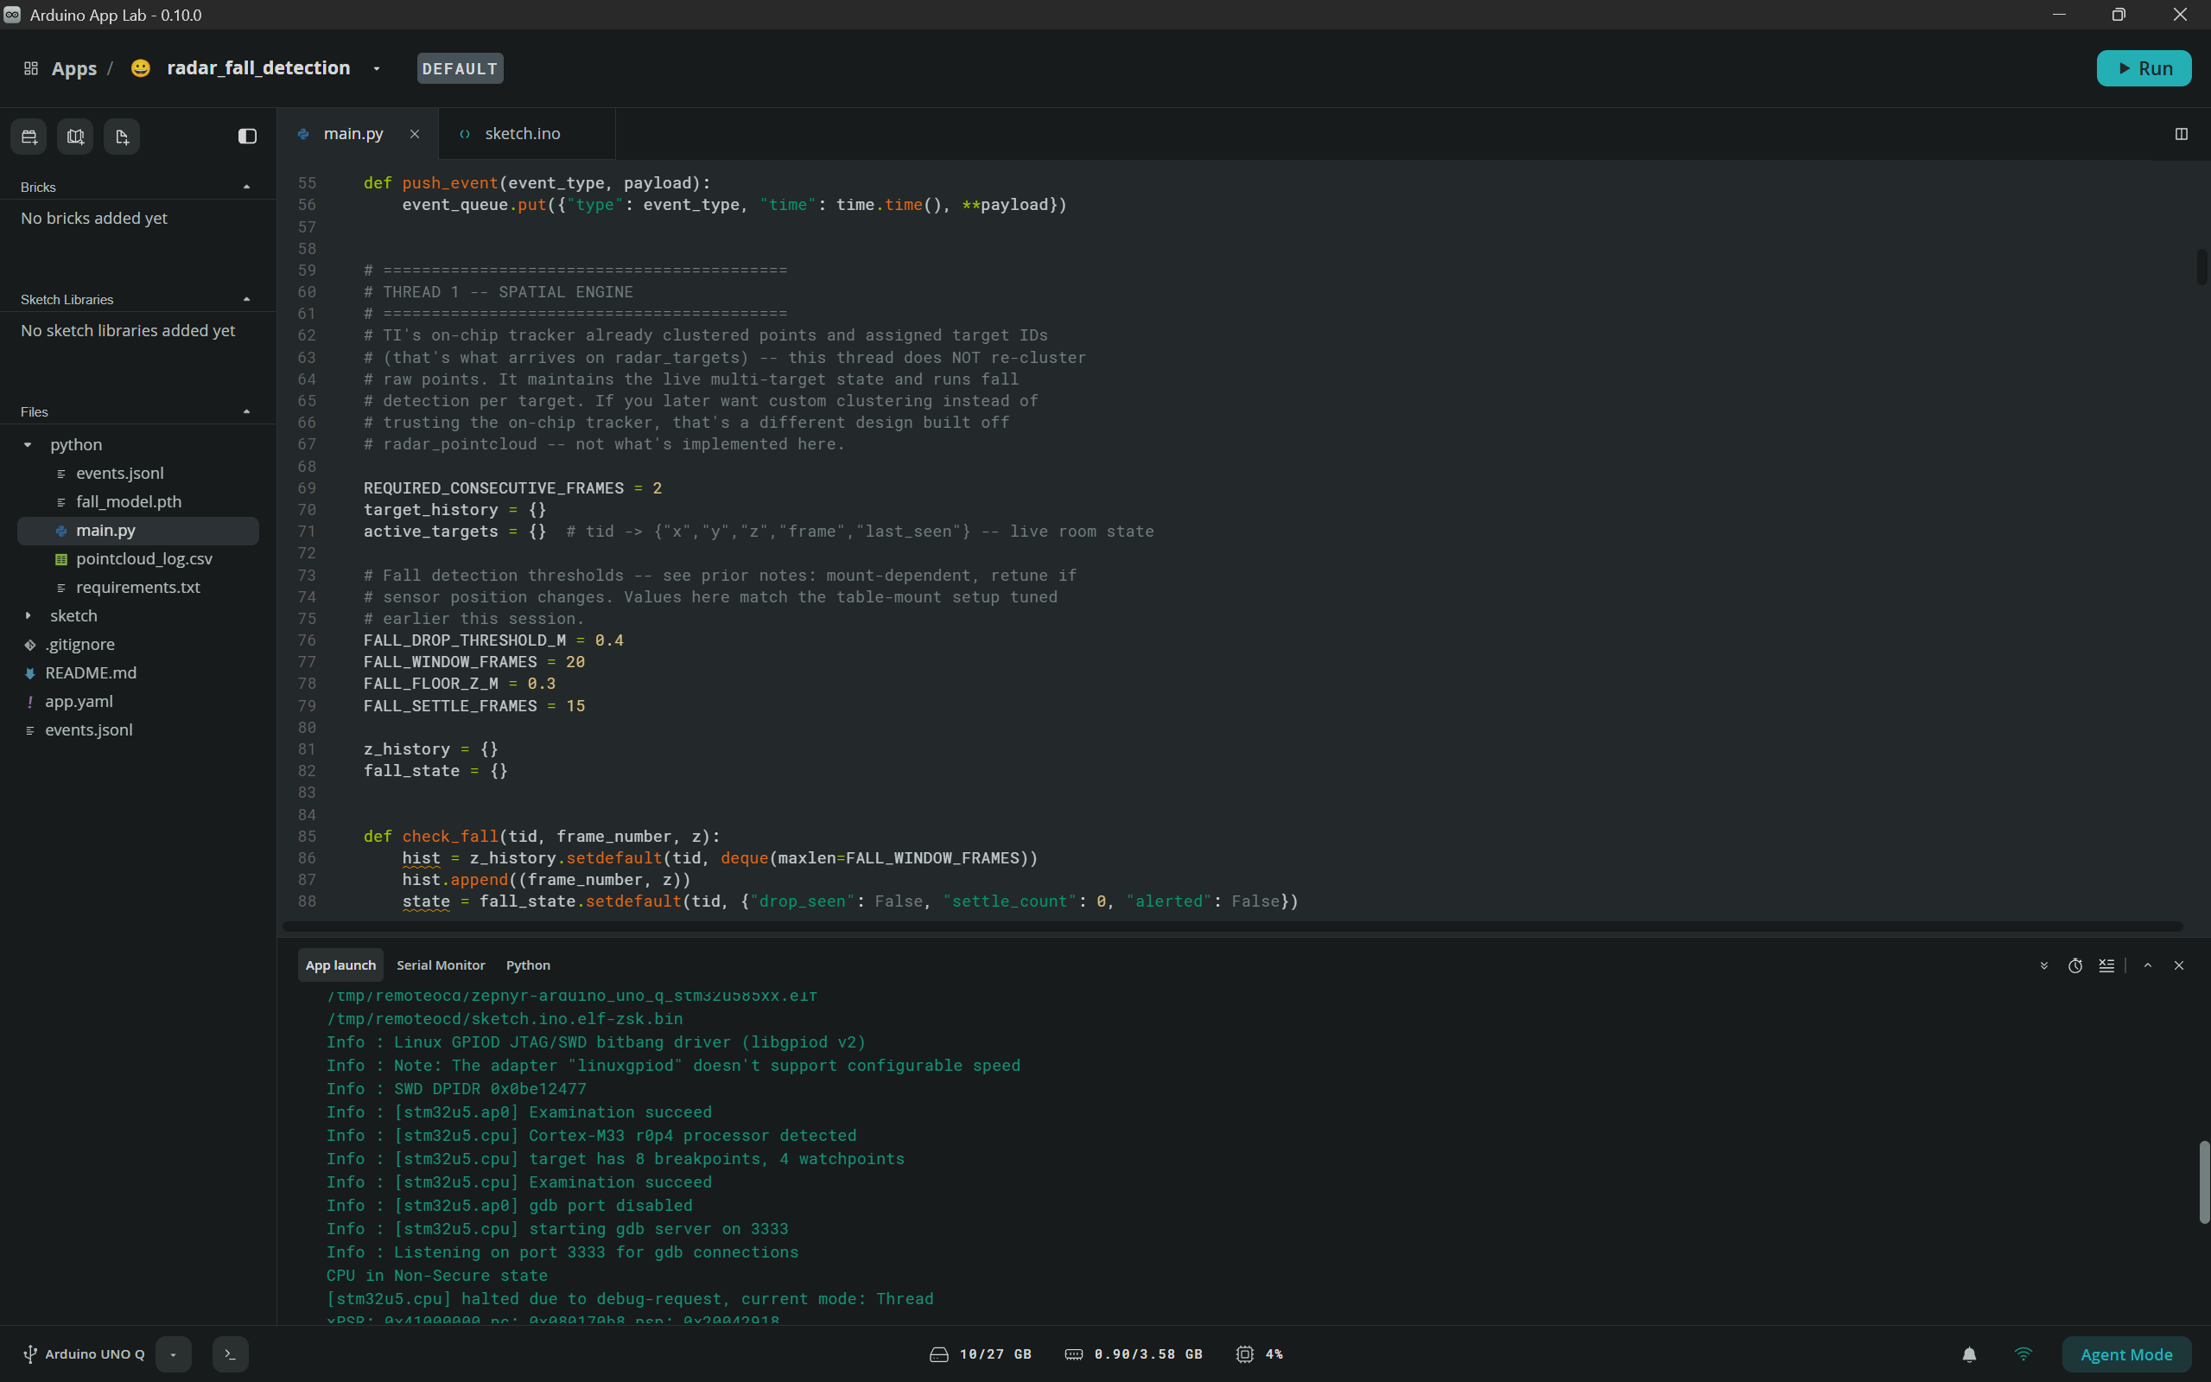
Figure 3: Arduino App Lab running sketch + Python application simultaneously

7. Challenges, Learnings & Future Improvements

Challenges Faced

TLV Type Identification: TI's Vital Signs + Tracking firmware does not emit the standard TLV type 1 (raw point cloud) found in other TI reference code. The actual point cloud is TLV 1020 (MMWDEMO_OUTPUT_MSG_COMPRESSED_POINTS) in a spherical format requiring per-frame unit header decompression. Identifying and implementing this took significant cross-referencing of TI SDK source and E2E forum posts.
DMA UART Ingestion: Achieving DMA-level zero-copy receive on the STM32 at 921,600 baud was architecturally impossible at the .ino sketch level — ZephyrSerial has no setRxBufferSize() and the DMA buffer is fixed by devicetree. The solution was fast polled reading with on-device parsing and pruning to reduce bridge payload.
RouterBridge Channel Sync: Ensuring callback enqueue latency never stalled the STM32 required full decoupling of receive (callback to queue) from processing (queue to thread), using Python queue.Queue with non-blocking callbacks on the Linux MPU.
PyTorch Model Loading: An early crash occurred when a .pth state_dict file was loaded as if it were a full model object. Fix: instantiate MyCNN() first, then call model.load_state_dict(torch.load(...)), followed by model.eval().

What You Learned & What’s Next

We learned how to architect a safety-critical edge AI pipeline across two heterogeneous processors on a single board — combining hard real-time UART parsing on an STM32 with full PyTorch inference on an embedded Linux MPU. We gained hands-on experience with TI mmWave TLV internals (including the rarely documented TLV 1020 compressed format), real-time UART constraints, and the importance of per-field sanity filtering on noisy high-baud links.
Future Improvements:
1. Ceiling-Mount Validation: Deploy at >= 2 m ceiling height with a downward radar tilt to observe a genuine standing-to-floor fall arc and validate real-fall geometry.
2. On-Device Retraining Pipeline: Add a data-capture mode that writes labelled point cloud windows to the Linux MPU storage, enabling periodic retraining of MyCNN on environment-specific data for improved generalisation.
3. Multi-Target Vitals: Extend the vitals algorithm to independently track heart rate and breathing rate per tracked person ID, supporting multi-occupant rooms in care facilities.

8. Declaration
We confirm this is our original, unpublished work. The Arduino® UNO™ Q is the primary board in this project. All team members have reviewed and agree to this report.
Date
Arduino Physical AI Challenge India 2026 · Robu.in × Arduino · contest@robu.in

