Shawn Thomas

BIOL 4910/ PBIO 7005

Dr. Bucksch

28 FEB 2017

Homework 1

1. Reference: http://lifehacker.com/5983680/how-the-heck-do-i-use-github

Files submitted on Github

1. See Problem2ST.py

Picture of the DLA cluster grown from the bottom n=3000. Walkers are generated from the top of the figure and then “walk” randomly and then stick to the bottom of the array to produce this DLA. 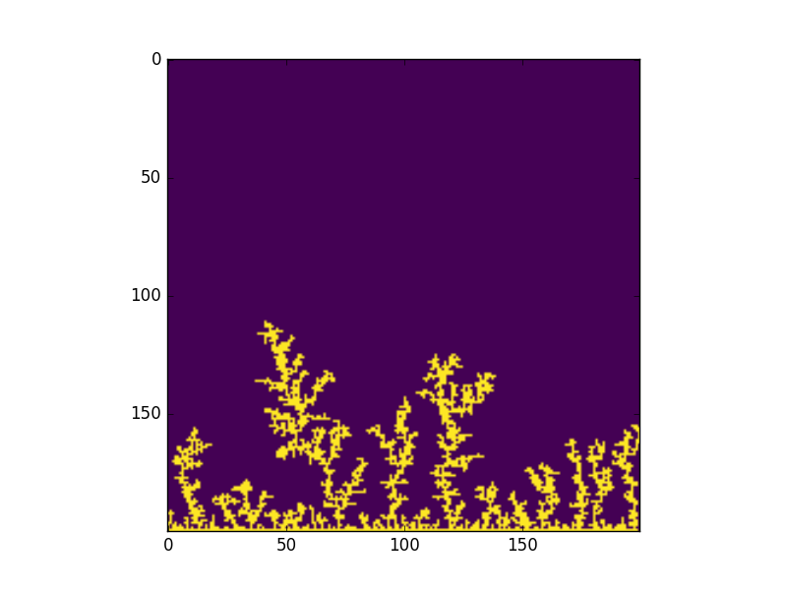

1. See Problem3ST.py

This branching structure starts from the center (which is the same as the in class examples), but then instead of the points starting their walk from around the border of the image, they start from the central point and immediately stick, once a zero has been reached. This makes the DLA take a circular shape rather than a branching structure, because the points are more likely to fill in the space closest to the center because they immediately stick once they have reached a zero from the structure. In this structure the n~1400 because it is taking a long time to get more walkers. 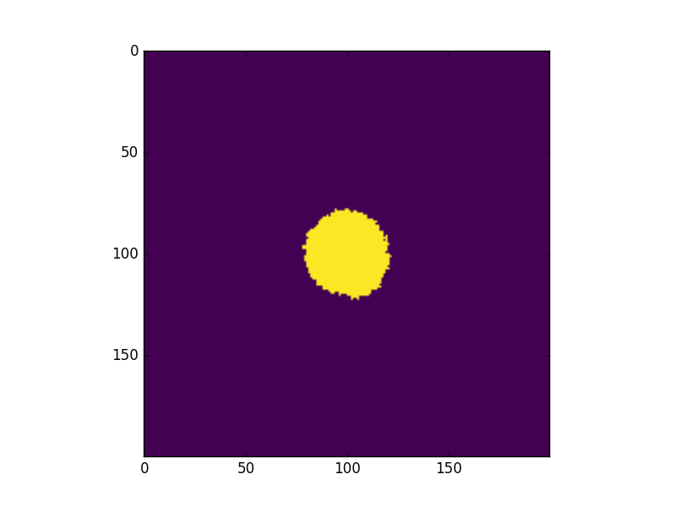

1. n/a
2. Using clustersize of 500 because for inside out, it takes a long time to finish larger clustersizes with my code.

Higher fractal dimension values are seen in clusters that are more clumped and dense like problem 3, and lower as we see a more spread out cluster like the class example.

See Problem5ST.py

DLA- Class example

cluster diameter: 42.9534631898

cluster size: 500

fractal dimension: 2.02630214854

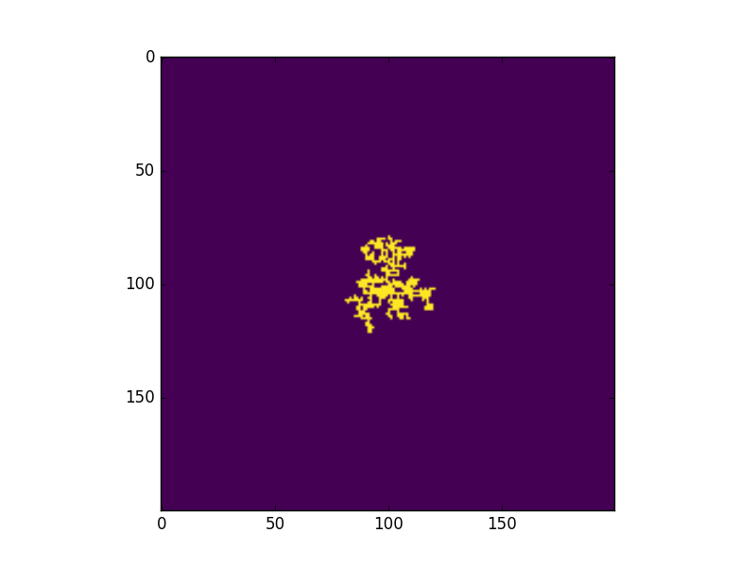

See Problem3ST.py

DLA- inside out

cluster diameter: 28.3019433962

cluster size: 500

fractal dimension: 2.34532692349

