

Date 2016/6/10

Date 2016/6/5

Software Engineering Project – 1

Final Submission

Kaluthara Koralalage Sandakelum Tharindu Adikaram

CuRTIN ID- 18875678

SLIIT ID – IT14124136

Curtin University – Department of Computing

Assignment Cover Sheet / Declaration of Originality

Complete this form if/as directed by your unit coordinator, lecturer or the assignment specification.

|  |  |  |  |  |
| --- | --- | --- | --- | --- |
| Last name: | Adikaram | Student ID: | 18875678 | |
| Other name(s): | Kaluthara Koralalage Sandakelum Tharindu | | | |
| Unit name: | SEP-1 | Unit ID: | ISAD3000 | |
| Lecturer / unit coordinator: | Mr.Tharindu Perera | Tutor: |  | |
| Date of submission: | 2016-06-10 | Which assignment? |  | SEP-1 Final Document |

I declare that:

* The above information is complete and accurate.
* The work I am submitting is *entirely my own*, except where clearly indicated otherwise and correctly referenced.
* I have taken (and will continue to take) all reasonable steps to ensure my work is *not accessible* to any other students who may gain unfair advantage from it.
* I have *not previously submitted* this work for any other unit, whether at Curtin University or elsewhere, or for prior attempts at this unit, except where clearly indicated otherwise.

I understand that:

* Plagiarism and collusion are dishonest, and unfair to all other students.
* Detection of plagiarism and collusion may be done manually or by using tools (such as Turnitin).
* If I plagiarise or collude, I risk failing the unit with a grade of ANN (“Result Annulled due to Academic Misconduct”), which will remain permanently on my academic record. I also risk termination from my course and other penalties.
* Even with correct referencing, my submission will only be marked according to what I have done myself, specifically for this assessment. I cannot re-use the work of others, or my own previously submitted work, in order to fulfil the assessment requirements.
* It is my responsibility to ensure that my submission is complete, correct and not corrupted.

|  |  |  |  |
| --- | --- | --- | --- |
| Signature: |  | Date of  signature: | 2016-6-10 |

*(By submitting this form, you indicate that you agree with all the above text.)*

# Abstract

### By Writing This Document My objective was to Give a brief an idea about the Mobile Application and The Web Application I developed. As SEP – 1 Project our Team were Assigned to Develop a Smart Mobile Application within three months of time period for the 1994 A/l Batch of the Royal College. The application is Called 94’Royalists. The Application Should contains Special features which are specially designed for the Royalists’94. Currently the Members are in different Countries and different professions. Our Objective was to Gather all of them Together.

### The purpose of developing the app is to Gather all the 94’Royalists in to a one group and keep close relationship with each other. Every member can Participate with the Application from any country by downloading it using Play store. The Application Provide facilities to Create sub groups, Post Events , Maintain a Calendar, and Maintain Professional Profile etc. And Admin has provided a separate web application for the Administrative tasks. In The Application I have Developed The Business Profile, Advertisement Handling and part of web application for the admin. As mentioned in the Requirement we had to Develop the Application to Run in three platforms. Android, Windows and MAC OS.

### Cordova is the Best Frame work that I found out to Achieve the Above Requirements. As the Main technologies we used Ionic, AngularJS, HTML, PHP and MySQL to fulfill the requirements of the Mobile application. And PHP, HTML and MySQL for the web application.

### Finally I was able to successfully Implemented the Tasks Allocated to me. Every User of the Application has given access to the Business profile

### .

### My recommendation is to use the Application with care because all the details of the users of the application can be accessible through the Application.

Table of Contents

[Abstract 2](#_Toc453301155)

[Figure Table](#_Toc453301155) 6

[Introduction](#_Toc453301162) 7

[Project Scope](#_Toc453301168) 8

[Problem Specification](#_Toc453301177) 9

[1. Registering To The Business Profile](#_Toc453301178) 9

[2. Show Business Card](#_Toc453301180) 9

[3. Edit the Content Of The Business Card](#_Toc453301182) 9

[4. Post Advertisement](#_Toc453301184) 10

[5. Show Advertisement](#_Toc453301186) 10

[6. Detail View Of an Advertisement](#_Toc453301188) 10

[7. Edit/Delete Advertisement](#_Toc453301190) 11

[8. Post Advertisement through Web Browser](#_Toc453301192) 11

[9. Show Advertisement through Web Browser](#_Toc453301194) 11

[10. Edit/Delete Advertisement through Web Browser](#_Toc453301196) 12

[Procedure](#_Toc453301200) 13

[Functional Requirement Specification](#_Toc453301208) 14

[User Functionalities](#_Toc453301209) 14

[Registering To The Business Profile](#_Toc453301209) 14

[Show Business Card](#_Toc453301216) 15

[Edit the Content Of The Business Card](#_Toc453301225) 16

#### [Mobile based Functionalities of the Admin ……………………………………......................................](#_Toc453301209) 17

[Post Advertisement](#_Toc453301230) 17

[Show Advertisement](#_Toc453301236) 18

[Detail View Of an Advertisement](#_Toc453301242) 19

[Edit Advertisement](#_Toc453301250) 20

#### [Web based Functionalities of the Admin ……………………………………..........................................](#_Toc453301209) 21

[Post Advertisement](#_Toc453301256) 21

[Show Advertisement](#_Toc453301261) 22

[Edit Advertisement](#_Toc453301266) 23

[Non-Functional Requirement Specification](#_Toc453301271) 24

[1. Security](#_Toc453301272) 24

[2. Maintainability](#_Toc453301274) 24

[3. Modularity](#_Toc453301276) 24

[4. User Friendliness](#_Toc453301278) 24

[5. Complexity](#_Toc453301280) 24

[6. Usability](#_Toc453301282) 25

[7. Portability](#_Toc453301284) 25

[Technology](#_Toc453301286) 26

[Hardware and Software Specification](#_Toc453301308) 29

[Software Specification](#_Toc453301309) 29

[Hardware Specification](#_Toc453301313) 30

[Use Case Scenarios for functional Requirements](#_Toc453301324) 31

[Register Use Case Scenario](#_Toc453301355) 31

[Show Business card Use Case Scenario](#_Toc453301359) 33

[Edit Business Card Use Case Scenario](#_Toc453301362) 34

[Show Advertisement Use Case Scenario](#_Toc453301365) 36

[Detail View of an Advertisement](#_Toc453301371) 37

[Edit/Delete Advertisement](#_Toc453301374) 38

[Post Advertisement](#_Toc453301378) 40

[Implementation](#_Toc453301346) 42

[Mobile Application](#_Toc453301209) 43

[Register to the business card](#_Toc453301355) 43

[Show Business card](#_Toc453301359) 44

[Edit Business Card](#_Toc453301362) 44

[Post Advertisement](#_Toc453301365) 44

[Show Advertisement](#_Toc453301368) 45

[Detail View of an Advertisement](#_Toc453301371) 45

[Edit/Delete Advertisement](#_Toc453301374) 46

[Web Application](#_Toc453301209) 46

[Post Advertisement](#_Toc453301378) 46

[Show Advertisement](#_Toc453301381) 47

[Edit/Delete Advertisement](#_Toc453301384) 47

[Learning Curve](#_Toc453301387) 48

[Implementation Progress](#_Toc453301394) 51

[Interface Designing](#_Toc453301405) 54

[Mobile View](#_Toc453301209) 54

[Register For the Business profile](#_Toc453301406) 54

[Show business card](#_Toc453301409) 56

[Edit business card](#_Toc453301411) 57

[Post Advertisement](#_Toc453301414) 58

[Show advertisement](#_Toc453301416) 59

[Detail view of an advertisement](#_Toc453301418) 60

[Edit advertisement](#_Toc453301420) 61

[Web View](#_Toc453301209) 62

[Post advertisement](#_Toc453301422) 62

[Show advertisement](#_Toc453301424) 63

[Edit advertisement](#_Toc453301426) 64

[Test Cases](#_Toc453301428) 65

[Test 1](#_Toc453301429) 65

[Test 2](#_Toc453301430) 67

[Test 3](#_Toc453301431) 69

[Test 4](#_Toc453301432) 71

[Test 5](#_Toc453301430) 73

[Test 6](#_Toc453301431) 75

[Bugs Identified](#_Toc453301433) 77

[Challenges](#_Toc453301443) 78

[Solutions](#_Toc453301450) 79

[Lessons Learned](#_Toc453301458) 80

[Repository and blog Details](#_Toc453301464) 81

[Group Blog](#_Toc453301465) 81

[Group Repository](#_Toc453301469) 81

[Individual Blog](#_Toc453301473) 81

[Individual Repository](#_Toc453301477) 81

[Next Semester Plan](#_Toc453301481) 82

[Reference](#_Toc453301483) 84

[Final Project Summery](#_Toc453301502) 85

[Appendix](#_Toc453301509) 86

[Archtectural Diagram](#_Toc453301465) 86

[Learning Curve Gant Chart](#_Toc453301469) 87

[Implementation Gant Chart](#_Toc453301473) 88

[Next Semester Plan](#_Toc453301477) 89

[Use Case Diagram](#_Toc453301477) 90

# 

# Figure table

|  |  |  |
| --- | --- | --- |
| Figure No | Description | Page No |
| Figure 1 | Learning Curve Line Chart | 48 |
| Figure 2 | Learning Curve Bar Chart | 49 |
| Figure 3 | Leaning Hours | 49 |
| Figure 4 | Tasks within the Learning Curve | 50 |
| Figure 5 | Implemented time period Line Chart | 51 |
| Figure 6 | Implemented time period Bar Chart | 52 |
| Figure 7 | Implemented Hours | 52 |
| Figure 8 | Implemented tasks | 53 |
| Figure 9 | First Register Page | 54 |
| Figure 10 | Second Register Page | 55 |
| Figure 11 | Business Card | 56 |
| Figure 12 | Before Load Button Clicks | 57 |
| Figure 13 | After Load Button Clicks | 57 |
| Figure 14 | Post Advertisement | 58 |
| Figure 15 | Show Advertisement | 59 |
| Figure 16 | Detail view of an Advertisement | 60 |
| Figure 17 | Edit Advertisement | 61 |
| Figure 18 | Post Advertisement(web application) | 62 |
| Figure 19 | Show Advertisement(web application) | 63 |
| Figure 20 | Edit Advertisement(web application) | 64 |
| Figure 21 | Test Register Page 1 (Success) | 66 |
| Figure 22 | Test Register Page 1 (Validation) | 68 |
| Figure 23 | Test Business Card (Success) | 70 |
| Figure 24 | Test Business Card (Validate) | 72 |
| Figure 25 | Test Post Advertisement (Validate) | 74 |
| Figure 26 | Test Post Advertisement (Web Application Validate) | 76 |
| Figure 27 | Next Semester Plan | 83 |
| Figure 28 | System Architecture Diagram | 86 |
| Figure 29 | Learning Curve Gant Chart | 87 |
| Figure 30 | Implementation Gant Chart | 88 |
| Figure 31 | Next Semester plan Gant Chart | 89 |
| Figure 32 | Use Case Diagram for My Part | 90 |

# Introduction

### Software Engineering Project – 1(SEP-1) One of subjects in the First semester of third Year. The content Of This subject is to Create a software or partially Completed software as a project that Fit for a one Semester. The Project was Assigned to us by the Academic Committee. It Was A Mobile Application to develop. The main objective was to create a Specifically designed Smart Application which can be accessed only for the old Boys group of 94 in Royal Collage.

### Mr. Indraka Udayakumara was act as the client as well as Mr.Udara Samarathunga Was act as the supervisor. All the requirements regards to the application are Collected by conducting several Client Meetings. The idea of how to develop such an Application what are the processes should apply for the developing application and advices in difficulties given by the Supervisor Mr.Udara Samarathunga.

### The group of 94 was depressed and the smart app is to have close relationship with the group members and store information related to all members concerned be accessed easily. The app will also be a source to Know event details via publishing of advertisements on it, Ability to find contact details and other relevant information on a user. User Profile, Business Profile, Event Handling, Group handling, Sub Group Management, Favorite Contact list, System Calendar, Private Message and Conversations, are the Main features Provided by the Application. Any Member who has Registered to the System Will be checked by the admin and he decide whether to accept the user as a member or reject the request. The Members who are accepted by the Admin will be provided credentials to access the system. The Admin is also provided with a separate Web application for ease of access to the administrative tasks.

### The Application Needs to be accessed using several platforms. Based on such a requirement the Mobile application was developed using Mobile Application development methods and Technologies. Cordova Framework is used as the Framework. Ionic, AngularJS, HTML, PHP ,MySQL are used as the Programming languages. For the Web Application HTML,PHP and MySQL are used as the Programming Languages.

### The Mobile Application and Web Application was developed by group of members and the group is concluded 5 members. Each member has developed nearly 10 User stories for this semester. In Both Applications my User stories was to develop the Business profile for each Member and Advertisement Handling section for the Admin and part of Web application for the Admin.

# Project Scope

### The SEP -1 Project is to Develop a Mobile Application for the 1994 batch of Royal College to Gather the Members together. And The Administrator should have a separate web Application for the Administrative tasks.

### The Mobile Application is providing facilities of Register to the System, login to the System, Maintain a User Profile, Crate Sub Groups, create private chat , create Conference chat list, Post Events and notices to the Subgroups, suggest friends for the sub groups, Maintain favourite contact list, advance search, access the timeline of favourite friends, send birthday notifications, send other notifications, maintain event calendar, Maintain a Business card, Register for the business card, Post Advertisement, Show Advertisement, View a detail description of each advertisement, Edit and Delete Advertisements. The application should be install and run in 3 platforms Android, IOS and Windows.

### The Web Application is providing facilities in order to make it easier for administrator to work with both Mobile application and Web application. All the tasks that belongs to the Administrator should be provided from both Mobile Application and Web Application.

### Both Applications should be hosted in order to access from anywhere. The Mobile Application should be apple to download from a store. And the Authenticated users will be having the facility to access the features of the Mobile Application.

### To complete the Mobile Application and Web Application and host it the estimated time is around seven months.

### The goal of developing Mobile Application is to gather all The members of royalist’s 94 group together and make as one group. Then Every group member will be able to access the details of every other member at any time. And the members would be able to communicate through the application. Members are also given specifically defined grouping Subgroups.

### The part of the mobile Application should be Delivered at the end of the semester and the other part is developed incrementally. At the End of two semesters the both Applications should be in a deliverable state and the both applications should have been hosted to access from anywhere.

### The Project is part of the Software Engineering Project – 1 subject. And the Project Scope should match for a six month period because the second semester the subject SEP - 2 is also a part of the Software Engineering project – 1.

# Problem Specification

## Registering To The Business Profile

### The Client Want me to Create a Separate profile for the Business Purposes. Even though the Users have to provide their Information’s when registering to the system he wants a separate registration criteria for the Business profile too. But in the Business profile the Members are not asking to provide the information which they have already provided with the initial registration. The client asked to provide a registration form only to gather information about their professional and working place details. And also he wants me to create the registration form as two separate fields. Then if a Member wants he can fill only the first area and postponed the further registration ,and continue at any time he wish.

## Show Business Card

### In the Requirement Specification The client has clearly mentioned that he Want a Business card for each Member of the system. The Details provided through the registration forms mentioned above should be displayed in the Business card. As client wants the Business Card of a member can be seen by other Members of the System.

## Edit the Content Of The Business Card

### Once Member has Registered for the Business card his professional Details will be shown through the Business Card. But if he wants to change the Details of the Business card There Should be a way to Edit the Details. So as mentioned in the requirement specification I have created a separate area for the Editing purposes of the Business card. And according to the Client requirement if a Member wants to change all the details in the business card the fields in the Editing area should be empty. Or if a member wants to do only minor modifications he should have provided the currently available information’s then he has the ability to change only the required areas.

## Post Advertisement

### The organization hired an external person as the Admin of the System. The Admin has given Several tasks to do. One of them is to Post Advertisement. In the System the Members can post their advertisements. But the process is done by the Admin. Members who wants to post advertisements are send all the advertisement details and the Banner to the Admin using external Medias outside the System. By Considering the Information received admin decide whether the advertisement should be posted or not. For that Admin should have a separate area. Client has asked me to develop a separate area for client to post the Advertisements.

## Show Advertisement

### The Advertisements which have been posted by the admin should show in a list view. As mention in the requirement specification the admin should have given ease of access to a list of advertisements currently available in the system. Then admin can have a clear idea of how many advertisements are currently available in the system and what are the Advertisements currently in the system.

## Detail View Of an Advertisement

### The Client has clearly mentioned that there should be a Separate page for each advertisement in the advertisement list in order to view the detail view of each advertisement. In the detail view the type of the advertisement , description , Posted time posted Date and the Banner will be displayed.in the Current Moment this Page can only be accessed by the Admin.

## Edit/Delete Advertisement

### The Advertisements Which are currently available in the system should be should be edited according to the willingness of the members. The Editing is done by the Admin. Under editing the Admin can change all the information such as type, Banner and description of the advertisement. According to the clients perspective he mentioned that the editing of an advertisement is not that much necessary because if a member wants to change his advertisement he can send a new information regards to the advertisement and admin can again post it by deleting the currently existing one. But if it only need to change the time period that the advertisement should post and all the other details are correct no point of sending a new Advertisement again. So admin should be able to edit currently existing Advertisements.

## Post Advertisement through Web Browser

### The client has clearly mentioned that the Admin should have facility to access all Advertisement related things through a web view also. Because Admin will receive all the Advertisement related information from the medias external to the system. And before post the he has to analyze them. Then By having two ways the admin will easy to access the Advertisement details. Such as the details which are coming through the mobile phone can be directly posted through the Application and the details which are coming through a web browser, from other external medias can be posted to the system using a browser. The purpose of using a web view is to make it easier for the Admin.

## Show Advertisement through Web Browser

### The Advertisements currently available in the app/system are shown to the admin through the web browser. Every time when admin logs in to the system advertisements will be loaded. Admin can decide whether an advertisement needs to be deleted or updated. And the Number of advertisements currently available in the system. The purpose of this page to be implemented is admin can easily check that the number of maximum Advertisements have been exceeded in the system and capture a brief idea about what the corresponding advertisement is about without going to the detail View of the Advertisement.

## Edit/Delete Advertisement through Web Browser

### This Function has the same task as in the Mobile app. While displaying the Advertisement admin has given authority to Edit the advertisement. Change the Time Period of the Advertisement, Change type and other details. Even the Banner can be updated according to the user Preference.

### I f user Wants to remove his Advertisement from displaying user can just has to send an email then admin will remove the Advertisement from the system.

### Admin Has Been Provided a separate page for the Editing purposes.

# Procedure

### After receiving the Requirements the requirement analysis was done. Several Client Meetings had to be conducted for gathering all the requirements and clear out all the unstable requirements. After identifying all the requirements they were categorized in to sub parts in order to spread them throughout the calendar for the semester period.

### After the requirement analysis process I have defined a learning curve for identifying the time scope of the project. The time is properly allocated for the learning purposes and the implementation process. Due to the technology was a new one the time taken for the learning purpose was a considerable one. It is near to half of the development time.

### Once the requirements were gathered the main task was to identify which technology will suit for the Mobile application and which technology will suit for the Web Application. Due to the Mobile application should be able use in several platform with web technologies the most suitable way was to use hybrid mobile app development methods. Under the circumstances As the framework the Cordova has been used. And for the web Application PHP, MySQL, CSS, HTML was used.

### When comes to the Implementation phase firs all the Interfaces have been identified which should be there to deliver the project. After getting the clients feedback for the Interfaces the coding part started. When coding the Database was a necessary one since it was the main part of the whole project. By drawing ER diagrams creating schema-relations the database was designed. After Completing the designing procedure of the Database the Implementation of the Interfaces have been started.

### For the coding it took nearly three weeks because of the technological issues. The final stage of the implementation was implementing the actual system. For that all the parts have to be integrated to a one place.

### At the end of the semester the Partially completed Mobile application was developed. And the Mobile Application can be delivered even though it is partially completed. The web Application was Implemented successfully. But have to hosted in order to use it.

### After the Implementation has successfully completed. The testing was stated. Each Interface and functionality was tested using several test cases to make sure the quality of the Application is stable. And All the Client requirements have been met.

# Functional Requirement Specification

#### User Functionalities

## Registering To The Business Profile

### Each User has a Separate Profile called Business Profile along with the Normal User profile. Business Profile Maintain all the Professional Details regarding to the user. It contains all the formal information of each user.

### Initially When a New user entering to the Business Profile He will Be Redirected to fill two Forms regards to his Profession and Working Place. In the Forms User will be asked to provide some basic details for Registration Purpose for the business Profile.

### Gathering Information is done Under Two Steps. Those are Professional Details and Working Place Details. Initially the user will be redirected to the Professional Detail page. All the Information Regards to a user’s profession will have to be provided here through a form. The detailed required for the Completion of professional detail Page is Profession of The User, Skills Based on the Profession, Awards the user has achieved based on the Profession etc.

### After Submitting the Profession Details the user is able to postponed Further Registration Progress or the user can Directly Go to The next Registration page, which is asking for users to Provide Working Place details.

### In the Working Place detail Page user will be given a separate Form to fill out Details of his Working Place. The Details that user has to provide is Name of the Working Place, Address of the Working place, Contact No used for Working Purposes, Email Used For Professional Activities and Working hours(During Which time user is Busy) etc.

### After Fill out all two forms the Data will be stored in the database for the Future reference.

## Show Business Card

### The purpose of Asking users to provide Professional Details and Working place details is to Show them as a card to the users who are viewing the Business Card of a another user. It is called the Business card. Each user has provided a business Card.

### Business card Content a Summary of all Details which a user provided while he is registering to the Business Profile.

### Any user can View the Business Card of a user at any time.

### At the Top of the Business card Image of the user Has been Displayed.

### The details are Categorized under Two headings called Professional details and Working place details.

### Under Professional Details all the Information regards to Profession such as Status of the Profession, Skills based on the profession, Awards Achieved regarding to the profession etc. are shown.

### Under Working place Details all the Information regards to Working Place such as Name of the Working Place, Address of the Working Place, Contact number Use within the Working Hours, Email Address use for Working Purposes and Normal Working Hours etc. are Shown.

### The Data Send to the Database Using Previous Two forms are used to Display the Business Card.

## Edit the Content Of The Business Card

### Each User Who is held Responsible for his Business card Can Edit the content of the Business card at any time. Bottom of each Business card there is a Button Called Edit. The Edit Button Redirect users to the Edit Business Card Page Which is a Separate Page.

### In the Edit Business Card Page Users Will Be provided the facility to edit the Content of his Business card.

### After Entering to the Edit Page User has given a Choice Whether he can load the current data to the fields or he can keep the Fields Empty. If User wants to Load current data in the database to the Fields There is a separate button to fulfill the Purpose. And also If the user willing to change all the Information In the Business card he can Keep The fields Empty and Fill as he wish.

### User can Change only the details which He would like to Change. Other Details won’t be changed unless User Has edited them.

#### Mobile based Functionalities of the Admin

## Post Advertisement

### Admin has Given Authority to Post Advertisements According to the Users Requirements.

### User has to send All the Details about the advertisement and the Banner of the Advertisement to the Admin. This Process is not an Internal Process of the System.

### After Receiving the Information Regards to the Advertisement Admin Can take the Action Whether the Advertisement Should post or not. To post the Selected Advertisements Admin has given a Separate Interface. Through the Interface Admin can provide all the Details of the Advertisement.

### The details Required to Submit an Advertisement are Type of the Advertisement (To which category the Advertisement Belongs.), Title of the Advertisement, Banner need to show, Brief Description About the Banner, Contact Number Whom Should Be Contacted regards to the Advertisement, Email Which User would like to show in the Advertisement, Start date of the Advertisement and End date of the Advertisement.

### All the Information’s provided through the Interface goes to the database.

## Show Advertisement

### The All Posted Advertisements are showed in a Separate Page as a list Format to the Admin. Admin Can Have Idea about Which Advertisements have been Posted and how much Advertisements Are Currently Available in the System.

### The Banner of the Advertisement, Title of the Advertisement, Description of the Advertisement and the Posted date and Posted Time will be displayed in the list View.

### The purpose of providing such a list is to make it easy for admin to Access any Advertisement at any time.

### Each Item in the List Will Act as a Link to a Separate Page.

### The Details of the Advertisements are retrieved from the database.

## Detail View Of an Advertisement

### Each Advertisement in the list has a separate page for detail view.

### Once Admin Clicks one of the Advertisements in the Show Advertisement Page He will be redirected to a separate page called Detail view. Every Advertisement has a detail View Page.

### The Content of the Details View page is Banner Related to the Clicked Advertisement Detail Description about the banner etc.

### Bottom of the page Adin has given the Authority to Delete the Existing Advertisement or Edit the Content of the Current Advertisement.

### Once the Delete Button Clicks The existing Advertisement will be Deleted with the Banner.

### Once the Edit button clicks the Admin will be Redirect to a Separate Page Which fulfill the Editing Purpose.

### The Details of the Advertisement will be retrieved from the database.

## Edit Advertisement

### There is a separate Page Designed for the Editing Purposes of the Advertisements.

### Once The Admin Clicks the Edit Button at the Bottom of the Detailed View page the admin will be redirected To the Edit advertisement page. In Here Admin only be able to visit to the Edit Advertisement Page after he clicks the desired advertisement which he want to edit.

### In the Edit Advertisement Page Admin Will Be provided the facility to edit the Content of Advertisements.

### After Entering to the Edit Page Admin has given a Choice Whether he can load the current data to the fields or he can keep the Fields Empty. If Admin wants to Load current data in the database to the Fields There is a separate button to fulfill the Purpose. And also If the user willing to change all the Information In the Business card he can Keep The fields Empty and Fill as he wish.

### Admin can Change only the details which He would like to Change. Other Details won’t be changed unless Admin has edited them.

#### Web Based Functionalities of the Admin

## Post Advertisement

### As in the Mobile Application Admin also has given the Facility to do The Tasks Using Web pages For make it easy for him to do the Administrative tasks . All the Advertisement related activities have been implemented to do using a web browser .

### Admin has provide a separate tab for posting advertisement among others. The tab will redirect admin to a separate page which has specially designed for the post advertisement purpose.

### Post Advertisement is one of the main Activity within them. The details which required to post an advertisement are type of the Advertisement, Banner of the Advertisement, Start and End date of the Advertisement, and a brief description. There is a separate Page for posting Advertisement. Only administrator have provided the authority to access the post advertisement in the web site.

### In the Post Advertisement page admin has given a large view to for the easiness than in the mobile view.

## Show Advertisement

### In the Web application admin have also been provided with show advertisement facility. The Advertisements currently available in the system are shown in list format. The number of advertisements currently available in the system and the which advertisements should remove and which advertisements should keep in the system can be decided by the admin by looking at the list view.

### But here detail view page is not provided. Because the once admin provided the list view it contains all the information regards to the advertisement in clearly. Without going for another page Admin can view the details of the advertisement form the list view.

### And the lists are not working as a link to a separate page as in the Mobile application. Because every corner of list the admin has provided a button where the admin can enter to the edit advertisement page.

### The Details of the Advertisements are retrieved from the same database which mobile Application is connected.

## Edit Advertisement

### There is a separate Page Designed for the Editing Purposes of the Advertisements. Every corner of an advertisement in the show page is given a edit button. The Edit button will redirect admin to the Edit Advertisement page.

### In the Edit Advertisement Page Admin Will Be provided the facility to edit the Content of Advertisements.

### After Entering to the Edit Page Admin has given a Choice Whether he can load the current data to the fields or he can keep the Fields Empty. If Admin wants to Load current data in the database to the Fields There is a separate button to fulfill the Purpose. And also If the user willing to change all the Information In the Business card he can Keep The fields Empty and Fill as he wish.

### Admin can Change only the details which He would like to Change. Other Details won’t be changed unless Admin has edited them.

# Non-Functional Requirement Specification

## Security

### Access to the system has been provided to different users with different access privilege levels. And every user has a validated user name and password to logging to the system. All user name and passwords are validated at the logging and it helps to make the Mobile app and the Web application a secure one. The User gain access to the Business Profile after login through the system. Admin has been given a special Login credentials because he has privileges to access separate areas which uniquely provided to him. The web application is created only for the Administrative tasks.

## Maintainability

### The Mobile Application provide the user to do the relevant update on their Business Profile on time they want. Any changes they will be doing will appear in the Application instantly. And Admin has been Provided the facility to maintain advertisements at any time.

## Modularity

### To reduce the Complexity of the Mobile Application It has been developed under several Modules. The changes can be added easily. Web solution has developed by module by module in development so that any new feature can be added easily to the system and this helps to reduce the complexity of the system.

## User Friendliness

### In this Mobile Application all user stories are implemented in user friendly manner by using images , reliable layouts, fonts and different colors .And user can navigate through the Application very easily. Without any technical help any user can easily use the Application.

## Complexity

### To reduce the Complexity of the Mobile Application The number of pages have Been reduced. Each page has provided with Eye-catching themes. The application size has reduced up to 50MB. To reduce the Complexity the Web application has been developed only for the Administrative tasks which cannot done easily with a Mobile Application.

## 

## Usability

### The Mobile Application is specially designed for a specific group of people. The features available in the Application are designed to have familiar relationship with the members of the Application. The Themes, Names and Activities are designed to make close relationship with the Users.

## Portability

### The Mobile application could be installed in 2 platforms including Android and IOS. The Web application could be installed in any platform include Windows, Linux , Ubuntu.

# Technology

#### Mobile Application technologies

### The Mobile Application has to be developed using Mobile Languages such as Android, Windows or IOS according to the requirement.

### I have Installed Windows 8.1 Pro 64 bit Operating System to install all the Application software needed for the Project. The average capacity to install Windows 8.1 is around 20GB. Windows 8.1 is released on April 8, 2014.

### On the Windows Platform I had to install the Application software needed for the Project to be continued. Cordova is a framework which is used to build Native Mobile applications using HTML5, CSS and Java Script. Normally web applications cannot access the functionalities of native Mobile. But with Cordova it has provide the functionalities to access the Native mobile features with web functionalities. The mobile application which is developed for the SEP-1 project is a hybrid application which can access both Native Mobile features and web features. The Application is developed by using Cordova as the Framework.

### Android is A Mobile Application Development language which is familiar with the java. The Operating System only support android if the Java JDK is installed in the Machine. I have used Java Development Kit 1.8.0\_77 Version and jre 1.8.0\_77 which is released 2016. After installing Java it should be accessed globally . in order to access globally the environment variable must be declared.

### The Cordova is working with Android so that the android should be installed in the machine in order to working with the Cordova framework. I have used the Android SDK Installer version 1.16.0.0. The Android SDK provide the facility to select the version of the Android we need to install. When working with the latest versions of android the size of the application will be high. But using older version will not provide facility to access the application. By considering the terms I have used Android jellybean Version. (Version 4.1–4.3.1) which has released July 9, 2012.

### Cordova should be installed using Command prompt. Command prompt can be accessed by the following way.

### Ctrl + windows Key Type ‘cmd’

### In the Command Prompt to install Cordova the command npm install -g Cordova will be needed. It will installed the latest version of the Cordova framework into the corresponding machine.

### And also I have installed AntOnWindows which is needed for Android app development. AntOnWindows is a insurance company in India. I have installed AntOnWindows version 7.

### Even though the GitHub is not Needed for developing Android applications I have installed the GitBash to commit all the changes of my Application while it is developing. The version I have used is 2.8.0 64 bit GitBash.

### I have Used Ionic on the Cordova Framework to develop the Application. Ionic use Cordova proper at the core.  Ionic is a powerful HTML5 SDK that helps to build native-feeling mobile apps using web technologies like HTML, CSS, and JavaScript. Ionic is focused mainly on the look and feel, and UI interaction of the mobile application. Ionic use AngularJS for the data binding and data passing.

### AngularJS is a Structural Framework for developing Dynamic web apps. AngularJS is mostly working with the HTML. It is used for data Binding purposes and dependency Injection purposes. AngularJS also is a Framework for JavaScript. In the mobile Application I have used Backend as PHP and MySQL. When parsing data through the ionic and PHP the data should be converted to JSON format.

### JSON  is short for **JavaScript Object Notation**, and is a way to store information in an organized, and easy-to-access manner.

### 

#### Web Application Technologies

### The Admin Has provided a web application in order to make the Administrative tasks easy. The technology which is using for the Web Application and Mobile Application is different. But Both Applications use PHP and MySQL as Back end Development technologies.

### For the Web Application I have used HTML, CSS as the front end Development methods. And As Back end Development Technologies I have used PHP , MySQL and JavaScript.

### I have Used the PHP as the Main backend language. PHP is open source general purpose scripting language that is especially suited for web development and can be embedded to the HTML. The PHP version which I have used for the Web Application is 5.5.12 which has released on 30 Apr 2014.

### The data Retrieved by the PHP are send to the database using MySQL language. MySQL is specially using for store data into a database. The version of the MySQL is 5.6.17 which is released on 2012 and changed in 2014-03-07.

### To Connect the Web Application to the Server I have used the Apache Server. Apache is open source license and freely available web server for web development purposes. I am Using the Apache HTTP 2.4.9 version which is released on  17 Mar 2014 .

### CSS (Cascading Style Sheets) is used for designing purposes of the Web Application. It is a Markup language. There are Several methods for styling purposes. Inline Style, Embedded CSS, Import CSS file within CSS, Linking to separate CSS file.

### To improve the Quality and the Eye-catching of the Web Application I have used the Designing features provide by the Bootstrap framework. The Bootstrap is also called as frond end development Framework. Bootstrap is the most popular framework for developing responsive web sites with the CSS, HTML, And JavaScript.

WampServer is used in windows. It provide facilities to create web applications along with the PHP, MySQL and Apache. Wamp Uses PHPMyadmin to connect with the databases. WampServer 2.5 64 bit version is used to developed the Web application. And the WampServer 2.5 has released on 2014-05-06.

#### IDE

### For the Coding Purposes I have used different IDE’s. The main IDE which I was used to code is Sublime text 3 which was released on 12 May 2016. And the notepad ++ is also used for the Coding purposes. It was released on 2016-03-28. The version I am using is Notepad++ 6.9.1.

# Hardware and Software Specification

#### Software Specification

## Mobile Application

### The mobile Application which is developed for 94’Royalist group can be able to run on Android , and IOS. In Android there are several versions. Such as Gingerbread, honeycomb, Ice Cream Sandwich, Jellybean, Kit Kat , Lollipop and the latest stable version Marshmallow. According to my Knowledge the Application can be run on Every Version after released from Android Jellybean. Because the Ionic is support up to Android 6(Marshmallow) from Android 4.1(Jellybean).

### As in the Android the IOS also has released several versions from IOS 1 to 9. Our Application can be run any IOS version released after the IOS 7. Because the Ionic is support up to IOS 9 from IOS 7.

### The Internet facilities should be there in Order to Access most features. The App can be run on any device Under the Platforms mentioned above.

## Web Application

### The Web Application can only be accessed by the Administrator. To run the web Application there should be a web support. There are some Specific browsers which are allowed for the Application due to the usage of Bootstrap.

### In Android Mobile or other Android Media devices the bootstrap support only for the Chrome , Firefox and Android Browser.

### The Internet facilities should be there in Order to Access most features.

### In IOS Mobile or other IOS Media devices the Web Application can only run on Chrome and Safari web browsers.

### As well as the web Application can be accessible through the Desktop, laptop, notebook and all the other devices which provide facilities related to the web browsers. In other Media device external to the Mobile Devices the Web application will working fine for the Most Browser versions. Every device should have Internet Facilities.

#### Hardware Specification

## Mobile Application

### For the Installation purpose of the Mobile Application it will need around 40MB. And for the Offline Services extra 5MB will have to be used. The Capacity can be changed under some circumstances.

### To Run the Application It should be installed on a platform so the RAM capacity will changed according to the Platform.

## Web Application

### Web Application is running on the Web browser. And a browser is necessary to have the features of the Web Application.

# Use Case Scenarios for functional Requirements

#### Register Use Case Scenario

## **Level :** User Level

**Actors :** Registered User

**Goal**

### This use case describes how a user can register to the Business Profile in the Mobile Application System by providing valid professional details about him.

**Main Success Scenario**

### This use case starts when an actor wishes to Register to the Business Profile in the Mobile Application System. The registration is done under two categories. First user should register to the first category after that he can decide whether to proceed with further registration or continue the registration.

1. User types user’s Profession in a text field.
2. User types user’s Skills related to the profession in a text field.
3. User types user’s Awards achieved by the Profession in a text Area.
4. User types user’s Contact number in a text field.
5. User types user’s Working Place name in a text field.
6. User types user’s Working Place address in a text field.
7. User types user’s Working Place Contact number in a text field.
8. User types user’s Professional E-Mail address in a text field.
9. User types user’s Normal Working hours in a text field.

**Alternative Flows**

## Invalid Register Details

* 1. If user keeps the Profession text field empty system will display an appropriate error message. Then user will be provided to enter the Profession again.

4.1. If user enter a Contact number with letters System will display an error message. Then user will be provided to enter the Contact no again.

4.2. If user enter a Contact number with lower than 10 digit or more than 10 digit system will display an error message. Then user will be provided to enter the Contact no again.

4.3 . If user enter a Contact number which the first digit is not 0(Zero) the system will display an appropriate error message.

5.1. If user keeps the Working Place Name text field empty system will display an appropriate error message. Then user will be provided to enter the Working Place Name again.

8.1. If user enter an E-Mail address without ‘@’ sign system will display an appropriate error message. Then user will be provided to enter the E-Mail again.

**Pre-Conditions**

The User should have a stable Internet Connection.

**Post-Conditions**

If the use case was successful, the actor is now successfully Registered to the Business Profile. The User will be provided with a business Card.

#### Show Business Card Use Case Scenario

**Level :** User Level

**Actors :** Registered User

**Goal**

This use case describes how a user will be provided a Business Card.

**Main Success Scenario**

This use case starts when a user Registered to the Business profile by providing the details.

1. The user connects to the system press the Button Business card
2. The user will be shown his Business Card.

**Alternative Flows**

## Not registered

2.1. If User hasn’t provided the details the business card will be an empty one.

**Pre-Conditions**

1. The User should have a stable Internet Connection.
2. The User is a Registered user to the Business Card.

**Post-Conditions**

If the use case was successful, the user is now has accessed to his Business Card. From this point user is able to edit the Business card Details. If not the system state is unchanged.

#### Edit Business Card Use Case Scenario

**Level :** User Level

**Actors :** Registered User

**Goal**

This use case describes how a user can Edit his Business card in order to change them accordingly.

**Main Success Scenario**

This use case starts when an actor view his Business card and if he wants to change the details appearing in the Business Card. The Business card can be edited as users wish.

1. User types user’s Profession in a text field.
2. User types user’s Skills related to the profession in a text field.
3. User types user’s Awards achieved by the Profession in a text Area.
4. User types user’s Contact number in a text field.
5. User types user’s Working Place name in a text field.
6. User types user’s Working Place address in a text field.
7. User types user’s Working Place Contact number in a text field.
8. User types user’s Professional E-Mail address in a text field.
9. User types user’s Normal Working hours in a text field.

**Alternative Flows**

## Invalid Register Details

* 1. If user keeps the Profession text field empty system will display an appropriate error message. Then user will be provided to enter the Profession again.

4.1. If user enter a Contact number with letters System will display an error message. Then user will be provided to enter the Contact no again.

4.2. If user enter a Contact number with lower than 10 digit or more than 10 digit system will display an error message. Then user will be provided to enter the Contact no again.

4.3 . If user enter a Contact number which the first digit is not 0(Zero) the system will display an appropriate error message.

5.1. If user keeps the Working Place Name text field empty system will display an appropriate error message. Then user will be provided to enter the Working Place Name again.

8.1. If user enter an E-Mail address without ‘@’ sign system will display an appropriate error message. Then user will be provided to enter the E-Mail again.

**Pre-Conditions**

The User should have a stable Internet Connection.

Before Edit user should have viewed his Business Card.

**Post-Conditions**

If the use case was successful, the actor is now successfully Changed the content of the Business Card. The User will access the other features of the System.

#### Show Advertisement Use Case Scenario

**Level :** User Level

**Actors :** Admin

**Goal**

This use case describes how Admin can view the Summery of Advertisements posted on the System.

**Main Success Scenario**

This use case starts when the admin enters to the Advertisement area after providing the login credentials..

1. Admin Will Show all the Advertisement currently available in the System in list view.

**Pre-Conditions**

The System should be provided stable Internet Connection.

**Post-Conditions**

If the use case was successful, the admin can access the other features of the System. If not the system state is unchanged.

#### Detail View of an Advertisement Use Case Scenario

**Level :** User Level

**Actors :** Admin

**Goal**

This use case describes how Admin can view the Detail description and the content and all the related information regards to the advertisements posted on the System.

**Main Success Scenario**

This use case starts when the admin enters to the Advertisement view page and clicks on a corresponding advertisement after providing the login credentials.

1. Admin Will Show all the Information regards to the advertisement which he clicks before entering to the Detail view page.

**Pre-Conditions**

1. The System should be provided stable Internet Connection.
2. Admin should click on an Advertisement.
3. There Should be advertisements posted on the System.

**Post-Conditions**

If the use case was successful, the admin can Edit the content of the Advertisement or delete the advertisement.

#### Edit Advertisement Use Case Scenario

**Level :** User Level

**Actors :** Admin

**Goal**

This use case describes how the Admin can Edit the advertisements currently available in the System in order to change them accordingly.

**Main Success Scenario**

This use case starts when an actor view the detail view of the advertisement and if he wants to change the details of the advertisement. The details of the advertisements are changed when users ask admin to do so.

1. Admin types Title of the Advertisement in a text field.
2. Admin Upload the Banner of the Advertisement.
3. User types a brief description about the advertisement what the advertisement is about.
4. Admin types the contact number which users should call regarding to the advertisement.
5. Admin types the Email Address which users should send mail regarding to the advertisement.
6. Admin types start date when the advertisement should post.
7. Admin types End date when the advertisement should remove.

**Alternative Flows**

## Invalid Register Details

* 1. If admin keeps the Title text field empty system will display an appropriate error message. Then admin will be provided to enter the Title again.

2.1. If Admin keeps the upload banner area empty the System will display an error message. Then admin will be provided to upload the Banner again.

4.1. If Admin enter a Contact number with letters System will display an error message. Then Admin will be provided to enter the Contact no again.

4.2. If Admin enter a Contact number with lower than 10 digit or more than 10 digit system will display an error message. Then Admin will be provided to enter the Contact no again.

4.3 . If Admin enter a Contact number which the first digit is not 0(Zero) the system will display an appropriate error message. Then Admin will be provided to enter the Working Place Name again.

5.1. If Admin keeps the Working Place Name text field empty system will display an appropriate error message. Then Admin will be provided to enter the Working Place Name again.

5.1. If Admin enter an E-Mail address without ‘@’ sign system will display an appropriate error message. Then Admin will be provided to enter the E-Mail again.

**Pre-Conditions**

The Admin should have a stable Internet Connection.

Before Edit Admin should have viewed detail view of the Advertisement.

**Post-Conditions**

If the use case was successful, the actor is now successfully Changed the content of the Advertisement.

The Admin will access the other features of the System.

#### Post Advertisement Use Case Scenario

**Level :** User Level

**Actors :** Admin

**Goal**

This use case describes how the Admin can post the advertisements which will provide by the users of the Application.

**Main Success Scenario**

This use case starts when a user send Advertisement details to Admin to post it on the Application. Only admin has the authority to post advertisement in the system.

1. Admin types Title of the Advertisement in a text field.
2. Admin Upload the Banner of the Advertisement.
3. User types a brief description about the advertisement what the advertisement is about.
4. Admin types the contact number which users should call regarding to the advertisement.
5. Admin types the Email Address which users should send mail regarding to the advertisement.
6. Admin types start date when the advertisement should post.
7. Admin types End date when the advertisement should remove.

**Alternative Flows**

## Invalid Register Details

* 1. If admin keeps the Title text field empty system will display an appropriate error message. Then admin will be provided to enter the Title again.

2.1. If Admin keeps the upload banner area empty the System will display an error message. Then admin will be provided to upload the Banner again.

4.1. If Admin enter a Contact number with letters System will display an error message. Then Admin will be provided to enter the Contact no again.

4.2. If Admin enter a Contact number with lower than 10 digit or more than 10 digit system will display an error message. Then Admin will be provided to enter the Contact no again.

4.3 . If Admin enter a Contact number which the first digit is not 0(Zero) the system will display an appropriate error message. Then Admin will be provided to enter the Working Place Name again.

5.1. If Admin keeps the Working Place Name text field empty system will display an appropriate error message. Then Admin will be provided to enter the Working Place Name again.

5.1. If Admin enter an E-Mail address without ‘@’ sign system will display an appropriate error message. Then Admin will be provided to enter the E-Mail again.

**Pre-Conditions**

The Admin should have a stable Internet Connection.

Admin should receive the details regarding to the advertisement from the current users of the Application.

**Post-Conditions**

If the use case was successful, the admin is now successfully post the Advertisement to the system to view other users.

The Admin will access the other features of the System.

# Implementation

### The Implementation has been done using Cordova frame work and AngularJS Framework. The for the Front End The ionic is used. Ionic is basically work with HTML and CSS components. The Ionic creator is provide the prototype of creating Mobile Application. All the Components are provided with the ionic creator. Ionic creator has been used for the designing purposes of the interfaces.

### Ionic Creator also provide the Model View Control Architecture. When download the project designed with the Ionic creator It provide the folder structure which is needed for the Model View Control(MVC) architecture. Ionic creator provide MVC Architecture with AngularJS.

### AngularJS is a JavaScript framework which is most popular for developing JavaScript projects. And JavaScript is very popular for MVC architecture. AngularJS is also called as front end Framework.

### There is a folder architecture provided by the ionic creator which related to the MVC architecture. But we only have to deal with the file and directories of the WWW Folder. It contains a File name Index.html which is the Main file. The Editing can be done to the Index.html file or we can define our own files. And also The WWW file contains set of folders called CSS , Template , lib and JS.

### Among the files CSS folder contains all the .css files which are linked to the html files.

### Lib Folder contains the Libraries related to the ionic.

### And inside the template folder any number of templates of interfaces can be defined.

### There is another folder called js and the js folder contains all the JavaScript files. Initially the js folder contains app.js ,controller.js and routes.js files. App.js file is used to create centralize place for all custom Scripts. And Controller.js file contains the Controllers regards to each interface. The controlling of the Interface will be done inside the corresponding controller. Route.js file define the paths how pages are redirect. All the redirection methods are defined in the route.js. when redirecting a page from one page to another page it is happening through the route.js file.

The Back End is developed using PHP and MySQL. The values hold from the angular models will be send to the Corresponding PHP files. But when parsing data from AngulaJS to PHP a data conversion mechanism should be used. The mechanism is send an array of object in JSON format using POST method. After receiving, the Data should be converted back to normal in order to send them to Database.

To send data to Database MySQL is used. MySQL is working as a scripting language.

In the Web Application the Front end is developed Using HTML, JavaScript, CSS and also the bootstrap framework is used for the design purposes.

Backend is as same as the Mobile Application but the data need not to be converted to JSON. Because the data capture from the HTML can directly pass to the PHP. Inside the PHP , MySQL is used to send data to the Database.

In order to send data to the database the database connection should be created. Inside the db.php file the connection has created.

The database related to both Mobile Application and Web Application is called as ‘smartapp’. All the data related to the two applications are send and received from the ‘smartapp’ database.

#### Mobile Application

## Register to the business card

### The data is Provided to the Interface by using text fields. Text fields take the input from the User and Assign the value of the text fields to ng-models. Ng-model hold the values of all the text fields. By clicking the submit button the values captured by the ng-models will be send to a user defined method which has coded inside the corresponding controller related to the current interface.

### There are two interfaces responsible for registering purpose.one is called ‘professionaldetails’ and the other one is ‘workingPlaceDetails’ User can register for the two pages at two times. But initially user will have to register at the professionaldetail page.

### The post method is used to send data from angular.js to a PHP file in order to send them to the Database. When sending data from the angularJS to PHP the data is in the JSON format. But MySQL can’t send JSON formatted data inside the PHP file. After converting data to MySQL format, using MySQL quarries data are send to the Data Base. For the professional detail page I have used insert query due to the user is a new user. But for the working details page I have used update query because user should be given the facility to postponed the registration and continue later. When continuing later user is not new to the business profile. The Database table related to the Registration is ‘businesscard’ table. The database connection has established by including the ‘db.php’ file.

## Show Business card

### When showing the Business card it is the Other way around of register process. The Data send to the database while registering are retrieved from this interface.

### In the PHP file using a select query the corresponding data related to the current login user will be retrieved. To make the connection db.php class has include inside the php file. Those data will be send to the AngularJS controller related to the business card interface with the JSON format. Inside the controller all data are bind to the variables using scope object. Those variable are used in the business card interface to fill the fields of business card. The table in the database is ‘businesscard.

## Edit Business Card

### In the Edit Business card The Details can be edited according to the users preference. Initially the edit page shows empty fields. But when the ‘Load Data’ button clicks all the data available in the business card will be available in the text fields. For that a separate function has called to the button click with the ng-click. However user should have filled all the fields which he needs.

### The edited data are gathered from the ng-model and passed to the corresponding controller through function. Inside the function the data are send to the PHP file with the post method. After receiving the data inside the php file data are converted to the MySQL format. Those data are send to the database with a update query. the reason for using update query is the user already has a record with a id. The table in the database is ‘businesscard’.

## Post Advertisement

### The data is Provided to the Interface by using text fields and a drop down. Text fields and drop down take the input from the User and Assign the value of the text field and selected item from the drop down to ng-models. Ng-model hold the values of all the text fields. By clicking the submit button the values captured by the ng-models will be send to a user defined method which has coded inside the corresponding controller related to the current interface.

### The post method is used to send data from angular.js to a PHP file in order to send them to the Database. When sending data from the angularJS to PHP the data is in the JSON format. But MySQL can’t send JSON formatted data inside the PHP file. After converting data to MySQL format, using MySQL quarries data are send to the Data Base. For the purpose of sending data to the data base I have used insert query due to the advertisement is a new one. The database connection has established by including the ‘db.php’ file. The table in the database is ‘postadvertisement’.

## Show Advertisement

### When showing the advertisements currently available in the system the Data send to the database while posting advertisements are retrieved and display through this interface.

### In the PHP file using a select query the corresponding data related to the advertisements currently available in the system will be retrieved. The data retrieved with a while loop because there are more than one advertisement records available in the database. To make the connection db.php class has include inside the php file. Those data will be send to the AngularJS controller related to the show advertisement interface with the JSON format. Inside the controller all data are bind to the variables using scope object. Those variable are used in the show advertisement to show the details about all the advertisements. When showing all the advertisement ng-repeat has used in order to repeat the details of all the advertisements. The table in the database is ‘postadvertisement’.

## Detail View of an Advertisement

### When showing the Business card it is the Other way around of register process. The Data send to the database while registering are retrieved from this interface.

### In the PHP file using a select query the corresponding data related to the desired advertisement will be retrieved. The advertisement is selected by a mouse click. To make the connection db.php class has include inside the php file. Those data will be send to the AngularJS controller related to the advertisement which user has clicked with the JSON format. Inside the controller all data are bind to the variables using scope object. Those variable are used in the detail view of advertisement interface to fill the corresponding fields. The table in the database is ‘postadvertisement’.

## Edit/Delete Advertisement

### In the Edit Advertisement The Details can be edited according to the users preference. Initially the edit page shows empty fields. But when the ‘Load Data’ button clicks all the data regards to the business card will be available in the text fields. For that a separate function has called to the button click with the ng-click. However user should have filled all the fields which he needs.

### The edited data are gathered from the ng-model and passed to the corresponding controller through function. Inside the function the data are send to the PHP file with the post method. After receiving the data inside the php file data are converted to the MySQL format. Those data are send to the database with a update query. the reason for using update query is the Advertisement already has a record with a id.

### When the delete button pressed it called to a separate function inside the corresponding controller and send the id of the advertisement which the user want to delete using post method. Inside the PHP file the delete query is being executed. To make the connection inside the PHP file db.php has included. The table in the database is ‘postadvertisement’.

#### Web Application

## Post Advertisement

### The data is Provided to the Interface by using text fields and a drop down. Text fields and drop down take the input from the User and Assign the value of the text field and selected item from the drop down to Variables. variables hold the values of all the text fields and drop downs. By clicking the submit button the values are send to the PHP file.

### The post method is used to send data from the interface to a PHP file in order to send them to the Database. Using MySQL quarries data are send to the Data Base. For the purpose of sending data to the data base I have used insert query due to the advertisement is a new one. The database connection has established by including the ‘db.php’ file. The data is send to the same table called ‘postadvertisement’ as in the Mobile Application

## Show Advertisement

### When showing the advertisements currently available in the system the Data send to the database while posting advertisements are retrieved and display through this interface.

### In the PHP file using a select query the corresponding data related to the advertisements currently available in the system will be retrieved. The data retrieved with a while loop because there are more than one advertisement records available in the database. To make the connection db.php class has include inside the php file. The php file is also working as the interface while retrieving data.

## Edit/Delete Advertisement

### The data corresponding to the advertisement is retrieved from the database and assigned to the text fields initially. User can edit the details of the fields as he wish. When the submit button clicks the data will be send to a php file and inside the php file data will send to the database. A update queries used to send data to the database. Because the editing advertisement already has a record in the table.

### Delete is done separately. When the delete button clicks the id of the corresponding advertisement will send to the php file and inside the php will use delete query to delete the entire row of the advertisement. After delete the advertisement details won’t be available in the system for the future reference.

# Learning Curve

### Learning Curve is a Graphical Representation of tasks that we have to continue during the project time. This also call as experience curves, cost curves, efficiency curves, and productivity curves. The time when the task started and task finished can identify using a Learning Curve. The total time spent for a project will be proportionally relational to the size of the project. Learning curve helps to manage the Project and display the work flow.

### Here I have specially shown the time taken for the Study purposes even though the Interface Design and Development time has included as one task. All the Areas that I have study to develop the Application have Shown here. and the total Time spent for the Implementation purposes also Include as a one task and hasn’t separated in to sub tasks because in the **Figure** **29** I have shown the Time periods allocated to the Tasks within which Designing and Implementing the application.

### Learning Curve mainly for the Tasks I have Completed During the Study Period. The Learning Curve Displays Tasks Against the Time.

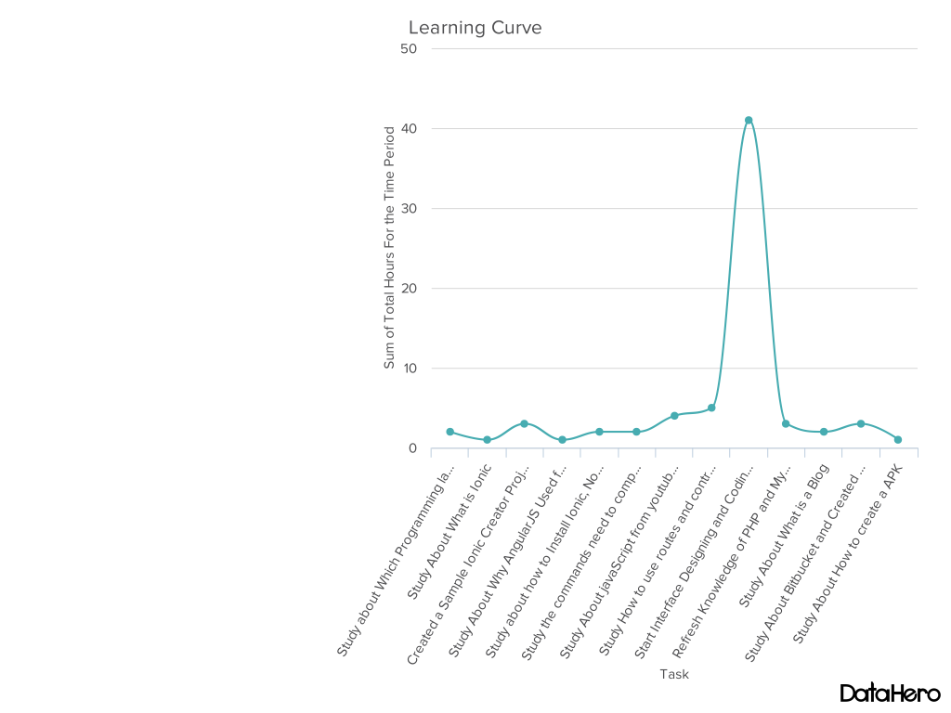

Line Chart Represent the Learning Curve

Time - Hours

**Figure 1**

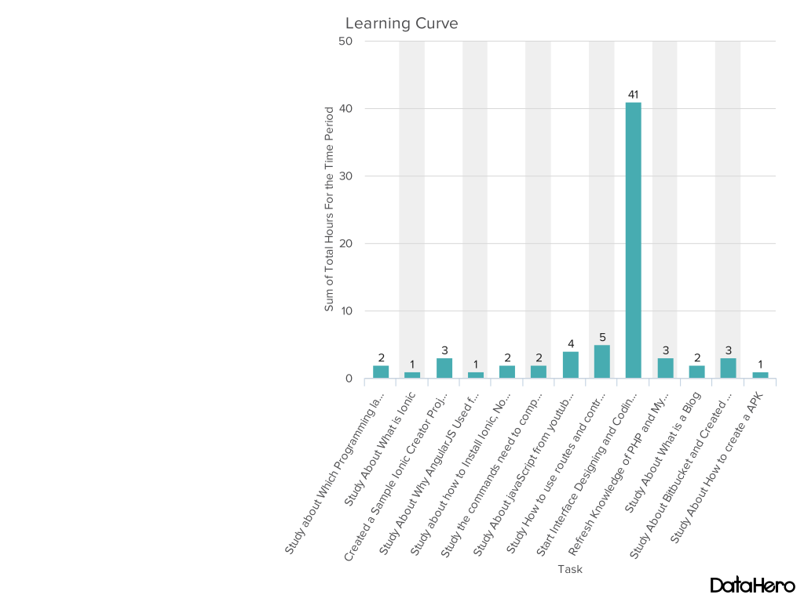

Bar Chart Represent the Learning Curve

Time - Hours

**Figure 2**

## No of Total Hours Taking For the Learning purposes , Interface design and Implement purposes.

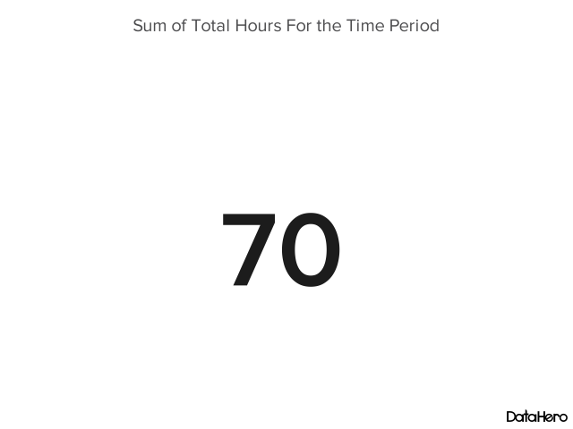

**Figure 3**

## Tasks Done During the Study Period.(The Table contains the total Time taken to the Interface Designing and Implementation)

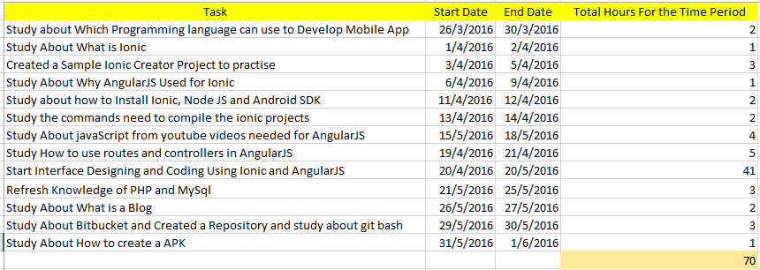

**Figure 4**

### Gantt Chart for the Learning Curve will be available under Appendix **Figure 29**

# Implementation Progress

### Here I have specially shown the total time taken for the Interface Designing and Implementation purposes of the Application .The Time and the tasks done within the time have shown here. even though the Interface Design and Development time has included as one task. In this Charts and tables I haven’t Include the time taken for the Study purposes because I have Generated a Learning curve specially for the times I spend for the study purposes. the **Figure 30** are mainly focused on the times spend for the Study purposes.

### The charts are mainly for the Tasks I have Completed During Interface Designing and Implementation Period. The Charts Displays Tasks Against the Time.

# DataHero Interface Design and Implemented Time Period (1)

Line Chart Represent the Implementation Progress

Time - Hours

**Figure 5**

# DataHero Interface Design and Implemented Time Period

Bar Chart Represent the Implementation Progress

Time - Hours

**Figure 6**

# 

## No of Total Hours Taking For the Interface design and Implement purposes.

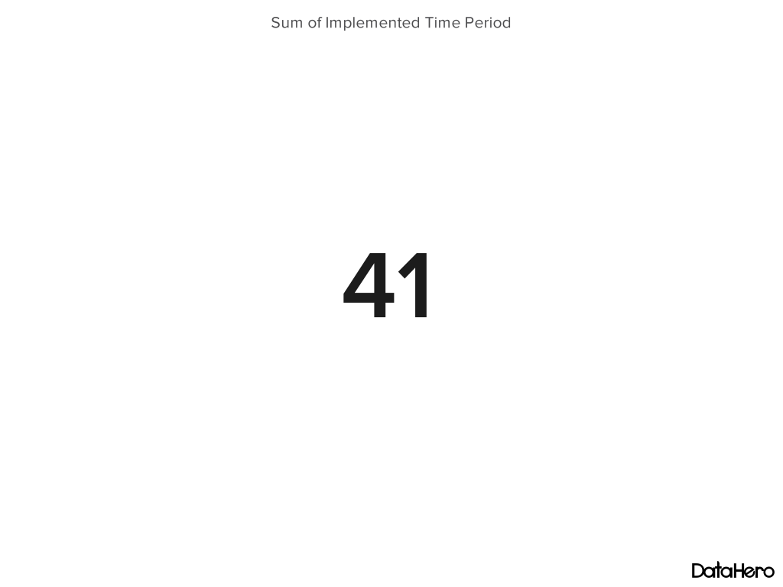

**Figure 7**

## Tasks Done During the Interface designing and Implementing Period.

# 

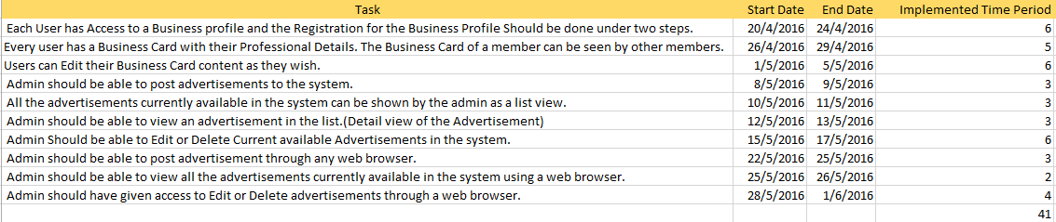

**Figure 5**

**Figure 8**

### Gantt Chart for the Implementing time period will be available under Appendix **Figure 30**

# Interface Designing

#### Mobile View

## Register For the Business profile

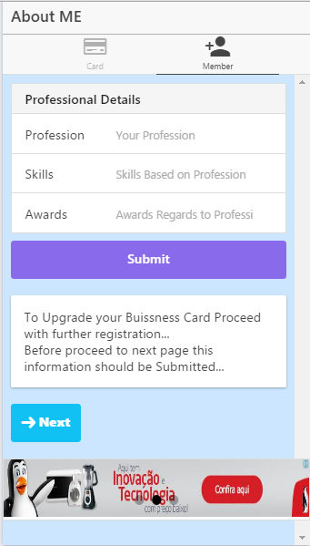

**Figure 9**

### This interface shows the first registration page. In this page user will have to provide their professional details. Initially user should complete the this registration page. After that user could be able to postponed the registration or continue.

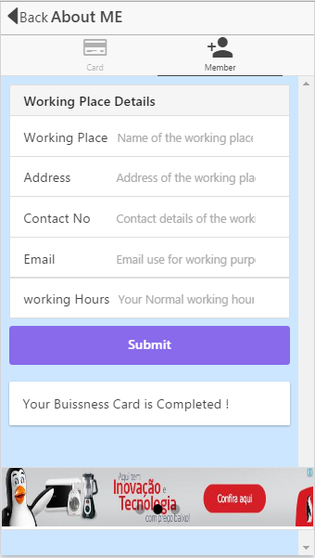

**Figure 10**

### This interface shows the next step of the registration process. In this Interface user will have to provide the working place details. Before proceed to this step user should have finished the first step.

## Show business card

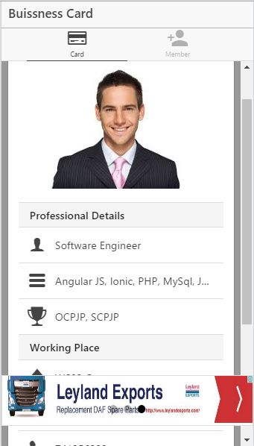

**Figure 11**

### The business card of the user is shown by this user interface. Every user can view the business card of another user.

## Edit business card

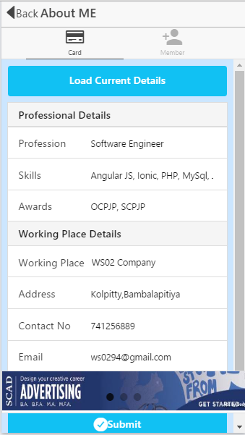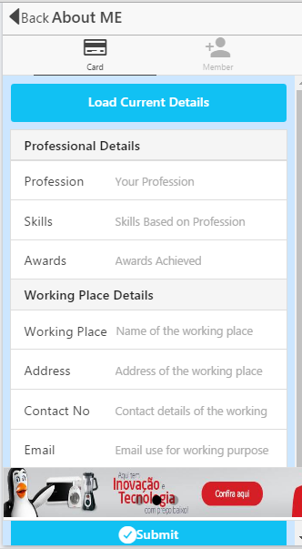

**Figure 12 Figure 13**

### Before clicks the load data button After load data button clicked

### This interface is designed for the editing purposes of the business card.

## Post Advertisement

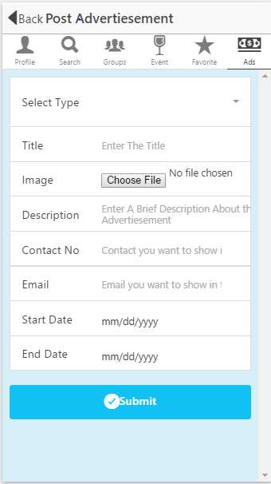

**Figure 14**

### Admin has given a separate page for posting advertisements. This interface is used by the admin to post the advertisements to the system.

## Show advertisement

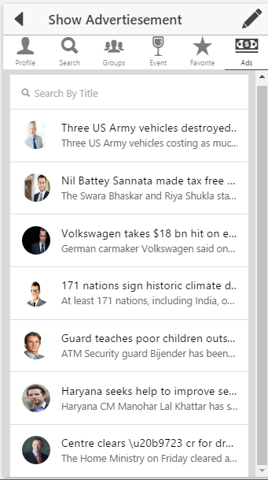

**Figure 15**

### The advertisements Currently available are shown in a list view to the admin. This interface shown how the advertisements are shown in a list view.

## Detail view of an advertisement

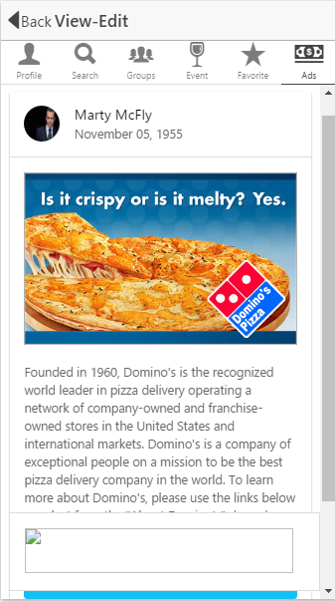

**Figure 16**

### Once clicked on a advertisements in the list view the user will be redirected to a page where the detail description of the advertisement is available. This interface shows a detail view of a sample advertisement.

## Edit advertisement

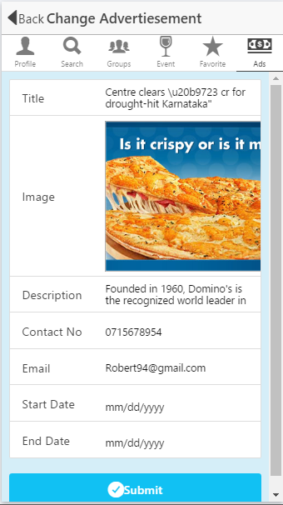

**Figure 17**

### Edit advertisement allows user to edit the advertisement. And the button will redirect user to a separate page where the editing facilities are provided.

#### Web view

## Post advertisement

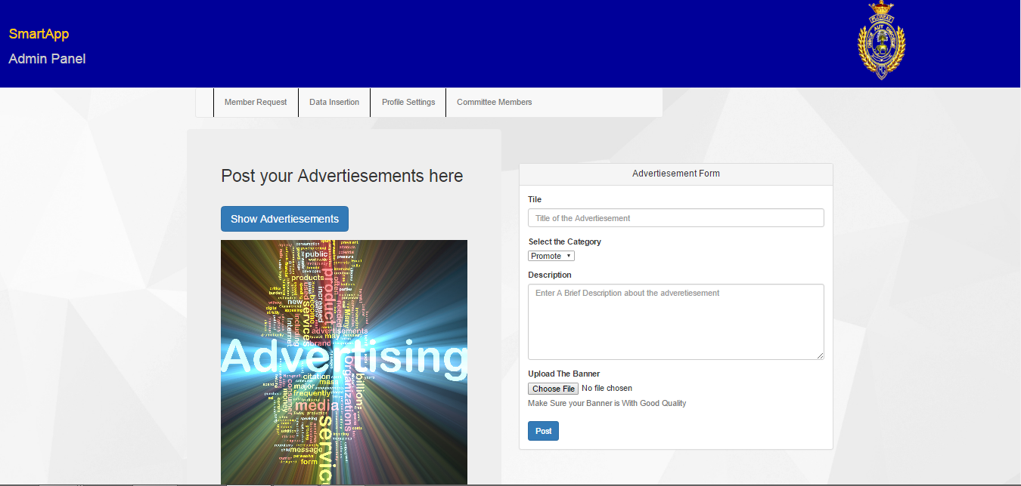

**Figure 18**

### Admin has given a separate page for posting advertisements. This interface is used by the admin to post the advertisements to the mobile system. (Notice - The size of the browser has reduced to capture the image clearly).

## Show advertisement

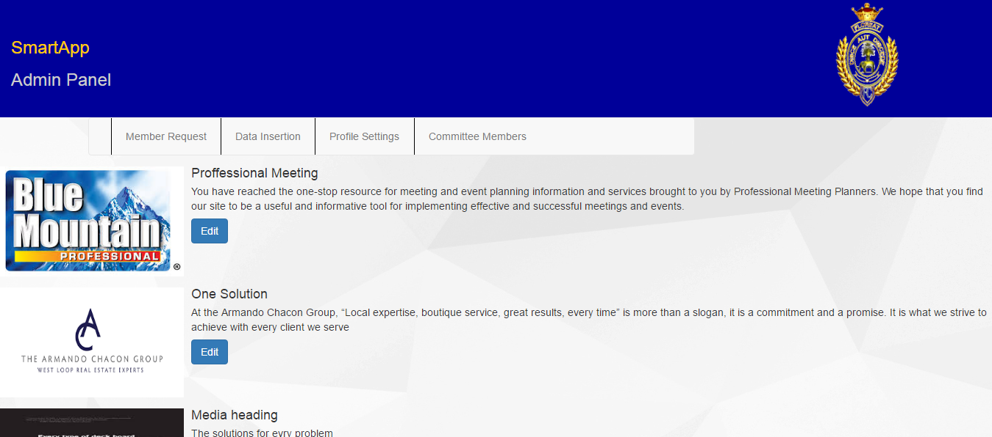

**Figure 19**

### The advertisements currently available are shown in a list view to the admin. This interface shown how the advertisements are shown in a list view. As in the Mobile Application the Admin will not provide with a separate interface for the detail view of the advertisement. All the details about the advertisement are shown here.

## Edit advertisement

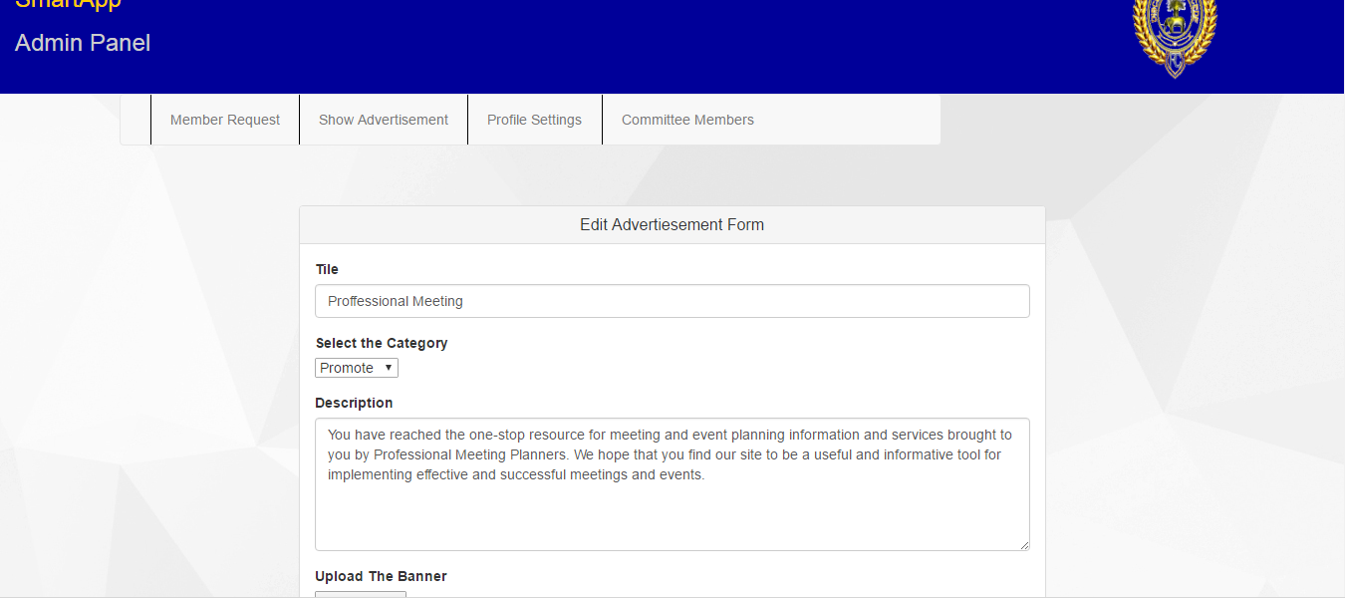

**Figure 20**

### Edit advertisement allows user to edit the advertisement. And the button will redirect user to a separate page where the editing facilities are provided. When user initially comes to the page all the details regards to the advertisement will be already filled to the fields.

# Test Cases

#### Mobile Application

## Test 1

### This test is mainly used for the testing purposes of the two registration pages.

### Test cases -

### Test if user doesn’t keep fields empty he can successfully registered.

### Preconditions -

### User must be logged in to the system already

### Input test data -

### Complete All the fields with the correct information

### Steps to be executed -

### 1)Enter input(correct )profession, skills and awards on the respective fields

### 2)click submit button

### Expected results -

### User must be displayed a confirmation message

### Actual results -

### A confirmation dialog box displayed

### Pass/fail -

### Pass

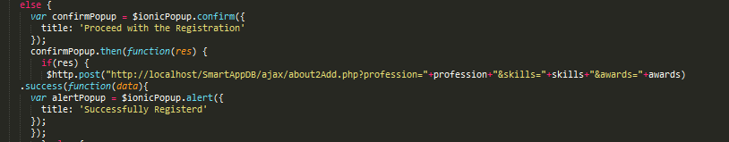

Code Part related to the Test Case 1

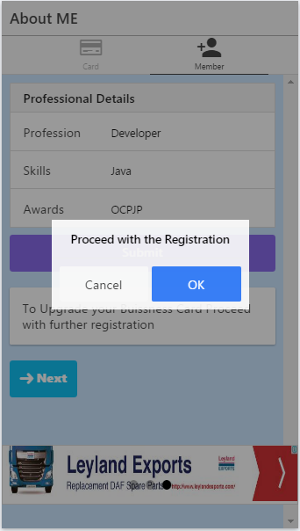

**Figure 21**

### As shown in the **Figure** when user successfully registered for the register page 1(which is used to provide professional details) will prompt a confirmation dialog box asking whether the registration is correct and proceed with the registration or abort the registration.

## Test 2

### This test is mainly used for the testing purposes of the two registration pages.

### Test cases -

### Test if user keeps fields empty error message displayed.

### Preconditions -

### User must be logged in to the system already

### Input test data -

### Keep Incomplete fields

### Steps to be executed -

### Enter input with keeping professional field empty and skills and award fields with data

### Expected results -

### Proper error must be displayed and prompt to enter the details again

### Actual results -

### Error message displayed and prompt to enter the details again

### Pass/fail -

### Pass

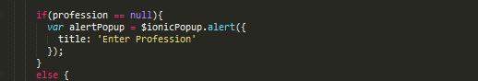

Code Part related to the Test Case 2

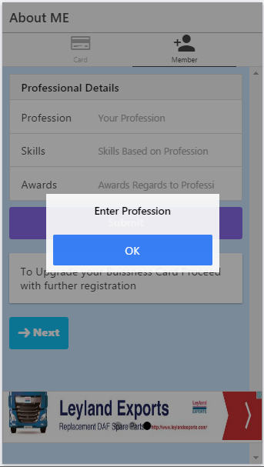

**Figure 22**

### As shown in the **Figure** while userprovidingdetails if he keeps profession area empty an error will popup saying that profession is a required thing. But for the Skills and awards it is not a must to fill out the two text fields.

## Test 3

### This test is mainly used for the testing purposes of the two register pages.

### Test cases -

### If user successfully registered a successful message should be displayed

### Preconditions -

### User must be logged in to the system already

### Input test data -

### Fill all the fields with correct details

### Steps to be executed -

### enter a profession, skills and awards in the correct fields.

### Expected results -

### Confirmation message display and when clicks ok successful message displayed.

### Actual results -

### Confirmation message display and successful message displayed.

### Pass/fail -

### Pass

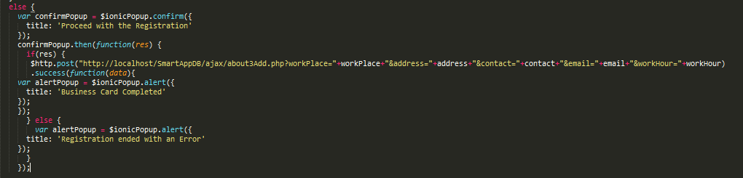

Code Part related to the Test Case 3

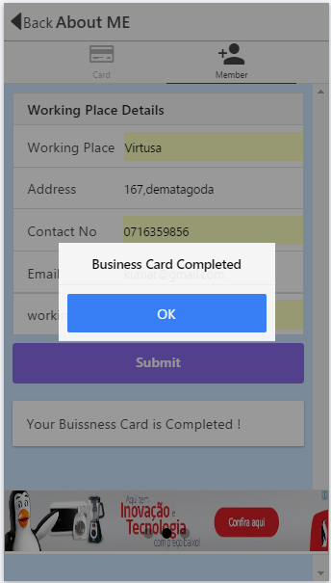

**Figure 23**

If user clicks the cancel button the details will not go to the database and registration process will abort. But if user clicks on accept button the registration details will go the database saying the registration process is successful.

## Test 4

### This test is mainly used for the testing purposes of the Edit Business card page.

### Test cases -

### Test if user keeps fields empty error message displayed.

### Preconditions -

### User must be logged in to the system already

### Input test data -

### Keep Incomplete fields

### Steps to be executed -

### Enter input with keeping working place field empty and all the other fields with data

### Expected results -

### Proper error must be displayed and prompt to enter the details again

### Actual results -

### Error message displayed and prompt to enter the details again

### Pass/fail -

### Pass

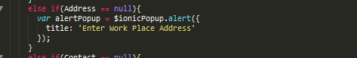

Code Part related to the Test Case 4

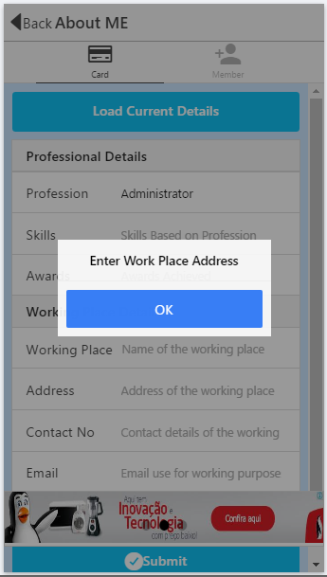

**Figure 24**

### As shown in the **Figure 23** while userprovidingdetails for the update purpose if he keeps working place field empty and other fields filled with data an error will popup saying that the field information is a required thing.

## Test 5

### This test is mainly used for the testing purposes of the Edit Business card page.

### Test cases -

### Test if user keeps fields empty error message displayed.

### Preconditions -

### User must be logged in to the system already

### Input test data -

### Keep Incomplete fields

### Steps to be executed -

### Enter input with keeping type field empty and all the other fields with data

### Expected results -

### Proper error must be displayed and prompt to enter the details again

### Actual results -

### Error message displayed and prompt to enter the details again

### Pass/fail -

### Pass

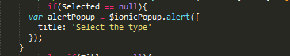

Code Part related to the Test Case 5

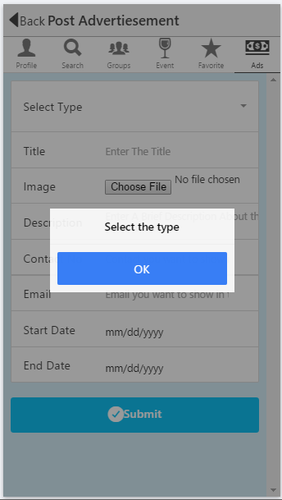

**Figure 25**

### As shown in the **Figure** while Adminprovidingdetails for the post advertisement purpose if he keeps any field empty in the form, an error will popup saying that the field information is a required thing. Admin can’t leave any field empty without completing.

## Test 6

### This test is mainly used for the testing purposes of the post advertisement page in the Web Application.

### Test cases -

### Test if user keeps fields empty error message displayed.

### Preconditions -

### User must be logged in to the system already

### Input test data -

### Keep Incomplete fields

### Steps to be executed -

### Enter input with keeping title field empty and all the other fields with data

### Expected results -

### Proper error must be displayed and prompt to enter the details again

### Actual results -

### Error message displayed and prompt to enter the details again

### Pass/fail -

### Pass

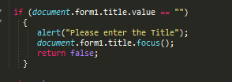

Code Part related to the Test Case 6

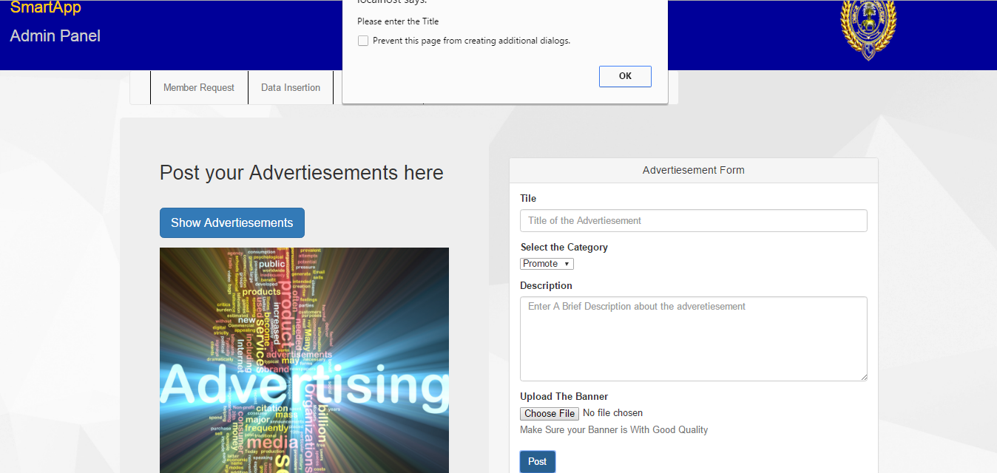

**Figure 26**

### As shown in the Figure while Admin providing details for the post advertisement purpose if he keeps any field empty in the form, an error will popup saying that the field information is a required thing. Admin can’t leave any field empty without completing.

# Bugs Identified

### The Mobile application is based on the Client requirements in order to provide facility to connect all the members of 94’Royalists together. The Application is a large Application with several features specially provide for the royalists’94.

### The Application should be connected with the Internet to access the most of features. Because the Members are around all over the world. The Application should be globalized to be accessed from each and every corner of the world. Without internet connection it will be difficult to achieve. If internet connection is failed the features which need Internet won’t be able to access at the time according to the users need.

### And when the offline access is provide it requires significant amount of system memory. Three can be Mobile devices which has limited memory capacity. So providing everything offline will affect to the members with limited memory capacity.

### But using server will be reduce the ease of access of the Mobile application due to every update will have to be done with the Internet connection.

### The efficient design of the mobile Application will allow the customer to Access the System easily and Navigate through it. For that, System must be designed with Gamification items and eye-catching items. But it will cause to increase the size of the Application. When increasing the size of the Application it will needs more storage capacity to install within the Mobile phone or any other media device.

### Each member should be an authenticated member. The Application contains most of the private information about all members. The security must be increased in order to prevent unauthenticated access to the system. The system is directly connected to the Internet then the probability of unauthorized accesses will be increased.

### The Mobile Application Should be able to use in any Mobile Phone under any Platform but there are many platforms for mobile application development. Such as IOS, Android, Windows, Blackberry etc. A user could be able to access the application with any platform.

### The Mobile Application is accessed by many members at concurrently. When the number of users are increased the response time will get increased. This affect only for the activities done using internet. When number of users are accessing the same Database Concurrently the users will have to be wait for a long time period for a response.

### Admin has provided a separate web application for make the administrative tasks easier. But without the Internet access the web application tasks cannot be completed.

# Challenges

### The Mobile Application had to be developed using Cordova Framework with Ionic, AngularJS, HTML and PHP. I have Used Ionic and AngularJS for the first time for SEP-1 Project. And the half of the Application has to develop within two and half months. Due to the Reason While Developing Mobile Application and Web application I had face to lot of impediments and challenges.

### The Cordova framework is most based on the Plugins. Plugins plays the most difficult part of Cordova. To study the Plugins which needed for the Mobile application it took much time. Since the Cordova is in MVC architecture I had to study about all the areas regarding to the MVC architecture.

### The resources about Ionic are very less since the Technology was a new one. Ionic was introduced to the Society in the middle of 2015 for the Hybrid Application Development.

### I had to Improve My Knowledge about the PHP and MySQL within the given time period to develop the web application.

### The Ionic creator was used to develop the Interfaces of the Application. The Big Challenge which I was faced during the Designing part of the Mobile Application was related with the ionic creator. In the Ionic creator once an interface has been created and download the Project for further editing Purposes it was impossible to use ionic creator for the downloaded project. From the point the editing should done manually while locate in the machine.

### The Project is developed with the agile process. Every Agile programming tools and websites need to purchase. Unless they are purchased the tools can be used only for a limited time period (trial period). When recording information regards to each sprints and progress it needs to be done manually by using excel sheets. It is Difficult to create graphs and progress reports when the Information are recorded with the Excel sheets.

# Solutions

### There were Several Problems occurred while developing the mobile Application and Web Application. And I could found out the optimal solutions for the most of the problems in order to enhance the quality of the productivity.

### System must be informative, robust, responsive, user-friendly and secure. System should be designed to allow possible future expansion, for an example more product lines.

### In order to develop the Mobile application run on Android, IOS and Windows the best development technology is ionic. Because it provide facility to run a Mobile Application on both Android and IOS. And the Ionic 2 version has released on 2016-03-29. As in the feedback the new version is support for the Windows platform up to windows 10. Then the new version can be used to convert the existing app to run on the Windows Platform.

### In the Ionic Blog they daily update the news of new components of ionic. And using forums provided by the ionic official site the information can be gathered at any time by sending a message mentioning the problem.

### After download the Project created with the Ionic creator the components, JavaScript parts can be used easily with the resources provided at the Official site. After downloading the project from the ionic creator it will provide all the folder structures related to the MVC Architecture.

### To show the Agile Process the manual drawings are done. The gnat chart and learning curve has been developed with the online web services. And the tasks progress have been recorded using office Excel.

### The Application size is reduced by minimizing number of unnecessary interfaces.

# Lessons Learned

### The main lesson learned from this project is to face challenges when using new technologies. Learned how to gather information in short period of time to improve the knowledge in some specific areas that has never been covered.

### The Lessons learned from other than the implementation are how to gather requirement by conducting client meetings. How to let know the client that how we have met the requirements and which procedure that we are used for the achievement of requirements. Since we have conducted the agile process the requirements has been changed time to time. And we identified how we can achieved the changing requirements without extracting the time period.

### The usage of project management tools and how to maintain them with accordance to the project criteria has been identified during the project time period.

### In addition to those we experienced the team working, how to face problems together when there are bugs occurs in the project.

### While developing the project the time was a critical thing to manage. And we identified methods to manage time with the scope.

# Repository and blog Details

#### Group Blog and Repository Details

## Group Blog

### Name – [Curtin\_Sep\_06](http://oursepgroup.blogspot.com/" \t "_self)

### Created with – Blogger

### Blog Address - <http://oursepgroup.blogspot.com/>

## Group Repository

### Name – SmartApp

### Created with – BitBucket

### Repository Link - <https://bitbucket.org/sep5/smartapp/src>

#### Individual Blog and Repository details

## Individual Blog

### Name – SEP – Project

### Created With – WordPress

### Blog Address - <https://sepprojectblog.wordpress.com/>

## Individual Repository

### Name – SmartApp

### Created With – GitHub

### Repository Link - <https://github.com/shawntharoo/SmartApp.git>

# Next Semester Plan

Although the SEP -1 and SEP – 2 are subject names they both carrying a one project for the whole year. In SEP – 1 part of the project should be completed and at the end of SEP – 2 the whole project should be deliverable and should be bugs free.

As because the projects are going on in Agile manner the project should develop in incremental manner. At the end of the SEP – 1 project time period the first iteration should completed. And the report is based on the iteration plan.

For the SEP -2 There should be another plan with the user stories in order to conduct it throughout the next semester (almost 4 months).

The User stories that I have identified for the next Iteration according to the clients requirements.

* Advertisements should be displayed bottom of the application. And time to time the advertisements should be rotate.
* User should have access to temporarily disable the advertisements on his application without showing them bottom of the application.
* While rotating by clicking on an advertisement user or admin could be able to enter to the detail view page of the advertisement. Detail view page contains all the information regards to the advertisement.
* The configurations should be managed in order to host the Mobile Application and the web Application.
* Improve the Application to send advertisement details to the Admin through the application instead of using external medias.
* Improve the application for Admin to accept or reject the Advertisements from the Mobile application.
* Improve the application for Admin to accept or reject the Advertisements from the Web Application
* User should be notified when his advertisement is accepted or rejected by the Admin.
* Admin Should be able to search Advertisements by the title or the description.

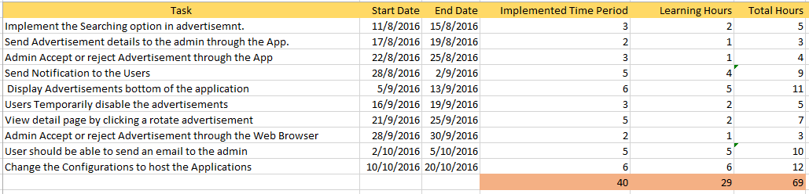

**Figure 27**

### Gantt Chart for the next semester plan will be available under Appendix **Figure 31**

# 

# Reference

### Ionic Components/CSS

### <http://ionicframework.com/docs/components/#header>

### Angular JS

### <http://angularcode.com/simple-task-manager-application-using-angularjs-php-mysql/>

### Bootstrap (Bootstrap)

### <https://www.youtube.com/watch?v=CqOOOMeGb5A&list=PLVDYxb1dYhnqUn0_liNeONyicF1Y3ajLp>

### Angular JS (You Tube)

### <https://www.youtube.com/watch?v=s3qZF4jhgDo&list=PLYxzS__5yYQmX2bItSRCqwiQZn5dIL1gt>

### PHP

### <http://www.w3schools.com/php/>

### Ionic Install

### <https://www.youtube.com/watch?v=LLX2FEg0TjU>

### GitHub Install

### <https://www.youtube.com/watch?v=qVOwGyQB3DQ>

### Create Repository

### <https://help.github.com/articles/create-a-repo/>

### How to Create a Blog

### <https://www.youtube.com/watch?v=NCWCT0PmAJg>

# Final Project Summery

### As the project of the Software Engineering one Project – 1 we were assigned to develop a Mobile application for the Royalist 1994 group members. As well as the Mobile Application we had to develop a web Application for the Admin. Admin is an external person who is hired for the operations of the system. So admin will have access to a separate area of the Application.

### The Smart Application Developed contains all the functionalities which a Normal Social Application can do. It can be run On 3 platforms. Android, Mac OS and Windows. It Contains with Different Kind of features.

### The features provided with the Smart Mobile application are specifically designed for a specific people set of people. The application can be used only by the authorized users.

### The main features provided by the mobile application are maintain a general profile, Create sub groups, maintain events, maintain a calendar for the events, follow members, post advertisement, Generate Business card, chatting features. The web application is developed for the admin to make the tasks easier. Admin has given all the administrative tasks with the web application also.

### And the end of the semester I have covered the part that was assigned to me. I have full filled the tasks needed to be delivered within the first iteration in the product. The development was done with the agile process. Agile processes and Agile tools had to be used in order to continue with the project.

### The subject Software Engineering – 2 is also the continuation of the SEP – 1 subject. I have decided to continue with the iteration two of the mobile Application within the SEP – 2 time period.

# Appendix

#### Architectural diagram For the Mobile Application

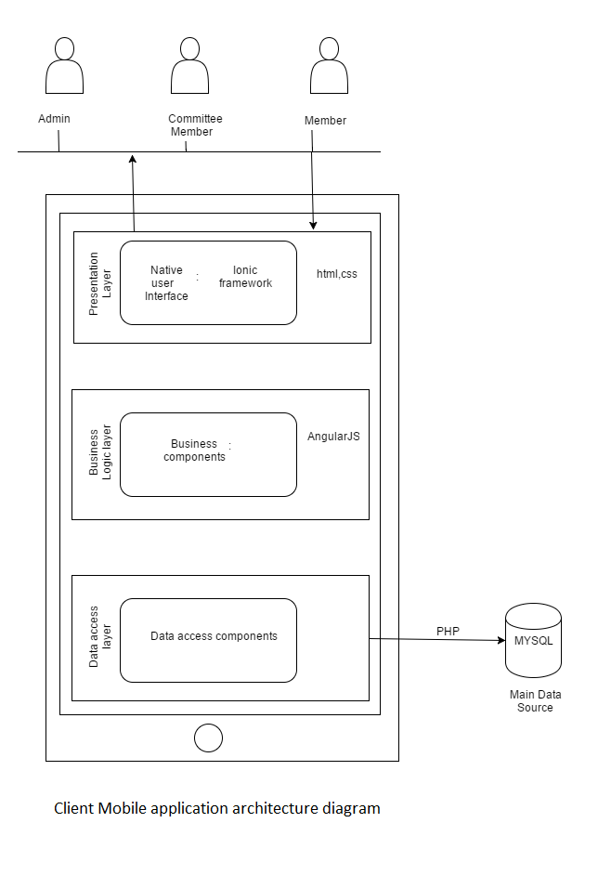

**Figure 28**

# Gant chart for the Learning Curve

# LearningCurve

# Figure 29

Notice - The Image Size can be increased without reducing the clarity

# Gant chart for the Implementation

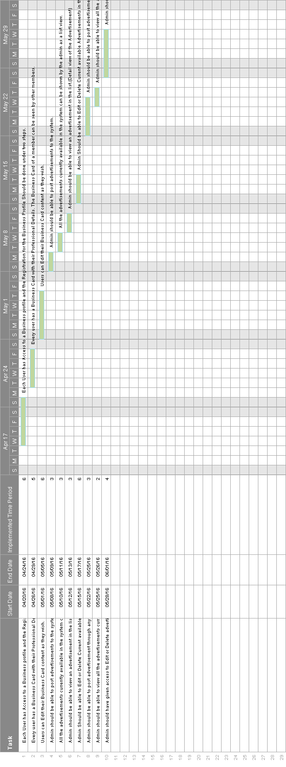

# 

Figure 30

Notice - The Image Size can be increased without reducing the clarity

# Gant chart for the Next Semester Plan

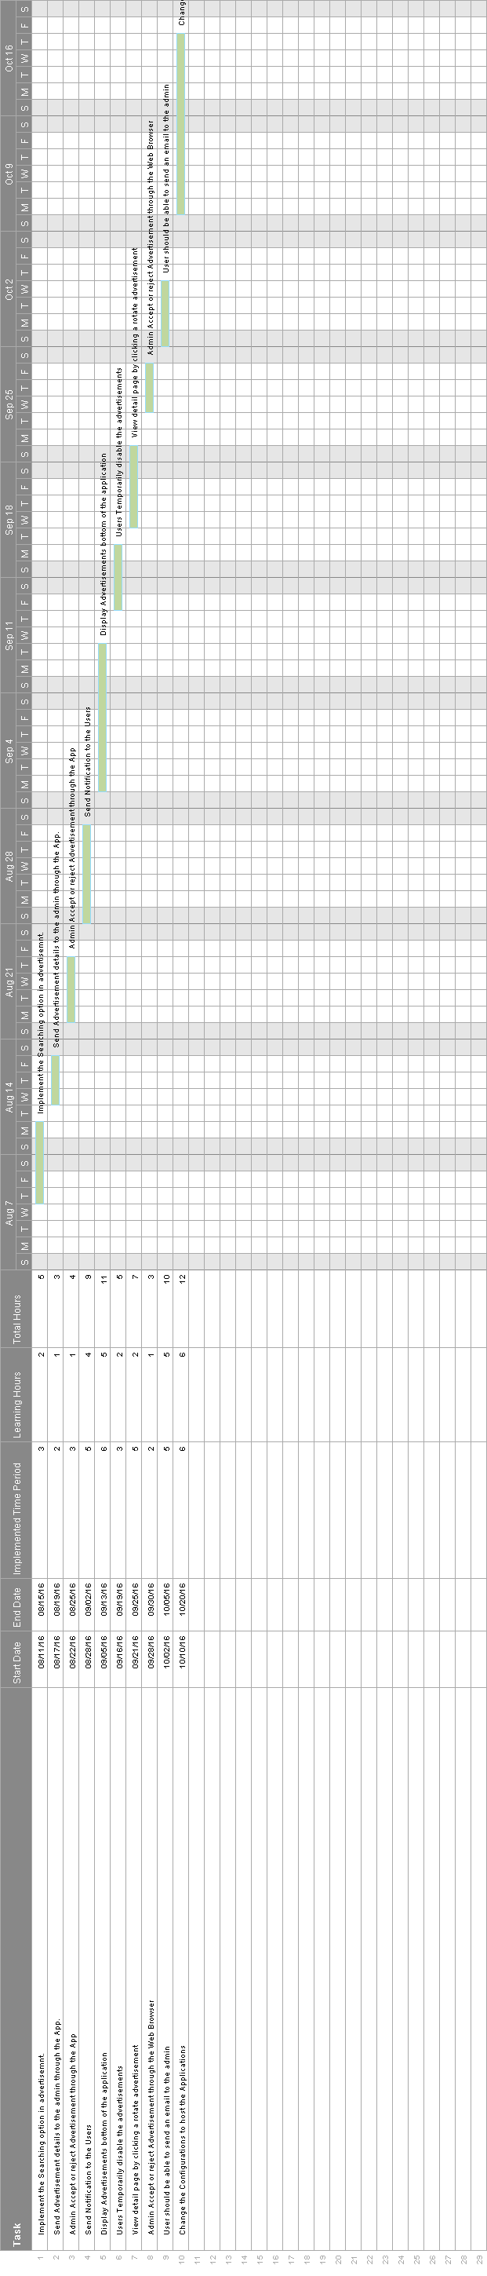

Figure 31

Notice - The Image Size can be increased without reducing the clarity

# Use Case Diagram for my part

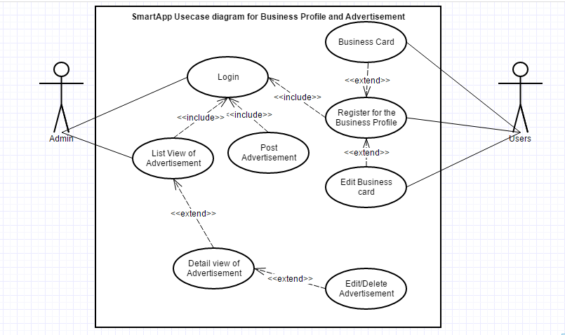

Figure 32