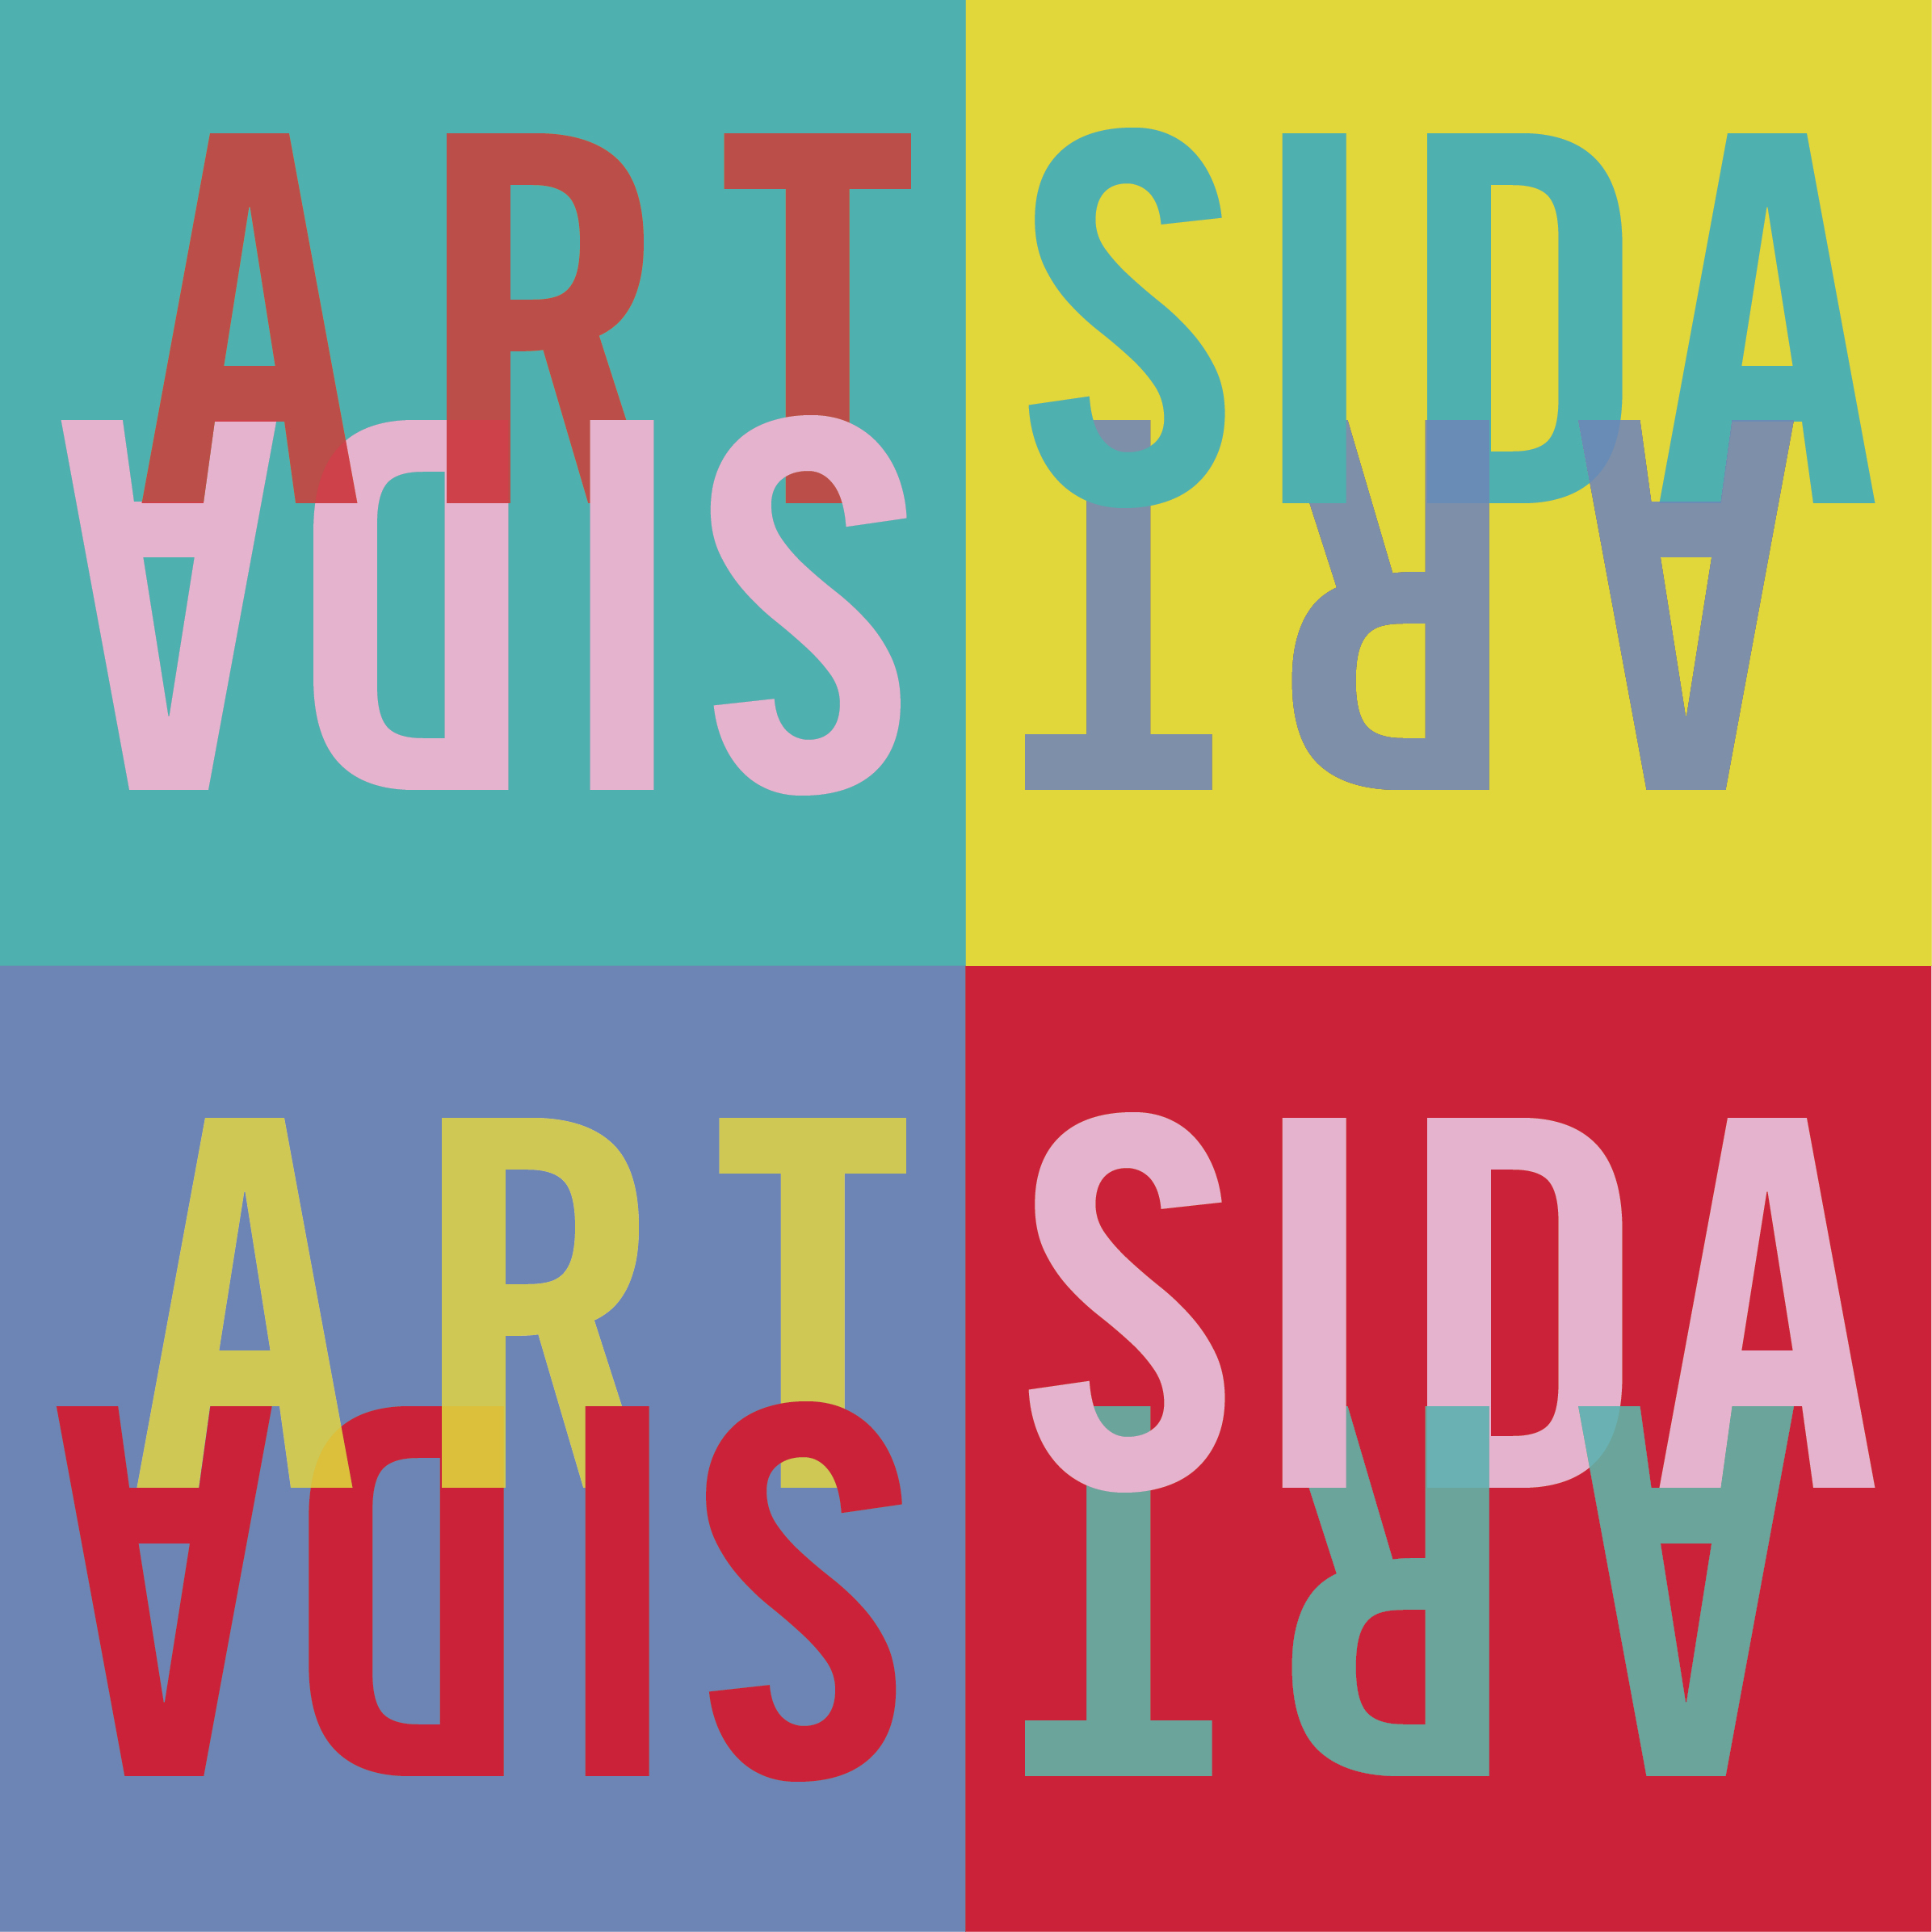

**Artsida 6: Raise Your Hand for ACCM**

**Artist Contract**

Between

**AIDS Community Care Montreal**, a non-profit organization incorporated under Part III of the Québec Companies Act (matriculation # 1143858976) and registered as a charitable organization by the Canada Revenue Agency (registration # 11914 9698 RR 0001), having its main office at 2075 Plessis, Basement Level, Montreal, Quebec, Canada H2L 2Y4.

Referred to hereinafter as "the Dealer"

And

ARTIST FULL NAME: ___________________________________________________________

ADDRESS: ___________________________________________________________

___________________________________________________________

TELEPHONE: ___________________________ EMAIL: _______________________________

Referred to hereinafter as "the Artist".

1. **PURPOSE:** The Artist hereby appoints the Dealer as agent for the purpose of displaying, exhibiting and auctioning of the Artist's work of art below:

|  |  |
| --- | --- |
| Title |  |
| Medium |  |
| Dimensions |  |
| Year of production |  |
| Estimated value |  |

And hereinafter referred to as "the Artwork". The Dealer shall not permit the Artwork to be used for any other purpose without the express consent of the Artist.

The Artist understands that the Dealer is a charitable organization conducting activities to prevent HIV transmission and to provide support to people living with HIV, and that the event to which the artwork is being donated is a fundraising activity for the Dealer.

It is understood that the Artist donates the Artwork and that it will not be returned to the Artist unless an express agreement to the contrary has been reached.

1. **WARRANTY:** The Artist hereby warrants that he/she created and possesses unencumbered title to the Artwork, and that the description as provided to the Dealer is true and accurate. In addition, the Artwork in exchange is signed and attributed to the Artist according to the usual practices of the Artist. It is further understood that the sale of the Artwork does not include the right to reproduce the Artwork, which right remains that of the Artist, and that this will be communicated clearly to the purchaser.
2. **INDEMNIFICATION:** The Artist agrees to indemnify the Dealer against all costs and expenses (including reasonable attorney's fees) incurred by the Dealer in connection with any claims made against the Dealer that any Artwork that is a part of this Agreement is not an original creation of the Artist or infringes upon a third party’s copyright.
3. **ARTIST RESPONSIBILITY:** The Artist shall be required to deliver the Artwork to the Dealer before July 31st, 2015. The Artist shall also deliver the Artwork in good condition, unless otherwise specified by the Artist during the submission process. Upon selection, the Artist will submit the Artist Contract, Certificate of Authenticity and proof of estimated value before July 31st, 2015. If these documents are not submitted by the deadline, the Dealer reserves the right to withdraw the Artwork from the auction.
4. **TRANSPORTATION RESPONSIBILITIES:** The Artist is responsible for proper packaging and safe shipping of Artwork to the Dealer.

It is understood that if the Artwork is exceptionally returned to the Artist, the Dealer is responsible for the adequate and safe packaging of the returned artwork. The Artist is responsible for all fees related to the shipping of the returned Artwork, including the original shipping, handling and insurance fees when the Artwork was sent to the Dealer.

1. **PRICE:** The Artist consents to, and authorizes, the Dealer to determine:
   1. The estimated value of the Artwork, taking into consideration the proof of estimated value provided by the Artist;
   2. The starting bid price of the Artwork.
2. **RESERVE BID:** The Artist agrees to set a minimum or reserve bid as specified in the Online Submission Form which, by the signing of this agreement, authorizes the auctioneer to determine that if the bids are not commensurate with this reserve bid, the auctioneer will withdraw the piece from the auction.
3. **EVALUATION:** If the proposed estimated value is $1000 or over, a proof of estimated value in the form of a prior receipt for a value of similar format is required. Otherwise, the Dealer will set the estimated value, which will be under $1000.
4. **REPRODUCTION:** The Artist reserves all right to the reproduction of the Artwork and this shall be clearly indicated by the Dealer to purchasers of the Artwork. The Artist gives permission for the reproduction of the Artwork for promotional or marketing purposes of the Dealer in connection with the event.
5. **PROMOTION:** The Dealer shall use its best efforts to promote the Artwork of the Artist. The Dealer shall identify clearly the Artwork with the Artist’s name, title, media, and related information. It is at the Dealer’s discretion how the Artwork will be displayed physically at the event.

The Artist is responsible for providing a digital image of the Artwork to be posted on the event web site and for the printed Catalogue. The Dealer agrees to take precautions to prevent the images of the Artwork used on the website from being circulated.

1. **DURATION:** The Artist and Dealer agree that the Artwork is considered for auction upon receipt of said Artwork and shall be posted on the website [www.artsida.org](http://www.artsida.org) for the duration of the online preview and bidding period and up to and including the date of the auction event. Moreover, after these time periods, the Dealer agrees to pursue the promotion to sell the artwork. It is understood that the artwork will remain purchased by the dealer until one year following the date of the event.
2. **SUBSEQUENT SALE:** The Artist will not take advantage of contracts developed through the event to sell the Artwork returned from the event to the exclusion of any benefit to the Dealer.
3. **RETURN OF WORKS:** The Dealer becomes the exclusive owner of the Artwork once the Artist signs this contract and delivers the Artwork to the Dealer. After this, the Artist can no longer request the return of the Artwork, except in the situation the Artwork is not sold at the event. In this case, the Dealer has up to one full year (from the date of the event) to sell the Artwork by other means, all the while respecting the conditions of sale established by the Artist in the on-line submission form. If the Dealer fails to sell the Artwork within one full year, the Artist has the right to request the return of the Artwork back to the Artist. The Artist will be responsible for all costs related to the return of the Artwork. If the Artist, after one full year of non-sale, does not wish for the Artwork to be returned to the Artist and therefore renounces all future rights to request the return of the Artwork, the Dealer has the right to sell the Artwork without needing to respect the conditions of sale, or to do what the Dealer wishes with the Artwork.
4. **EXPENSES:** The Artwork is available for exhibit and auction as is. Cost of appropriate framing is the responsibility of the Dealer. Under special arrangements, the Dealer may deem it necessary to assume framing costs which will be deducted as reimbursement from the total sales price of said Artwork. Promotion, advertising costs and costs of exhibitions shall be absorbed by Dealer.
5. **INSURANCE:** The Artist agrees and understands that Dealer is not responsible or liable for damage or loss of the Artwork caused by or resulting from theft, flood, volcanic eruption, earth movement including, but not limited to earthquake, landslide, mud flow, earth sinking, rising, shifting, or Acts of God. The Artist understands that they will not be compensated for any damage or loss of Artwork.
6. **CALCULATION OF AMOUNT OF TAX RECEIPT TO BE PROVIDED TO THE ARTIST:** A tax receipt to the Artist shall be provided for the estimated value as established by the Dealer. A tax receipt can only be provided to the Artist if the Artist agrees to donate the full amount of the successful bidding price.
7. **REMOVAL FROM FACILITY:** Dealer will not permit any Artwork to be handed over to potential customers for the purpose of sale on approval. Once the Artwork is in the possession of the Dealer, they are considered the temporary property of the Dealer.
8. **ENTITLEMENT TO BUYER INFORMATION:** The Artist is entitled to be informed of the final sale price of the Artwork and is entitled to know the name of the third-party purchaser. Third-party purchasers are aware that they are not required to provide telephone number(s) but may provide email addresses for future correspondence at their discretion. Artists and purchasers are encouraged to communicate in writing only unless otherwise agreed between the Artist and the purchaser.
9. **TERMINATION OF AGREEMENT:** This Agreement can be terminated at any time by 30 days written notification of cancellation from either party. In the event of the Artist’s death, the estate of the Artist shall have the right to terminate this agreement under the same conditions. All accounts shall be settled and any unsold Artwork returned to the Artist or, in the case of the Artist’s death, the personal representatives of executor within 30 days of that notification of termination.
10. **ACCOUNTING:** Dealer agrees to provide Artist with a complete accounting to include the following information: the title of the Artwork sold, date of sale, name of purchaser, sale price and costs as outlined in the present agreement. This accounting shall be provided within a reasonable period of the sale of the Artwork or of the termination of the present agreement.
11. **INTEGRATION:** This agreement constitutes the entire understanding between the parties. Its terms can only be modified in writing signed by both parties.
12. **NOTICES AND CHANGES OF ADDRESS:** All notices shall be sent to the Artist at the address specified in the present Agreement. Each party agrees to give written notification of address prior to date of said changes.
13. **JURISDICTION:** This agreement shall be governed by the laws of the Province of Québec and the parties expressly agree that any dispute based on this Contract shall be undertaken before a Quebec court.
14. **INTERPRETATION:** If any clause of the present contract is deemed to be invalid, the remaining clauses will nonetheless remain in force and shall be interpreted in such manner as to constitute the whole agreement.
15. **LANGUAGE:** The parties agree that the present agreement and associated materials be drawn up in the English language.

IN WITNESS WHEREOF, the parties have signed:

**The Artist:**

Signed at

_______________________________ ________________________________

City Date

_______________________________ ________________________________

Print full name Signature

**The Dealer:**

Signed at

_______________________________ ________________________________

City Date

_______________________________ ________________________________

Print full name Signature