**Computer Organization**

**Architecture diagram:**

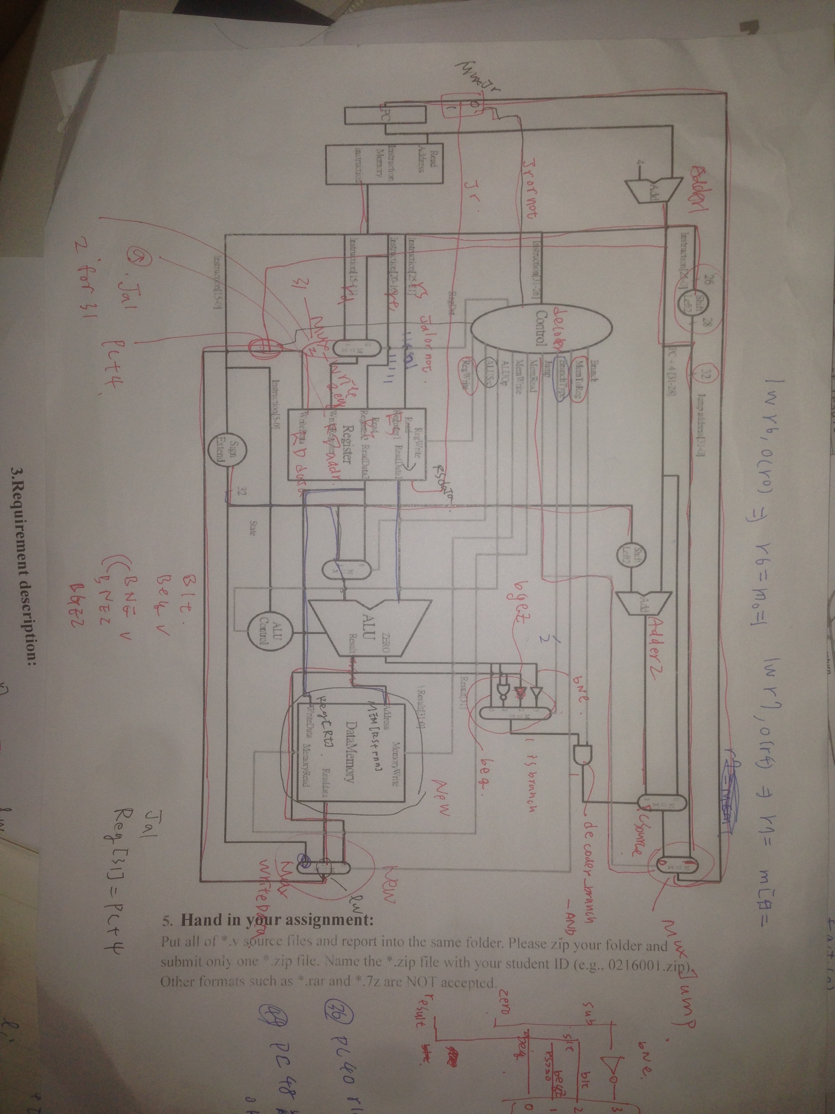

**Detailed description of the implementation:**

**Problems encountered and solutions:**

**Lesson learnt (if any):**