1. Set up the project
2. Create project on VisualStudio.com
3. Initialize with read me & VisualStudio gitignore
4. Go to Dashboard and then “open in visual studio”
5. In VS team explorer, clone the repo
6. Close the preview VS and open regular VS
7. File new project, uncheck the “Create a directory for solution”
8. Run it
9. check it in – Commit & Sync
10. Add “Environment” key to web.config



1. Add to About Action

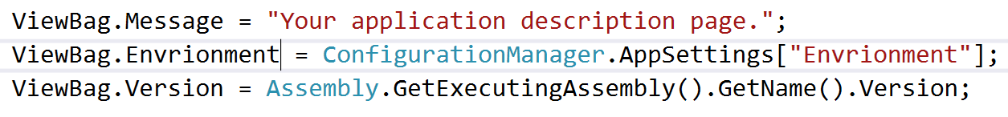

1. Add to About View

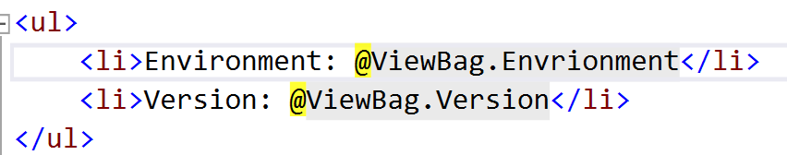

1. Run it, show the values
2. Check it in & Sync
3. Create an AppService Web App (for production)
   1. Portal.azure.com
4. Create a build definition
   1. Azure Web App Template
   2. Set Agent to Hosted VS2017, set subscription and web app
   3. Set a CI trigger
   4. Save & queue
   5. Show the build happening
   6. Show the app running, environment will be wrong
5. Change the environment
   1. Set an “application settings” key in Azure Portal
   2. Show the app running, environment should say production
6. Show automated builds
   1. Make a change on the home page
   2. Check it in & sync
   3. Show build starts automatically
   4. Show website is updated in production
   5. But version not is not changing
7. Set the version number
   1. Add the “Assembly Info” VS.com plugin to VS.com
   2. Add the Assembly info task just above the build
   3. Set the version number to $(Build.BuildNumber)
   4. Set the options Build number format to $(Build.DefinitionName)_$(date:yyyy).$(date:MM).$(date:dd)$(rev:.r)
   5. Save & queue
   6. Show the build number on the about screen
8. Change the title again
   1. Check it in and Sync
   2. Show that the automated build happened and deployed to production
   3. But perhaps we should have someone checking my work before we push it to production
9. Add Dev & Test Environments and a build steps
   1. Create two more AppService Web Apps (for dev & test)
      1. Portal.azure.com
      2. Set the Environment in each
   2. Delete the Azure App Service Deploy Task from the CI pipeline
   3. Save & queue the build
   4. Show the build happening, and that it no longer updated production
   5. Press the “release” button to crease a release definition for our build
   6. “Azure App Service Deployment” | Next
   7. Check “Continuous Deployment” | Create
   8. Set the Name for the environment & map it to the right web app (for dev)
   9. Set the Name for the environment & map it to the right web app (for test)
   10. Set the Name for the environment & map it to the right web app (for prod)
   11. Queue a new build
   12. Show the release happening
   13. Show that it hit dev, but not test or prod
   14. Approve it for test
   15. Approve for prod
10. Done