SDS 392 Intro. to Sci. Programming
Final Project: Infectious Disease Simulation
Chu-Hsiang Wu (cw32746)

Please find the attached C++ codes for implementation details. For each exercise, use make exN, where N is the number of the exercise, to compile the codes and create a binary file main for code execution.

Contagion
- Run a number of simulations with population sizes and contagion probabilities. Are there cases where people escape getting sick?

Answer: Yes, there are cases where some people in the population do not get sick. This happens when the probability of disease transmission is too low such that the transmission of disease does not occur between immediate contacts of a sick person and a susceptible person within the days needed for disease recovery.

- Incorporate inoculation: read another number representing the percentage of people that has been vaccinated. Choose those members of the population randomly. Describe the effect of vaccinated people on the spread of the disease. Why is this model unrealistic?

Answer: The model is unrealistic because the disease is only transmitted linearly between 2 neighbors in the population, i.e., the disease transfer route is limited by the dimension of the array, which is 1-D in the current case. Therefore, disease transmission breaks down too easily when the two immediate neighbors of an infected person is inoculated.

Spreading
- Code the random interactions. Now run a number of simulations varying: 1. The percentage of people inoculated, and 2. the chance the disease is transmitted on contact. Record how long the disease runs through the population. With a fixed degree of contagiousness, how is this number of function of the percentage that is vaccinated?

Answer: Given a population of 200 people, the results are shown below:
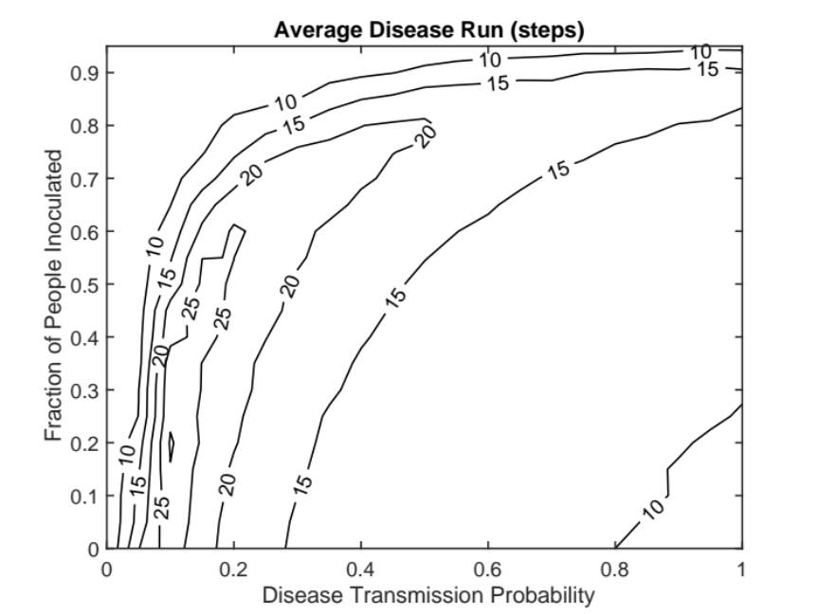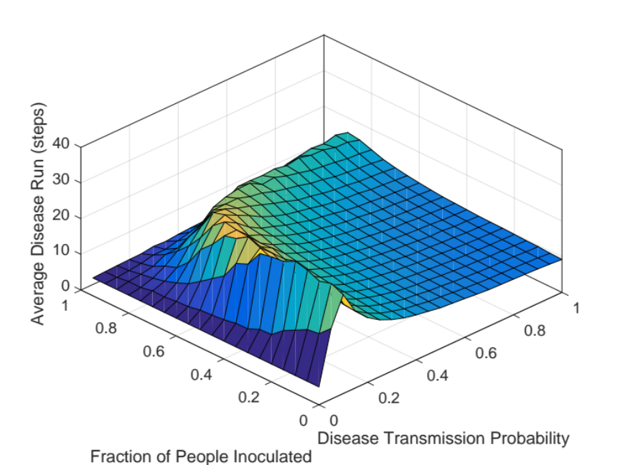

When the disease transmission probability is fixed, the average duration for disease transmission generally slightly increases first then decreases as the fraction of people inoculated increases. The longest duration in which the disease is transmitted occurs when the transmission probability is about 0.1 and the fraction of people inoculated is about 0.2. It is observed that the disease transmission typically ends very fast when the transmission probability is too low, i.e., only very few get infected, or too high, i.e., everybody gets affected very quickly and then recovers. Disease transmission also ends immediately when a large population is inoculated from day 1.

- Investigate the matter of ‘herd immunity’: if enough people are vaccinated, then some people who are not will still never get sick. Let’s say you want to have this probability over 95 percent. Investigate the percentage of inoculation that is needed for this as a function of the contagiousness of the disease.

Answer: Figures below show the results for herd immunity for a group of 200 people:
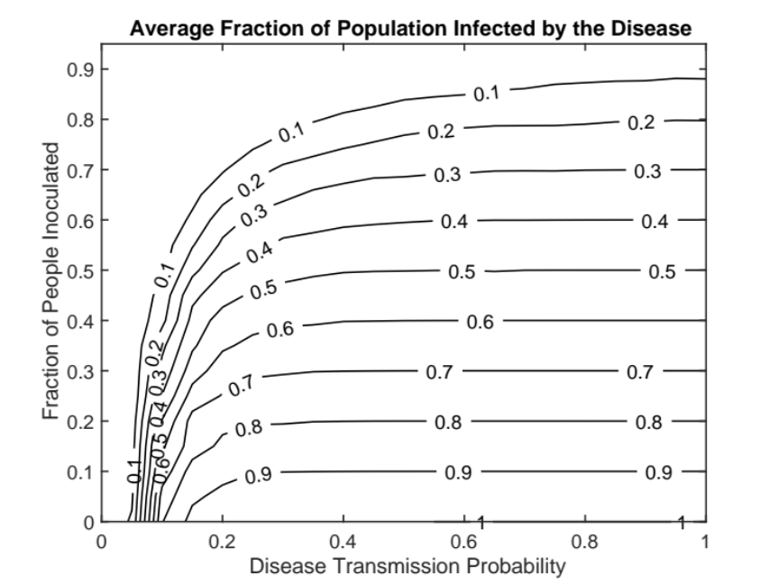
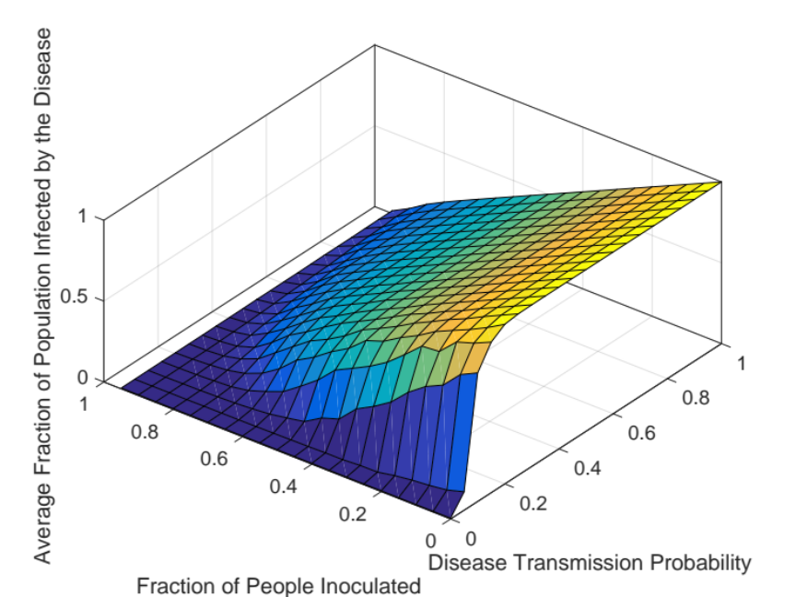

It is shown that either the disease transmission probability has to be very low (< ~0.05), or the fraction of inoculated people has to be very high (>~0.9) in order to have >95% of people stays healthy during the disease run. In other words, we want to know the boundary where < 5% of people will be infected by the disease:
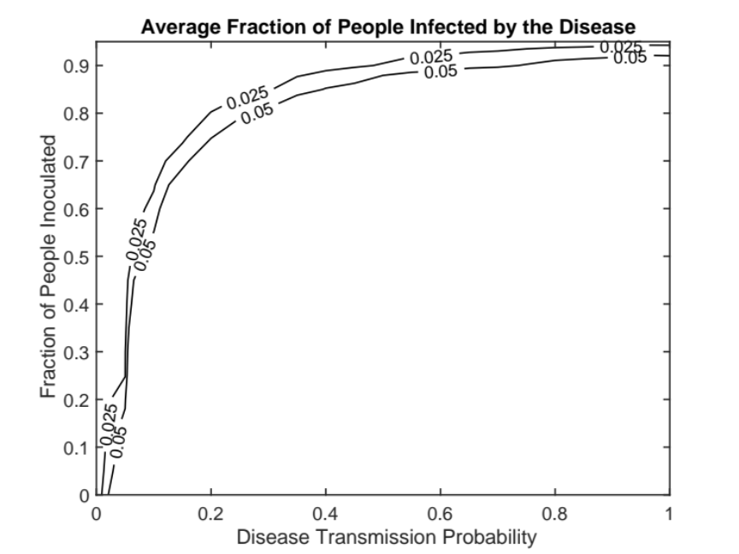
The contour line where 5% of the population is infected by the disease tells the necessary inoculation required in the population for 95% of the people to remain healthy during the disease run as a function of disease transmission probability.

- You can make the model more realistic by letting inoculation be only partly effective. For instance, 50 of people got the flu vaccine, but it was only 40% effective; 90% of people have the measles vaccine, and it is about 97%effective. How does your model function in this case? Keep in mind that different diseases have different degrees of infectiousness.

Answer: Figures below show the results when the vaccine is only 40% effective.
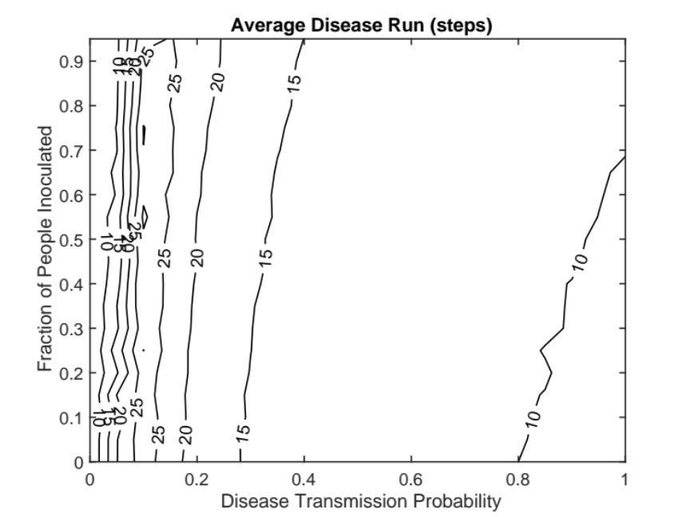
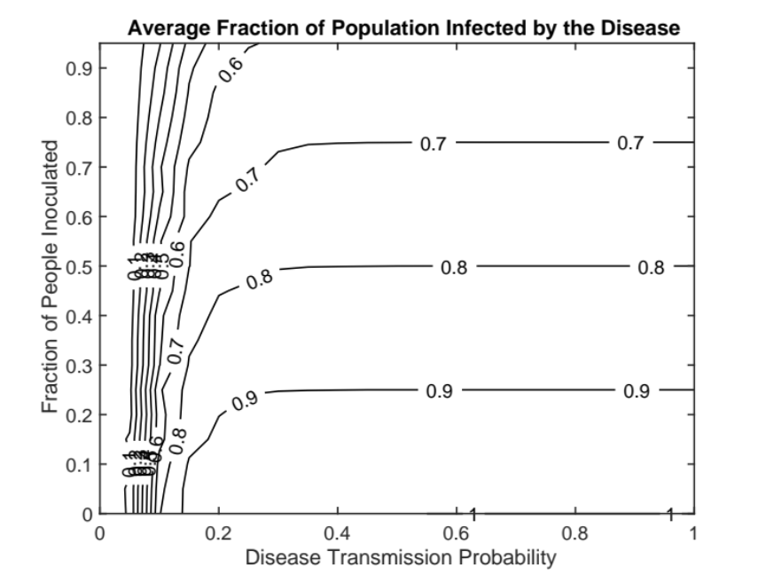
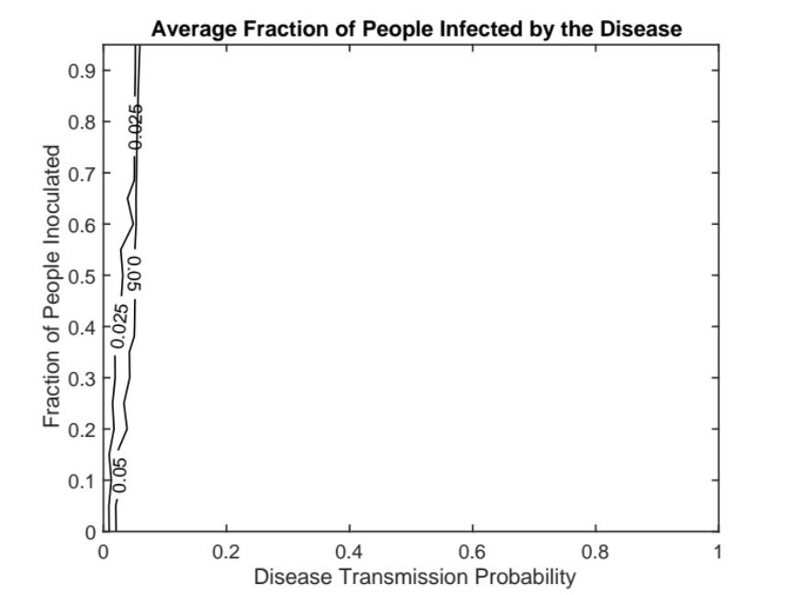

Basically, results from partly effective vaccination are “magnified” versions of results from 100% effective vaccination, i.e., the plots are elongated in the y-direction in the above plots. In such cases, herd immunity of the majority of people staying healthy is harder to achieve (even impossible to achieve) at a given disease transmission probability. More people are likely to be infected, but the disease won’t necessarily run longer—since it depends on the combination of disease transmission probability and fraction of effectively inoculated people.

