Lab #4: Phase-Plane Analysis and Design

EE 552: Robotic Control System

by

Shawon Dey

1. **Code for phase plot similar to one of the figure:**

clc

clear all

close all

warning off

%system dynamic

f = @(t,X) [ X(1) + (X(1).*X(2)); -X(2) + (X(2).*X(2)) + (X(1).*X(2)) + (X(1).*X(1).*X(1))];

%resolution

Ts= 50;

x1 = linspace(-4,4,Ts);

x2 = linspace(-4,4,Ts);

[x,y] = meshgrid(x1,x2);

u = zeros(size(x));

v = zeros(size(x));

t=0;

for i = 1:numel(x)

dx = f(t, [x(i); y(i)]);

u(i) = dx(1);

v(i) = dx(2);

end

%normalization of all vectors

for i = 1:numel(x)

Vmod = sqrt(u(i).^2 + v(i).^2);

u(i) = u(i)/Vmod;

v(i) = v(i)/Vmod;

end

quiver(x,y,u,v,'b');

figure(gcf)

axis ([-4, 4 -4 4])

title('Phase plot for Ts=50')

**Figure:**

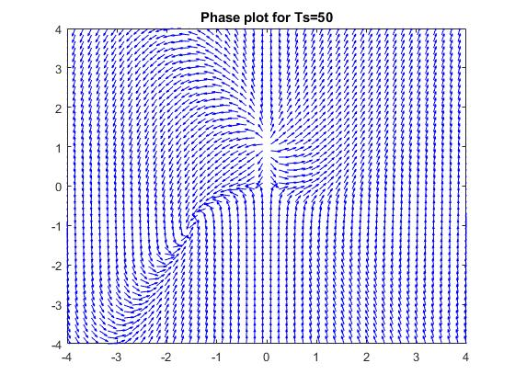

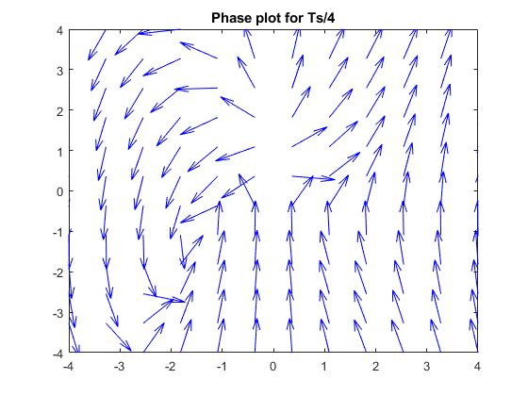

1. **Code to show a subset of trajectories on the phase plane**

clc

clear all

close all

warning off

%system dynamic

f = @(t,X) [ X(1) + (X(1).*X(2)); -X(2) + (X(2).*X(2)) + (X(1).*X(2)) + (X(1).*X(1).*X(1))];

%resolution

Ts= 50;

x1 = linspace(-4,4,Ts);

x2 = linspace(-4,4,Ts);

[x,y] = meshgrid(x1,x2);

u = zeros(size(x));

v = zeros(size(x));

t=0;

for i = 1:numel(x)

dx = f(t,[x(i); y(i)]);

u(i) = dx(1);

v(i) = dx(2);

end

%normalization of all vectors

for i = 1:numel(x)

Vmod = sqrt(u(i).^2 + v(i).^2);

u(i) = u(i)/Vmod;

v(i) = v(i)/Vmod;

end

quiver(x,y,u,v,'b');

figure(gcf)

axis ([-4, 4 -4 4])

hold on

%calling sequence: ode45(fname, tspan, xinit)

for i=-5:0.1:5

[T,x] = ode45(f,[0 10],[i i]);

plot(x(:,1),x(:,2),'r')

hold on

[T,x] = ode45(f,[10 0],[i i]);

plot(x(:,1),x(:,2), 'r')

end

**Figure:**

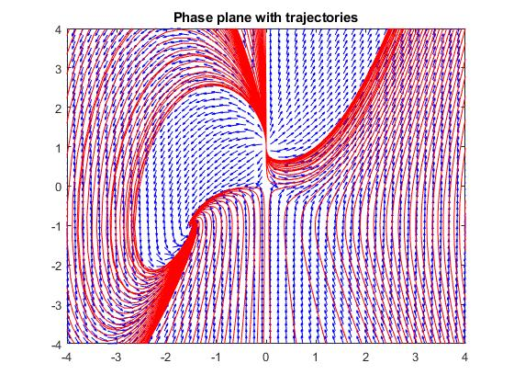

1. **(a) Code to validate the solution for a linear system**

clc

clear all

close all

warning off

%system dynamic

f = @(t,X) [-0.313*X(1) + 56.7*X(2); -0.0139*X(1) - 0.426*X(2)];

%resolution

Ts= 50;

x1 = linspace(-4,4,Ts);

x2 = linspace(-4,4,Ts);

[x,y] = meshgrid(x1,x2);

u = zeros(size(x));

v = zeros(size(x));

t=0;

for i = 1:numel(x)

dx = f(t,[x(i); y(i)]);

u(i) = dx(1);

v(i) = dx(2);

end

%normalization of all vectors

for i = 1:numel(x)

Vmod = sqrt(u(i).^2 + v(i).^2);

u(i) = u(i)/Vmod;

v(i) = v(i)/Vmod;

end

quiver(x,y,u,v,'b');

figure(gcf)

axis ([-4, 4 -4 4])

hold on

%calling sequence: ode45(fname, tspan, xinit)

for i=-5:0.1:5

[T,x] = ode45(f,[0 10],[i i]);

plot(x(:,1),x(:,2),'r')

hold on

[T,x] = ode45(f,[10 0],[i i]);

plot(x(:,1),x(:,2), 'r')

end

title('Phase plane with trajectories')

**Figure:** 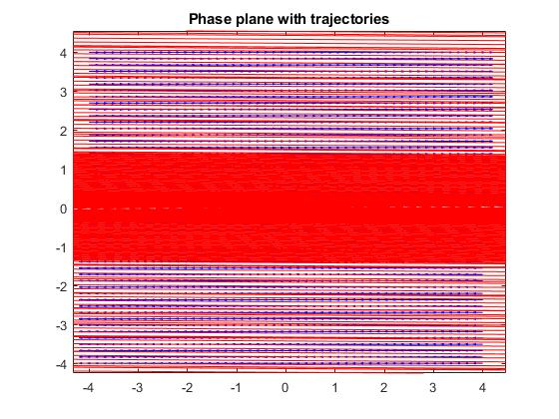

1. **(b) Code to validate the solution for a nonlinear system**

clc

clear all

close all

warning off

%system dynamic

f = @(t,X [-sin(X(1))+cos(X(2)); -cos(X(1))];

];

%resolution

Ts= 50;

x1 = linspace(-4,4,Ts);

x2 = linspace(-4,4,Ts);

[x,y] = meshgrid(x1,x2);

u = zeros(size(x));

v = zeros(size(x));

t=0;

for i = 1:numel(x)

dx = f(t,[x(i); y(i)]);

u(i) = dx(1);

v(i) = dx(2);

end

%normalization of all vectors

for i = 1:numel(x)

Vmod = sqrt(u(i).^2 + v(i).^2);

u(i) = u(i)/Vmod;

v(i) = v(i)/Vmod;

end

quiver(x,y,u,v,'b');

figure(gcf)

axis ([-4, 4 -4 4])

hold on

%calling sequence: ode45(fname, tspan, xinit)

for i=-5:0.1:5

[T,x] = ode45(f,[0 10],[i i]);

plot(x(:,1),x(:,2),'r')

hold on

[T,x] = ode45(f,[10 0],[i i]);

plot(x(:,1),x(:,2), 'r')

end

title('Phase plane with trajectories')

**Figure:**

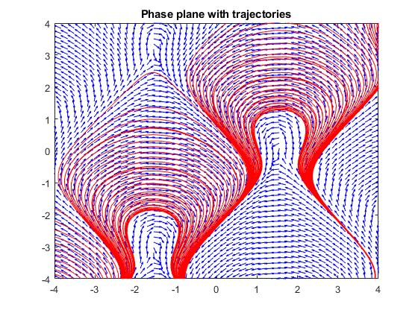

**3.(c) Code to validate the solution for a pendulum system**

clc

clear all

close all

warning off

%system dynamic

f = @(t,X) [ X(2); -sin(X(1))];

%resolution

Ts= 50;

x1 = linspace(-4,4,Ts);

x2 = linspace(-4,4,Ts);

[x,y] = meshgrid(x1,x2);

u = zeros(size(x));

v = zeros(size(x));

t=0;

for i = 1:numel(x)

dx = f(t,[x(i); y(i)]);

u(i) = dx(1);

v(i) = dx(2);

end

%normalization of all vectors

for i = 1:numel(x)

Vmod = sqrt(u(i).^2 + v(i).^2);

u(i) = u(i)/Vmod;

v(i) = v(i)/Vmod;

end

quiver(x,y,u,v,'b');

figure(gcf)

axis ([-4, 4 -4 4])

hold on

%calling sequence: ode45(fname, tspan, xinit)

for i=-5:0.1:5

[T,x] = ode45(f,[0 10],[i i]);

plot(x(:,1),x(:,2),'r')

hold on

[T,x] = ode45(f,[10 0],[i i]);

plot(x(:,1),x(:,2), 'r')

end

title('Phase plane with trajectories')

**Figure:**