**C Sc 335 Analysis and Design Artifacts for Final Project**

**1. Team Name:**  Rick’n Around

**2. Project: Pokemon: Safari Zone**

**3. Team Members**: _ Shawtaroh Granzier-Nakajima Eric Evans

Matt Shaffer Joey McCalanahan

**4. Candidate Objects or Class Hierarchies**

List the most important objects, or an inheritance hierarchy name, and the single responsibility of each.

|  |  |
| --- | --- |
| **Candidate Object** | **Single Responsibility in 1 or 2 sentences** |
| GUI | Handle Graphics and manages main method and objects |
| Pokemon | Pokemon Objects (Handles individual pokemon stats) |
| Pokedex | Handles master lists (loading all constructors from large directory of pokemon images names, etc.) of pokemon, |
| Player | Manages inventory, items, caught pokemon list (personal pokedex) |
| Inventory | Handles counts of items (Safari Balls, Potions, Revive) |
| BattlePanel | extends JPanel, implements battle scene gui and actionlistener logic |
| MenuPanel | extends JPanel. implements in-game menu. |
| StartupPanel | extends JPanel, implements pre-game menu. |
| BitMap | Manages bit-art manipulation for graphics |
| StatsPanel | extends JPanel, displays end of game stat summary/ |
| Splash Screen | Extends JPanel, handles splash screen art, starting game menu |
| SoundPlayer | Extends Thread, plays ambiance sound effects. |
| KeyListener | Listens for player input (moves avatar arounf world) |
| WindowListener | Catch closing for persistance options |

**5. Sequence Diagram 1:** Your team UML Sequence Diagram should show the most important scenario you can think of. Your sequence diagram should show most of your objects from above and how they communicate with each other.

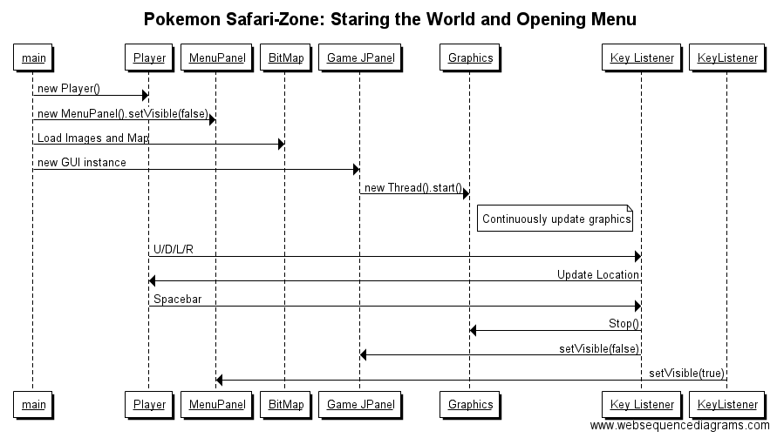

**6. Sequence Diagram 2:** Your team UML Sequence Diagram should show the second most important scenario you can think of. Your sequence diagram should show most of your objects from above and how they communicate with each other.

