

Exercises

Chapter 1 (Introduction)
- Login to your linux and check what is your default shell by running the command :
#> echo $SHELL

Chapter 2 (shell basic)
man
- There is any man on the man command?
- /etc/shadow is a special file that contains the password information for the system's accounts.
What is the right man command (below) to view the manual page of the shadow file?
#> man shadow
#> man 3 shadow
#> man 5 shadow
(Tip: Remember, there are many sections in man command.
e.g: section 1 for commands and section 3 is for C-Library)

wild cards
Run the following commands:
#> mkdir ~/wild
#> cd ~/wild
#> touch {fred,frank,penny}_{williams,wells,fery}.{1,2,3}
------Name------ ------Surname------ -Category-
Now observe the file that was created in the directory by running ls.

Answer the following questions:
1. What the following command do:
#> ls *_*.3

2. What the following command do:
#> ls *_w*.*

3. List only people in category 2, whose first name begins with "f" and surname begin with “w”.

4. List only those people whose names have 5 characters in them.

Redirecting I/O
- Run the following command
#> mkdir ~/redirect
#> cd ~/redirect
#> find /proc /bin -name "*sh"

a. What the following redirection do:
#> find /proc /bin -name "*sh" 2>error

b. What the following redirection do:
#> find /proc /bin -name "*sh" 2>/dev/null

c. Redirect all the find matches into a file and the error into other file by running:
#> find /proc /bin -name "*sh" > out 2>error_c
Observe the file out and the file error.c to see that it worked ok.

d. Redirect all the matches into a file and the error into the same file.

Note: using > redirection will overwrite the file!
In order to avoid unwanted overwrite you can run the command:
#> set -o noclobber (+o will enable it back)

- What is the different between > and >>?

- Understand what the command “wc –l” doing (man wc)
a. Run the command
#> wc -l
The command is waiting for your input (stdin is the keyboard that is why it’s wait for your typing).
So writes few lines and then press ctrl-D (it’s tell the wc command that there is no more input).
What is the number that you got?

b. How do you count how many lines there are in the file /etc/hosts.

Pipes + Basic commands(cut, grep, sort) + command listing(; && ||)
- The following command will show you all the directories in /etc.
#> ls -l /etc | grep ^d
Add another pipe to the command above in order to count the directories. (Tip: use wc -l)

- Run the following command to get the module of the cpu in your computer :
#> cat /proc/cpuinfo | grep "model name" | sort -u

Note : /proc/cpuinfo contains many details on your CPU cores..
Without the sort –u, you may see few identical lines.
Each line for every core in the system (CPU can contain many cores)

- Playing with ls and command listing.
a. What the following command do:
#> ls -l /tmp/file || echo Not exist

b. Change the command to redirect the error message “ls: /tmp/file: No such file or directory” to
the garbage(/dev/null)

- Print a sorted list of the users that configured in the system:
Tip: use cut to get the first field in /etc/passwd, remember that the delimiter should be ‘:’

- In one command listing do:
Check if there is a signal with the name SIGSYS. (Tip: to see all the signals uses kill –l)
If there is then execute the command - echo “SIGSYS exist”
Tip : When grep command found a match then it finished ok.

- Find two different commands to count how many users’ uses bash by default.
Tip : The last field in /etc/passwd determines the default shell of the user.

- Print how many users exist on the lecture's remote host.
Tip : use ssh to execute remote command on the /etc/passwd of the remote host.
Processes
- Working with background, forground and jobs
  - Run the command (in foreground)
#> sleep 1000000
  - Move the command to run in the background by pressing ctrl-z and then bg command.
  - Run the command jobs to see the job number of the “sleep 100000”.
  - Return the sleep job\process to the foreground by running the command fg.
  - Kill the job from the foreground. (Tip : don’t use ctrl-z, maybe ctrl-c?)

- Another game with processes
  - Run the command in background.
#> sleep 1000000 &

  - Observe the process sleep in the process tree by running the command :
#> ps --forest -f (it will show you only the processes in your current shell)
#> ps --forest -ef (it will show you all the processes in the system)
or
#> ps -efH (same but look different)

  - print only the “sleep 100000” process by grep the ps –efH command :
#> ps -efH| grep “sleep 100000” | grep –v grep
root <PID> 15638 0 15:29 pts/1 00:00:00 sleep 1000000

What you will see without the "| grep -v grep" ?

  - Kill the process “sleep 100000” by sending SIGKILL signal(his number is -9).
Be careful don’t kill your self!
#> kill -SIGKILL PID
or
#> kill -9 PID

  - Try to see if the process was killed by running :
#> ps -efH| grep “sleep 100000” | grep –v grep || echo “The process is not running”

What is the "||" in the above command means?

Chapter 3 (Shell Environment)
- Explore your current environment variables by running :
#>env

- Play with your prompt variable:
  - Change your prompt to be # sign by redefine the PS1 variable :
#> PS1=#

  - Change the prompt to much nicer one [user@hostname:dir] :
#> PS1=”[\u@\h \w]#”

  - Logout(exit command) and login again is the prompt saved?

  - Put the variable PS1=”[\u@\h \w]#” into the end of your ~/.bashrc.

  - logout and login again, is the new prompt saved?

- Playing with your PATH variable
  - print the content of the PATH variable by running :
#> echo $PATH

  - unset the PATH variable by :
#> unset PATH
#> echo $PATH

  - Why you can run /bin/ls BUT not ls?

  - Logout(exit command) and login again to recover the PATH env. Now you should succeed to do ls command.

  - Explain what the following assignment do(Tip: dot after the :)?
#> PATH=${PATH}:.

- Just playing with a regular \ environmental variable and
  - Create a new variable which contain the OS type
#> OST=`uname`
  - Execute bash command. Can you see this variable?

  - Run the command “exit” to exist the new bash.
Now make the variable OST to become environmental variable.

  - Execute bash command again. Can you see this variable now?

  - Exit from the new bash, and then unset the OST by :
#> unset OST
Now what is the content of OST now?
  - Define the OST =`uname` inside a text file ~/myenv

  - Source the ~myenv in your current shell and check that the OST exists.

Chapter 4 (Advanced Editing Tools)
Grep
- This grep print the /etc/services without any comment lines and without any empty lines.
#> egrep -v “^#|^$” /etc/services
Can you explain what ^# match and what ^$ match?

- Is the following command do the same?
#> cat /etc/services | egrep -v “^#|^$”

sed
- What the following sed do :
#> sed 's/root/ROOT/g' /etc/passwd| grep –i root
Tip :You can check it by running before :
#> cat /etc/passwd | grep root
#> sed 's/root/ROOT/g' /etc/passwd | grep -i root
Note: a. The “grep -i root” also match ROOT string
b. This sed command is not change the /etc/passwd it just print the file with the sed replacements.

- Try to run the same sed command but without the “g”, what is the difference?
#> sed 's/root/ROOT/' /etc/passwd | grep –i root

- What the following sed do :
#> sed '1d' /etc/hosts

- What the following sed do :
#> sed '/^#/d' /etc/services | wc -l

- Print the /etc/passwd without the lines that have “bash” on it.

- How to print a file without any empty line?

awk
- Which block of commands out of the three (BEGIN,main processing and END) in the structure of awk is not optional?

- The following awk is printing all the uses in the system, what is the -F: means?
#> awk -F: ‘{print $1}’ /etc/passwd

- What the following awk prints?
#> echo “HPUX%Solaris%Linux” | awk –F% '{print $3}'

- Use awk on the output of “who” command to display only the terminals and the user name associated with them.

- What the following awk prints:
#> awk ‘{print NR, $0}’ /etc/passwd
Tip: see “man awk” to understand what NR special variable in awk means.
Also see in the man what it $0 means.

- Create the file /tmp/myfile which contain :
john 10 20 30
kobi 5 5 10
jasper 20 10 2
Every line shows the worker name and his 3 last salaries.
Print the worker name and his average salary.
The output should be:
john AVG-salary is 20
kobi AVG-salary is6.66667
jasper AVG-salary is10.6667

- Bonus – print also the average salary of all the workers together.
Tip : print it in the END but don't forget to summaries each worker's
salary inside the MAIN section of the awk.
The output should be:
AVG-salary is 12.444

Chapter 5 (scripting)
systemStatus.sh
- Analyze the following script ~/systemStatus.sh (see next page)
  - Write comments inside the script which explains each line in the script.
  - Execute the script and check his output and his return code (echo $?)
#> chmod u+x systemStatus.sh
#> ./systemStatus.sh
  - Try to change the thresholds for affecting the script output.

- Add to the script systemStatus.sh another two system checks:
2.1 Checking that the minimal free space swap is 100MB. (TIP: use the free –m command)
2.2 Checking that there are not more the 120 running processes on the system.

- Change the script to become a daemon(endless while loop)
Run the daemon in the background and redirect its output to a log file ~/systemStatus.log.
Open a different terminal and watch the log file by the command #>tail –f ~/systemStatus.log.
See if there is any change in the output of the systemStatus log when you run the following commands:
#> find / >/dev/null 2>&1 &
#> tar cf /tmp/etc.tar /etc >/dev/null 2>&1

systemStatus.sh (Basic script)

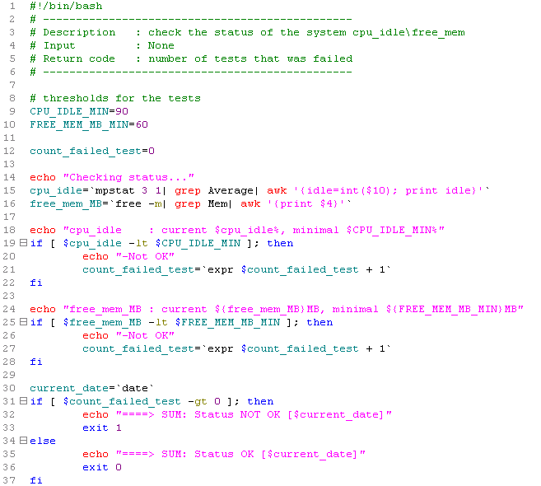

checkDirSize.sh
- Analyze the following script ~/checkDirSize.sh (see next page)
  - Write inside the script comment which explains each line in the script.
  - Create the an empty directory /tmp/testdir and execute the script:
#> chmod u+x checkDirSize1.sh
#> mkdir /tmp/testdir
#> ./checkDirSize.sh
What is the output and what is the return code?

  - Create big file inside the /tmp/testdir and run again:
#> dd if=/dev/zero of=/tmp/testdir/file40M bs=1MB count=40
#> ./checkDirSize.sh
What is the output and what is the return code?

  - Create another big file inside the /tmp/testdir and run again:
#> dd if=/dev/zero of=/tmp/testdir/file20M bs=1MB count=20
#> ./checkDirSize.sh
What is the output and what is the return code?

  - delete the file /tmp/testdir/file20M and run the script
#> rm /tmp/testdir/file20M
#> ./checkDirSize.sh
What is the output and what is the return code?

- The current script checkDirSize.sh operates always on the directory /tmp/testdir and with quota 50MB.
Change the script to get the directory and the quota as arguments.
Don’t forget to validate that the script got 2 arguments and also that the quota is a number.
if the script failed in the validations exit the script with exit code 2 and print a USAGE like :
“checkDirSize.sh <directory> <quota in MB>”
Tip: Uses $# for knowing how many args you got in the script.
Uses grep regular expression validate if argument is a number.

- Make the script as a daemon (endless while loop), so every 5 second it will check if the directory is in quota. Try also to use function “abort” for print error message and exist.
Tip: In order to test the script use one terminal for running the demean and other terminal to create
or delete files in the directory.

- Make the script to trap two signals:
  - A signal named SIGINT, when the script traps this signal it should ignore it.
Tip: In order to send this signal you should run the script in the foreground (without &) and then press ctrl-c (which send SIGINT signal to the script).
  - A signal named SIGUSR1, when the script traps this signal it should run function that will delete the largest file in the tested directory.
Tip : Use the following command inside the script to trap “trap delete_larg_file SIGUSR1”.
Test the script by sending SIGUSR1 signal with the command “kill –SIGUSR1 <PID>”
checkDirSize.sh (Basic script)
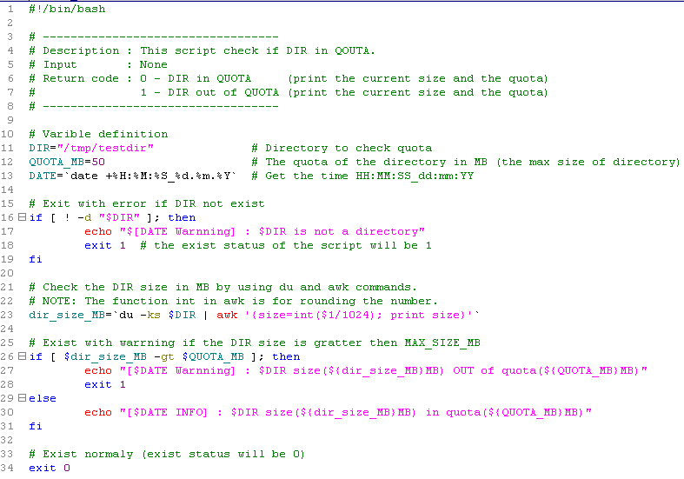
psMonitor.sh
- The psMonitor.sh script gets a file name as an argument, This file contains list of processes.
- The script should verify for each process (in the file) if its currently running on the system.
- If the script found that a process is not running it will restart it (in the background).
- Example for a file(~/psMonitor.conf) which contains the processes to monitor:
/home/xiv/systemStatus.sh:/home/xiv/systemStatus.log
/home/xiv/checkDirSize.sh /home/xiv 100:/home/xiv/checkDirSize.log

Explanation: <Command to monitor>:<The log file of the command>

To implement this script do the following steps:
- Create a script (psMonitor.sh) which get file name as an argument ($1).
The script should validate that it got only one argument ($#), if not exit with appropriate usage.
Also the script should validate that the file name is exist (-f <file>), if not it should exit with error.
Note: Create the same input file name above, so the psMonitor will work on the two daemons that you
already developed.

- The script should read the file line by line (Tip: Uses while with read command).
For each line the script should print the line number, command and log file.
For example, for the first line in the psMonitor.conf the script should print :
1) Command (/home/xiv/systemStatus.sh)
Log (/home/xiv/systemStatus.log)

TIP : You should split each line(awk –F:) to get the command and the log file in separated variables.

- Check if the command is running in the system (TIP: ps -eHf|grep $command....)
If process is running then get his PID (awk it) and print the following:
1) Command (/home/xiv/systemStatus.ssh)
Log (/home/xiv/systemStatus.log)
-> IS already running [PID=1235]

If process is NOT running then print the following:
1) Command (/home/xiv/systemStatus.sh)
Log (/home/xiv/systemStatus.log)
-> IS NOT running, restart it...

- After printing “IS NOT running, restart it” the script should run the command in background (&) and redirect its stdout \ stderr to its log file(>log 2>&1)
Tip : in order to run a command as a value in variable(e.g var=”ls”) just do $var.

- Bonus -> Help the script to ignore comments or empty lines from the ps2monitor.
Tip: use egrep to see if the line is a comment or empty.

Chapter 6 (useful commands)
find
- What does the following command do :
#> find /tmp -name core -type f -print | xargs /bin/rm –f

Tip: notice that the following command do the same think :
#> find /tmp -name core -type –exec /bin/rm –f {} \;

- Find and print all the files which bigger then 20MB (Tip -size)
Tip: RTFM on flag –size.

- find all the files which their permission is 664
Tip: RTFM flag –perm.

file
- How many shell scripts there are in the directory /bin/* ?
Tip : Try to run the command file on a script and see the output.

s\diff
- copy the file /etc/init.d/crond to /tmp and make some changes inside the /tmp/crond.
Try to identify the changes between /etc/init.d/crond and /tmp/crond.(use diff and sdiff)
check also what it the exist code of the diff command.

- Just do diff between to identical files, what s the exit code will be?

- There is another way to compare between files?(man cksum <filename>)
screen
- Try to do the example in the lecture.

script
- When you are going to use this command?

- Try to use it and then see the file it generates.
#> script -f /tmp/logMyShell.log
#> pwd
#> ls –l
ctrl-D
#> cat /tmp/logMyShell.log

alias
- Explain and try to run the following aliases:
#> alias ll=’ls -l’
#> alias stopme=’kill -9’

Bonus exercising:

- We learned about 3 types of redirection (<, >, >>), But there is another redirection (<<).
Try to find how to use it for creating a file. (Tip: cat <<END >file)

- Cut out only the ip address from the output of the command “ifconfig eth4” (Do it with one line).

- One sed command to print only second and the third characters.(Tip : regex grouping)

- Write a script (with the name bonus.sh) that do the following tasks:
- The script should print how many environment variables exits. (Tip: use env command)
- The script check if there is environment variable with the name AGE , if so it should print its content.
If AGE is not exist, the script should print “there is no AGE variable found”.

Tip: Before you run the script, define a regular variable AGE with the command “AGE=50”.
Try also to define it as a environmental variable with the command “export AGE=50”

- Write a “for” statement that will print which ips ,in your network, are available(not answer to ping) and which are occupied.

- Write a script that will execute any given command on all the servers that listed in /etc/hosts.
Note : the script will get the command as an argument.

- Observe the startup script of the crontab which locate in /etc/init.d/crond.
Understand how it’s work, what are the arguments, functions, sourcing files?



