
Akron/Canton Chapter

Joint Meeting with Society of Plastics Engineers

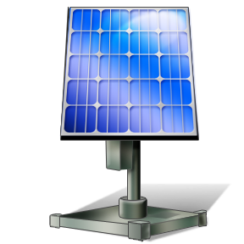
Flexible Electronics

Monday, April 16, 2012
Martin University Center
105 Fir Hill

Speaker: Dr. Xiong Gong
Assistant Professor of Polymer Engineering
The University of Akron, Department of Polymer Engineering

IEEE Members and 1 Guest - $20 each
Students - $5
Non-members $25

5:00 Cash Bar
6:00 Dinner (Buffet)
7:00 Program

Semiconducting polymer optoelectronic and electronic devices have evolved as promising cost-effective alternatives to silicon-based devices. Dr. Gong will speak on developments in the area of polymer solar cells and polymer phototdectors.


Contact Rick Buchanan @ (330) 497-8250 or R.Buchanan@ieee.org for reservations by Friday, April 13, 2012.

