**IEEE**

**Summer Social**

**Saturday, August 9, 2014**

**7:30 pm**

**Tickets @ $25 each for IEEE members and 1 guest, $10 for students.**

**Dinner (optional) at The Wooster Inn prior to the show @ $20 per person**

**Contact Rick Buchanan at (330) 497-8250 or** [r.buchanan@ieee.org](mailto:r.buchanan@ieee.org) **for reservations PRIOR TO JUNE 27**

**.**

**WE ARE ASKING THAT YOU PRE-PAY FOR THESE TICKETS**

[](http://ohiolightopera.org/index.php)

**OLO Premiere**  
*OH, LADY! LADY!!*   
**(1918)  
Music by Jerome Kern  
Lyrics by P. G. Wodehouse  
Book by Guy Bolton and P. G. Wodehouse**

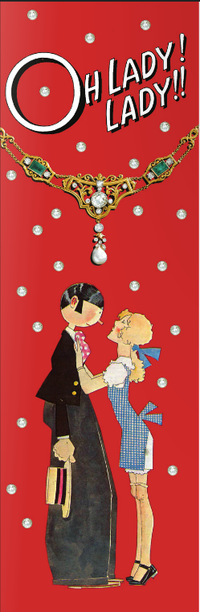Between 1915 and 1924, composer Jerome Kern teamed with librettists/lyricists Guy Bolton and famed British author/humorist P. G. Wodehouse on a series of intimate musical comedies - the so-called Princess shows (four of the shows opened at Broadway's 299-seat Princess Theatre). They featured not the exotic locales and the dukes and duchesses of operetta, nor the lavish spectacle of the *Ziegfeld Follies*, but rather the romantic and comic entanglements of everyday Americans, in current dress and modern dialogue. These shows forever changed the landscape of Broadway; Richard Rodgers, Cole Porter, George Gershwin, and numerous others credited these musicals with inspiring their own development and quest for a theatrical style. Among American songwriters, Kern was the supreme melodist - no more convincingly showcased than in his 1918 Princess musical *Oh, Lady! Lady!!* The story focuses on wedding plans of Mollie Farrington and Willoughby "Bill" Finch, which are temporarily derailed by the objections of Mollie's mother, the arrival of Bill's old flame May, and the heist of the Farrington family jewels by the ex-girlfriend of Bill's valet Spike. Wodehouse was at his wittiest and most playful, introducing characters named May Ann Ayes, Lettice Romayne, and Cassie Roll. And Kern's score bristles from beginning to end with catchy, sentimental tunes, including the song "Bill," which was eventually dropped from the score, but resurfaced a decade later in *Show Boat*.