**IEEE**

***Institute of Electrical and Electronic Engineers***

***Akron/Canton Section***

**Tour of the SGB USA/OTC Services**

**Transformer Repair Plant in Louisville, OH**

**Monday, February 16, 2015**

[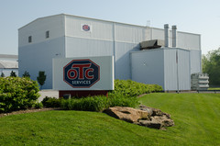](http://www.sgb-smit.com/uploads/pics/IMG_5121_01.JPG)

In conjunction with the transformer tutorials given on Saturday, February 14 a tour of the SGB repair plant for power transformers will be offered.

1 CPD hour will also be available.

**Location**: OTC Services Inc., 1776 Constitution Ave., Louisville, OH

**Time**: 6:00 pm

Dinner afterwards at Grinders in Louisville.

Please contact Rick Buchanan at (330) 497-8250 or [r.buchanan@ieee.org](mailto:r.buchanan@ieee.org) for reservations no later than Friday, February 13.