SHARDA UNIVERSITY
INVENTION DISCLOSURE FORM
CONFIDENTIAL
Please fill in the details with complete information.
IMPORTANT
Please note that patent is always about a solution to an existing technical/industrial problem. As such, draft patent document (IDF) should be crafted in a manner so as to distinctly highlight the existing technical problem, the technical advancement proposed by the inventor(s), and the manner in which the proposed advancement solves the existing technical problem.
➢ Particulars of Inventors
S No | Name (Full) | Department/ School | Designation | Mobile No. | Email | Official Address
1 | Muhammad Shayaan Ali | Department of Computer Science and Engineering | Student | 9136182311 | 2023433557.muhammad@ug.sharda.ac.in | Student, Greater Noida, Sharda University
2 | Shruti Tyagi | Department of Computer Science and Engineering | Student | 8826043366 | 2023566902.shruti@ug.sharda.ac.in | Student, Greater Noida, Sharda University
3 | Riddhima Sharma | Department of Computer Science and Engineering | Student | 8860850003 | 2023567320.riddhima@ug.sharda.ac.in | Student, Greater Noida, Sharda University
4 | Ashish Kumar | Department of Computer Science and Engineering | Assistant Professor | 8410707739 | ashish.kumar4747@gmail.com | Assistant Professor, Greater Noida, Sharda University
Intelligent DevOps Monitoring & Incident Response System
Abstract:
The present invention proposes an Intelligent DevOps Monitoring and Incident Response System for continuously monitoring software infrastructure, identifying abnormal system behaviour, analyzing operational incidents, and safely automating the response to them. The system collects infrastructure, container and application metrics using Prometheus. Abnormal behaviour is detected by two complementary detectors: configured rule-based alert conditions for known failure patterns, and a machine-learning anomaly detector (for example, Isolation Forest combined with rolling statistical scoring) for deviations that no predefined rule covers. Both detectors emit events in a single, common incident format, and each event of interest is transmitted through a WebSocket-based real-time communication layer to an intelligent analysis component.
Before analysis, a context builder automatically collects the related metrics of every service in the dependency chain of the affected service over a time window around the event, so that the analysis can separate the root-cause service from services that only show symptoms. The intelligent analysis component uses a Large Language Model (LLM) to interpret the incident and its context, identify the probable incident type, determine the likely root-cause service, and produce a structured, schema-validated response plan. The LLM never executes actions directly.
A policy validator placed between the LLM and the action executor checks every proposed action against an action allowlist, a known-target list, a confidence threshold, cooldown rules and approval requirements before it runs; risky or low-confidence actions are routed to a human operator for approval. After execution, a verifier re-evaluates the triggering conditions; if the incident is unresolved, it is re-analyzed together with the record of actions already attempted, up to a configured maximum number of attempts, after which it is escalated to a human operator. When the LLM is unavailable, times out, returns invalid output or reports low confidence, deterministic runbooks provide a fallback response.
The proposed system integrates metrics-based monitoring with statistical anomaly detection, dependency-aware incident analysis and safety-validated automated response, thereby reducing the dependency on continuous manual analysis of alerts. It provides a continuous monitoring-to-response pipeline consisting of data collection, anomaly/alert detection, incident correlation and context building, real-time event transmission, intelligent incident analysis, policy validation, response execution and verification, thereby improving the efficiency and safety of DevOps operations compared with conventional monitoring systems that primarily generate alerts without intelligent contextual analysis.
Field of Invention:
The present invention relates to the fields of DevOps, cloud infrastructure monitoring, software system observability, artificial intelligence, machine learning, and automated incident management.
More particularly, the invention relates to an intelligent monitoring and incident-response mechanism that combines Prometheus-based metric collection, rule-based and machine-learning-based anomaly detection, dependency-aware context building across multiple services, real-time WebSocket-based event communication, Large Language Model-based root-cause analysis, a policy-based safety validation layer between the analysis engine and the action executor, and a verification and bounded re-analysis loop for detecting and handling operational issues in software and computing infrastructure.
Description of Prior Art:
1) Conventional DevOps Monitoring Systems
Traditional DevOps monitoring systems continuously collect infrastructure and application metrics such as CPU utilization, memory consumption, network activity, service availability, request rates, and error rates. Monitoring platforms can generate alerts when predefined thresholds or conditions are violated. However, conventional monitoring systems primarily provide observability and alert generation rather than complete intelligent incident understanding and resolution. When an alert is generated, DevOps engineers may need to manually inspect multiple metrics, dashboards, logs, and system components to determine the underlying cause of the incident, which increases the time required to identify and resolve operational problems.
2) Rule-Based Alerting Systems
Existing monitoring solutions commonly use threshold-based or rule-based alerting — for example, CPU utilization exceeding a predefined threshold, memory usage exceeding a predefined threshold, service availability falling below a defined level, error rate exceeding a specified limit, or response latency exceeding a specified value. Although such rules are effective for detecting known conditions, they may not provide sufficient contextual interpretation of complex incidents involving multiple simultaneously changing metrics. A single alert may also be related to several underlying system conditions, making manual correlation necessary.
3) Conventional Incident Response
After an alert is generated, incident handling frequently requires a human operator to receive the alert, inspect monitoring information and logs, examine related system behaviour, identify the probable cause, determine an appropriate remediation, execute the remediation, and verify whether the incident has been resolved. This creates a gap between incident detection and incident resolution — the monitoring system can identify that something is wrong, but the subsequent reasoning and response remain dependent on human intervention.
4) Limitations of Existing Systems
The existing approaches can suffer from one or more of the following limitations:
- Excessive number of alerts requiring manual investigation.
- Difficulty correlating multiple monitoring indicators and log events.
- Limited contextual interpretation of alerts.
- Separation between monitoring, log analysis, and incident-response mechanisms.
- Dependence on predefined rules for known failure conditions, with limited ability to flag previously unseen anomalies.
- Increased time between alert generation and diagnosis.
- Increased human involvement in repetitive incident analysis.
- Difficulty converting raw monitoring data into an actionable response.
- Lack of an integrated pipeline connecting monitoring, anomaly detection, root-cause analysis, and response execution.
- Threshold rules cannot detect gradual or multi-metric deviations (for example, a slow memory rise) before a hard limit is reached.
- In multi-service systems, the alerting service is often only a downstream symptom, not the root cause.
- Applying LLM output directly to infrastructure is unsafe without validation, because LLMs can produce incorrect or hallucinated actions.
5) Gap and Motivation Identified
Based on the above limitations, there is a need for a system capable of connecting continuous monitoring, statistical anomaly detection, dependency-aware incident correlation, real-time event processing, intelligent incident analysis, and incident response within a unified workflow. The identified gap is not merely the absence of monitoring data — modern monitoring systems can already collect large quantities of operational metrics and logs. The major gap is the ability to transform such information into context-aware incident understanding and actionable, auditable response, while keeping a human operator in the loop for sensitive remediation actions. The proposed invention addresses this gap by introducing an intelligent processing layer between monitoring and incident response.
In particular, there is a need to use LLM reasoning for incident response while guaranteeing that no unvalidated action reaches the infrastructure, and that remediation attempts are bounded and verified.
6) Existing AI-assisted Operations Tools
Recent tools such as k8sgpt, HolmesGPT and Datadog Bits AI apply LLMs to diagnose infrastructure problems. These tools mainly explain or summarize issues, and either leave remediation to the engineer or carry out actions without a separate, deterministic safety layer. They also do not combine rule-based and ML-based detection into a common incident format with runbook fallback, or bound re-analysis using the history of attempted actions. Statistical anomaly detection methods (e.g., Isolation Forest, Liu et al., ICDM 2008) and graph-based root-cause methods (e.g., MicroRCA, Wu et al., NOMS 2020) detect or localize faults, but do not generate and safely execute a verified remediation.
Summary of the Invention and Technical Advancement:
The invention provides the following technical advancements over existing systems:
1. Dependency-aware context builder. When an event is received, the system automatically collects the metrics, container states, restart counts and recent actions of all services in the dependency chain of the affected service over a time window around the event, together with the service topology. This lets the analysis engine tell the root-cause service apart from services that only show the symptom.
2. Policy-based safety validator between the LLM and the executor. The LLM outputs a structured response plan that is validated against a schema. An action is executed only if it is on an action allowlist, its target is a known service, its confidence is at or above a configured threshold, it does not violate a cooldown period, and the per-incident action limit has not been reached. Otherwise it is routed for human approval or escalated. The LLM never executes commands directly.
3. History-aware, bounded re-analysis loop. If verification shows the incident is unresolved, the incident is re-analyzed with the attempt number and the list of previously attempted actions and their outcomes, so a failed action is not repeated. After a maximum number of attempts (e.g., 3), the incident is escalated to a human.
4. Dual detection with a unified incident format and deterministic fallback. Rule-based alerts and ML-detected anomalies are converted into one common incident event. Deterministic runbooks provide a fallback response, which keeps the system working when the LLM fails, and also serve as a non-LLM baseline for comparison.
Disclose working of invention along with drawing, schematics and flow diagrams with explanation:
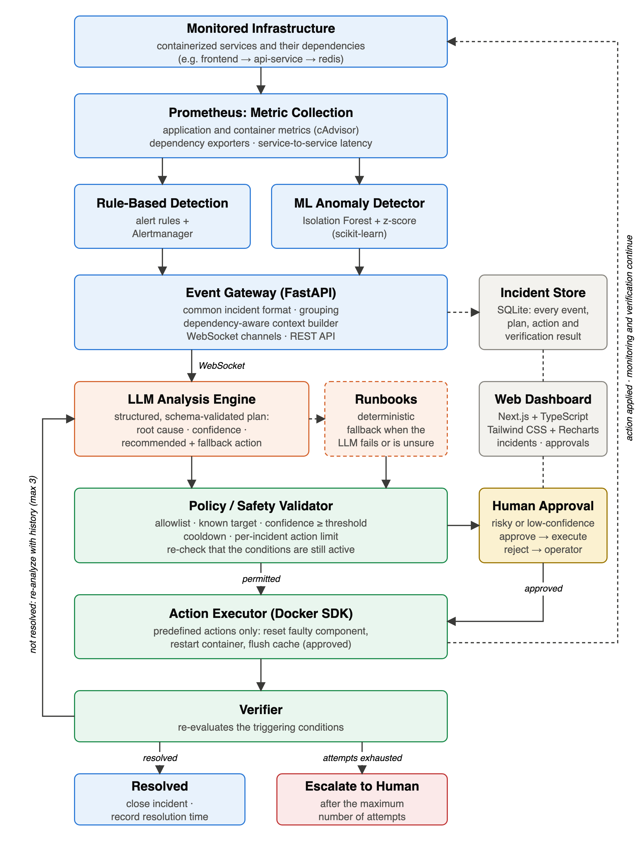
Fig 1. Proposed Intelligent DevOps Monitoring and Incident Response – System Architecture
The proposed system is divided into:
1. Client Layer
- Users access the platform through a monitoring and incident-response dashboard built using Next.js and TypeScript.
- The dashboard, styled using Tailwind CSS and visualized using Recharts, displays a service map with live metrics, active and past incidents with their root-cause analysis, the response plans and executed actions, the queue of actions awaiting human approval, and the health of every component of the pipeline.
2. Gateway and API Layer
- Monitoring events and dashboard requests are handled by an event gateway built using FastAPI (Python).
- The gateway receives rule-based alerts and ML anomalies, converts them into a common incident format, groups related events into a single incident, builds the incident context, transmits incidents and response plans over WebSocket channels, records every event, plan and action in the incident store, and exposes REST endpoints for the dashboard.
3. Core Monitoring, Detection and Analysis Services
- Prometheus: Continuously collects infrastructure and application metrics such as CPU, memory, service availability, request rate, error rate and response latency; container-level metrics through a container metrics exporter (cAdvisor); dependency metrics through exporters (e.g., for a Redis cache); and the latency of each call from one service to the next.
- Rule-Based Detection: Alert rules evaluated by Prometheus and routed by Alertmanager detect known failure conditions, such as high CPU or memory usage, high latency, a high error rate, or a service or dependency being down, and deliver them to the gateway.
- Anomaly Detection Engine: A Python and Scikit-learn based module analyzes per-service features at fixed intervals with a model trained on normal behaviour, to identify deviations that no threshold rule covers, such as a gradual rise in memory usage.
- Context Builder: For each incident, collects the last several minutes of key metrics of every service in the dependency chain, together with container state, restart counts, the service topology and the actions already attempted.
- Real-Time WebSocket Channels: Transmit incidents to the analysis component, and response plans and action outcomes to the response system and the dashboard, with minimal delay.
- LLM Analysis Engine: Receives the incident and its context and performs incident identification, correlation, probable root-cause analysis and generation of a structured response plan. In the implemented prototype the LLM runs locally (an 8-billion-parameter model served by Ollama). Deterministic YAML runbooks provide the plan when the LLM fails or is not confident.
- Response System: A responder service consisting of a policy validator, an action executor using the Docker SDK, and a verifier. Only predefined actions, such as resetting a faulty component or restarting a container, are executed automatically; actions such as flushing a cache require human approval, and arbitrary commands are never executed.
4. Data Layer
- A relational incident store (SQLite in the prototype; PostgreSQL may be used at larger scale) records every incident, alert, response plan, executed action and verification result, and maintains an auditable history of the monitoring-to-resolution pipeline.
5. Infrastructure
- Docker and Docker Compose are used to run the complete system consistently across environments.
- A dockerized testing environment, seeded with intentionally faulty services, a fault injector that records the ground truth of every injected fault, and a load generator (Locust), is used to safely reproduce DevOps failure scenarios and validate the detection and remediation pipeline.
- Git and GitHub are used for source control and collaborative development.
6. Overall Working
Step 1 – Monitoring Data Collection. Prometheus continuously collects application, container and dependency metrics from the monitored infrastructure, including the latency of each call from one service to the next.
Step 2 – Detection (Rule-based and ML-based). Configured threshold rules evaluate the incoming metrics and raise alerts for known failure conditions. In parallel, the machine-learning anomaly detector polls per-service features (CPU usage, memory usage ratio, 95th-percentile latency, error rate, request rate and upstream call latency) at fixed intervals and scores them with a model trained on normal behaviour. It raises an event only when the anomaly persists for at least two consecutive evaluation windows. Each event carries the event source (rule or ML), the anomaly score where applicable, the top contributing features and an incident identifier.
Step 3 – Event Correlation and Context Building. Events that arrive within a time window and share a dependency chain are grouped into one incident. After the first event, the gateway waits for a short settle interval so that events from the root-cause service and from dependent services showing symptoms are analyzed together. The context builder then attaches the service topology, the last N minutes of key metrics for every service in the chain, container state and restart counts, recent actions and the history of attempts. Ground-truth or fault-labelling signals, where present, are excluded from the analysis context.
Step 4 – Real-Time Event Transmission. The incident is transmitted through the WebSocket channel to the LLM Analysis Engine. Separate channels are used for incident events and for response plans and action outcomes.
Step 5 – Intelligent Incident Analysis. The prompt includes the service topology and the list of allowed actions. The LLM produces a structured response plan (root-cause service, incident type, severity, probable cause, evidence, confidence score, recommended action, fallback action and explanation), which is validated against a schema. If the LLM times out, is unreachable, returns output that fails validation or reports a confidence below the threshold, deterministic runbooks produce the response plan instead. Safeguards against incorrect or fabricated LLM output include: a constrained action vocabulary supplied in the prompt; strict schema validation of the output; rejection of unknown services or actions; a confidence threshold; required evidence fields that cite metrics from the supplied context; deterministic runbook fallback; and human approval for risky actions.
Step 6 – Decision (Policy Validation). A proposed action is executed automatically only if: (a) the response plan passes schema validation; (b) the action type is on the allowlist of predefined actions; (c) the target is a known service; (d) the confidence is a number between 0 and 1 at or above the threshold (e.g., 0.7); (e) the same action on the same target has not been taken within the cooldown period (e.g., 5 minutes); (f) the per-incident action limit (e.g., 3) has not been reached; and (g) the action is not classed as risky. Risky actions, such as flushing a cache or changing resource limits, and low-confidence plans are routed to a human operator for approval through the dashboard. If the recommended action is rejected, the plan's fallback action is validated in its place; if neither passes, the incident is escalated. The policy validator treats every response plan as untrusted input, regardless of its source.
Step 7 – Response Execution. Immediately before execution, the triggering conditions are checked again, and the action is withheld if they have already cleared. The executor carries out only predefined actions from the allowlist (for example, resetting a faulty component or restarting a container) and checks the allowlist again itself. Arbitrary shell commands are never executed.
Step 8 – Verification and Re-analysis. After a settling period (30–60 seconds), the verifier re-evaluates the conditions that fired for the root-cause service and the services that depend on it. If the incident is resolved, it is closed and its time to resolution is recorded. If it is not resolved, the incident is re-analyzed with the attempt number increased by one and the list of previous actions and their outcomes, so a failed action is not repeated. Only one action per incident is in progress at a time, and a plan produced for an earlier attempt is discarded. After the maximum number of attempts (e.g., 3), the incident is escalated to a human operator.
Step 9 – Continuous Monitoring. Prometheus continues monitoring the infrastructure, and every event, plan, action and verification result is recorded in the incident store and shown on the dashboard. The complete pipeline is: Prometheus → Rules + ML Detector → Gateway / Context Builder → WebSocket → LLM Analysis (with runbook fallback) → Policy Validator → Executor → Verifier.
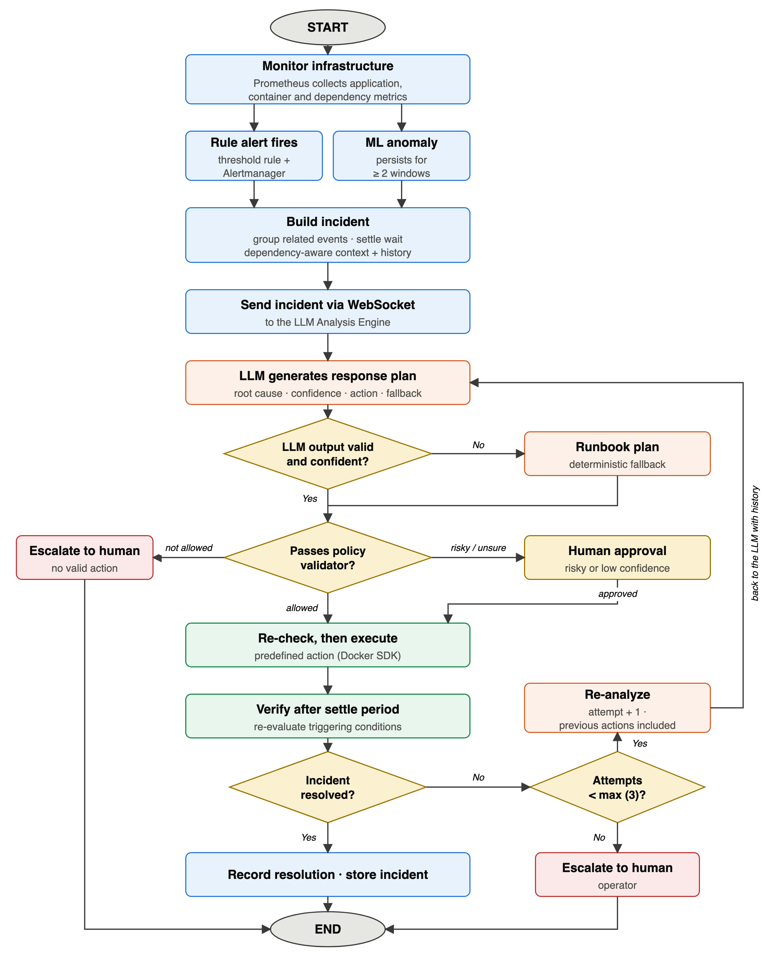
Fig 2. Sequential Workflow of Intelligent DevOps Monitoring and Incident Response
How it works:
The workflow begins with continuous monitoring of the DevOps infrastructure by Prometheus, which collects application, container and dependency metrics. Abnormal behaviour is detected either by a rule-based alert or by the Scikit-learn based anomaly detection model, and both produce an event in the same format. The gateway groups related events into one incident and builds its context from every service in the dependency chain, and the incident is transmitted through the WebSocket-based real-time communication layer to the LLM Analysis Engine. The LLM analyzes the context and produces a structured response plan; if the LLM fails or is not confident, a deterministic runbook produces the plan instead. The policy validator then checks the proposed action against the allowlist, the known targets, the confidence threshold, the cooldown and the per-incident action limit; risky or low-confidence actions go to a human operator for approval through the dashboard. Approved actions are executed by the Docker-SDK-based executor, and the verifier checks whether the incident has been resolved. If it has not, the incident is re-analyzed together with the actions already attempted, up to a maximum number of attempts, after which it is escalated to a human operator. All incidents, response plans, executed actions and verification results are recorded in the incident store and displayed on the dashboard.
GENERAL UTILITY / APPLICATIONS / ADVANTAGES OF THE INVENTION:
1. General Utility
The invention provides an intelligent mechanism for continuously monitoring software and computing infrastructure and for responding to the operational incidents that arise within it. Its primary utility is to bridge the gap between monitoring/alert generation and incident resolution by combining metric collection, statistical anomaly detection, dependency-aware context building and LLM-based reasoning with a policy-validated, auditable remediation engine. The system can be used by DevOps and Site Reliability Engineering (SRE) teams to reduce alert fatigue, accelerate root-cause identification, and support faster, safer and more consistent incident response than conventional monitoring systems.
2. Applications
- Cloud Infrastructure: Monitoring and responding to incidents occurring in cloud-hosted computing environments.
- DevOps and CI/CD Infrastructure: Monitoring deployment environments, build systems, services, and application infrastructure.
- Containerized Environments: Monitoring container-based applications and infrastructure, including Docker-orchestrated services.
- Microservice Architectures: Identifying and analyzing operational issues affecting distributed services, including faults that propagate across dependent services so that the alerting service differs from the root-cause service.
- Web Applications: Monitoring application availability, performance, errors, and service behaviour.
- Enterprise IT Infrastructure: Supporting monitoring and incident response for enterprise servers, applications, and services.
- Production Systems: Assisting operational teams in detecting and responding to production incidents.
3) Advantages of Invention
- Continuous monitoring of infrastructure, container and application metrics.
- Statistical anomaly detection that complements conventional threshold-based alerting, detecting unknown or gradual anomalies before hard thresholds are crossed.
- Real-time event transmission between monitoring infrastructure and the intelligent analysis system.
- Identification of the root-cause service, not only the service showing the symptom, using dependency-aware context.
- Intelligent, context-aware interpretation of alerts instead of relying exclusively on raw monitoring information.
- No unvalidated LLM output reaches the infrastructure: actions pass an allowlist, schema validation, a confidence threshold, a cooldown and, for risky actions, human approval.
- Automated or human-approved response for identified incidents.
- Bounded remediation with no infinite loops: a maximum number of attempts, then escalation.
- Continued operation when the LLM is unavailable, through deterministic runbook fallback.
- Reduced manual investigation effort for repetitive operational incidents.
- Faster transition from detection to response by integrating monitoring, analysis, and remediation.
- Scalable, containerized architecture in which monitoring, analysis, and response components can be independently expanded.
- Human-in-the-loop capability, allowing sensitive remediation actions to require operator approval.
- Continuous feedback, where post-response verification determines whether the incident has been resolved.
- An auditable record of each incident's evidence, reasoning, action and verification result.
Implementation Status:
A working prototype has been built and tested end-to-end on Docker Compose with a three-service application (a frontend service, an API service and a Redis cache). It implements rule-based detection with Prometheus and Alertmanager, an event gateway with dependency-aware context building and WebSocket channels, an LLM analysis engine (a locally hosted 8-billion-parameter model) with deterministic runbook fallback, the policy validator, the action executor, the verifier with bounded re-analysis and escalation, an incident store, and a web dashboard built with Next.js, TypeScript, Tailwind CSS and Recharts. A fault injector reproduces failure scenarios and records their ground truth. The machine-learning anomaly detector is under development.
In preliminary tests on injected faults, every logged fault was detected, in 18–35 seconds; in a pilot of eight runs with the complete loop, every fault was remediated and verified automatically; and an adversarial test of 29 malformed, hallucinated or malicious response plans resulted in no unsafe action being executed. These results are preliminary; the full evaluation across all failure scenarios is planned, and its results will be reported when complete.
Claims:
1. A system for intelligent monitoring and incident response, comprising:
a metrics collection module configured to collect metrics of a plurality of services;
one or more detectors, including a rule-based detector, each configured to emit events in a common incident format;
an event gateway comprising a context builder configured to, on receipt of an event concerning a first service, retrieve metrics of the first service and of every service in its dependency chain over a time window associated with the event;
a real-time communication layer;
an analysis engine based on a large language model (LLM), configured to output a structured response plan comprising a root-cause service, a confidence score and a recommended action;
a policy validator, interposed between the analysis engine and an action executor, configured to permit execution only of actions satisfying an allowlist of action types, a known-target constraint, a confidence threshold and a cooldown constraint; and
a verifier configured to re-evaluate the triggering conditions after an action is executed.
2. The system of claim 1, wherein the one or more detectors further comprise a machine-learning anomaly detector configured to score per-service metrics with a model trained on normal behaviour, and wherein events from the rule-based detector and the machine-learning anomaly detector are converted into the common incident format.
3. The system of claim 1, wherein, when the verifier determines that the incident is unresolved, the incident is resubmitted to the analysis engine together with an attempt count and a record of previously attempted actions, and the incident is escalated to a human operator when the attempt count reaches a configured maximum.
4. The system of claim 1, further comprising deterministic runbooks applied when the analysis engine times out, is unreachable, returns output that fails schema validation, or returns a confidence below the threshold.
5. The system of claim 1, wherein actions classed as risky, and response plans whose confidence is below the threshold, are routed to a human approval interface instead of being executed automatically.
6. The system of claim 1, wherein fault-labelling or ground-truth signals are excluded from the context supplied to the analysis engine and to any detector.
7. The system of claim 2, wherein the machine-learning anomaly detector emits an event only after an anomaly persists for a configured number of consecutive evaluation windows, and the event includes an anomaly score and top contributing features.
8. The system of claim 1, wherein, immediately before executing a validated action, the triggering conditions are re-evaluated and the action is withheld if they are no longer active, so that an action is not applied to a service that has already recovered.
9. The system of claim 3, wherein at most one action per incident is in progress (executing, being verified or awaiting approval), and a response plan whose attempt number is lower than the incident's current attempt is discarded, so that a plan produced from an outdated view of the incident cannot trigger an action.
10. The system of claim 1, wherein the response plan further comprises a fallback action; when the recommended action is rejected by the allowlist, known-target or cooldown constraint, the fallback action is validated in its place, and when neither passes the incident is escalated.
11. The system of claim 1, wherein the policy validator operates independently of any validation of the analysis engine's output, treating every response plan as untrusted: non-finite or non-numeric confidence values, malformed action fields and malformed attempt identifiers are rejected, and the action executor independently re-checks the allowlist before executing.
12. The system of claim 1, wherein the event gateway, on receiving a first event, waits for a configured settle interval before forwarding the incident for analysis, so that events from the root-cause service and from dependent services showing symptoms are analyzed together as one incident.
13. The system of claim 1, wherein every event, response plan and action outcome is recorded in an incident store, from which detection time, root-cause accuracy, action correctness and time to resolution are computed against injected-fault ground truth.
14. A method for intelligent monitoring and incident response, comprising:
(a) collecting metrics of a plurality of services;
(b) detecting abnormal behaviour with one or more detectors, including a rule-based detector, and emitting an event in a common incident format;
(c) on receipt of an event concerning a first service, building a context comprising metrics of the first service and of every service in its dependency chain over a time window associated with the event;
(d) generating, with an LLM-based analysis engine, a structured response plan comprising a root-cause service, a confidence score and a recommended action;
(e) validating the recommended action, by a policy validator separate from the analysis engine, against an allowlist of action types, a known-target constraint, a confidence threshold and a cooldown constraint;
(f) executing the action only if it passes step (e);
(g) re-evaluating the triggering conditions after execution; and
(h) when the incident is unresolved, repeating steps (d) to (g) with an attempt count and a record of previously attempted actions, and escalating the incident to a human operator when the attempt count reaches a configured maximum.
15. The method of claim 14, wherein step (b) further comprises detecting abnormal behaviour with a machine-learning anomaly detector, and step (d) is performed by deterministic runbooks when the analysis engine fails, returns invalid output or returns a confidence below the threshold.
Disclaimer:
The undersigned inventor(s) hereby declare that all statements, descriptions, and representations made in this Invention Disclosure Form are true, complete, and made to the best of their knowledge and belief. The inventor(s) shall bear sole responsibility and liability for the accuracy, validity, and authenticity of the information and data provided herein. The Research and Development Cell (RDC), the Institution, and any associated patent attorney, agent, or representative shall not be held liable or accountable for any inaccuracies, omissions, misrepresentations, or consequences arising from the information furnished by the inventor(s).
Signature of Inventor(s):
Signature: ______________________________
Name: Muhammad Shayaan Ali
Date: ____________________

Signature: ______________________________
Name: Shruti Tyagi
Date: ____________________

Signature: ______________________________
Name: Riddhima Sharma
Date: ____________________

Signature: ______________________________
Name: Ashish Kumar
Date: ____________________

