SHARDA UNIVERSITY
INVENTION DISCLOSURE FORM
CONFIDENTIAL
Please fill in the details with complete information.
IMPORTANT
Please note that patent is always about a solution to an existing technical/industrial problem. As such, draft patent document (IDF) should be crafted in a manner so as to distinctly highlight the existing technical problem, the technical advancement proposed by the inventor(s), and the manner in which the proposed advancement solves the existing technical problem.
➢ Particulars of Inventors
S No | Name (Full) | Department/ School | Designation | Mobile No. | Email | Official Address
1 | Muhammad Shayaan Ali | Department of Computer Science and Engineering | Student | 9136182311 | 2023433557.muhammad@ug.sharda.ac.in | Student, Greater Noida, Sharda University
2 | Shruti Tyagi | Department of Computer Science and Engineering | Student | 8826043366 | 2023566902.shruti@ug.sharda.ac.in | Student, Greater Noida, Sharda University
3 | Riddhima Sharma | Department of Computer Science and Engineering | Student | 8860850003 | 2023567320.riddhima@ug.sharda.ac.in | Student, Greater Noida, Sharda University
4 | Ashish Kumar | Department of Computer Science and Engineering | Assistant Professor | 8410707739 | ashish.kumar4747@gmail.com | Assistant Professor, Greater Noida, Sharda University

Intelligent DevOps Monitoring & Incident Response System
Abstract: The present invention proposes an Intelligent DevOps Monitoring and Incident Response System for continuously monitoring software infrastructure, identifying abnormal system behaviour, analyzing operational incidents, and assisting in automated incident response. The system collects infrastructure and application metrics using Prometheus and visualizes them through Grafana dashboards, while application and system logs are aggregated using Loki and Promtail. The collected metrics and logs are continuously evaluated using configured threshold rules together with a machine-learning-based anomaly detection module, and any monitoring event of interest is transmitted through a WebSocket-based real-time communication layer to an intelligent analysis component.
The intelligent analysis component utilizes a Large Language Model (LLM) to interpret the monitoring event and associated operational context, identify the probable incident, determine its likely root cause, and generate an appropriate remediation recommendation. The generated response is passed to a response/remediation engine, implemented using containerized worker processes, which can execute or propose predefined remediation actions according to the identified incident and configured operational policies.
Before analysis, a context builder automatically collects the related metrics of every service in the dependency chain of the affected service over a time window around the event, so that the analysis can separate the root-cause service from services that only show symptoms. The LLM produces a structured, schema-validated response plan and never executes actions directly. A policy validator placed between the LLM and the executor checks every proposed action against an action allowlist, a known-target list, a confidence threshold, cooldown rules and approval requirements before it runs. After execution, a verifier re-evaluates the triggering conditions; if the incident is unresolved, it is re-analyzed together with the record of actions already attempted, up to a configured maximum number of attempts, after which it is escalated to a human operator. When the LLM is unavailable, times out, returns invalid output or reports low confidence, deterministic runbooks provide a fallback response.
The proposed system integrates conventional metrics-based monitoring with statistical anomaly detection, intelligent event interpretation, and automated response generation, thereby reducing the dependency on continuous manual analysis of alerts. The system is designed to provide a continuous monitoring-to-response pipeline consisting of data collection, anomaly/alert detection, real-time event transmission, intelligent incident analysis, response generation, and incident resolution, thereby improving the efficiency of DevOps operations compared with conventional monitoring systems that primarily generate alerts without intelligent contextual analysis.
Field of Invention:
The present invention relates to the fields of DevOps, cloud infrastructure monitoring, software system observability, artificial intelligence, machine learning, and automated incident management.
More particularly, the invention relates to an intelligent monitoring and incident-response mechanism that combines Prometheus-based metric collection, Grafana-based visualization, Loki/Promtail-based log aggregation, machine-learning-based anomaly detection, real-time WebSocket-based event communication, Large Language Model-based root-cause analysis, and automated or semi-automated remediation for detecting and handling operational issues in software and computing infrastructure.
The invention further relates to dependency-aware context building across multiple services, a policy-based safety validation layer between the analysis engine and the action executor, and a verification and bounded re-analysis loop.
Description of Prior Art:
1) Conventional DevOps Monitoring Systems
Traditional DevOps monitoring systems continuously collect infrastructure and application metrics such as CPU utilization, memory consumption, network activity, service availability, request rates, and error rates. Monitoring platforms can generate alerts when predefined thresholds or conditions are violated. However, conventional monitoring systems primarily provide observability and alert generation rather than complete intelligent incident understanding and resolution. When an alert is generated, DevOps engineers may need to manually inspect multiple metrics, dashboards, logs, and system components to determine the underlying cause of the incident, which increases the time required to identify and resolve operational problems.
2) Rule-Based Alerting Systems
Existing monitoring solutions commonly use threshold-based or rule-based alerting — for example, CPU utilization exceeding a predefined threshold, memory usage exceeding a predefined threshold, service availability falling below a defined level, error rate exceeding a specified limit, or response latency exceeding a specified value. Although such rules are effective for detecting known conditions, they may not provide sufficient contextual interpretation of complex incidents involving multiple simultaneously changing metrics. A single alert may also be related to several underlying system conditions, making manual correlation necessary.
3) Conventional Incident Response
After an alert is generated, incident handling frequently requires a human operator to receive the alert, inspect monitoring information and logs, examine related system behaviour, identify the probable cause, determine an appropriate remediation, execute the remediation, and verify whether the incident has been resolved. This creates a gap between incident detection and incident resolution — the monitoring system can identify that something is wrong, but the subsequent reasoning and response remain dependent on human intervention.
4) Limitations of Existing Systems
The existing approaches can suffer from one or more of the following limitations:
- Excessive number of alerts requiring manual investigation.
- Difficulty correlating multiple monitoring indicators and log events.
- Limited contextual interpretation of alerts.
- Separation between monitoring, log analysis, and incident-response mechanisms.
- Dependence on predefined rules for known failure conditions, with limited ability to flag previously unseen anomalies.
- Increased time between alert generation and diagnosis.
- Increased human involvement in repetitive incident analysis.
- Difficulty converting raw monitoring data into an actionable response.
- Lack of an integrated pipeline connecting monitoring, anomaly detection, root-cause analysis, and response execution.
- Threshold rules cannot detect gradual or multi-metric deviations (for example, a slow memory rise) before a hard limit is reached.
- In multi-service systems, the alerting service is often only a downstream symptom, not the root cause.
- Applying LLM output directly to infrastructure is unsafe without validation, because LLMs can produce incorrect or hallucinated actions.
5) Gap and Motivation Identified
Based on the above limitations, there is a need for a system capable of connecting continuous monitoring, log aggregation, statistical anomaly detection, real-time event processing, intelligent incident analysis, and incident response within a unified workflow. The identified gap is not merely the absence of monitoring data — modern monitoring systems can already collect large quantities of operational metrics and logs. The major gap is the ability to transform such information into context-aware incident understanding and actionable, auditable response, while keeping a human operator in the loop for sensitive remediation actions. The proposed invention addresses this gap by introducing an intelligent processing layer between monitoring and incident response.
In particular, there is a need to use LLM reasoning for incident response while guaranteeing that no unvalidated action reaches the infrastructure, and that remediation attempts are bounded and verified.
6) Existing AI-assisted Operations Tools
Recent tools such as k8sgpt, HolmesGPT and Datadog Bits AI apply LLMs to diagnose infrastructure problems. These tools mainly explain or summarize issues, and either leave remediation to the engineer or carry out actions without a separate, deterministic safety layer. They also do not combine rule-based and ML-based detection into a common incident format with runbook fallback, or bound re-analysis using the history of attempted actions. Statistical anomaly detection methods (e.g., Isolation Forest, Liu et al., ICDM 2008) and graph-based root-cause methods (e.g., MicroRCA, Wu et al., NOMS 2020) detect or localize faults, but do not generate and safely execute a verified remediation.
Summary of the Invention and Technical Advancement:
The invention provides the following technical advancements over existing systems:
1. Dependency-aware context builder. When an event is received, the system automatically collects the metrics, container states, restart counts and recent actions of all services in the dependency chain of the affected service over a time window around the event, together with the service topology. This lets the analysis engine tell the root-cause service apart from services that only show the symptom.
2. Policy-based safety validator between the LLM and the executor. The LLM outputs a structured response plan that is validated against a schema. An action is executed only if it is on an action allowlist, its target is a known service, its confidence is at or above a configured threshold, it does not violate a cooldown period, and the per-incident action limit has not been reached. Otherwise it is routed for human approval or escalated. The LLM never executes commands directly.
3. History-aware, bounded re-analysis loop. If verification shows the incident is unresolved, the incident is re-analyzed with the attempt number and the list of previously attempted actions and their outcomes, so a failed action is not repeated. After a maximum number of attempts (e.g., 3), the incident is escalated to a human.
4. Dual detection with a unified incident format and deterministic fallback. Rule-based alerts and ML-detected anomalies are converted into one common incident event. Deterministic runbooks provide a fallback response, which keeps the system working when the LLM fails, and also serve as a non-LLM baseline for comparison.
Disclose working of invention along with drawing, schematics and flow diagrams with explanation:
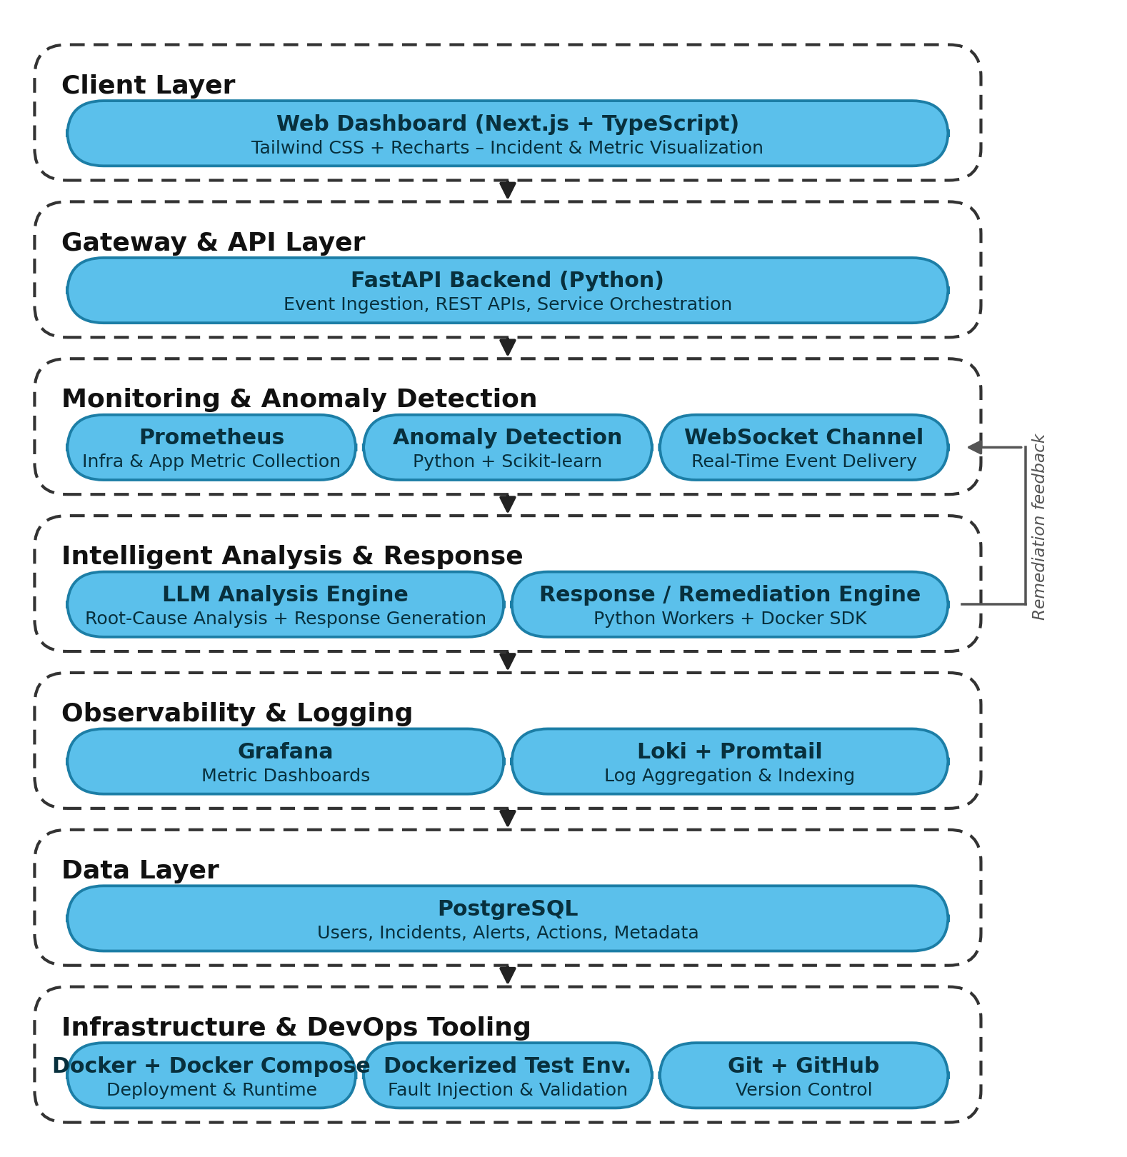
Fig 1. Proposed Intelligent DevOps Monitoring and Incident Response – System Architecture
The proposed system is divided into:
1. Client Layer
- Users access the platform through a monitoring and incident-response dashboard built using Next.js and TypeScript.
- The dashboard, styled using Tailwind CSS and visualized using Recharts, displays live incidents, alert history, root-cause explanations, and recommended or executed remediation actions.
2. Gateway and API Layer
- User and service requests are handled by a backend built using FastAPI (Python).
- The API layer manages routing of monitoring events, exposes REST endpoints for the dashboard, and coordinates communication between the monitoring, analysis, and response components.
3. Core Monitoring and Analysis Services
- Prometheus: Continuously collects infrastructure and application metrics such as CPU, memory, disk, network, service availability, request rate, error rate, and response latency.
- Anomaly Detection Engine: A Python and Scikit-learn based module continuously analyzes incoming metrics to statistically identify abnormal behaviour, complementing conventional threshold-based rules.
- Real-Time WebSocket Channel: Transmits detected alerts/anomalies as monitoring events to the intelligent analysis component with minimal delay.
- LLM Analysis Engine: Receives the monitoring event and associated context (metric history, related logs, affected service) and performs incident identification, correlation, probable root-cause analysis, and generation of a remediation recommendation.
- Response/Remediation Engine: A set of Python worker processes, using the Docker SDK, execute or propose predefined remediation actions such as restarting a container, scaling a service, or adjusting configuration, according to configured operational policies.
4. Observability and Logging
- Grafana: Provides detailed, real-time dashboards for infrastructure and application metrics, incident trends, and system health.
- Loki and Promtail: Collect, aggregate, and index application and system logs, which are supplied to the LLM Analysis Engine as additional context during root-cause analysis.
5. Data Layer
- PostgreSQL stores users, incidents, alerts, generated responses, executed actions, and system metadata, and maintains an auditable history of the monitoring-to-resolution pipeline.
6. Infrastructure
- Docker and Docker Compose are used to run the complete system consistently across environments.
- A dockerized testing environment, seeded with intentionally faulty services, is used to safely reproduce DevOps failure scenarios and validate the detection and remediation pipeline.
- Git and GitHub are used for source control and collaborative development.
7. Overall Working
- Prometheus continuously collects metrics from the monitored DevOps infrastructure.
- The anomaly detection engine and configured threshold rules evaluate the incoming metrics; when an abnormal condition is identified, a monitoring event is generated.
- The event is transmitted through the WebSocket channel to the LLM Analysis Engine, together with relevant log context obtained from Loki.
- The LLM Analysis Engine interprets the event, identifies the probable incident and affected service, estimates the probable cause, and generates a recommended response.
- The recommended response is evaluated against configured safety policies; permitted actions are passed to the Response/Remediation Engine for execution, while sensitive actions are escalated to a human operator for approval through the dashboard.
- A response is treated as valid only if it passes schema validation, the action type is on an allowlist of predefined actions (arbitrary commands are never executed), the target is a known service, the confidence is a number between 0 and 1 at or above a threshold (e.g., 0.7), the same action has not been applied to the same target within a cooldown period (e.g., 5 minutes), and the per-incident action limit (e.g., 3) has not been reached. Risky actions, such as flushing a cache or changing resource limits, always require human approval. Immediately before execution the triggering conditions are re-checked, and the action is withheld if they have already cleared.
- Once a response is executed, Prometheus continues monitoring the affected service, and the resulting metrics are used to verify whether the incident has been resolved; unresolved incidents are re-analyzed, creating a continuous feedback loop.
- Re-analysis is bounded: the incident is re-submitted to the LLM with the attempt number and the list of actions already tried, so a failed action is not repeated, and after a maximum number of attempts (e.g., 3) the incident is escalated to a human operator. If the LLM is unavailable, times out, returns invalid output or reports low confidence, a deterministic runbook supplies the response.
- Safeguards against incorrect or fabricated LLM output include: a constrained action vocabulary supplied in the prompt; strict schema validation of the output; rejection of unknown services or actions; a confidence threshold; required evidence fields that cite metrics from the supplied context; deterministic runbook fallback; and human approval for risky actions.
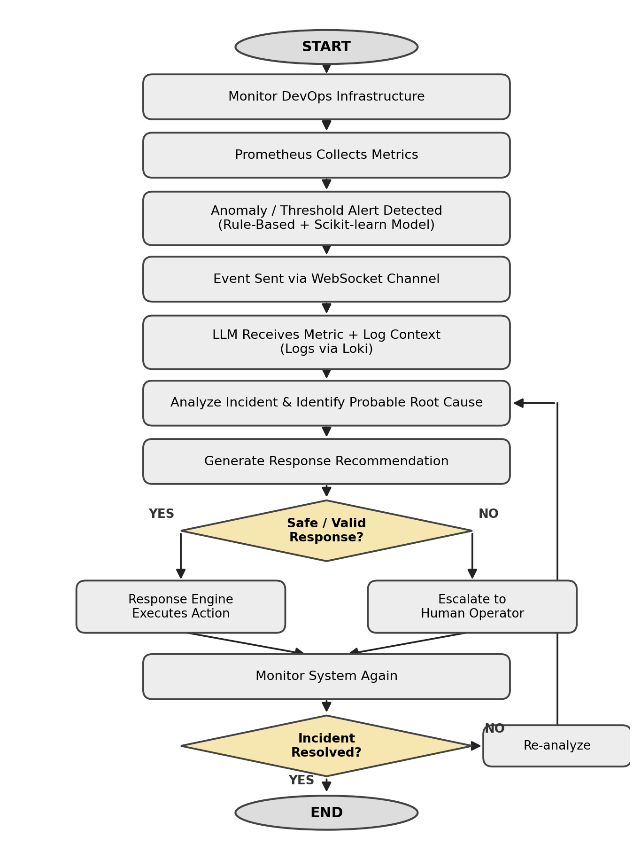
Fig 2. Sequential Workflow of Intelligent DevOps Monitoring and Incident Response
How it works:
The workflow begins with continuous monitoring of the DevOps infrastructure by Prometheus, which collects metrics such as CPU, memory, service availability, and error rate. These metrics are continuously evaluated using both threshold-based rules and a Scikit-learn based anomaly detection model. When an alert or anomaly is identified, an incident-related event is generated and transmitted through a WebSocket-based real-time communication layer to the LLM Analysis Engine, along with related logs retrieved from Loki. The LLM analyzes the available metric and log context to identify the probable incident, determine its likely root cause, and generate a recommended remediation. Depending on configured operational policies, the recommendation is either executed automatically by the Response/Remediation Engine, implemented as Docker-SDK-based worker processes, or escalated to a human operator through the dashboard for approval. All incidents, generated responses, and executed actions are logged to PostgreSQL, and Prometheus continues monitoring the affected service to verify whether the incident has been resolved, re-analyzing the situation if it has not.
GENERAL UTILITY / APPLICATIONS / ADVANTAGES OF THE INVENTION:
1. General Utility
The invention provides an intelligent mechanism for continuously monitoring software and computing infrastructure and for responding to the operational incidents that arise within it. Its primary utility is to bridge the gap between monitoring/alert generation and incident resolution by combining metric collection, log aggregation, statistical anomaly detection, and LLM-based reasoning with a configurable, auditable remediation engine. The system can be used by DevOps and Site Reliability Engineering (SRE) teams to reduce alert fatigue, accelerate root-cause identification, and support faster, more consistent incident response than conventional monitoring systems.
2. Applications
- Cloud Infrastructure: Monitoring and responding to incidents occurring in cloud-hosted computing environments.
- DevOps and CI/CD Infrastructure: Monitoring deployment environments, build systems, services, and application infrastructure.
- Containerized Environments: Monitoring container-based applications and infrastructure, including Docker-orchestrated services.
- Microservice Architectures: Identifying and analyzing operational issues affecting distributed services.
- Microservice Environments: Environments in which faults propagate across dependent services and the alerting service differs from the root-cause service.
- Web Applications: Monitoring application availability, performance, errors, and service behaviour.
- Enterprise IT Infrastructure: Supporting monitoring and incident response for enterprise servers, applications, and services.
- Production Systems: Assisting operational teams in detecting and responding to production incidents.
3) Advantages of Invention
- Continuous monitoring of infrastructure and application metrics, supplemented by log aggregation.
- Statistical anomaly detection that complements conventional threshold-based alerting.
- Real-time event transmission between monitoring infrastructure and the intelligent analysis system.
- Intelligent, context-aware interpretation of alerts instead of relying exclusively on raw monitoring information.
- Probable root-cause analysis using the metric and log context supplied to the LLM.
- Automated or human-approved response generation for identified incidents.
- Reduced manual investigation effort for repetitive operational incidents.
- Faster transition from detection to response by integrating monitoring, analysis, and remediation.
- Scalable, containerized architecture in which monitoring, analysis, and response components can be independently expanded.
- Human-in-the-loop capability, allowing sensitive remediation actions to require operator approval.
- Continuous feedback, where post-response monitoring is used to determine whether the incident has been resolved.
- Detection of both known failures (rules) and unknown or gradual anomalies (ML) before hard thresholds are crossed.
- Identification of the root-cause service, not just the service showing the symptom, using dependency-aware context.
- No unvalidated LLM output reaches the infrastructure: actions pass an allowlist, schema, confidence threshold, cooldown and approval checks.
- Bounded remediation with no infinite loops: a maximum number of attempts, then escalation.
- Continued operation when the LLM is unavailable, through deterministic runbook fallback.
- An auditable record of each incident's evidence, reasoning, action and verification result.
Implementation Status:
The system architecture and design of the proposed invention have been prepared, including the monitoring layer (Prometheus, Grafana, Loki/Promtail), the real-time event layer (WebSocket-based communication), the anomaly detection module, the LLM-based analysis and root-cause engine, the response/remediation engine, and the data storage layer. The main workflows for metric collection, anomaly detection, incident analysis, response generation, and remediation execution have also been planned, along with a dockerized test environment for safely reproducing DevOps failure scenarios. The project is currently being developed in stages, with some core components implemented — including the Prometheus-based metric collection setup and the FastAPI backend — and the remaining components, including the LLM-based root-cause engine and the automated response engine, planned for further development. The complete system has not yet been fully deployed or tested as a final working product, and performance targets have been defined for future testing but have not yet been measured.
Claims:
1. A system for intelligent monitoring and incident response, comprising: a metrics collection module; a rule-based detector and a machine-learning anomaly detector, each configured to emit events in a common incident format; an event gateway comprising a context builder configured to, on receipt of an event concerning a first service, retrieve metrics of the first service and of every service in its dependency chain over a time window associated with the event; a real-time communication layer; an LLM-based analysis engine configured to output a structured response plan comprising a root-cause service, a confidence score and a recommended action; a policy validator, interposed between the analysis engine and an action executor, configured to permit execution only of actions satisfying an allowlist, a known-target constraint, a confidence threshold and a cooldown constraint; and a verifier configured to re-evaluate the triggering conditions after execution.
2. The system of claim 1, wherein, when the verifier determines the incident is unresolved, the incident is resubmitted to the analysis engine together with an attempt count and a record of previously attempted actions, and the incident is escalated to a human operator when the attempt count reaches a configured maximum.
3. The system of claim 1, further comprising deterministic runbooks applied when the analysis engine times out, returns output that fails schema validation, or returns a confidence below the threshold.
4. The system of claim 1, wherein actions classed as risky are routed to a human approval interface instead of being executed automatically.
5. The system of claim 1, wherein the machine-learning anomaly detector emits an event only after an anomaly persists for a configured number of consecutive evaluation windows, and the event includes an anomaly score and top contributing features.
6. The system of claim 1, wherein fault-labelling or ground-truth signals are excluded from the context supplied to the analysis engine and the anomaly detector.
7. A method corresponding to claims 1–6, comprising the steps of monitoring, dual detection, context building, LLM analysis, policy validation, execution, verification and bounded re-analysis.
8. The system of claim 1, wherein, immediately before executing a validated action, the triggering conditions are re-evaluated and the action is withheld if they are no longer active, so that an action is not applied to a service that has already recovered.
9. The system of claim 2, wherein at most one action per incident is in progress (executing, being verified or awaiting approval), and a response plan whose attempt number is lower than the incident's current attempt is discarded, so that a plan produced from an outdated view of the incident cannot trigger an action.
10. The system of claim 1, wherein the response plan comprises a recommended action and a fallback action; when the recommended action is rejected by the allowlist, target or cooldown constraint, the fallback action is validated in its place, and when neither passes the incident is escalated.
11. The system of claim 1, wherein the policy validator operates independently of the analysis engine's output validation, treating every response plan as untrusted: non-finite or non-numeric confidence values, malformed action fields and malformed attempt identifiers are rejected, and the action executor independently re-checks the allowlist before executing.
12. The system of claim 1, wherein the event gateway, on receiving a first event, waits for a configured settle interval before forwarding the incident for analysis, so that events from the root-cause service and from dependent services showing symptoms are analyzed together as one incident.
13. The system of claim 1, wherein every event, response plan and action outcome is recorded in an incident store, from which detection time, root-cause accuracy, action correctness and time to resolution are computed against injected-fault ground truth.
Disclaimer:
The undersigned inventor(s) hereby declare that all statements, descriptions, and representations made in this Invention Disclosure Form are true, complete, and made to the best of their knowledge and belief. The inventor(s) shall bear sole responsibility and liability for the accuracy, validity, and authenticity of the information and data provided herein. The Research and Development Cell (RDC), the Institution, and any associated patent attorney, agent, or representative shall not be held liable or accountable for any inaccuracies, omissions, misrepresentations, or consequences arising from the information furnished by the inventor(s).
Signature:
Name:
Date: 4 Aug 2026

