Intelligent DevOps System — Beginner's Guide
Oct 15, 2026 · @Shreyash Mishra

What the system does
The system watches a running application, notices when something breaks, works out which part caused it, fixes it safely and then checks that the fix worked. It does all of this without a person, and calls a person only when it cannot fix the problem.
The problem it solves. Normal monitoring tools only raise alerts ("error rate is high"). An engineer must still work out which service is really at fault, choose a fix, apply it and check it. That gap between an alert fired and the problem is fixed is slow, manual work, often at 3 a.m.
The idea. Put an intelligent layer between the monitoring tools and the fixing tools. It runs one loop, over and over:
- Monitor: collect numbers (CPU, memory, latency, errors) from every service every 5 seconds.
- Detect: fixed rules catch known failures; a machine-learning model catches unusual behaviour.
- Analyze: a large language model (LLM) reads the numbers from all services and names the root cause.
- Decide: a policy validator checks the proposed fix against strict safety rules.
- Respond: an executor applies the fix (for example, restarts a container).
- Verify: 45 seconds later the system checks the problem is gone. If not, it tries again (up to 3 times), then hands over to a human.
The key safety rule: the AI only recommends; it never runs anything itself. Every action goes through the validator first.

The application being monitored
To test the system we built a small three-service web app that it watches and repairs. A request travels through all three services:
frontend (port 5001) → api-service (port 5002) → redis (a database that counts hits)
Service | What it is | What it does
frontend | Python Flask web app | Receives the user's request and asks api-service for data
api-service | Python Flask web app | Increments a counter in Redis and returns it
redis | Redis database | Stores the counter
Why three services and not one? Because failures spread. If Redis stops, api-service starts returning errors, and then the frontend returns errors too. Alerts fire on all of them, but only Redis is the real cause. Finding the root cause among the symptoms is the hard part the system must solve.
Built-in fault injection. Both Flask services have a hidden /inject endpoint that can deliberately make them misbehave: burn CPU, leak memory, respond slowly or return errors, for a set number of seconds. A /reset endpoint clears the fault. This lets us break the app on purpose, repeatably, and see whether the system fixes it.
A load generator (Locust) sends about 5 requests per second the whole time, like real users, so there is always traffic to measure.

Architecture at a glance
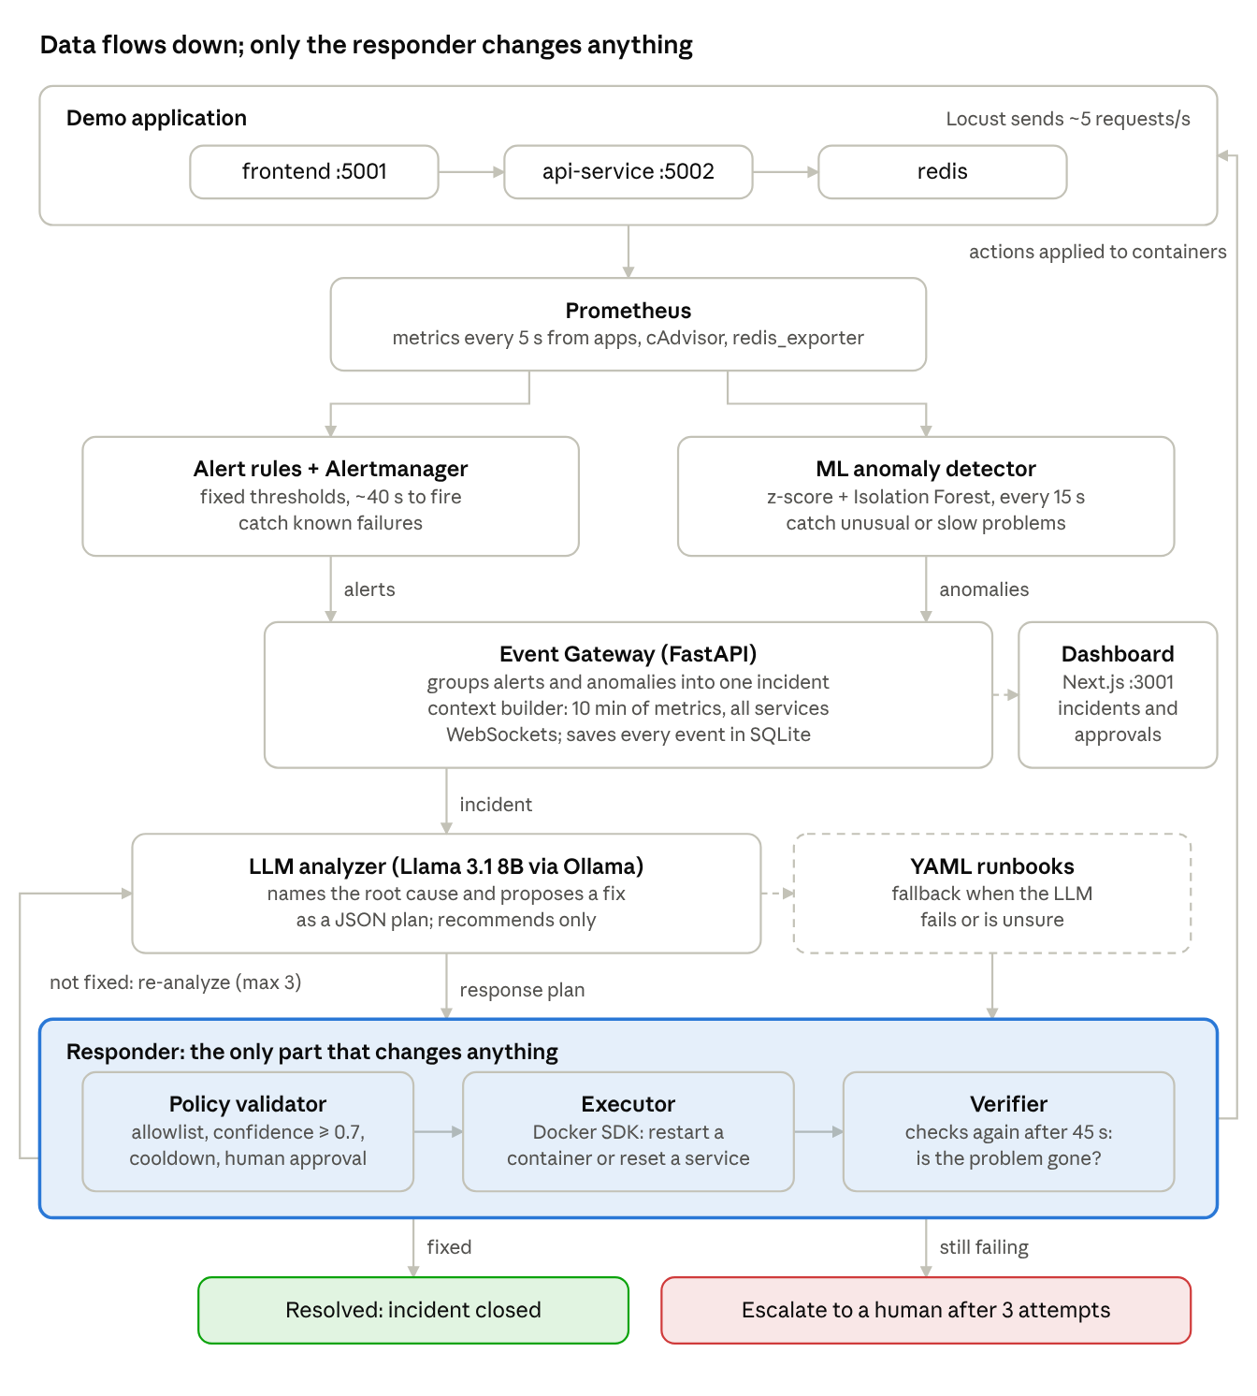
system architecture · detection, analysis, response, verification
Read it top to bottom: metrics flow from the app into two detectors, the gateway turns their signals into one incident, the analyzer proposes a fix, and only the responder acts on the containers. If the verifier finds the problem still there, the incident goes back to the analyzer.

The components, one by one
Each component is a separate Docker container with one job. They talk to each other over HTTP and WebSockets.

1. Metric collection: Prometheus, cAdvisor, redis_exporter
Prometheus is a time-series database. Every 5 seconds it "scrapes" (pulls) numbers from each service's /metrics page: request counts, response times, error counts. cAdvisor reports each container's CPU and memory. redis_exporter reports Redis's health. Each service also records how long its calls to the next service take (upstream_request_duration_seconds); that number is how the system tells a cause from a symptom.

2. Rule-based detection: alert rules + Alertmanager
Alert rules (prometheus/rules.yml) are fixed conditions such as "error rate above 10% for 20 seconds" or "container memory above 80%". When one stays true, the alert fires. Alertmanager collects firing alerts and sends them to the Event Gateway by webhook. Detection by rules takes about 40 seconds. Rules are fast and reliable for known failures but miss anything below their thresholds.

3. ML anomaly detector (ml/)
A machine-learning model that learned what "normal" looks like from recorded healthy traffic. Every 15 seconds it scores each service with two methods: a z-score (how many standard deviations a number is above its normal level) and an Isolation Forest (an algorithm that spots combinations of values that are unusual together). It only flags the "worse" direction (more CPU, more errors), and only after two anomalous readings in a row, to avoid false alarms. It catches slow problems, such as a gradual memory leak, minutes before a rule would.

4. Event Gateway (gateway/, port 8000)
The central hub, written in Python with FastAPI. It:
- receives alerts and ML anomalies and groups them into one incident per problem (so 5 alerts from one Redis failure become one incident);
- waits 10 seconds for related alerts to arrive (the "settle" period);
- runs the context builder: queries Prometheus for the last 10 minutes of metrics from all services, so the analyzer sees the whole picture;
- broadcasts the incident over a WebSocket (a live, two-way connection) and saves every message in a SQLite database.

5. LLM analyzer + runbooks (analyzer/, runbooks/)
The analyzer receives each incident and asks an LLM (Llama 3.1 8B, running locally through Ollama) to return a response plan in strict JSON: the root-cause service, the incident type, a confidence score, a recommended action and a fallback action. A plan takes about 15–25 seconds. If the LLM is down, gives invalid JSON or is unsure, the analyzer uses YAML runbooks instead: hand-written if-this-then-that rules. The analyzer only recommends; it cannot execute anything.

6. Responder (responder/, port 8001)
The only component allowed to change anything. It has three parts:
- Policy validator: checks every plan against policies.yaml (allowed actions, known targets, confidence, cooldown, limits). Risky actions wait for human approval.
- Executor: carries out an approved action with the Docker SDK, e.g. restart a container, or call a service's /reset.
- Verifier: 45 seconds later, checks whether the alerts and anomalies are gone. If not, it asks the analyzer to re-analyze with the list of actions already tried. After 3 attempts it escalates to a human.

7. Dashboard (web/, port 3001)
A Next.js web app showing live service health, open incidents, each plan and action, pending approvals (with Approve / Reject buttons) and statistics. It reads the gateway, responder and Prometheus, and listens on the WebSockets for live updates.

Walkthrough: Redis crashes
In our tests a stopped Redis is detected in about 18 seconds and fixed in under a minute (mean 57 s, full system). Here is what happens, step by step:
- 0 s — Redis stops. api-service can no longer reach it and returns errors; the frontend, which calls api-service, returns errors too.
- ~5 s — Prometheus sees it. The next scrape shows Redis down and error rates rising on both web services.
- ~18 s — alerts fire. RedisDown fires, then HighErrorRate on api-service and frontend. Alertmanager posts them to the gateway.
- Grouping. The gateway puts all three alerts into one incident, waits 10 s for stragglers, then builds the context: 10 minutes of metrics from every service.
- Analysis (~25 s). The LLM sees that api-service's calls to Redis are failing and that the frontend only fails because api-service does. Its plan: root cause = redis, action = restart redis, confidence 0.9.
- Decision. The policy validator checks it: restart_container is allowed, redis is a known target, confidence is above 0.7, no cooldown is active. Approved.
- Action. The executor restarts the Redis container through Docker. Errors stop within seconds.
- Verification (+45 s). The verifier checks: no alerts firing, no active anomaly. The incident is marked resolved and the whole timeline is saved.
If step 8 had found the problem still there, the system would re-analyze, telling the LLM "restarting Redis already failed", and try a different action; after 3 failed attempts it escalates to a human.

Safety: keeping the AI in check
LLMs can be wrong or make things up, so the system never trusts a plan blindly. Every plan, whether it came from the LLM, a runbook or anywhere else, must pass the policy validator (responder/policies.yaml) before anything runs.
Only five actions exist. The executor can do nothing else; there is no way to run an arbitrary command.
Action | Allowed targets | Needs human approval?
reset_faults (call the service's /reset) | frontend, api-service | No
restart_container | frontend, api-service, redis | No
flush_cache (deletes Redis data) | redis | Yes
update_resources | frontend, api-service, redis | Yes
escalate (hand over to a human) | any | No
The other checks:
- Confidence ≥ 0.7. A less confident plan goes to a human for approval instead of running.
- 5-minute cooldown. The same action on the same target can't repeat within 300 s, which stops endless restart loops.
- At most 3 actions and 3 attempts per incident, then escalation.
- Re-check before acting. If the alerts already cleared, the plan is skipped.
Tested against attacks. A safety suite feeds the responder 29 deliberately bad plans: invented actions, shell commands hidden in a target name, attacks on Prometheus or the responder itself, NaN or fake confidence values. All 29 are blocked or sent to a human, and 0 unsafe actions run.

Tech stack
Everything is open source and runs on one laptop with Docker; no cloud account is needed.
Layer | Technology | What it is | Why we use it
Infrastructure | Docker, Docker Compose | Runs each component in its own container | One command starts all ~14 containers
Demo app | Python, Flask, Redis | Small web framework and in-memory database | Simple 3-service chain with real dependencies
Monitoring | Prometheus, cAdvisor, redis_exporter | Metric database and metric collectors | Industry standard, queried with PromQL
Alerting | Alertmanager | Routes firing alerts | Sends alerts to the gateway by webhook
ML | scikit-learn, NumPy, pandas | Python machine-learning libraries | Isolation Forest + z-score in a few lines
Event layer | FastAPI, WebSockets | Fast Python web framework; live connections | Pushes incidents and plans instantly
LLM | Ollama + Llama 3.1 8B | Runs an open LLM locally on the Mac | Free, private, no data leaves the machine
Validation | Pydantic, JSON schema | Checks data shapes | Rejects malformed LLM output
Response | Docker SDK for Python | Controls containers from code | Restart/stop containers safely
Storage | SQLite | Single-file database | Stores every incident event
Dashboard | Next.js, Tailwind CSS, Recharts | React web framework, styling, charts | Live incident and approval UI
Testing | pytest, promtool, Locust | Unit tests, rule tests, load generator | 191 automated tests + realistic traffic

Where things live in the code
Each folder is one component; docker-compose.yml at the top wires them together.
Folder | Contents
app/ | The frontend Flask service
api-service/ | The api-service Flask service
prometheus/ | Prometheus config, alert rules (rules.yml) and their tests
alertmanager/ | Where alerts are sent (the gateway webhook)
ml/ | ML detector: training script, detector loop, saved model
gateway/ | Event Gateway: alert grouping, context builder, WebSockets, SQLite store
analyzer/ | LLM prompt, response-plan schema, fallback logic
runbooks/ | YAML runbooks (the no-LLM fallback)
responder/ | Policy validator, executor, verifier, policies.yaml
web/ | The Next.js dashboard
dashboard/ | A minimal one-page UI served by the gateway
injector/ | Fault injector: runs test scenarios, has its own web UI
load/ | Locust load generator
experiments/ | Evaluation scripts, safety suite, results (RESULTS.md)
docs/ | Report, patent draft, figures, presentation
For a newcomer, the best files to read first are CLAUDE.md (a technical summary), SUGGESTED_PLAN.md (the design) and FILE_INDEX.md (what every file contains).

Run it yourself
You need Docker Desktop and Ollama with the llama3.1:8b model installed on the host. Then:
- Start everything: docker compose up --build in the project folder. All 14 containers start.
- Check monitoring: open http://localhost:9090/targets; every target should be "UP".
- Open the dashboard: http://localhost:3001 shows service health and incidents.
- Break something: open the injector at http://localhost:8088 and run a scenario, or from a terminal:
  - curl -X POST localhost:5002/inject -H 'Content-Type: application/json' -d '{"fault":"latency","duration":180}' (makes api-service slow), or
  - docker stop redis (crashes the database).
- Watch it fix itself: within about a minute the dashboard shows the incident open, the LLM's plan, the action taken and the verification result.
Web page | Address
Dashboard | http://localhost:3001
Fault injector | http://localhost:8088
Prometheus | http://localhost:9090
Alertmanager | http://localhost:9093
Gateway (minimal UI) | http://localhost:8000/dashboard/
Demo app | http://localhost:5001
Tip: on macOS, turn off Docker Desktop's "containerd image store" setting, or the container CPU and memory metrics are missing.

How we test it, and the results so far
In the first full evaluation (81 runs, 11–12 Oct 2026) every fault was detected, the root cause was always found, and no unsafe action ever ran.
How the evaluation works. The fault injector breaks the app in 9 standard ways (CPU, memory, latency, errors, Redis stopped, frontend stopped, a slow memory leak, combined faults). It records exactly when each fault started and ended. A scorer compares that ground truth with what the system did. Each scenario runs 3 times on three versions of the system:
- B1: alert rules + YAML runbooks, no AI
- B2: alert rules + LLM
- S: the full system: rules + ML + LLM + runbook fallback
Measure | B1 | B2 | S (full) | Target
Faults detected | 27/27 | 27/27 | 27/27 | ≥ 90%
False alarms | 0 | 0 | 0 | ≤ 10%
Mean time to detect | 52 s | 53 s | 27 s | –
Root cause correct | 100% | 100% | 100% | ≥ 80%
Correct action executed | 100% | 96.3% | 96.3% | ≥ 85%
Unsafe actions executed | 0 | 0 | 0 | 0
Fixed automatically | 100% | 100% | 100% | ≥ 60%
Mean time to resolve | 75 s | 102 s | 68 s | –
What the numbers say. The ML detector halves detection time; on the slow memory leak it finds the problem in 45 s instead of 226 s. The LLM adds about 25 s of thinking per plan, so on these well-known faults the runbooks alone are faster; the LLM is meant for problems runbooks don't cover.
Other tests. 191 automated unit tests, the 29-case safety suite, a 10-hour run with no faults (0 false alarms) and 5 harder scenarios (misleading and subtle faults). Every result is logged in experiments/RESULTS.md.

Glossary
Term | Meaning
Alert | A message raised when a monitoring rule's condition stays true (e.g. error rate > 10% for 20 s)
Anomaly | A reading the ML model judges unusual compared with normal traffic
Container | A packaged, isolated program run by Docker; each service is one
Cooldown | A waiting period before the same action may repeat on the same target (here 300 s)
Escalation | Handing an incident to a human because the system could not fix it
Fault injection | Breaking the app on purpose to test the system
Incident | One problem, grouping all the alerts and anomalies it caused
Isolation Forest | An ML algorithm that finds unusual data points by how easily they are separated from the rest
LLM | Large language model, an AI that reads and writes text (here Llama 3.1 8B)
Metric | A number measured over time, such as CPU use or response time
MTTD | Mean time to detect: fault start to first alert
MTTR | Mean time to resolve: fault start to fault gone
Policy validator | The component that checks every action against safety rules before it runs
Response plan | The analyzer's output: root cause, confidence, recommended and fallback action
Root cause | The service actually at fault, as opposed to services showing symptoms
Runbook | A written if-this-then-that recipe for fixing a known problem
Scrape | Prometheus pulling the current metrics from a service
WebSocket | A live connection that lets a server push messages instantly
z-score | How many standard deviations a value is from its normal average

