Evaluation Results: Intelligent DevOps Monitoring & Incident Response
Final results of the §10 evaluation, 11-22 Oct 2026. Generated 23 Oct 2026 from experiments/results/.
Headline. The full system (S) detected every core fault in 29.0 s on average, against 53.1 s for the rule-based baselines, and recovered in 74.1 s. Across 730 runs no system executed an unsafe action or raised a false alarm.

1. What was tested
Faults were injected into a 3-service demo app (frontend → api-service → Redis) on one Mac with Docker Compose, under steady load (Locust, 5 users). Four variants of the system were compared; every action went through the same policy validator, was verified after 45 s and escalated after 3 attempts.
System | Detection | Analysis | Runs
B1 | Prometheus rules | YAML runbooks | 180 core + 50 extra
B2 | Prometheus rules | LLM (llama3.1:8b) | 180 core + 50 extra
S (full system) | Rules + ML detector | LLM with runbook fallback | 180 core + 50 extra
SF (LLM down) | Rules + ML detector | Runbooks only (LLM unreachable) | 40 (core scenarios 3, 4, 6, 8)

Core suite: 9 faults the runbooks cover (CPU, memory, latency, errors, stopped containers, gradual leak, CPU + latency), 20 runs per scenario per system. Extra suite: 5 harder faults (corrupted cache and slow Redis, which mislead towards api-service; 0.6 s latency and 5% errors, below the alert thresholds; a fault that recurs after every fix), 10 runs each.

2. Core suite: 540 runs
Metric | B1 runbooks | B2 LLM | S full system
Faults detected | 100% | 100% | 100%
False-positive incidents | 0 | 0 | 0
Unsafe actions executed | 0 | 0 | 0
Root cause correct (first plan) | 100% | 100% | 97.2%
Correct action executed | 100% | 92.2% | 93.9%
Fixed automatically | 100% | 100% | 99.4%
MTTD mean / median | 53.1 s / 29.2 s | 52.8 s / 28.4 s | 29.0 s / 26.4 s
MTTR mean / median | 75.3 s / 50.4 s | 104.9 s / 83.0 s | 74.1 s / 71.6 s
Escalated to a human | 0% | 0% | 0.6%

MTTD = fault start → incident opened. MTTR = fault start → fault gone. n = 180 runs per system.
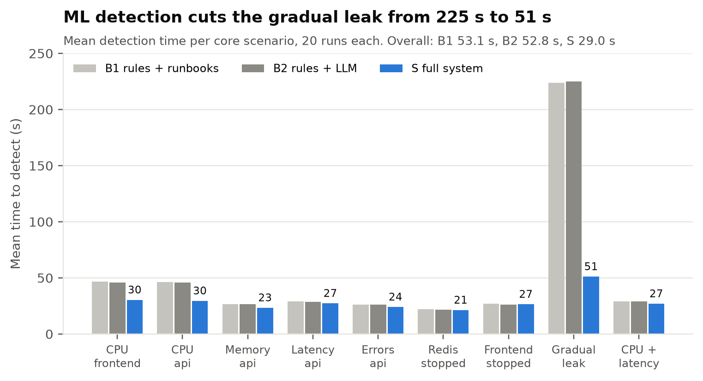
Figure 1. Detection time per core scenario. The ML detector halves detection on the CPU faults (~46 s → ~30 s) and catches the gradual memory leak before the memory alert, 225 s → 51 s. On the other faults the alert rules are about as fast.
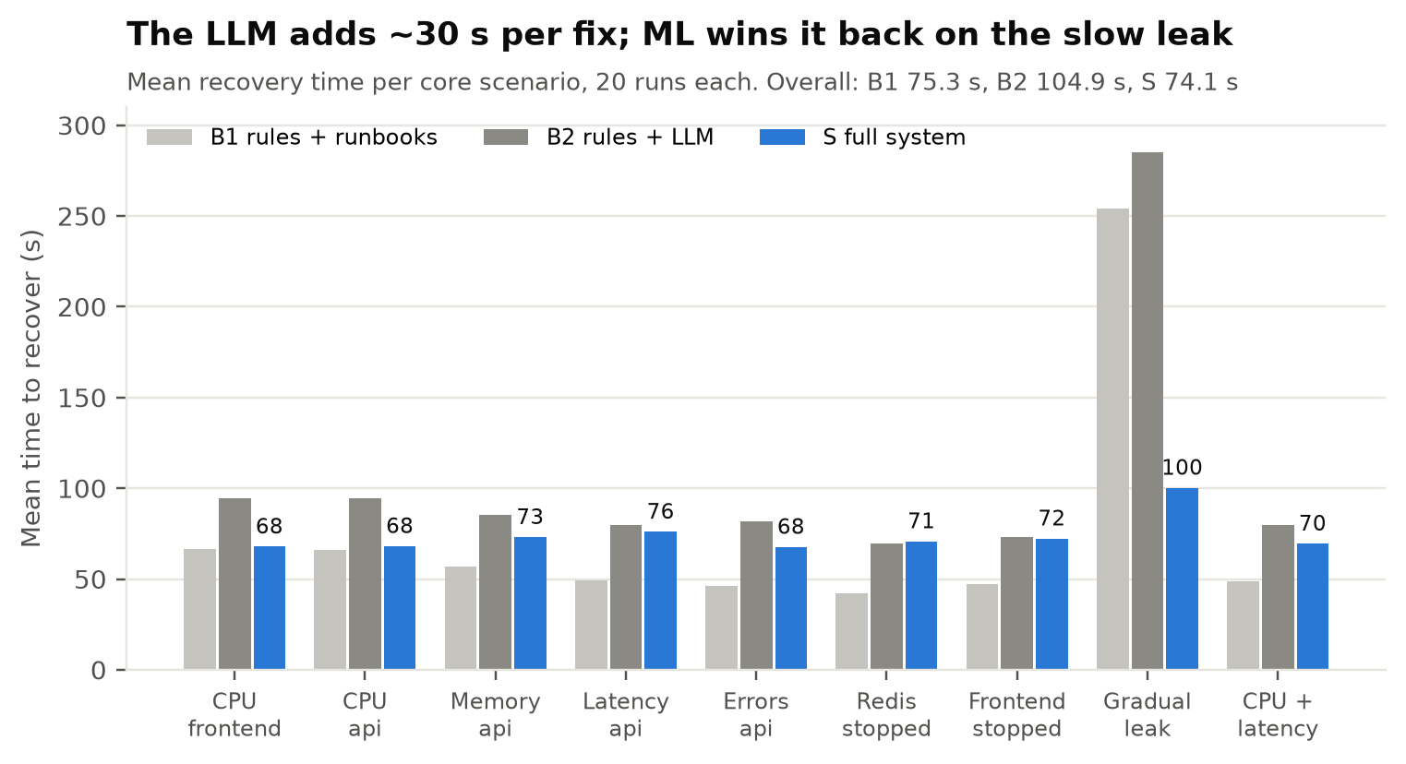
Figure 2. Recovery time per core scenario. Asking the LLM adds about 30 s to every fix (B1 → B2). S gets that time back only on the gradual leak, so its overall mean (74.1 s) equals the runbooks' (75.3 s); without the leak the runbooks are faster (53.0 s vs 70.8 s).
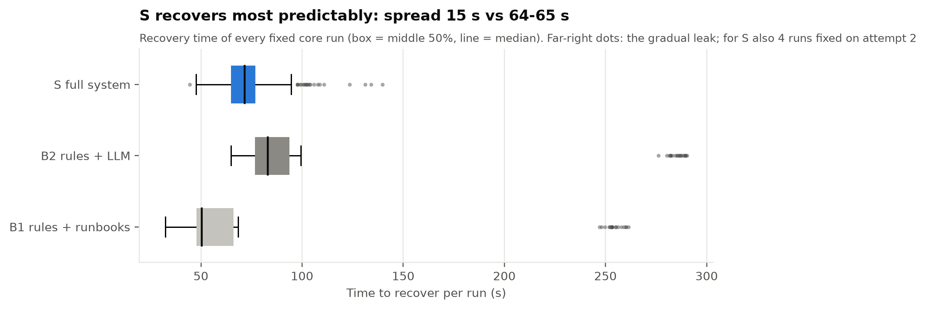
Figure 3. Spread of recovery times. S is the most predictable system: its recovery time varies by 15 s (standard deviation) against about 64 s for the baselines, whose gradual-leak runs take over 4 minutes.
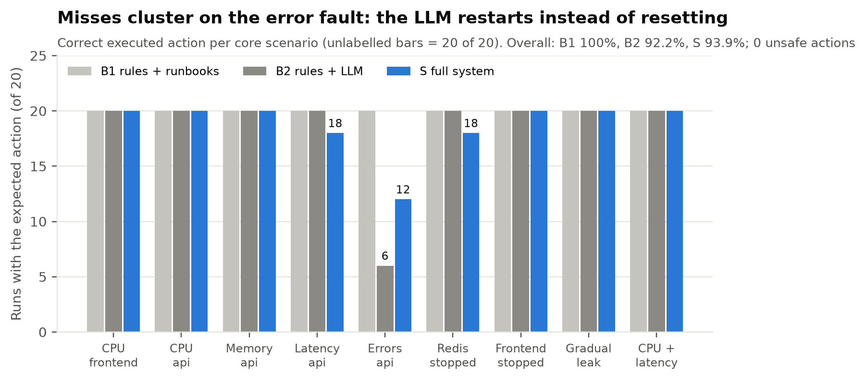
Figure 4. Correct executed action per scenario. The runbooks never miss. Almost all LLM misses are on the error fault, where it restarts the container instead of resetting the fault (the restart also clears the fault, so it is not harmful). S's 4 misdiagnoses (latency and Redis) were all fixed on the second attempt by the verify loop.
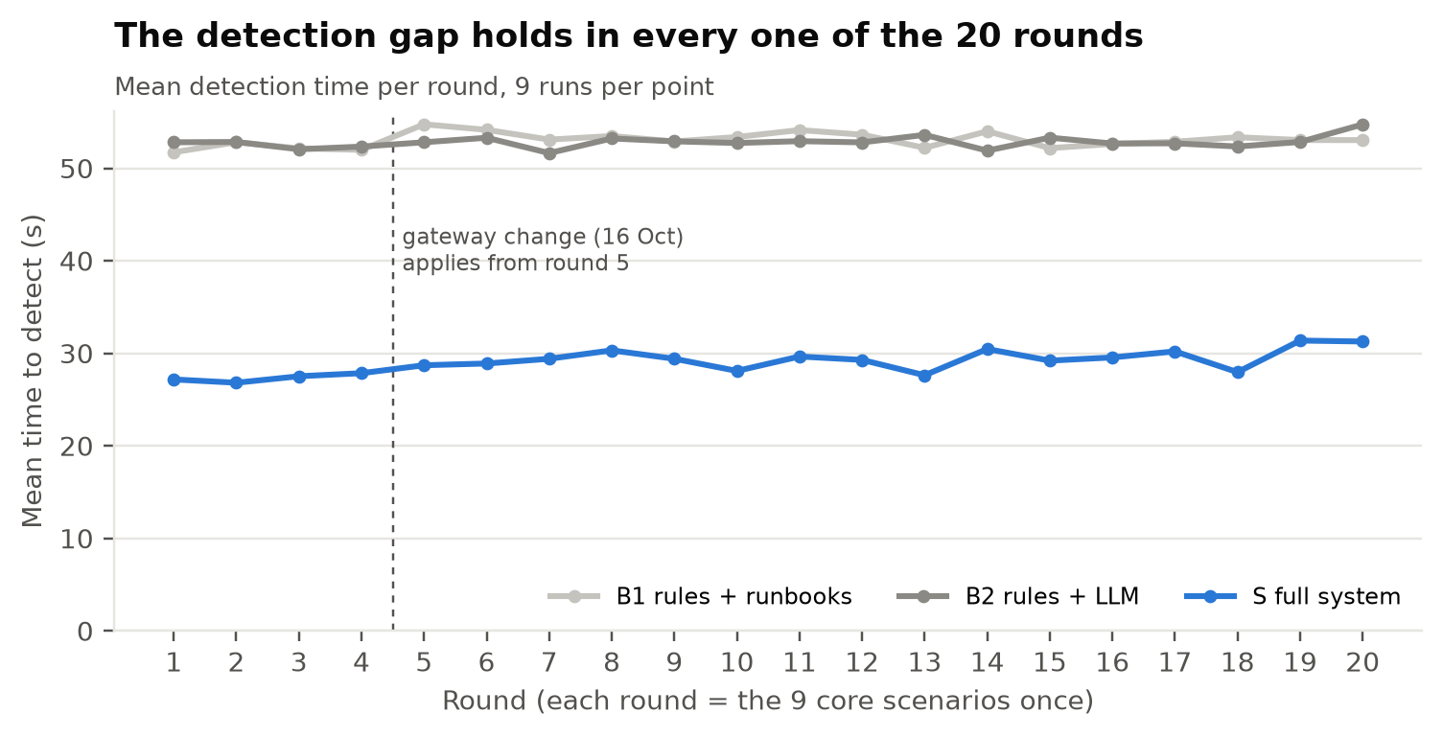
Figure 5. Detection time round by round. The gap between S and the baselines is stable across all 20 rounds, including after the 16 Oct gateway change (round 5 onwards), so pooling all rounds is justified.

3. Extra suite: harder faults (190 runs)
Scenarios 10-14, 10 runs each, on B1, B2 and S (the LLM-down system SF ran different, easier faults; see the next table).
Metric | B1 | B2 | S
Runs | 50 | 50 | 50
Faults detected (of all runs) | 60% | 60% | 90%
Fixed automatically (of all runs) | 0% | 0% | 20%
Escalated to a human (of detected runs) | 100% | 100% | 68.9%
Unsafe actions executed | 0 | 0 | 0
False-positive incidents | 0 | 0 | 0

Losing the LLM: S and SF on the same four core faults. SF is about 30 s faster when it works (no LLM call) but fixes fewer faults, because the runbooks have no plan for a latency incident the ML detector opens before the alert fires.
Scenario | S (LLM up), 20 runs | SF (LLM down), 10 runs
Memory | 20/20 fixed, 73 s | 10/10 fixed, 48 s
Latency | 20/20 fixed, 76 s | 4/10 fixed, 43 s
Redis stopped | 20/20 fixed, 71 s | 10/10 fixed, 35 s
Gradual leak | 20/20 fixed, 100 s | 10/10 fixed, 70 s
Overall | 100% fixed | 85% fixed

Mean recovery time of the fixed runs. SF shows that the system keeps working, safely, when the LLM is unreachable; it is not a better system.
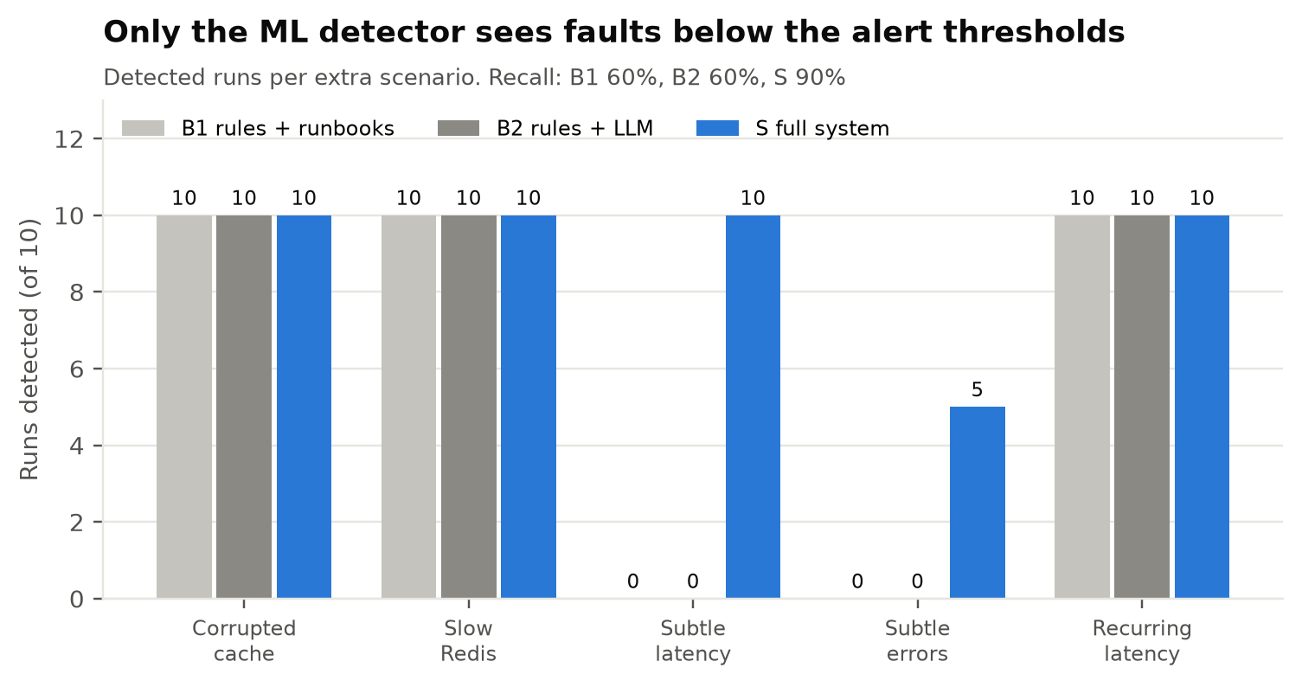
Figure 6. Detection per extra scenario. Faults below the alert thresholds are invisible to the rules: B1 and B2 detect 0 of 20. S detects the 0.6 s latency in all 10 runs and fixes it every time; the 5% error rate is detected in only 5 of 10 runs, late (160 s on average), and the responder skipped those plans as 'already cleared'.
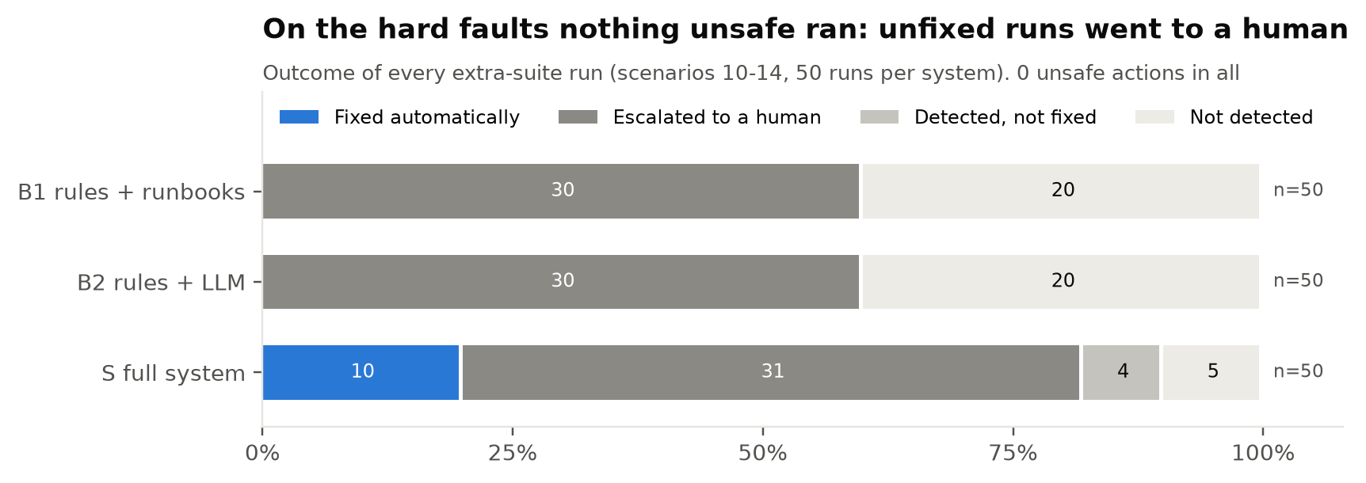
Figure 7. Outcome of every extra run. No variant traced the misleading Redis faults (corrupted cache, slow Redis) to Redis: all blamed api-service, tried reset and restart, and escalated after 3 attempts. The recurring fault was escalated in all 30 runs, as designed. Nothing unsafe was executed: what the system could not fix went to a human.
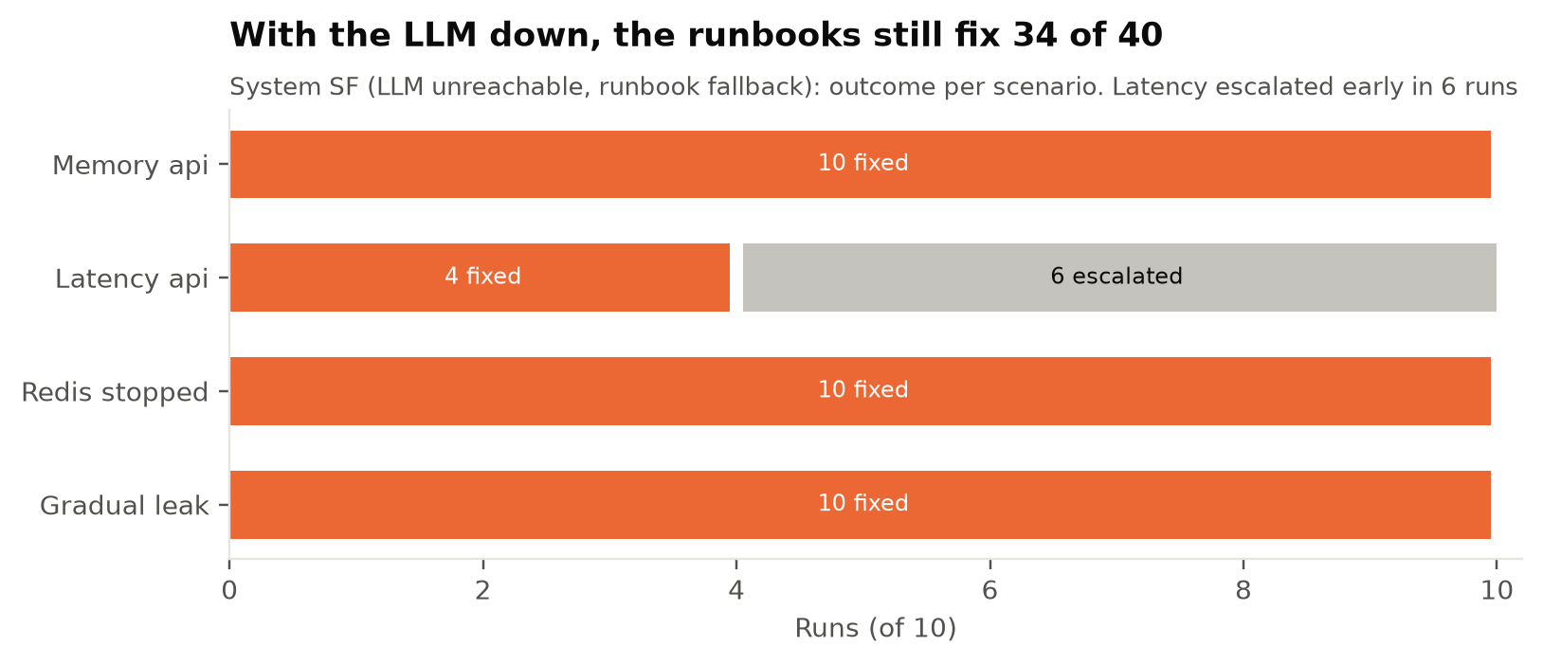
Figure 8. With the LLM unreachable, the runbook fallback still fixes memory, Redis-stopped and gradual-leak faults in every run, faster than S (no ~30 s LLM call). Latency is the gap: when the ML detector opens the incident before the latency alert fires, no runbook matches, and 6 of 10 runs were escalated early.

4. Cost of the LLM
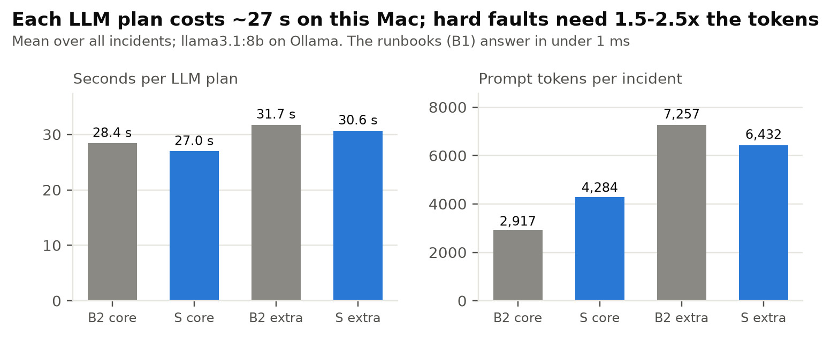
Figure 9. Each LLM plan takes about 27-32 s with llama3.1:8b on this Mac, against under 1 ms for a runbook. Hard faults need several attempts, so the prompt tokens per incident rise from about 3-4k to 6-7k.

5. False alarms with no faults (soak test)
System S ran with no faults for 22 hours over 2 nights, with 42 harmless events (a container restart or a load change between 2 and 10 users every 30 minutes). It raised 0 false alarms and executed no actions.
Soak | Window (UTC) | Hours | Events | False alarms | Actions
1 | 2026-10-12 19:01 → 10-13 05:01 | 10 | 19 | 0 | 0
2 | 2026-10-22 21:54 → 10-23 09:54 | 12 | 23 | 0 | 0

6. Limits of these results
- One machine and one model (llama3.1:8b): LLM latency depends on this Mac.
- All core faults are ones the runbooks were written for; the extra suite covers faults they were not.
- The ML detector was trained at the same load (5 users) as the evaluation.
- B0 (a human fixing the faults by hand) was not run, so the claim 'faster than a human' (O6) is not measured.
- No plan ever proposed a risky action, so the human-approval path was tested by the safety suite and a live round trip, not by these runs.
- Extra suite: 10 runs per cell. Scenarios 10 and 11 are designed to mislead.

Sources
- experiments/results/eval_stage3_{B1,B2,S}_runs.csv, eval_stage3_summary.json (core, RESULTS.md §18a)
- experiments/results/eval_extra_stage3_{B1,B2,S,SF}_runs.csv, eval_extra_stage3_summary.json (extra, §18b)
- experiments/results/soak_1_summary.json, soak_2_summary.json (soak tests, §16 and §19)
- Figures: docs/results/make_figures.py; this document: docs/results/build_doc.py

