1. Write a program to eliminate the common elements in the given 2 arrays and print only the non-repeating

elements and the total number of such non-repeating elements.

Input Format:

The first line contains space-separated values, denoting the size of the two arrays in integer format respectively.

The next two lines contain the space-separated integer arrays to be compared.

[Sample](https://www.rajalakshmicolleges.net/moodle/mod/quiz/view.php?id=5127) Input:

5 4

1 2 8 6 5

2 6 8 10

[Sample](https://www.rajalakshmicolleges.net/moodle/mod/quiz/view.php?id=5127) Output:

1 5 10

3

[Sample](https://www.rajalakshmicolleges.net/moodle/mod/quiz/view.php?id=5127)  Input:

5 5

1 2 3 4 5

1 2 3 4 5

[Sample](https://www.rajalakshmicolleges.net/moodle/mod/quiz/view.php?id=5127) Output:

NO SUCH ELEMENTS

For example:

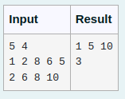

Answer

l=input()

l1=set(input().split(' '))

l2=set(input().split(' '))

l=list(l1^l2)

r=[]

for i in l:

r.append(int(i))

for i in sorted(r):

print(i,end=" ")

print()

print(len(l))

2. Coders here is a simple task for you, Given string str. Your task is to check whether it is a binary string or not by using python set.

Examples:

Input: str = "01010101010"

Output: Yes

Input: str = "REC101"

Output: No

For example:

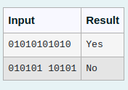

Answer

n=input()

if (set(n)=={'0', '1'}):

print("Yes")

else:

print("No")

3.Given an array of integers nums containing n + 1 integers where each integer is in the range [1, n] inclusive.There is only **one repeated number** in nums, return this repeated number. Solve the problem using set.

**Example 1:**

**Input:** nums = [1,3,4,2,2]

**Output:** 2

**Example 2:**

**Input:** nums = [3,1,3,4,2]

**Output:** 3

For example:

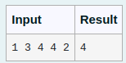

Answer

l=[int(n) for n in input().split()]

a=set()

for i in l:

if i in a:

print(i)

a.add(i)

4. Given an array of strings words, return the words that can be typed using letters of the alphabet on only one row of American keyboard like the image below.

In the **American keyboard**:

* the first row consists of the characters "qwertyuiop",
* the second row consists of the characters "asdfghjkl", and
* the third row consists of the characters "zxcvbnm".

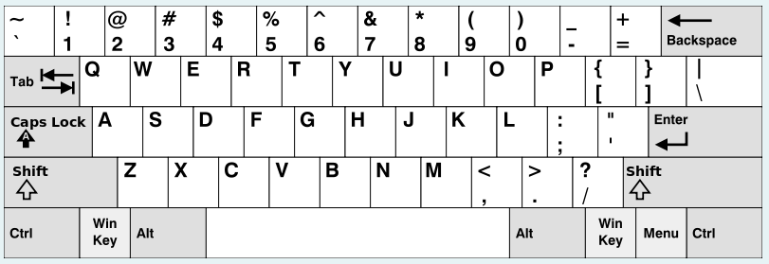

**Example 1:**

**Input:** words = ["Hello","Alaska","Dad","Peace"]

**Output:** ["Alaska","Dad"]

**Example 2:**

**Input:** words = ["omk"]

**Output:** []

**Example 3:**

**Input:** words = ["adsdf","sfd"]

**Output:** ["adsdf","sfd"]

For example

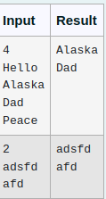

Answer

l=[]

t=[]

n=int(input())

for i in range(n):

l.append(input())

for i in l:

f=1

if i[0] in "qwertyuiopQWERTYUIOP":

for j in i:

if j not in "qwertyuiopQWERTYUIOP":

f=0

break

if f==1:

t.append(i)

elif i[0] in "asdfghjklASDFGHJKL" :

for j in i:

if j not in "asdfghjklASDFGHJKL":

f=0

break

if f==1:

t.append(i)

elif i[0] in"zxcvbnmZXCVBNM":

for j in i:

if j not in "zxcvbnmZXCVBNM":

f=0

break

if f==1:

t.append(i)

if len(t)==0:

print("No words")

else:

for i in t:

print(i)

5. Given a tuple and a positive integer k, the task is to find the count of distinct pairs in the tuple whose sum is equal to **K**.

**Examples:**

**Input:** t = (5, 6, 5, 7, 7, 8 ), K = 13   
**Output:** 2   
**Explanation:**   
Pairs with sum K( = 13) are  {(5, 8), (6, 7), (6, 7)}.   
Therefore, distinct pairs with sum K( = 13) are { (5, 8), (6, 7) }.   
Therefore, the required output is 2.

For example

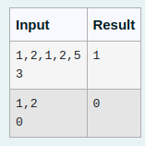

Answer

arr=eval(input())

k=int(input())

s=set()

for i in range(len(arr)):

for j in range(len(arr)):

if(i==j):

continue

if(arr[i]+arr[j]==k):

if (arr[i],arr[j]) in s or (arr[j],arr[i]) in s:

continue

s.add((arr[i],arr[j]))

print(len(s))