Electromigration Analysis for MTTF calculations

Mahesh N. Jagadeesan,
Analog IC Research Group, The University of Texas at Arlington
jmaheshn@yahoo.com, October, 2002

1. Introduction

Electromigration is caused by high current density stress in metallization patterns and is a major source of breakdown in electronic devices. It is therefore an important reliability issue to verify current densities within all stressed metallization patterns. Both electromigration and joule heating are used in self consistent solutions for maximum allowed interconnect peak current density. The maximum allowed temperature and current density solutions monotonically increase as duty cycle r decreases ^{[1]}. With the help of the layout parameters the peak current density is calculated and analyzed with the estimated values obtained from various interconnect nodes of the circuit. Using these analyses, peak current density solutions can be used to generate adequately safe current density design guidelines.

2. Electromigration
Electromigration is the current induced transport of the conducting material. In the presence of high current stresses, electron momentum is transferred to atoms in the conducting material yielding a net atomic flux. This net flux causes conducting material to be depleted “up wind” and accumulated “down wind.” Regions where the interconnect material has been depleted will form a void, leading to interconnect open-circuit failure. Likewise, interconnect material can also accumulate and extrude to make electrical contact with neighboring interconnect segments, potentially leading to circuit failure due to the formation of a short circuit. Either outcome can contribute to the gradual ``wearing out'' of a current stressed interconnect over time.
The formation of voids and accumulations is dependent on the underlying microstructure of the metal film from which the interconnect has been patterned as discussed earlier. Once deposited, the metal film has a distribution of grain sizes. This metal film is then etched to produce the desired interconnect layer.
3. Modern approach towards Electromigration of aluminum
With the aid of micro fabrication techniques, a sub micrometer relief of a large number of parallel grooves in silica is made. Aluminium is sputter deposited onto the groove pattern. If molten, it flows into the grooves. If the correct amount of Al is deposited, all grooves are filled with Al, while the ridges are left uncovered. After solidification, the aluminium in the grooves is single-crystalline and in neighboring grooves it has often the same crystallographic orientation. These single-crystalline structures are used as a starting point for a number of electromigration tests.
The electromigration behavior of a single-crystalline Al line in a groove has exceptionally long lifetimes for the single-crystalline Al lines. Moreover, the noise - related to movement of defects in the metal - in the resistance is very low. Until now, no one has unraveled the exact nature of the resistance noise. Test lines with more complicated grain structures are being developed by variations in the geometry. Alternatively, continued growth (after melting and recrystallization) will be used to grow a thin film with very large grains in which eventually test lines will be defined. The Al in the groove pattern acts, thus, as a seed layer.
Electromigration estimation is separated into two steps. The first step checks for violations of the current density limits, and the second step assess the mean-time-to-failure (MTTF) for all wire segments. While most interconnect segments exhibit AC current behavior, almost every signal interconnect line on a chip includes interconnect segments that exhibit DC current behavior. Therefore signal wires must be checked for both peak and RMS current density violations. Hence the cumulative probability of failure for a projected lifetime has to be determined.

4. Electromigration Analysis

This paper describes a system for reliability analysis of VLSI CMOS circuits with emphasis on electromigration analysis for MTTF calculations. This process does not restrict itself for the power and ground lines but for all the metal lines in a circuit at the layout level. The procedure consists of three main steps: Computation of peak current densities for power, ground and other metal lines in a circuit; Extraction of RC parameters from layout designed, using circuit netlist; and verification of the estimated peak values with the values extracted from the layout parameters.

4.1. Computation of peak current densities:

For the maximum allowed current density, J_{peak} value, self-consistent solutions are obtained for the maximum allowed peak current density J_{peak} as a function of waveform ^{[1]}, which comprehends simultaneously both of the relevant temperature dependent mechanisms-electromigration (EM) and joule heating (JH). It was shown that solutions for maximum allowed temperature and peak current density J_{peak} depend on the duty cycle r of the waveforms ^{[4]}. One of the unique behaviors of these solutions is that J_{peak} has constant temperature EM-like behavior near r=1, but constant temperature Joule heating-like behavior for smaller r. We consider only the case of unipolar (and rectangular) pulsed dc operation in an isolated single level of metal. Examples of the parametric dependence of J_{peak} versus r on lead width, underlying oxide thickness, and EM current density specification were given. Here, we focus on the application of these solutions to current density design guidelines which ensure that reliability requirements are met.

For a unipolar (and rectangular) pulsed dc waveform with duty cycle r and peak current density J_{peak}, the standard definition of J_{rms} results in ^{[5]}

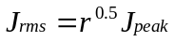
-----------------(1)

The reason to consider the unipolar pulsed dc is that the maximum allowed Jpeak for a symmetrical pure ac is greater than for the pulsed dc case, making the latter a worst-case. We use the relations Jpeak = Jrms/r^{0.5} and Jpeak = Javg/r in (3) and (5), respectively ^{[1]}. Then we eliminate Jpeak to obtain the self-consistent equation between mean metal lead temperature, Tm and r:

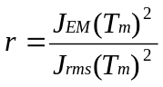
-----------------(2)

For Joule Heating (JH), the steady state equation for Quasi one dimensional (1-D) heat transport equation is given by ^{[4]}.

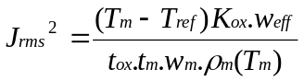
-----------------(3)

where J_{rms} is the root-mean-square (rms) current density, Tm is the mean metal lead temperature, is the maximum allowed junction reference temperature in the silicon (chosen to be 100 C), K_{ox} is the underlying oxide thermal conductivity, t_{ox} is the underlying oxide thickness, tm is the metal thickness, wm is the metal width, ρ_{m} is the temperature dependent metal resistivity.

One aspect of joule heating is shown in fig 1, which shows three single level metal systems. The most realistic case is on the right, in which heat can be lost out the top and the sides of the metal lead. It requires two-dimensional (2-D) calculations to solve for the temperature rise of a long lead. The second case in the middle has no oxide covering through which heat loss can occur, but edge losses are comprehended. The quasi-two-dimensional (2-D) solution can be found analytically, as done by Bilotti ^{[16]}, to obtain w_{eff} / w_{m} (w_{eff} = w_{m} + 0.88 t_{ox}, accurate to 3% for ^{[3]}). The third case on the left hand side occurs when the width is much wider than the underlying oxide thickness, with negligible heat losses out the sides or top. It leads to the simple (1-D) heat loss solution with w_{eff} / w_{m} =1. The 1-D limit is valid in the limit, w_{m} >> t_{ox} whether there is an oxide covering (as in the right-hand side case), or not (as in the left two cases). The important point is that the 1-D solutions, having less heat loss, will always have the highest temperatures, and therefore are worst case for the maximum allowed peak current density. It is natural to refer to the 1-D solution as the worst-case “thermally-wide” case. In this work the expressions as obtained by Bilotti ^{[16]} has been considered for the worst-case current density peak values.

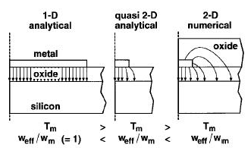

Fig 1, Single level metal layers with different metal widths and heat flow across them ^{[4]}

We assume that interconnect reliability is dominated by lead failure, rather than by contact or via failure. Black’s equation for dependence of EM lifetime on current density and temperature ^{[3]} leads to the relation which must be satisfied by the current density to maintain equal EM reliability lifetimes ^{[4]}

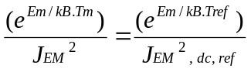
-----------------(4)

where J_{EM} is dc current density at temperature Tm, Em is the activation energy for the EM mechanism, and J_{EM, dc, ref} is the dc EM current density specification at the temperature T_{ref}. One very important consequence of (2) is: if the metal temperature increases, the activation energy for EM requires that J_{EM} decrease. From (4) we define the function J_{EM} (Tm)

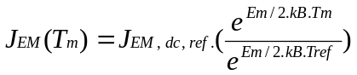
-----------------(5)

Throughout this work, the material values were considered from Table 1 for all calculations. While these values are reasonable for illustrative purposes, these may not be the best values available in the literature.

Table 1, Values of material parameters used. ^{[1]} ^{[4]}

Parameter | Value | Units
Kox | 1.52 | W .m^{-1 .}K⁻¹
Km | 243 | W .m⁻¹ .K⁻¹
ρ_{m} (Tm) | 4.2918 E -8 | Ω .m
Em | 7 E -1 | e.V
Jem, dc, ref | 6 E 9 | A .m⁻²
Tox | 3 E –6 | .m
Tm | 0.5 E –6 | .m
Wm | 3 E –6 | .m
k_{B} | 1.38 E –23 | J / k

4.1.1. Extraction of interconnect Area from layout:

Interconnect with an insufficient width may be subject to electromigration and eventually cause the failure of the circuit at any time during its lifetime. This problem has gotten worse over the last couple of years due to the ongoing reduction of circuit feature sizes. For this reason, it is becoming crucial to address the problems of current densities and electromigration during layout generation ^{[11]}.

With advancements in integrated circuits process technology, feature dimensions below 0.35 microns are currently used by the semiconductor industry. As the physical size decreases, the delay of electrical signals traveling in the interconnections is equivalent or greater than the gate delay.

For example, the interconnect capacitances between aluminum and silicon dioxide dielectric represents 50 percent of the total delay in a 0.25 µm technology. In a 0.18 µm technology this capacitance can represents up to 70 percent, and it is expected to contribute up to 80 percent in a 0.15 µm technology ^{[12]}.

The parasitic capacitance of each net has two components: area and perimeter. The relationship between wire height and width increases in deep-submicron technology (1.8 for 0.25 µm technology and will reach 2.7 for 0.07 µm technology) ^{[13]}, resulting in a major contribution for perimeter capacitances. Also, the number of interconnect layers is increasing to 6-7 layers. These two facts make the coupling capacitances as important as ground capacitances.

4.1.2. Capacitance Extraction for Area estimation:

Interconnect capacitance in each node in a circuit is calculated using the model shown in Figure 2. It consists of two conduction layers over the substrate, considered as a reference plane (ground plane).

There are three capacitance components at any node ^{[14]}:
- Overlap capacitance (C_{over}) - due the overlap between two conductors in different planes. They are C21a and C23a in the Figure 2.
- Lateral capacitance (C_{lat}) - is the capacitance between two conductors in the same plane. In the Figure 1 is C22lat.
- Fringing capacitance (Cfr) - due the coupling between two conductors of different planes. They are C21fr and C23fr in the Figure 2.

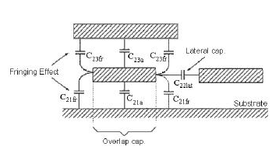

Fig 2, Capacitance model showing different capacitance components^{[15]}.

The intrinsic capacitance is the capacitance between one conductor layer and the ground plane. It has two components: overlap and fringing capacitances. Two parallel plates model the overlap capacitance. It is calculated using the traditional formulation based in the overlap area ^{[15]}:

C_{over} = C_{area} W. L
-----------------(6)

Where C_{area} is capacitance per unit area (fF/µm²), and W.L is the overlap area (..m²).

The fringing capacitance is due to the edge of one conductor and the surface of the other one (in this case, the ground plane). It is calculated by:

C_{fr}=2.C_{length}.L
-----------------(7)

Where C_{length} is the capacitance per unit length (fF/µm).
Thus, the intrinsic capacitance is the sum of these two components.

C_{int} = (C_{area} W+2.C_{length}).L
-----------------(8)

This modelling approach is not restricted to the structure shown here but applicable to any arbitrary geometry. However structures such as vias are not modelled using this approach. In order to extract the interconnect area, the overlap capacitance is observed using Spectre simulator from Cadence tools and the capacitance per unit area, C_{area} is estimated using the Advanced Design Systems (ADS).

The interconnect width extraction for the electromigration analysis was done in 2 different ways. In the first approach, the parasitic capacitances were used to arrive at the metal interconnect area fron which the width was calculated with some assumptions for a constant length. So for the parasitic capacitance extraction, some of the cadence RCX tools like the Diva and the layout tool Virtuoso were used.

4.1.3. Interconnect Area Extraction with DIVA:

With the schematic of the circuit, the layout was drawn using the Virtuoso XL layout editor, appendix 1, 2. After the Layout Vs Schematic (LVS) and Design Rules Check (DRC) checks, the layout created is used to derive an extracted layout with the capacitance values. For this extraction procedure the rules from the diva extraction are used. This extracted layout holds the values for the overlap capacitances between a substrate and the metal line and also the capacitance between the two metal lines, appendix 3, 4. From the extracted overlap capacitance values, the interconnect width was hard to extract withou the values for the metal lengths. So the values for WxL was calculated using the capacitance per unit area obtained from the ADS program using equation (6).

The C_{area} which is the capacitance per unit area is obtained from the Advanced Design systems, an Agilent tool. A microstrip line is taken as a length of the interconnects with the dimensions for the width, W and the length, L set to unit values. The parameters for the substrate were set and the microstrip line is set between the termination resistances. With this kind of set up the ADS was programmed to generate the S- parameter values, with the help of which the SPICE model generator in ADS creates a lumped capacitance and resistance values, appendix 5, 6, 7. The capacitance thus obtained is taken for the unit area capacitance value for the interconnect area estimation from the equations (6), (7), (8). The constant values used for the substate and the microstrip line used in ADS and the outputs values estimated from the spice is given the table below.

Table 2, Parameter values used in ADS.

Parameter | Value | Units
Substrate thickness, H | 1 E -5 | .m
Rel. Dielectric const, Er | 3.9
Rel. permeability, Mur | 1 E -6 | .m
Cond. Thickness, T | 1 E -6 | .m
Microstrip width, W | 1 E -6 | .m
Microstrip length, L | 1 E -6 | .m
Capacitance, C | 3.54 E -8 | f
Resistance, R | 1.96 E 2 | Ω

4.1.4. Metal width from VCR:

With the procedure described before the width of the metal line is hard to obtain if the length is not known. But would be the best method if the layout is going to be used as the input. If the schematic is converted to layout using the routers from cadence, namley the Virtuoso Custom Router (VCR) or the chip assembly arouter, the width of the metal and poly lines and be extracted from the device library rules created by the router.

The virtuoso custom router is a routing tool from cadence, which allows automatic routing between the devices on a circuit. There is also an option for manual routing which allows the user to route the metal lines which might be custom required for special circuits. The input to the VCR is the schematic and the placement tool works to place the devices in the circuit at the optimum places and the placed schematic is then taken by the routing tool and the metal lines and the poly lines are drawn. The lines are drwn according to the rules file created by the VCR, depending on the dimension requirements from the user. So the rules file can be used to look into the interconnect information with which the layout has been drawn. This width gives the different metal lines used in the circuit and their corresponding widths which were set during the routing procedure, appendix 8, 9.

The following table gives the parameters extracted from the above procedures, along with the calculated current density value.

Table 3, Calculated current density values.

Parameter | Value | Units
width, W | 3 E -6 | .m
J _{EM}(T m) | 1.65 E 9 | A .m⁻²
J_{rms} (T m)² | 2.22 E 21 | A .m⁻²
J_{rms} | 4.71 E 10 | A .m⁻²
r | 1.23 E -3
J_{peak} | 1.34 E 12 | A .m⁻²
J_{calc} | 9.68 E 11 | A .m⁻²

4.2. Verification of Current Densities:

A verification method must take temperature, characteristics of the process, and the combination of the materials into account and relate it with the current density that has been measured ^{[2]}. For example, different metallization materials in a given process technology may have different restriction on their permitted permanent current densities. Hence, we need to correlate a measured current density with temperature and material characteristics in order to determine if an actual current density violation occurs. Based on Black’s law ^{[4]} and the requirement of equal lifetimes for wires (MTTF(T) = MTTF(Tref)) which are exposed to a temperature T ≠ Tref, equation (1) was derived ^{[2]}. It determines the relation betweeen an acceptable current density J_{max}(T) at an actual tempereature T and a material-dependent maximum current density J_{peak} (Tref) at a given reference temperature Tref, respectively

|J_{max}(T)| ≤ | J_{peak} (Tref)|.exp ( - (Q/nkTref)(1-(Tref/T)))

-----------------(9)

with Q denoting experimentally determined activation energy, k denoting the Boltzmann’s constant, Tref usually 100 C for silicon ^{[3]}, and T the working temperature.

With the peak values for the current density as obtained from table 3, and the values estimated from the circuit simulations the current density violation checks are done. The extracted current density values in a circuit with the specific interconnect dimensions should confirm to this current density validation and should fall below the estimated peak current density values J_{peak.} For the J_{max} values the simulations done by Sampath ^{[17]} is considered and the violation checks are done to see if these values exceed the peak values.

5. MTTF Calculations

Electromigration failure of contacts and vias in deep sub micron IC technologies is the key concern for interconnect reliability. Elecromigration failure of contacts and vias in advanced interconnect systems, where the low restivity conductor such as Al is clad by refractory layers of Ti or TiN, occurs by the drift of conductor away from the contact leaving the refractory materials intact. The reliability of a VLSI chip is ultimately limited by the failure characteristics of its basic building materials, under the stress imposed by the operating environment. Among all the IC technological trends, scaling is an important method for reducing die size and thus increasing circuit performance and complexity. Common wear-out processes in IC’s are highly influenced by scaling of device dimensions since this usually leads to increased electrical stress.

If the reliability of a system can be expressed in terms of a failure parameter, then it should be possible to express it as a numerical index so that it could be seen as a fitness of the design created. The Mean Time To Failure ^{[9]}, MTTF of a system is the expected time a system will operate before the first failure occurs. It turns out that the presence of dormant faults can drastically reduce the Mean Time To Failure, MTTF, of a system. The effect of electro-migration on the time to failure was investigated. The MTTF of a conductor under a constant current stress is expressed by the following equation, ^{[6]}

MTTF = AJ^{-n} exp {Ea/ kT} -----------------(6)

Where Ea - Activation Energy,
J - Current density,
T - Temperature in degrees Kelvin
A - constant depending on geometry and material parameters – scaling factor
K - Boltzmann constant,
n - constant ranging from 1 to 7.

The electromigration, Vm can be expressed as

Vm = G J exp {-(Ea/kT)} -----------------(7)

Where G is proportionality constant. Combining these two equations,

MTTF, _{dc} = G A/(Vm)^{n} exp {-(n-1) Ea/kT} -----------------(8)

So the various parameters involved in the calculation of the MTTF are Activation energy, temperature and the electromigration effects. One problem caused by electromigration is the reduction in the effective operating dimensions of interconnects to a micron or a sub-micron. The other kind is material related, which is basically caused by high current densities.

Three associated problems in electromigration are referred to as joule heating, current crowding and material reactions. The effect of each of these parameters is required to arrive at a reliability parameter in terms of the MTTF, with which the fitness of the design can be evaluated.

5.1. Current Density, Current Crowding ^{[7]}

Scaling down the geometry of integrated circuits increases the current density and associated joule heating in interconnect tracks and vias, leading to a greater incidence of thermal stress and electro migration failure mechanisms. The current density peaks for geometries containing sharp corners, such as those found at a track-via junction. The peak current densities will therefore be scaled according to the finite-element discretization.

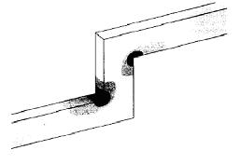
Fig 3. Current crowding for a track width of 1.5 um

5.2. Temperature

The identification of peak temperatures in multilevel interconnects is important because electromigration failure is temperature-dependent and because it can lead to stress gradients being set up inside the structure or even melting. In general, the peak temperature does not coincide with the peak current density but is found to be geometry dependent. As the track width increases the current density in the track reduces so that the joule heating is greater in a via, where the current density is largest.

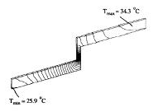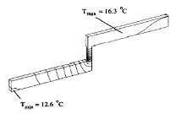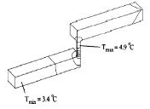

Fig 4. Temperature contours in metallic track as a function of changing track width

Given the track and via dimensions, an approximate value for the current density can be determined by supposing it to be constant across the cross-sectional area of the track. At bends in the track and at contact vias the current density often exceeds these estimates by significant amounts and can lead to preferential failure at these points. The finite-element method is used here for one-dimensional approximation. The temperature profile and peak temperature depends on the aspect ratio of the via and track widths. For the case where the track and via widths are equal the peak temperature coincides with the volume of current crowding. This suggests that such structures are most susceptible to failure.

Methods of failure in narrow interconnect include:
- Void failures along the length of the line- internal failures,
- Diffusive displacements at the terminals of the line that destroy the contact,
- Joule heating and alloy composition.

Analysis must account for electromigration caused due to momentum transfer and scattering due to imperfections in lattice, errors due to lattice defects are not noticeable at the design level. These are post process defects that must be eliminated during fabrication. ^{[10]}

6. Conclusion and future work

- A simple method for electomigration analysis was devised and the current density and temperature violations were checked for MTTF calculations. In summary, the thermal effects will limit the maximum allowed Jpeak, not EM performance.
- For this project, the interconnect widths were first extracted and using the current density violation check expressions do the electromigration analysis.
- Once these analysis confirms that current densities do not exceed the limits, the mean time to failure (MTTF) calculations are done for the interconnects.
- Two methods have been worked on for the estimation of the interconnect dimensions from different layout design tools.
- Although the parasitic extraction method could not be used for the metal width extraction, the interconnect area extracted from this method is used to estimate the width.

The future works for this project include,

- Design and simulation of some basic test circuits for the electomigration analysis and MTTF calculations.
- Calculation of Jpeak for these circuits for a fixed width interconnects and the estimating the failure times.
- Devising a method for the extraction of the interconnect width for variable width interconnect circuits.
- Extraction of interconnect width at the layout level for variable width interconnect circuits, using metal line parasitic either from Cadence tools.
- Formulating a capacitance extraction technique for VLSI circuits which have the overlap, fringing and other intrinsic capacitance values, which might be used for the interconnect width estimations.
- Charge based capacitance measurement (CBCM) may be method which might lead to capacitance estimations which could be related to interconnect dimensions.
- Developing a PERL script for incorporating the electromigration analysis – current density and temperature violation checks, and the MTTF calculations.
- Determination of current crowding and hot spots at different places in a circuit for estimating the failure time. By this way the MTTF estimations can be done for a specific number of metal lines surrounding the hot spots.
- Extending this work for circuits from industry and performing analysis and calculations for specified interconnects alone for processing time optimization.

References

[1] Hunter, W. R., The implications of self-consistent current density design guidelines comprehending electromigration and Joule heating for interconnect technology evolution Electron Devices Meeting, 1995., International, 1995 Page(s): 483 -486

[2] Jerke, G.;Lienig, J., Hierarchical current density verification for electromigration analysis in arbitrarily shaped metallization patterns of analog circuits Design, Automation and Test in Europe Conference and Exhibition, 2002.Proceedings,2002 Page(s): 464 -469

[3] Black, J. R.: “Electromigration failure models in aluminium metallization for semiconductor devices” Proc. Of the IEEE, vol. 57, no. 9, 1969, pp. 1587-1594

[4] Hunter, W. R., Self-consistent solutions for allowed interconnect current density. II. Application to design guidelines Electron Devices, IEEE Transactions on , Volume: 44 Issue:2,Feb.1997 Page(s): 310 -316

[5] Hunter, W. R., Self-consistent solutions for allowed interconnect current density. I. Implication for Technology Evolution Electron Devices, IEEE Transactions on , Volume: 44 Issue:2,Feb.1997 Page(s): 304 -309

[6]. Goel, A. K.; Au-Yeung, Y. T., Electro migration in the VLSI interconnect metallizations, Circuits and Systems, 1989, Proceedings of the 32nd Midwest Symposium on, 1990Page(s): 821 -824 vol.2.

[7]. W. Wu, S. H. Kang, J. S. Yuan, A. S. Oates; Electromigration Performance for Al/SiO2, Cu/SiO2 and Cu/low-K interconnect systems including Joule heating effect, Integrated Reliability Workshop Final Report, 2000 IEEE International, 2000 Page(s): 165 -166

[8]. Chin-Chi Teng; Yi-Kan Cheng; Rosenbaum, E.; Sung-Mo Kang, iTEM: a temperature-dependent electromigration reliability diagnosis tool Computer-Aided Design of Integrated Circuits and Systems, IEEE Transactions on , Volume:16, Issue:8, Aug.1997 Page(s): 882 -893

[9]. Sakimoto, M.; Itoo, T.; Fujii, T.; Yamaguchi, H.; Eguchi, Temperature measurement of Al metallization and the study of Black's model in high current density , K. Reliability Physics Symposium, 1995. 33rd Annual Proceedings., IEEE International , 1995 ,Page(s): 333 -341

[10]. Setlik, B.; eskett, D.; Aubin, K.; Briere, Electromigration investigations of aluminum alloy interconnects, M.A. University/Government/Industry Microelectronics Symposium, 1997., Proceedings of the Twelfth Biennial , 1997 Page(s): 159 -160

[11]. Lienig, J.; Jerke, G.; Adler, Electromigration avoidance in analog circuits: two methodologies for current-driven routing T. Design Automation Conference, 2002. Proceedings of ASP-DAC 2002. 7th Asia and South Pacific and the 15th International Conference on VLSI Design. Proceedings. , 2002

[12]. Ferreira, F.K.; Moraes, F.; Reis, R, LASCA-interconnect parasitic extraction tool for deep-submicron IC design,. Integrated Circuits and Systems Design, 2000. Proceedings. 13th Symposium on , 2000 Page(s): 327 -332

[13] Semiconductor Industry Association. The National Technology Roadmap for Semiconductor. Available by WWW in http://notes.sematech.org/ntrs/PublNTRS.nsf, 1997

[14]. N.D. Arora, K.V. Raol, R. Schumann and L.M. Richardson, Modeling and Extraction of Interconnect Capacitances for Multilayer VLSI Circuits. IEEE Transactions on Computer Aided Design of Integrated Circuits and Systems, 15(1):58-66, Jan. 1996.

[15]. Arora, N.D.; Raol, K.V.; Schumann, R.; Richardson, Modeling and extraction of interconnect capacitances for multilayer VLSI circuits, L.M. Computer-Aided Design of Integrated Circuits and Systems, IEEE Transactions on , Volume: 15 Issue: 1 , Jan. 1996 Page(s): 58 -67

[16] A. A. Bilotti,“ Static temperature distribution in IC chips with isothermal heat sources,” IEEE Trans. Electron Devices, vol. ED-21, pp. 217–226, Mar. 1974.

[17] Sampath, Barath. K., “Electromigration dependent MTTF Calculations”, Analog IC Research Group, University of Texas, Arlington.

Appendix:

- Schematic of a comparator circuit from Virtuoso Schematic viewer, used for interconnect width extraction.

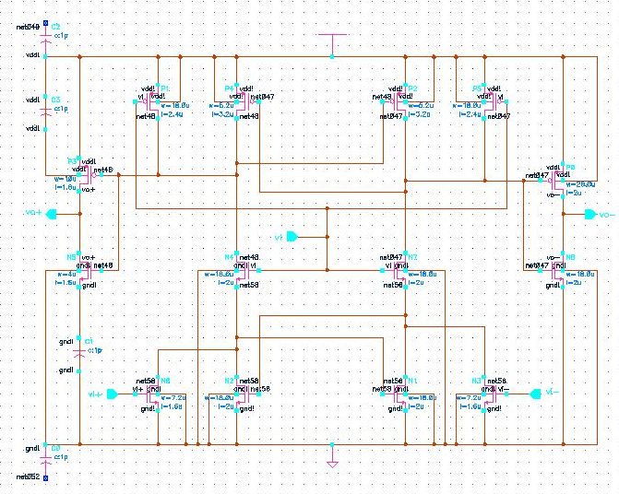

- Layout of the comparator circuit, from Virtuoso XL, layout editor.

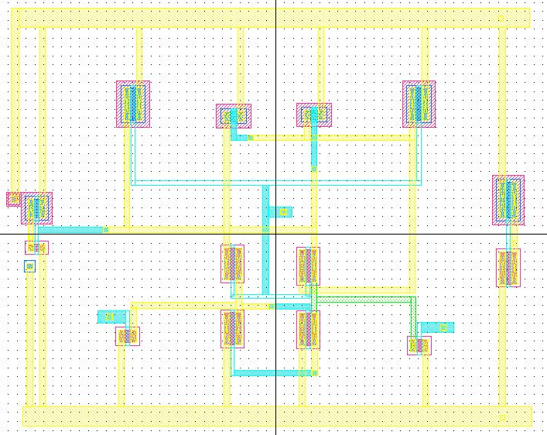

- Layout with parasitics extracted using the DIVA tool for RCX.

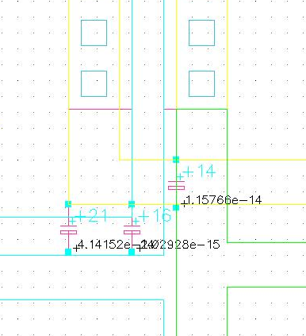

- Extracted netlist with capacitance values.

* # FILE NAME: /HOME/MNJ2566/CADENCE/SIMULATION/LATCOMP/HSPICES/EXTRACTED/
* NETLIST/LATCOMP.C.RAW
* NETLIST OUTPUT FOR HSPICES.
* GENERATED ON SEP 11 01:19:36 2002

* FILE NAME: ANALOGPROJECT_LATCOMP_EXTRACTED.S.
* SUBCIRCUIT FOR CELL: LATCOMP.
* GENERATED FOR: HSPICES.
* GENERATED ON SEP 11 01:19:36 2002.

C26 0 11 6.39743995083618E-15 M=1.0
C28 0 6 7.79007985370192E-15 M=1.0
C30 0 5 2.79615994393896E-15 M=1.0
C32 0 4 4.23776004522189E-15 M=1.0
C34 0 3 4.66207992959951E-15 M=1.0
C36 VL 0 32.1993611786774E-15 M=1.0
C38 0 11 5.05824020364566E-15 M=1.0
C40 0 7 41.4152016175486E-15 M=1.0
C42 0 6 46.1368004347693E-15 M=1.0
C44 0 5 17.8663998878651E-15 M=1.0
C46 2 0 2.64480002670406E-15 M=1.0
C48 VDD! 0 169.023202010142E-15 M=1.0
C50 VL 7 2.02928003041744E-15 M=1.0
C52 VL 6 3.59359995916447E-15 M=1.0
C54 0 24 11.5765602263845E-15 M=1.0
M56 VDD! 6 1 VDD! AMI16P L=1.6E-6 W=10E-6 AD=39.9999998401679E-12
+AS=39.9999998401679E-12 PD=18.0000006366754E-6 PS=18.0000006366754E-6 M=1
M58 VDD! 7 6 14 AMI16P L=3.2E-6 W=5.2E-6 AD=20.8000006107767E-12
+AS=20.8000006107767E-12 PD=13.1999995574006E-6 PS=13.1999995574006E-6 M=1
M60 VDD! 6 7 15 AMI16P L=3.2E-6 W=5.2E-6 AD=20.8000006107767E-12
+AS=20.8000006107767E-12 PD=13.1999995574006E-6 PS=13.1999995574006E-6 M=1
M62 VDD! VL 7 16 AMI16P L=2.4E-6 W=18E-6 AD=72.0000031817492E-12
+AS=72.0000031817492E-12 PD=25.9999997069826E-6 PS=25.9999997069826E-6 M=1
M64 VDD! VL 6 13 AMI16P L=2.4E-6 W=18E-6 AD=72.0000031817492E-12
+AS=72.0000031817492E-12 PD=25.9999997069826E-6 PS=25.9999997069826E-6 M=1
M66 2 23 VDD! 17 AMI16P L=2E-6 W=20E-6 AD=79.9999996803358E-12
+AS=79.9999996803358E-12 PD=28.0000003840541E-6 PS=28.0000003840541E-6 M=1
M68 0 6 1 0 AMI16N L=1.6E-6 W=4E-6 AD=15.9999999360672E-12
+AS=15.9999999360672E-12 PD=12.0000004244503E-6 PS=12.0000004244503E-6 M=1
M70 5 3 0 0 AMI16N L=2E-6 W=7.2E-6 AD=28.8000005788103E-12
+AS=28.8000005788103E-12 PD=15.2000002344721E-6 PS=15.2000002344721E-6 M=1
M72 0 4 12 0 AMI16N L=2E-6 W=7.2E-6 AD=28.8000005788103E-12
+AS=28.8000005788103E-12 PD=15.2000002344721E-6 PS=15.2000002344721E-6 M=1
M74 11 5 0 0 AMI16N L=2E-6 W=18E-6 AD=72.0000031817492E-12
+AS=72.0000031817492E-12 PD=25.9999997069826E-6 PS=25.9999997069826E-6 M=1
M76 6 VL 7 0 AMI16N L=2E-6 W=18E-6 AD=72.0000031817492E-12
+AS=72.0000031817492E-12 PD=25.9999997069826E-6 PS=25.9999997069826E-6 M=1
M78 5 11 0 0 AMI16N L=2E-6 W=18E-6 AD=72.0000031817492E-12
+AS=72.0000031817492E-12 PD=25.9999997069826E-6 PS=25.9999997069826E-6 M=1
M80 5 VL 6 0 AMI16N L=2E-6 W=18E-6 AD=72.0000031817492E-12
+AS=72.0000031817492E-12 PD=25.9999997069826E-6 PS=25.9999997069826E-6 M=1
M82 2 23 0 0 AMI16N L=2E-6 W=18E-6 AD=72.0000031817492E-12
+AS=72.0000031817492E-12 PD=25.9999997069826E-6 PS=25.9999997069826E-6 M=1

* RUN N88Z
.MODEL AMI16N NMOS ( LEVEL=49 VERSION=3.1 TNOM=27 TOX=3.04E-8 XJ=3E-7
+NCH=7.5E16 VTH0=0.5815607
K1=0.9340278 K2=-0.0670013 K3=4.2645743 K3B=-2.14936900E+00 W0=2.544414E-7
+NLX=1.146796E-7 DVT0W=0 DVT1W=5.3E6 DVT2W=-3.20000000E-02 DVT0=1.8024609
+DVT1=0.4371369 DVT2=-1.54891200E-01 U0=640.0382895 UA=1.134603E-9
+UB=4.305021E-18 UC=6.425777E-11 VSAT=1.025002E5 A0=0.6075572 AGS=0.1089496
+B0=9.758203E-7 B1=9.451406E-7 KETA=-1.21885000E-02 A1=0 A2=1 RDSW=2.163377E3
+PRWG=-1.00000000E-03 PRWB=6.127803E-3 WR=1 WINT=6.756618E-7 LINT=1.125536E-7
+DWG=-1.93782500E-08 DWB=2.628633E-8 VOFF=-8.36217000E-02 NFACTOR=0.4949859
+CIT=0 CDSC=2.4E-4 CDSCD=0 CDSCB=0 ETA0=0.1365138 ETAB=-4.26980000E-02
+DSUB=0.5907438 PCLM=1.1870837 PDIBLC1=5.419543E-3 PDIBLC2=1.208657E-3
+PDIBLCB=0 DROUT=0.0281681 PSCBE1=1.072772E9 PSCBE2=5.002526E-9 PVAG=0.0523589
+DELTA=0.01 MOBMOD=1 PRT=0 UTE=-1.50000000E+00 KT1=-1.10000000E-01 KT1L=0
+KT2=0.022 UA1=4.31E-9 UB1=-7.61000000E-18 UC1=-5.60000000E-11 AT=3.3E4 WL=0
+WLN=1 WW=0 WWN=1 WWL=0 LL=0 LLN=1 LW=0 LWN=1 LWL=0 CAPMOD=2 CGDO=2.7E-10
+CGSO=2.7E-10 CGBO=0 CJ=2.806451E-4 PB=0.9785784 MJ=0.5305733 CJSW=1.464911E-10
+PBSW=0.99 MJSW=0.1 PVTH0=-6.14433000E-02 PRDSW=-9.89097000E+02
+PK2=-5.38285000E-03 WKETA=4.117011E-3 LKETA=-9.83540000E-04 PAGS=0.482296 )
* RUN N88Z
.MODEL AMI16P PMOS ( LEVEL=49 VERSION=3.1 TNOM=27 TOX=3.04E-8 XJ=3E-7
+NCH=2.4E16 VTH0=-8.05862700E-01 K1=0.4627141 K2=-3.91696500E-03 K3=13.4883082
+K3B=-2.56565860E+00 W0=2.209688E-7 NLX=6.936779E-7 DVT0W=0 DVT1W=5.3E6
+DVT2W=-3.20000000E-02 DVT0=2.431363 DVT1=0.5455412 DVT2=-7.25453000E-02
+U0=268.4532224 UA=4.801783E-9 UB=4.238494E-18 UC=-1.00000000E-10
+VSAT=1.09645E5 A0=0.2531802 AGS=0.155562 B0=4.547478E-6 B1=1.951094E-6
+KETA=-1.35114000E-02 A1=0 A2=1 RDSW=1.45858E3 PRWG=-1.00000000E-03
+PRWB=-1.00000000E-03 WR=1 WINT=6.473685E-7 LINT=9.093131E-9
+DWG=-1.55533100E-08 DWB=3.228232E-8 VOFF=-6.72947000E-02 NFACTOR=0.9890363
+CIT=0 CDSC=4.036955E-4 CDSCD=0 CDSCB=0 ETA0=0.0188953 ETAB=0 DSUB=0.0223077
+PCLM=15 PDIBLC1=0 PDIBLC2=1E-5 PDIBLCB=0 DROUT=3.896422E-3 PSCBE1=1.83251E10
+PSCBE2=5.004583E-9 PVAG=0 DELTA=0.01 MOBMOD=1 PRT=0 UTE=-1.50000000E+00
+KT1=-1.10000000E-01 KT1L=0 KT2=0.022 UA1=4.31E-9 UB1=-7.61000000E-18
+UC1=-5.60000000E-11 AT=3.3E4 WL=0 WLN=1 WW=0 WWN=1 WWL=0 LL=0 LLN=1 LW=0 LWN=1
+LWL=0 CAPMOD=2 CGDO=2.7E-10 CGSO=2.7E-10 CGBO=0 CJ=2.959698E-4 PB=0.7491338
+MJ=0.4414592 CJSW=1.464496E-10 PBSW=0.9434007 MJSW=0.1 PVTH0=0.188273
+PRDSW=-9.90000000E+02 PK2=-1.46098000E-02 WKETA=0.0149993 LKETA=0.0152763
+PAGS=2.85026 )

* INCLUDE FILES

* END OF NETLIST
.TEMP 25.0000
.OP
.save
.OPTION INGOLD=2 ARTIST=2 PSF=2
+ PROBE=0
.END

- Microstrip line used in ADS for unit area capacitance estimation.

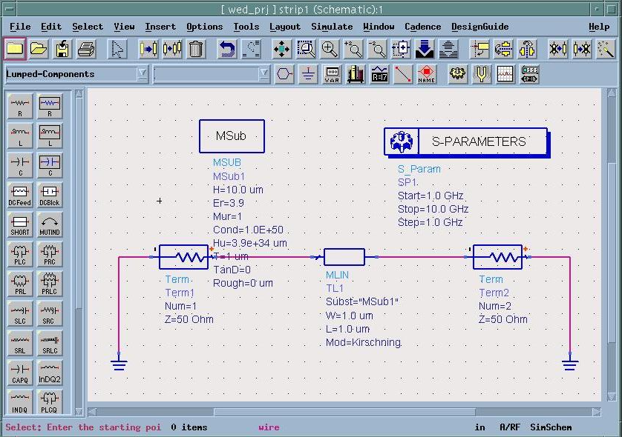

- S-parameters generated for the microstrip line.

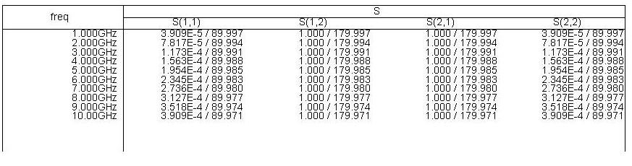

- SPICE model generated by ADS with R and C values.

SPICE 2G6 netlist generated from [S] parameters

.subckt strip1op 1 2
* L in nH, C in pF
R1 1 2 196.666
C1 1 2 35415.9P
.ENDS
* end of sub-circuit

- Layout as created by Virtuoso Custom Router.

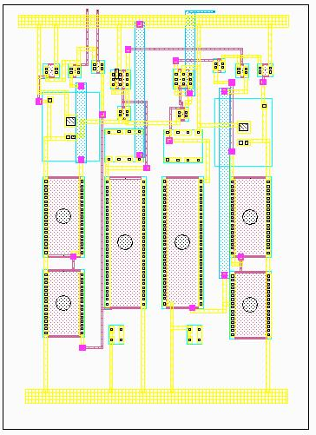

- devicelib.rules file from Virtuoso Custom Router.

; Translation Rules 2.0
; Title: deviceLib.rules
; Technology File: deviceLib
; Creator: Rules Editor 4.4.6.100.29
; Creation Date: Oct 16 20:14:09 2002
; From: layoutPlus version 4.4.6 Tue Jun 19 19:38:33 PDT 2001 (cds11612)
; User: jmaheshn

iccRevision = "2.0"
iccTechnologyFile = "deviceLib"

iccLayers =
list(
list( '("metal2" "drawing") "metal" "orthogonal" 3.0 0.6 nil t)
list( '("via" "drawing") "cut" "off" 0.6 1.2 nil t)
list( '("metal1" "drawing") "metal" "orthogonal" 0.6 0.6 nil t)
list( '("cont" "drawing") "cut" "off" 0.6 0.6 nil t)
list( '("poly" "drawing") "polysilicon" "orthogonal" 0.6 0.6 nil t)
list( '("ndiff" "drawing") "n_diffusion" "off" 0.0 0.6 t nil)
list( '("pdiff" "drawing") "p_diffusion" "off" 0.0 0.6 t nil)
)

iccVias =
list(
list( '("deviceLib" "M1_POLY1" "symbolic") t)
list( '("deviceLib" "M2_M1" "symbolic") t)
)

iccEquivalentLayers =
list(
list(
'("metal2" "drawing")
'("metal2" "net")
'("metal2" "pin")
)
list(
'("metal1" "drawing")
'("metal1" "net")
'("metal1" "pin")
)
list(
'("poly" "drawing")
'("poly" "net")
'("poly" "pin")
)
)

iccBoundaryLayers =
list(
list( '("metal2" "drawing") '("metal2" "boundary") 0.0)
list( '("via" "drawing") '("prBoundary" "drawing") 0.0)
list( '("metal1" "drawing") '("metal1" "boundary") 0.0)
list( '("cont" "drawing") '("prBoundary" "drawing") 0.0)
list( '("poly" "drawing") '("poly" "boundary") 0.0)
list( '("ndiff" "drawing") '("prBoundary" "drawing") 0.0)
list( '("pdiff" "drawing") '("prBoundary" "drawing") 0.0)
)

iccScopes = list(
)

iccKeepouts = list(
)

iccConductors = list(
list( nil list(
list(
"andnot" list('("ndiff" "drawing") '("poly" "drawing"))
'("poly" "drawing") "MOSFET" t
)
list(
"andnot" list('("pdiff" "drawing") '("poly" "drawing"))
'("poly" "drawing") "MOSFET" t
)
) 32)
)

