**SSTBuilder Users Manual**

**Overview**

SSTBuilder is a cross platform GUI based tool used to assist users in configuring and building the SST software.

SSTBuilder does not eliminate the pre-requisite requirements necessary to build SST (such as Boost, and MPI), instead it provides a more user friendly display of all the available configuration options for SST. Additionally, specific configuration options can be saved as a profile and easily restored allowing the user to easily handle multiple configurations.

**Installation and Running**

SSTBuilder is a separate application that is included as part of the SST distribution, and is located in a sub-directory below the root of the main SST directory.

SSTBuilder requires a MacOSX or Linux based machine that is running the native graphical windows manager.

The source code for SSTBuilder is located at <sstroot>/tools/sstbuilder

Pre-compiled versions of SSTBuilder are located in the <sstroot>/tools/sstbuilder/release_linux and <sstroot>/tools/sstbuilder/release_macosx. The precompiled versions were built using Ubuntu 12.04 and Mac OSX 10.8.4. In both release directories, any support files are provided as necessary.

Linux Distribution:

* A starting profile is provided named “startup.sbdr”. This provides a preliminary starting profile.
* Cross platform shared object files (Qt libraries) are provided. The user must set their LD_LIBRARY_PATH to point to <sstroot>/tools/sstbuilder/release_linux/lib. This is usually done in the .bashrc file. Also the qt.conf file is configured to load any Qt plugins located in the <sstroot>/tools/sstbuilder/release_linux/plugins directory.
* The binary file sstbuilder was built using 64 bit Ubuntu Linux v12.04, gcc v4.6.3 and Qt v5.0.2

Mac OSX Distribution:

* A starting profile is provided named “startup.sbdr”. This provides a preliminary starting profile.
* The framework sstbuilder.app is available and built for Mac OSX 10.8.4 The sstbuilder.app is a framework (directory) that contains everything necessary (program binary, icons, shared libraries, etc) to run the application.
* The sstbuilder.app was build using 64 bit OSX 10.8.4, clang v425.0.28 and Qt v5.0.2

If the pre-compiled versions do not run properly, the user should build the application for their system. Instructions are included below.

Linux Compile:

* Download and install the Qt 5.0.2 (or newer) Development Kit located at http://qt-project.org/downloads and perform a standard install.
* Run the Qt Creator development interface, and load the sstbuilder.pro file. Then compile the SSTBuilder application.
* To find out the shared object dependencies for the sstbuilder, cd to the directory containing the sstbuilder, and run > ldd sstbuilder (using a terminal).

Mac OSX Compile:

* Download and install the Qt 5.0.2 (or newer) Development Kit located at http://qt-project.org/downloads and perform a standard install.
* Qt for Mac requires Apple xcode development suite to be installed from <http://developer.apple.com/xcode>
* Run the Qt Creator development interface, and load the sstbuilder.pro file. Then compile the SSTBuilder application.
* To find out the shared object dependencies for the sstbuilder.app, cd to the directory containing the sstbuilder.app, and run

>otool –L sstbuilder.app/Contents/MacOS/sstbuilder (using a terminal).

* To finalize the sstbuilder.app framework, cd to the directory containing the sstbuilder.app, and run

>macdeployqt sstbuilder.app (using a terminal). This will merge the required shared objects into the sstbuilder.app framework so that the framework can be delivered as a standalone application. Note: macdeployqt is a Qt provided application and must be in the users PATH environment for proper operation.

**General Usage Concepts**

* All dependencies (external packages) for building SST must be properly compiled and installed on the system. These pre-requisites include: GNU Libtools, Boost, MPI (OpenMPI or MPICH), DRAMSIM2, Gem5, QSim, etc.

See <https://code.google.com/p/sst-simulator/wiki/SSTBuildAndInstall3dot0series> for more information.

* SSTBuilder provides a convenient and graphical method for performing the SST configuration, compile and install, but does not eliminate the requirements for setting appropriate environment path variables.
* SSTBuilder allows for various SST setup profiles to be quickly selected by storing environment variables and SST configuration options as a profile. Profiles can be modified and saved to files and restored as necessary.
* When SSTBuilder starts up, it will load the default profile (.sstbuilder file in the users home directory).
* Any changes to the SSTBuilder setup will be automatically written to the default profile. Additionally, the user can save the current setup as a separate profile. This saved profile can then later be loaded to restore the setup.
* Any profile that is loaded will then become the default profile.
* Environment groups are a collection of environment variables that can be enabled/disabled as a group. Environment groups are created/edited in the setup dialog. Environment groups allow for quick configuration changes to different versions of dependent libraries. For example one Environment group can be configured for OpenMPI whereas a separate group can be setup for MPICH.
* When SSTBuilder runs autogen.sh, configure or make, it will load the enabled Environment groups for that particular run.

**Initial Startup and Usage**

1. When SSTBuilder is started for the first time, the program will have no loaded profile, and will look as shown

(Figure 1)

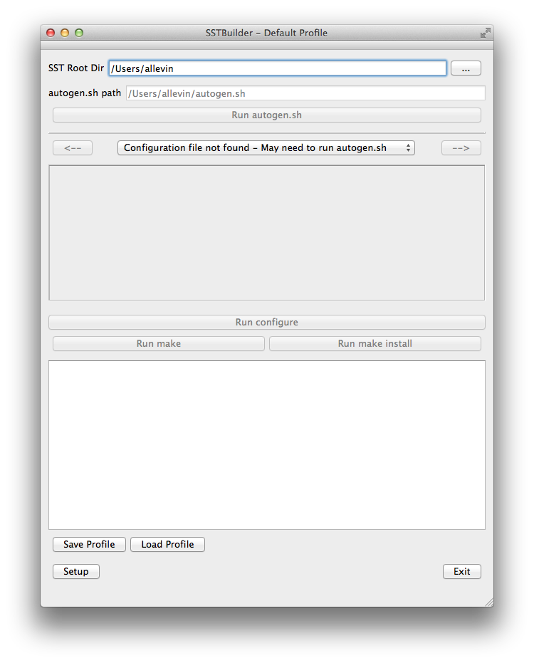

Figure

2) If the user clicks the “Setup” button, the dialog will show the setup dialog with unpopulated Environment Groups (Figure 2).

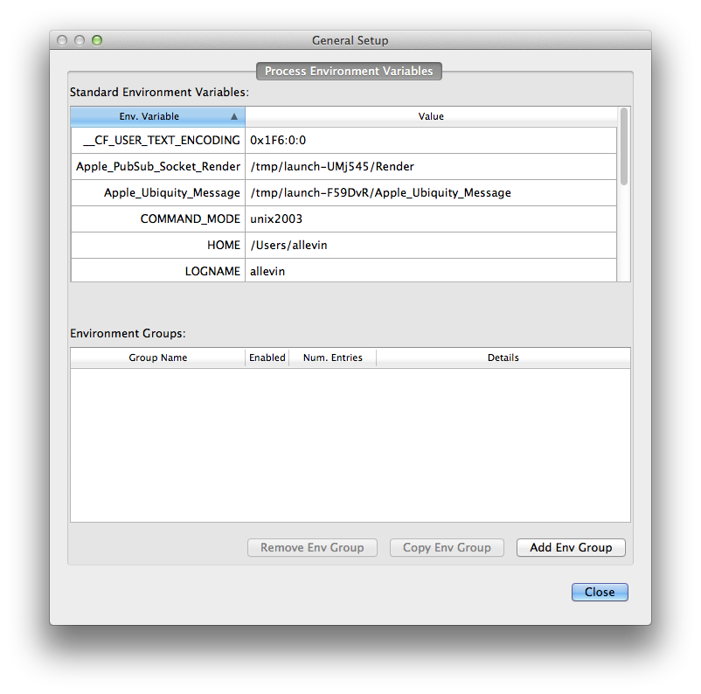

Figure

3) The user should load the starting profile by clicking the “Load Profile” Button and finding the “startup.sbdr” file in the located in the same directory as the application (Figure 3).

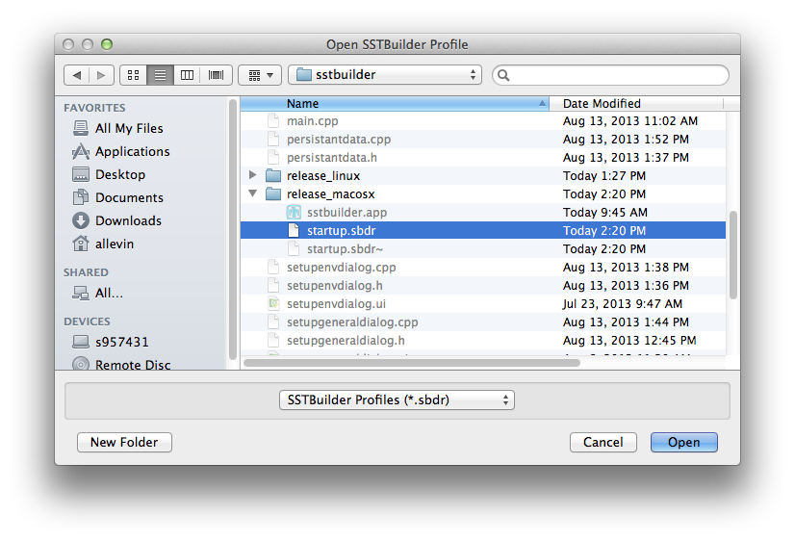

Figure

4) After loading the profile, the title of the application will change to show what profile is currently active (Figure 4).

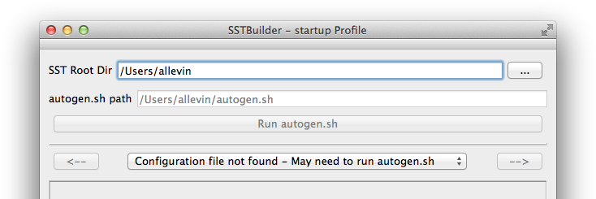

Figure

5) If the user clicks the “Setup” button, the dialog will now show the setup dialog with populated Environment Groups for that configuration (Figure 5)

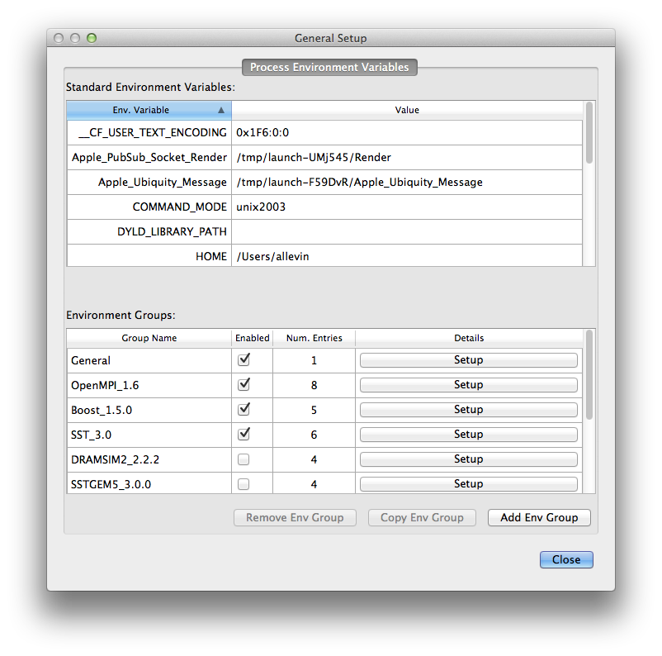

Figure

6) The user must select the SST Root directory by either entering the path or clicking the “…” button. This directory must be where the autogen.sh file is located. When configured properly, the “Run autogen.sh” button will be enabled and the autogen can be run to generate an SST configuration file as shown (Figure 6).

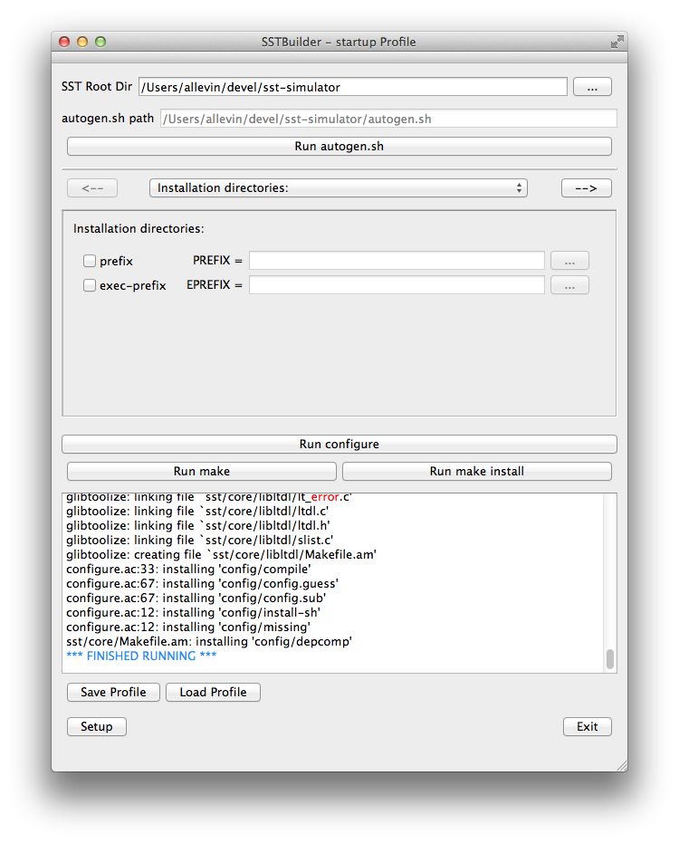

Figure

7) Note that after the output window displays a dump of the Environment variables used for the process, and the process (in this case autogen.sh) output (Figure 7).

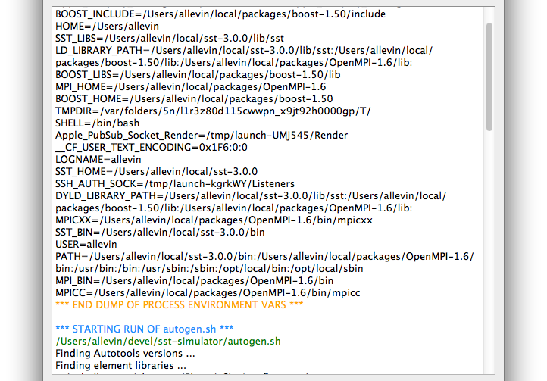

Figure

8) Once the autogen.sh has been run, all of the various configuration options can be set as desired (Figure 8).

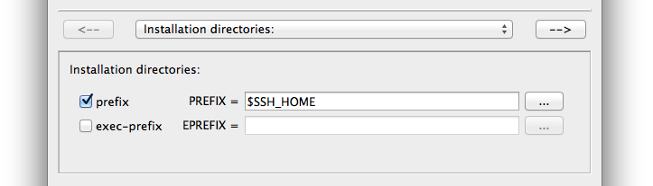

Figure

9) Once all the configuration options are selected, the “Run configure” button is pressed. This will generate a dialog previewing the configure command settings (the user can use this to verify their configuration) (Figure 9).

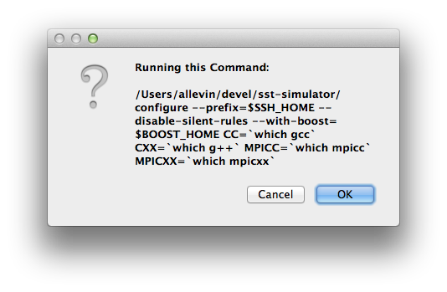

Figure

10) After accepting the preview dialog, SST will be configured. As before, the environment variables and output from configure will be displayed in the output window (Figure 10).

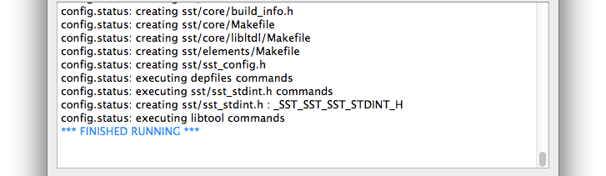

Figure

11) Finally, if configure was successful and a Makefile was created, the user can click either the “Run make” or “Run make install” as desired.

**Main Screen**

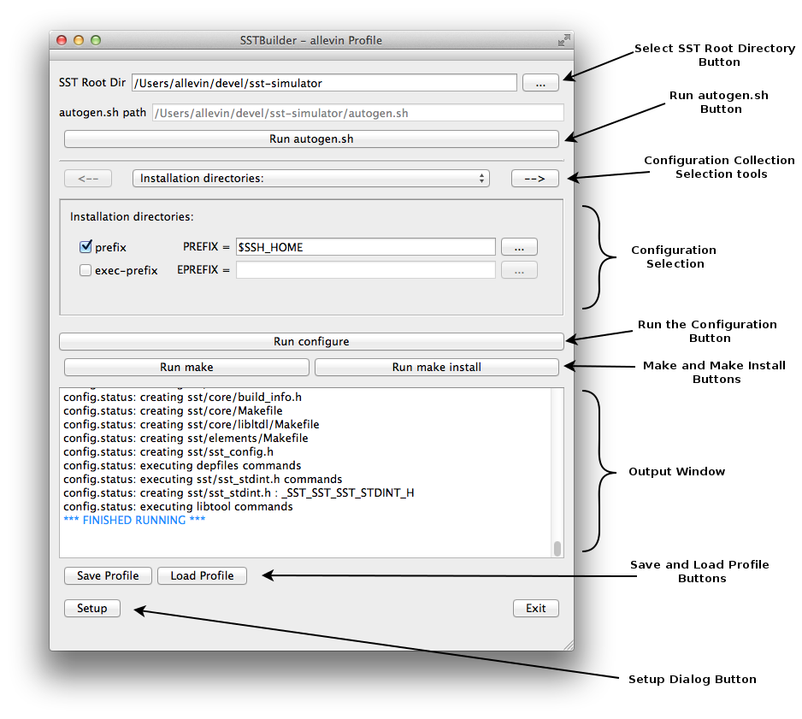

* In the main window, the configuration area is dynamically populated from the configuration file created by autogen.sh. There will be a number of groupings that can be switched by the arrow buttons and/or the pull-down control.
* The current selections are:
  + Installation directories: – Where to install SST.
  + Fine tuning of the installation directories: – Finer grain control over the SST installation directories.
  + Program names: - Modifications to the program names
  + System types: - Settings for various system types
  + Optional Features: - Settings for optional SST features.
  + Optional Packages: - Settings for optional SST Packages.
  + Some influential environment variables: - Various complier and other settings.
* Clicking on a configuration setting checkbox will enable/disable that option.
  + Most of the configuration settings have a entry field for additional information (such as targeted home directory for SST). Some of these entry fields must be populated. These required fields will be marked with “<Required>” when the configuration setting is enabled.
  + Entry fields that are meant for directories, will contain a button “…” which will allow the user to select a specific directory if desired. The user can also manually enter a path or use an environment variable (example $SST_HOME).
  + Entry fields can also contain environment variables or execute strings (example `which gcc`) to provide entries in the fields that will be passed to the system shell when the run button is pressed.
* The configuration settings and entries are saved as part of a profile. When creating a new configuration file (by running autogen.sh), the program will attempt to do its best to match up old configuration choices with the updated configuration file.

**Setup Dialog**

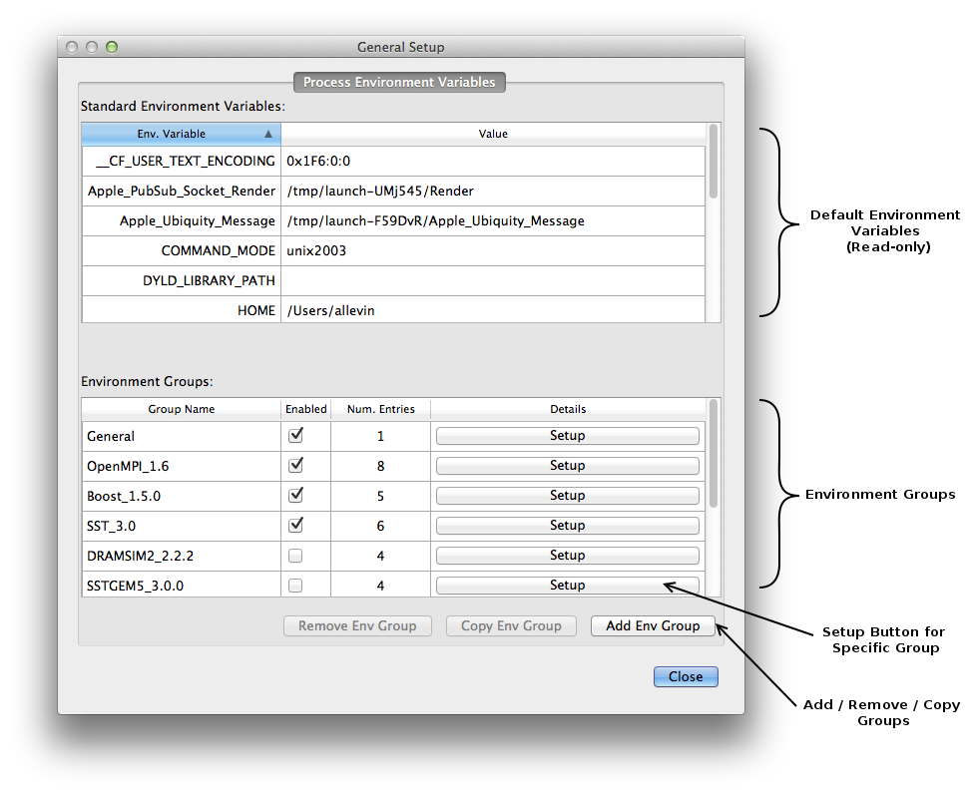

fsfsadfsadf

**Environment Group Setup Dialog**

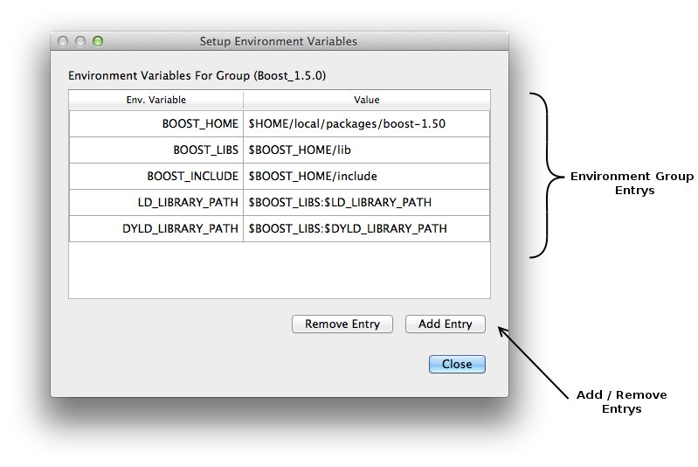

fsfsafsdfsad