Artisan Essentials – Website Documentation
This document provides an overview, screenshots, structure, and functional details of the Artisan Essentials stationery e-commerce website.

1. Introduction
Artisan Essentials is a premium stationery shop offering branded products such as Moleskine, Pilot, Faber-Castell, Staedtler, Tombow, and more. The website features a modern interface with interactive product cards, filters, sorting options, search, and a dynamic shopping cart system.

2. Homepage
The homepage introduces the brand with a premium theme and elegant fonts. It includes a navigation bar, hero section, featured products, and quick access to the shop.
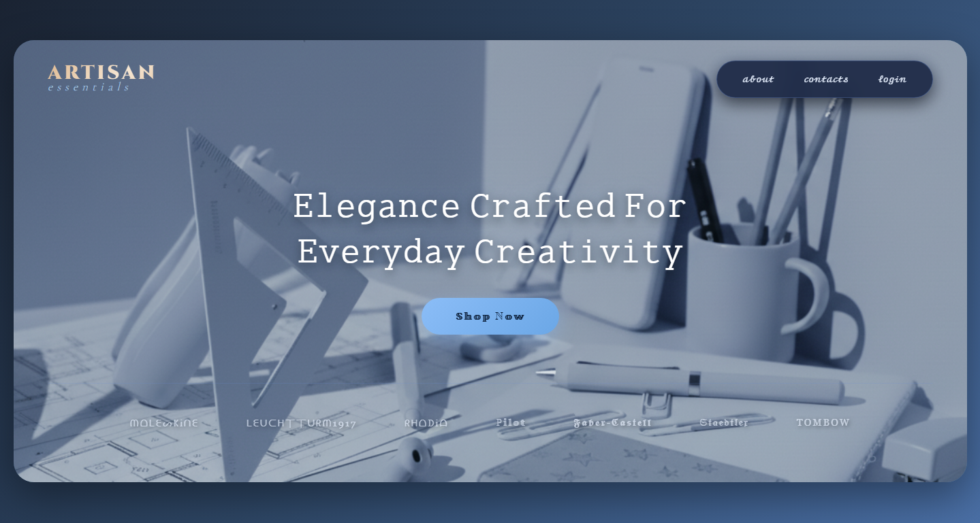

3. Navigation Bar
The website features a fully responsive navigation bar with links to Home, Shop, About, and Contact pages. The cart icon dynamically updates based on user interaction.
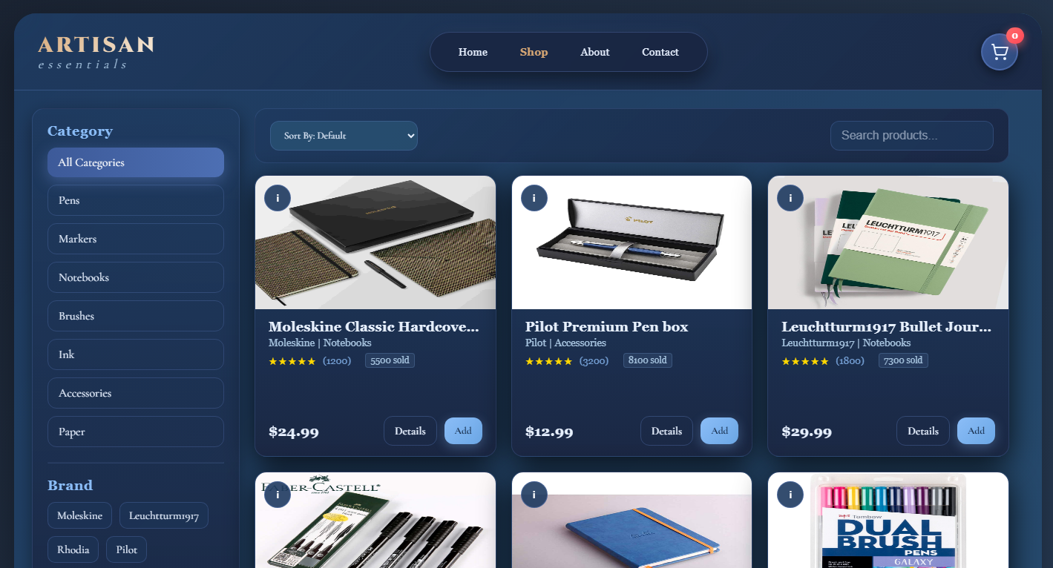

4. Shop Page
The Shop page is the most interactive section of the website. It includes:
- Category filters
- Brand filters
- Search bar
- Sorting options
- Dynamic product cards with flip animations
- Product modal for detailed view
- Shopping cart sidebar

5. Product Cards
Each product card displays title, brand, category, rating, price, sales count, and options for adding to cart or viewing details. Cards include a front and back side with smooth 3D flip animation.

6. About Page
The About page explains the brand's mission, craftsmanship, and attention to quality. It maintains a premium visual identity to reflect the brand’s tone.
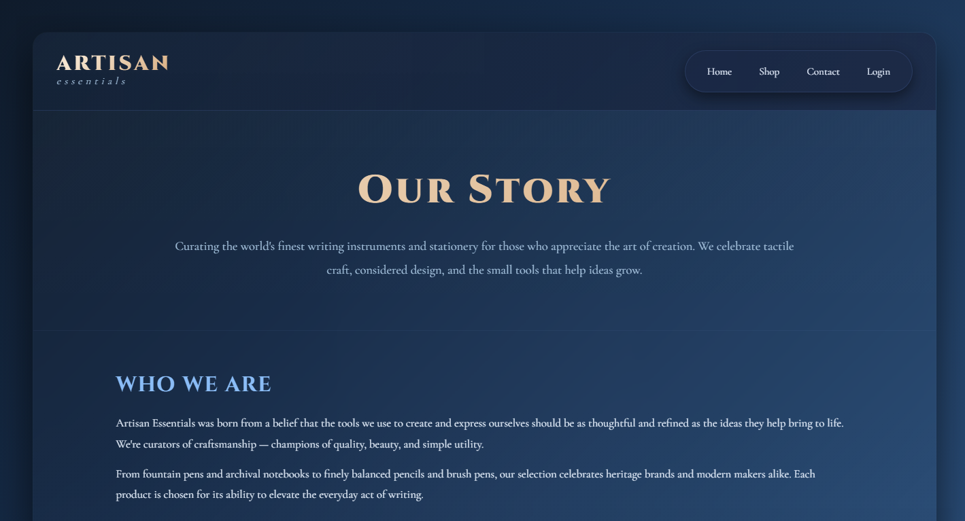

7. Contact Page
The Contact page contains a modern contact form, social links, and store location. Users can contact the Artisan Essentials team for inquiries and support.
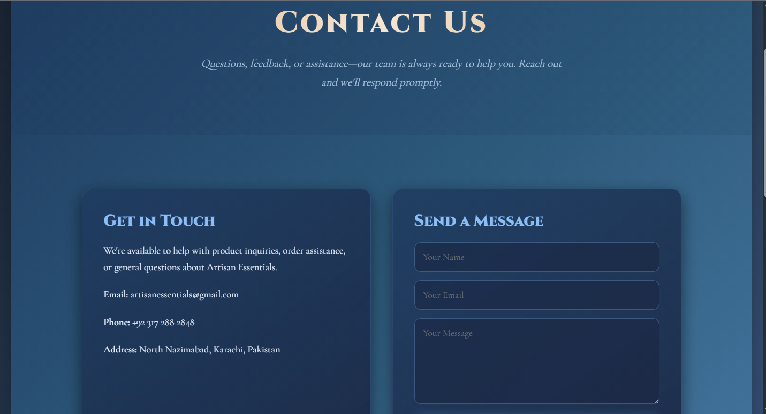

8. Footer
The footer includes all essential information including quick links, social media, contact details, and copyright.
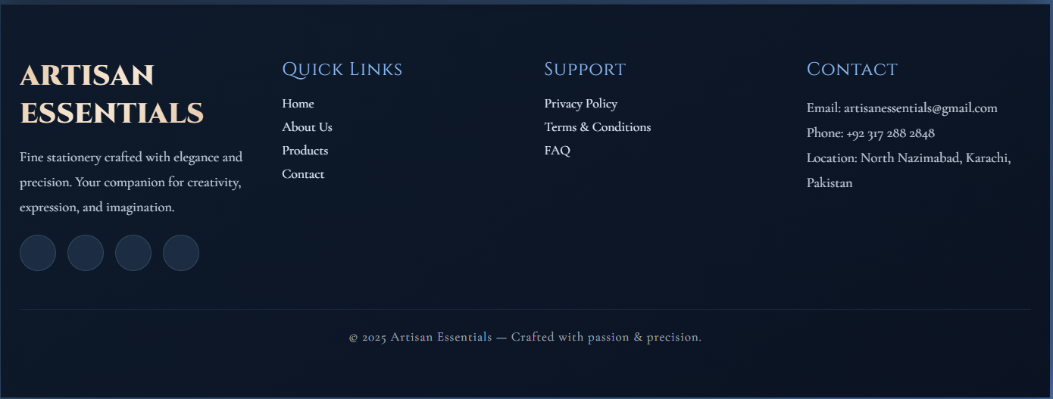

9. Summary
The Artisan Essentials website presents a clean, modern, and premium browsing experience with functionalities comparable to real e-commerce websites. Its strong branding, animations, and user-friendly features make it an excellent stationery shop interface.

